Virtual Server Creation in AWS Cloud

- Step 1: - Go to the browser and search for aws console login
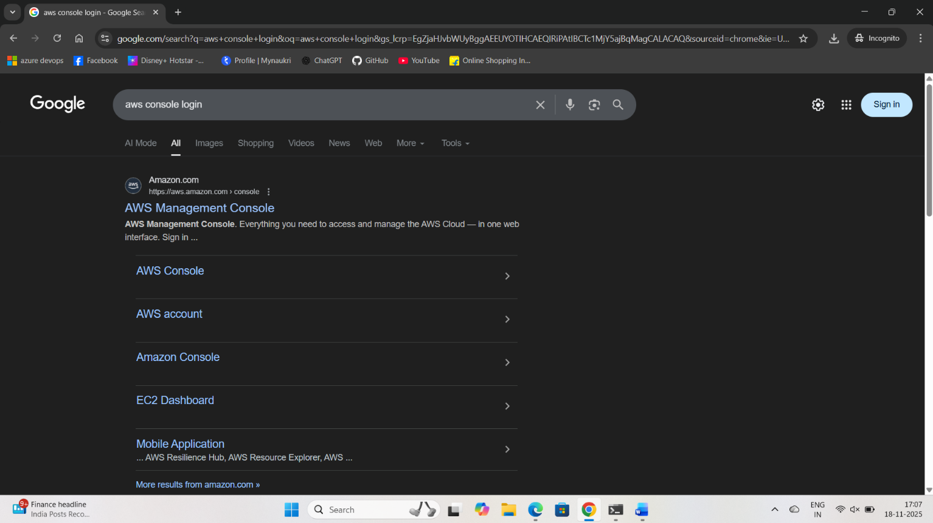

- Step 2: - Select the AWS Management Console. It takes you into Home Page of AWS Management Console website

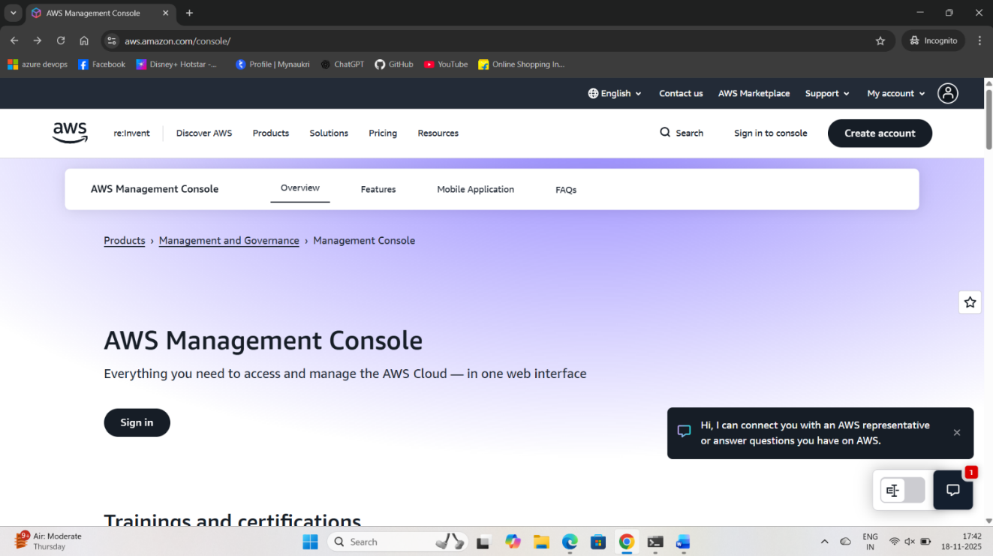

Step 3: - Select Sign in to Console, then we will be redirected to the login page
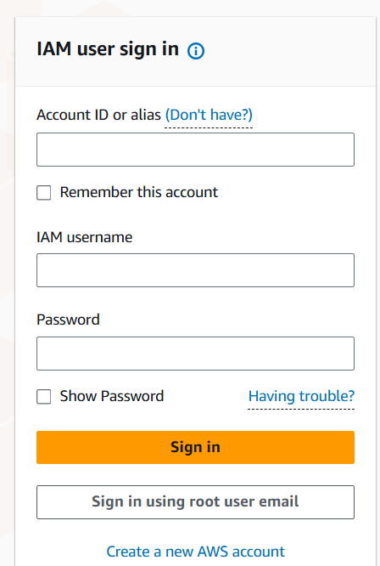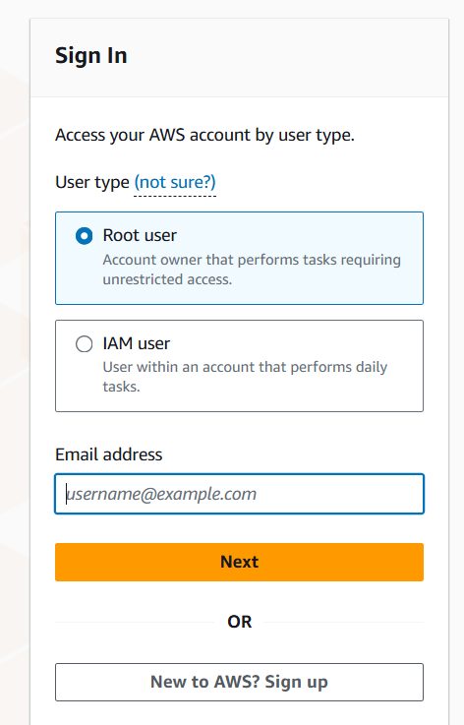
- In Page got to sign in using root user email then it will be showing Root User and IAM User
- In that I am going with Root user it has Adim Access so I am Using Root User and enter the registered Email id and click on Next
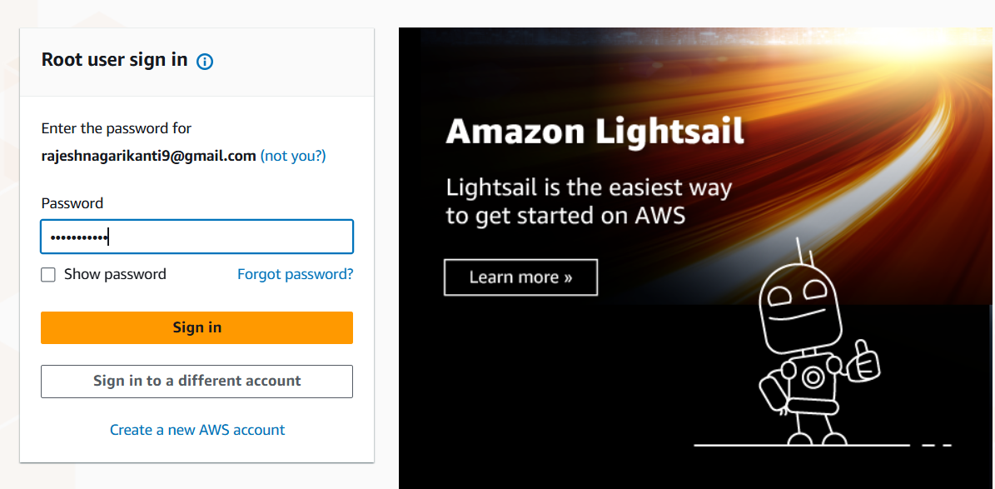

- Give Password and click on sign in, then you will be redirected into MFA (Multifactor Authentication) Page
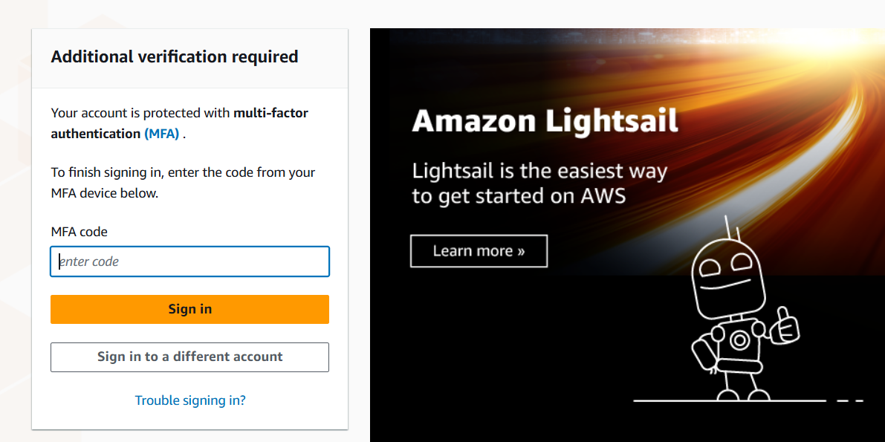
- Here in this step, it will ask for MFA code generated in the Microsoft Authenticator
- Here, I Have Authenticated from the Microsoft Authenticator app to sign in which is for secure login
- Then it will take us to the home page of AWS Cloud

Step 4: - Now we are going to create a server in the Aws Cloud

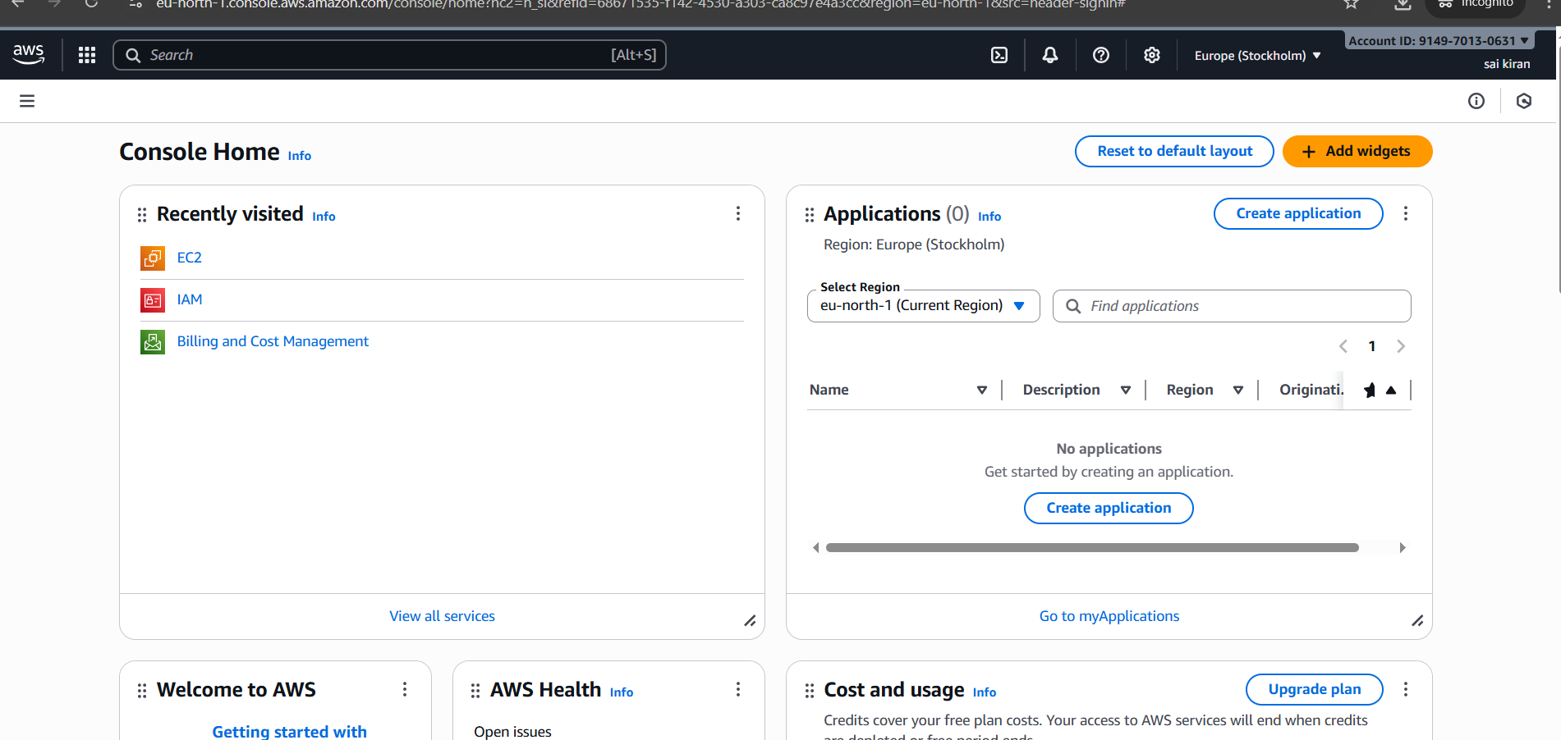

- Now in this Home page We Can see number of services available
- In this Home page we are going to create a Server using EC2 Service
- EC2 Stands for Elastic Compute Cloud Essentially, it allows users to rent virtual servers, known as "instances," on demand, enabling them to run applications and workloads without the need to purchase and maintain physical hardware.

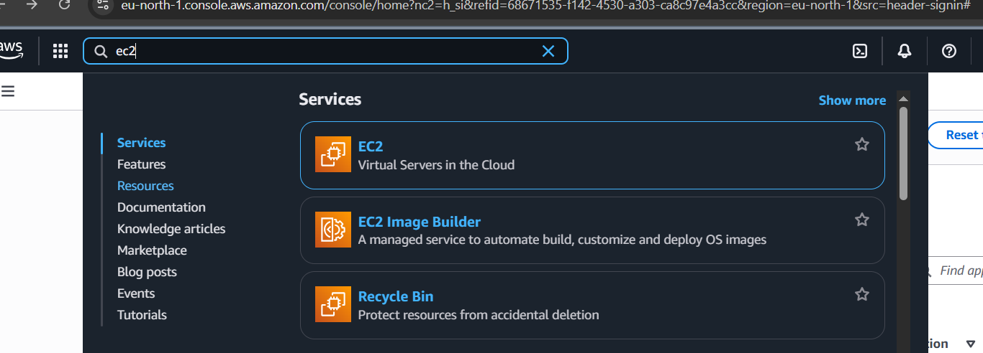
- Now we are going with EC2 for Server (Instance) creation, select EC2 in the services provided, by Searching in the given search bar
- Now Select EC2 Service it will redirect into EC2 page
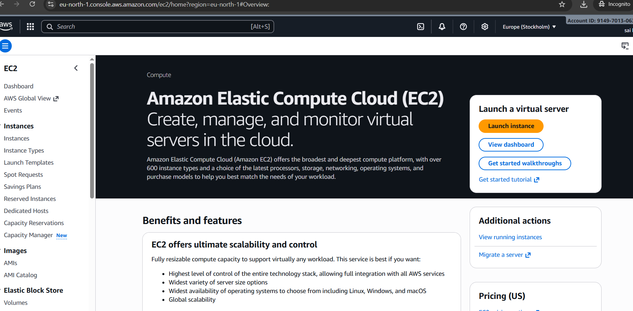
- Here we can see Launch Instance in the EC2 page to create a server then we will be into the server creation

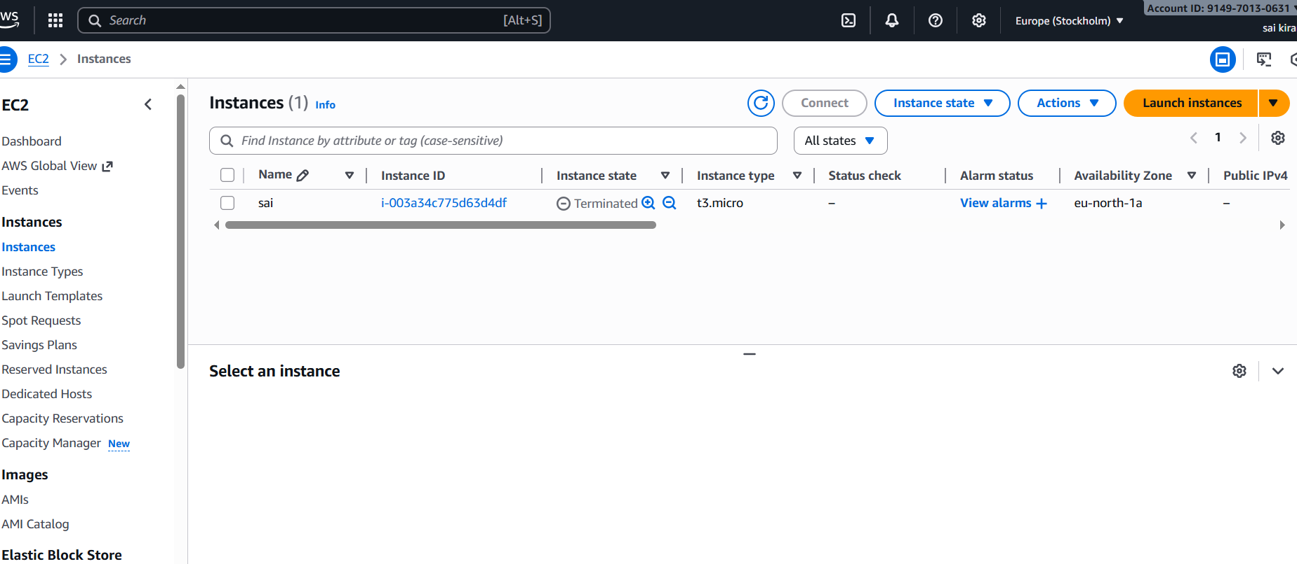

- In this screen we can see many tabs are available to create Instance, we click on the Launch Instance

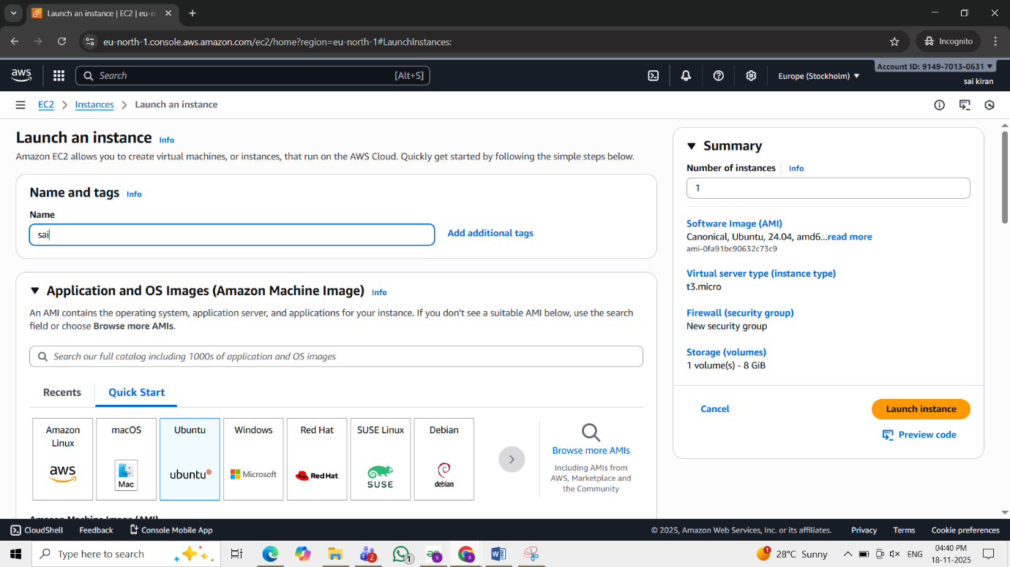

- Now we will give the Name for the server and select the Operating System (OS)
- We are selecting Ubuntu (OS) which is a Linux Distribution which is used widely

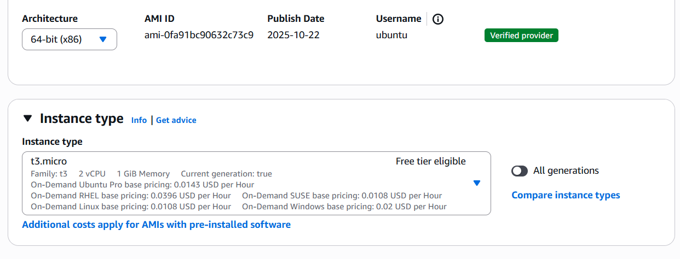

- After selecting the Ubuntu OS, we have to give the Instance type
- The instance type provides resources like CPU, RAM etc.
- which are used to balance the workload and Performance

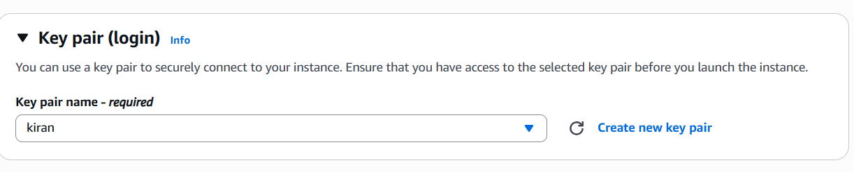
- Here we have to create a key pair which is used to connect to the server Securely
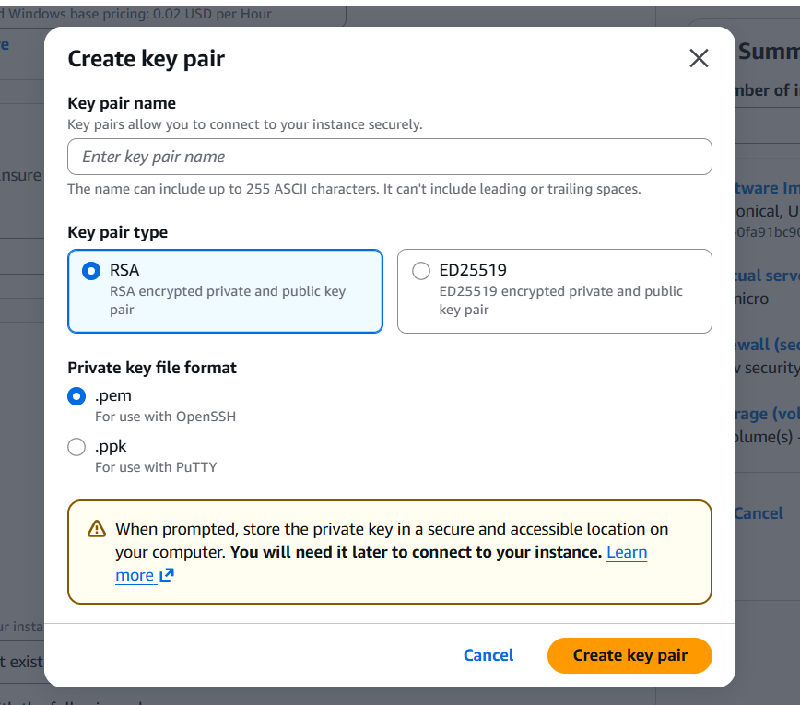
- Name the ley pair and key pair type should be RSA and key file format as .pem
- Now click on create key pair then a copy of .pem file will be downloaded in our device

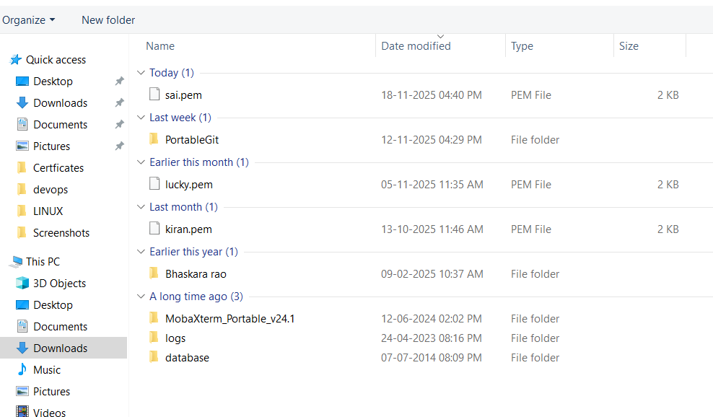

- Next, we have to give the Network Configuration and Storage Configuration
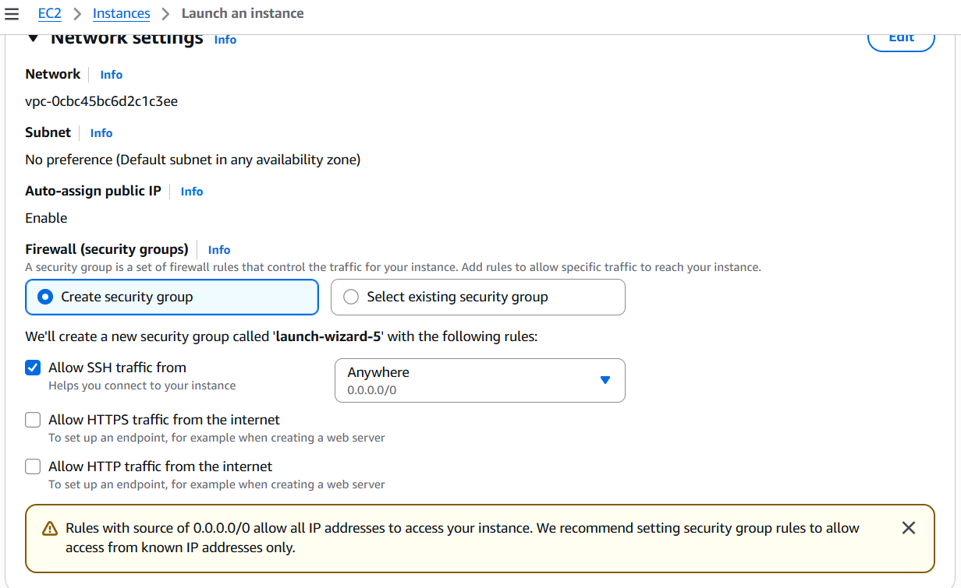
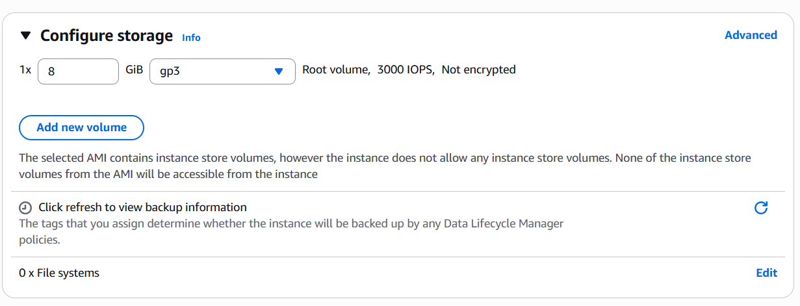
- We have to give the Network and Storage Configuration according to our requirements

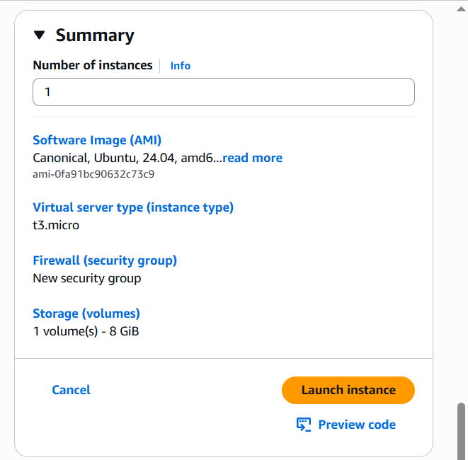
- After Configuration of Network and Storage, we have Select no of servers we want to create

- After all the Configurations done then click on the Launch Instance

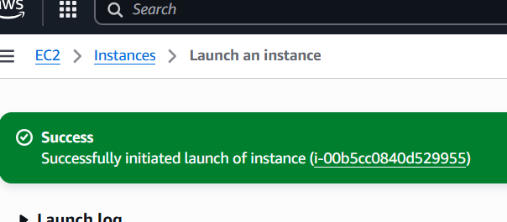
- Now we have created a Server Successfully

- Step 5: - Connecting to the AWS server from Our local device
- We Have to go to Instances and select the instance which we have created and click on connect

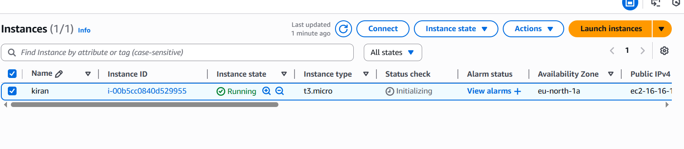
- After we click on the connect, we can see the Instance Configuration details in that select SSH Client
- There we can see Instance Id and also Public Ip and Example
- Among those we have to Copy the IP in Example

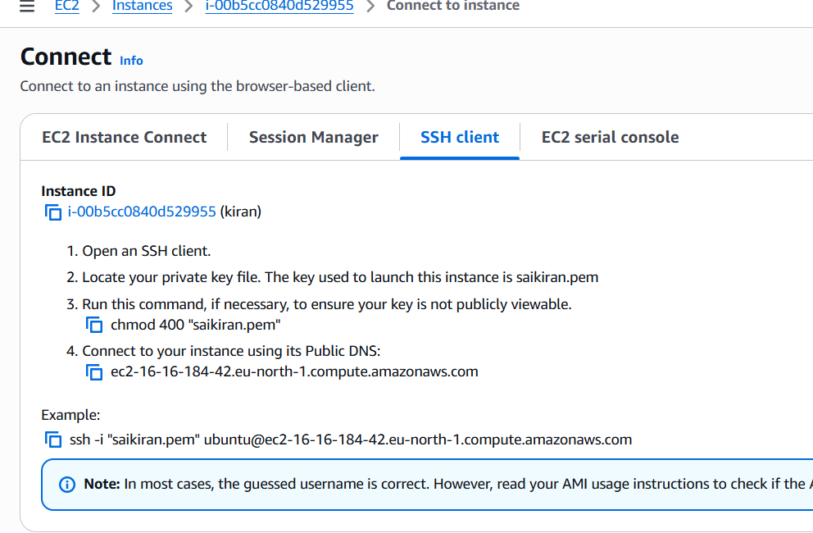

- Now we have to give that copied IP in the PowerShell terminal to connect to the virtual server created in the AWS Cloud
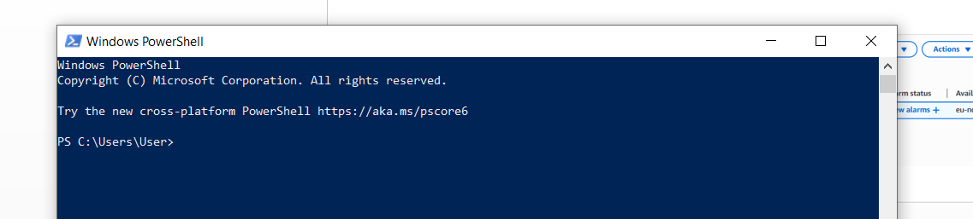

- After Opening the terminal, we have to go the file/folder where we have saved the .pem file and paste the secure shell which we have copied from SSH client and Enter

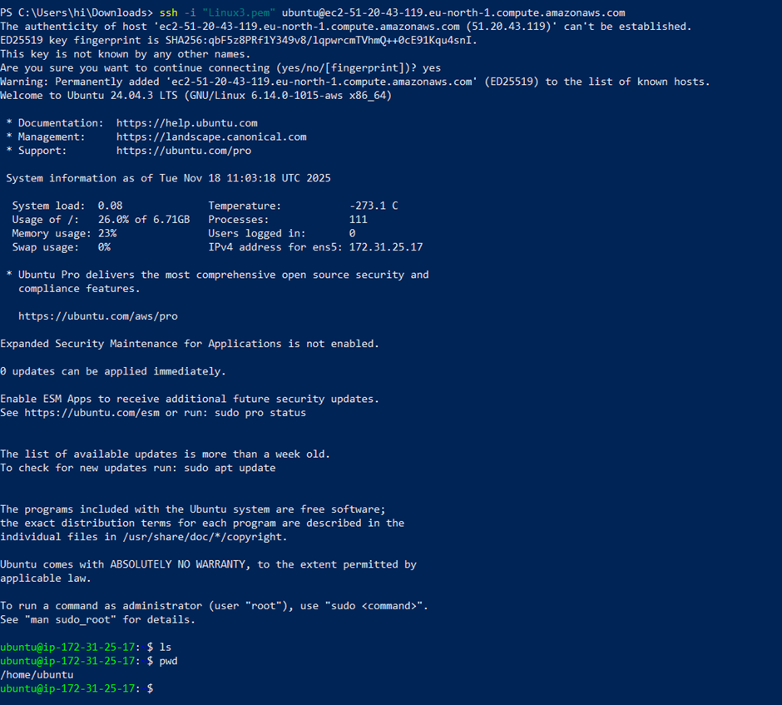

- We Have Successfully connected to the virtual server which we have created in the Cloud

