**Azure Machine Learning**

Azure Machine Learning is a cloud service for accelerating and managing the machine learning project lifecycle. Machine learning professionals, data scientists, and engineers can use it in their day-to-day workflows: Train and deploy models and manage MLOps.

You can create a model in Azure Machine Learning or use a model built from an open-source platform, such as Pytorch, TensorFlow, or scikit-learn. MLOps tools help you monitor, retrain, and redeploy models.

Azure Machine Learning is for individuals and teams implementing MLOps within their organization to bring machine learning models into production in a secure and auditable production environment. Data scientists and ML engineers will find tools to accelerate and automate their day-to-day workflows. Application developers will find tools for integrating models into applications or services. Platform developers will find a robust set of tools, backed by durable Azure Resource Manager APIs, for building advanced ML tooling.

**Machine learning project workflow**

Typically, models are developed as part of a project with an objective and goals. Projects often involve more than one person. When experimenting with data, algorithms, and models, development is iterative.

**Project lifecycle**

While the project lifecycle can vary by project, it will often look like this:

Machine learning project lifecycle diagram

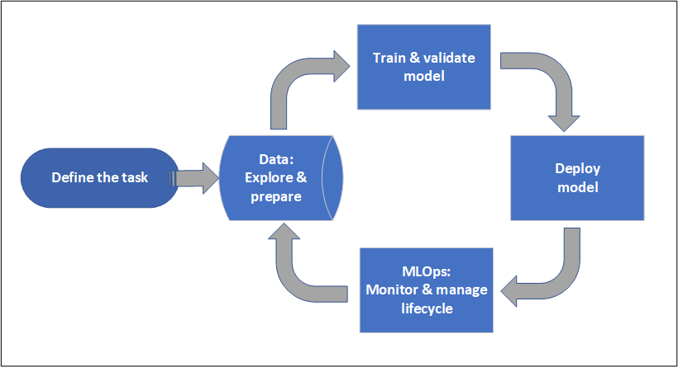

A workspace organizes a project and allows for collaboration for many users all working toward a common objective. Users in a workspace can easily share the results of their runs from experimentation in the studio user interface or use versioned assets for jobs like environments and storage references.

When a project is ready for operationalization, users work can be automated in a machine-learning pipeline and triggered on a schedule or HTTPS request.

**Create the workspace resources you need to get started with Azure Machine Learning.**

The workspace is the top-level resource for your machine learning activities, providing a centralized place to view and manage the artifacts you create when you use Azure Machine Learning. The compute resources provide a pre-configured cloud-based environment you can use to train, deploy, automate, manage, and track machine learning models.

**Prerequisites**

An Azure account with an active subscription.

**Create the workspace**

If you already have a workspace, skip this section and continue to Create a compute instance.

If you don't yet have a workspace, create one now:

* Sign in to Azure Machine Learning studio
* Select Create workspace
* Provide the following information to configure your new workspace:

|  |  |
| --- | --- |
| Field | Description |
| Workspace name | Enter a unique name that identifies your workspace. Names must be unique across the resource group. Use a name that's easy to recall and to differentiate from workspaces created by others. The workspace name is case-insensitive. |
| Subscription | Select the Azure subscription that you want to use. |
| Resource group | Use an existing resource group in your subscription or enter a name to create a new resource group. A resource group holds related resources for an Azure solution. You need contributor or owner role to use an existing resource group. For more information about access, see Manage access to an Azure Machine Learning workspace. |
| Region | Select the Azure region closest to your users and the data resources to create your workspace. |

* Select Create to create the workspace.

**Create a Resource group**

* Select Resource groups
* Select Create

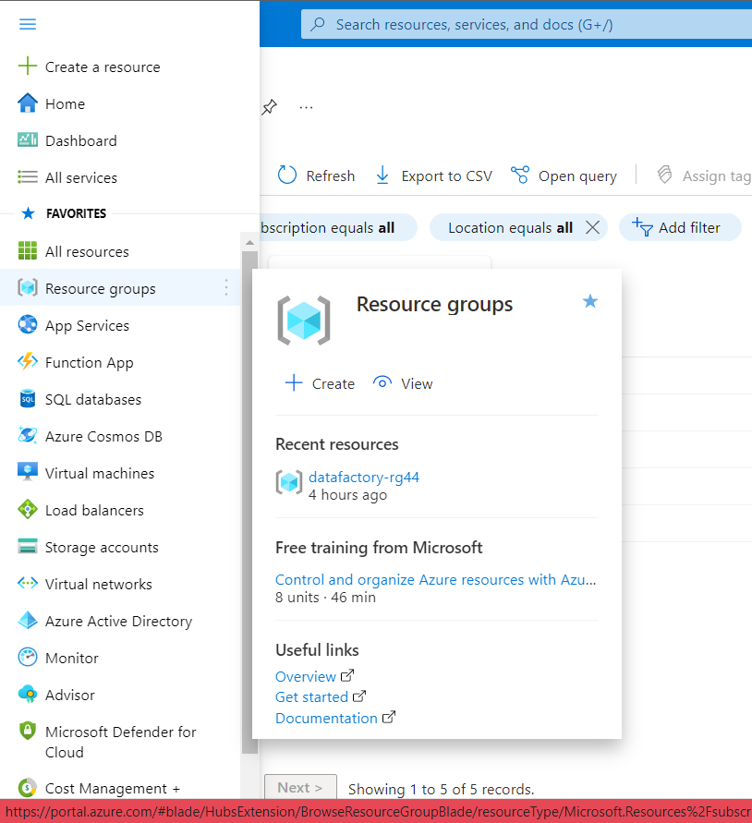



* Subscription: Select your Azure subscription.
* Resource group: Enter a new resource group name.
* Region: Select an Azure location, such as Central US, East US.

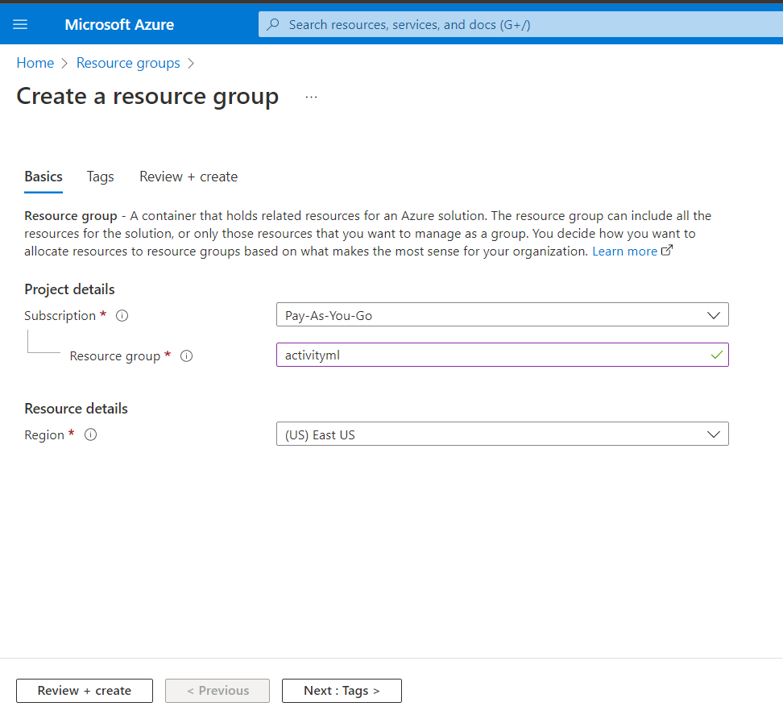



* Select Next
* Select Review + create
* Select Create. It takes a few seconds to create a resource group

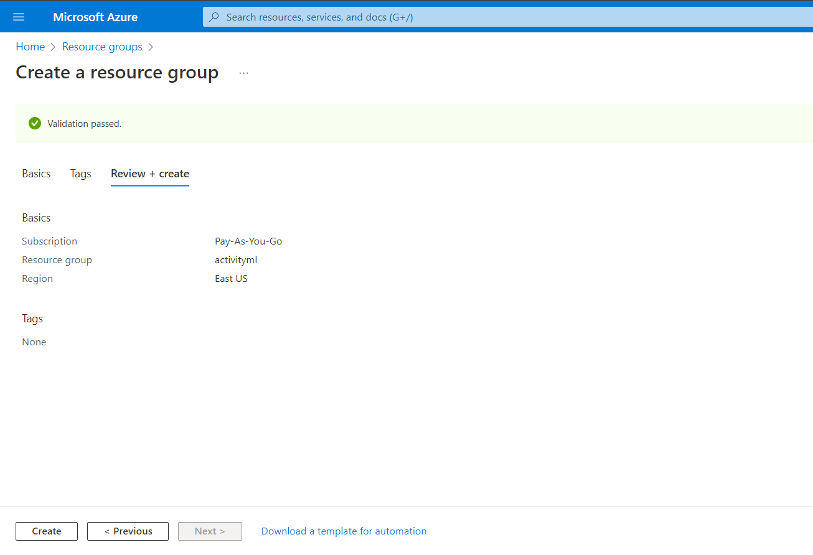

* Select Refresh from the top menu to refresh the resource group list, and then select the newly created resource group to open it. Or select Notification(the bell icon) from the top, and then select Go to resource group to open the newly created resource group

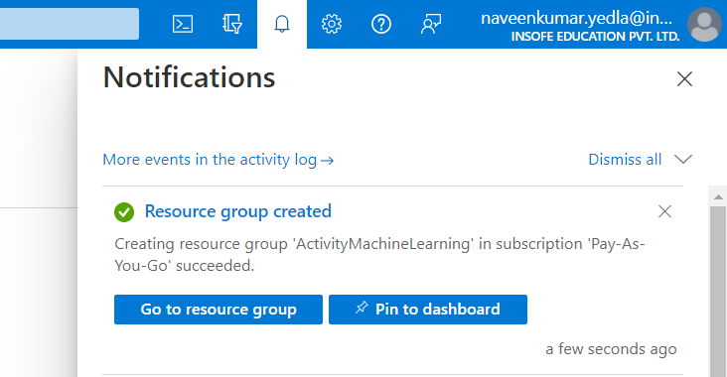

**Create Azure Machine Learning Workspace.**

* Select All services
* Select AI + machine learning
* Select Azure Machine Learning

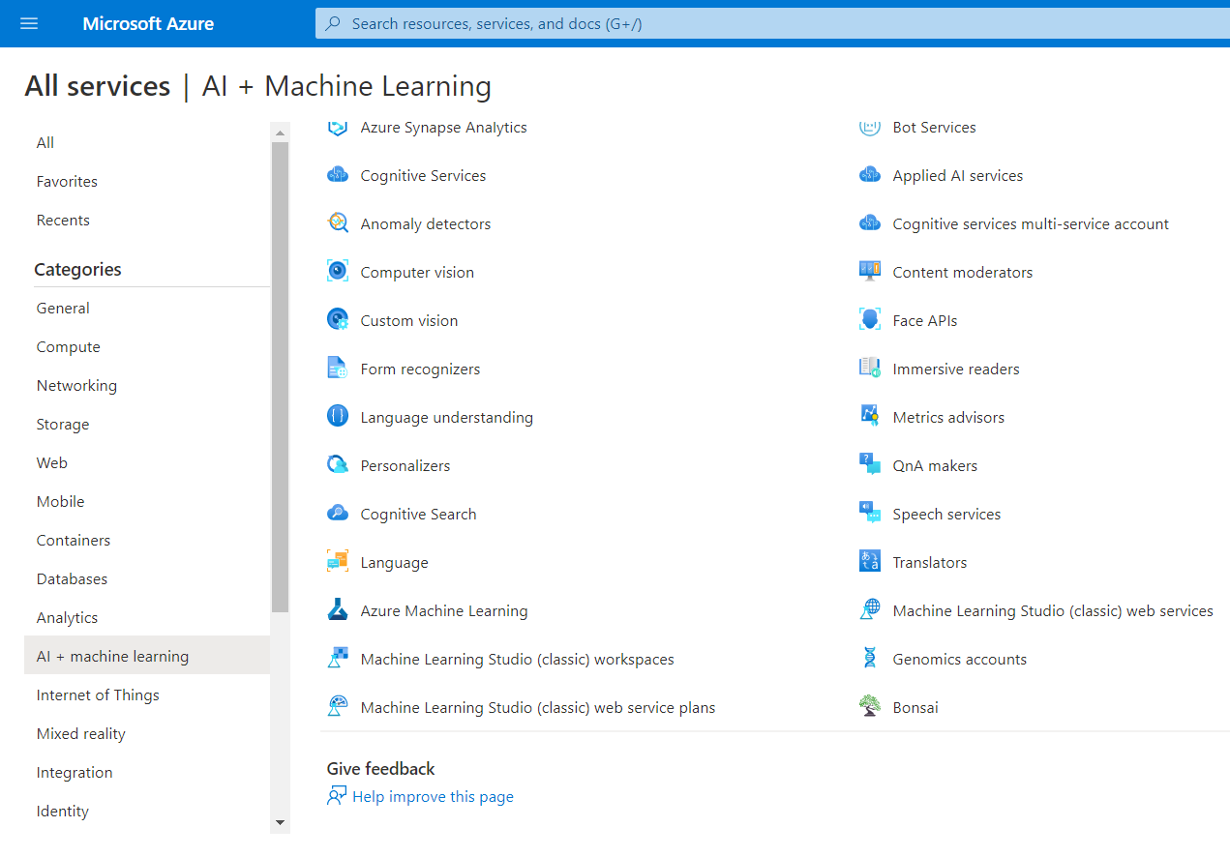

* Select Create

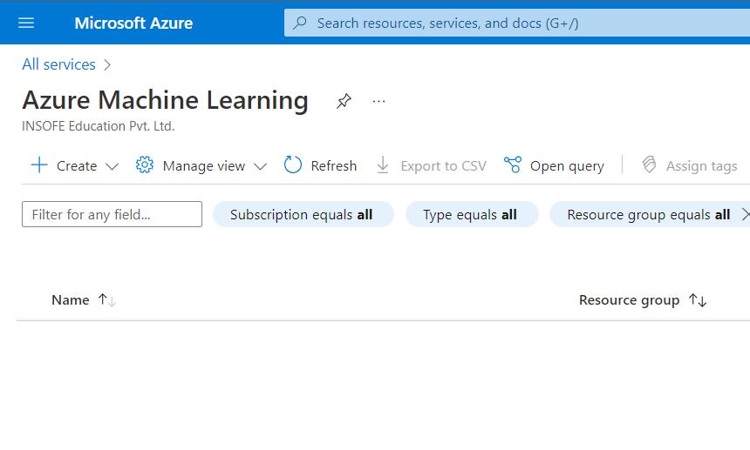

* Subscription: Select your Azure subscription.
* Resource group: Enter a new resource group name that you created above.
* Workspace Name: Enter a new workspace name.
* Region: Select an Azure location, such as Central US, or East US.
* Storage account and remaining cells will be created automatically.
* Select Review + create.

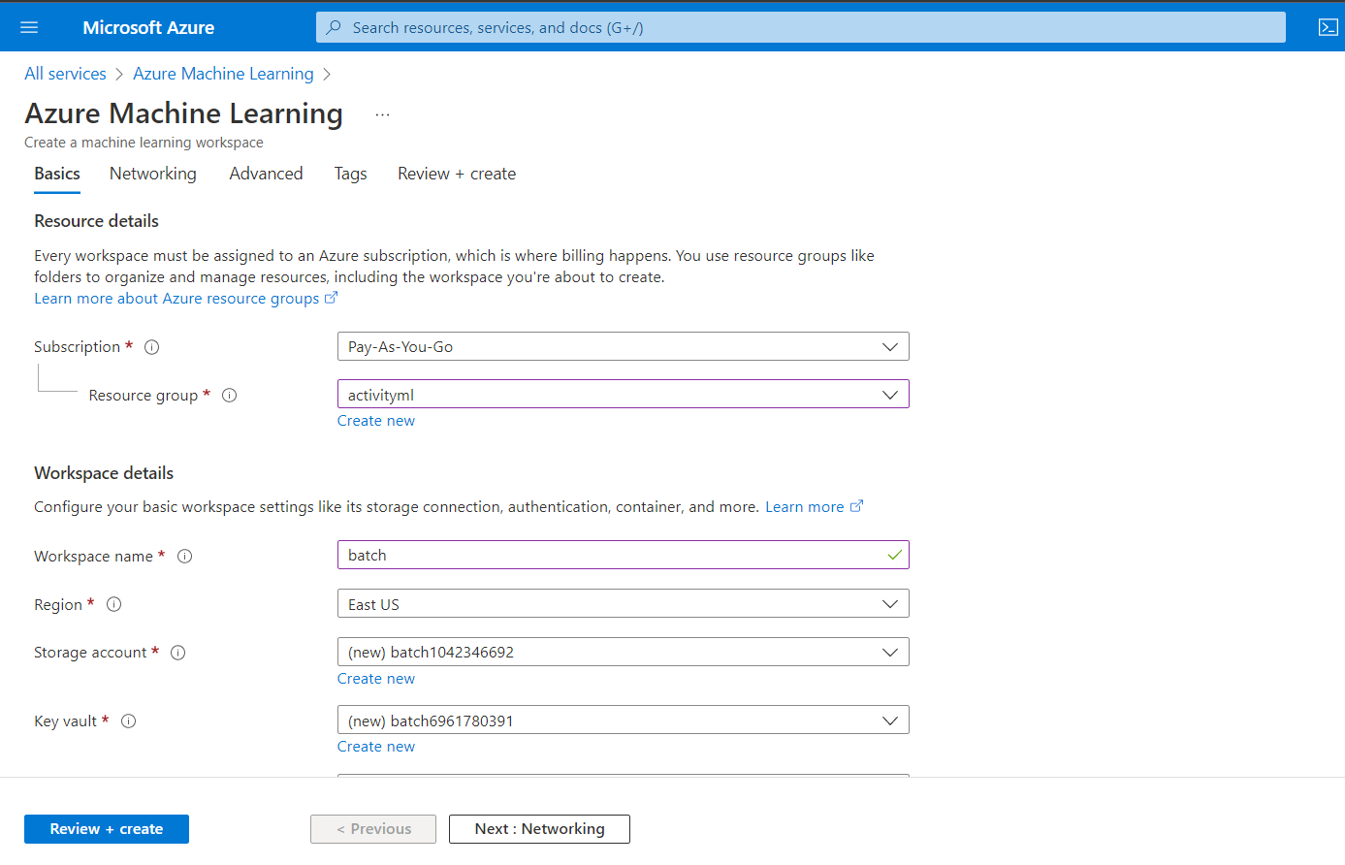

* Select Review + create.
* Select create. It takes a few seconds to create an Azure Machine Learning workspace.

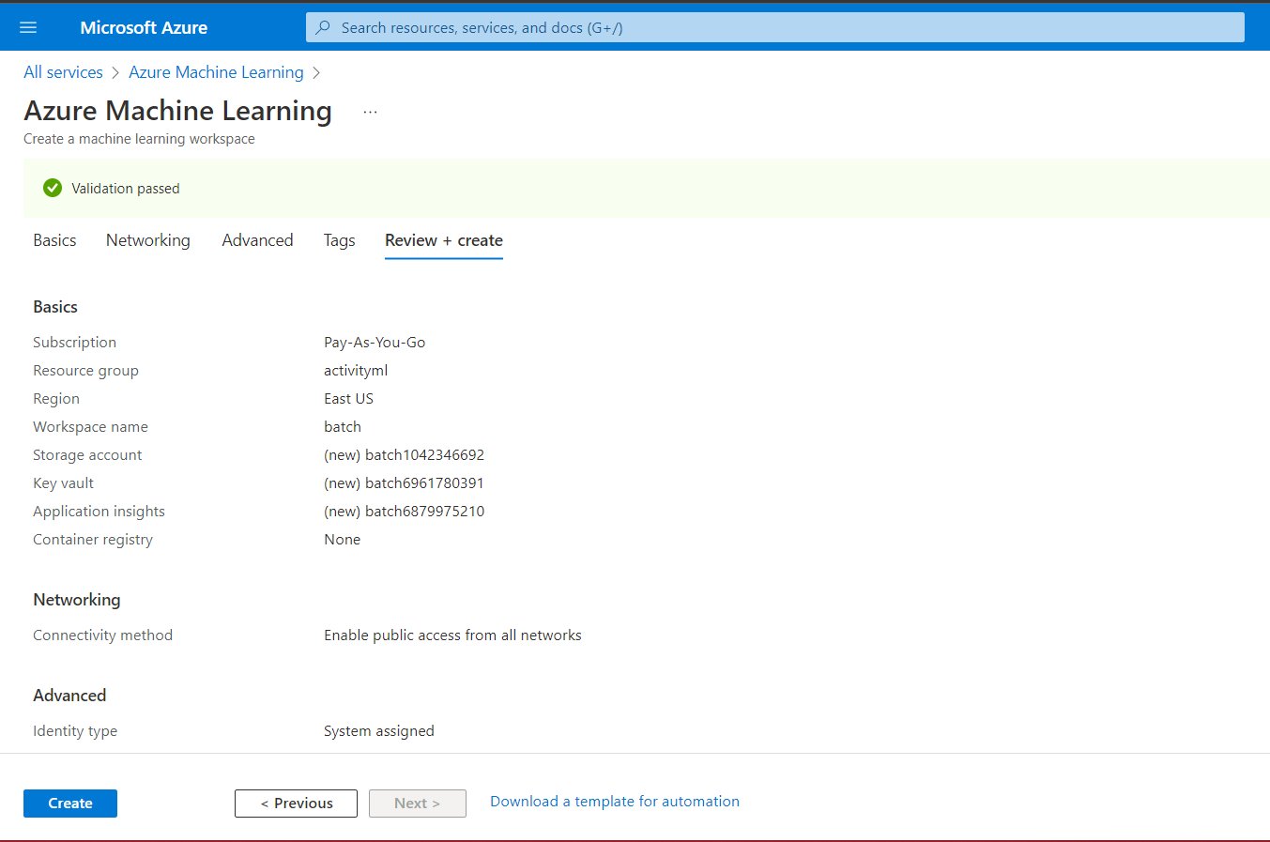

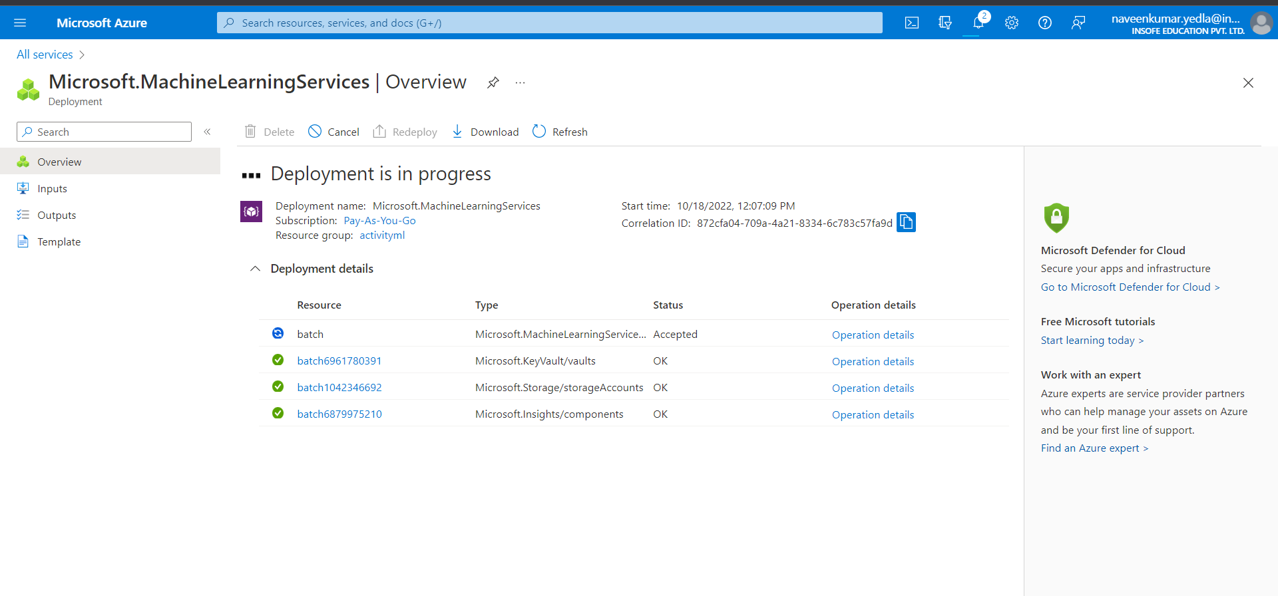

* Open the Azure machine learning workspace which you have created
* Select Launch studio.

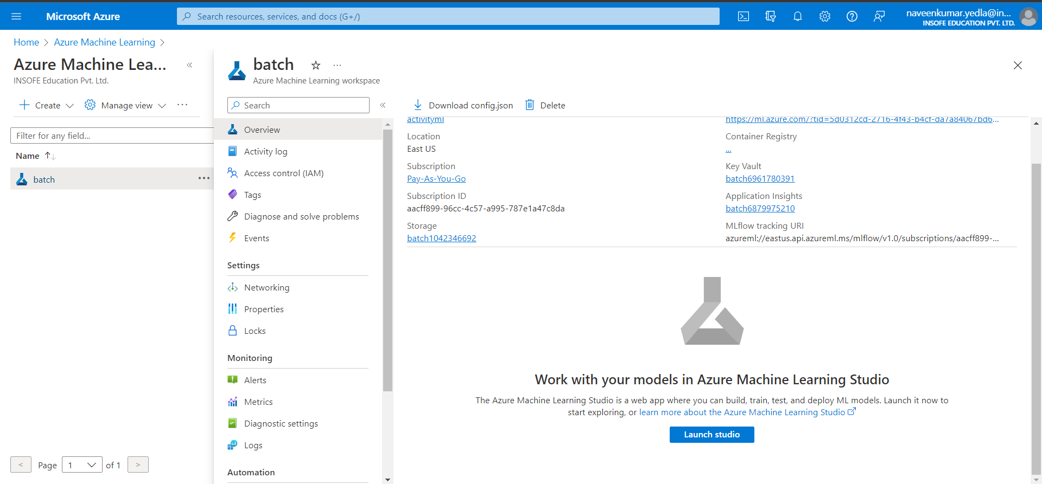

* This the azure machine learning workspace which you have created

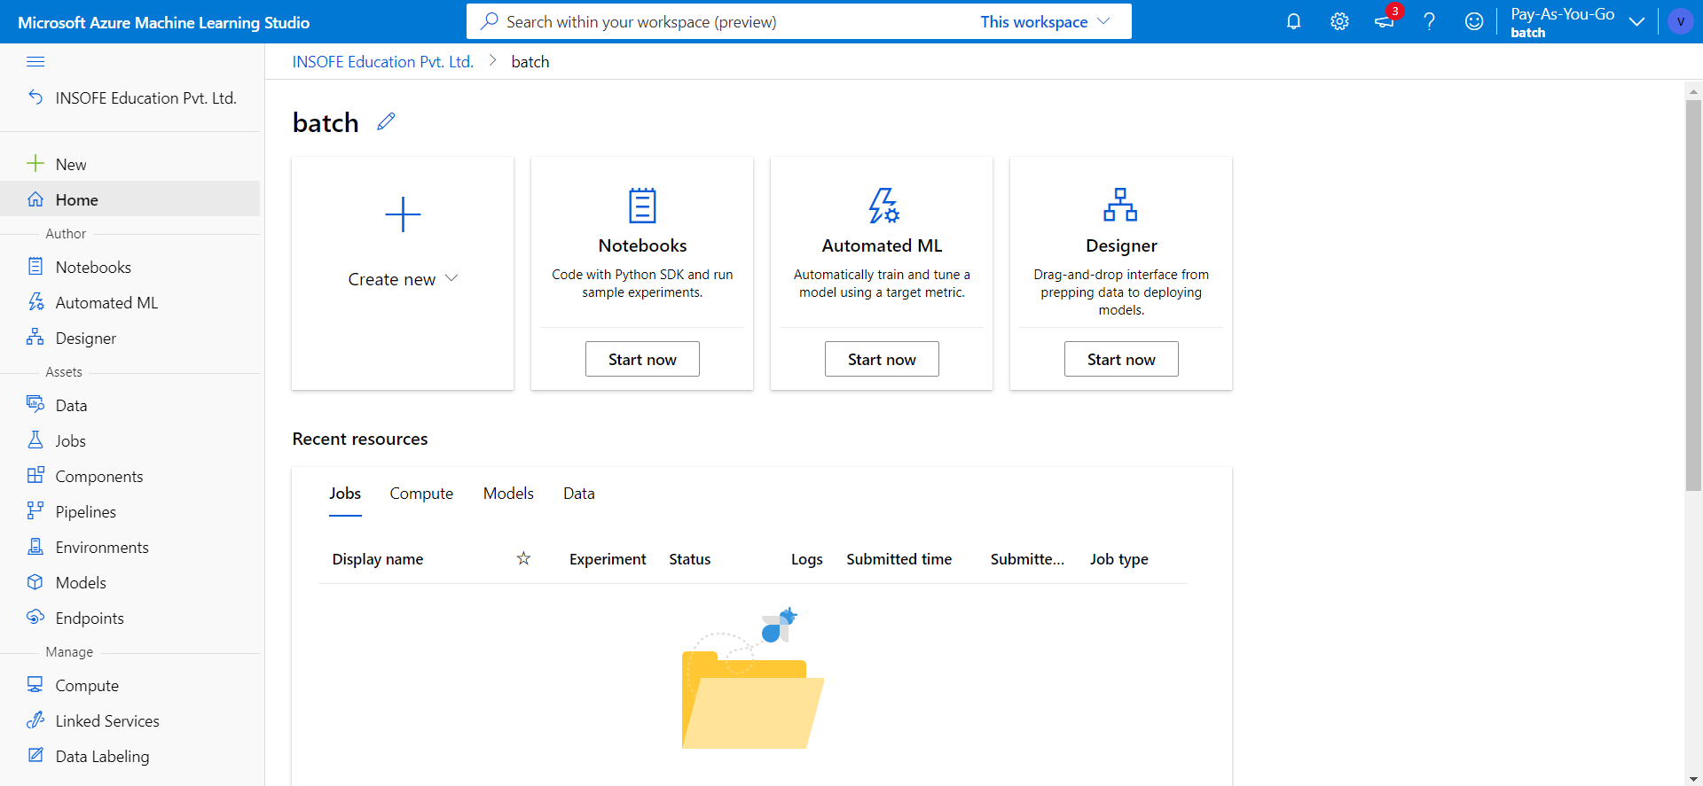

**Create compute instance**

You could install Azure Machine Learning on your own computer. But in this quickstart, you'll create an online compute resource that has a development environment already installed and ready to go. You'll use this online machine, a compute instance, for your development environment to write and run code in Python scripts and Jupyter notebooks.

Create a compute instance to use this development environment for the rest of the tutorials and quickstarts.

* If you didn't just create a workspace in the previous section, sign in to Azure Machine Learning studio now, and select your workspace.
* On the left side, select Compute.
* Select +New to create a new compute instance.
* Supply a name, Keep all the defaults on the first page.
* Select Create.

* Compute name: Enter a new compute name.
* Location: Automatically location was selected as in resource group.
* Select create

* It will take a few seconds to create a compute instance

* Select Notebooks
* Select Create

* Enter the file name
* File type (. ipynb)
* Select Create

* Create a jupyter notebook file and run some python codes

* Upload any dataset
* Select upload files and upload any dataset
* Compute instance should be selected

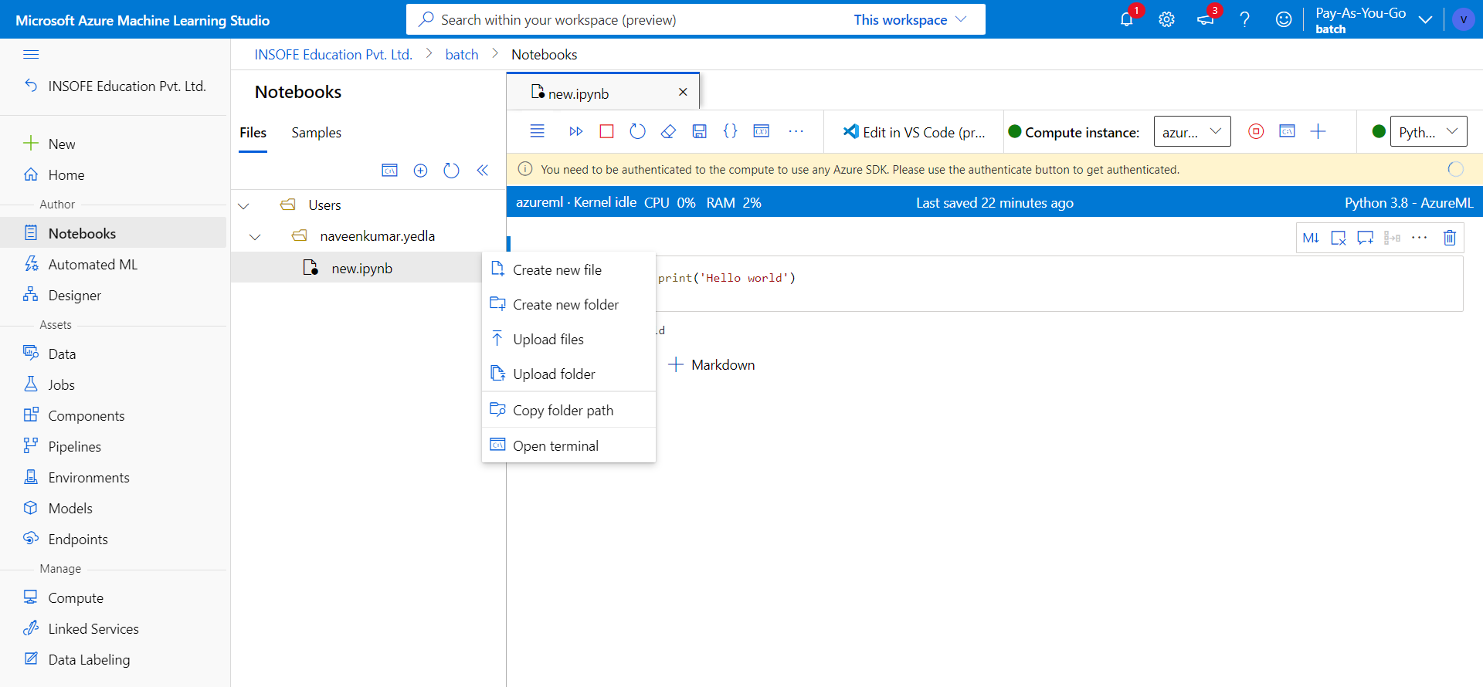

* Do pre-processing on the dataset which you have uploaded

