**COPY DATA TOOL AZURE DATA FACTORY**

Prerequisites: blob storage, ADF

* Create blob storage account and upload iris.csv dataset in a blob container name container as Myinput
* Create the ADF and login to the ADF studio

Once you logged into Azure data Factory studio

* Select “Ingest” click on it

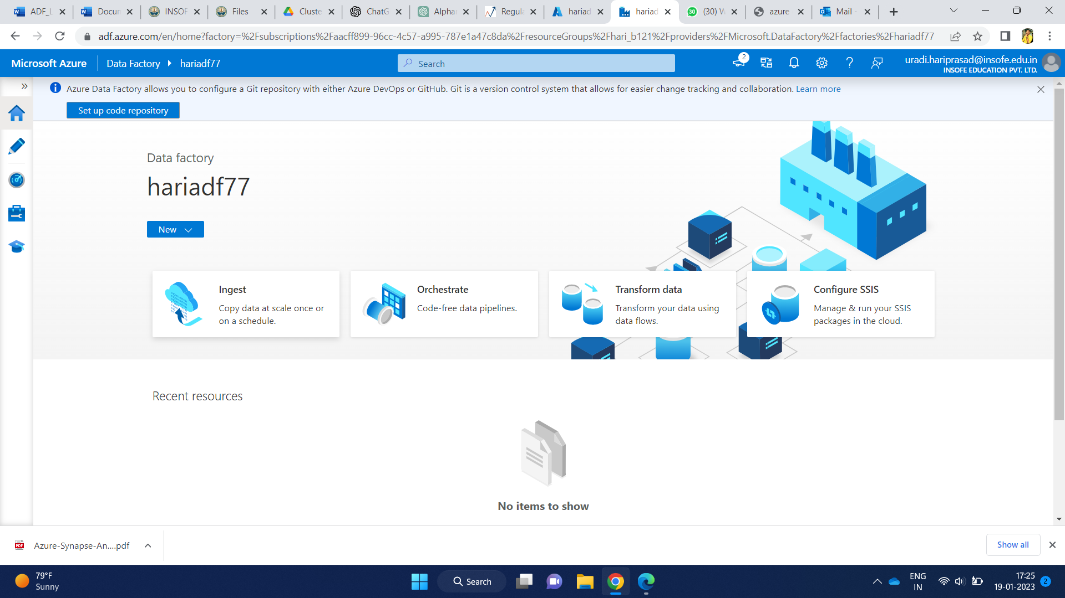

* Select “Build-in copy task” and click on next

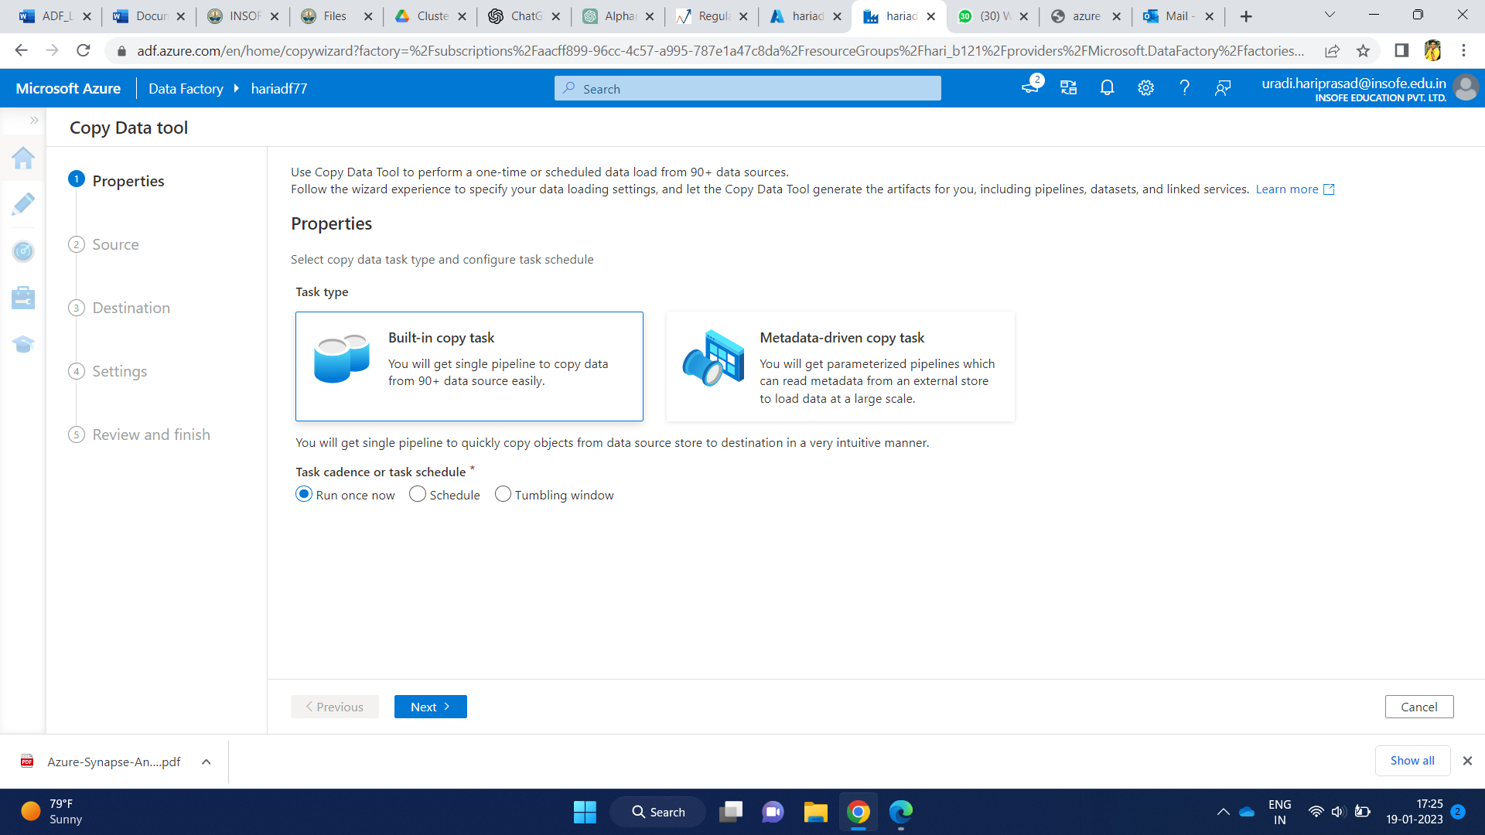

* Select source type as “ALL”
* For connection, select “new connection”

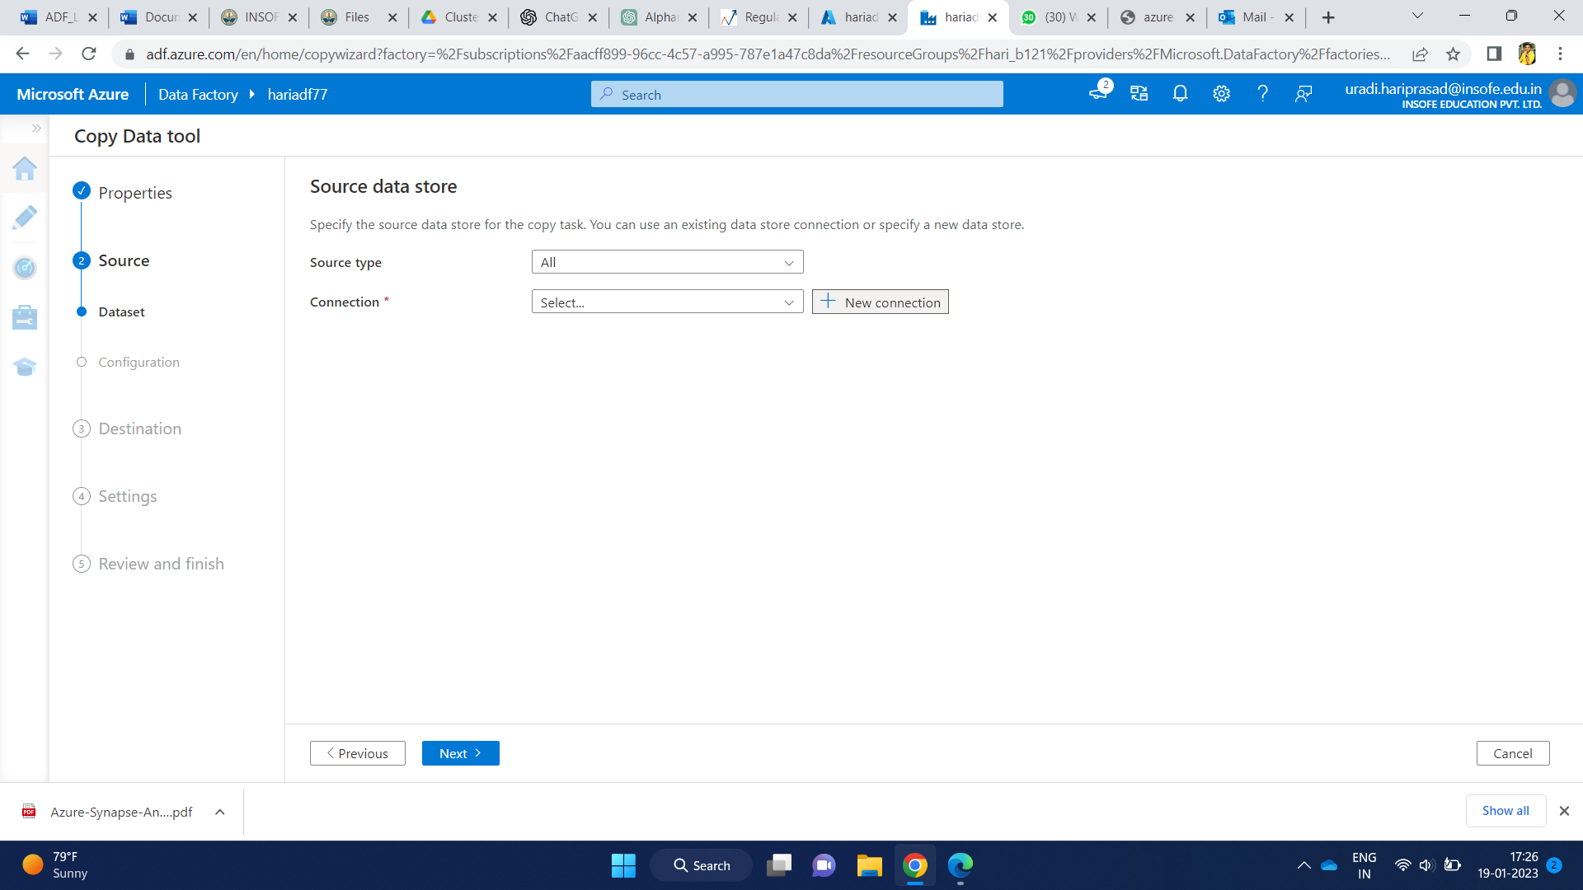

* Then select the respective storage type (Blob) that you have created.
* Click on continue

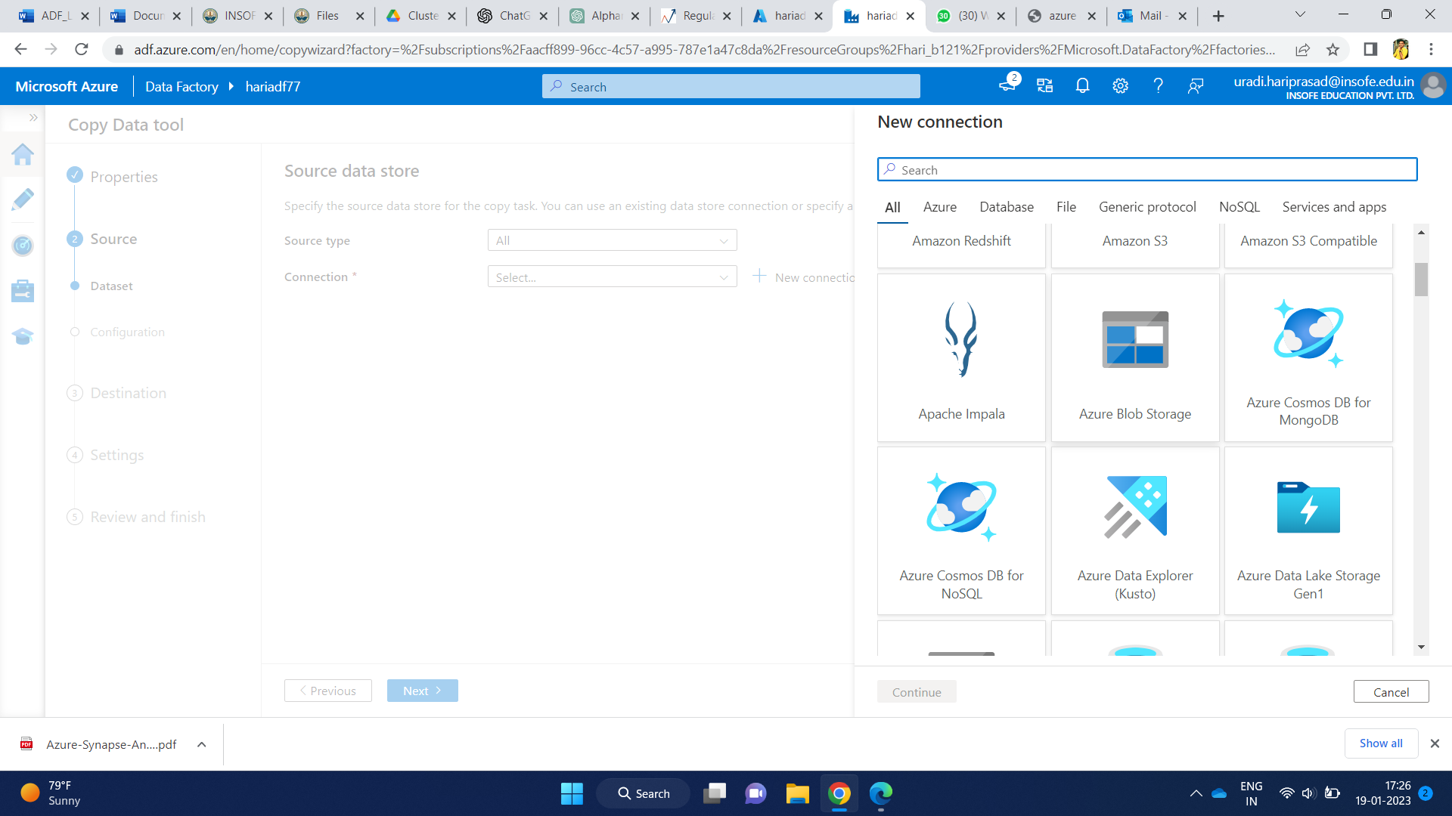

* Give the name for your blob storage and description
* For ‘connect for integration runtime’ select ‘auto resolve integration runtime’
* Select authentication type as account key
* Select your azure subscription

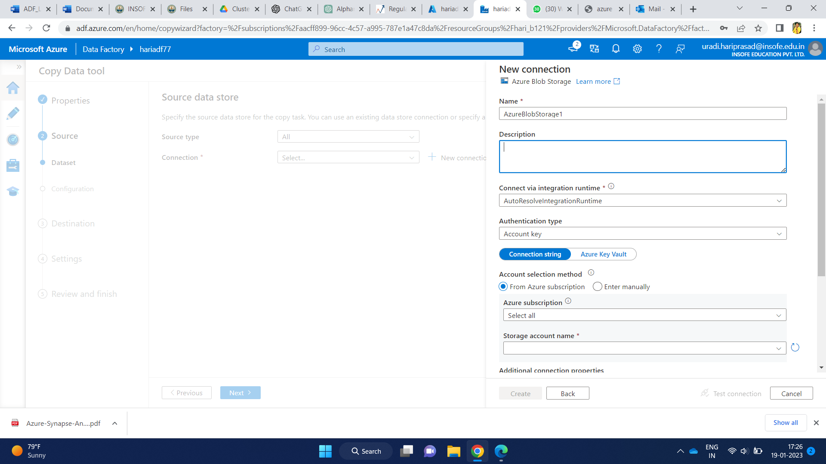

* Select your storage account
* Enable “To linked service”
* Click on create

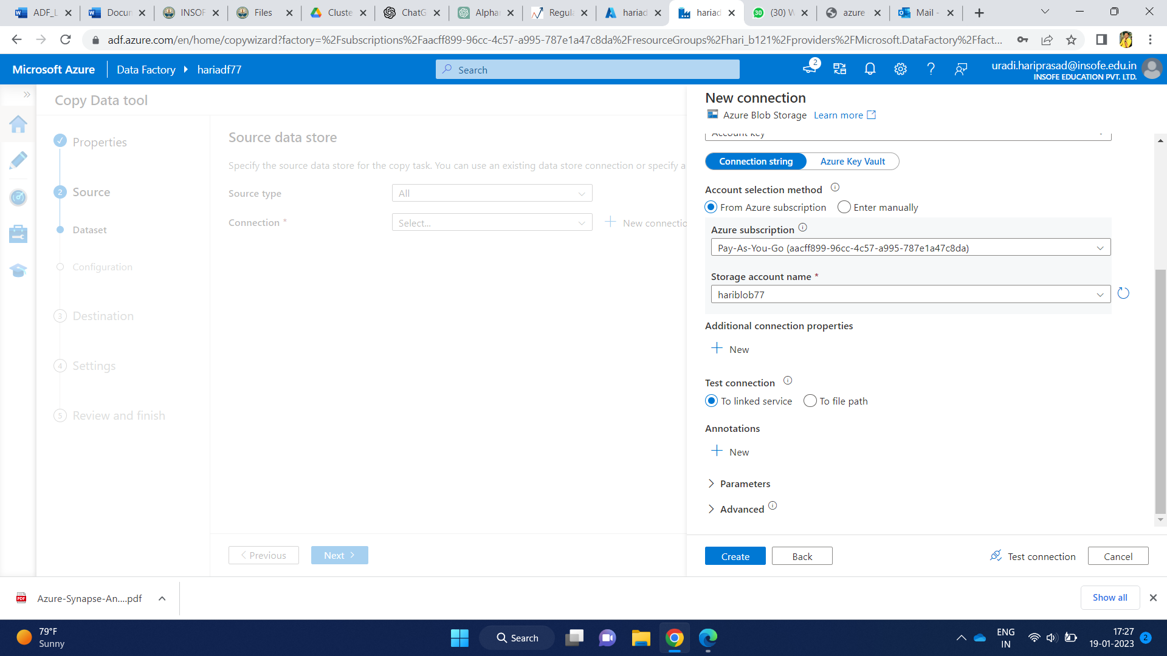

* We have to specify the path of the dataset which stored in your blob storage

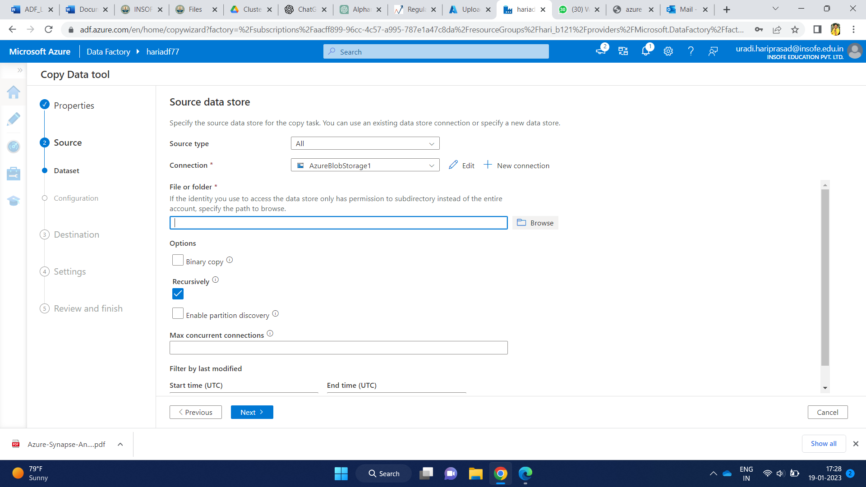

* Click on ‘browse’ and get the path of the dataset I.e input/

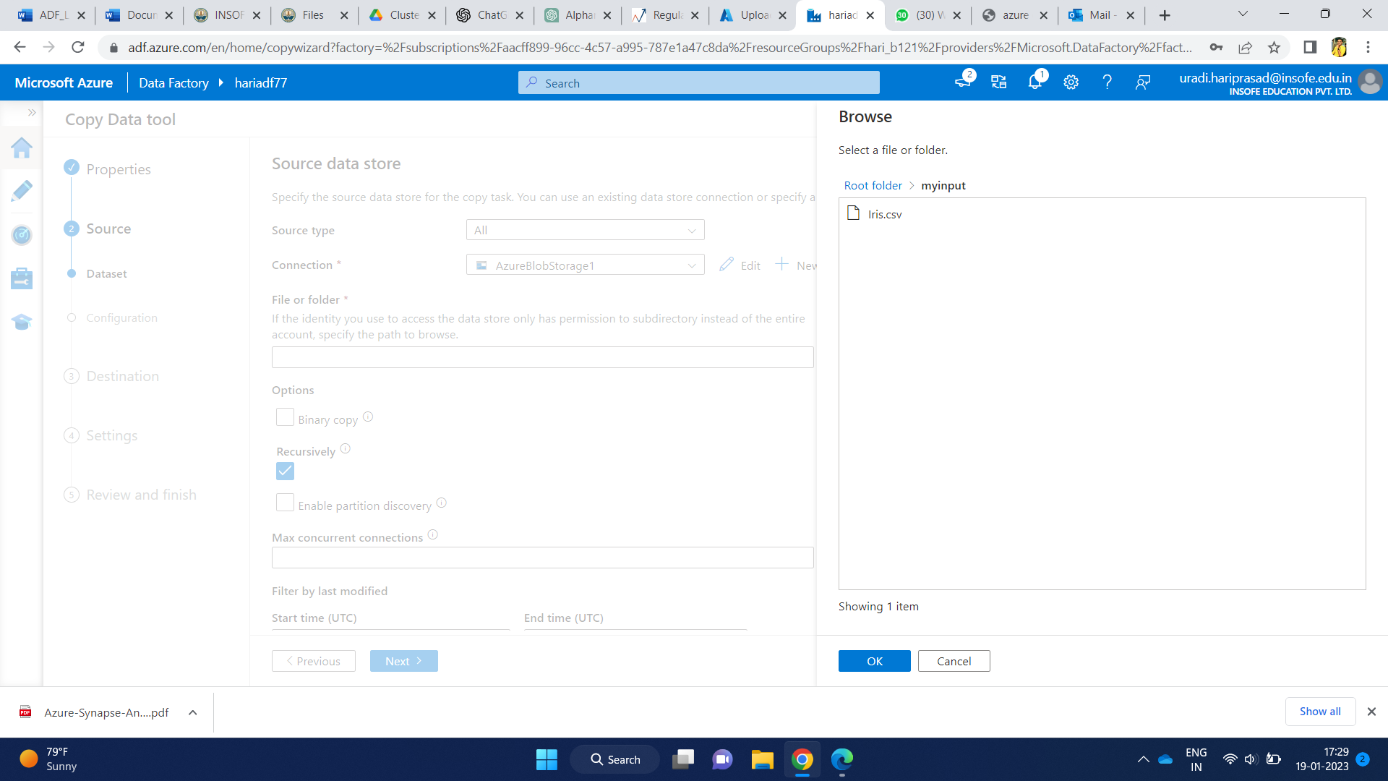

* Click on “next”

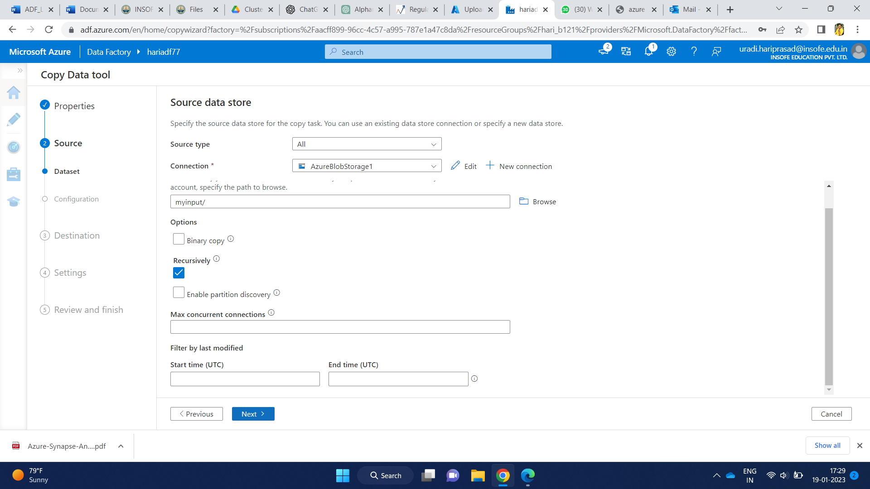

* Select file format as delimited Text
* To view the data, click on preview data
* Enable or tick for ‘first row as header’

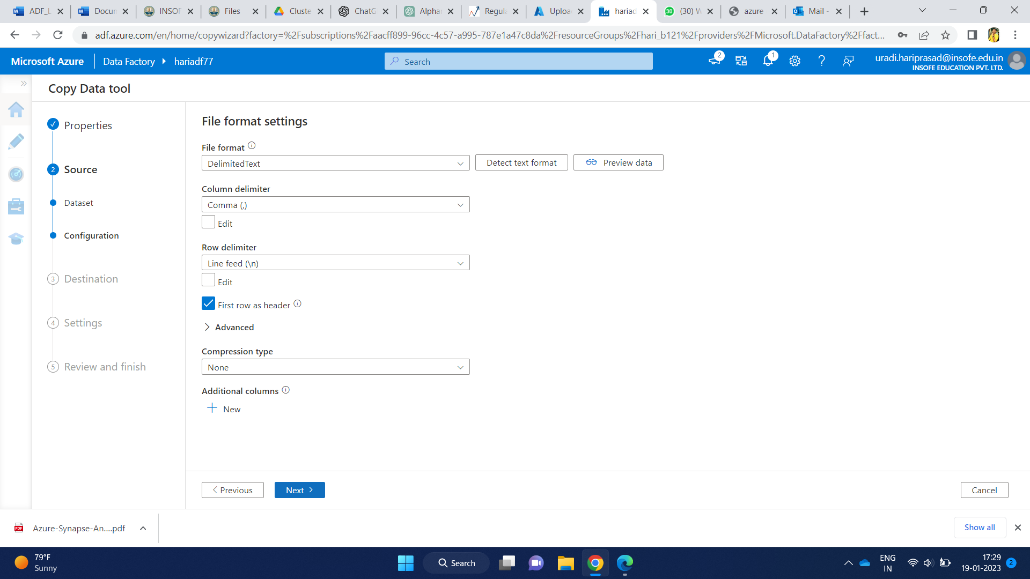

* In this step, we have define our destination data store i.e, where you want to store your output data
* Select destination type as ‘ALL’
* Under connection select existing “Azureblobstorage1” storage type
* In folder path, type “output” automatically folder named output will be created
* Give file name for your output file
* Select copy behavior as merge files
* Then, Click on next

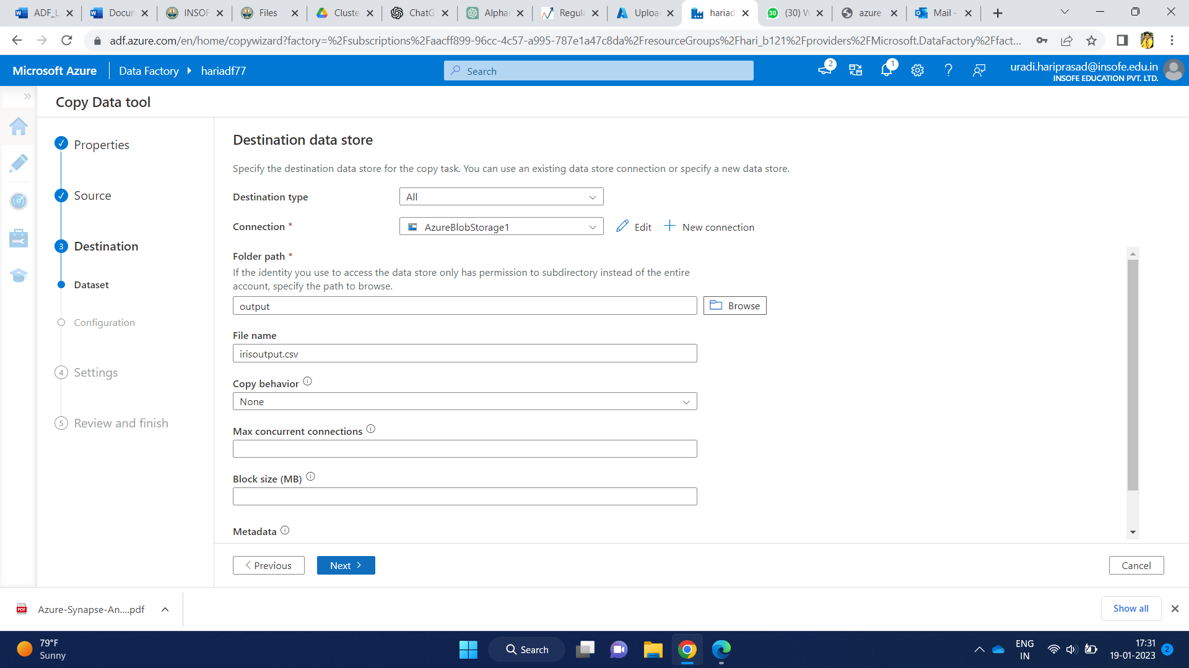

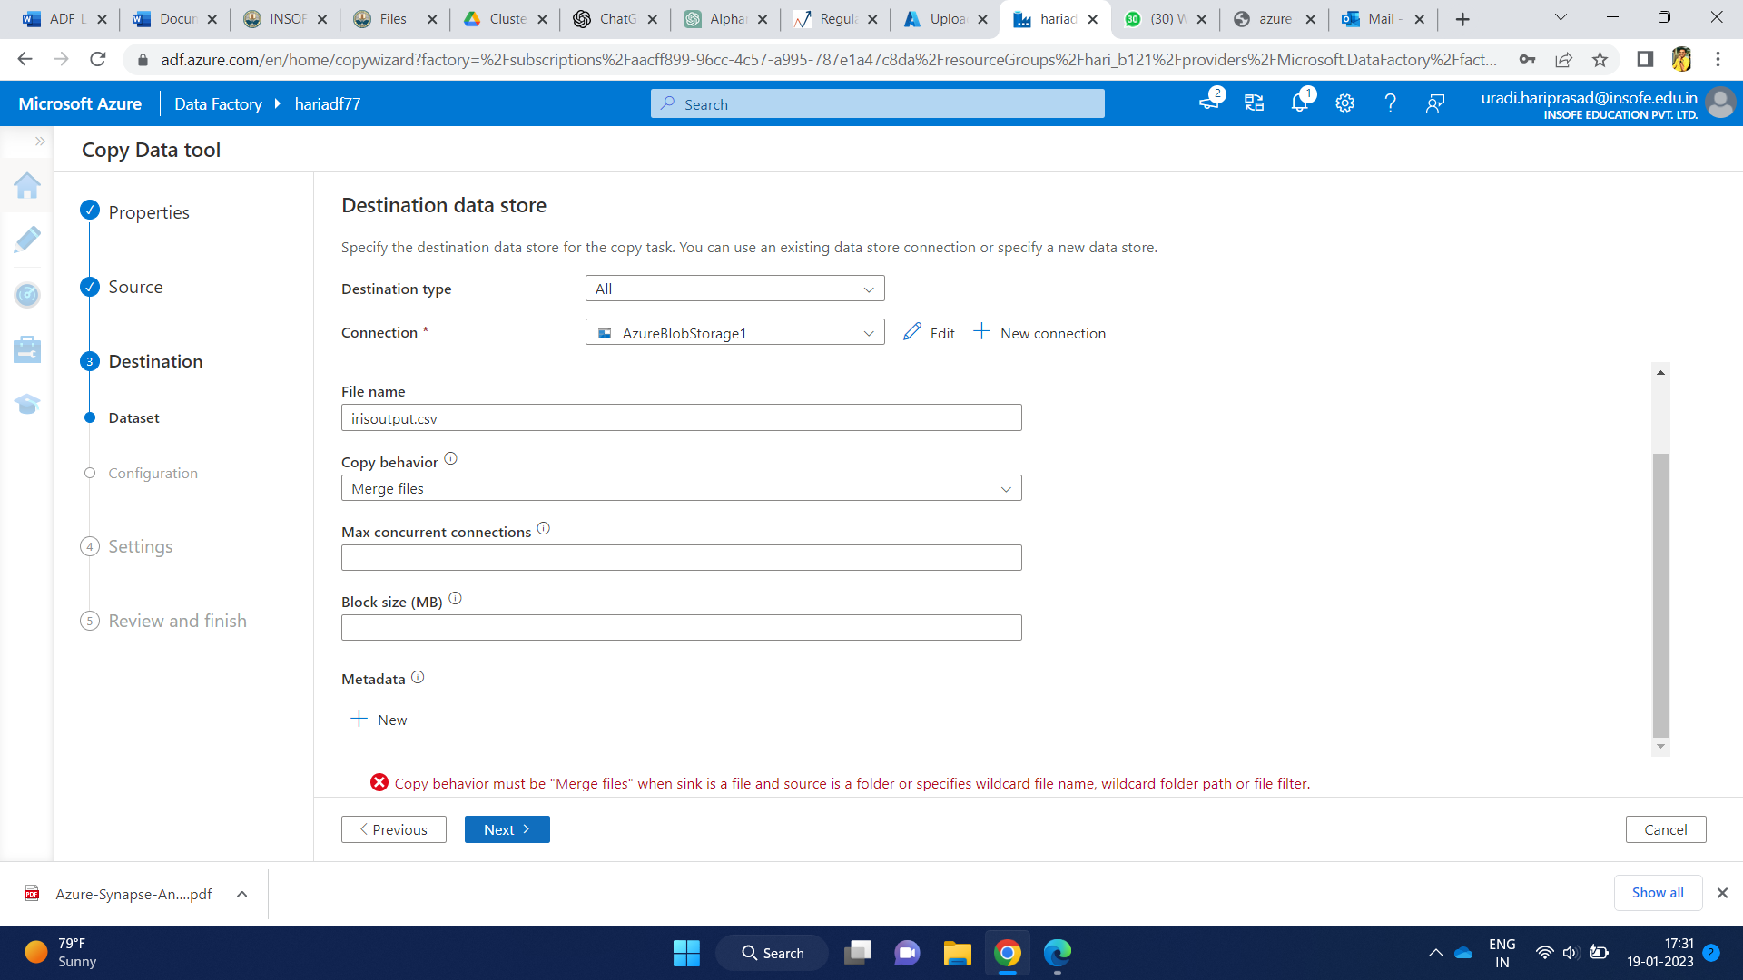

* Select file format as delimited Text
* Enable or tick for ‘add header to file’
* Click on next

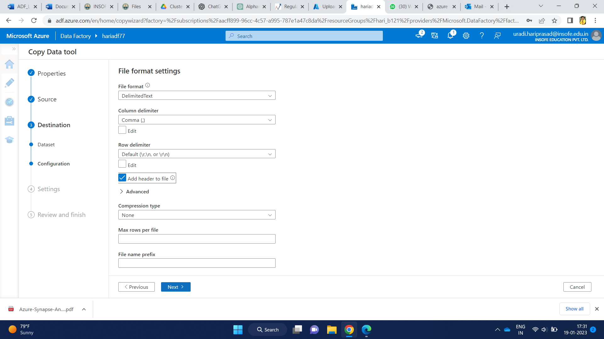

* Give name to your task and description
* Click on next

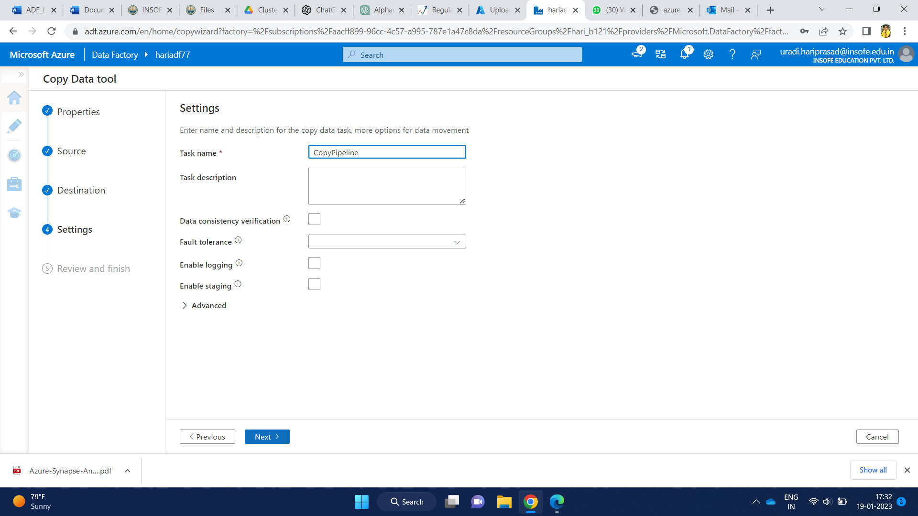

* It shows the summary and details of your task
* Click on next

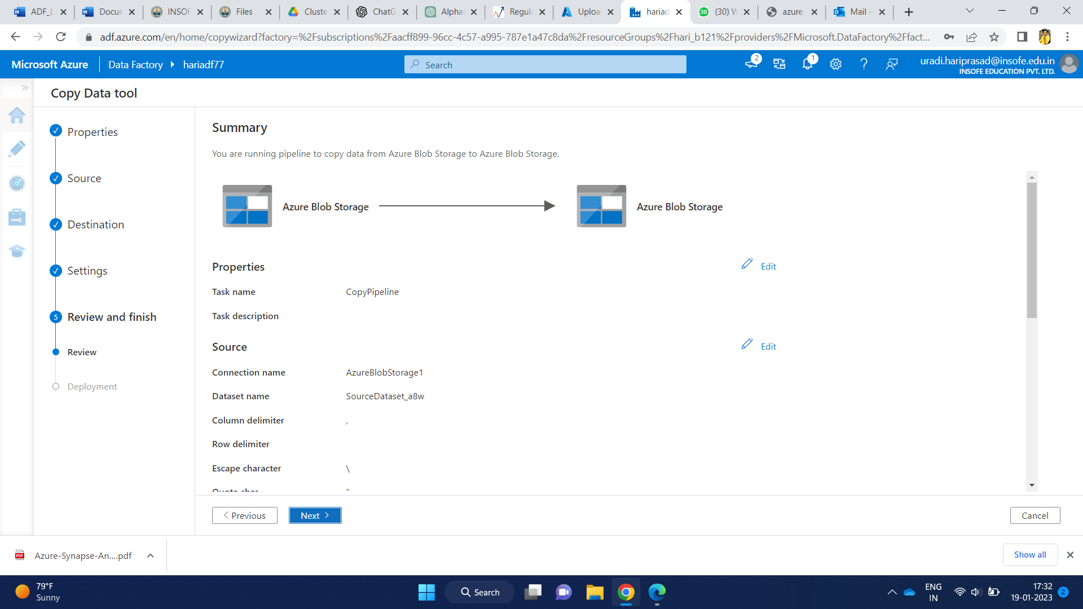

* The pipeline start running and it take some time for deployment
* It shows the status of your pipeline
* Then your pipeline has been created and ran successfully
* Click on finish

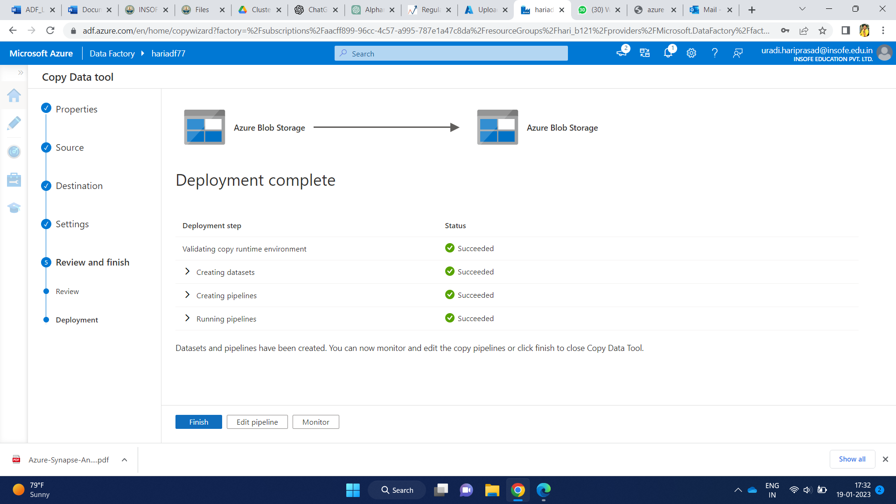

* To check the status of your pipeline
* Click on monitor icon, it shows the list of pipelines that your created and its status.

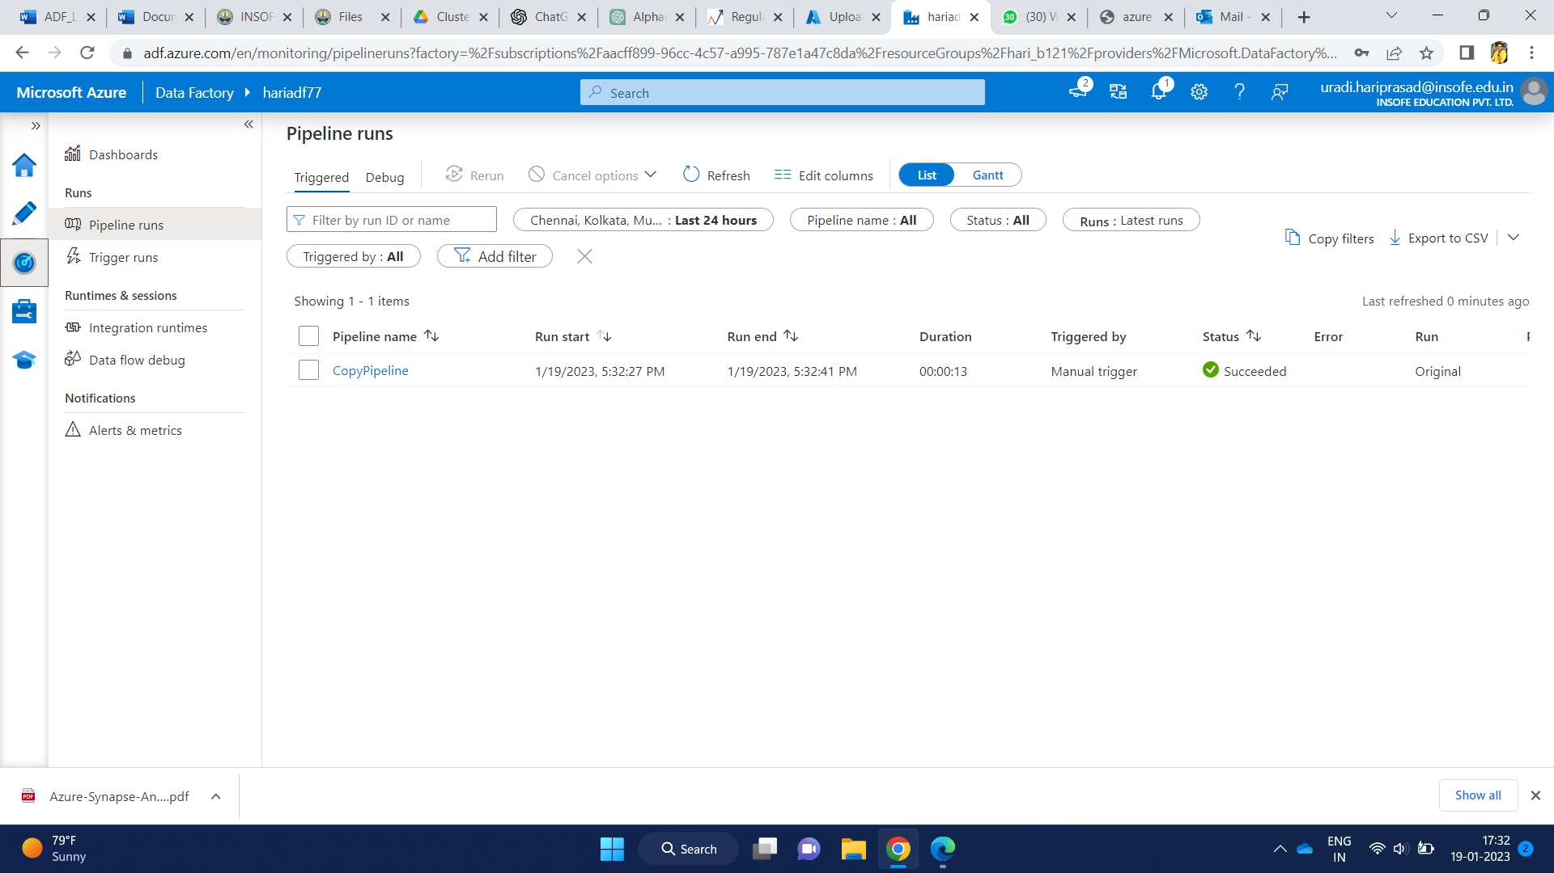

* Now, get into your azure portal
* To check your output file, follow the below sequence
* Blob storage > containers > output > output file