**VIRTUAL NETWORKS**

1. Select Create a resource in the upper left-hand corner of the portal.
2. In the search box, enter Virtual Network. Select Virtual Network in the search results.
3. In the Virtual Network page, select Create.

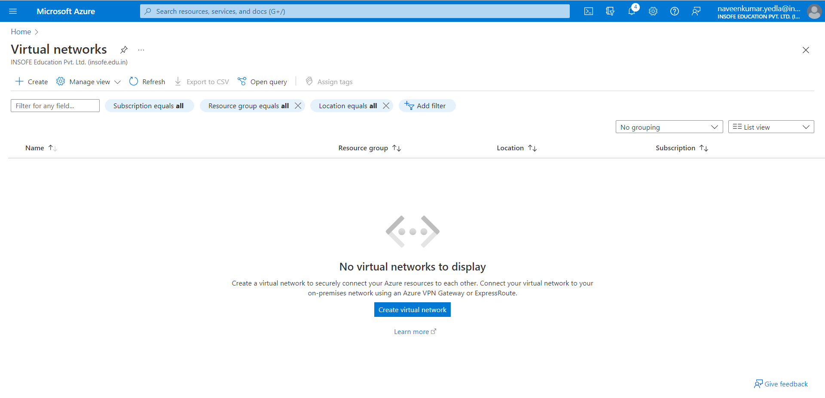

1. In Create virtual network, enter or select this information in the Basics tab.
2. Select the subscription: Pay-As-You-Go
3. Resource group if exist select it otherwise create a new resource group.
4. Virtual network name: Give any unique name. (Naveen)
5. Select the region: East US.

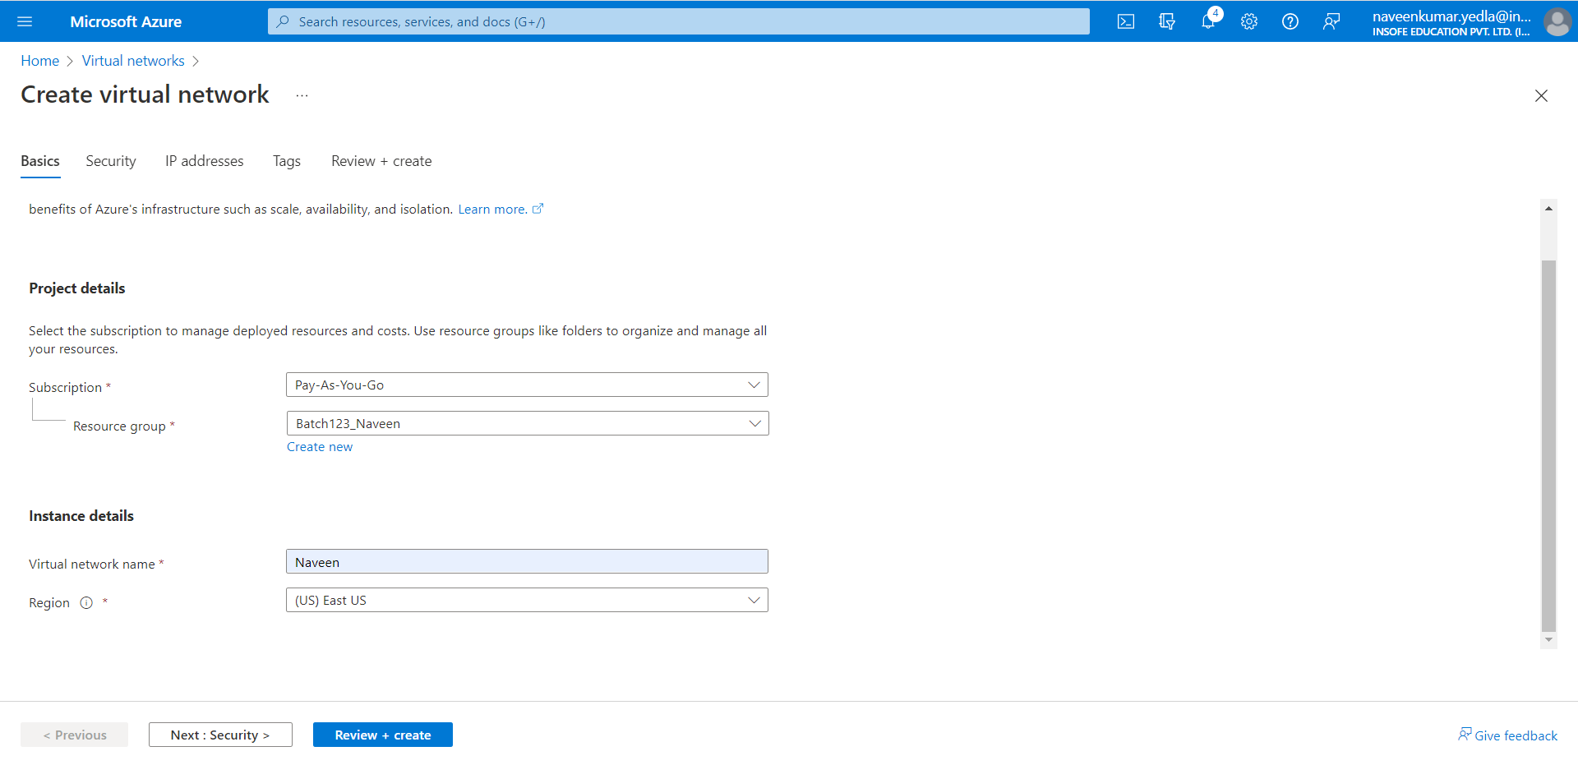

1. Select the IP Addresses tab.
2. Existing IP address for Virtual Network – 10.0.0.0/16
3. Under the subnets section Click on default edit.

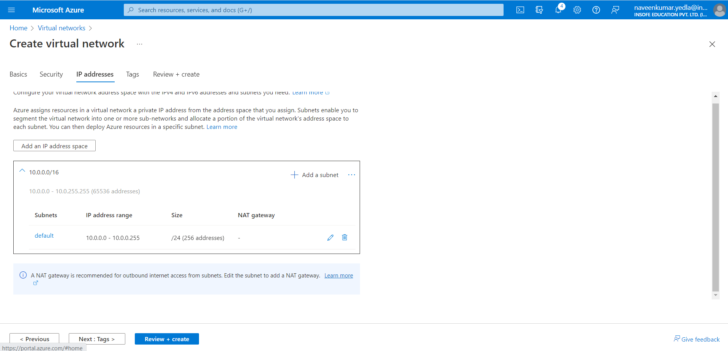

1. Edit the subnet 1 follow the instructions shown in below and click on save.

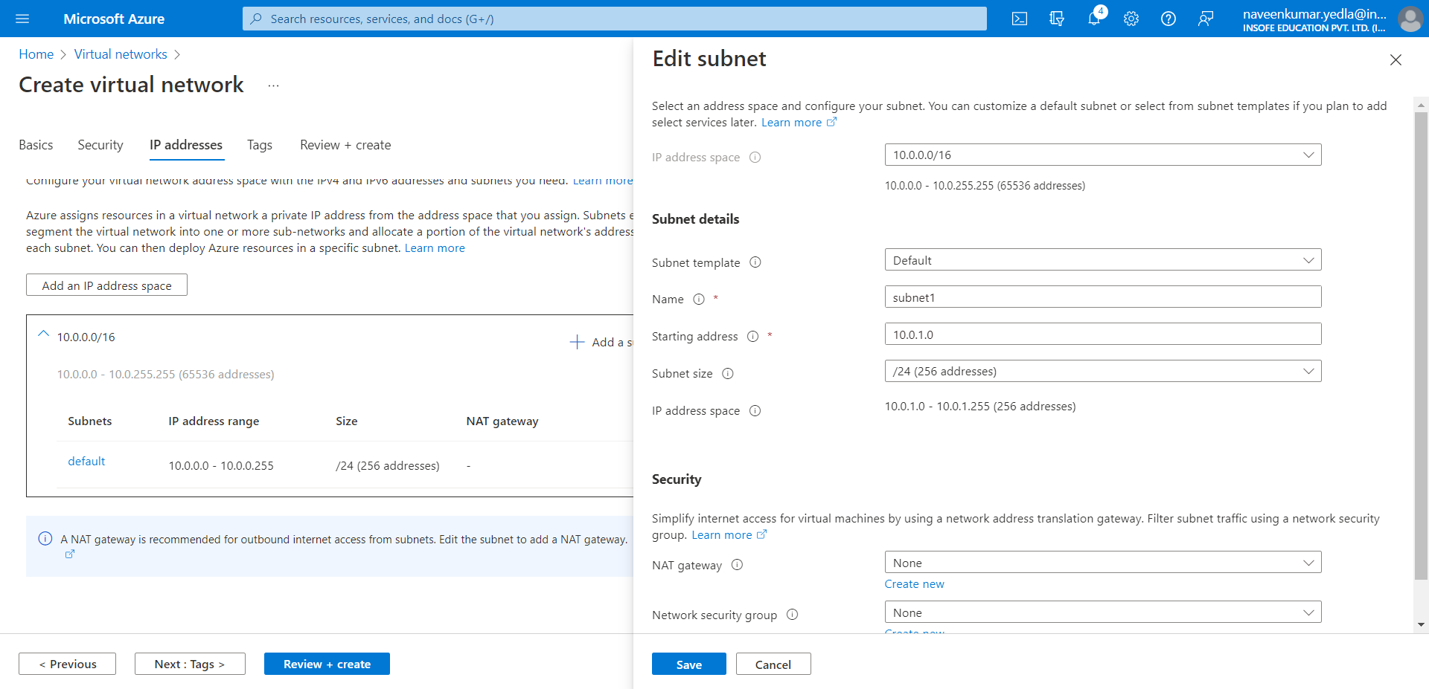

1. Click on Add a subnet and Create subnet 2 follow the instructions shown in below and click on save.

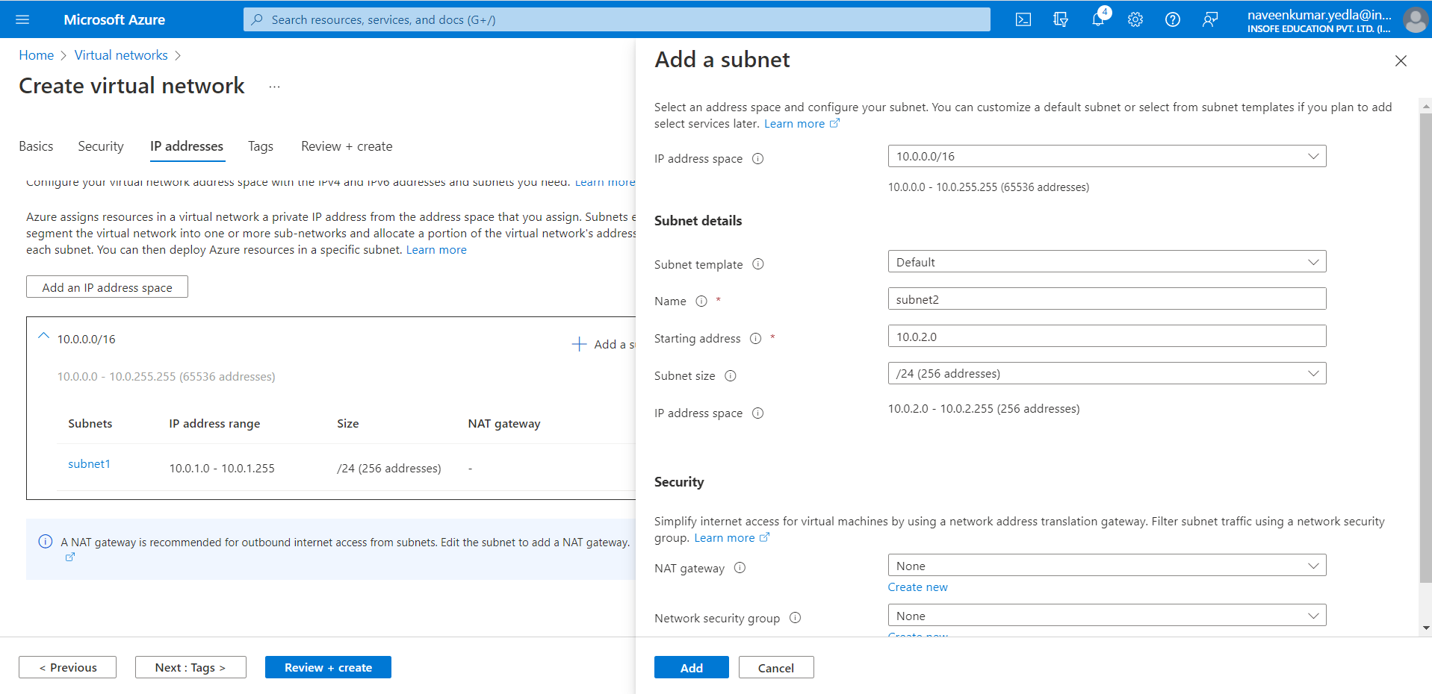

1. Click on Review + create.
2. Click on Create.

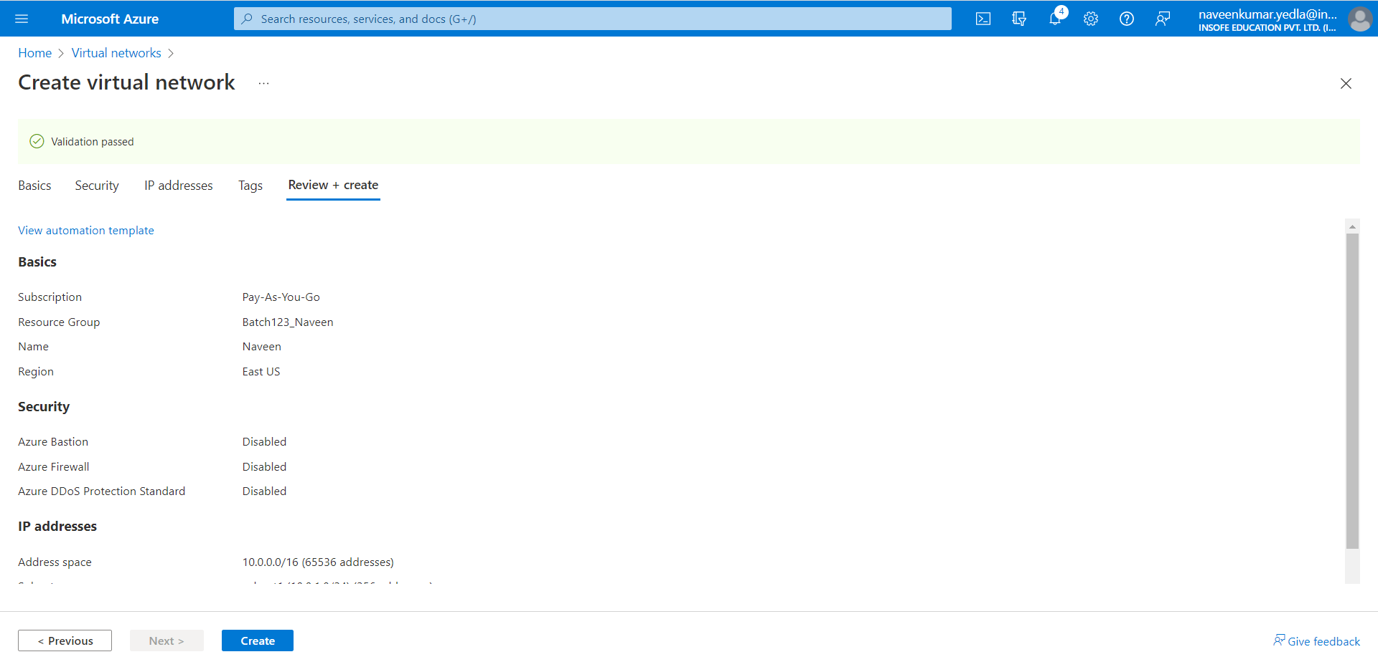

1. It will few seconds to deploy the resource. After deployment is complete click on Go to resource.

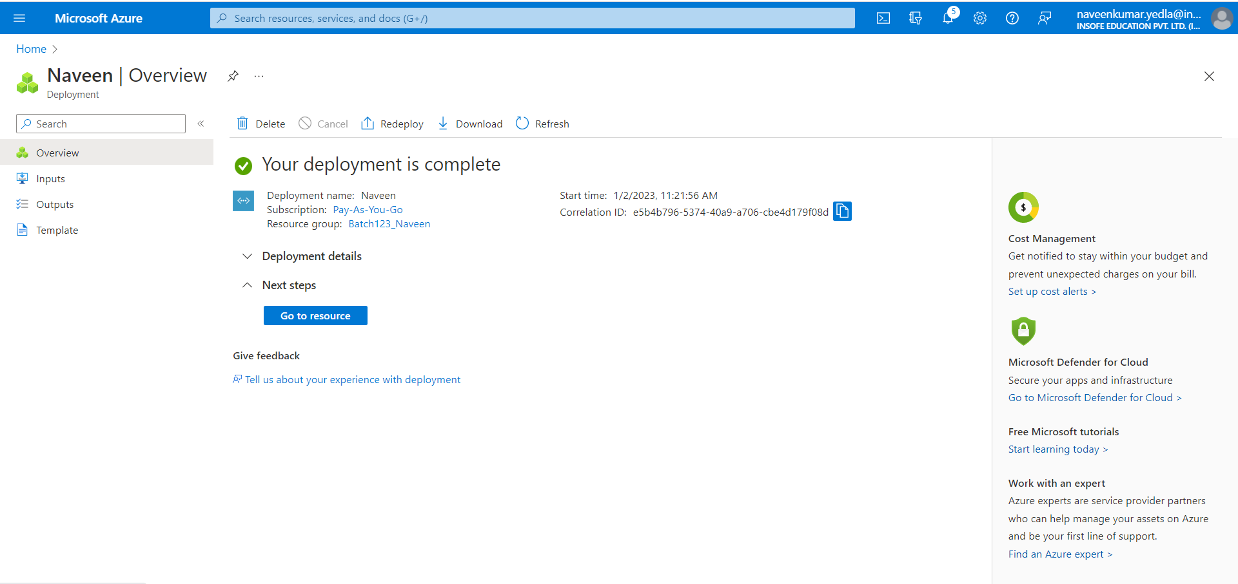

## **Create virtual machines**

Create two VMs in the virtual network:

## **Create the first VM**

1. On the upper-left side of the portal, select Create a resource > Virtual machine.
2. Click on Create.

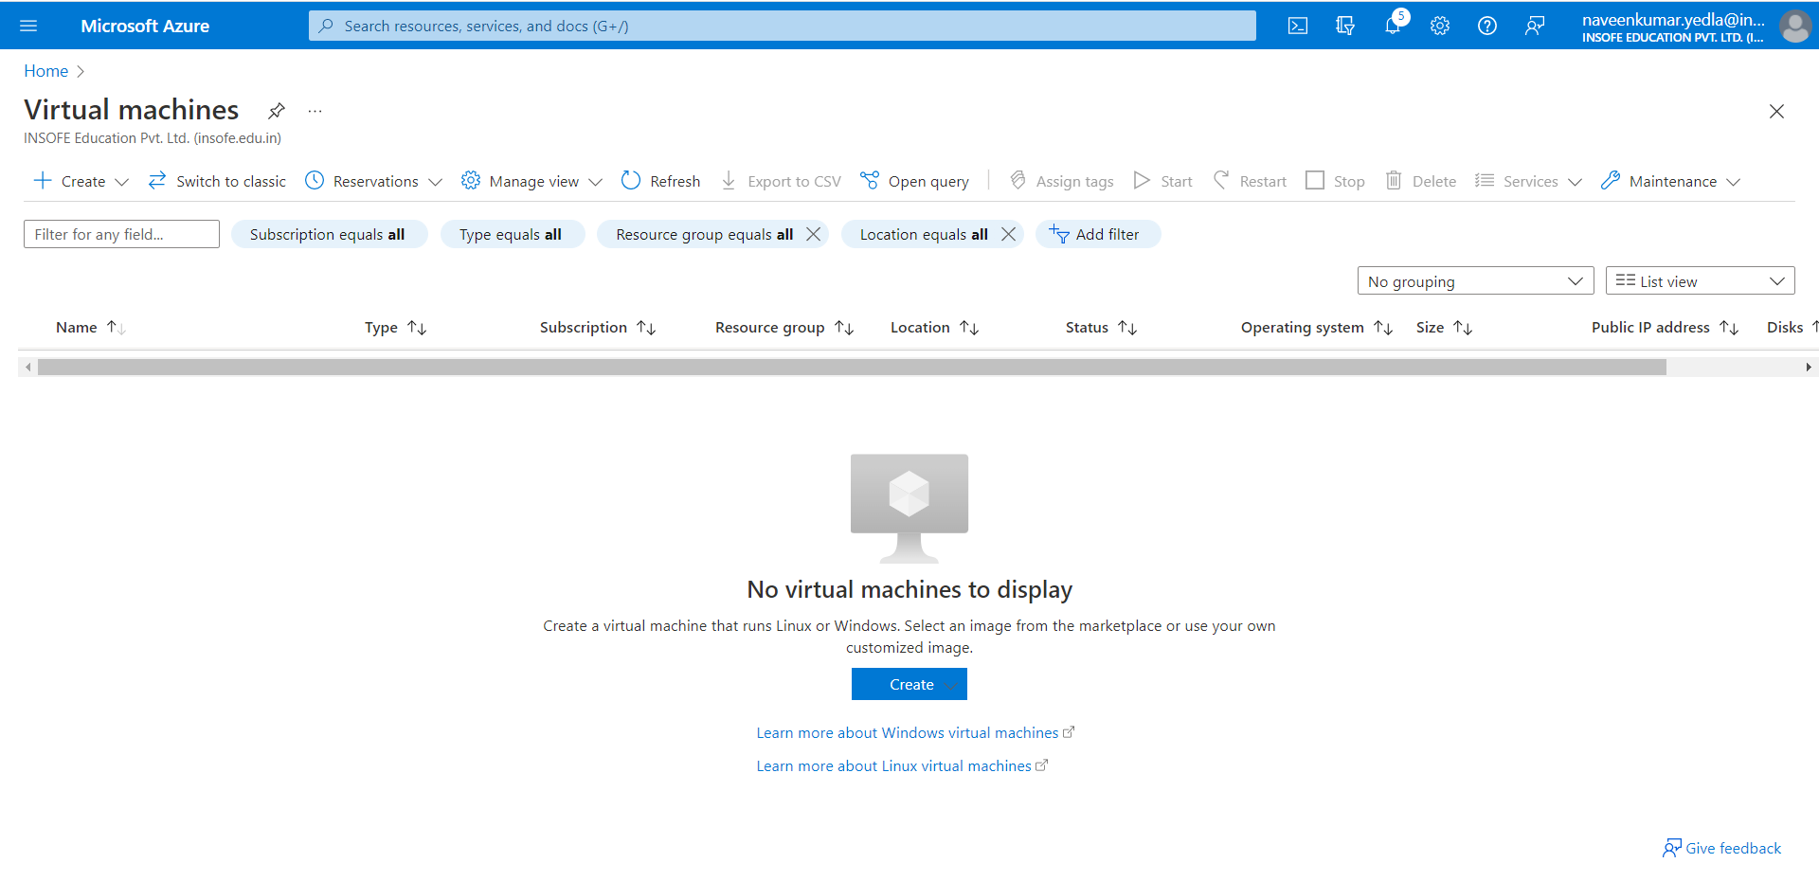

1. Under the basics Blade select the subscription and enter the Resource group if exit. Otherwise create a new Resource group.
2. Under Instance details, enter name of VM (myvm1)for the Virtual machine name and choose Windows Server 2019 Datacenter *- Gen 2* for the Image. Leave the other defaults.

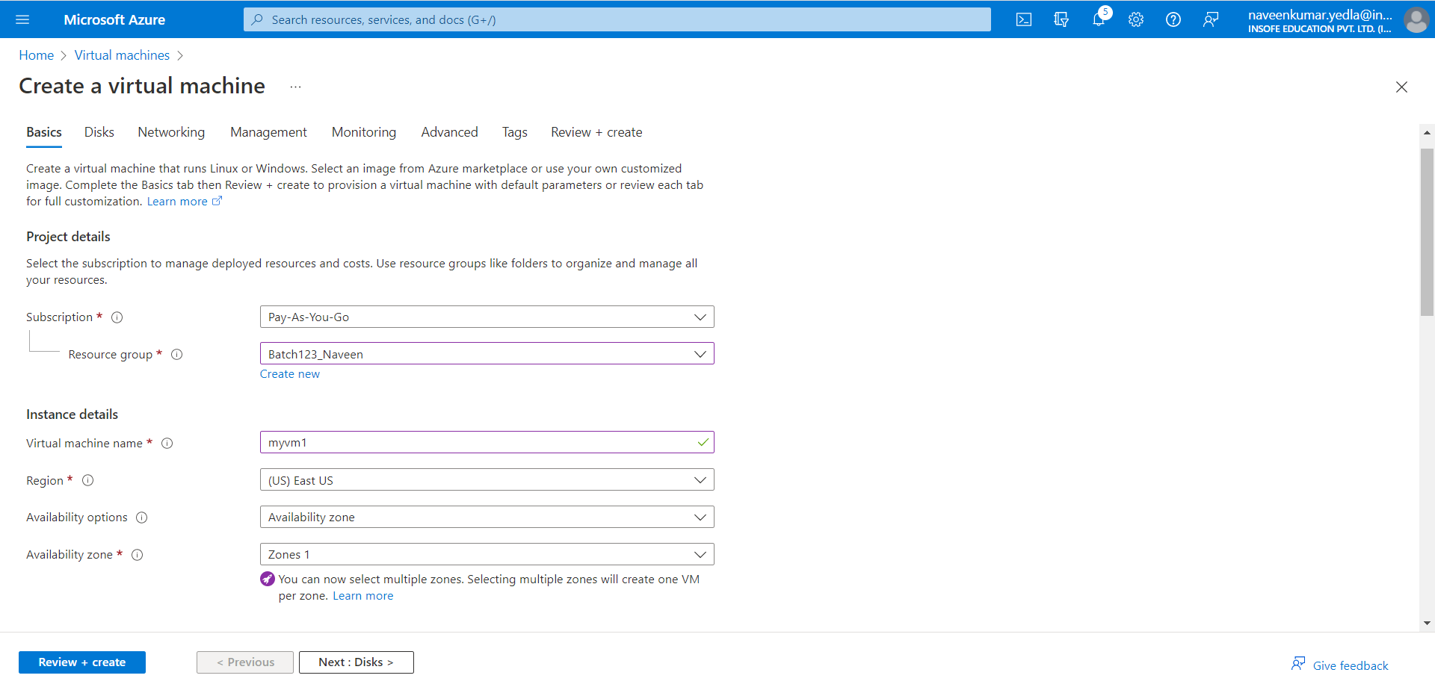

1. Under Administrator account, provide a username, such as naveen and a password. The password must be at least 12 characters long and meet the defined complexity requirements.

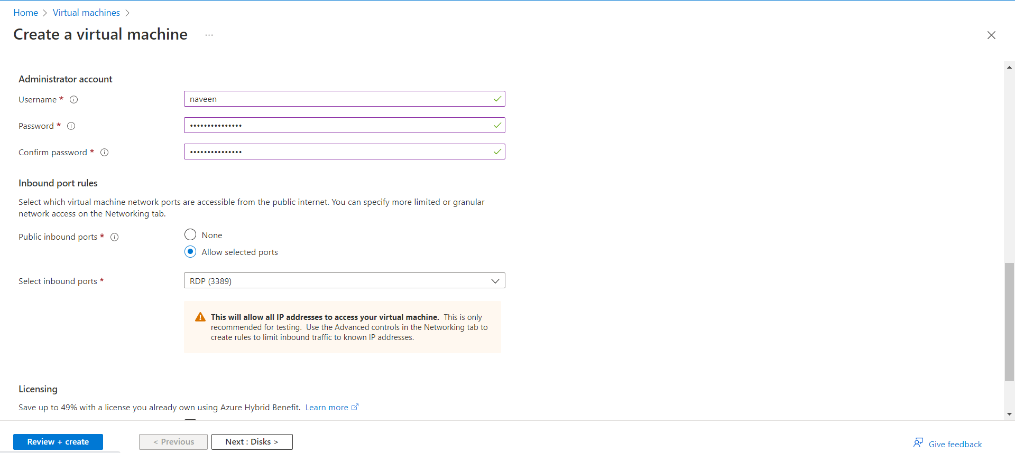

1. Select the networking tab. In networking tab select the virtual network which you have created (Naveen) and subnet 1. Leave remaining all defaults.

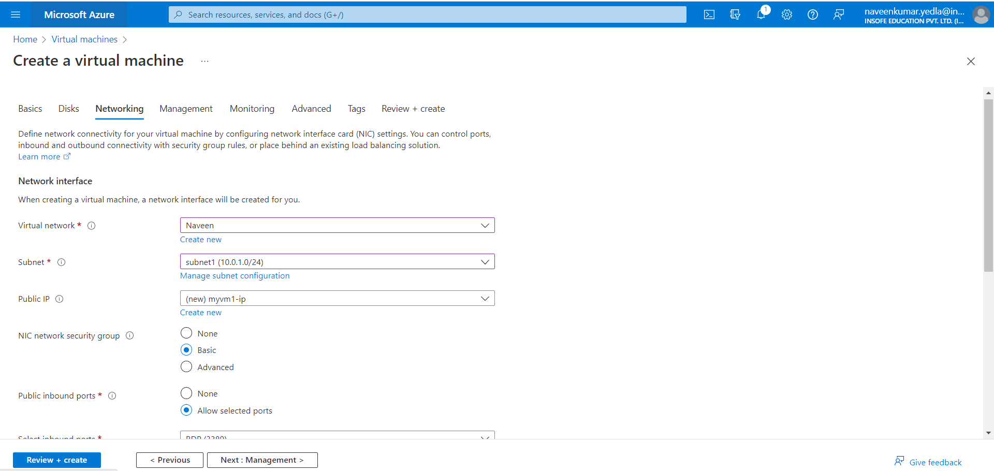

1. Select the Review + create tab, or select the blue Review + create button at the bottom of the page.
2. Review the settings, and then select Create.

### **Create the second VM**

1. Follow the same steps which is show above to create VM1 and create VM2.
2. Except in the Networking tab in subnet Section select the subnet 2. Follow the same shown.

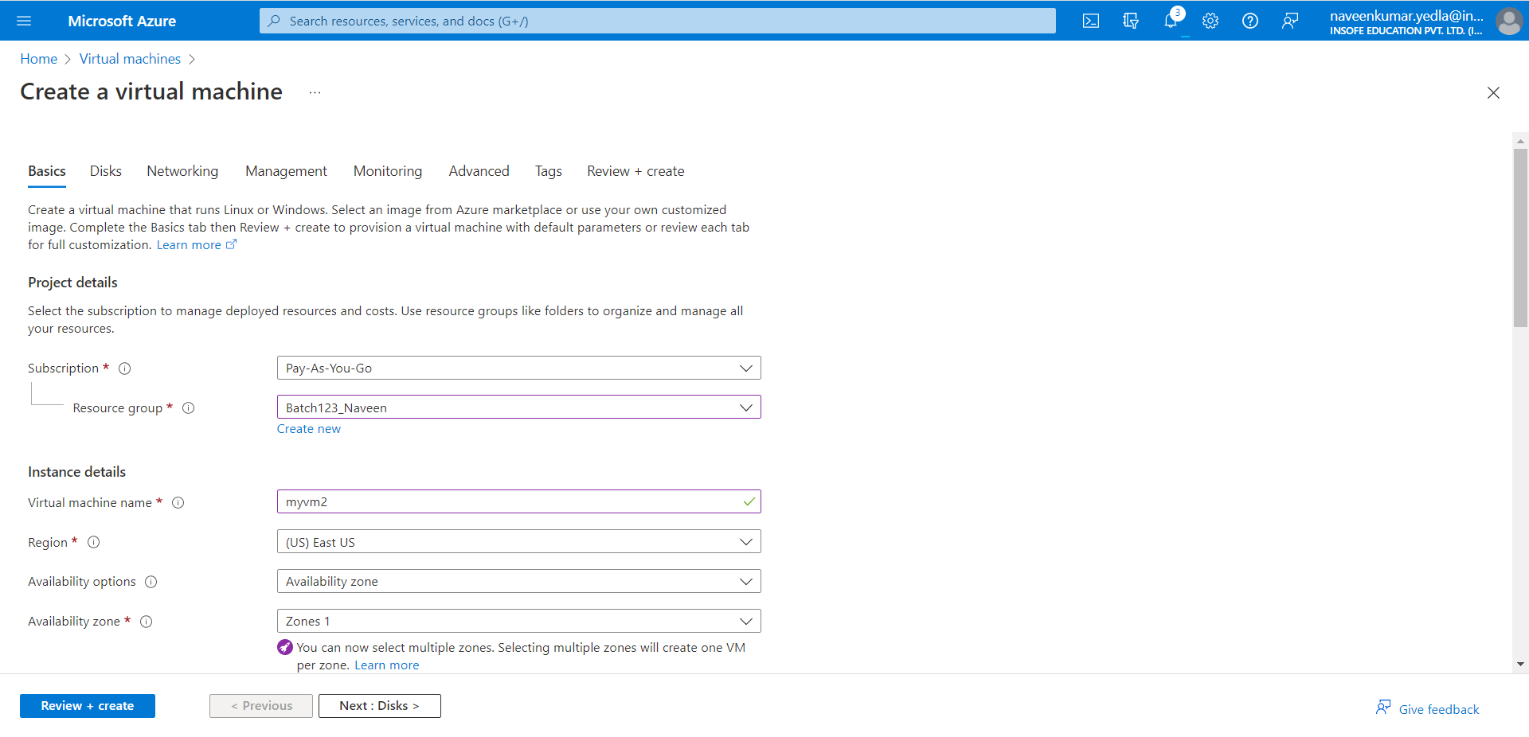

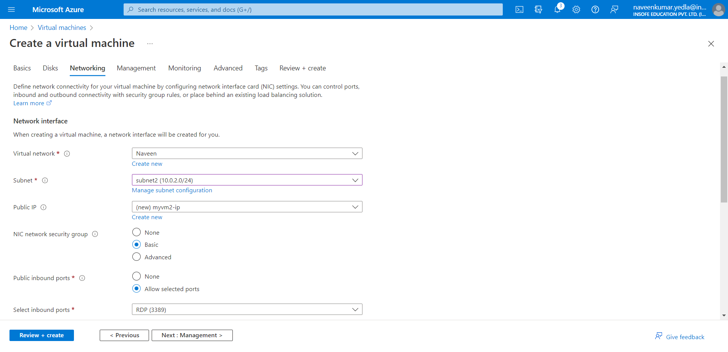

1. Select the Review + create tab, or select the blue Review + create button at the bottom of the page.
2. Review the settings, and then select Create.

**Note**

1. Azure provides a default outbound access IP for VMs that either aren't assigned a public IP address or are in the back-end pool of an internal basic Azure load balancer. The default outbound access IP mechanism provides an outbound IP address that isn't configurable.
2. The default outbound access IP is disabled when a public IP address is assigned to the VM, the VM is placed in the back-end pool of a standard load balancer, with or without outbound rules, or if an [Azure Virtual Network NAT gateway](https://learn.microsoft.com/en-us/azure/virtual-network/nat-gateway/nat-overview) resource is assigned to the subnet of the VM.
3. VMs that are created by virtual machine scale sets in flexible orchestration mode don't have default outbound access.
4. For more information about outbound connections in Azure, see [Default outbound access in Azure](https://learn.microsoft.com/en-us/azure/virtual-network/ip-services/default-outbound-access) and [Use source network address translation (SNAT) for outbound connections](https://learn.microsoft.com/en-us/azure/load-balancer/load-balancer-outbound-connections).

## **Connect to myVM1**

1. On windows Search, Search for RDP (Remote desktop Connection)
2. In Computer tab enter the Public IP address of your myVM1. Public IP address is specified in the Overview of your VM.

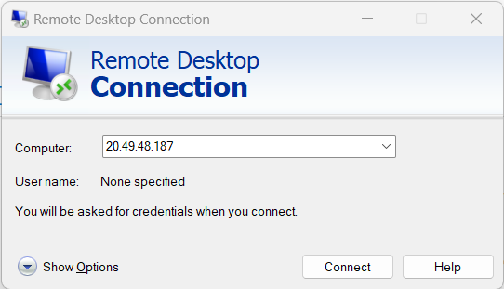

1. Click on Connect.
2. Enter your credentials and click on OK.
3. VM will open.

**Open both the VM’s Simultaneously**

## **Connect to myVM2**

1. On windows Search, Search for RDP (Remote desktop Connection)
2. In Computer tab enter the Public IP address of your myVM2. Public IP address is specified in the Overview of your VM.



1. Click on Connect.
2. Enter your credentials and click on OK.
3. VM will open.

## **Communicate between VMs**

1. Copy the IP address form myVM2 subnet2 IP address.
2. In myVM1 virtual machine open PowerShell.
3. In the PowerShell of myVM1 enter: ping 10.0.1.4

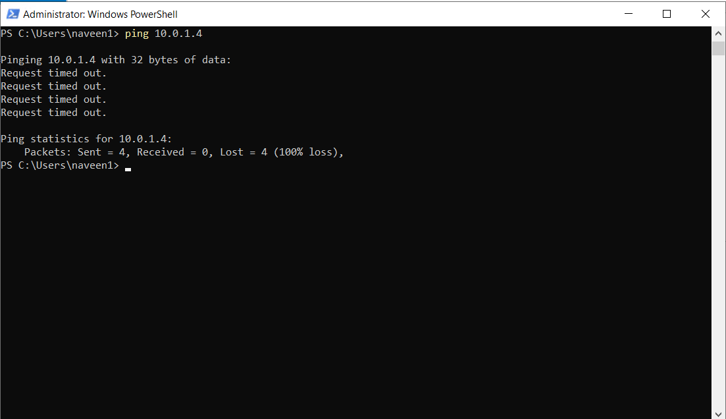

1. The ping fails, because it uses the Internet Control Message Protocol (ICMP). By default, ICMP isn't allowed through your Windows firewall.
2. To allow myVM2 to ping myVM1 in a later step, enter this command:
3. Enter: ‘New-NetFirewallRule –DisplayName "Allow ICMPv4-In" –Protocol ICMPv4’

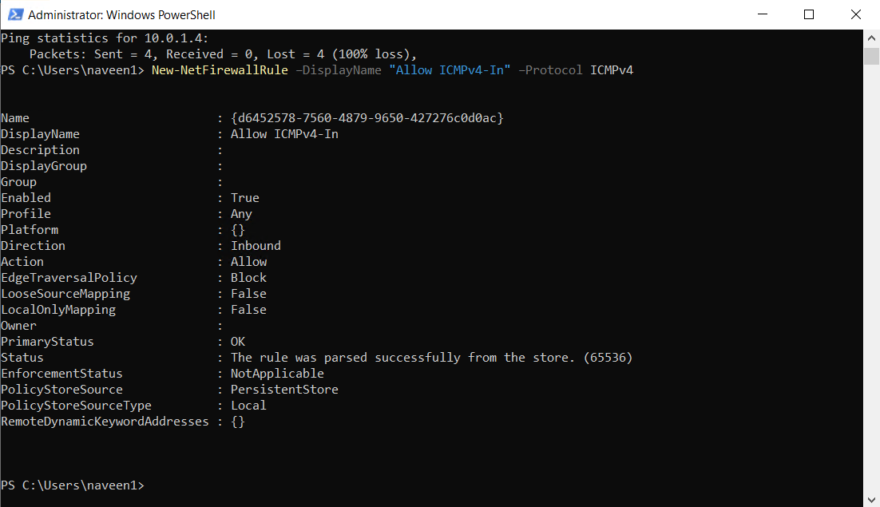

1. That command lets ICMP inbound through the Windows firewall.
2. Close the connection to myVM1.
3. Complete the steps in [Connect to myVM1](https://learn.microsoft.com/en-us/azure/virtual-network/quick-create-portal#connect-to-myvm1), but connect to myVM2.
4. Open PowerShell on myVM2, enter ping myVM1.

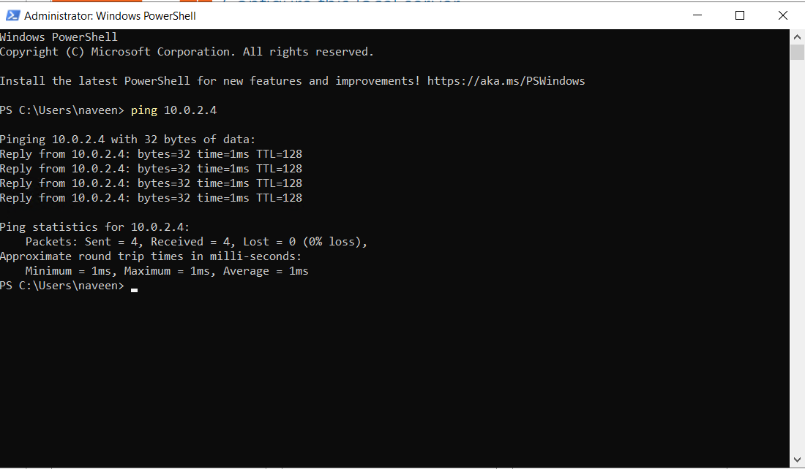

1. You'll receive a successful reply message like this:
2. Close the connection to myVM2.

## **Clean up resources**

In this quick start, you created a default virtual network and two VMs.

You connected to one VM from the internet and securely communicated between the two VMs.

When you're done using the virtual network and the VMs, delete the resource group and all of the resources it contains:

1. Search for and select myResourceGroup.
2. Select Delete resource group.
3. Enter myResourceGroup for TYPE THE RESOURCE GROUP NAME and select Delete.