**Create Virtual Machine**

1. Enter virtual machines in the search.
2. Under Services, select Virtual machines.
3. In the Virtual machines page, select Create and then Azure virtual machine. The Create a virtual machine page opens.

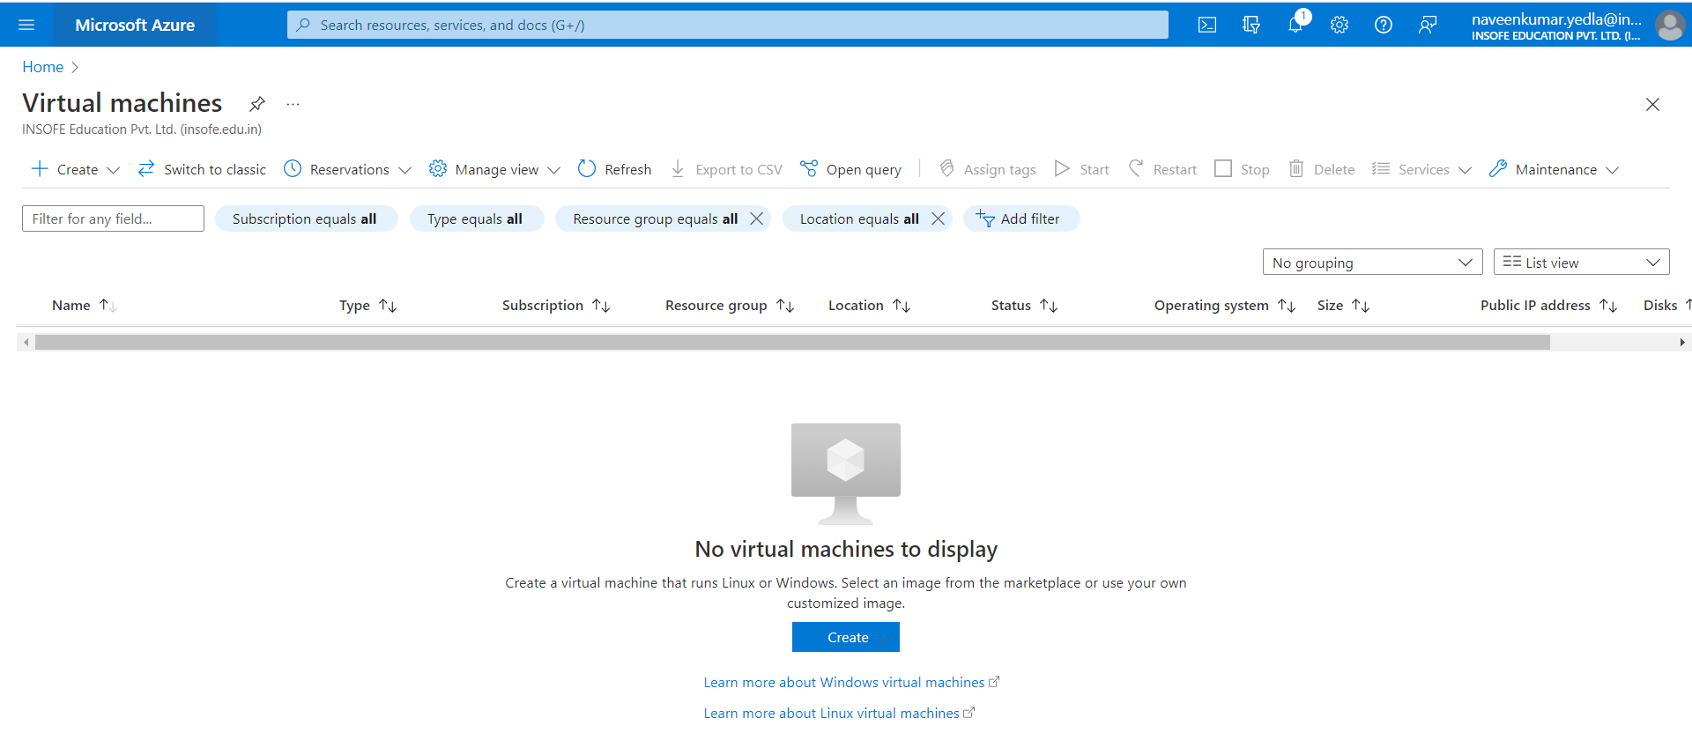

1. Under the basics Blade select the subscription and enter the Resource group if exist. Otherwise create a new Resource group.
2. Under Instance details, enter name of VM(naveen)for the Virtual machine name and choose Windows Server 2019 Datacenter *- Gen 2* for the Image. Leave the other defaults.

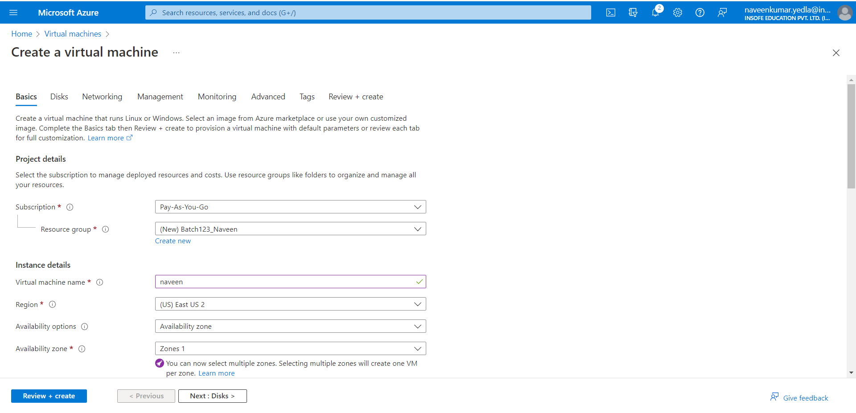

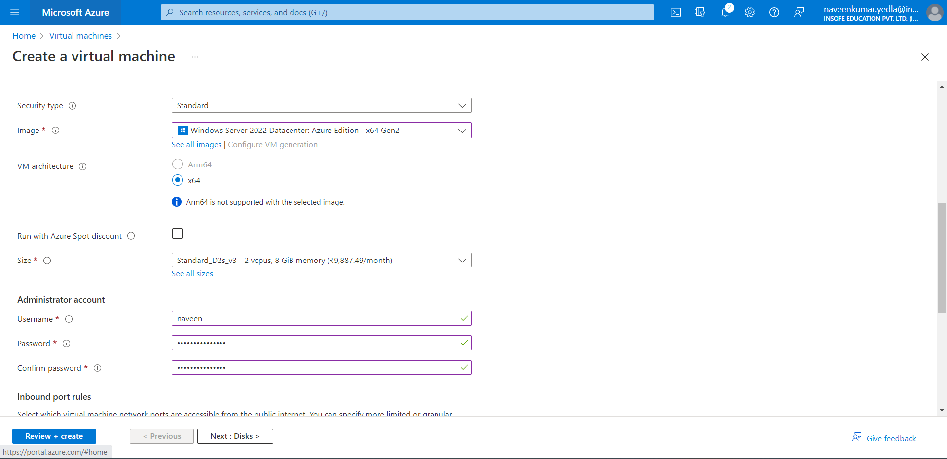

1. Under Administrator account, provide a username, such as naveen and a password. The password must be at least 12 characters long and meet the [defined complexity requirements](https://learn.microsoft.com/en-us/azure/virtual-machines/windows/faq#what-are-the-password-requirements-when-creating-a-vm-).



1. Under Inbound port rules, choose Allow selected ports and then select RDP (3389) and HTTP (80) from the drop-down.

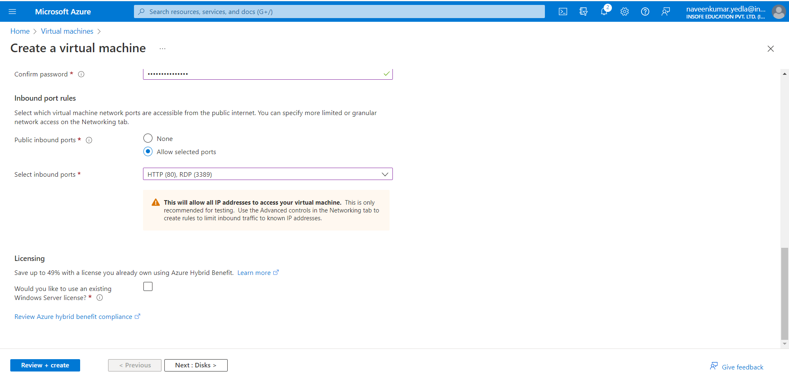

1. Leave the remaining defaults and then select the Review + create button at the bottom of the page.
2. After validation runs, select the Create button at the bottom of the page.

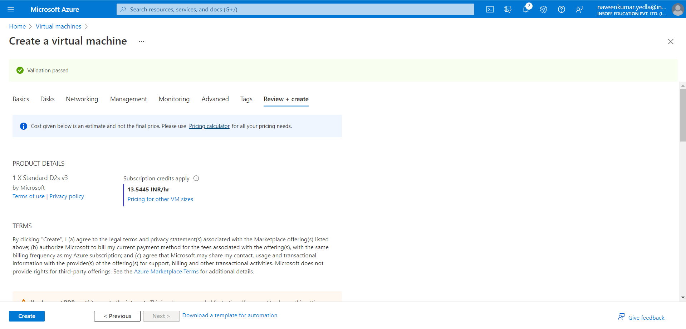

1. After deployment is complete, select Go to resource.

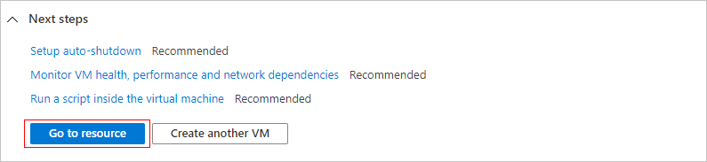

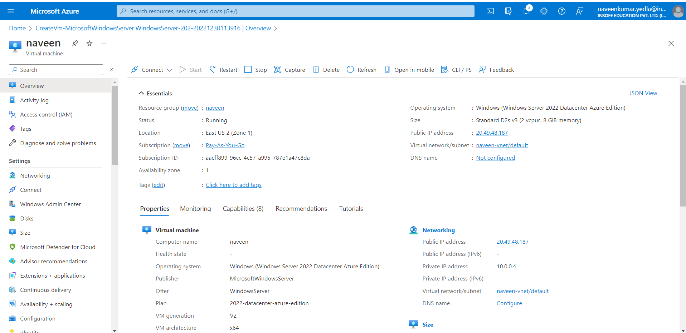

## **Connect to virtual machine**

Create a remote desktop connection to the virtual machine. These directions tell you how to connect to your VM from a Windows computer. On a Mac, you need an RDP client such as this [Remote Desktop Client](https://apps.apple.com/app/microsoft-remote-desktop/id1295203466?mt=12) from the Mac App Store.

1. On windows Search, Search for RDP (Remote desktop Connection)
2. In Computer tab enter the Public IP address of your VM. Public IP address is specified in the Overview of your VM. Eg:20.49.48.187

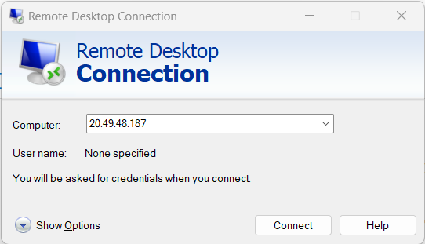

1. Click on Connect.
2. Enter your credentials and click on OK.

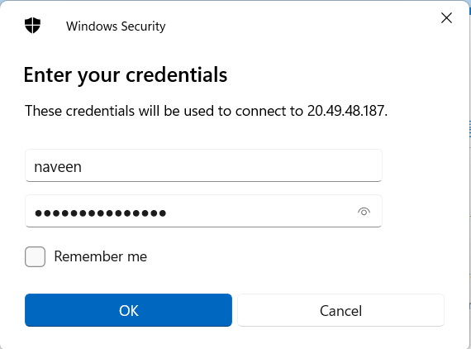

1. Virtual machine will open.

## **Install web server**

1. To see your VM in action, install the IIS web server. Server Manager settings will open automatically.
2. Select Add Roles and features.

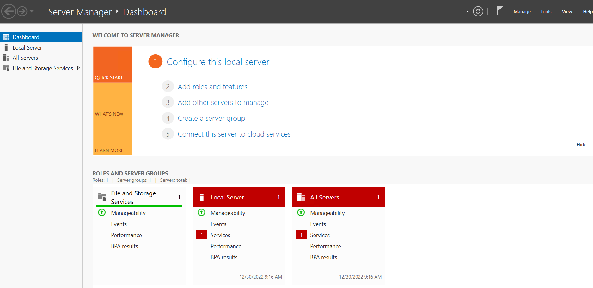

1. Click on next

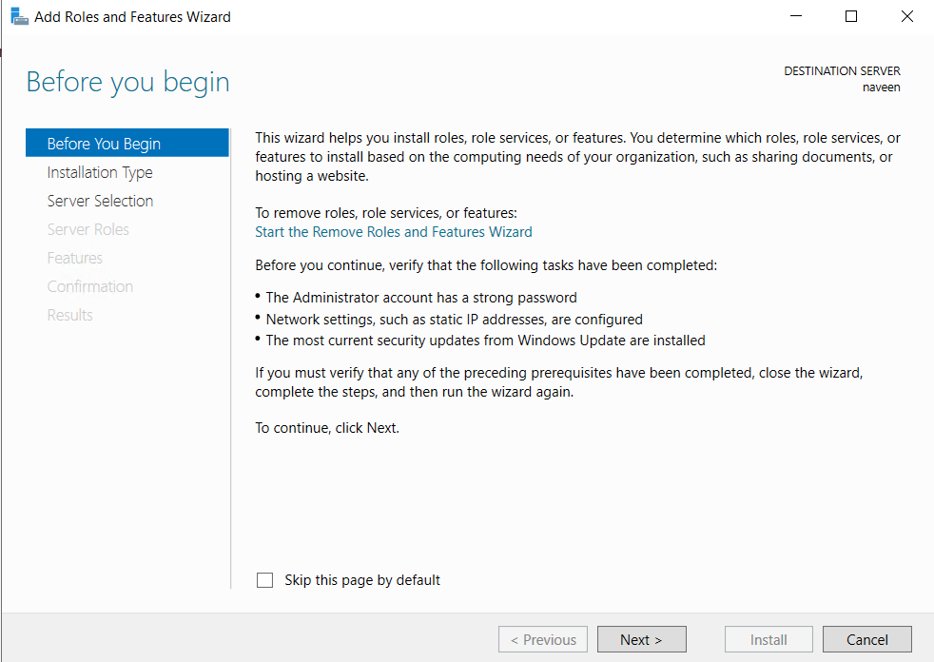

1. Click on next

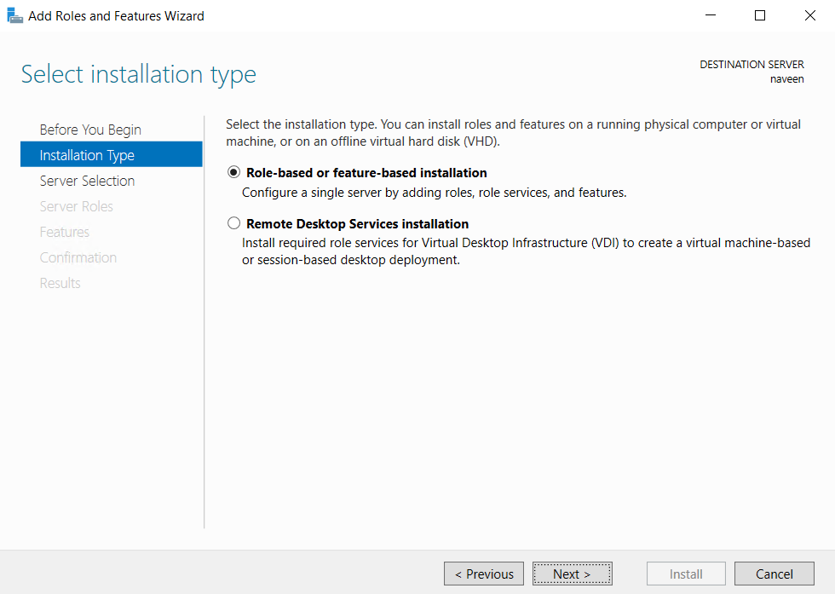

1. Click on next

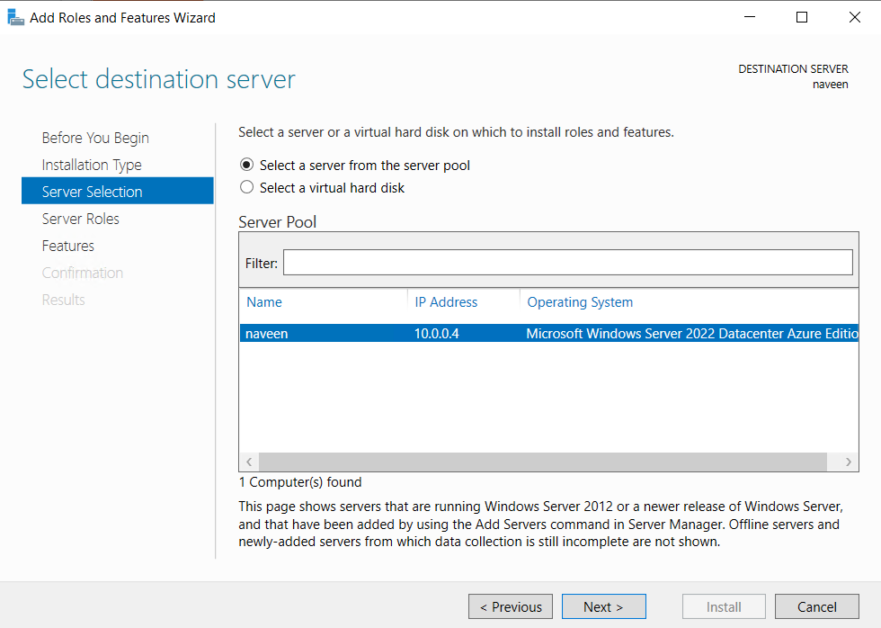

1. Select on Web Server (IIS) and click on next

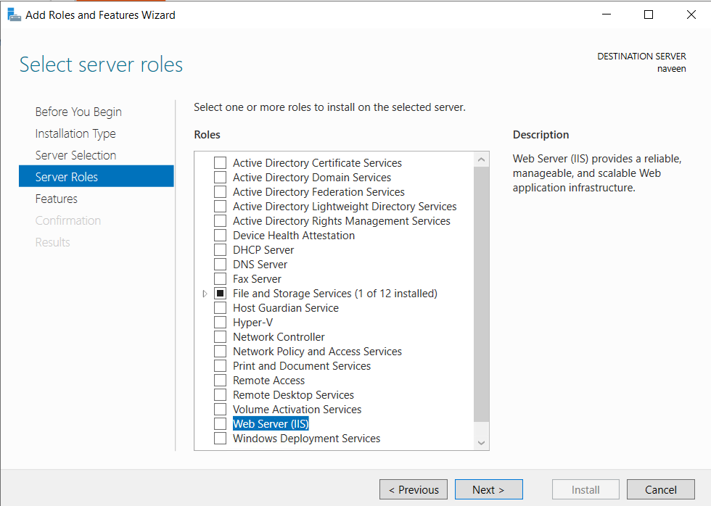

1. Click on Add Features.

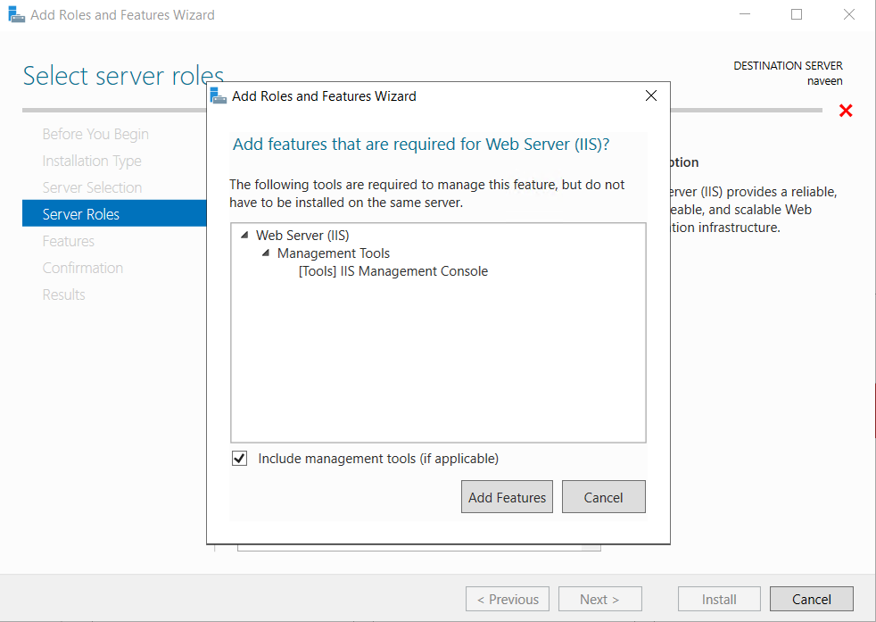

1. Click on Next.

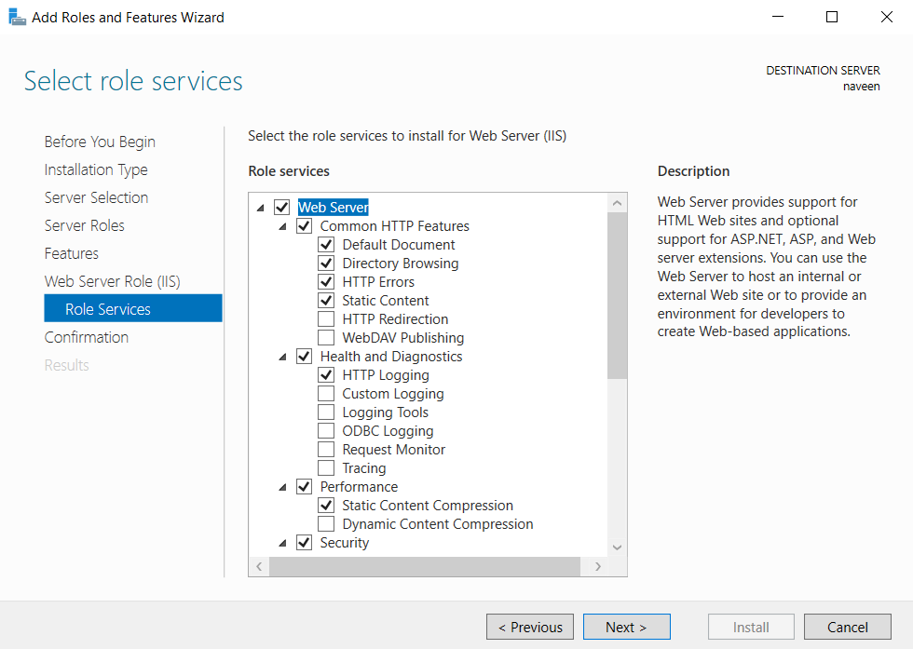

1. Click on Install.

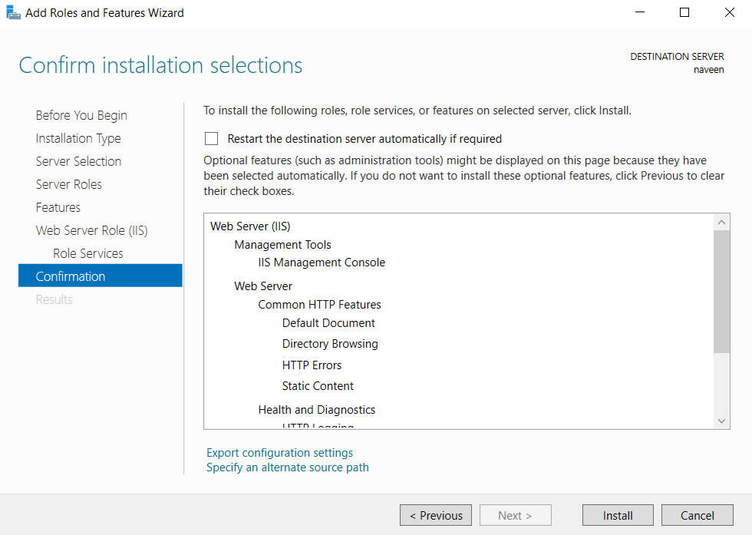

1. After installation open Internet Explorer and search for <http://localhost/.> The below shown image will displayed.

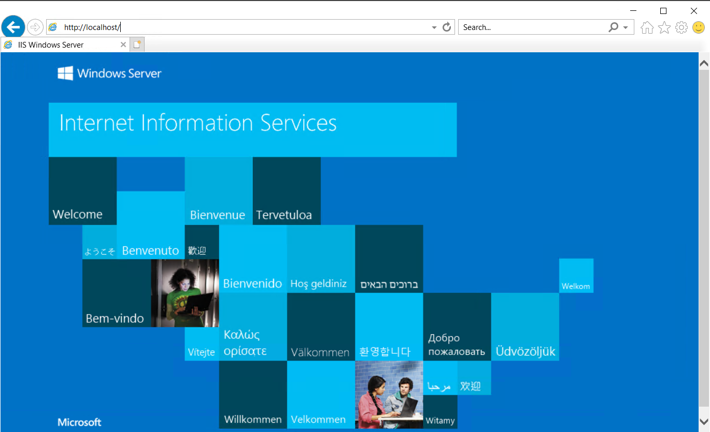

1. Now we are creating the internet bound between our local machine and the virtual machine. open the resource VM and select Networking.
2. Select the Add inbound Port rule.

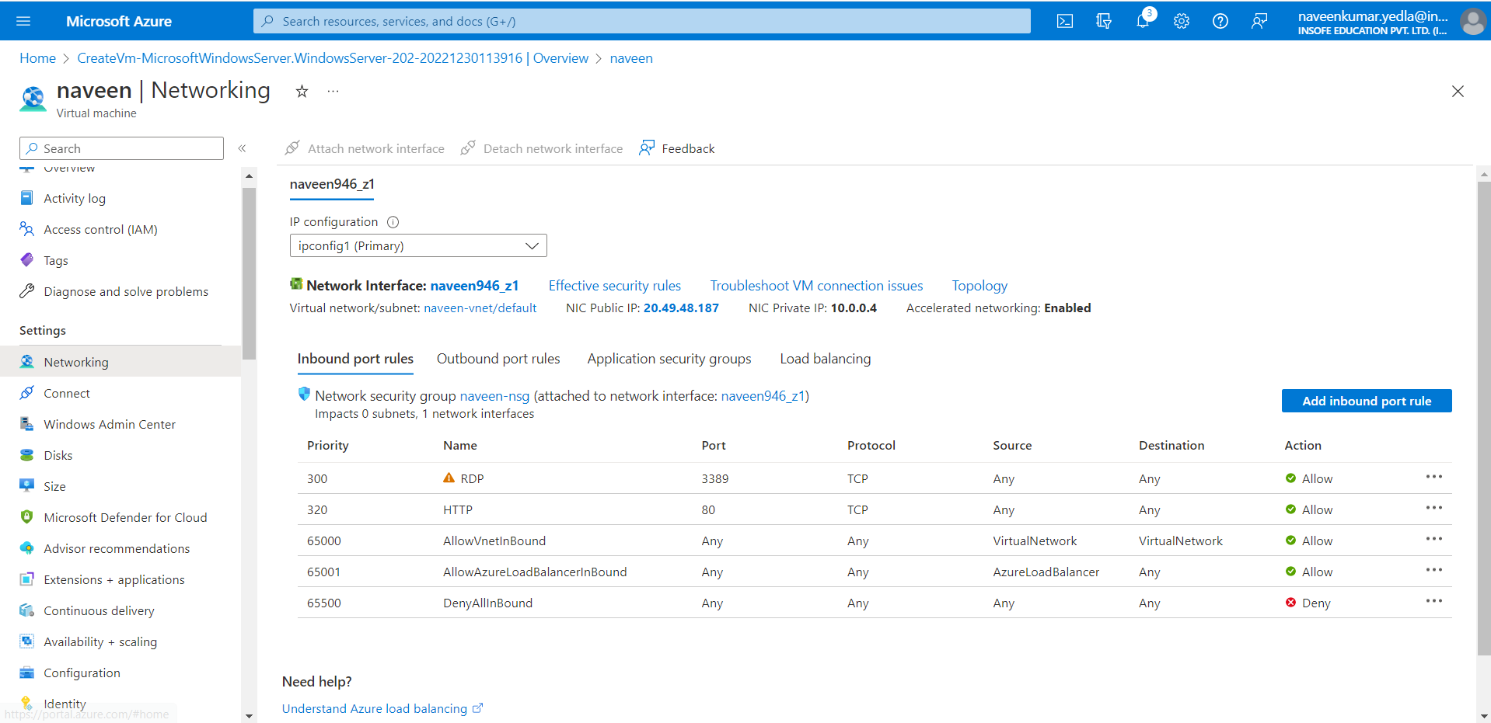

1. Follow the steps shown in below image.

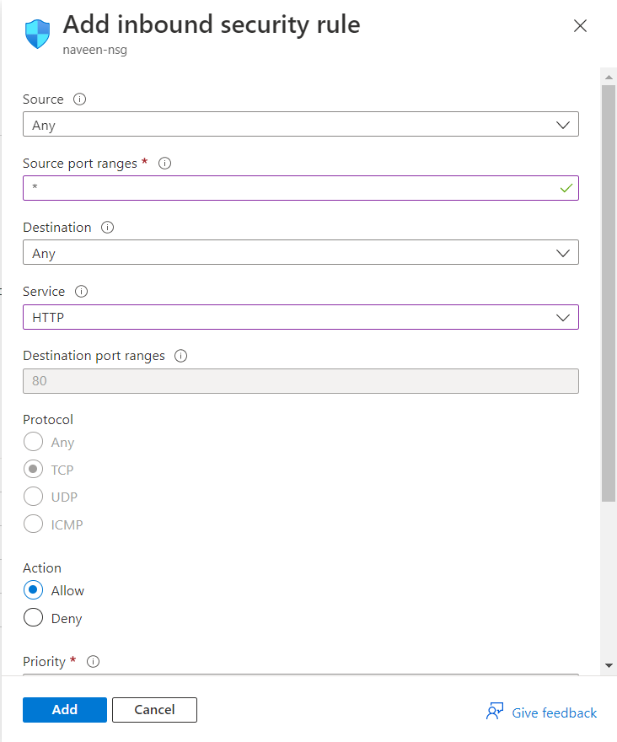

1. Click on Add.

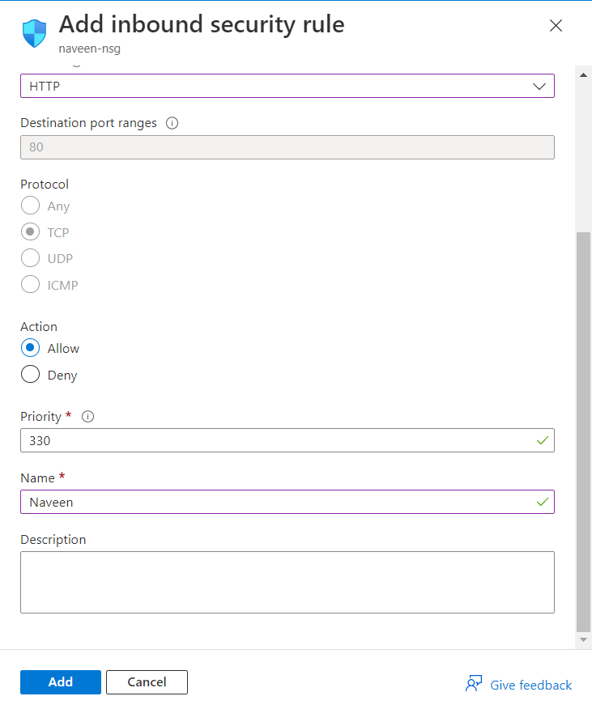

1. Now copy the Public IP address of the VM and open the browser in your local machine and paste it. The same image will be displayed.

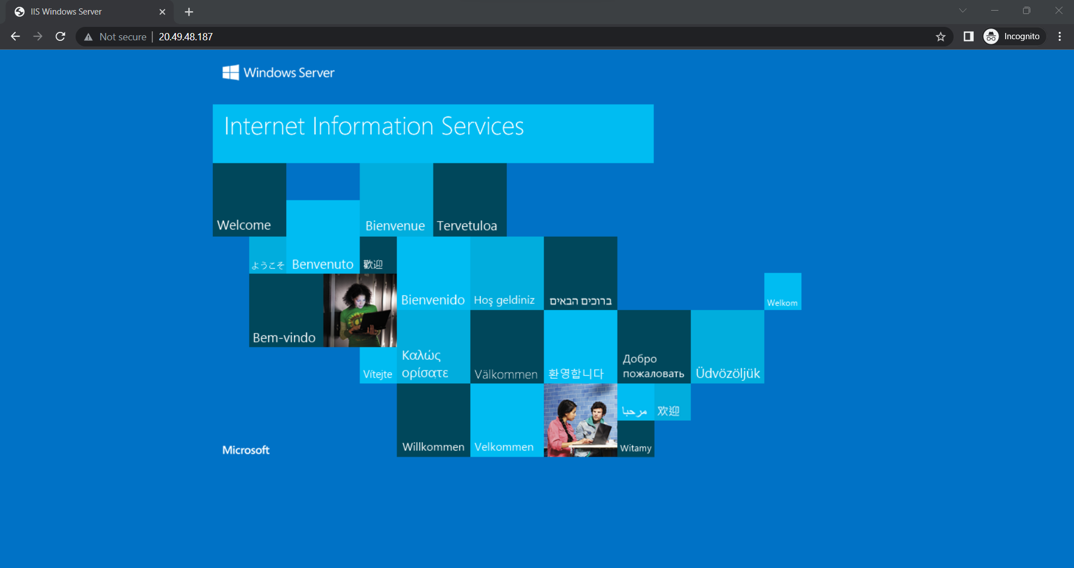

1. Now change the file and check.
2. Create a new file in your virtual machine. Direct to the folder This PC > Windows(C) > inetpub > wwwroot.
3. create a text file enter some information in the text file and change it to html extension.
4. In File Explorer on top bar select the option view and enable the file name extensions.
5. Now rename the file with the html extension.

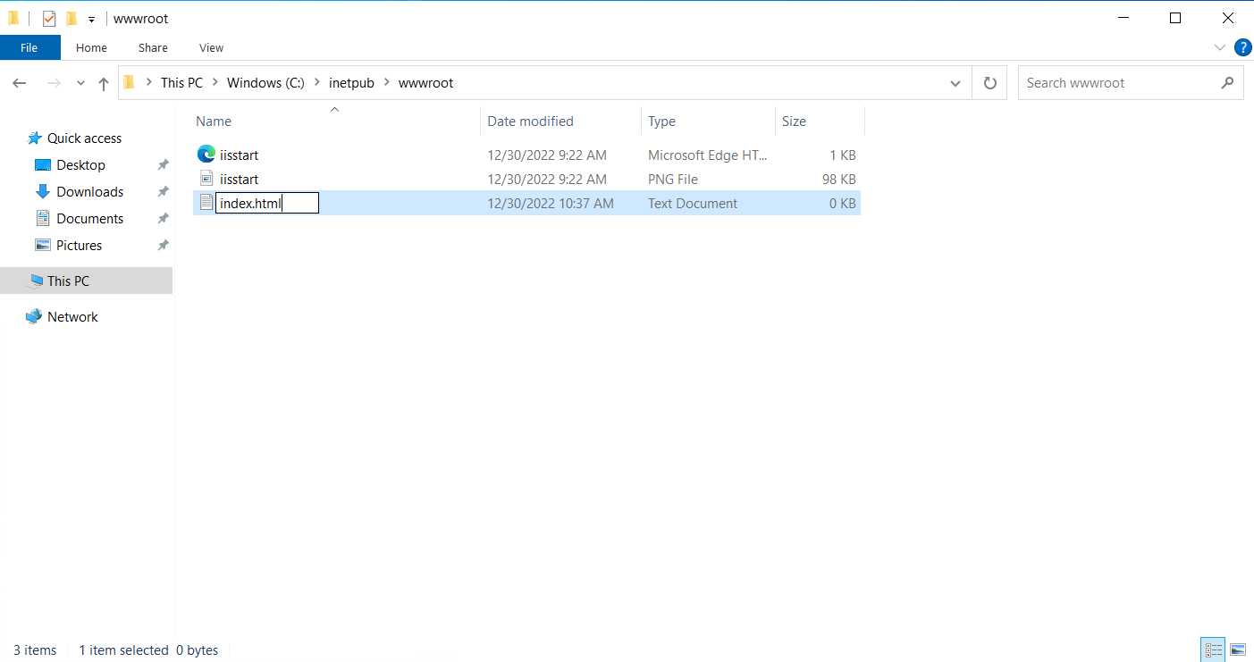

1. Open internet explorer in your virtual machine. search http://localhost/

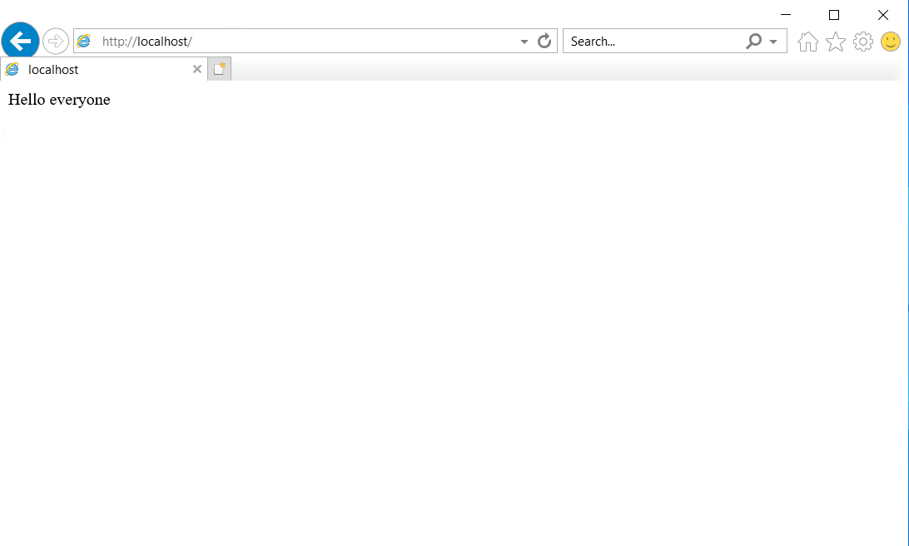

1. Now copy the Public IP address of the VM and open the browser in your local machine and paste it.

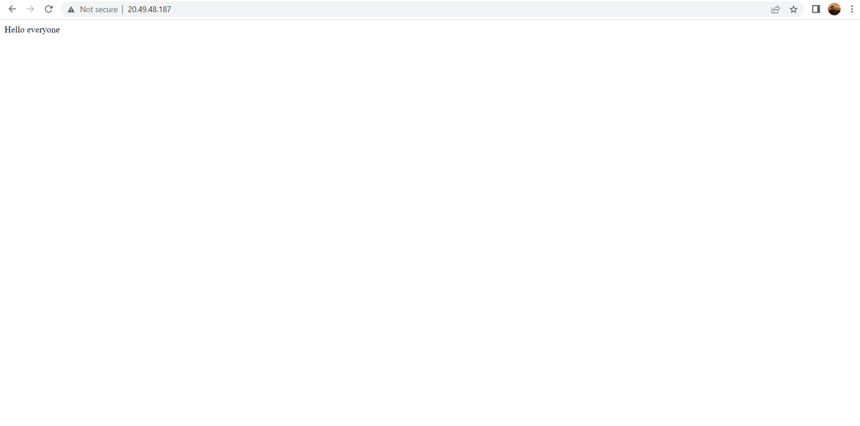

# **a Virtual Machine and Deploy a Web Server**

## **Clean up resources**

When no longer needed, you can delete the resource group, virtual machine, and all related resources.

## 