Q1) What is JavaScript? How to use it?

JavaScript is a versatile programming language that enables the creation of interactive and dynamic features on web pages. It goes beyond static content, allowing for real-time updates, interactive maps, animated graphics, and multimedia control. JavaScript forms the third essential layer of web development, complementing HTML (which structures content) and CSS (which styles content).

Q2) How many types of variables are there in JavaScript?

(i) Automatically: By simply assigning a value to a variable without declaring it (not recommended due to scope issues).

(ii) var: Used in older JavaScript code for declaring variables. It has function scope.

(iii) let: Introduced in ES6 (ECMAScript 2015), it allows block scope variable declaration.

(iv) const: Also introduced in ES6, it is used for declaring constants which cannot be reassigned.

Q3) Define Data Types in JavaScript.

(i) Number: Represents numeric values, e.g., 42 or 3.14.

(ii) String: Represents sequences of characters, e.g., "Hello, World!".

(iii) Boolean: Represents logical values, true or false.

(iv) Array: An ordered collection of values, e.g., [1, 2, 3].

(v) Object: A collection of key-value pairs, e.g., {name: 'John', age: 30}.

(vi) Null: Represents the intentional absence of any object value.

(vii)Undefined: Indicates that a variable has been declared but not assigned a value.

Q4) Write a mul() function that works correctly when invoked with the following syntax.

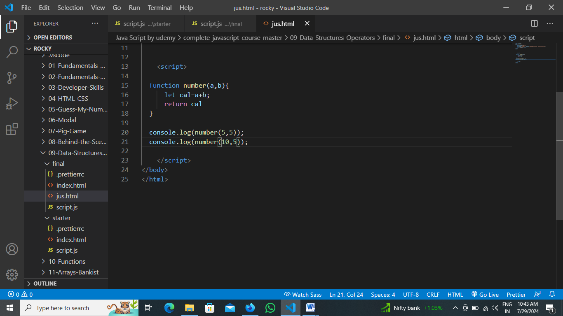

Q5) What is the difference between undefined and undeclared in JavaScript?

**(i)Undefined**: This occurs when a variable has been declared but not assigned a value. For

let x;

console.log(x); Outputs: undefined

(ii) **Undeclared**: This occurs when a variable is referenced without being declared in any scope. This leads to a ReferenceError. For example:

console.log(y) Throws ReferenceError: y is not defined

Q6) Using console.log() print out the following statement:

console.log("The quote 'There is no exercise better for the heart than reaching down and lifting people up.' by John Holmes teaches us to help one another.");

console.log("The quote by Mother Teresa: 'If you can't feed a hundred people, then feed just one.'");

Q7) Check if typeof '10' is exactly equal to 10. If not, make it exactly equal.

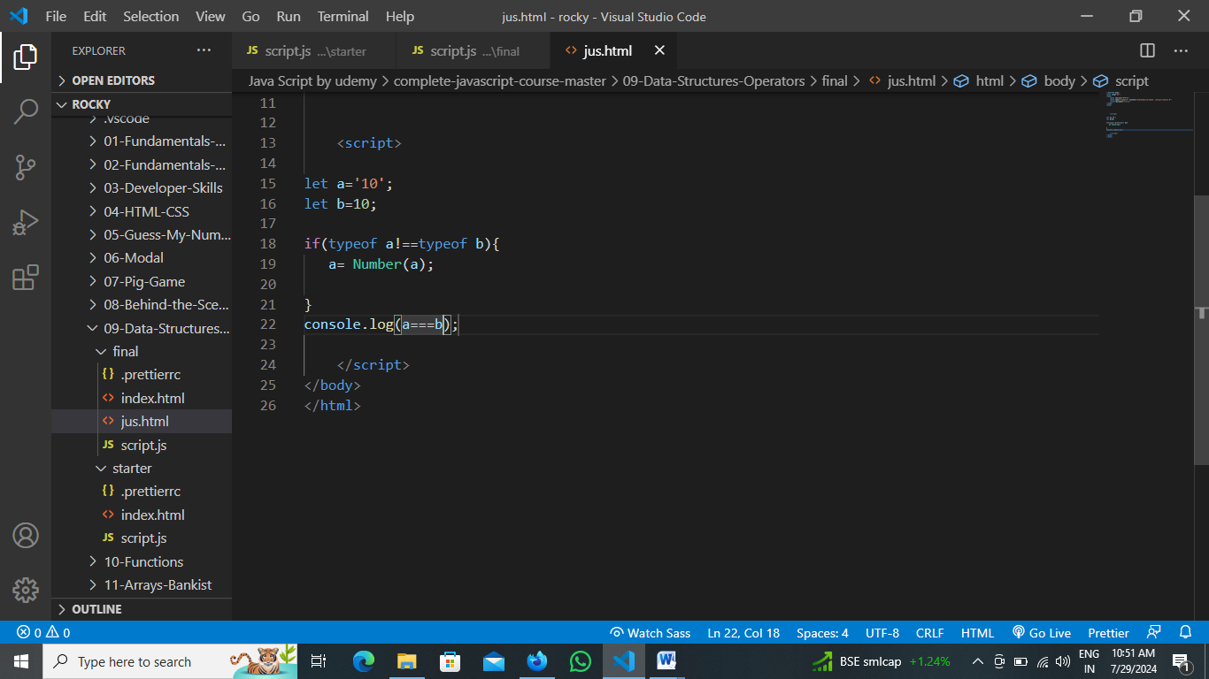

Q8) Write a JavaScript Program to find the area of a triangle.

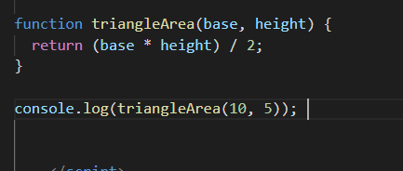

Q9) Write a JavaScript program to calculate days left until next Christmas.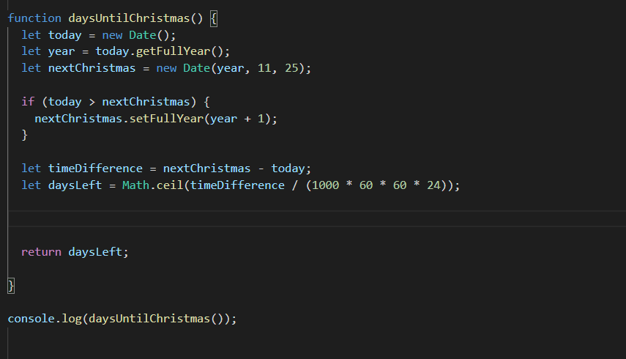

### Q10) What is a Conditional Statement?

Conditional statements in JavaScript control the flow of code execution based on certain conditions. These statements allow for different actions depending on whether a condition evaluates to true or false. The primary conditional statements are if, else if, else, and switch.

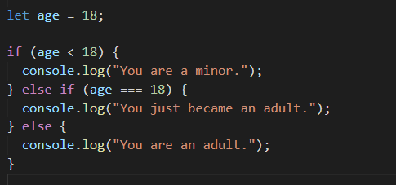

Q11) Find circumference of Rectangle formula : C = 4 * a ?

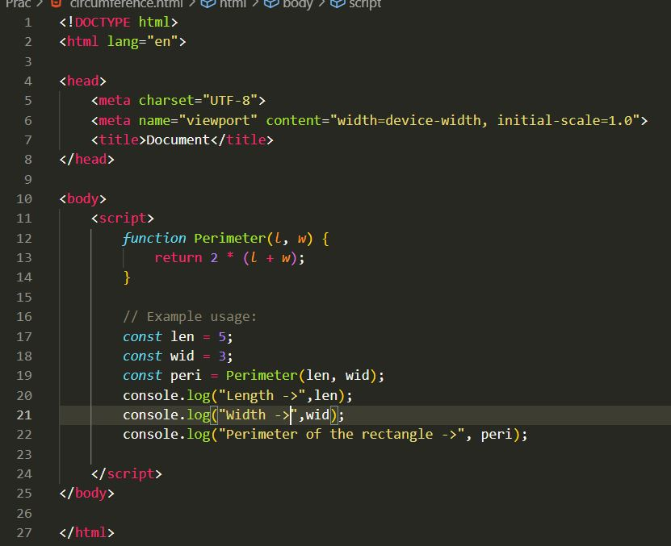

Q12) Write a program to convert years into days and days into years.

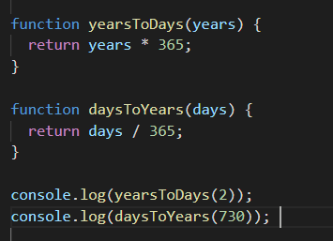

Q13) Convert temperature from Fahrenheit to Celsius.

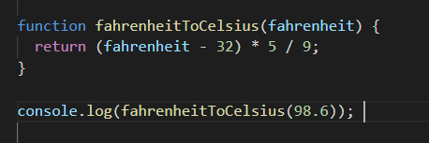

Q14) Write a JavaScript exercise to get the extension of a filename.

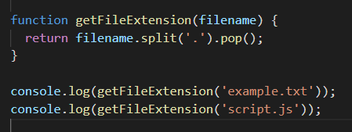

Q15) What is the result of the expression (5 > 3 && 2 < 4)?

True

Q16) What is the result of the expression (true && 1 && "hello")?

Hello

Q17) What is the result of the expression true && false || false && true?

false

Q18) What is a Loop and Switch Case in JavaScript? Define them.

**Loop**: A loop is a control structure that repeats a block of code as long as a specified condition is true. Common loops in JavaScript include for, while, and do-while.

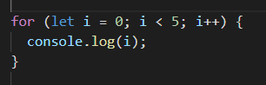

**Switch Case**: A switch statement allows a variable to be tested for equality against a list of values, with each value being called a case.

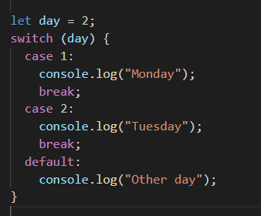

Q19) What is the use of isNaN function?

NaN means ‘Not-a-Number’ in Javascript. It is a function which return true if it is Not a number and false if it is a number.

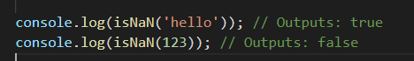

Q20) What is the difference between && and || in JavaScript?

(i) && and || is used in JavaScript with multiple expressions.

(ii) && stands for ‘and’. It is used to check if all the expressions before and after && are true or not. If even a single expression among multiple expression is false. It will print false.

(iii) || stands for ‘or’. It is used to check if even a single expression is true among all the expressions and if even a single expression is found true it will print true.

Q21) What is the use of void(0)?

The void(0) expression is used in JavaScript primarily to prevent the browser from performing the default action when clicking on a link. It's often used in combination with the href attribute of anchor (<a>) tags to create "dummy" or "void" links that don't navigate anywhere but still trigger some JavaScript functionality.

Q22) Check if a number is positive or negative in JavaScript.

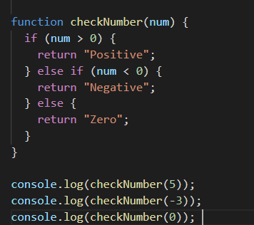

Q23) Find if a character is a vowel or not.

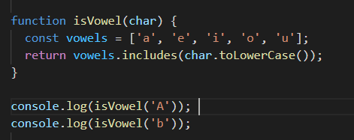

Q24) Write to check whether a number is negative, positive or zero.



Q47) What are the drawbacks of declaring methods directly in JavaScript objects?

(i) Inefficiency: Each time an object is created, the methods are recreated, which can consume unnecessary memory and processing time.

(ii) CodeReadabilityandMaintainability: When methods are defined within the object itself, it can clutter the code and make it harder to read and maintain. Updating a method would require changing it in every instance of the object.

Q59) What is BOM vs DOM in JavaScript?

|  |  |  |
| --- | --- | --- |
| Aspect | BOM (Browser Object Model) | DOM (Document Object Model) |
| Purpose | Interacts with the browser's environment | |  | | --- | |  |  |  | | --- | | Interacts with the document structure | |
| Scope | Browser-specific, not standardized | Standardized across different browsers |
| Main Components | window, navigator, screen, history, location | Document, elements, attributes, text nodes |
| Functionality | Manages browser windows, user information, navigation | Manipulates HTML/XML content |
| Example Use Case | Displaying an alert box, getting browser information | Adding a new element to the HTML document |

Q60) Array vs Object differences in JavaScript?

|  |  |  |
| --- | --- | --- |
| Aspect | Array | Objects |
| Definition | An ordered collection of values, indexed by numerical keys (indices). | An unordered collection of key-value pairs, where keys are strings (or symbols) and values can be of any type. |
| Use Case | |  | | --- | |  |  |  | | --- | | Suitable for storing lists of items that need to be accessed by their order. | | Suitable for storing data that needs to be accessed by named keys. |
| Syntax | Declared using square brackets [ ]. | Declared using curly braces { }. |
| Accessing Elements | Accessed by numerical indices, e.g., array[0]. | Accessed by keys, e.g., object.key or object["key"]. |
| Iteration | Iterated using loops like for, for...of, forEach(), map(), etc. | Iterated using for...in, Object.keys(), Object.values(), Object.entries(), etc. |

Q67) What is JavaScript?

* JavaScript is a**programming language used for creating dynamic content on websites.** It is a **lightweight, cross-platform**and**single-threaded**programming language. JavaScript is an **interpreted**language that executes code line by line providing more flexibility. It is a commonly used programming language to**create dynamic and interactive elements in web applications.** It is easy to learn.

Q68) What is negative Infinity?

Negative Infinity, denoted as `-Infinity`, is a special value in mathematics and programming that represents a value that is smaller than any other real number. It is the opposite of positive infinity (`+Infinity`). In programming contexts, such as JavaScript, it is often used to represent values that are the smallest possible numeric values or to indicate that an operation results in a value that is too small to be represented or meaningful within the defined numeric range.

Q69) Which company developed JavaScript?

JavaScript was developed by Netscape Communications Corporation. The language was created by Brendan Eich in 1995 while he was working at Netscape. Initially, it was called Mocha, then renamed to LiveScript, and finally, it was branded as JavaScript to leverage the popularity of Java, even though the two languages are quite different.

Q70) What are undeclared and undefined variables?

(i) Undeclared variables: These variables are not declared using var, let, or const. Accessing an undeclared variable results in a ReferenceError.

(ii) Undefined variables: These variables are declared but not assigned a value. Accessing an undefined variable returns undefined.

Q71) What is the difference between ViewState and SessionState?

|  |  |  |
| --- | --- | --- |
| Aspect | ViewState | SessionState |
| Purpose | Maintains the state of a web page across postbacks | Maintains the state of a user's session across multiple pages |
| Scope | |  | | --- | |  |  |  | | --- | | Page-level | | Application-level |
| Data Persistence | Data is persisted only for the duration of the page's life cycle | Data is persisted for the duration of the user sess |
| Storage Location | Encoded and stored in a hidden field on the page | Stored on the server, with a session ID sent to the client |
| Data Size | Limited to the size of the page | Can store larger amounts of data compared to ViewState |

Q72) What are the disadvantages of using innerHTML in JavaScript?

(i) Security Risk: innerHTML allows you to insert any HTML code, including malicious scripts. This can be exploited for Cross-Site Scripting (XSS) attacks, where attackers inject scripts into your page to steal data or redirect users.

(ii) Performance Issues: innerHTML can be slow, especially when dealing with large amounts of content. This is because it replaces the entire content of the element, including any existing event listeners, and then re-parses the new HTML.

(iii) Limited Functionality: innerHTML isn't ideal for all situations. It can't easily append content or handle complex DOM manipulations.

(iv) Harder to Maintain: Code using innerHTML can become messy and difficult to maintain, especially when dealing with multiple elements or complex content.

Q73) How to read and write a file using JavaScript?

* In web browsers, JavaScript primarily operates within a sandboxed environment that restricts direct access to the local file system for security reasons. However, JavaScript can interact with files indirectly through mechanisms like file input elements and APIs that allow interaction with files selected by users.

**(i) Reading a File (Using File Input Element)**

* To read a file that a user has selected, you can use an <input type="file"> element in your HTML and then handle the file in JavaScript

### (ii) Writing to a File

* Directly writing to files from JavaScript in a browser-based environment is not possible due to security restrictions. However, if you are working in a Node.js environment or have access to server-side JavaScript (e.g., using frameworks like Express), you can write files using Node.js file system (fs) module