**ABSTRACT**

The major competition in automobile industries exists in the field of design and cost of any components. One of the important components of the automobile is the engines and its parts. Assembling and dismantling of the engine is a difficult, tedious process consuming lot of human effort and time as well. If defects may be due to valve leak, bend or abnormal combustion, then the total set up of engine should be dismantled part by part, which is again a time consuming process. In order to reduce the time consumption in dismantling process, we have designed “the replica of rocker arm shaft” through which the whole cylinder head can be dismantled from the engine without much damage to the engine and the other components.

**Introduction about engines in shook Leyland:**

Engines are the heart of the automobiles. Engines are used to move up the whole automobile body. Value analysis and Value Engineering should be employed for the engine design. In most of the automobiles, different varieties of engines are used. Engine varies depending upon the size, variety, type, applications, specialized purposes. Engine’s capacity also varies depending upon the application for light duty vehicles, 4 cylinder engines is used, for heavy duty vehicles such as trucks, lorries 6 cylinder engines are used such as H series engines. H stands for “Hino”. H series engine is used for heavy duty purpose; H series engine is huge in construction. It comprises of many major and minor components. In H-series engine, many parts are available. Several important parts of the H-engines are, Intake and exhaust values, Intake and exhaust manifold, Rocker arm assembly, cylinder head, cylinder top, fuel injector pipe, fuel injector, bolts, nuts, studs, common rails, injector pipes, Turbocharger, Exhaust gas recirculation, poppet valves, tappet valves, pushrod, camshaft, flywheel, piston head, rocker arm shaft, fuel filter, fuel sump, thermostat,etc..

**ASSEMBLING AND DISASSEMBLING**

Due to its more complexity structure, the assembling of the single engine is considered as the time consuming process. It requires more man power for fixing it with proper proportions and alignments. As in case of any problem or any improper assembling the whole setup is to be removed or dismantled one by one. Same as the assembling process, disassembling process is very difficult and time consuming one. Due to its complex structure, each and every part is to be removed carefully for the reworking purpose.

**TIME REDUCTION IN DISMANTLING**

Due to its complex structure involving many parts, disassembling of parts is time consuming sometimes disassembling cause’s damage to the parts. For this, we are designing the special shaft which looks similar to the rocker arm shaft. It should be the “REPLICA OF ROCKER ARM SHAFT” (DUMMY). After designing the replica of rocker arm shaft, just we have to remove fewer parts such as fuel injector, bolts, valve caps, etc, then we are fitting the replica of rocker arm shaft is fitted into the cylinder head with the help of crank hook (electronically operating hook) is used to hold and lift the whole cylinder head setup, from the top of the engine. Then, we can easily rework with the cylinder head, which was lifted and hung over the engine through crank hook.

**H-SERIES ENGINES IN SHOP 5(ENGINE ASSEMBLY ):**

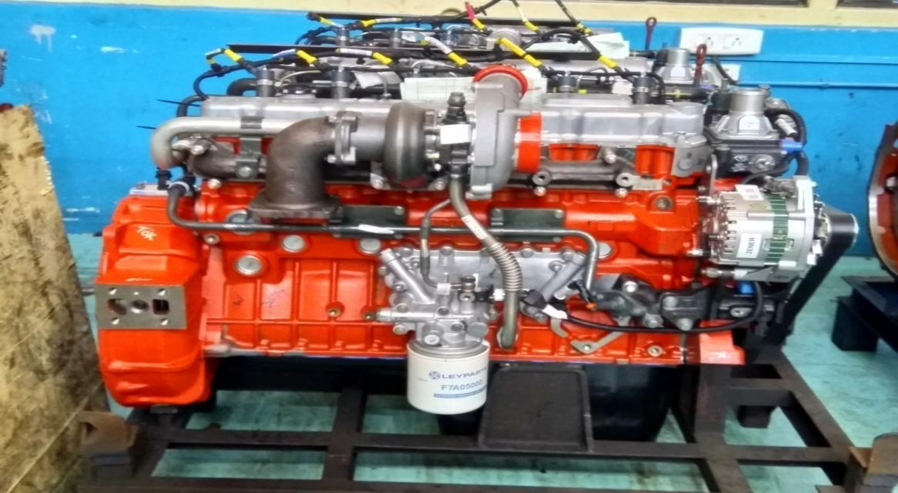

**FIG (1.1 ) FRONT VIEW OF H-SERIES ENGINE**

The specification for 6 cylinder H-series engine will be followed. The engine model for 6 cylinder h series H-series engine, will be followed. The engine model for 6 cylinder H series engine is H6ETICRC3. The BHP range for their type of engine is 225 HP; its speed rate is about 2300-2500 rpm. The maximum torque developed by this engine is 800Nm at the speed rate of 1700 to 1900 rpm, its bore stroke is 104x113, and the capacity of this engine is 5.76 litres. The compression ratio for this engine is 17:5:1. Its direction of rotation is anticlockwise, when viewed from flywheel end. The total weight of the engine is 530 kg, and its dimensions of the engine are 1060x760. The maximum interval of maintenance is 500 hrs. The applications for these engines are crane, cold miller.

**CHAPTER 2**

**LITERATURE REVIEW**

**2.1 G.A.Nassef, A.Elkhabit, .et al (2016) ‘Analysis of a Failed Rocker Arm Shaft of Passenger Car Engines’, Science Direct, 2016**

This paper investigates the failure of a rocker arm shaft of a passenger car. The shaft failed by brittle fracture across one of the four holes supporting the shaft into the cylinder head. Microscopic observation of the failed shaft revealed that the four dark etching areas are surface hardened zone of martens tic microstructure. Microscopic investigation of the failed shaft reveals the presence of micro cracks close to the supporting holes. This premature failure has occurred by the rapid crack propagation because of the lower toughness of marten site. Excluding design reasons, failures such as consequential failure, improper lubrication, faulty manufacturing. For all the above reasons and given the results of the above investigation, such failure is attributed to improper heat treatment of the shaft during manufacturing. It is recommended to conduct a proper heat treatment to the whole body of the arm in order to prevent recurrent failures in the future.

**2.2 Uday.A, Chirag.K (2015) ‘Productivity Improvement in Engine Assembly Line at GM India Put Ltd’, 2015**

In this paper, the main focus is to reduce the bottleneck areas by applying necessary techniques for improving the productivity. It is found that the main areas where bottleneck happens are, head assembly key up station, tappet line and hot testing of engines. We notified that various NVA (non value added) activities and with the help of pare to principle, they sorted out most probable causes i.e. Traffic problem of cart, unwanted movements and handling of equipments etc. By applying all these techniques, then the productivity improvement in one assembly system causes improvement in other

subsystem too, NVA reduction by proper sequences of arrangement in activities by the installation of new tool and trouble shooting for head sub assembly, tappet line sub assembly and hot test cells etc.

**2.3 Mr.Syed Muja hid, Mr.siraj sheikh (2013) ‘Rocker Arm’, International journal of Innovative Research in Science, engineering and Technology, 2013**

This paper reviews the various types of rocker arms based on the sources from the last 40 years, in order to understand the rocker arm, for its problem identification and further optimization. In this paper, the various types of rocker arms and their materials are studied. Rocker arm is an important component of engine, failure of rocker arm makes an engine useless, also requires costly improvement. The most suitable material for the rocker arm is steel because, it has better fatigue strength than the aluminium.

**2.4 Mr.Sachin Bache, Mr.P.Swaminadhan, .et al (2018) ‘Design and Static Structural Analysis of Rocker Arm in IC Engine’, International Journal of Engineering Science and Research Technology, 2018**

In this paper, the failure of rocker arm in valve actuating mechanism is discussed. To study and analyse the stresses generated, they are modelling the rocker arm using CATIA CAD software and various regions of stresses and deformation found out using OPTISTRUCT-RADIOSS structural analysis solver which gives solution for structural optimization using finite element analysis (FEA). The main purpose of this study is to determine the value of stresses in rocker arm at extreme conditions. The design can be optimized by reducing the amount of material used. Stresses within the rocker body are calculated by using Finite Element Analysis and validated with type help of result obtained by using analytical mathematical formulae.

**2.5 Amole B. Son wane, Day A. Debase (2017), ‘Continuous Improvement of Automobile Engine Assembly Line’, International Journal of Innovation in Engineering, Research and Technology, 2017**

In this paper, the discussion starts as, currently manufacturing industries are facing a greater competition in the market. Due to this, competition among industries is, trying to improve and increase the both quality productivity continuously. So the main focus was given on the review of recent research related to continuous improvement of automobile engines assembly line and a case study of automotive industry. The present work gives an overview of previously done research work and for new research; it gives a direction for continuous improvement of automobile engine assembly line. Also with the help of case study, it is explained how to reduce major breakdown causing production loss at engine assembly line.

**2.6 Mr. Sager Gide, Mr.Jagrit Shrives, Mr.R.R.Kharde (2015), ‘Review on Critical Speed Improvement in Single Cylinder Engine Valve Train’, International Journal of Innovation in Engineering Research and Technology, 2015**

In this paper, Mr. Agar Gide proposed that the purpose of valve train is to operate the inlet and outlet valves of engine. The valve train mainly consists of rocker arm, pushrod, cam, poppet valve and spring for keep the valve in closed position. The valve spring parameters are optimized based on the space availability, buckling of pushrod, and natural frequency of system. It is observed that the valve jump engine speed with respect to optimized valve spring is enhanced. In order to capture the dynamic behaviour of the valve train system closely, each coil of the nested valve springs is modelled as separate flexible body and the contacts between coils of these flexible bodies are established.

**2.7 Mr.Syed Muja hid Husain, Mr.Siraj Sheikh (2013), ‘Design and Analysis of Rocker Arm’, International Journal of Mechanical engineering and Robotics Research, 2013**

In this paper, Mr.Syed Muja hid Husain proposed about Rocker arm of Tata Sumo vista. The CAD Models of Rocker arm was developed and created using the Pro/E Software. The analysis of created CAD Model was done by the ANSYS Software. By the use of ANSYS Software, the Equivalent Stress and Maximum Shear Stress were determined. The result obtained by the ANSYS compared with the Manual calculation i.e. the pin of Rocker arm is under Shear Stress.

**2.8 Dr.Goteti Catania, Mr. Eddy Srinivasalu ( ), ‘Design Optimization of IC Engine Rocker Arm using Taguchi based Design of Equipments’,**

In this paper, Dr.Goteti Catania proposed that the Rocker arms have been optimized for delivering better performance. Rocker arms are mainly subjected to cyclic loads and their fatigue life plays a vital role in the design. Therefore, this works aims at designing the rocker arm for higher fatigue life by changing material and arm ratio. The Rocker arm is modelled using CATIA Software and the fatigue analysis is carried out using ANSYS Software. By using Taguchi method the optimal combination for maximum fatigue life is for Rocker made with structural steel and arm ratio 1:1.

**2.9 Dvina Kumar, B.Sudeendra Srinivas (2017), ‘Design and fabrication of Rocker Arm’, International Journal of Core Engineering and Management, 2017**

In this paper, the main objective of this project is design and performs structural Analysis of the Rocker Arm by using ANSYS Software. The Geometric model of the Rocker arm is developed and created by using CAD Software CATIA The present work deals with the three dimensional solid modelling, design and analysis of rocker arm of an IC Engine. The Rocker arm is designed and the forces on the same are calculated. The structural analysis is carried out using different materials in order to arrive at optimized design of rocker arm. The finite element method is the most popular approach and found commonly used for analysing fracture mechanics problem.

**2.10 Mr. Agar Judah, Mr.P.J.Patil, et al, (2018), ‘Experimental and Finite Element Analysis of Rocker Arm for Bending Failure’, International Journal of Advanced Engineering and Research Development, 2018**

Rocker arms oscillate about rocker arm shaft because of action of push rod on one side and spring action on other side which causes bending of rocker arm as a result the bending stresses are induced the failure of rockers takes place due to these stresses. This paper deals with the theoretical and finite element analysis of rocker arm. The bending stress developed by the theoretical and finite element analysis of rocker arm is under static condition. Among the above two methods most static condition is considered for better results of rocker arm.

**2.11 Mr.Mahdi Chef Isa, Mr.Irwan Mohr nor, (2014), ‘Failure Analysis of a Diesel Engine Rocker Arm’, Research Gate, 2014**

This paper presents the failure analysis of a diesel engine rocker arm used in ships and boats, which failed in service a detailed metallurgical investigation was conducted to identify the mode of failure and the point at which the crack was initiated. The fractographic study showed the presence of metals particles and scratches adjacent to the crack region which contributed to stress localisation, resulting in the crack being initiated and propagated. The metallurgical examination showed the presence of benchmarks and from its orientations. Based on these observations it can be stated that failure of rocker arm was due to fatigue failure.

**2.12 Mr.Nakul Ban sod, Mr. Harbinger Singh Neigh, (2015), ‘Tappet Noise Reduction in Motor Cycle Engine, International Journal of Engineering Development and Research, 2015**

In internal combustion engine the tappet noise is a major function. The tappet noise is a noise made by the lash or clearance between rocker arm and valve stem in an engine tappet noise is characterized by its characteristic “Take Take”, Sound which is clearly audible when the engine dynamometer runs at 1400rpm. The noise of the tappet generally occurred by the improper setting of tappets at the subassembly of tappet section and at the main section of assembly stations. By various corrective actions are counter measures taken as per the requirements of the tappet sections, provides increased tension of the timing gear chain for better and noiseless performance.

**2.13 Mr.Shyam H. Bambharoliya, Mr.Hemant R. Thacker, (2015), ‘Reducing Reduction Rate in Small Scale Machining Unit using Seven Quality Control Tools’, International Journal of Engineering Development and Research, 2015**

The main objective of any organisation is to increasing the productivity and profitability. In order to increase the productivity and profitability, we have to reduce the defects and rejection of the product by the seven quality control tools and techniques. In today’s competitive market the major concern is to satisfy the customers for their requirements. After reviewing the major defects of the product which leads to unsatisfaction to the customer to be solved by the quality control techniques.

**2.14 Mr.V.R.Magdum, Mr.S.H.Sawant, (2017), ‘An Overview of Design and Analysis of Rocker Arm’, International Research Journal of Engineering and Technology, 2017**

In this paper, Mr.V.R.Magdum proposed that the rocker arm is an object which provides motion to the valve stem still, the increased strength and durability of rocker arm is under research for which provides better performance of the valve actuating mechanism in an IC Engine. So, the design of the rocker arm can be made by the CATIA Software. And the various parameters such as stress, fatigue regarding to rocker arms can be evaluated and analysed by the ANSYS Software. The researches started finding out various parameters according to the applications of the rocker arm.

**2.15 Mr. Przemyslaw Kodiak, Mr. Krzysztof, (2016), ‘The Analysis of Friction in the Bearing of Rocker Arms’, Journal of KONES Power Train and Transport, 2016**

In this paper, Mr. Przemyslaw Kodiak proposed that the Rocker arms shafts are important parts in the cylinder head to hold the rocker arms for providing the valve actuation mechanisms in order to achieve the better performance of the engine. The various modifications are done in the rocker arm assembly such as rocker shaft, rocker arms, bearing of rocker arms which influence the good performance of the engine. The bearing of the rocker arm is of the slide type and made with the axis fixed via pin to the cylinder head. The resulted values of the friction torque in rocker arm bearing for different operating conditions of engine were presented in this paper.

**CHAPTER 3**

**METHADOLOGY**

**3.1 IDENTIFICATION OF THE PROBLEM:**

* In engine assembly shop, the major problem exists in the cylinder head, due to valve leak, valve bend etc.,If so, then it is subjected to reworking of cyinderhead in the rectification area
* We observed that the time consumption for reworking the cylinder head is very large, which affects the production rate in the engine assembly shop.
* The existing dismantling method may cause damage to other parts, while removing them for reworking of cylinder head.

**3.1.1 ISSUES IN CYLINDER HEAD:**

* Blow hole
* Cylinder head cracks
* Valve bend
* Leaking head gasket side effects

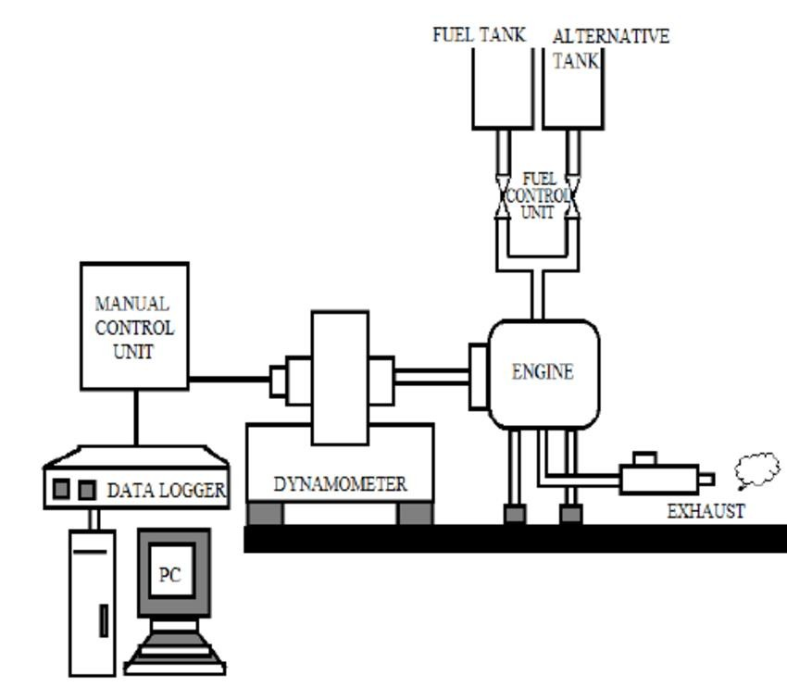**3.1.2 COMPUTERIZED SIX CYLINDER DIESEL ENGINE TEST SETUP:**

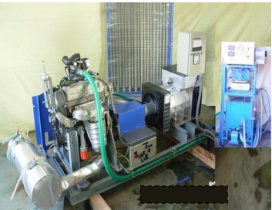

Fig

Fig (3.1.1) Diesel engine test setup Fig (3.1.2) Computerized test setup

* If any problem arises we can check and analyze the engine by using this engine test setup.
* To connect the engine in testing software.
* And further process to rectify the problems.

**3.1.3 CYLINDER HEAD:**

In an internal combustion engine, the **cylinder head** (often informally abbreviated to just **head**) sits above the cylinders on top of the cylinder block. It closes in the top of the cylinder, forming the combustion chamber.

This joint is sealed by a head gasket. In most engines, the head also provides space for the passages that feed air and fuel to the cylinder, and that allow the exhaust to escape. The head can also be a place to mount the valves, spark plugs, and fuel injectors. A **cylinder** is the central working part of a reciprocating engine or pump, the space in which a piston travels. [Multiple cylinders are commonly arranged side](https://en.wikipedia.org/wiki/Cylinder_(engine)#cite_note-hsw-1) by side in a bank, or engine block, which is typically cast from aluminum or cast iron before receiving precision machine work.

Cylinders may be sleeved (*lined* with a harder metal) A sleeveless engine may also be referred to as a "parent-bore engine".

A cylinder's displacement, or swept volume, can be calculated by multiplying its cross-sectional area (the square of half the bore by pi) by the distance the piston travels within the cylinder (the stroke). The engine displacement can be calculated

By multiplying the swept volume of one cylinder by the number of cylinders.

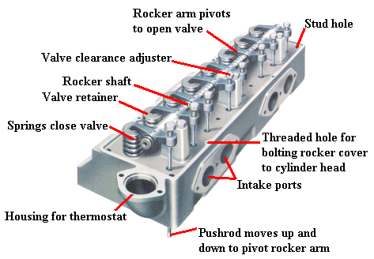 Fig 3.1.3 Cylinder Head

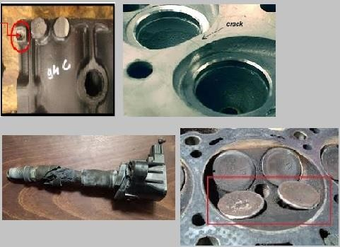 Engine Displacement = Cylinder Volume * Number of Cylinders

**3.1.4 ISSUES IN CYLINDER HEAD:**

* Blow hole
* Cylinder head cracks
* Valve bend
* Leaking head gasket side effects

**3.1.5 PARETO DIAGRAM:**

Pareto diagram is a tool that arranges items in the order of the magnitude of their contribution. It identifies a few items exerting maximum influence.

From data, quantities of defects Pareto chart are prepared.

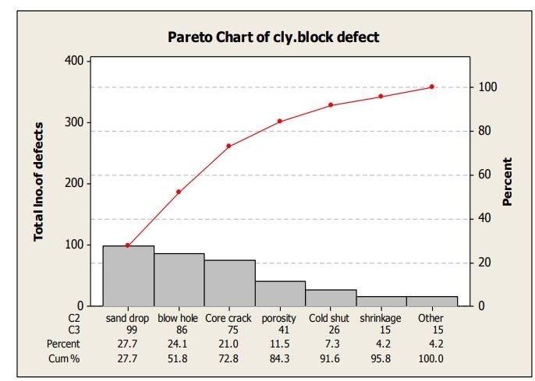

Fig (3.1.5) Pareto chart analysis

**3.1.6 GENERALPROCESSTOREMOVALOFCYLINDERHEAD**

* In general, if engine is absorbed abnormal combustion then, we proceed to check out fuel injector problems.
* In early process to remove the cylinder head it is necessary to remove all the parts which are attached to cyl.head i.e., Rocker Arm Shaft, Exhaust manifold, FuelInjectoretc...
* In this method we want morethan3man-powers to work and time consumption Is more.

**3.1.7 BASIC PROCEDURE TO REMOVAL OF CYLINDER HEAD**

* Remove the Rocker Arm Shaft from the head
* Remove Inlet & Exhaust Manifold
* And, they remove EGR (Exhaust Gas Recirculation)
* Turbocharger and TG Elbow
* Thermostat
* Common Rail Injector
* Cylinder Head Bolts
* Valve Cap, leak Pipes and Gasket

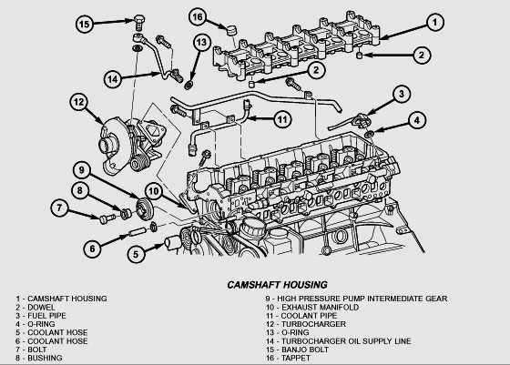

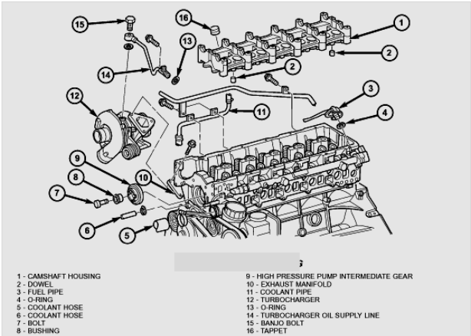

**Fig (3.1.7) Overview of Engine Parts**

**3.1.8 DRAWBACKS ON EXISTING METHOD:**

* Damage of gasket and its surrounding parts, while dismantling.
* Replacement of damaged parts.
* Time Consumption is very large.
* Need more than 3 Labors to work for this process of dismantling and assembling.
* The productivity rate is reduced, due to time lag.

**3.2 SELECTION OF SUITABLE SOLUTION:**

* As the engine comprises of many components, and due to its complex structure,” THE REPLICA OF ROCKER ARM SHAFT” is designed to remove the cylinder head together with major parts, without causing any damage to other parts.

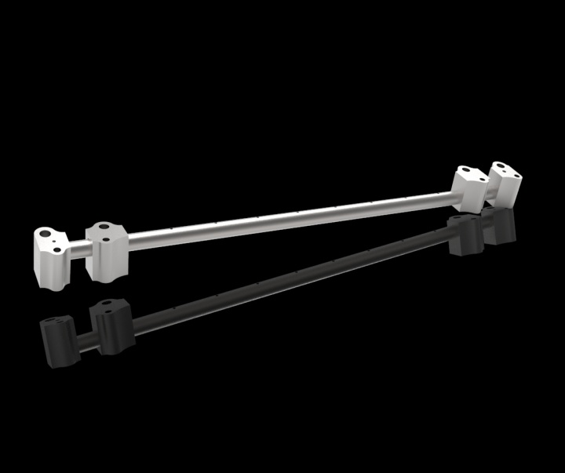

Fig (3.2) Solid works model on rocker shaft

**3.2.1 Designing the replica of rocker arm shaft:**

* In the real rocker arm shaft, rocker arms are available in the rocker arm shaft. The purpose of existing rocker arm shaft is to transmit the radial motion of the cam lobe into the linear movement to operate the poppet valves for opening and closing the flow.
* In the replica of rocker arm shaft, there a long shaft, 2 movable (adjustable) support rocker valve and 2 both side fixed rockers.
* In this replica of rocker arm shaft, rocker arms are not involved.
* The main purpose of this shaft is to hold and withstand the weight of the cylinder head.
* Two movable support rocker valve is designed for fixing the shaft to the cylinder head at right position
* Electronically operated crane hooks are used to hook up and to lift up the shaft with cylinder head assembly.

**3.2.2 Drafting the replica of rocker arm shaft**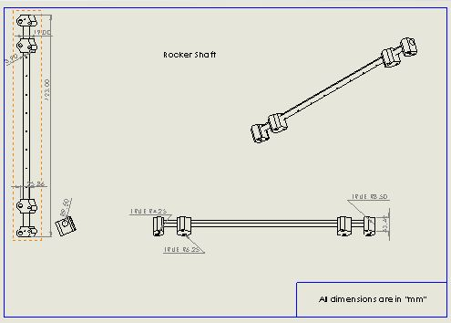

Figure (3.2.2)-rocker arm model on drafting dimensional view

After designing the replica of the rocker arm shaft, the drafting for the particular shaft is performed by using the solid works software.

**3.2.3 Design of different parts of the rocker arm shaft:**

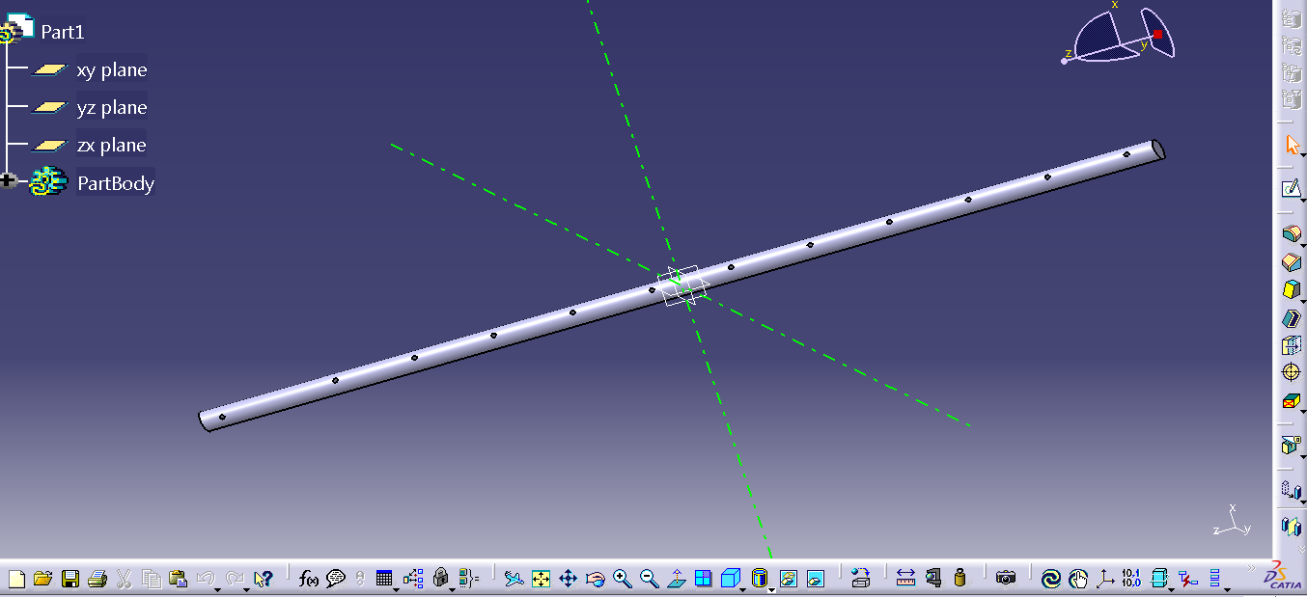

Fig (3.2.3.1) design of the shaft

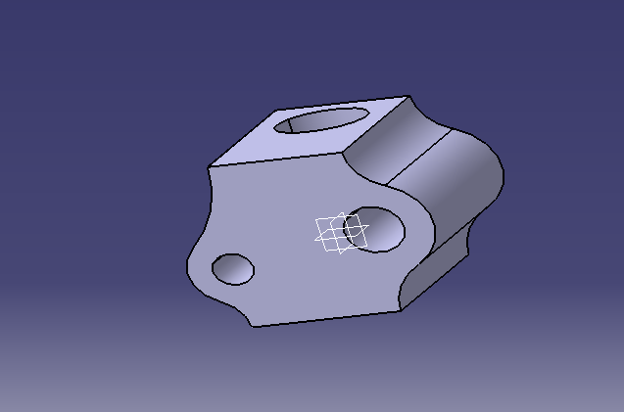

Fig (3.2.3.2) design of the support rocker valve

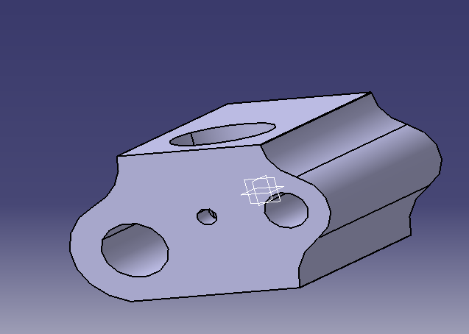

Fig (3.2.3.3) Design of the left side fixed part

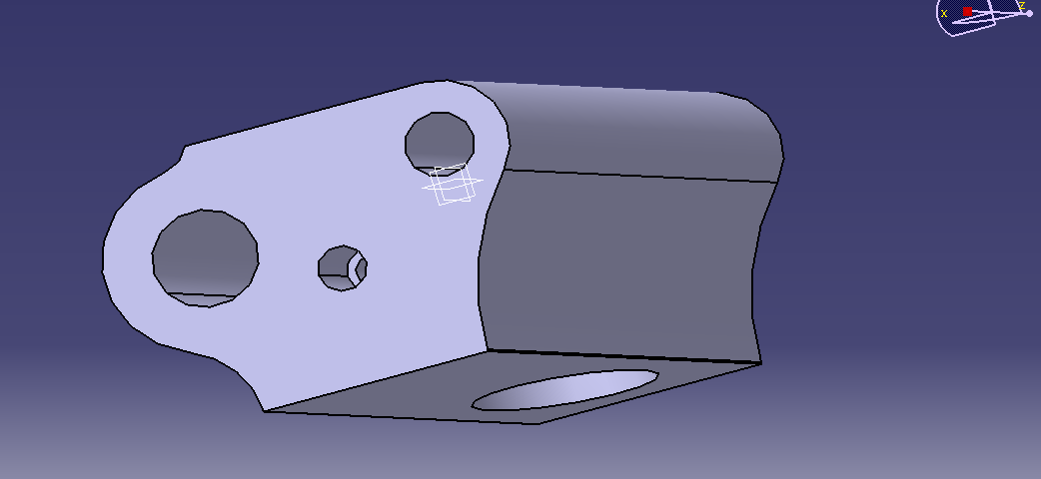

Fig (3.2.3.4) Design of the right side fixed part

**3.2.4 ASSEMBLY OF THE REPLICA OF ROCKER ARM SHAFT**

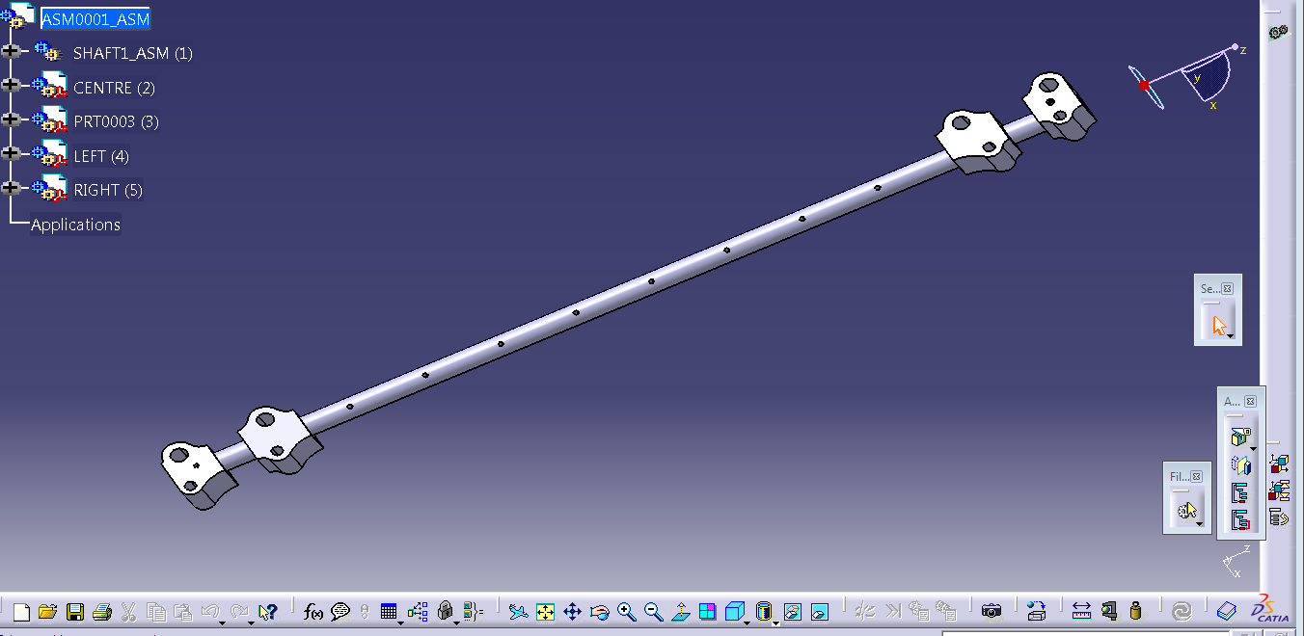

Fig (3.2.4.1) Caria model

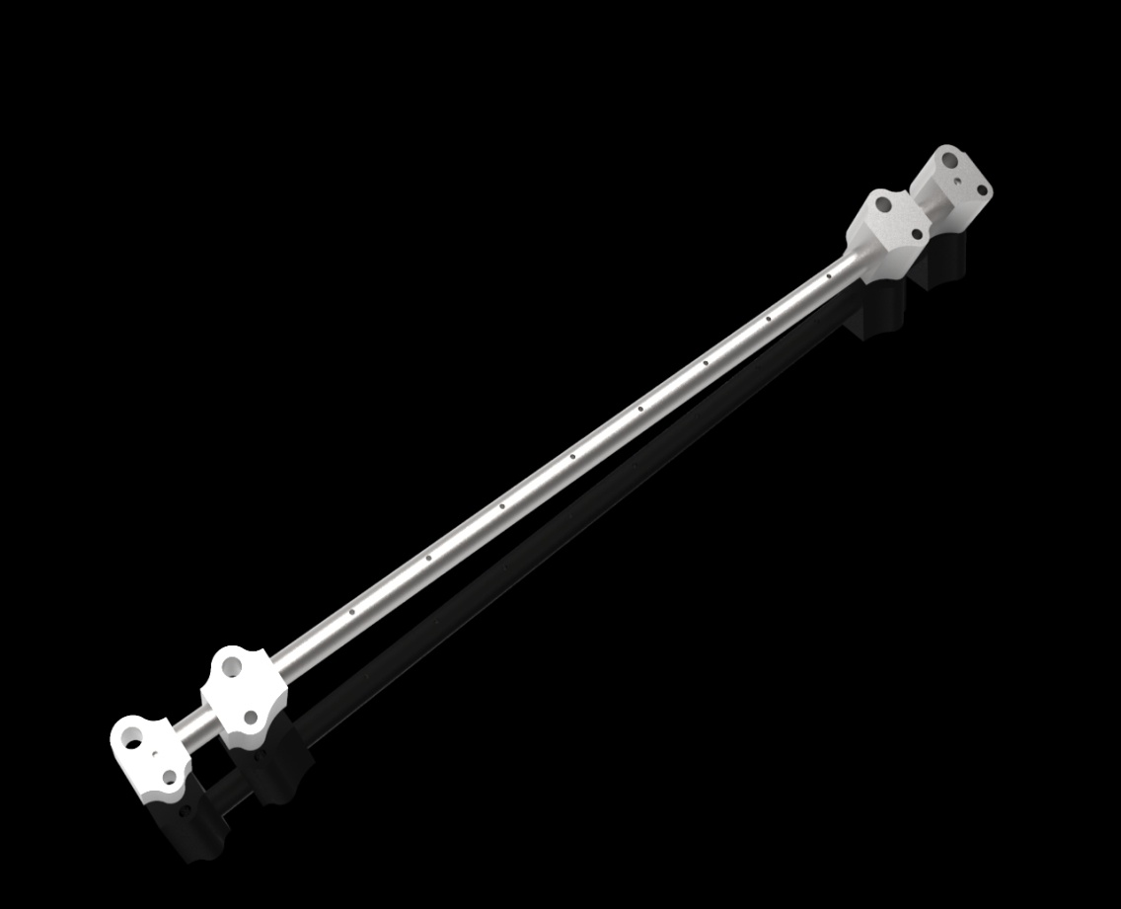

Fig (3.2.4.2) Solid works model

Fig (3.2.4.3) Solid works shaft model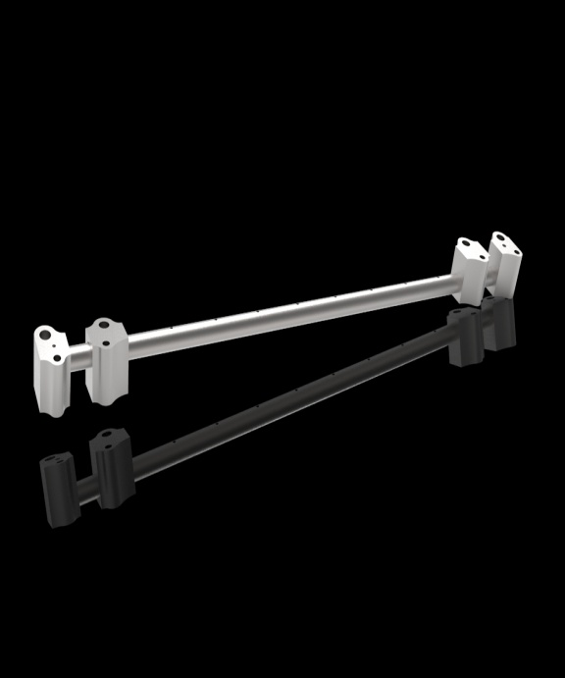 Fig (3.2.4.3) Solid works view

Fig (3.2.4.4) Solid works inclined view

**3.2.5 Manufacturing and implementation of the rocker arm shaft in cylinder head**

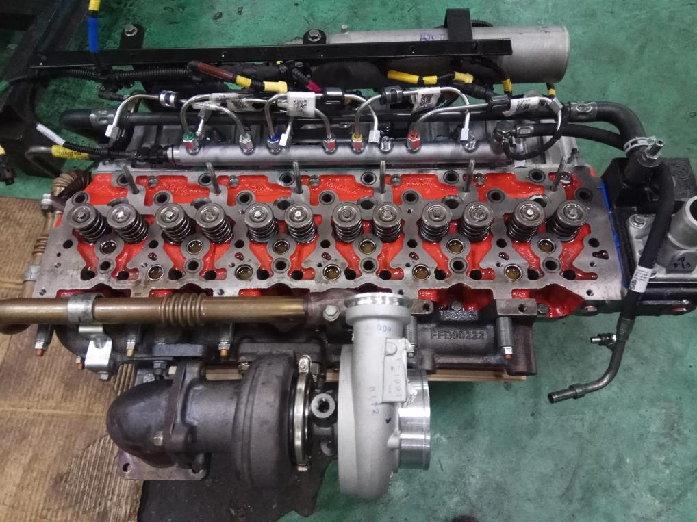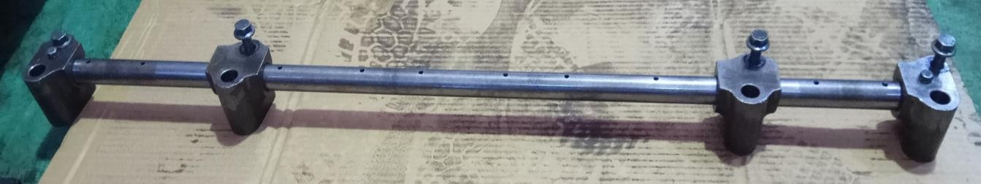

Fig (3.2.5) Replica of rocker arm shaft replacement

* After designing the rocker arm shaft, the shaft is to be manufactured and fitted into the cylinder head.
* The rocker arm shaft is to be fitted in to the holes of the cylinder head, bolted up and lifted by using the crane hook

**3.2.6 OUR PROCEDURE FOR THE REMOVAL OF THE CYLINDER HEAD BY USING ROCKER ARM SHAFT:**

• Here remove the original rocker arm shaft from the cylinder head

• Inlet and outlet manifolds, fuel pipes and common rails

• Corners cylinder bolts to be removed.

• After they placed the dummy rocker arm in existing part.

• In the crane hook’s is wear in the shaft to pull up.

• Automatically is comes out the cylinder head without remove any outer parts from the engine.

**3.2.7 Advantages over existing method:**

* Very less time consumption.
* Need for manpower is less
* No major damages of engine parts, while dismantling

**3.2.8 OUR PROCEDURE OF REMOVAL THE CYLINDER HEADS:**

* Here remove the original rocker arm shaft from the cylinder head
* Inlet and outlet manifolds to remove.
* Removed the fuel pipes and command rail.
* It’s surrounding parts to be removed.
* Conner’s cylinder bolts to be removed.
* After they placed the dummy rocker arm in existing part.
* In the crane hook’s is wear in the shaft to pull up.
* Automatically it comes out the cylinder head without remove any outer parts from the engine.

**3.2.9 REMOVAL BY DUMMY SHAFT:**

* Existed rocker arm is removed. In the cylinder head
* And they required to be removed with the help of electric spanner.
* Dummy Shaft is placed to the existed of rocker arm
* Tightened the bolts at the brackets in shaft
* With use of EOT to pull up dummy shaft slowly.
* It can be easily to replacement of damaged parts and efficiently we can repair the piston damaged
* In normal method compare this is very efficient our industry and economical wise is good.

**3.3.0 Below Parts to be Removed our Technique:**

* Rocker arm shaft
* Fuel Injector Piper
* Fuel Injector
* Cylinder Head Bolts
* Valve cap
* Inlet & Exhaust Manifold

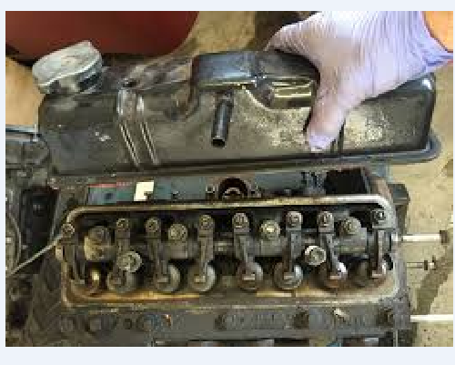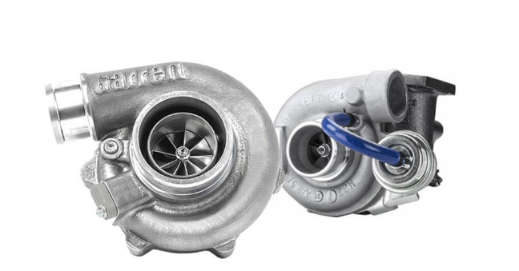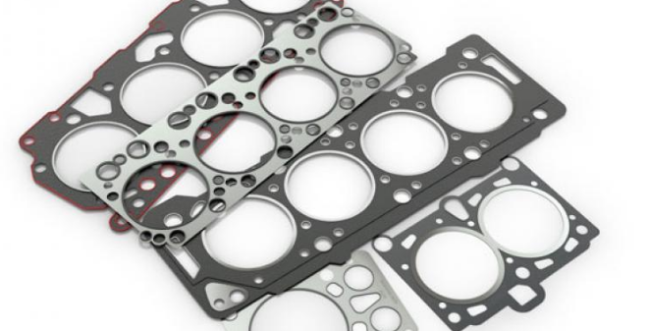

Fig (3.3.0) of rocker arm shaft fig (3.3.1) turbo charger fig (3.3.2) of gasket

**CHAPTER 4**

**WORKING AND OPERATION**

**4.1 Working**

* Engine varies according to the size, variety, type, applications, and other specialized purposes. Engine’s capacity also varies depending upon the application such as light duty vehicles and heavy duty vehicles. For light duty vehicles, 4 cylinder engines are used, and for heavy duty vehicles such as trucks, Lorries etc...6 cylinder engines such as H series engines are used (H stands for “Hino”which is used in Ashok Leyland).
* In an internal combustion engine, the cylinder head (often informally abbreviated to just head) sits above the cylinders on top of the cylinder block
* . Due to these complex structure that involving many parts, in the engine, identification of error in the engine is difficult, if the engine is not functioning.
* .After the identification of the error in particular part i.e. fuel injectors in the cylinder head, and then only the rework or the rectification work of cylinder head is performed.
* In general, same as the assembling process, disassembling process is very difficult and time consuming one. Due to its complex structure, each and every part is to be removed carefully for the reworking purpose.
* Engin is absorbed abnormal combustion then, we proceed to check out the fuel injector problems. In early process to remove the cylinder head, following things to done.
* The following parts to be removed are Rocker arm shaft, Exhaust manifold, Fuel Injector, Remove the rocker arm shaft from the head, Remove Inlet& Exhaust manifold, And, then remove EGR(Exhaust Gas Recirculation), Turbocharger and TG Elbow, Thermostat, Common Rail Injector, Cylinder Head Bolts, Valve Cap, Leak pipes and Gaskets.
* Diassembling of parts is time consuming sometimes disassembling cause’s damage to the parts. For this, we are designing the special shaft which looks similar to the rocker arm shaft i.e. “REPLICA OF ROCKER ARM SHAFT ”
* Elcentrically operating hook is used to hold and lift the whole cylinder head setup with the replica of rocker arm shaft, from the top of the engine. Then, we can easily rework with the cylinder head, which was lifted and hung over the engine through crank hook**.**

**4.2 Sequence of operation**

**Step1:** The Rocker Arm Shaft from the Cylinder head is to be removed first.



Figure 4.2.1-Step 1

**Step2:** After the removal of rocker arm shaft, thenemote Inlet & Exhaust Manifold...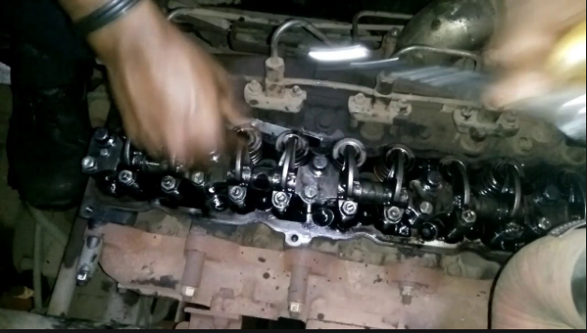

Figure 4.2.2- Step 2

**Step 3:-**Then EGR (Exhaust Gas Recirculation) is removed.

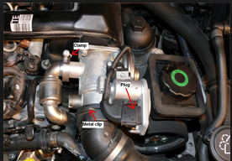

Figure 4.2.3-Step 3

**Step4:** Turbocharger and TG Elbow is removed.



Figure 4.2.4-Step 4

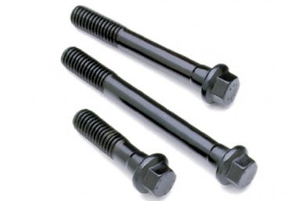

**Step 5:** Thermostat, Common Rail Injector, Cylinder head bolts, valve caps, leak pipes and gaskets are to be removed.

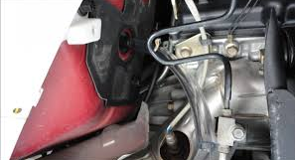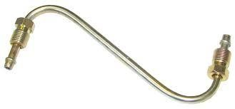

Fig (4.2.5) Thermostat fig (4.2.6) Leak pipe

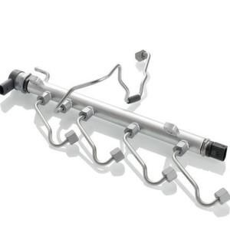



Fig (4.2.7) Common Rail Fig (4.2.8) Gaskets

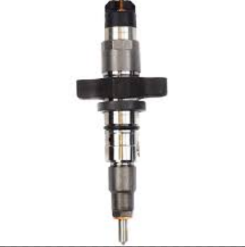

Fig (4.2.9) Fuel injector

**Step 6:** Then the cylinder head is removed from the engine**.**



Figure 4.3 - Step 6

**CHAPTER 5**

**5.1 Time calculation**

**5.1.1 DISMANTLING:**

**Step 1:**

Inlet and Exhaust manifold

Rocker Arm Shaft = 35 mines

EGR, Thermostat, Common Rail & injector

**Step 2:**

Turbocharger-Elbow

Cylinder Head bolts, Manifold Gaskets = 30mins

Valve cap pins, Lube oil Pipes

**Step 3:**

Banjo Bolt, Tappet

Oil Supply Line & Liners = 15 mines

Other Exterior Parts

**In this method for dismantling the cylinder head, time consumption is 1 Hr.20 min**

**5.1.2 ASSEMBLE:**

After finished they dismantle the parts to check & analyze the damages at in piston.For re-assemble they consume same time. In this method we found the drawbacks, which they are more time consumption and material damaging for the removing process. So, we use the new technique in the removal of cylinder head to avoid unwanted things.

**5.2 TABULATION: (Calculation of time)**

**REMOVING THE CYLINDER HEAD OLD TECHNIQUE TO OUR TECHNIQUE:**

|  |  |  |  |  |
| --- | --- | --- | --- | --- |
| **S.NO** | **TECHNIQUE USED** | **DISMANTLING TIME** | **ASSEMBLING TIME** | **TOTAL TIME** |
| 1 | Normal Method | 1 Hr : 20 mins | 1 Hr | 2 Hr: 20 mins |
| 2 | New Method  (Our Technique) | 30 mins | 25 mins | 55 mins |

**TOTAL TIME SAVED BY OVERCOMING THE OLD TECHNIQUE :**

Total time saved = (Total time taken by normal method) –

(Total time taken by new method)

= ( 2 Hr : 20 mins) – ( 55 mins)

Total time saved = 1 Hr : 25 mins

By comparing those two methods, new method is considered as the most promising method. In existing method, the total time used is **2 Hr : 20 mins**. And in the new method , the total time used is **55 mins.**  The total time saved by new method is **1 Hr : 25 mins.**

**5.3 PIE- CHART EXPLAINED**

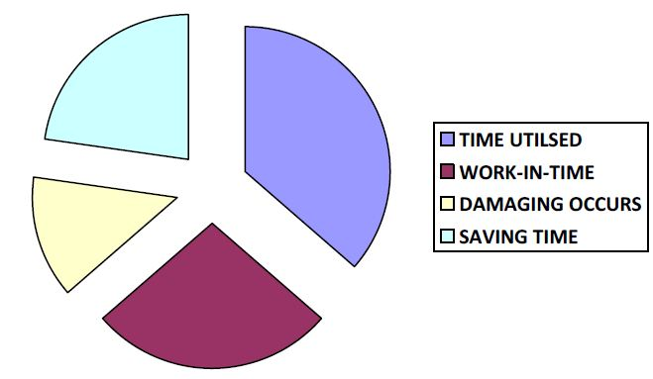

**(a) NORMAL METHOD**

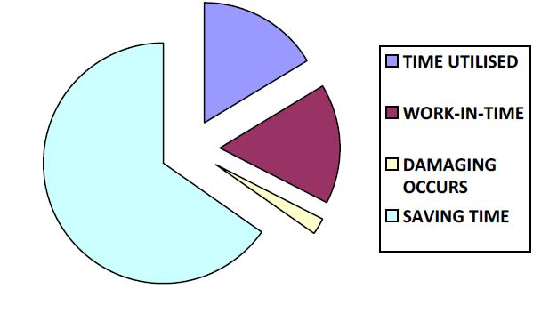**(b) NEW METHOD**

**CHAPTER 6**

**ADVANTAGES AND DISADVANTAGES**

**6.1Advantages**

* Performance is good.
* Emission of pollutants such as HC, Knox, etc, .are reduced.
* Adaptability of this engine is good.
* Greater fuel economy.
* Highest load carrying capacity.
* Time consumption is reduced.
* Damage to other engine parts is reduced.
* No need of skilled labours.
* Quick removal of cylinder head
* Quick fixing of engine parts.

**6.2 Disadvantages**

* High horse power is not developed by H-series engines.
* This engine is not subjected for heavy working vehicles such as military vehicles, submarines etc,
* Frequent maintenance is required.

**CHAPTER 7**

**CONCLUSION**

* In our technique the dismantling time of cylinder head may be reduced in greater extent compared to the traditional technique.
* By overcoming the time consumption of dismantling of cylinder head, rate of production may be increased. Here, we can also avoid the damages of the surrounding parts of the cylinder heads.
* Replication of rocker arm shaft may be used to remove the cylinder head in effective manner without removing the major parts such as inlet and exhaust manifold, EGR, etc…
* Here we have designed the rocker arm shaft and given for manufacturing, after receiving the product, we can able to calculate the time consumption by using this method.
* By using this replica of rocker arm shaft, we can easily remove the cylinder head for the reworking purposes.
* We can improve the production rate by reducing the time consumption for rectifying the defective engines.
* Thus we are concluding that, we can reduce the time consumption in reworking, and we can avoid damage to other parts of the engine and we can improve the productivity of the engine by using this replica of rocker arm shaft.

**CHAPTER 8**

**REFERENCE**

2.1 G.A.Nassef, A.Elkhabit, .et al (2016) ‘Analysis of a Failed Rocker Arm Shaft of Passenger Car Engines’, Science Direct, 2016

2.2 Uday.A, Chirag.K (2015) ‘Productivity Improvement in Engine Assembly Line at GM India Pvt Ltd’, 2015

2.3 Mr.Syed Mujahid, Mr.siraj sheikh (2013) ‘Rocker Arm’, International journal of Innovative Research in Science, engineering and Technology, 2013

2.4 Mr.Sachin Bache, Mr.P.Swaminadhan, .et al (2018) ‘Design and Static Structural Analysis of Rocker Arm in IC Engine’, International Journal of Engineering Science and Research Technology, 2018

2.5 Amole B. Son wane, Day A. Debase (2017), ‘Continuous Improvement of Automobile Engine Assembly Line’, International Journal of Innovation in Engineering, Research and Technology, 2017

2.6 Mr. Sager Gide, Mr.Jagrit Shrives, Mr.R.R.Kharde (2015), ‘Review on Critical Speed Improvement in Single Cylinder Engine Valve Train’, International Journal of Innovation in Engineering Research and Technology, 2015

2.7 Mr.Syed Muja hid Husain, Mr.Siraj Sheikh (2013), ‘Design and Analysis of Rocker Arm’, International Journal of Mechanical engineering and Robotics Research, 2013

2.8 Dr.Goteti Catania, Mr. Eddy Srinivasalu ( ), ‘Design Optimization of IC Engine Rocker Arm using Taguchi based Design of Equipments’,

2.9 Dvina Kumar, B.Sudeendra Srinivas (2017), ‘Design and fabrication of Rocker Arm’, International Journal of Core Engineering and Management, 2017

2.10 Mr. Agar Judah, Mr.P.J.Patil, et al, (2018), ‘Experimental and Finite Element Analysis of Rocker Arm for Bending Failure’, International Journal of Advanced Engineering and Research Development, 2018

2.11 Mr.Mahdi Chef Isa, Mr.Irwan Mohr nor, (2014), ‘Failure Analysis of a Diesel Engine Rocker Arm’, Research Gate, 2014

2.12 Mr.Nakul Ban sod, Mr. Harbinger Singh Neigh, (2015), ‘Tappet Noise Reduction in Motor Cycle Engine, International Journal of Engineering Development and Research, 2015

2.13 Mr.Shyam H. Bambharoliya, Mr.Hemant R. Thacker, (2015), ‘Reducing Reduction Rate in Small Scale Machining Unit using Seven Quality Control Tools’, International Journal of Engineering Development and Research, 2015