**Tutorial8  
  
  
*Exercise 6***

**

Step 6:Practice

1. Testing Login:

• Test the login system with both correct and incorrect credentials.

-incorrect password.

• Verify that users are redirected to the welcome page upon successful login.

2. Cookie Inspection:

• Use browser developer tools to inspect cookies. Verify that a cookie named user_id is set after successful login.

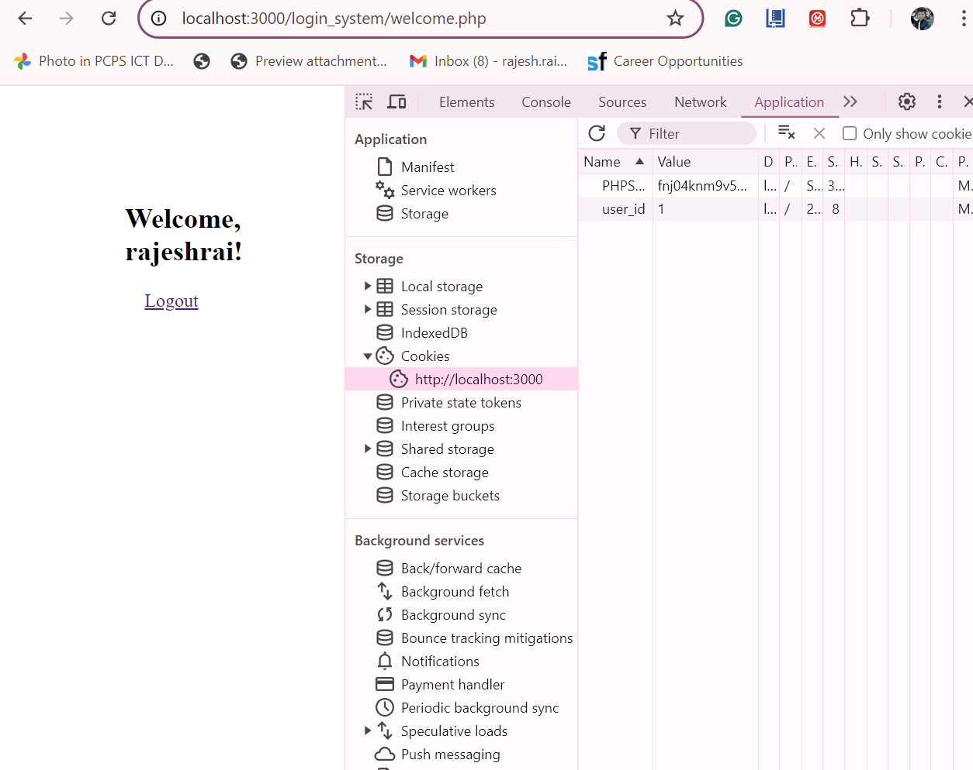

• Test the login page by disabling cookies in your browser and check if the login still works.

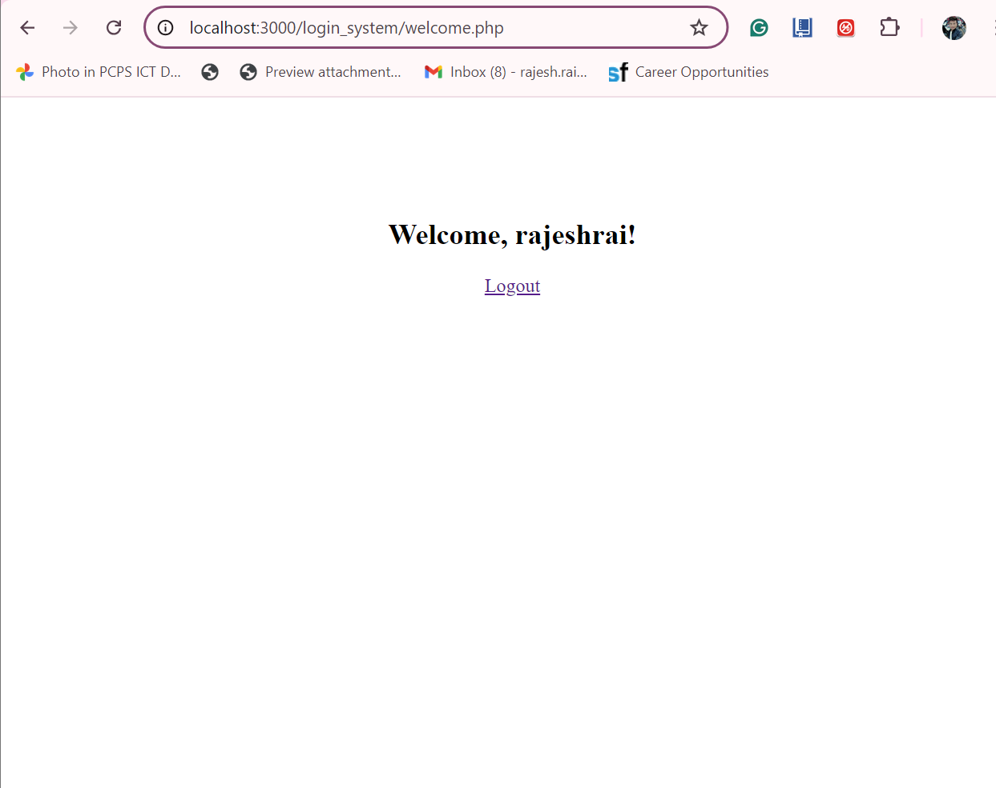

3. Logout Functionality:

• Test the logout functionality by clicking the "Logout" link on the welcome page. • Verify that both the session and cookie are destroyed, and the user is redirected to the login page. 4. Session Timeout:

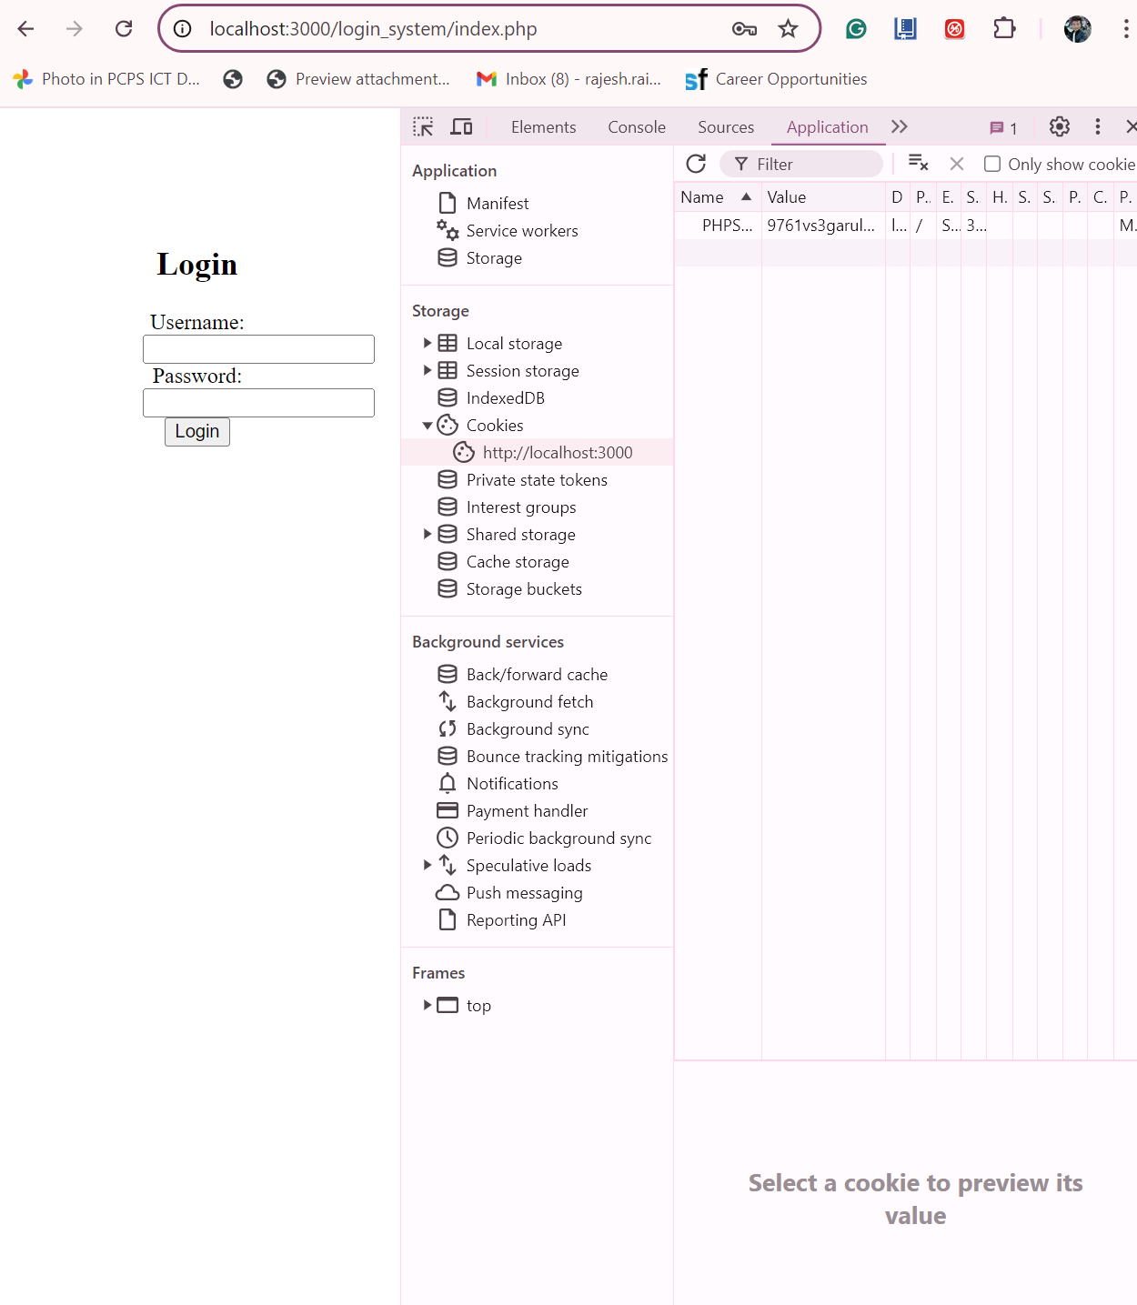

• Experiment with session timeout settings. Change the session timeout duration in the PHP configuration or use session_set_cookie_params to set a custom timeout.

