Rajesh Reddy Chilakala
Class Activity
8/8/2026
192325105
CSA-5103 Cryptography and Network Security

1.Implement the DES algorithm using a suitable
programming language or cryptographic library. Encrypt a given plaintext using
a secret key and decrypt the resulting ciphertext. Verify that the original
plaintext is successfully recovered.

Aim
To implement the Data Encryption Standard (DES) algorithm using Python, encrypt a given plaintext using a secret key, decrypt the resulting ciphertext, and verify that the original plaintext is recovered.

Procedure

1. Install the required Python cryptographic library:

pip install pycryptodome

2. Import the DES algorithm from `Crypto.Cipher`.
3. Select an 8-byte secret key.
4. Convert the plaintext into bytes and pad it to a multiple of the DES block size (8 bytes).
5. Create a DES cipher using CBC mode and an initialization vector (IV).
6. Encrypt the padded plaintext.
7. Decrypt the ciphertext using the same key and IV.
8. Remove the padding from the decrypted message.
9. Compare the recovered plaintext with the original plaintext.
10. Measure the encryption and decryption time.

Code
from Crypto.Cipher import DES
from Crypto.Random import get_random_bytes
from Crypto.Util.Padding import pad, unpad
import time

# 8-byte DES key
key = b"8bytekey"

# Plaintext
plaintext = b"Hello DES Encryption"

# Generate 8-byte IV
iv = get_random_bytes(8)

# ---------------- ENCRYPTION ----------------
cipher = DES.new(key, DES.MODE_CBC, iv)

padded_text = pad(plaintext, DES.block_size)

start = time.perf_counter()
ciphertext = cipher.encrypt(padded_text)
encryption_time = time.perf_counter() - start

# ---------------- DECRYPTION ----------------
decipher = DES.new(key, DES.MODE_CBC, iv)

start = time.perf_counter()
decrypted_padded = decipher.decrypt(ciphertext)
decryption_time = time.perf_counter() - start

decrypted_text = unpad(decrypted_padded, DES.block_size)

# ---------------- OUTPUT ----------------
print("----- DES -----")
print("Original Plaintext :", plaintext.decode())
print("Key :", key.decode())
print("Ciphertext (hex) :", ciphertext.hex())
print("Decrypted Text :", decrypted_text.decode())
print("Encryption Time :", encryption_time, "seconds")
print("Decryption Time :", decryption_time, "seconds")

if plaintext == decrypted_text:
print("Verification : SUCCESS")
else:
print("Verification : FAILED")

Output:
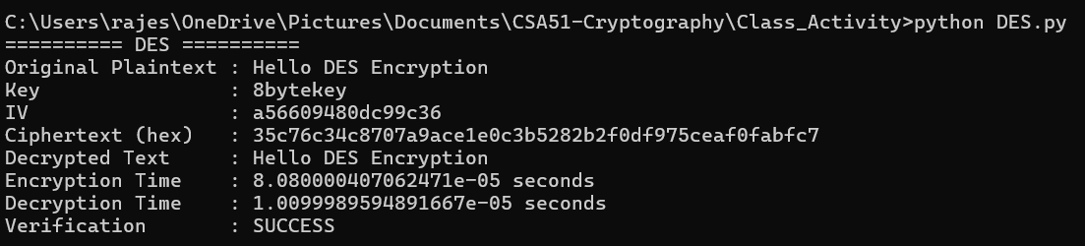

Result
The plaintext was successfully encrypted using DES and decrypted using the same secret key. The decrypted text was identical to the original plaintext.

2. Implement the 3-DES algorithm to encrypt and
decrypt a given text message. Compare its encryption and decryption time with
DES and analyze the security advantages of 3-DES.

Aim
To implement the Triple DES (3-DES/3DES) algorithm for encryption and decryption of a text message, compare its encryption and decryption time with DES, and analyze the security advantages of 3-DES.

Procedure
1. Install the PyCryptodome library.
2. Import the `DES3` cipher.
3. Select a valid 3-DES key.
4. Pad the plaintext to a multiple of the DES block size.
5. Generate an initialization vector (IV).
6. Encrypt the plaintext using 3-DES in CBC mode.
7. Decrypt the ciphertext using the same key and IV.
8. Remove the padding from the decrypted text.
9. Verify that the decrypted text matches the original plaintext.
10. Measure and compare the encryption and decryption times of DES and 3-DES.
11. Analyze the security improvement provided by 3-DES.

Code
from Crypto.Cipher import DES3, DES
from Crypto.Random import get_random_bytes
from Crypto.Util.Padding import pad, unpad
import time

# ---------------- COMMON DATA ----------------
plaintext = b"Hello 3DES Encryption"

# ================= DES =================
des_key = b"8bytekey"
des_iv = get_random_bytes(8)

des_cipher = DES.new(des_key, DES.MODE_CBC, des_iv)
padded_text = pad(plaintext, DES.block_size)

start = time.perf_counter()
des_ciphertext = des_cipher.encrypt(padded_text)
des_encryption_time = time.perf_counter() - start

des_decipher = DES.new(des_key, DES.MODE_CBC, des_iv)

start = time.perf_counter()
des_decrypted = des_decipher.decrypt(des_ciphertext)
des_decryption_time = time.perf_counter() - start

des_plaintext = unpad(des_decrypted, DES.block_size)

# ================= 3-DES =================
# 24-byte key for 3-key Triple DES
tdes_key = b"12345678ABCDEFGH87654321"
tdes_iv = get_random_bytes(8)

tdes_cipher = DES3.new(tdes_key, DES3.MODE_CBC, tdes_iv)
padded_text = pad(plaintext, DES3.block_size)

start = time.perf_counter()
tdes_ciphertext = tdes_cipher.encrypt(padded_text)
tdes_encryption_time = time.perf_counter() - start

tdes_decipher = DES3.new(tdes_key, DES3.MODE_CBC, tdes_iv)

start = time.perf_counter()
tdes_decrypted = tdes_decipher.decrypt(tdes_ciphertext)
tdes_decryption_time = time.perf_counter() - start

tdes_plaintext = unpad(tdes_decrypted, DES3.block_size)

# ================= RESULTS =================
print("========== DES ==========")
print("Original Text :", plaintext.decode())
print("Ciphertext (hex) :", des_ciphertext.hex())
print("Decrypted Text :", des_plaintext.decode())
print("Encryption Time :", des_encryption_time, "seconds")
print("Decryption Time :", des_decryption_time, "seconds")

if plaintext == des_plaintext:
print("Verification : SUCCESS")
else:
print("Verification : FAILED")

print("\n======== 3-DES =========")
print("Original Text :", plaintext.decode())
print("Ciphertext (hex) :", tdes_ciphertext.hex())
print("Decrypted Text :", tdes_plaintext.decode())
print("Encryption Time :", tdes_encryption_time, "seconds")
print("Decryption Time :", tdes_decryption_time, "seconds")

if plaintext == tdes_plaintext:
print("Verification : SUCCESS")
else:
print("Verification : FAILED")

# ================= COMPARISON =================
print("\n====== TIME COMPARISON ======")
print("DES Encryption :", des_encryption_time)
print("3-DES Encryption :", tdes_encryption_time)

print("DES Decryption :", des_decryption_time)
print("3-DES Decryption :", tdes_decryption_time)

if tdes_encryption_time > des_encryption_time:
print("3-DES encryption is slower than DES.")

if tdes_decryption_time > des_decryption_time:
print("3-DES decryption is slower than DES.")

OUTPUT:
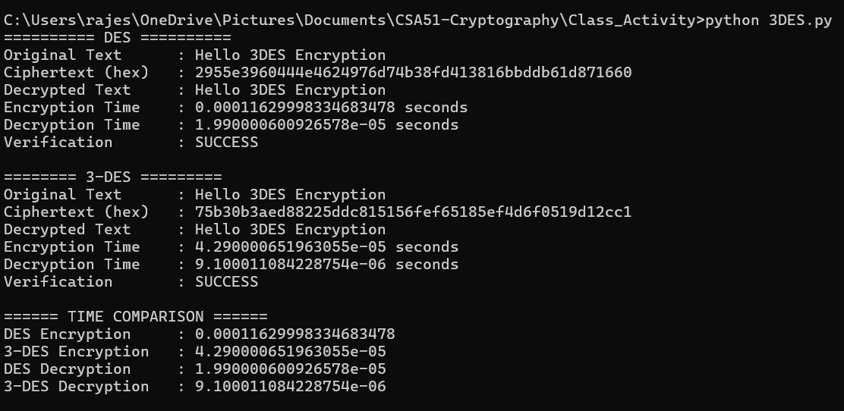

Result
The given text message was successfully encrypted and decrypted using both DES and 3-DES.
ShoreNote on Both Algorithms:
The original plaintext was recovered correctly in both cases.
The execution time of 3-DES is generally greater than DES because Triple DES performs the DES operation three times (Encrypt–Decrypt–Encrypt in the standard EDE construction).

Comparison
Feature | DES | 3-DES
Block size | 64 bits | 64 bits
Keying | 56-bit effective key | Up to 168-bit nominal key
DES operations | 1 | 3
Encryption speed | Faster | Slower
Decryption speed | Faster | Slower
Security | Weak by modern standards | Stronger than DES, but legacy
Modern recommendation | Not recommended | Not recommended for new systems

Security Analysis
- DES uses an effective 56-bit key, which is vulnerable to modern brute-force attacks.
- 3-DES applies the DES operation three times, significantly increasing the resistance to brute-force attacks compared with single DES.
- 3-DES can use three independent keys, giving a nominal key length of 168 bits, although its effective security is considerably lower than 168 bits because of cryptanalytic attacks.
- The major disadvantage of 3-DES is its slow performance, since three DES operations are required for each block.
- Both DES and 3-DES have a 64-bit block size, which is small by modern standards.
- For new applications, modern algorithms such as AES should generally be preferred over both DES and 3-DES.

Conclusion
DES and 3-DES were successfully implemented using Python. The encrypted ciphertext was decrypted successfully and the original plaintext was recovered. The timing comparison shows that 3-DES takes more time than DES because it performs three DES transformations. 3-DES provides substantially better security than DES, but both algorithms are considered legacy cryptographic standards and should not normally be selected for new applications.

