
Class Activity-7-7-2026

ITA1408 –ETHICAL HACKING

Submitted by
RAJESH REDDY CHILAKALA
192325105

Submitted to
Dr. PARTHIBAN S

SIMATS ENGINEERING
Saveetha Institute of Medical and Technical Sciences
Chennai-602105
August7 , 2026

Question:
A Symbian smartphone at IP 192.168.1.100 can be enumerated using Nmap to reveal host availability, open ports, service versions, and OS fingerprints. The results typically expose services like HTTP, SSH, or proprietary Symbian protocols, each carrying distinct risks such as weak authentication, outdated libraries, or unpatched vulnerabilities. Securing such a device requires strict patching, service minimization, and network segmentation.

Ans:

Enumeration Steps (Using Nmap)
1.Host Discovery
nmap -sn 192.168.1.100
Confirms if the Symbian device is live on the network.

2.Port Scanning
nmap -sS 192.168.1.100
Identifies open TCP ports (e.g., 22, 80, 443, 8080).

3.Service & Version Detection
nmap -sV 192.168.1.100
Reveals running services (e.g., Apache HTTPD, OpenSSH, proprietary Symbian services).

4.Aggressive Scan with OS Detection
nmap -A 192.168.1.100
Attempts OS fingerprinting and script-based enumeration.

Screenshorts of output: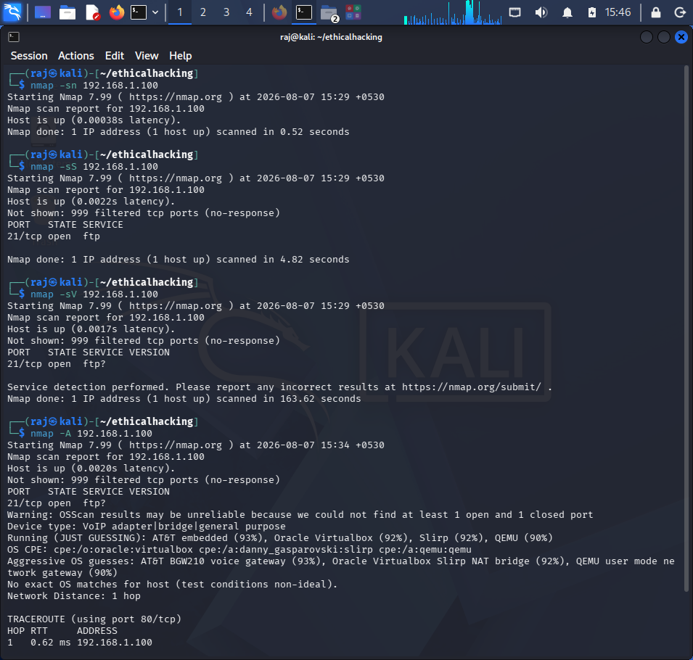
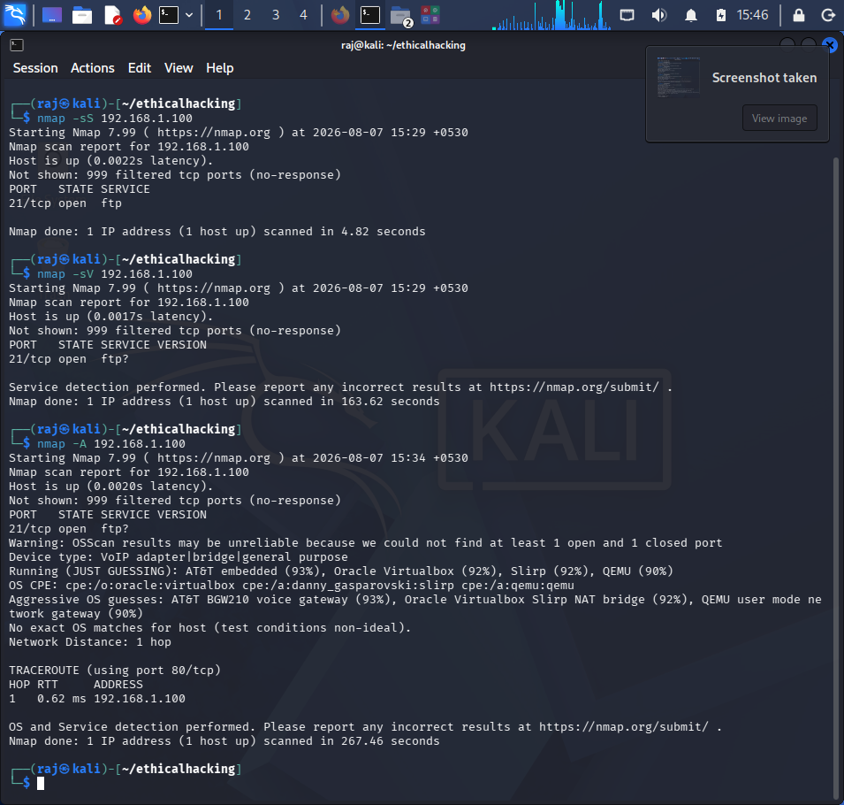

⚠️ Security Risks
- Outdated Services: Symbian OS is legacy, often running unpatched versions of Apache, OpenSSH, or SSL libraries.
- Weak Encryption: Older TLS/SSL stacks may allow downgrade or MITM attacks.
- Exposed Services: HTTP/SSH accessible externally increases attack surface.
- OS Fingerprinting: Attackers can tailor exploits once Symbian OS is identified.

✅ Recommended Security Improvements
- Patch & Update: Apply latest available Symbian firmware and service updates.
- Service Minimization: Disable unused ports (e.g., HTTP if not required).
- Strong Authentication: Enforce key-based SSH, disable password logins.
- TLS Hardening: Disable SSLv3/TLS1.0, enforce TLS1.2+.
- Network Segmentation: Isolate legacy Symbian devices from critical infrastructure.
- Monitoring & IDS: Deploy intrusion detection to flag unusual traffic.
- User Awareness: Train users to avoid installing unverified Symbian apps, which may open hidden services.

