
CO_1-AT_2-ASSIGNMENT

ITA1408 –ETHICAL HACKING

Submitted by
RAJESH REDDY CHILAKALA
192325105

Submitted to
Dr. PARTHIBAN S

SIMATS ENGINEERING
Saveetha Institute of Medical and Technical Sciences
Chennai-602105

August 7, 2026

1. OSINT Email Enumeration Assessment using theHarvester

Target Domain: tesla.com
Aim
To perform OSINTbased email enumeration using theHarvester and identify publicly available email addresses, subdomains, hosts, and IP addresses associated with the target domain.

Tools Required
Kali Linux
theHarvester
Internet Connection

Command Executed
theHarvester d tesla.com b all
Output:
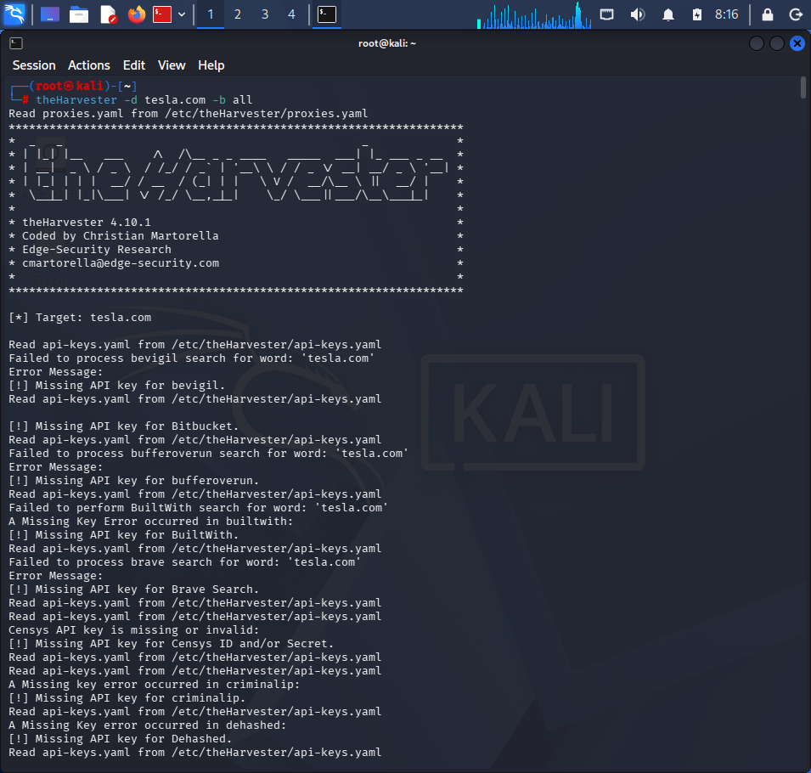
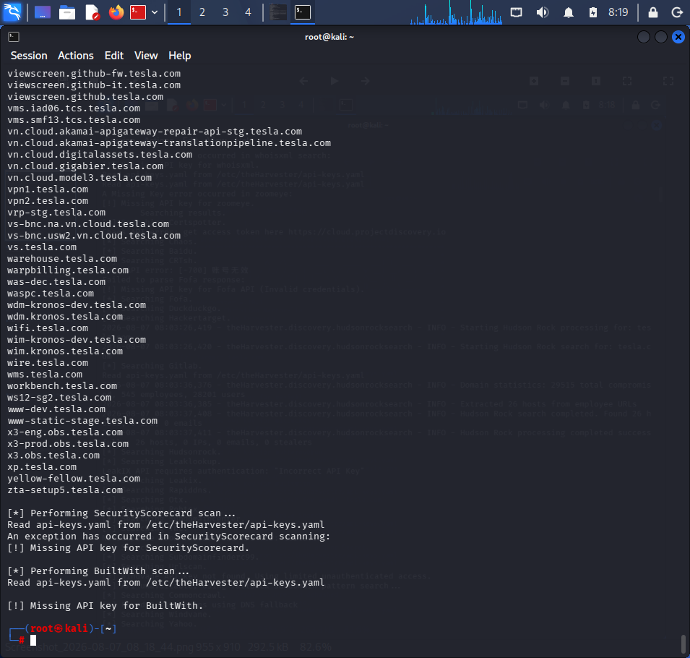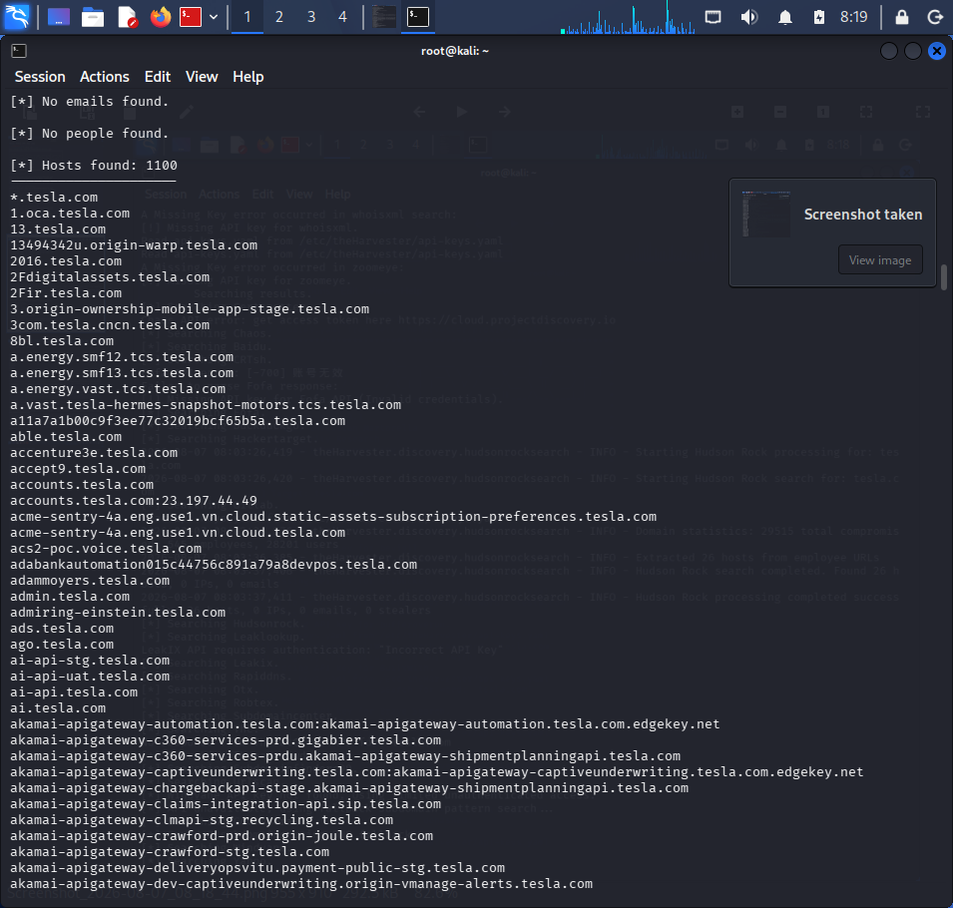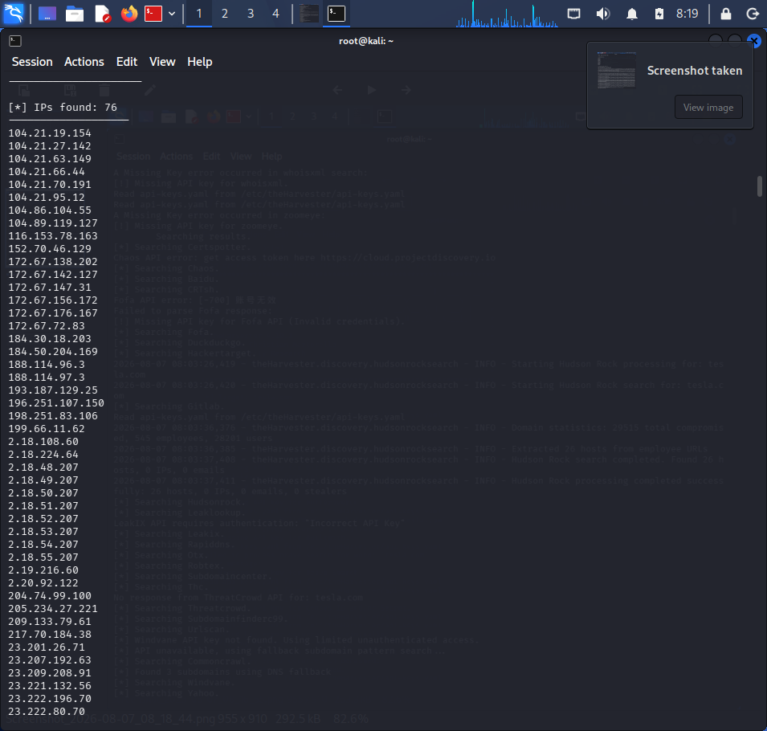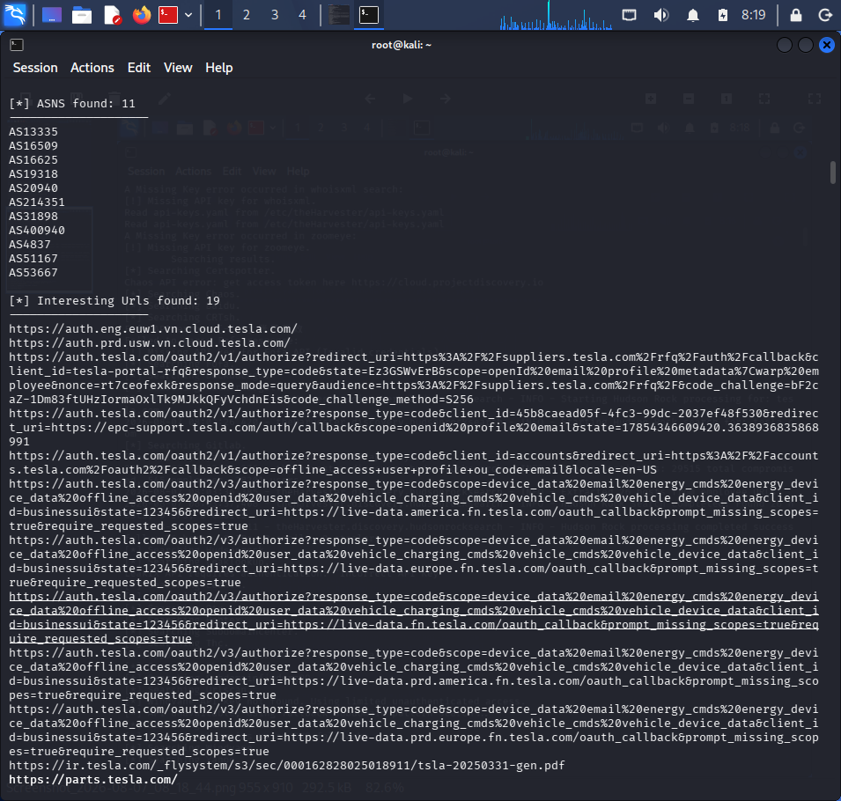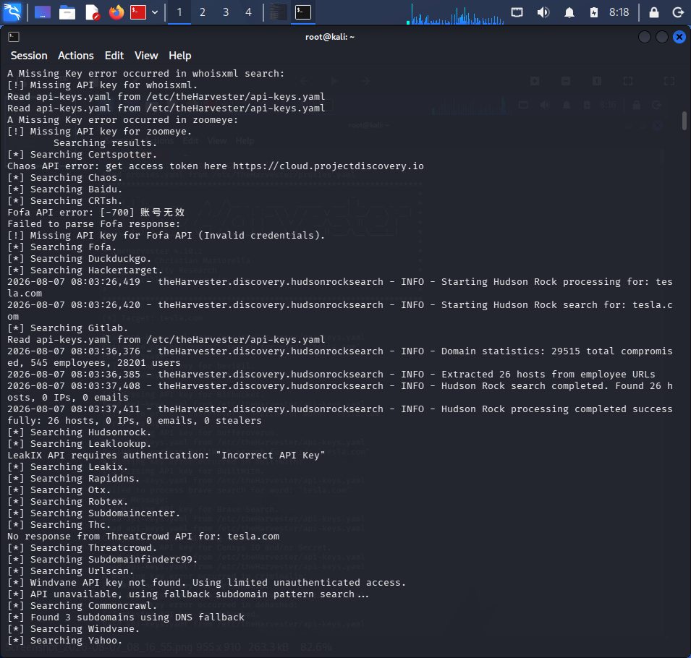

Risk Analysis
An attacker can use publicly available information during the reconnaissance phase.
Possible uses include:
1. Spear Phishing
Knowing employee email formats allows attackers to craft convincing phishing emails targeting specific departments.

Example:
Dear HR Team,
Please review the attached updated employee policy.
Regards,
Management
2. Credential Harvesting

Attackers may create fake Microsoft 365 or VPN login pages and send them to employees discovered through OSINT.

3. Impersonation

If email naming conventions are known, attackers can spoof addresses such as:
security@tesla.com
support@tesla.com
to trick users.

4. Target Identification
Subdomains reveal internal services like:
vpn.tesla.com
mail.tesla.com
which may become targets for password guessing or phishing.

5. Social Engineering

HR and Finance employees are commonly targeted because they handle confidential information.
Countermeasures

1. Avoid exposing employee email addresses publicly.

2. Implement SPF, DKIM, and DMARC.

3. Use security awareness training.

4. Enable MultiFactor Authentication (MFA).

5. Monitor domain exposure using OSINT monitoring tools.

6. Use generic contact forms instead of publishing employee emails.

7. Disable unnecessary subdomain exposure.

Conclusion
theHarvester successfully collected publicly available information. Although OSINT does not exploit systems directly, the gathered information can significantly aid attackers in planning phishing and impersonation attacks. Organizations should minimize publicly exposed information and strengthen email security controls.

2. Phishing Awareness Simulation using GoPhish

Aim
To conduct a phishing awareness simulation using GoPhish and evaluate user awareness.

Tools

Kali Linux
GoPhish
Dummy employee accounts

Starting GoPhish
cd gophish
./gophish
Open Browser
https://127.0.0.1:3333
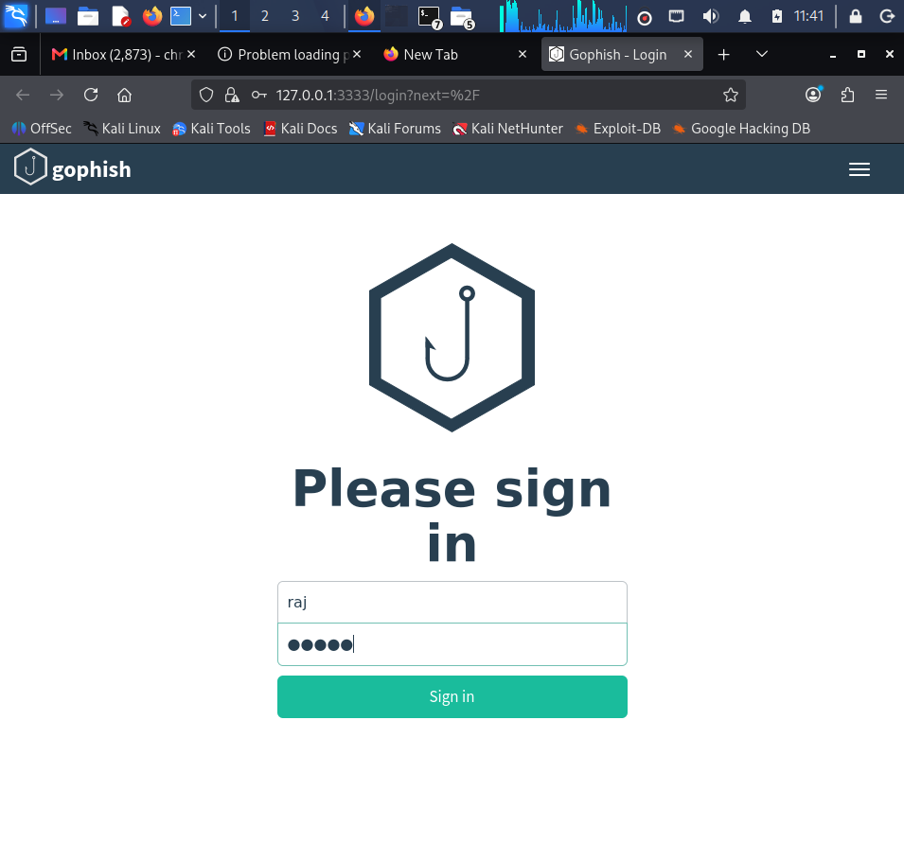

shows a subset of users entered credentials on the simulated page.

Recommendations

1. Conduct regular phishing awareness training.
2. Encourage verification of sender identities.
3. Promote reporting of suspicious emails.
4. Enable MultiFactor Authentication.

5. Use email filtering solutions.
6. Simulate phishing campaigns regularly.
7. Teach employees to inspect URLs before clicking.

Conclusion

The GoPhish campaign identified users who interacted with simulated phishing emails. Regular awareness programs and technical safeguards can reduce susceptibility to phishing attacks.

3. Nmap Aggressive Scan

Target
scanme.nmap.org
Aim

To gather operating system details, open ports, and service versions using an aggressive Nmap scan.

Command
nmap A scanme.nmap.org
PORT STATE SERVICE VERSION
22/tcp open ssh
80/tcp open http
9929/tcp open npingecho
31337/tcp open Elite
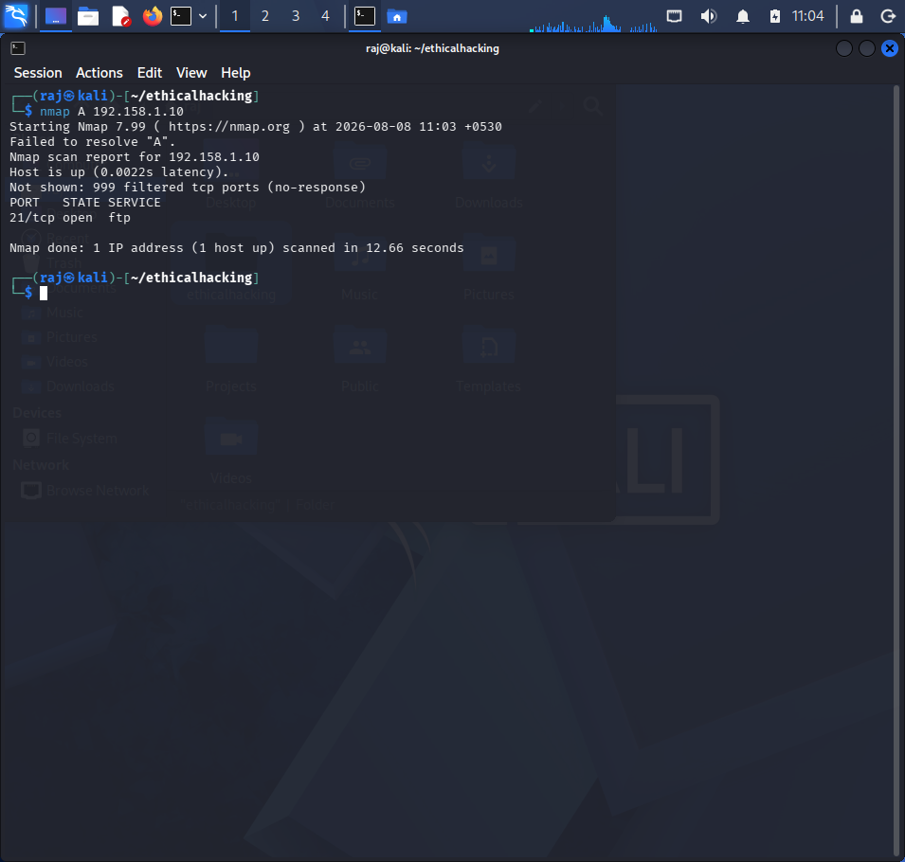
How an Attacker Could Use This Information

The information can support social engineering rather than direct exploitation.

Examples include:

Referencing the organization's SSH or web services to make communications seem credible.
Pretending to be IT support and asking employees to "verify" access after a supposed maintenance window.
Crafting phishing emails that mention publicly observed infrastructure to increase trust.
Targeting administrators responsible for exposed services with fake update notifications.

This illustrates how reconnaissance can make deceptive messages more believable.

Defensive Recommendations

1. Train employees to verify IT requests through official channels.

2. Keep systems patched and minimize unnecessary exposed services.

3. Use MFA for administrative and remote access.

4. Limit public exposure of system and version information where feasible.

5. Monitor logs for unusual reconnaissance activity.

6. Use firewalls and intrusion detection/prevention systems.

Conclusion

An aggressive Nmap scan provides detailed information about publicly exposed services. While such information alone does not compromise a system, it can be combined with social engineering techniques to increase the credibility of phishing or impersonation attempts. Strong user awareness and layered technical defenses help reduce these risks.

