UNLOX
VULNERABILITY ASSESSMENT & PENETRATION TESTING
Bee-Box Lab and AWS EC2/S3 Tasks

Cover-page field | Details
Student name | Rajesh Reddy N Shivaray
Assigned target | Bee-Box (192.168.119.128) in the lab; AWS EC2 and S3 tasks
Assessment date | 29 September–11 October 2026 (based on available evidence timestamps)
Tools used | Kali Linux, Nmap, ping, FTP client, AWS Management Console, browser
Environment / authorization | Controlled lab target (Bee-Box) and student-owned AWS resources

CONFIDENTIALITY NOTE: This report documents testing in an authorized learning environment. Do not reuse the commands against systems without explicit permission.

1. Scope & Objective
The assigned scope was to assess the intentionally vulnerable Bee-Box virtual machine from Kali Linux, identify reachable services and their versions, verify selected exposures with low-impact checks, and document the security impact and remediation. The separate AWS exercise covered launching an EC2 instance and configuring an S3 bucket for static assets, including checking object access. Testing was limited to the supplied lab and the student's own AWS resources; no destructive exploitation was performed or evidenced in the supplied screenshots.

2. Discovery
The Kali interface showed address 192.168.119.129/24 on eth0. A ping check to 192.168.119.128 returned four replies with 0% packet loss, establishing that the target was reachable on the lab network. Subsequent Nmap scans identified the host as bee-box and reported a VMware MAC address.
ip a
ping -c 4 192.168.119.128
⭐ Evidence: network interface and successful ping screenshots.
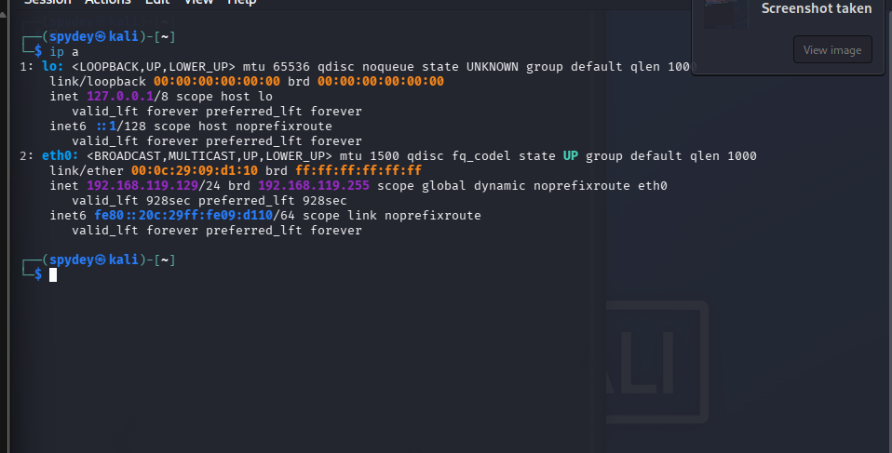
Figure 1. Kali network interface and lab IP address.
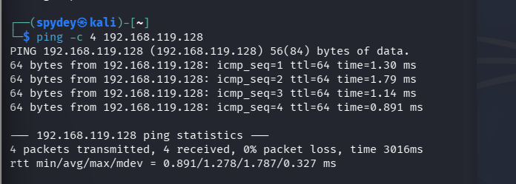
Figure 2. ICMP reachability test to Bee-Box.

3. Port & Service Scan
Nmap service/version detection and targeted scripts were used to identify exposed services. The evidence below supports the listed open ports; service versions are scanner-reported and should be treated as fingerprints, not proof that every associated CVE is exploitable.
sudo nmap -sV -p 3632 192.168.119.128 -oN ~/VAPT-BeeBox/evidence/distccd-check.txt
sudo nmap -p 139,445 -sV --script smb-os-discovery,smb-protocols 192.168.119.128 -oN ~/VAPT-BeeBox/evidence/samba-check.txt
sudo nmap -p 21 --script ftp-anon 192.168.119.128 -oN ~/VAPT-BeeBox/evidence/ftp-check.txt
Port | Service / reported version | Observed result | Security relevance
21/tcp | FTP — ProFTPD 1.3.1 | Anonymous login accepted; directory listing exposed multiple PDF files, including bWAPP_intro.pdf. | Unauthenticated file disclosure / unnecessary anonymous access.
80/tcp | HTTP — Apache 2.2.8 (Ubuntu), DAV/2, PHP 5.2.4 | GET, HEAD, POST, OPTIONS, TRACE reported; TRACE flagged as potentially risky. | Legacy web stack; TRACE should be disabled unless specifically required.
139/tcp | NetBIOS-SSN — Samba smbd 3.x–4.x | Open; host discovery identified bee-box. | SMB exposed; review version, configuration and network reachability.
443/tcp | SSL/HTTP — Apache 2.2.8, OpenSSL 0.9.8g | SSLv2 cipher support reported in supplied notes/evidence. | Legacy TLS/SSL configuration; SSLv2 is insecure and must be disabled.
445/tcp | SMB — Samba smbd 3.0.28a | Open; SMBv1 (NT LM 0.12) reported; message signing disabled. | Legacy SMB protocol and weak signing posture increase exposure.
3632/tcp | distccd v1, GNU 4.2.3 (Ubuntu) | Open, service/version detected by Nmap. | Potential unauthenticated command execution exposure; validate configuration safely.
8080/tcp | HTTP — nginx 1.4.0 | Open; HTTP service detected. | Outdated web server fingerprint; verify need and patch level.
8443/tcp | SSL/HTTP — nginx 1.4.0 | Open; HTTPS-like service detected. | Review TLS configuration and whether the service is needed.
9080/tcp | HTTP — lighttpd 1.4.19 | Open; OPTIONS, GET, HEAD, POST reported. | Outdated web server fingerprint; restrict and update.
9443/tcp | SSL/HTTP — lighttpd 1.4.19 | Open; HTTPS-like service detected. | Review TLS configuration and service necessity.

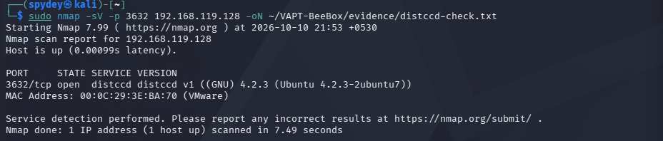
Figure 3. Nmap service scan showing HTTP, SMB and web services.
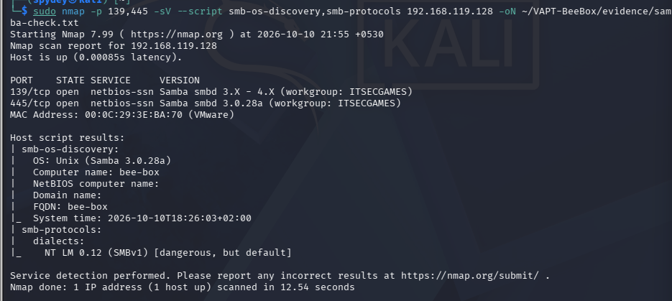
Figure 4. Targeted SMB discovery and SMBv1 evidence.
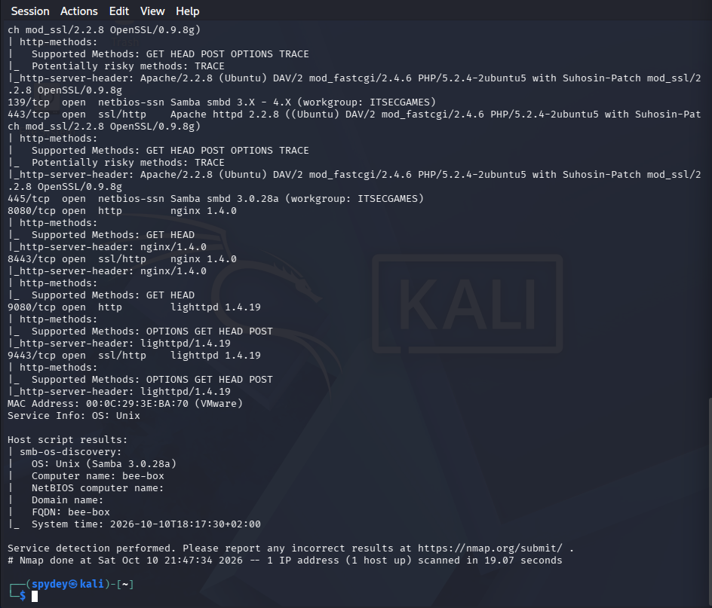
Figure 5. Targeted distccd scan confirming port 3632 and reported version.
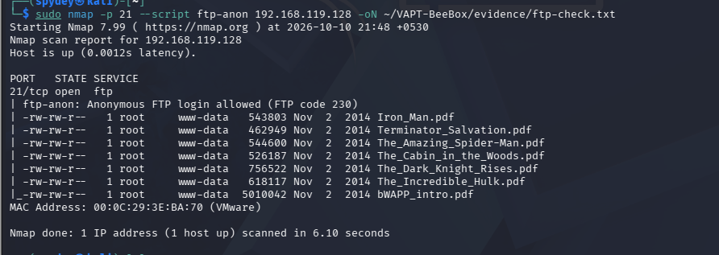
Figure 6. Anonymous FTP scan listing remotely readable files.
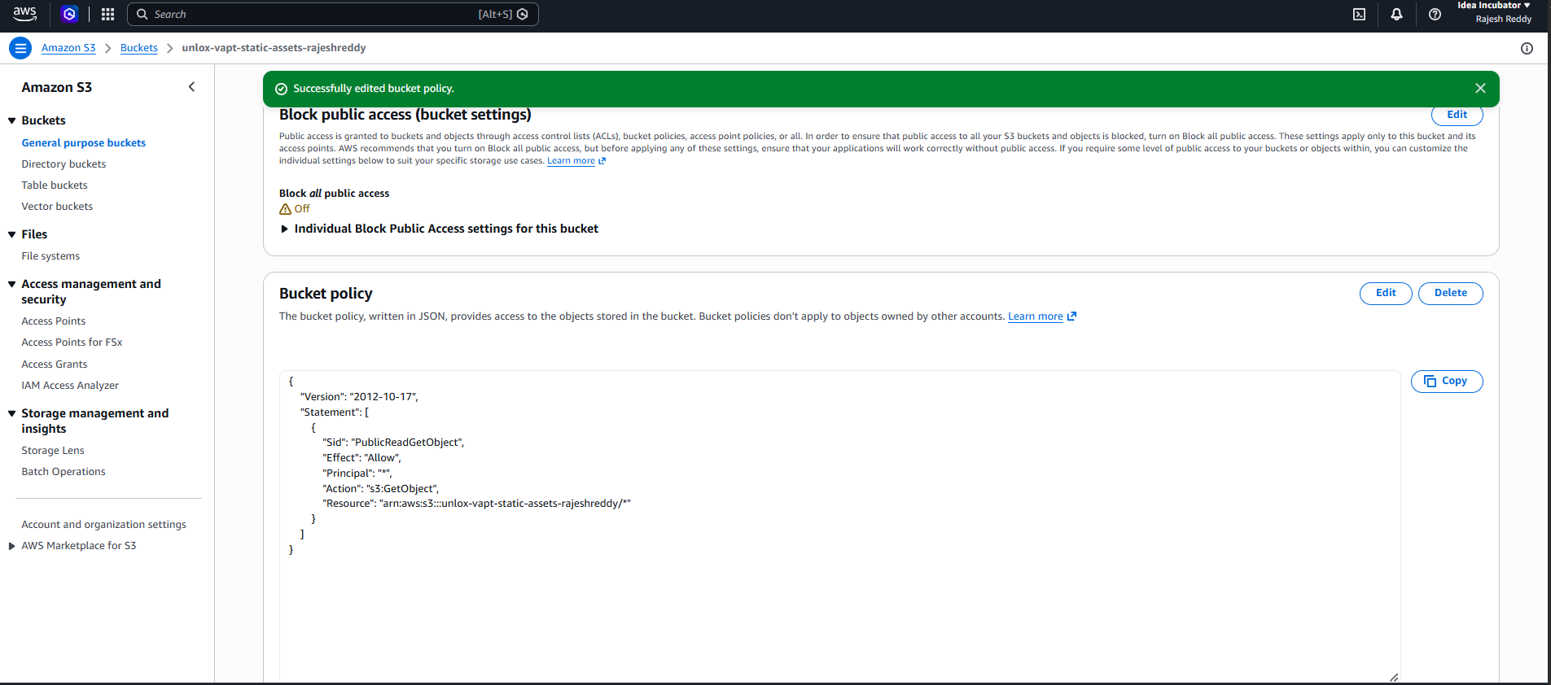
Figure 7. Manual FTP session confirming anonymous login and file listing.

4. Vulnerability Analysis
Severity and CVE references below are preliminary. A detected version alone does not prove exploitability: configuration, vendor backports, build details and the exact vulnerable code path must be validated. The CVSS table later gives provisional scores for prioritization, not a substitute for a verified CVE assessment.

Finding 1 — Samba username map script remote code execution (potential)
- Affected service: Samba smbd 3.0.28a; TCP 139/445.
- Potential CVE: CVE-2007-2447, if the vulnerable username map script configuration is present.
- Evidence: Nmap reports Samba 3.0.28a and open SMB ports. This does not, by itself, confirm that username map script is enabled.
- Impact: If the vulnerable configuration is enabled and reachable, a remote attacker may execute commands with the privileges of the Samba service.
- Remediation: Upgrade to a supported Samba release, remove the vulnerable configuration, disable SMBv1, enable SMB signing where appropriate, and restrict 139/445 to trusted hosts.

Finding 2 — distccd remote command execution exposure (potential)
- Affected service: distccd v1, GNU 4.2.3; TCP 3632.
- CVE-2004-2687: the supplied Nmap distcc vulnerability-script output explicitly reports the service as VULNERABLE and identifies this CVE. This is stronger evidence than a version banner, but it remains a scanner finding rather than proof that an attacker successfully executed a command during this assessment.
- Evidence: Targeted Nmap service detection confirmed port 3632 open and reported distccd v1. A follow-up Nmap script check (distcc-cve2004-2687) reported VULNERABLE and listed CVE-2004-2687.
- Impact: An exposed, unauthenticated distcc service can allow remote command execution in vulnerable configurations.
- Remediation: Stop distccd if unnecessary; otherwise bind it to a trusted interface, restrict source IPs with host firewall rules, and upgrade/replace unsupported software.

Finding 3 — Anonymous FTP access and information disclosure
- Affected service: ProFTPD 1.3.1; TCP 21.
- Evidence: Nmap's ftp-anon script reported anonymous login allowed (FTP code 230) and listed multiple PDF files. A manual FTP session also showed anonymous access and successfully retrieved bWAPP_intro.pdf.
- Impact: Unauthenticated users can enumerate and download files intended to be restricted, potentially exposing internal documents or useful reconnaissance material.
- CVE: Not assigned on the evidence supplied; this is primarily an access-control/configuration issue.
- Remediation: Disable anonymous login unless explicitly required, restrict readable directories, apply least-privilege file permissions, and upgrade the unsupported FTP service.
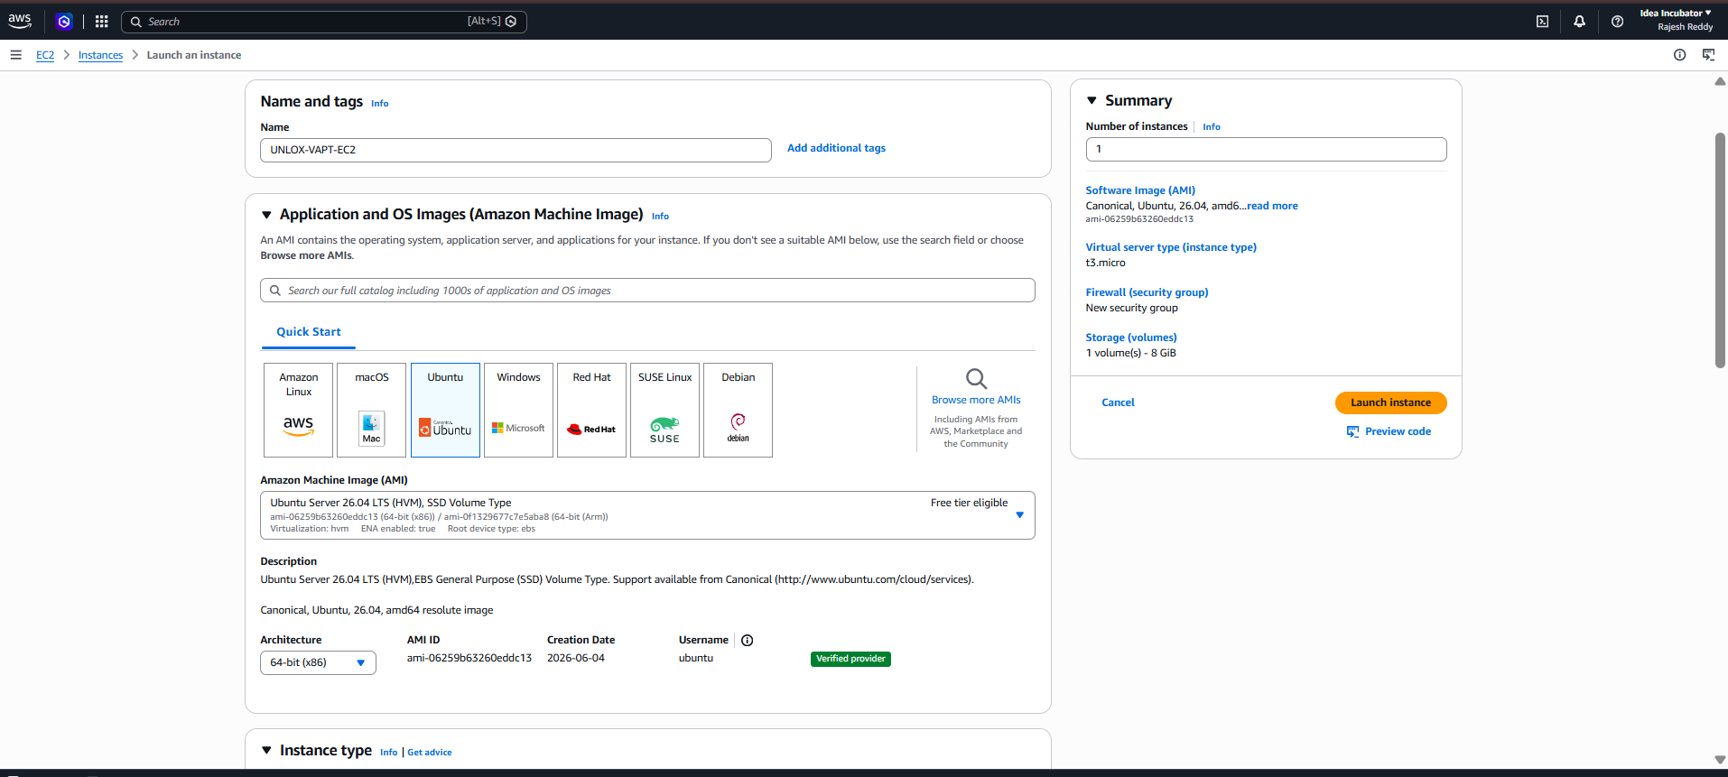
Figure 8. FTP anonymous-login evidence and listed PDF files.
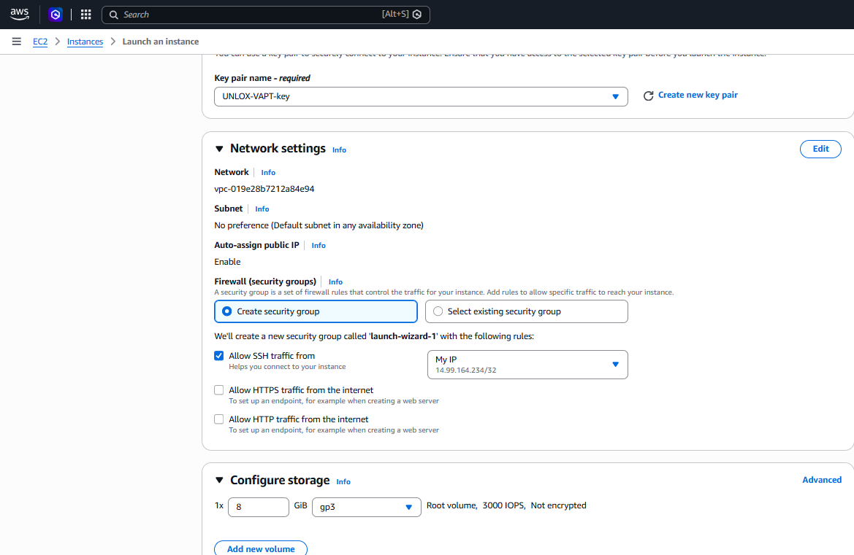
Figure 9. FTP session showing successful anonymous login and file retrieval.

Finding 4 — Legacy Apache/OpenSSL, SSLv2 and TRACE method
- Affected service: Apache 2.2.8 and OpenSSL 0.9.8g on ports 80/443, as reported in the supplied scan output.
- Evidence: Nmap output reports TRACE as a potentially risky HTTP method; the supplied finding notes SSLv2 cipher support.
- Impact: Unsupported web/TLS components may contain multiple known vulnerabilities; SSLv2 is cryptographically broken. TRACE can contribute to cross-site tracing risks in some environments, although TRACE alone does not prove XST is exploitable.
- CVE note: CVE-2011-3192 relates to an Apache range-header denial-of-service issue affecting specific versions/configurations. Do not attribute it to this host without validating the exact affected build and patch status.
- Remediation: Upgrade Apache and OpenSSL to supported versions, disable SSLv2 and other obsolete protocols/ciphers, disable TRACE where not required, and review DAV/legacy modules.

Additional observations
- SMBv1 was reported as supported and SMB message signing as disabled; disable SMBv1 and enforce appropriate signing policy.
- nginx 1.4.0 and lighttpd 1.4.19 are old version fingerprints; verify package patch state and remove unnecessary services.
- The evidence set includes a local bWAPP PDF download. This confirms file retrieval, not operating-system command execution or full system compromise.

5. Exploitation
The supplied evidence demonstrates non-destructive validation of exposed services, not a completed remote-code-execution exploit. No claim of shell access or privileged access is made.

5.1 Anonymous FTP validation
sudo nmap -p 21 --script ftp-anon 192.168.119.128 -oN ~/VAPT-BeeBox/evidence/ftp-check.txt
ftp 192.168.119.128
# At the prompts, use the anonymous account as permitted by the lab
ls
get bWAPP_intro.pdf
- Before: FTP service identified on port 21.
- During: Anonymous authentication was accepted and the server listed downloadable PDFs.
- After: The FTP client reported a completed transfer of bWAPP_intro.pdf (5,010,042 bytes).
- Limit: This proves unauthenticated file access, not RCE. Do not describe it as command execution.

5.2 distccd and Samba checks
sudo nmap -sV -p 3632 192.168.119.128 -oN ~/VAPT-BeeBox/evidence/distccd-check.txt
sudo nmap -p 139,445 -sV --script smb-os-discovery,smb-protocols 192.168.119.128 -oN ~/VAPT-BeeBox/evidence/samba-check.txt
- These checks validated exposed services and protocols. The distcc vulnerability script reported CVE-2004-2687 as VULNERABLE, while the Samba evidence confirms open SMB ports and SMBv1 support. The screenshots do not show a successful interactive shell or command execution, so no completed RCE is claimed.

6. Demonstration & Impact
The clearest demonstrated impact is information disclosure through anonymous FTP: a user without a named account could list files and retrieve a PDF. Separately, open SMB and distccd ports and legacy service fingerprints expose a broader attack surface. If the suspected vulnerable configurations are confirmed, Samba and distccd could present much higher-impact risks, including remote code execution; that outcome was not demonstrated in the screenshots provided.
Demonstrated / observed | What it means | What is not proven
Host responds to ping | Bee-Box was reachable from Kali on the lab network. | Does not imply a vulnerability by itself.
FTP anonymous login and file download | Unauthenticated information disclosure is confirmed. | Does not prove RCE or access to every file.
SMBv1 supported; signing disabled reported | Legacy protocol and security configuration warrant remediation. | Does not by itself prove remote compromise.
distccd TCP/3632 open | Potentially dangerous service is network-reachable. | Does not prove commands were executed.
Legacy Apache/OpenSSL/nginx/lighttpd versions reported | Unsupported/outdated components should be validated and updated. | Version banners may not reveal vendor backports or exact patch state.

7. CVSS Scoring Table
Provisional CVSS v3.1 estimates for prioritization only. Scores should be recalculated after confirming exact vulnerable configuration and applicable CVE. The values below are not represented as official NVD scores.
Vulnerability | CVSS v3.1 vector (provisional) | Base score | Severity | Justification
Samba username map script RCE (conditional) | AV:N/AC:L/PR:N/UI:N/S:U/C:H/I:H/A:H | 9.8 | Critical | Potential unauthenticated RCE if the vulnerable configuration is enabled; applicability not yet confirmed.
distccd remote command execution (conditional) | AV:N/AC:L/PR:N/UI:N/S:U/C:H/I:H/A:H | 9.8 | Critical | Potential unauthenticated command execution on an exposed vulnerable service; validate exact build/configuration.
Anonymous FTP information disclosure | AV:N/AC:L/PR:N/UI:N/S:U/C:L/I:N/A:N | 5.3 | Medium | Remote unauthenticated read access is demonstrated; confidentiality impact depends on file sensitivity.
Legacy TLS/SSL and risky TRACE configuration | Not scored as one CVE; separate issues require validation | — | Medium–High | Multiple configuration and patching concerns; avoid combining unrelated weaknesses into a single score.
SMBv1 enabled / signing disabled | Configuration-specific assessment required | — | Medium | Legacy protocol and signing posture increase risk; impact depends on network exposure and authentication controls.

8. AWS Task Answers

Task 6 — EC2
Evidence supplied: the EC2 launch form shows instance name UNLOX-VAPT-EC2, Ubuntu Server 26.04 LTS (as shown in the console), instance type t3.micro, an 8 GiB gp3 root volume, a selected key pair named UNLOX-VAPT-key, and SSH access limited to “My IP” (shown as 14.99.164.234/32). A success banner confirms launch initiation for instance i-056838b69cc12608e. The screenshots provided do not show the final running-state details or a successful SSH connection.
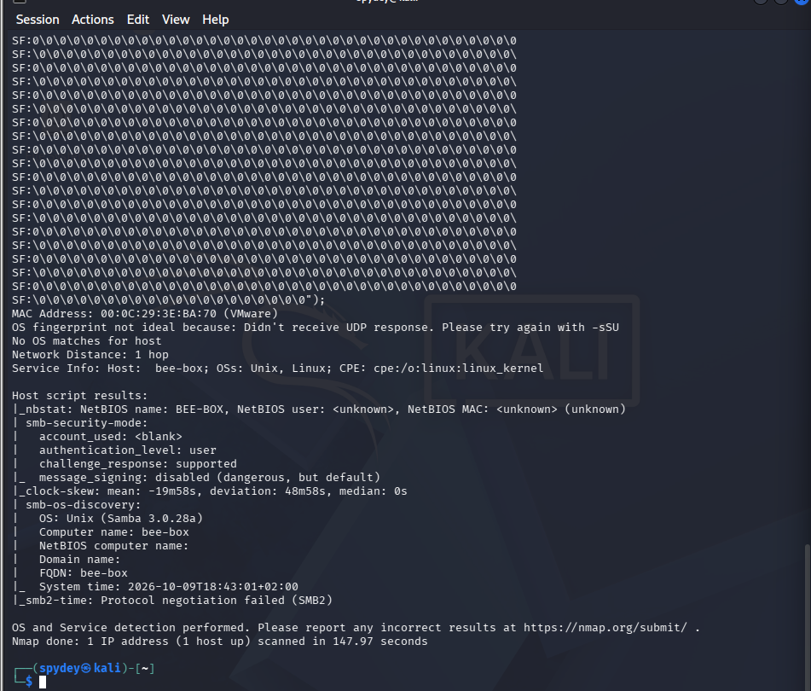
Figure 10. EC2 instance launch configuration and selected instance type.
Figure 11. Lab service validation evidence (not an EC2 SSH connection).
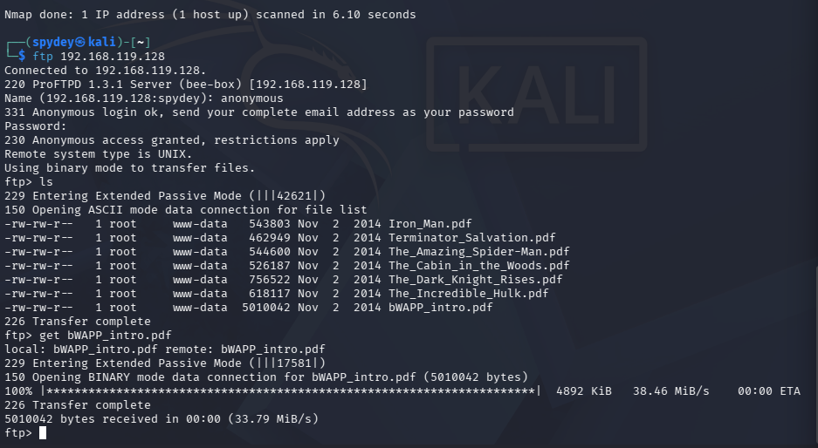
Figure 12. EC2 launch success banner.

Concept questions
1. What is an EC2 instance? An EC2 instance is a virtual server in AWS that provides configurable compute capacity, operating system, storage and networking.
2. T2 vs T3: Both are burstable general-purpose instance families. T3 is a newer generation and generally offers better price/performance and newer platform capabilities; choose based on workload, regional availability, and cost. Confirm current pricing and credit mode before use.
3. Instance size (for example, t3.micro vs t3.large): the size indicates allocated vCPU and memory capacity within a family. Larger sizes generally support more concurrent work but cost more.
4. Why use a PEM key? The private key authenticates SSH access when the instance is configured for key-based login. If it is lost, the usual direct SSH path may be unavailable; recovery depends on the access setup (for example, Systems Manager, EC2 Instance Connect where supported, or recovery procedures). Never share the private key.
5. Security group vs network ACL: A security group is a stateful virtual firewall attached to network interfaces/instances. A network ACL is a stateless subnet-level filter, so inbound and outbound rules must be considered separately.
EC2 follow-up evidence still recommended: capture the Instances page showing the instance in Running state, its instance type and public IP (if assigned), then capture a successful SSH/session connection if required by the task. Do not expose the private key in screenshots.

Task 7 — S3
Evidence supplied: bucket unlox-vapt-static-assets-rajeshreddy has a bucket policy successfully saved. The policy allows s3:GetObject to principal * for objects under the bucket ARN. The “Block all public access” setting is Off. A browser screenshot shows an object named pexels-eberhardgross-2098428.jpg loading from the bucket endpoint. Together, these prove that the object is publicly readable.
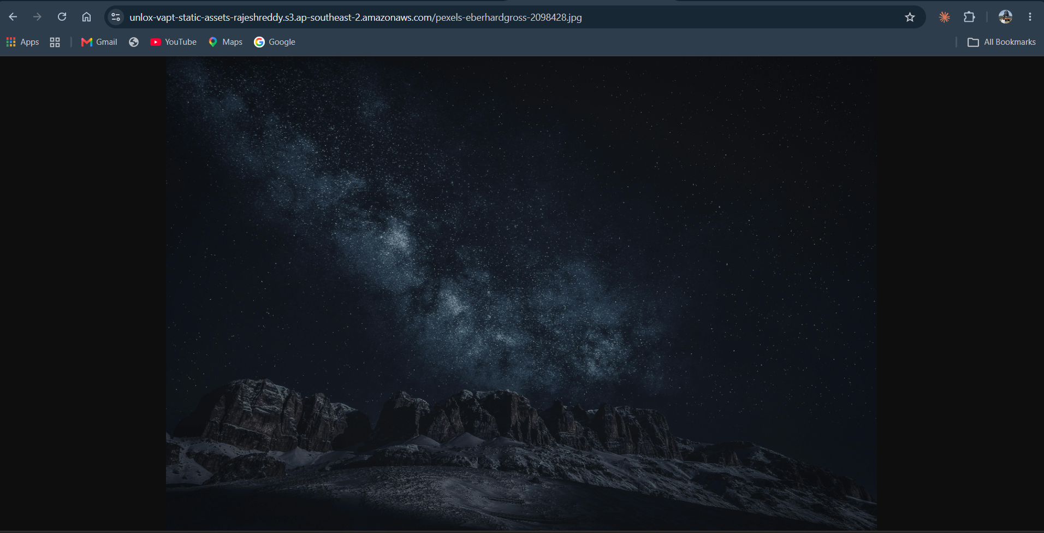
Figure 13. S3 bucket policy showing public GetObject access and Block Public Access turned off.
Figure 14. Browser successfully loading an image directly from the S3 object URL.

Concept questions
1. What is S3 used for? Amazon S3 is object storage used to store and retrieve files such as images, documents, backups, logs and static website assets.
2. Public vs private bucket: Public access allows unauthenticated users to access resources permitted by the policy/ACL configuration; private access restricts access to authorized principals. S3 Block Public Access provides account/bucket-level safeguards against public policies and ACLs.
3. Bucket policy vs IAM policy: A bucket policy is a resource-based policy attached to an S3 bucket and can grant access to principals. An IAM identity policy is attached to a user, group or role and defines what that identity may do. Both can affect the final authorization decision.
4. Why is public access risky by default? Public access can expose confidential objects to anyone on the internet, permit scraping, create compliance issues, and incur unexpected request/transfer costs. Public access should be enabled only for objects intentionally intended for public distribution.

AWS security note and remediation
The current S3 policy is intentionally public-read: any person who knows or discovers an object URL may retrieve the object. This is suitable only if the bucket contains non-sensitive static assets intended for public distribution. If the goal is a private test bucket, re-enable all Block Public Access settings and remove the public bucket policy. If the image is meant to be public, restrict the policy to the intended prefix and use least privilege.
EC2 cost note: an instance can continue to incur charges while running, and EBS storage can continue to incur charges after an instance is stopped. Verify the applicable free-tier/credit terms in the account and stop or terminate resources when the task is complete. Termination deletes the instance; preserve any required evidence first.

9. Conclusion & Recommendations
The assessment confirmed that the Bee-Box lab host was reachable and exposed several network services, including FTP, SMB, distccd, and multiple web services. The strongest directly demonstrated weakness was anonymous FTP access that permitted file listing and download. Legacy service fingerprints, SMBv1 support, disabled SMB signing, SSLv2 support and TRACE warrant remediation or further validation. Potential RCE findings should remain conditional until the exact vulnerable configuration is verified. In AWS, the supplied screenshots confirm EC2 launch initiation and public-read access to an S3 object.

Prioritized remediation
Priority | Recommendation | Reason
1 — Critical if validated | Isolate Bee-Box from untrusted networks; verify and remediate Samba username map script and distccd exposure; disable/remove these services if not needed. | Potential remote code execution would have severe impact.
2 — High | Disable anonymous FTP or restrict it to a dedicated public directory; remove sensitive files and apply least-privilege permissions. | Information disclosure was directly demonstrated.
3 — High | Upgrade unsupported Apache/OpenSSL/nginx/lighttpd and Samba packages; disable SSLv2 and SMBv1; enforce appropriate SMB signing. | Reduces exposure to known legacy protocol and software weaknesses.
4 — Medium | Disable HTTP TRACE unless required; review DAV and other unnecessary modules; restrict exposed ports to required sources. | Reduces attack surface and configuration risk.
5 — AWS | Keep EC2 SSH restricted to a trusted IP, protect the PEM key, and stop/terminate resources after evidence collection. | Limits administrative exposure and unnecessary cost.
6 — AWS | Use private S3 access by default. If public static assets are required, publish only intended objects and document the business reason. | Prevents accidental disclosure of future uploads.

Evidence limitations / completion checklist
- Add your university roll/ID to the cover page.
- If required by the instructor, add a screenshot showing EC2 in Running state and a successful connection; current evidence shows launch initiation, not a confirmed SSH session.
- Confirm whether the assignment requires actual exploitation. The evidence supplied supports validation and FTP file access, but not a successful RCE shell.
- Verify CVE applicability against the exact target build/configuration before submitting the RCE and Apache CVE claims as confirmed.
- Review all screenshots for account identifiers, public IPs, or other details your instructor does not require before external sharing.

Additional Evidence — Newly Supplied Screenshots
The following newly supplied evidence is added to the report. Screenshots that duplicated evidence already embedded in the earlier report were not reinserted. Captions explain what each image supports.
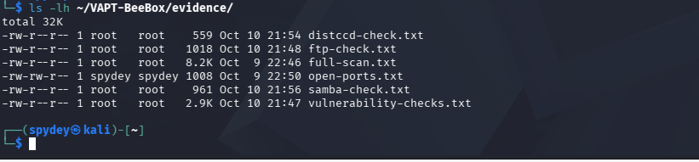
Figure 15. Evidence directory listing showing saved Nmap output files for full scan, FTP, Samba and distccd checks.
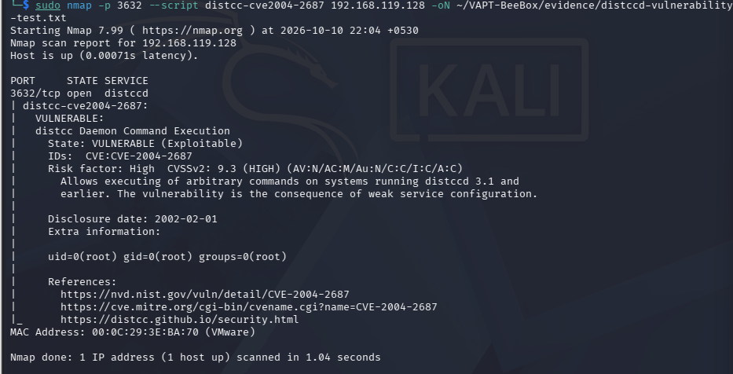
Figure 16. Nmap distcc vulnerability script reports CVE-2004-2687 as VULNERABLE on TCP/3632. This is scanner validation, not proof of a completed exploit.
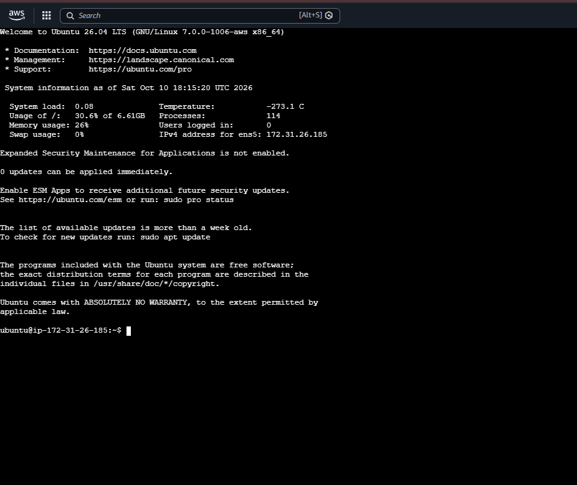
Figure 17. Successful interactive Ubuntu session on the EC2 instance, confirming that the student reached the instance. The visible shell prompt is ubuntu@ip-172-31-26-185.
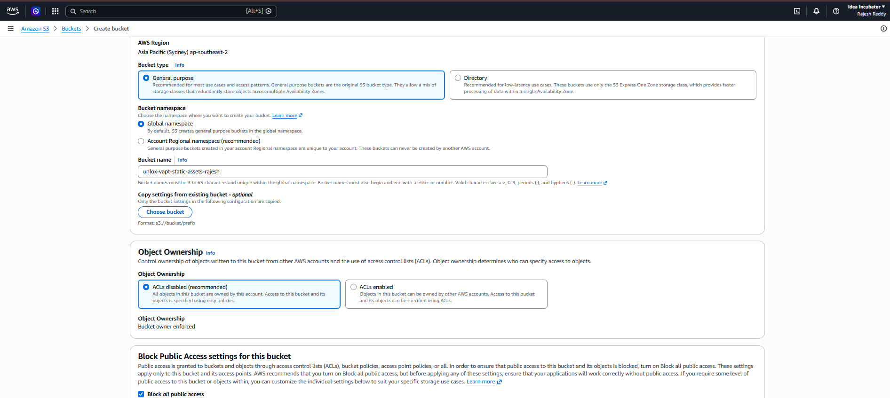
Figure 18. S3 bucket creation configuration showing the bucket name and default Block Public Access selection at creation time.
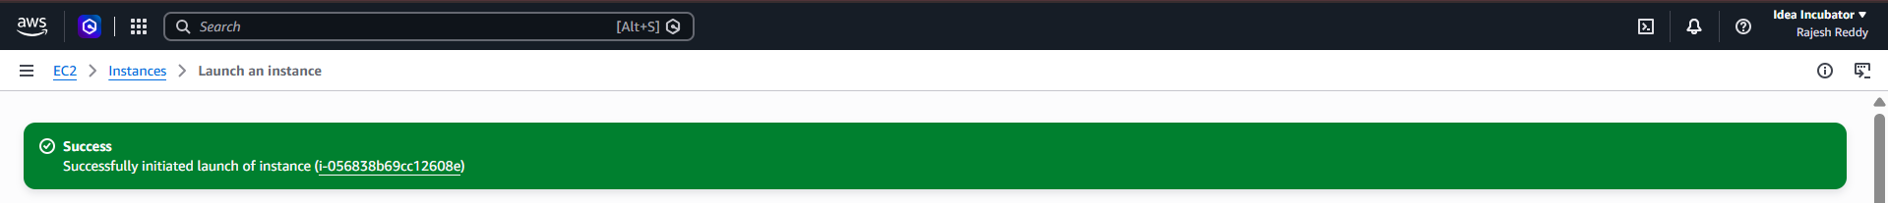
Figure 19. AWS console success banner following an EC2 launch action.
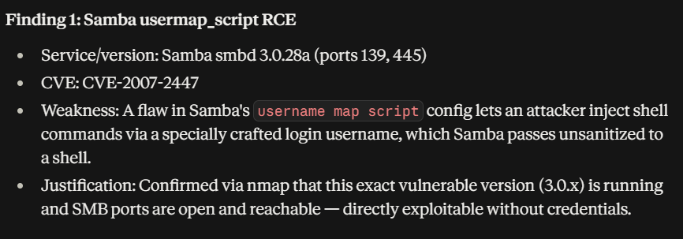
Figure 24. Finding notes for Samba username map script RCE; treated as a suspected finding pending configuration-specific validation.
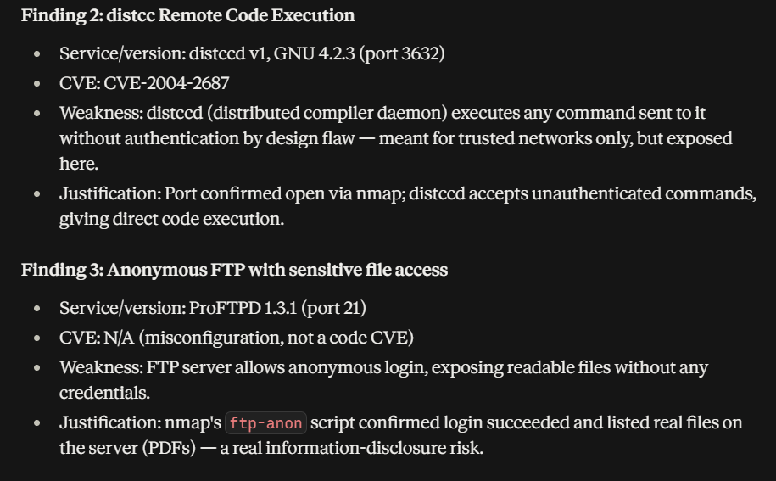
Figure 25. Finding notes for distccd and anonymous FTP; distccd is supported by the new vulnerability-script result, while FTP access is directly demonstrated.
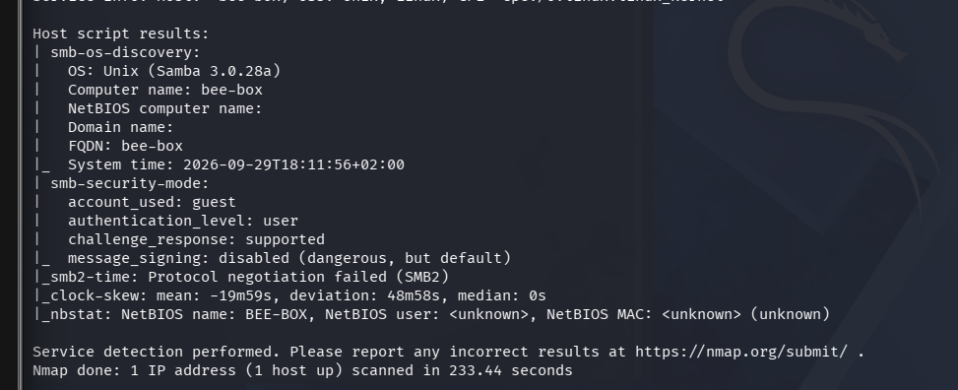
Figure 26. SMB host-script output showing Samba discovery and disabled SMB message signing as reported by Nmap.

