CONTENTS
1. Overview 2
There are two types of direct debits 2
2. Getting Started – Adding a new member 3
2.1 Create a new contact 3
2.2 Create Direct Debit Mandate 4
3. Create / Add Membership 6
3.1 View membership record 7
3.2 Create Authorisation file 7
3.3 View Activities 8
3.4 Process Direct Debit File 8
4. Add to Direct Debit Batch 9
4.1 Select Direct Debit Batch 9
4.2 View Direct Debit Batch Report 10
4.3 Generate BACS file 10
4.4 View Member Contribution Tab 11
4.5 View Membership Tab 11
5 Direct Debit Batch Report 12
Direct Debit Rejections 12

Overview

This document is designed to give an overview of the functions of CIVI Direct Debit Modules …etc….

Some of direct debit features covered in this document
- Direct debit mandate
- Authorization file
- Process Direct Debit run
- Create Direct Debit Batch Report
- Run Background job for membership renewal
- Direct debit rejection.

There are two types of direct debits

- Paperless Direct debit – Authorized by the bank
- Stranded direct debit - Authorized by the member

The Direct debit process allows a user to select all current member(s) whose membership(s) are due for renewal in the current month. Also it selects all new members who have a valid mandate(s) whose mandate id date generated is greater than 14 days prior to direct debit collection date

The following must be true for the member to be picked up in the current months Direct Debit Run:
- Member payment method is set to Direct Debit
- Member has a valid mandate
- Member has active membership
- New members mandate id date generated is greater than 14 days prior to direct debit collection date

Getting Started – Adding a new member

2.1 Create a new contact
To set up a new member paying by direct debit the contact would either already exists on the system or user needs to create a new contact by entering member’s details to the create New Individual screen (New individual screen can be accessed from the Contacts menu -see below)

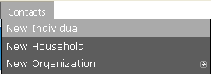

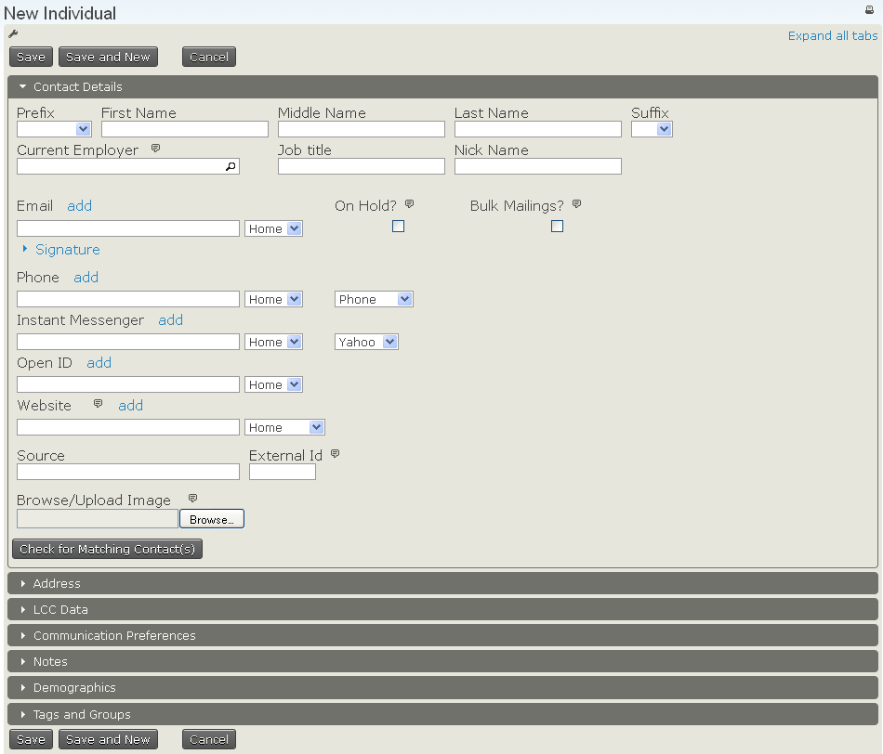

2.2 Create Direct Debit Mandate
Select Direct Debit Mandate tab from the contact screen, you should then be presented with the Direct Debit Mandate page – this is a display only page to list any existing mandates(s) the member holds.

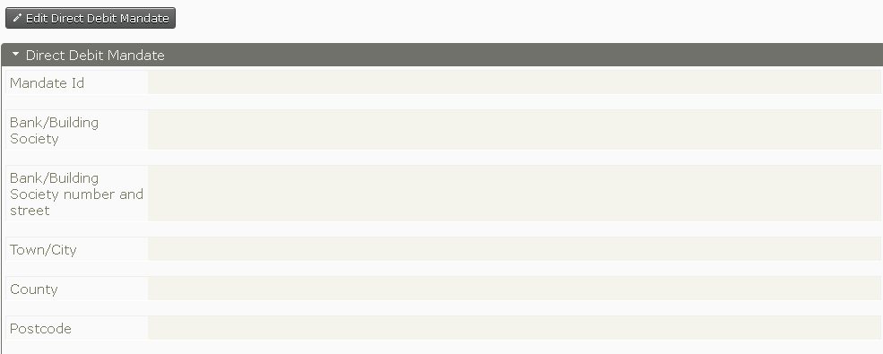

To create a new mandate click on: .

To create the direct debit mandate enter the contact bank details
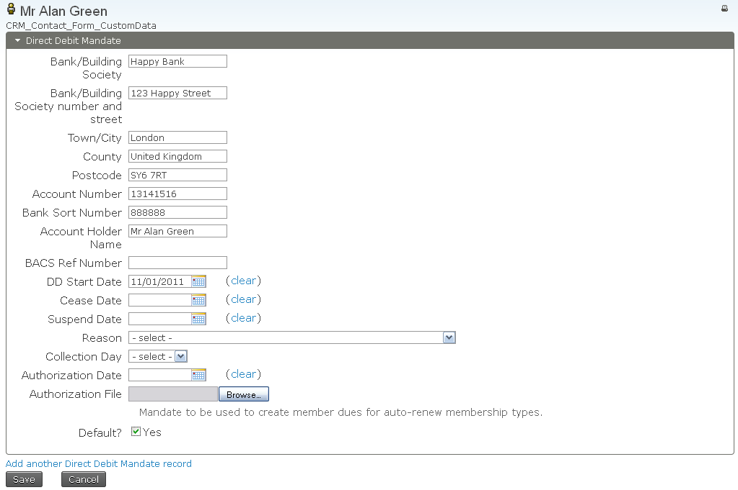

Clicks the Save button to save details you have entered. Note that the Direct Debit Mandate tab should now show

To view a mandate click on
Go
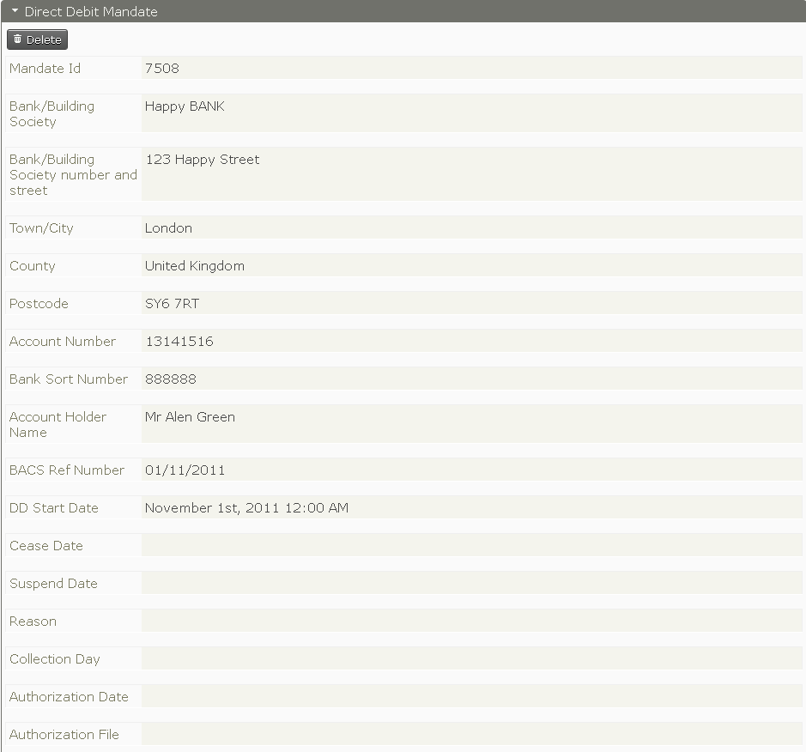

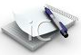
Note: - a member could have more than one mandate.
To add a second mandate click on Add another Mandate Option at the bottom of the screen see below (select’ yes’ in the mandate screen to chose the default mandate)


Enter details for the second mandate then save you should see two direct debit records created. The direct debit mandate number should now show 2see below

Create / Add Membership

Once the direct debit mandate is created then the next step is to add membership type to the record. To add a membership type, do the following
- Select membership tab
- A window allowing the user to add a new membership should appear 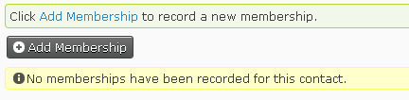
- Select Add Membership to record new membership alternatively click on Add Membership button the following screen will appear.
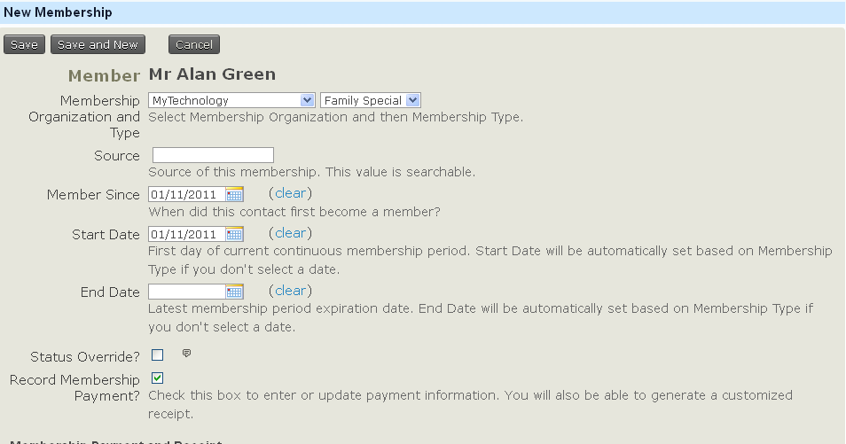

- Fill in all details
- Select Record Membership option
- Fill in payment details
- Make the contribution status pending
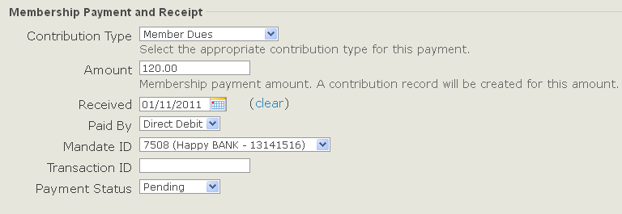

- Make sure the mandate id field has a value
- This is optional if selected a confirmation email will be sent to the member.
- Set payment method as Direct Debit and click Save button to save changes. 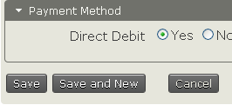

3.1 View membership record
The both the membership and contribution tabs should show one entry has been made.
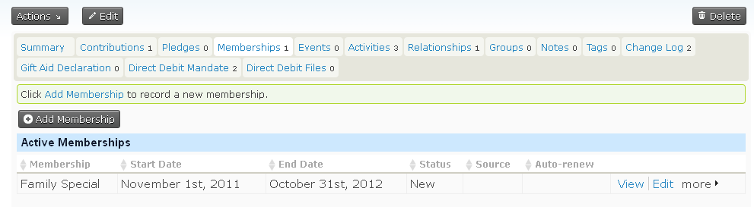

Notice 3 activities are created when

3.2 Create Authorisation file
From the Direct Debit menu select Create Authorisation File

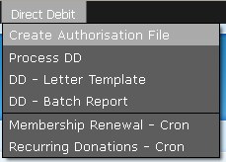

Once user select the create authorisation file option a background process will select all members who have mandate and their payment method set to direct debit.
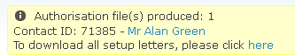

3.3 View Activities

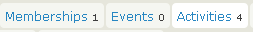

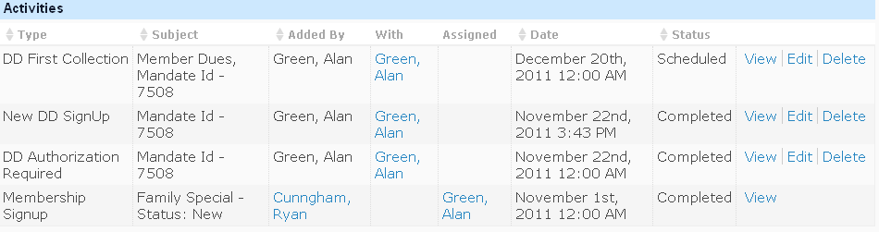

3.4 Process Direct Debit File
Selecting the menu option renews all memberships due for renewal in the current month and is paying by direct debit. This also creates a pending contribution linked to said membership record.

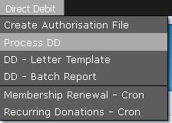

Add to Direct Debit Batch

Once Process direct debit is successfully completed user will be taken to the Batch creating screen where you will see all the contributions included in the current month’s direct debit run and you are asked to create/name the batch.
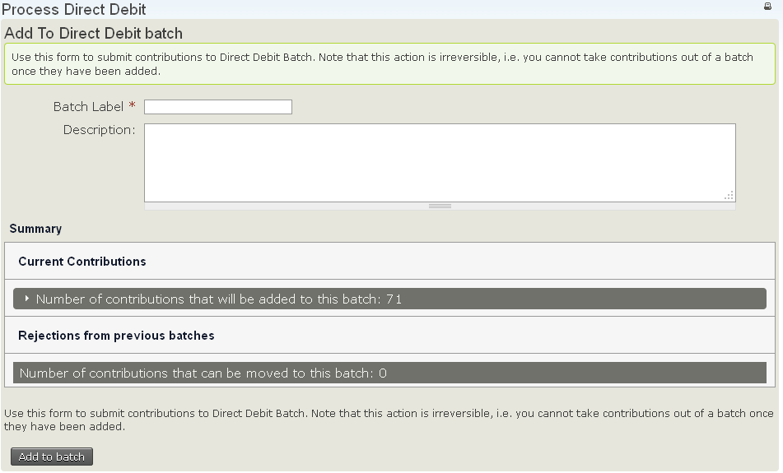
Click the ‘add to batch’ button; this will take you to the Direct Debit Report screen.

4.1 Select Direct Debit Batch
On this screen you need to select the batch you created/named on the previous screen, then select ‘preview report’
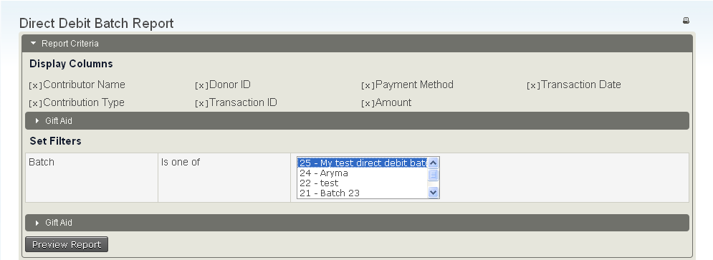

4.2 View Direct Debit Batch Report
On this screen you will be given the opportunity to view all the contributions that will be included in the BACS file
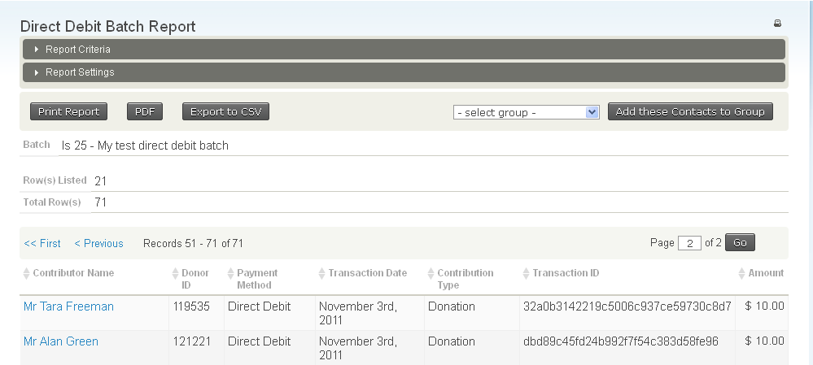

4.3 Generate BACS file

To complete the direct debit process the user needs to click the ‘GENERATE BACS File’ button. This will produce a file a text or .csv file and complete all pending contributions produces when you selected process DD
Open BACS file screen
User can select to save BACS file to location

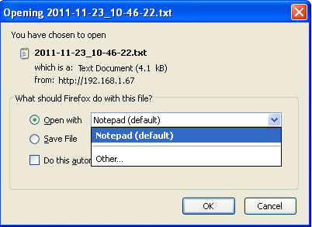

Note: - user can select to save file as Notepad (default option) or from the drop down list select other see below

9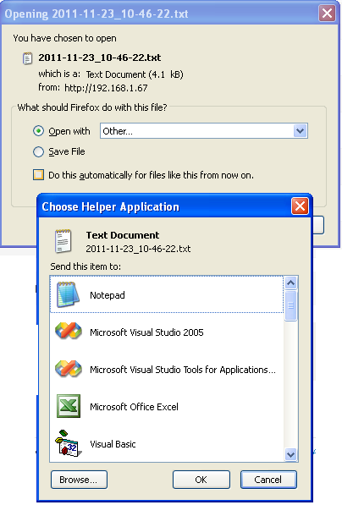

4.4 View Member Contribution Tab

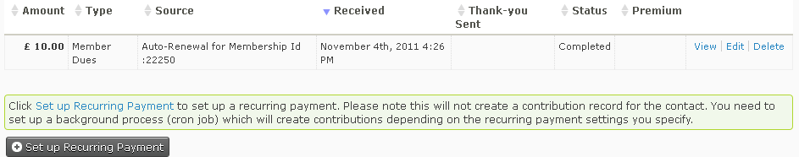

4.5 View Membership Tab
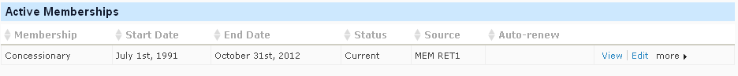

5 Direct Debit Batch Report

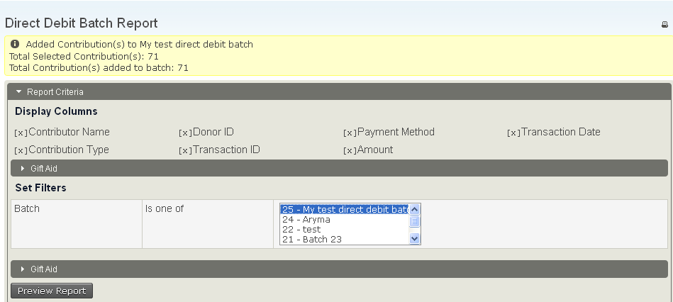

Direct Debit Rejections

This section is under development to be added later

