**Assignment 1**

Q.1)What is Business Processing re-engineering(BPR)? Explain?

Ans:-

* Business process reengineering is the act of recreating a core [business process](https://tallyfy.com/business-process) with the goal of improving product output, quality, or reduc ing costs.
* Typically, it involves the analysis of company [workflows](https://tallyfy.com/what-is-a-workflow/), finding processes that are sub-par or inefficient, and figuring out ways to get rid of them or change them.
* Business process reengineering became popular in the business world in the 1990s, inspired by an article called [Reengineering Work: Don’t Automate, Obliterate](https://hbr.org/1990/07/reengineering-work-dont-automate-obliterate) which was published in the Harvard Business review by Michael Hammer.
* His position was that too many businesses were using new technologies to [automate](https://tallyfy.com/guides/business-process-automation/) fundamentally ineffective processes, as opposed to creating something different, something that is built on new technologies.
* Think, using technology to “upgrade” a horse with lighter horseshoes which make them faster, as opposed to just building a car.
* In the decades since, BPR has continued to be used by businesses as an alternative to [business process management](https://tallyfy.com/guides/business-process-management-bpm/) (automating or reusing existing processes), which has largely superseded it in popularity.
* And with the pace of technological change faster than ever before, BPR is a lot more relevant than ever before.

**Business Process Reengineering Steps**

* As we’ve mentioned before, business process reengineering is no easy task.
* Unlike business process management or improvement, **both** of which focus on working with existing processes, BPR means changing the said processes **fundamentally**.
* This can be extremely time-consuming, expensive and risky. Unless you manage to carry out each of the steps successfully, your attempts at change might fail.

Step 1. Identity and Communicating the Need for Change

* If you’re a small start-up, this can be a piece of cake. You realize that your product has a high user drop-off rate, send off a text to your co-founder, and suggest a direction to pivot.
* For a corporation, however, it can be a lot harder. There will always be individuals who are happy with things as they are, both from the side of management and employees. The first might be afraid that it might be a sunk investment, the later for their job security.
* So, you’ll need to convince them why making the change is essential for the company. If the company is not doing well, this shouldn’t be too hard.
* In some cases, however, the issue is with the company not doing aswell as it could be. Meaning, you should do your research. Which processes might not be working? Is your competition doing better than you in some regards? Worse?
* Once you have all the information, you’ll need to come up with a very comprehensive plan, involving leaders from different departments. The management will have to play the role of salespeople: conveying the grand vision of change, showing how it’ll affect even the lowest-ranked employee positively.

Step 2. Put Together a Team of Experts

* As with any other project, business process reengineering needs a team of highly skilled, motivated people who will carry out the needed steps.
* In most cases, the team consists of:
* **Senior Manager.** When it comes to making a major change, you need the supervision of someone who can call the shots. If a BPR team doesn’t have someone from the senior management, they’ll have to get in touch with them for every minor change.
* **Operational Manager.** As a given, you’ll need someone who knows the ins-and-outs of the process – and that’s where the operational manager comes in. They’ve worked with the process(es) and can contribute with their vast knowledge.
* **Reengineering Experts.** Finally, you’ll need the right engineers. Reengineering processes might need expertise from a number of different fields, anything from IT to manufacturing. While it usually varies case by case, the right change might be anything – hardware, software, workflows, etc.

Step 3. Find the Inefficient Processes and Define Key Performance Indicators (KPI)

* Once you have the team ready and about to kick-off the initiative, you’ll need to define the right **KPIs**. You don’t want to adapt to a new process and THEN realize that you didn’t keep some expenses in mind – the idea of BPR is to optimize, not the other way around.
* While KPIs usually vary depending on what process you’re optimizing, the following can be very typical:
* **Manufacturing**
  + **Cycle Time** – The time spent from the beginning to the end of a process
  + **Changeover Time** – Time needed to switch the line from making one product to the next
  + **Defect Rate** – Percentage of products manufactured defective
  + **Inventory Turnover** – How long it takes for the manufacturing line to turn inventory into products
  + **Planned VS Emergency Maintenance** – The ratio of the times planned maintenance and emergency maintenance happen
* **IT**
  + **Mean Time to Repair –** Average time needed to repair the system / software / app after an emergency
  + **Support Ticket Closure rate –** Number of support tickets closed by the support team divided by the number opened
  + **Application Dev**.**–** The time needed to fully develop a new application from scratch
  + **Cycle Time –** The time needed to get the network back up after a security breach

Step 4. Reengineer the Processes and Compare KPIs

* Finally, once you’re done with all the analysis and planning, you can start implementing the solutions and changes on a **small** scale.
* Once you get to this point, there’s not much to add – what you have to do now is keep putting your theories into practice and seeing how the KPIs hold up.
* If the KPIs show that the new solution **works better**, you can start slowly scaling the solution, putting it into action within more and more company processes.
* If not, you go back to the drawing board and start chalking up new potential solutions.

Q.2) What is OLAP? Explain the functionalities of OLAP?

Ans:-

* **Online Analytical Processing (OLAP)** is a category of software that allows users to analyze information from multiple database systems at the same time.
* It is a technology that enables analysts to extract and view business data from different points of view.
* Analysts frequently need to group, aggregate and join data.
* These operations in relational databases are resource intensive.
* With OLAP data can be pre-calculated and pre-aggregated, making analysis faster.

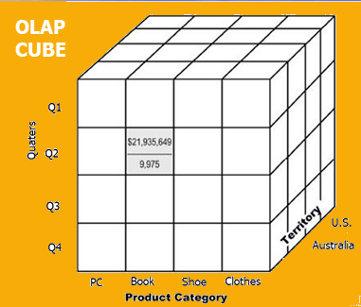

**How does it work?**

* A Data warehouse would extract information from multiple data sources and formats like text files, excel sheet, multimedia files, etc.
* The extracted data is cleaned and transformed. Data is loaded into an OLAP server (or OLAP cube) where information is pre-calculated in advance for further analysis.

**Basic analytical operations of OLAP**

Four types of analytical operations in OLAP are:

1. Roll-up
2. Drill-down
3. Slice and dice
4. Pivot (rotate)

**1) Roll-up:**

Roll-up is also known as "consolidation" or "aggregation." The Roll-up operation can be performed in 2 ways

1. Reducing dimensions
2. Climbing up concept hierarchy. Concept hierarchy is a system of grouping things based on their order or level.

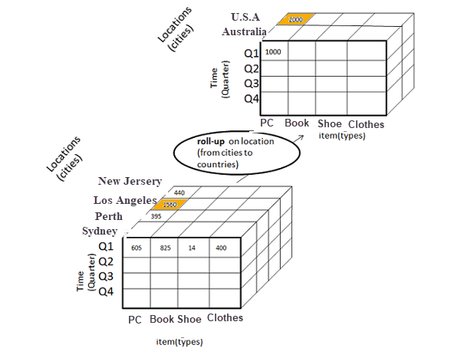

**2) Drill-down**

In drill-down data is fragmented into smaller parts. It is the opposite of the rollup process. It can be done via

1. Moving down the concept hierarchy
2. Increasing a dimension

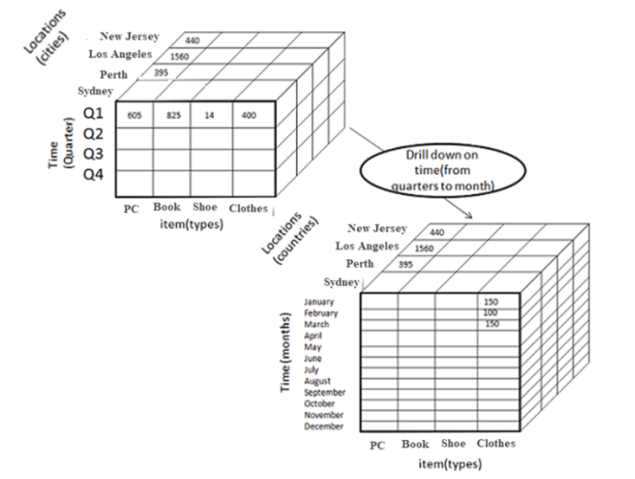

**3) Slice:**

Here, one dimension is selected, and a new sub-cube is created.

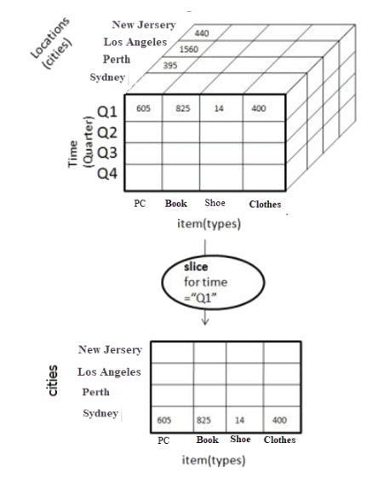

Q.3) What is EDI? Explain properly.

Ans:

Electronic Data Interchange (EDI) is the computer-to-computer exchange of business documents in a standard electronic format between business partners.

By moving from a paper-based exchange of business document to one that is electronic, businesses enjoy major benefits such as reduced cost, increased processing speed, reduced errors and improved relationships with business partners. Learn more about the benefits of EDI here. »

Each term in the definition is significant:

Computer-to-computer– EDI replaces postal mail, fax and email. While email is also an electronic approach, the documents exchanged via email must still be handled by people rather than computers. Having people involved slows down the processing of the documents and also introduces errors. Instead, EDI documents can flow straight through to the appropriate application on the receiver’s computer (e.g., the Order Management System) and processing can begin immediately. A typical manual process looks like this, with lots of paper and people involvement:

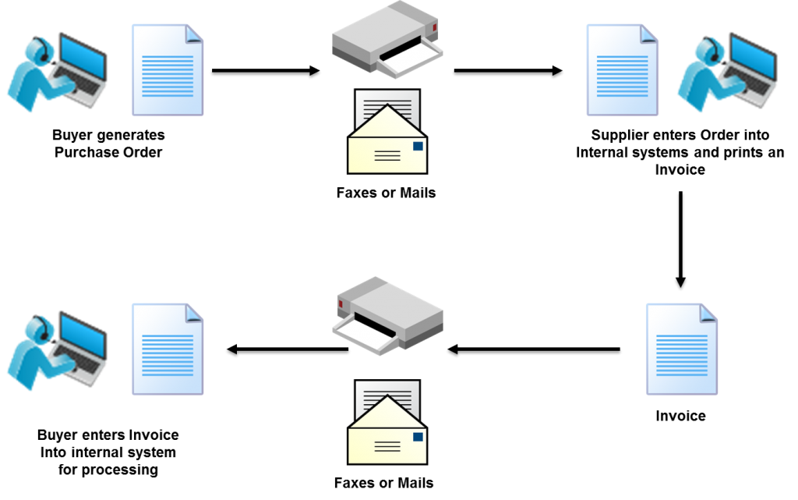

The EDI process looks like this — no paper, no people involved:

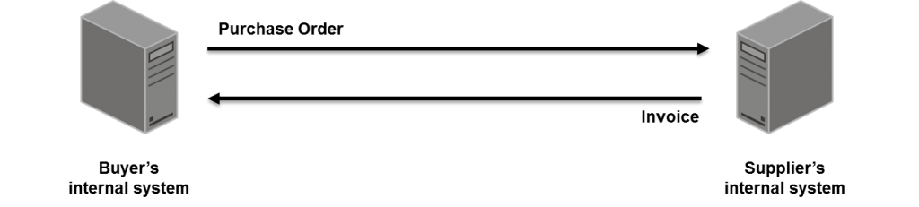

EDI (Electronic Data Interchange) Document Exchange

Business documents – These are any of the documents that are typically exchanged between businesses. The most common documents exchanged via EDI are purchase orders, invoices and advance ship notices. But there are many, many others such as bill of lading, customs documents, inventory documents, shipping status documents and payment documents.

Standard format– Because EDI documents must be processed by computers rather than humans, a standard format must be used so that the computer will be able to read and understand the documents. A standard format describes what each piece of information is and in what format (e.g., integer, decimal, mmddyy). Without a standard format, each company would send documents using its company-specific format and, much as an English-speaking person probably doesn’t understand Japanese, the receiver’s computer system doesn’t understand the company-specific format of the sender’s format.

Businesses typically use an EDI translator – either as in-house software or via an EDI service provider – to translate the EDI format so the data can be used by their internal applications and thus enable straight through processing of documents.

Business partners – The exchange of EDI documents is typically between two different companies, referred to as business partners or trading partners. For example, Company A may buy goods from Company B. Company A sends orders to Company B. Company A and Company B are business partners.

Q.4) What is the difference between Quality and Materials Management?

Ans:

Material Management:

* Materials management deals with controlling and regulating the flow of material in relation to changes in variables like demand, prices, availability, quality, delivery schedules etc.
* Materials management is the planning, directing, controlling and coordinating those activities which are concerned with materials and inventory requirements, from the point of their inception to their introduction in to the manufacturing process.
* It begins with the determination of materials quality and quantity and ends with its issuance to production to meet customer’s demand as per schedule and at the lowest cost.
* Materials management is concerned with planning, organizing and controlling the flow of materials from their initial purchase through internal operations to the service point through distribution.
* Materials management is a scientific technique, concerned with planning, organizing and control of flow of materials, from their initial purchase to destination.
* Materials management can be defined as that function of business that is responsible for the coordination of planning, sourcing, purchasing, moving, storing and controlling materials in an optimum manner so as to provide service to its customer, at a pre-decided level at a minimum cost.”
* Essentially, materials management is the process of uniting the activities involved in the acquisition and use of materials employed in the production of finished goods.

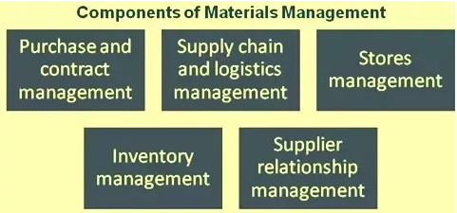

Quality Management:

* Quality management is the act of overseeing all activities and tasks that must be accomplished to maintain a desired level of excellence. This includes the determination of a quality policy, creating and implementing quality planning and assurance, and quality control and quality improvement. It is also referred to as [total quality management](https://www.investopedia.com/terms/t/total-quality-management-tqm.asp) (TQM).
* In general, quality management focuses on long-term goals through the implementation of short-term initiatives.
* At its core, TQM is a business philosophy that champions the idea that the long-term success of a company comes from customer satisfaction and loyalty. TQM requires that all stakeholders in a business work together to improve processes, products, services and the culture of the company itself.
* Quality management ensures that an organization, product or service is consistent. It has four main components: quality planning, quality assurance, quality control and quality improvement. Quality management is focused not only on product and service quality, but also on the means to achieve it.

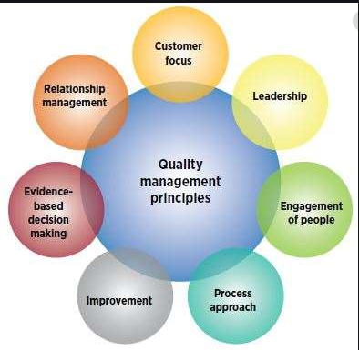

**Assignment – 2**

1) Explain the terminologies related to the industry as applicable:

a) Material Requirement Planning

Ans:

Material requirements planning (MRP) is a system for calculating the materials and components needed to manufacture a product. It consists of three primary steps: taking inventory of the materials and components on hand, identifying which additional ones are needed and then scheduling their production or purchase.

MRP is one of the most widely used systems for harnessing computer power to automate the manufacturing process.

It's important to note, however, that MRP and lean production are not the same and are considered by some practitioners to be antithetical, though some say MRP can help with lean production. MRP is considered a "push" production planning system -- inventory needs are determined in advance, and goods produced to meet the forecasted need -- while lean is a "pull" system in which nothing is made or purchased without evidence of actual -- not forecasted -- demand.

b) Bill of Material

Ans:

A bill of materials (BOM) is an extensive list of raw materials, components, and assemblies required to construct, manufacture or repair a product or service. A bill of materials usually appears in a hierarchical format, with the highest level displaying the finished product and the bottom level showing individual components and materials.

There are different types of bills of materials specific to engineering used in the design process; they're also specific to the manufacturing used in the assembling process.

The different types of bills of materials depend on the projected use and business needs. A manufacturing BOM is essential in designing enterprise resource planning (ERP) systems and materials requirement planning (MRP).

For example, a computer is exploded into hard drives, computer chips, random access memory panels, and processors. Each processor is exploded into an arithmetic unit, control unit, and a register.

c) Manufacturing Resource Planning

Ans:

Manufacturing Resource Planning (MRP II) is an integrated information system used by businesses. Manufacturing Resource Planning (MRP II) evolved from early Materials Requirement Planning (MRP) systems by including the integration of additional data, such as employee and financial needs.

The system is designed to centralize, integrate, and process information for effective decision making in scheduling, design engineering, inventory management, and cost control in manufacturing.

Both MRP and MRP II are seen as predecessors to Enterprise resource planning (ERP), which is a process whereby a company, often a manufacturer, manages and integrates the important parts of its business.

An ERP management information system integrates areas such as planning, purchasing, inventory, sales, marketing, finance, and human resources. ERP is most frequently used in the context of software, with many large applications having been developed to help companies implement ERP.

d) Distributed Requirement Planning

Ans:

Distribution requirements planning (DRP) is the process in which goods are delivered in a more efficient manner. These include considering the aspects of establishing a good, quantity of the good, and the direct location that it is needed to arrive at in a given time.

The pull or push method is utilized by DRP distribution, with pull and push differing from each other. The pull method includes goods shifting upward throughout the system and obtaining customer order achievement. Although management controls the amount of goods available, distribution inventory management is challenging because all orders are considered new to the supplying location as the demand is flowing upward, which is otherwise known as the “Bullwhip Effect”.

e) Product data Management

Ans:

Product data management (PDM) is the use of software to manage product data and process-related information in a single, central system. This information includes computer-aided design (CAD) data, models, parts information, manufacturing instructions, requirements, notes and documents.

The ideal PDM system is accessible by multiple applications and multiple teams across an organization, and supports business-specific needs. Choosing the right PDM software can provide a company in any industry with a solid foundation that can be easily expanded into a full PLM platform.

At its core, a PDM system provides solutions for secure data management, process enablement, and configuration management.

2) Explain the ERP module w.r.t. Finance and Plant Maintenance

Ans:

ERP systems bring together a variety of business processes and facilitate the movement of data between them, and finances are the core of those business processes. An ERP finance module supplies all of the other modules with the necessary data to carry their jobs out.

**ERP Finance Module Features**

1. Profit Tracking

A primary function of ERP financial management modules is profit tracking. The profit tracker will help provide a bird’s-eye view of how the business is using its financial resources, and of its overall financial health. Tracking your profits will show you where the majority of profits are coming from, while also determining the return on investment for any buy.

2. Ledger Management

Ledger management is another fundamental function of ERP financial systems. A general ledger provides a thorough record of all financial transactions. It integrates with all of your other ERP modules, such as inventory management or customer relationship management.

3. Accounts Payable

Accounts payable will manage all of the funds your company owes to your vendors and other creditors. An accounts payable feature integrates your payable data with your purchasing system so you can take control of your cash flows.

4. Accounts Receivable

Accounts receivable allows your business to manage all of the funds customers owe them. It will track customer payments as well as manage invoices and cash.

5. Fixed Asset Management

This solution tracks and manages all of your company’s tangible assets, such as manufacturing equipment, computers, company cars and office space. It will take into account depreciation calculations, compliance

**Plant Maintenance in resource ERP**

The Plant Maintenance module in ERP provides an integrated solution for supporting the operational needs of an enterprise-wide system. The module includes an entire family of products covering all aspects of plant/machine maintenance and becomes integral to the achievement of process improvement.

Machine Maintenance and Plant Maintenance module in ERP Software supports various options for structuring technical systems with its object, type and function-related views, and enables flexible navigation. Data concerning the planning processing and history of maintenance tasks is documented in the system and complies with business verification requirements.

The major sub-systems of eresource ERP Plant & Machine Maintenance module are:

* Breakdown Repair Log
* Equipment Master Register
* Machine Breakdown Log
* Maintenance Type1
* Man Power for Machine Details
* Preventive Maintenance Record
* Spare Part Installation Log