**VISVESVARAYA TECHNOLOGICAL UNIVERSITY**

**“Jnana Sangama”,** **BELAGAVI – 590018**



**A MINI PROJECT REPORT ON**

**“PERSONAL MANAGEMENT SYSTEM”**

Submitted in partial fulfillment of requirements for the *course*

**DBMS Laboratory with Mini Project [18CSL58]** *of Fifth Semester*

*of Bachelor of Engineering Information Science & Engineering*

*during the academic year 2022-23.*

**Submitted By**

|  |  |
| --- | --- |
| **Abhishek SM**  **4MH20IS003** | **Rajesh S**  **4MH20IS065** |

**Under the Guidance of**

**Prof. Puneeth**

**Assistant Professor**

**Dept. of ISE.**



**DEPARTMENT OF INFORMATION SCIENCE & ENGINEERING**

**MAHARAJA INSTITUTE OF TECHNOLOGY MYSORE**

**Belawadi, S.R. Patna (T), Mandya (D) – 571477. 2022 - 2023**

**MAHARAJA INSTITUTE OF TECHNOLOGY MYSORE**

**Belawadi, S.R. Patna (T), Mandya (D) – 571477.**

**DEPARTMENT OF INFORMATION SCIENCE & ENGINEERING**

**MAHARAJA INSTITUTE OF TECHNOLOGY MYSORE**

**MANDYA-571438**



**CERTIFICATE**

This is to certify that the mini project work entitled **“PERSONAL MANAGEMENT SYSTEM”** is a Bonafede work carried out by **Abhishek SM [4MH20IS003]** and **Rajesh S [4MH20IS065]** in partial fulfillment for the **DBMS Laboratory with Mini Project (18CSL58)** prescribed by the Visvesvaraya Technological University, Belagavi during the year 2021-2022 for the fifth semester B.E in Information Science and Engineering. The mini project report has been approved as it satisfies the academic requirements.

|  |  |
| --- | --- |
| Signature of Guide  ( **Prof. Puneeth**)  Assistant Professor, Dept. of ISE  MIT Mysore | Signature of HOD  (**Dr. Sharath Kumar Y H**)  Professor & Head, Dept. of ISE  MIT Mysore |

**Name of the Examiners** **Signature with date**

**1.**

**2**.

**ACKNOWLEDGEMENT**

We sincerely owe our gratitude to all the persons who helped and guided us in completing this mini project work.

We are thankful to **Dr. B.G. Naresh Kumar, Principal, Maharaja Institute of Technology Mysore**, for having supported us in our academic endeavours .

We are extremely thankful to **Dr Sharath Kumar Y. H, Professor** and **Head, Department**

**of Information Science and Engineering**, for his valuable support and timely inquiries into

the progress of the work.

We are greatly indebted to our **guide Prof. puneeth, Assistant Professor** **Department of Information Science and Engineering**, for the consistent co-operation and

Support.

We are obliged to all **teaching and non-teaching staff members** of **Department of**

**Information Science and Engineering,** for the valuable information provided by them in their

respective field’s. We are grateful for their co-operation during the period of our mini project.

**Abhishek S M [4MH20IS003]**

**Rajesh S [4MH20IS065]**

**ABSTRACT**

Personnel management is a crucial aspect of any human being and plays a vital role in his/her success. A good personnel management system helps to improve one’s own productivity and efficiency.

This project aimed to develop a comprehensive personnel management system for a hypothetical organization using PHP and framework. The system was designed to be user-friendly and scalable, with features such as gym schedule, personal diary , image and file upload and personal health care.

The system provided a platform for efficient management of personnel and helped increase the ones own productivity and efficiency.

In conclusion, the personnel management system proved to be a valuable tool for one individual and provided a platform for effective personnel management.

**TABLE OF CONTENTS**

**1. INTRODUCTION**

1.1 Overview ……….……………........……………...……….………....07

1.2 Problem statement …….……………….…………..………..…….....07

1.3 Existing system………………...……….….….. …...…………….....08

1.4 Proposed system………………..…....……………………..………..08

1.5 Advantage …………………….........……………………………......09

**2. SOFTWARE REQUIREMENTS**

2.1 Software used ….………………....…...……………………….…...10

2.2 Software description………...…………………………….……..….10

**3. SYSTEM ANALYSIS AND DESIGN**

3.1 Schema Diagram …..……….....…………………………………...13

3.2 E-R Diagram …………….…........……...………………………....15

3.3 Use Case Diagram …….………....…………...………………...…17

3.4 Data Flow Diagram ……..…….…….………...………...………...18

3.5 Sequence Diagram ………..….….………......………...……….....19

3.6 Description of Tables ………...…....……………………….……..20

**4. IMPLEMENTATION AND RESULTS**

4.1 Back End Implementations ……………….…………………….…...23

4.2 Triggers …………………..…………......…...………………..….....25

4.3 Normalization …………......………………………………………..26

4.4 Assertion ………………………….........…………………….……..27

4.5 Testing …………….…………..…............................……………....27

**5. SNAPSHOTS&DISCUSSIONS**

5.1 Snap Shots and discussion……………….…………………….. 28-34

**6. CONCLUSION AND FUTURE WORK**

6.1 Conclusion …………………………......................………....34

4.2 Future work ……………………….....………...….………... 36

**7. REFERENCES …….……………………………...…………...37**

**CHAPTER 1**

**INTRODUCTION**

* 1. **OVERVIEW:**

A personal management system (PMS) is a website that helps individuals manage their personal and professional information, tasks, and schedules. A PMS typically includes features such as a gym timing and workouts, health and tablet schedule, photo and file upload as well as retrieve and personal notes. In our PMS it also includes individual feedback counter where everyone can see it, as well as user can rate the website. A project report on a PMS would typically include information on the system's design and functionality, as well as any key features or benefits that it offers. Additionally, the report include information on the development process, including any challenges or obstacles that were encountered and how they were overcome. It may also include testing and evaluation results, as well as any future plans for the system.

* 1. **PROBLEM STATEMENT**
     1. Difficulty keeping track of personal and professional tasks and responsibilities: Many individuals struggle with keeping track of all of their tasks and responsibilities, leading to missed deadlines and forgotten obligations. A PMS would aim to provide a central location for individuals to manage their tasks and schedules, making it easier to stay organized and on top of their to-do list.
     2. Difficulty staying organized and managing personal information: Many individuals find it challenging to keep track of important personal information, such as contact information, bills, and important documents. A PMS would aim to provide a central location for individuals to store and manage this information, making it easier to stay organized and on top of important details.
     3. Difficulty setting and achieving gym routine: Setting and achieving gym routine can be challenging for many people, particularly when it comes to breaking down big goals into smaller, more manageable steps. A PMS would aim to provide tools for individuals to set and track gym timing and type, as well as providing resources and guidance to help individuals achieve that.
  2. **EXISTING SYSTEM**

In present system you have to login first. If you don’t have any account, you can register . After login you can choose to add note or upload photos and files or you can add your tablet schedule or you can schedule your gym timing and type of the workout you wanted. also you can check your BMI (body mass index) at any moment of time.

This websites user interface is user friendly where you can identify things quickly and get into it.

There is option for every user that he/she can give feedback which is public in view, users can see how others are using this, are they enjoying this website or not .

In the NOTE option user can add his thoughts , activity or anything user wish to. User can delete , edit and can view what he/she entered.

In the HEALTH option user can enter his/her tablet details , at what scheduled time user must take tablets.

In the PICS option user can choose photos of any size from their local storage and can upload here, and also he can view that photos dynamically.

In the FILES option user can upload and retrieve the files that the user wanted. Its more of like PICS UI.

**Drawbacks:**

* Low tech support
* Security is not assured
* Less efficient .
  1. **PROPOSED SYSTEM**

The aim of proposed system is to develop a system of improved facilities. The proposed system can overcome all the limitations of the existing system.

* Ensure data accuracy's.
* Proper control of the higher officials.
* Minimize manual data entry.
* Minimum time needed for the various processing.
* Better service.
* User friendliness and interactive.
* Minimum time required.
  1. **Advantages:**
* Faster System
* Accuracy
* Reliability
* Informative
* Easy updating and deleting of data

**CHAPTER 2**

**SOFTWARE REQUIREMENTS**

* 1. **Software Used:**

Operating system : Windows 98, XP, 7,8 or 10 or Linux

Languages (Front end) : HTML PHP and CSS [Bootstrap]

Back end : SQL

IDE : Visual studio, Notepad++, Xampp and MySQL

* 1. **Software Description**:
     1. **XAMPP(PhpMyAdmin)**

PhpMyAdmin can manage a whole MySQL server as well as a single database. To accomplish the latter you'll need a properly set up MySQL user who can read/write only the desired database. It's up to you to look up the appropriate part in the MySQL manual.

* Xampp browses and drop databases, tables, views, columns and indexes and create, copy, drop, rename and alter databases, tables, columns and indexes.
* It maintenance server, databases and tables, with proposals on server configuration and execute, edit and bookmark any SQL-statement, even batch-queries.
* It loads text files into tables, create and read dumps of tables and export data to various format of some where: CSV, XML, PDF, 150/IEC 26300 –.
* Open Document Text and Spreadsheet, Word, and LTX formats and import data and MYSQL structure from Open Document spreadsheets, as well as XML, CSV and SQL files administer multiple servers manage MySQL users
* Privileges and check referential integrity in MyISAM tables and using Query-by-ecample(QBE), create complex queries automatically connecting required tables and create PDF graphics of your Database layout.
* Create, edit, export and drop events and triggers communicate in synchronize two database residing on the same as well as remote servers.
  + 1. **PHP**:
* You need PHP 5.2.0 or newer, with session support, the Standard PHP Library (SPL) extension and JSON support.
* To support uploading of ZIP files, you need the PHP zip extension.
* For proper support of multibyte strings (eg. UTF 8, which is currently the default), you should install the mb string and c type extension.
* You need GD2 support of multi-byte string (eg . UTF-8, which is currently the

default), you should install the Mb string and c Type extensions.

* + 1. **The SQL Language:**

SQL is a language for relational database. SQL is a non-procedural i.e., when we use SQL we specify what we want to be done not how to do it. Features of SQL:

* SQL is an interactive query language.
* SQL is a database administration language.
* SQL is a database programming language.
* SQL is a client/server language
* SQL is a distributed database language.
* SQL is a database gateway language.

**Basic SQL Commands**

* Data Definition Language commands (DDL)
* Data Manipulation Language commands (DML)
* Transaction Control Language commands (TCL)
* Data control Language commands (DCL)
  + 1. **HTML:**

To publish information for global distribution, one needs a university-understood language, a kind of publishing mother tongue that all computers may potentially understand. The publishing language used by the World Wide Web is HTML (Hyper Text Markup Language)

➢Publish online documents with headings, text, tables, list, photos etc.

* Retrieve online information via hypertext links, at the click of a button

➢Includes spreadsheets, video clips, sound clips, and other applications directly in

the documents.

**CHAPTER 3**

**SYSTEM ANALYSIS AND DESIGN**

**System Analysis**

System analysis is a detailed of the various operations performed by a system and their relationship within and outside the system. It is a systematic technique that defines goals and objective. The goal of system development is to develop a system in line with the user requirement and analysis of the system plays important role. One of the main aspects of analysis is the defining the boundaries of the system.

The various tools of structured analysis are:

1. Schema Diagram
2. E-R Diagram
3. Use Case Diagram
4. Data Flow Diagram
5. Sequence Diagram
   1. **Schema Diagram:**

The design of the database is called a schema. This tells us about the structural view of the database. It gives us an overall description of the database. A database schema defines how the data is organized using the schema diagram. A schema diagram is a diagram which contains entities and the attributes that will define that schema. A schema diagram only shows us the database design. It does not show the actual data of the database.

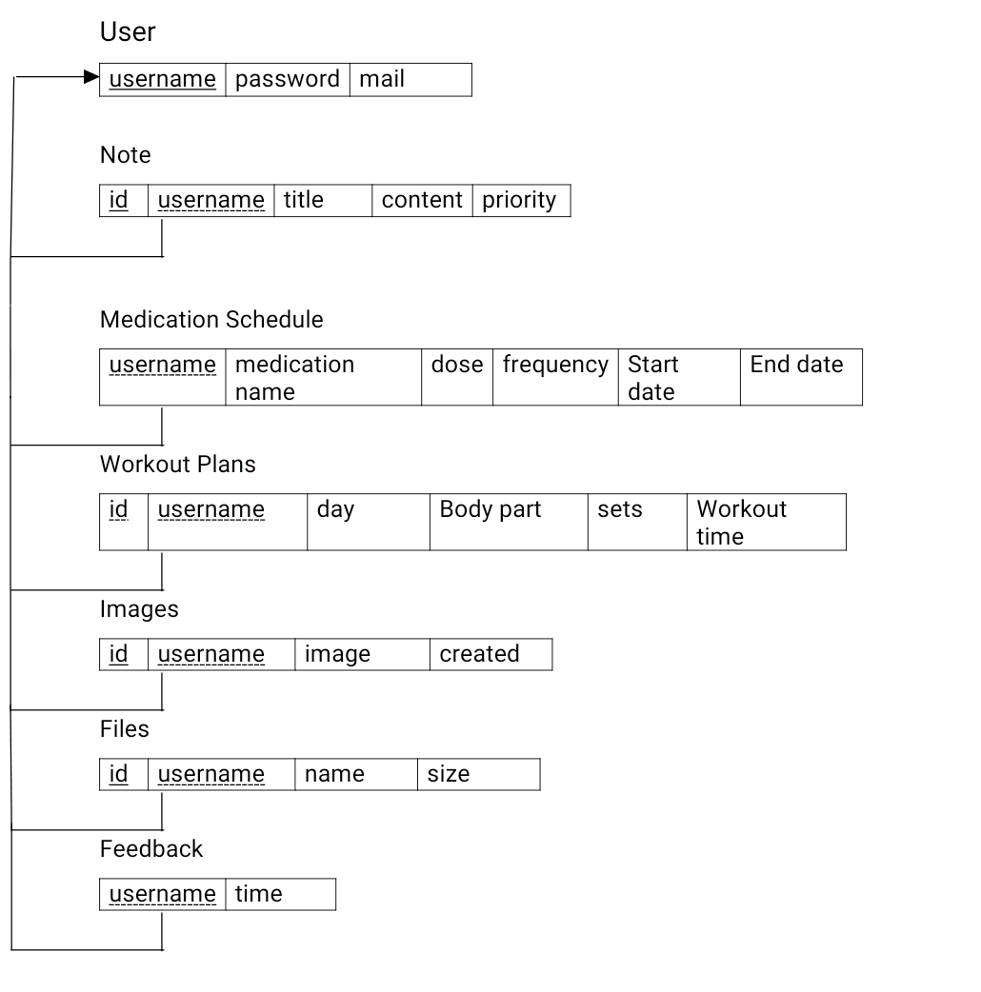

* 1. **Entity Relationship Diagram:**

**ER Diagrams Symbols & Notations:**

* Rectangles: This Entity Relationship Diagram symbol represents entity types.
* Ellipses: Symbol represent attributes.
* Diamonds: This symbol represents relationship types
* Lines: It links attributes to entity types and entity types with other relationship types.
* Primary key: attributes are underlined.
* Double Ellipses: Represent multi-valued attribute.

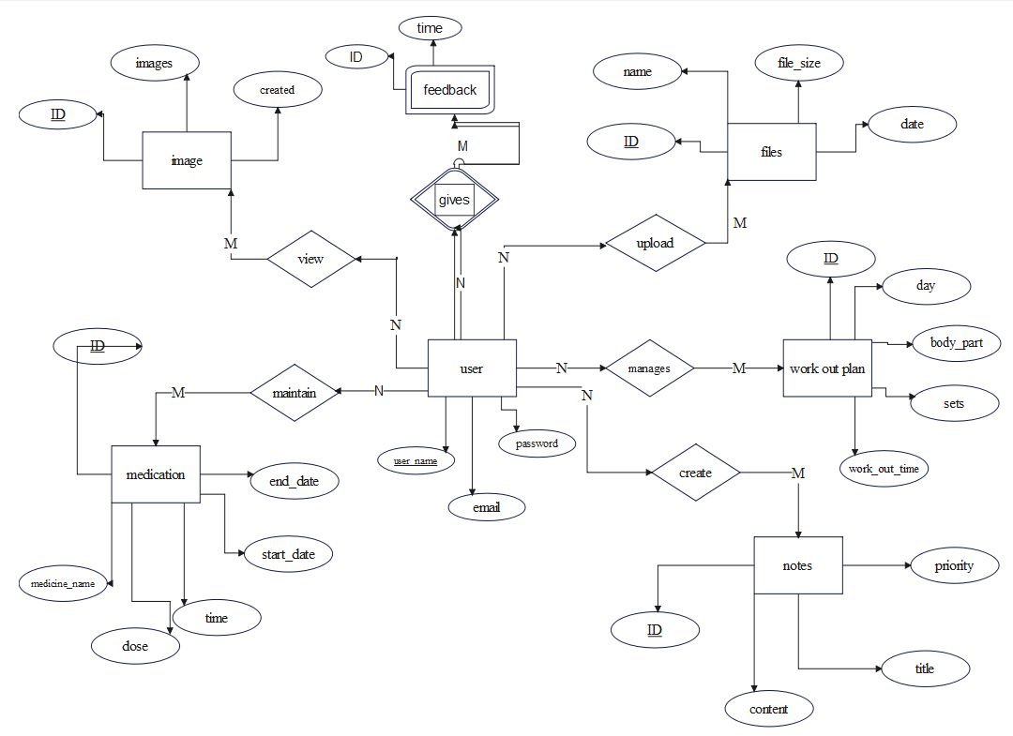

An ER model describes the relations between entities. It is adapted to represent relational data.

Data that cannot easily be put into this form should not be modelled with an ER model. ER is aimed at designing a database from scratch; using it to describe and change a database that already exists may be more difficult to do.

Even where it is suitable in principle, ER diagram is rarely used as a separate activity. One reason for this is that there are many tools that allow diagramming and that have other design support directly on relational database management system. These tools can extract database

diagrams that are very close to ER diagrams from existing databases, and they provide alternative views on the information contained in such diagrams.

* + 1. **E R Mapping:**
* Step 1: Mapping of regular entity type.
* Step 2: Mapping of weak entity type.
* Step 3: Mapping of 1 is to 1 relationship types. There is no 1 is to 1 relationship types in the ER Diagram.
* Step 4: Mapping of 1 is to N relationship types.
* Step 5: Mapping of M is to N relationship types.
* Step 6: Mapping of multivalued attributes.
* Step 7: Mapping of N-array Relationship types.
  + **Use Case Diagram :**

A use case diagram is a visual representation of a system's functional requirements. It represents the interactions between actors (users or external systems) and the system's functions (use cases) in a clear and concise manner. The diagram helps identify the relationships between the actors and use cases and provides a high-level view of the system's functionality. The actors are depicted as stick figures and the use cases are represented as oval shapes. The lines between the actors and use cases indicate the interaction between them. Use case diagrams are useful in the early stages of software development to communicate the requirements to the development tea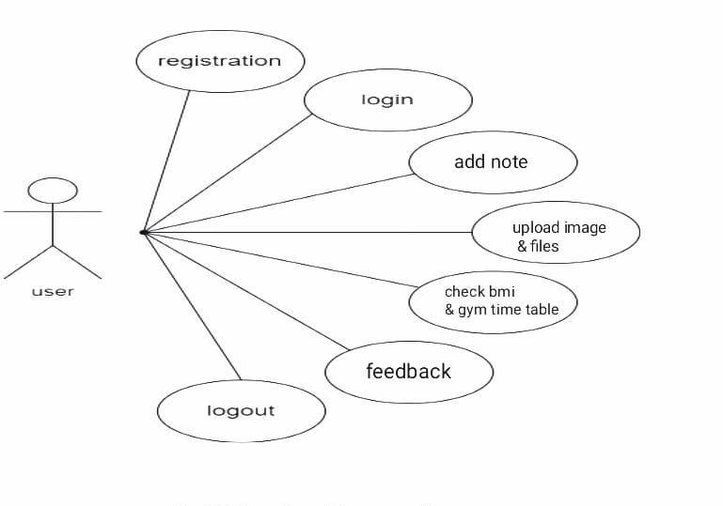m.

**3.3 Data Flow Diagram :**

DFD is a model, which gives the insight into the information domain and functional domain at the same time. DFD is refined into different levels. The more refined DFD is, more details of the system are incorporated. In the process of creating a DFD, we decompose the system into different functional subsystems. The DFD refinement results in a corresponding refinement of data.

Following is the DFD of the “Proposed System”. We have refined the system up to two levels. Each break-up has been numbered as per the rule of DFD. We have tried to incorporate all the details of the system but there is some chance of further improvisation because of the study that is still going on for the project development

The objective of a DFD is to show the scope and boundaries of a system as a whole. It may be used as a communication tool between a system analyst and any person who plays a part in the order that acts as a starting point for redesigning a system. The DFD is also called as a data flow graph or bubble chart.

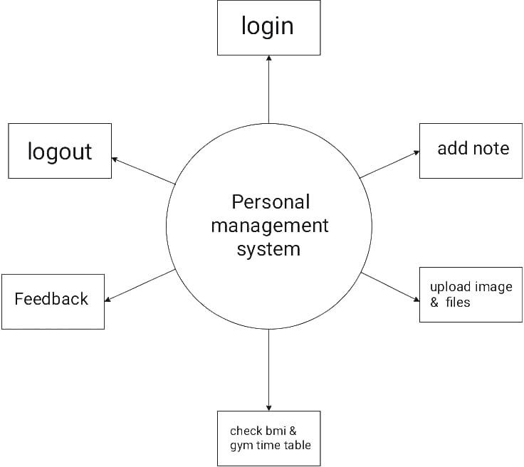

The following observations about DFDs are essential:

* All names should be unique. This makes it easier to refer to elements in the DFD.
* Remember that DFD is not a flow chart. Arrows is a flow chart that represents the order of events; arrows in DFD represents flowing data. A DFD does not involve any order of events.
  1. **Sequence Diagram:**

A sequence diagram is a type of Unified Modeling Language (UML) diagram that shows the interactions between objects in a system over time. It is a useful tool for visualizing the flow of interactions in a system and can help to understand the relationships between objects in a system.

In conclusion, the sequence diagram is a useful tool for understanding the interactions between objects in the personnel management system and for visualizing the flow of interactions in the system. It can help to understand the relationships between objects and the steps that users take to access the system and manage personnel information.

* 1. **TABLES DESCRIPTION:**

1. **DESC USER:**

* The “user” provides all information about the user.

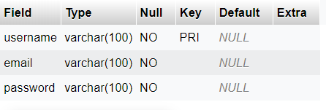

1. **DESC NOTE:**

* The “noter” provides all information about the note.

1. **DESC MEDICATION_SCHEDULE:**
   * The “medication _schedule” provides all information about the medication _schedule.

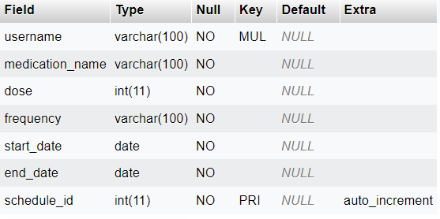

1. **DESC WORKOUT_PLANS:**

* The “workout _plans” provides all information about the workout _plans.

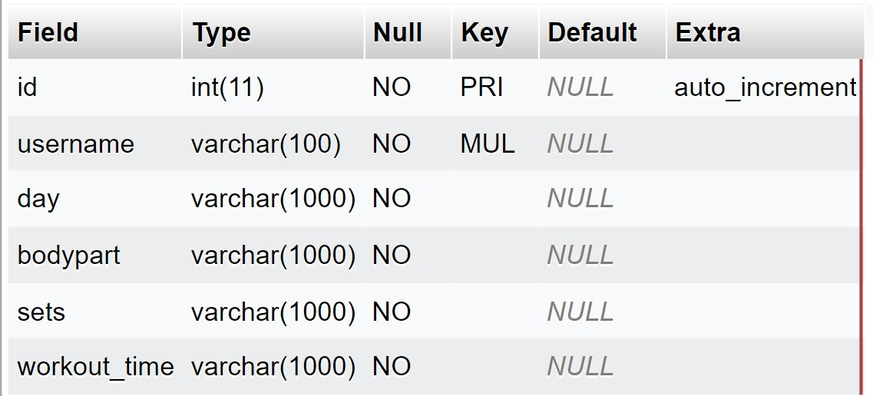

1. **DESC IMAGES;**

➢

The “images” provides all information about the images.

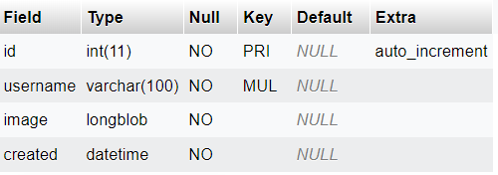

1. **DESC FILES;**
   * The “files” provides all information about the files.

1. **DESC FEEDBACK;**
   * 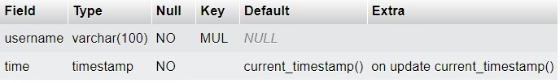The “feedback” provides all information about the feedback.

**CHAPTER 4:**

**IMPLEMENTATION AND RESULTS**

**4.1 Back End Implementations:**

All backend is done by using php, mysql and Xamapp;

* 1. **Database connection:**

// initializing variables

$username = "";

$email = "";

$errors = array();

// connect to the database

$db = mysqli_connect('localhost', 'root', '', 'project');

* 1. **Login:**

if (mysqli_num_rows($results) == 1)

{

$_SESSION['username'] = $username;

$_SESSION['success'] = "You are now logged in"; header('location: index.php');

}

Else

{

array_push($errors,"Wrongusername/password combination");

}

}

* 1. **Register:**

// form validation: ensure that the form is correctly filled ...

// by adding (array_push()) corresponding error unto $errors array

if (empty($username)) { array_push($errors, "Username is required"); } if (empty($email)) { array_push($errors, "Email is required"); }

if (empty($password_1)) { array_push($errors, "Password is required"); } if ($password_1 != $password_2) {

array_push($errors, "The two passwords do not match");

}

**4.14 images:**

$check = getimagesize($_FILES["image"]["tmp_name"]); if($check !== false){

$username =$_SESSION['username'];

$image = $_FILES['image']['tmp_name'];

$imgContent = addslashes(file_get_contents($image));

**4.15 files:**

$filename = $_FILES['myfile']['name'];

// destination of the file on the server

$destination = 'uploads/' . $filename;

// get the file extension

$extension = pathinfo($filename, PATHINFO_EXTENSION);

// the physical file on a temporary uploads directory on the server

$file = $_FILES['myfile']['tmp_name'];

$size = $_FILES['myfile']['size'];

* 1. **TRIGGER:**
* There is a basic triggers in this project.

Triggers are stored programs, which are automatically executed or fired when some events occur. Triggers are, in fact, written to be executed in response to any of the following events. A database manipulation (DML) statement (DELETE, INSERT or UPDATE) A database definition (DDL) statement (CREATE, ALTER, or DROP).

A database operation (SERVER ERROR, LOGON, LOGOFF,STARTUP OR SHUTDOWN).

Triggers can be defined on table, view, schema or database with which the event is associated.

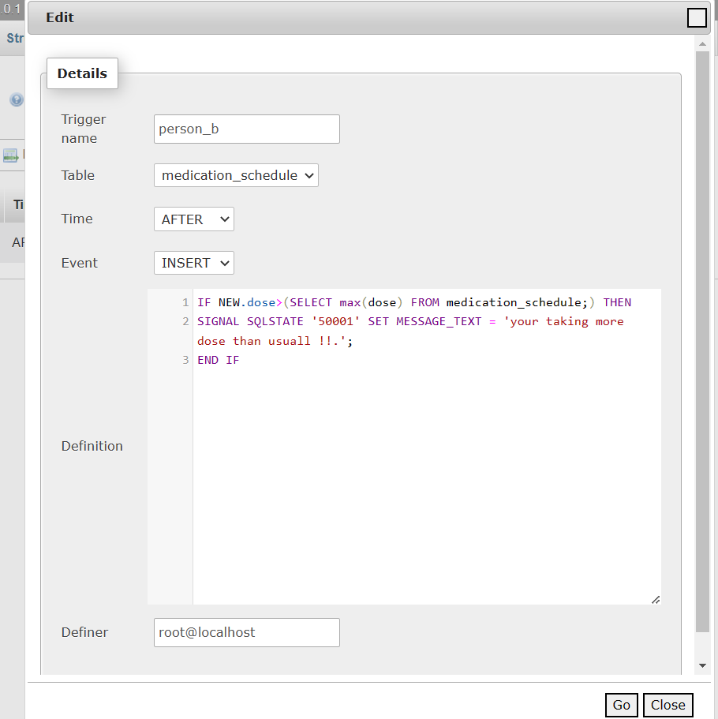

* 1. **Normalization**

1. **Normal Function:**

1NF disallows relations within relations or relations as attribute values within tuples. The only attribute values permitted by 1NF are single atomic (or individual) values.

**NOTE Table attributes and values :**



In the above picture we can see that there is no multivalued attribute.

1. **Normal Function:**

2NF: A functional dependency X Y is a full functional dependency if removal of any attribute A from X means that the dependency does not hold any more; that is, for any attritube A X,(X- {A}) does not functionally determine Y.

Example which satisfies 2NF:

**NOTE Table Schema :**

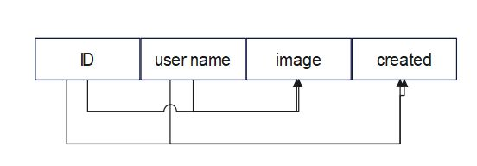

There are two candidate keys which do not partially imply any other attribute independently.

1. **Normal Function:**

Transitive functional dependency, A functional dependency X Y in

a relation schema R is a transitive dependency if there exists a set of attribute Z that are neither a primary nor a subset of any key of R (candidate key) and both X Z and

Y Z holds.

**NOTE Table Schema :**

There is no transitive relation in above schema, hence it doesn’t violate 3NF rule.

* 1. **Assertion:**

An assertion is a piece of SQL which makes sure a condition is satisfied, else or it stops the action being taken on a database.

An assertion is a constraint that might be dependent upon multiple rows of multiple tables.

Domain constraints, functional dependency and referential integrity are special forms of assertion are dependent (involve) on single row of a table at a time. Any modification to a database is allowed only if it would not cause any assertion are checked only when UPDATE or INSERT actions are performed against the table.

* 1. **Testing**

|  |  |  |  |  |  |
| --- | --- | --- | --- | --- | --- |
| No | Test cases | Case type | Expected Result | Actual Result | Pass / Fail |
| 1 | Login | 1. Invalid ID | The system will not accept the invalid ID &  throws message | The system will not allow to login into the  system | Pass |
|  |  | 2. Invalid Password | The system will not accept the invalid password and throws  message | The system will not allow to login into the system | Pass |
| 2 | Validation Testcase | 1.Require field  validation | Field should not be empty | Users have to enter the  value | Pass |

**Chapter 05**

**Snapshots and Discussions**

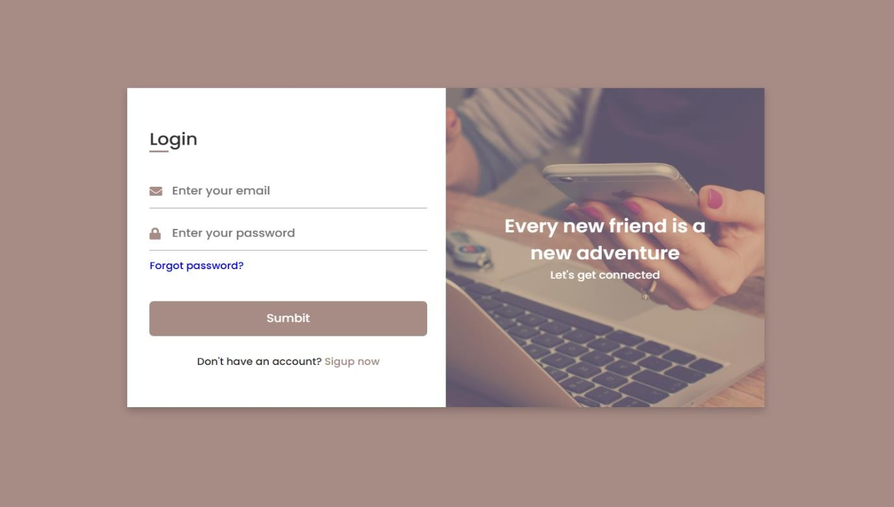

Fig 5.1 : login page.

* + - **Login Page :**

In this Page referring above the user-interface is designed in such a way that the coordinator has to provide email and password if he or she already has an account with the application. If the coordinator does not have an account,

should click on registration button to register.

If user gives wrong name and password it will pop respective Message and user want to enter from start.

Input:

* + - email
    - password

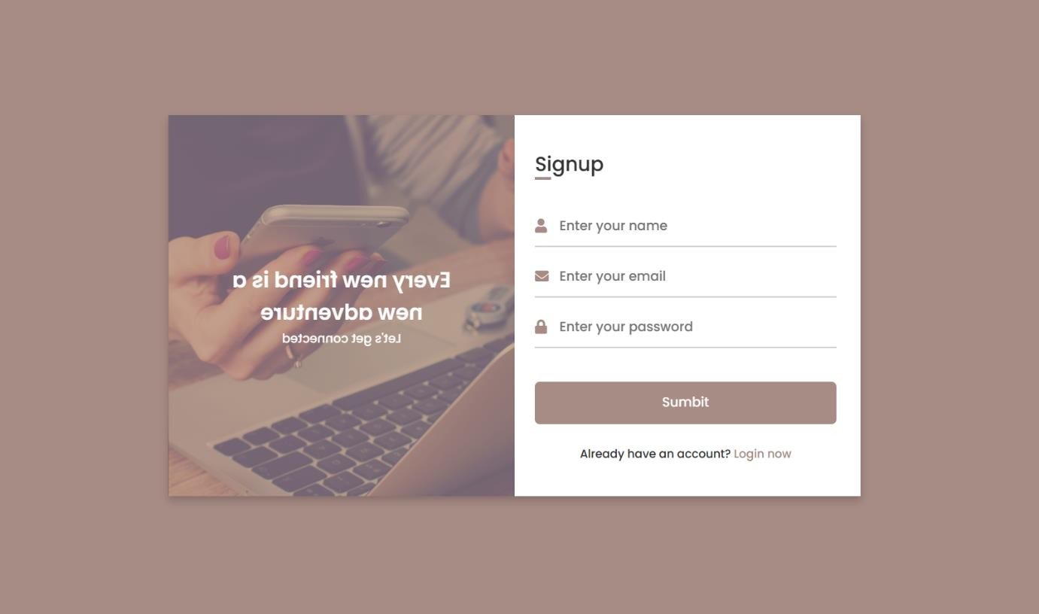

Fig 5.2 : signup page.

* + - **Sign Up Page :**

In this page referring above, the registration portal for opens up for coordinator who has to give following inputs :

1. Firstname
2. Email
3. Password

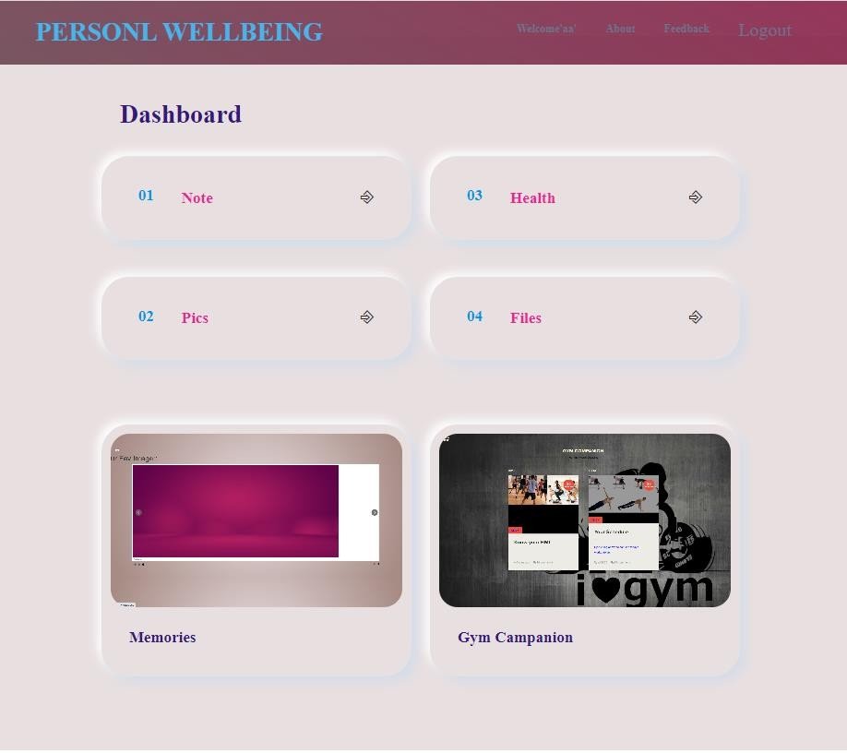

Fig 5.3 : Home page.

* Above snapshot is home page:

Their we have fallowing options:

1. Note
2. Health
3. Images
4. Files

in the note user can add his thoughts or any important note, also he can use this as his/her personal diary!

In the health section user can add his tablet details like tablet name, dose, from what date to start and end.

In the images section user can add pictures from local storage directly to to the database and can view dynamically.

In the files section user can add files and can download at any time he want.

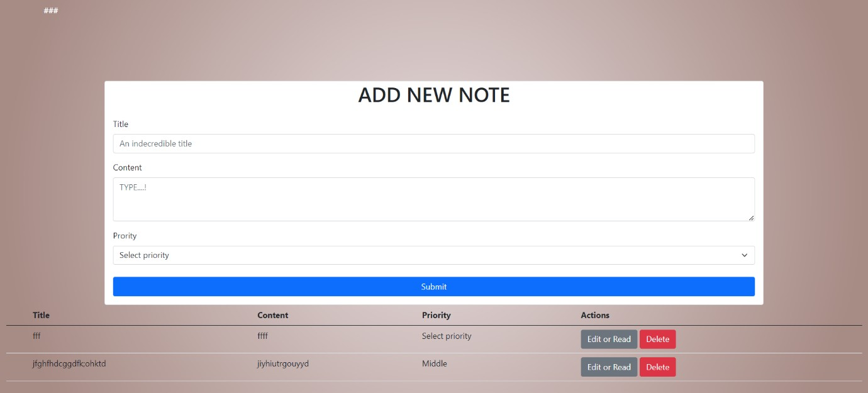

Fig 5.4 : Note page.

* + Above snapshot is for note taking:

In the note option we can add simple key notes or thoughts that user wish to or user can use this like a personal diary if he wants. User can delete the created note from the database.

User can also alter the previously updated note.

User can view all the note he entered in the note option

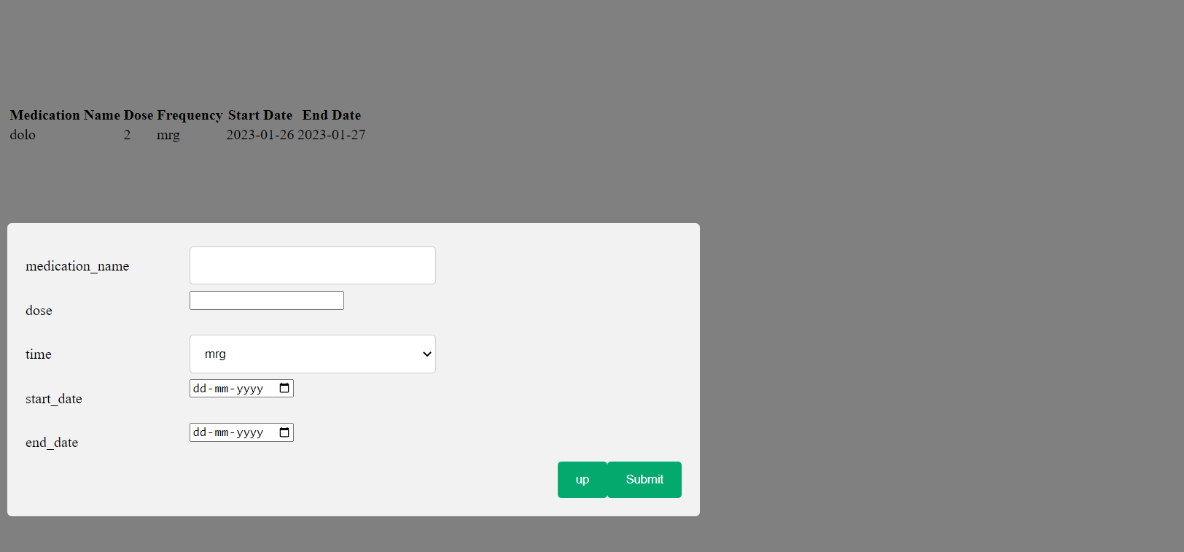

Fig 5.5:Medication schedule.

* + - The above snapshot shows about health:

In the health section user can add his or her drugs given by the doctor. User can add how much dose is to consume on the time basis.

User can also add frequency of the dose. Also start date of the tablet consumption and end of the tablet consumption.

By this user can organize his tablet schedule and can see this through.

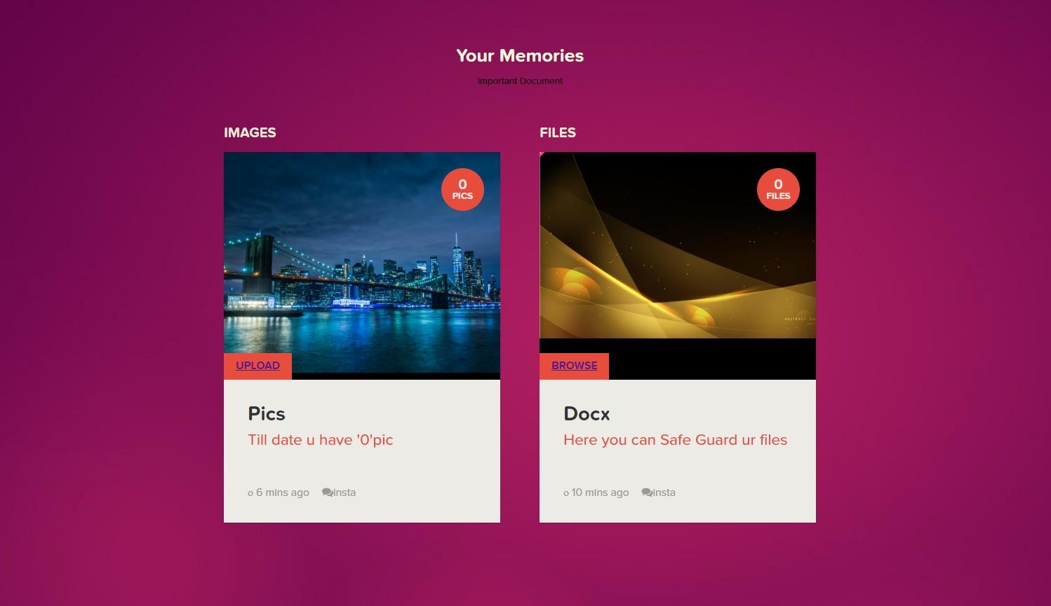

Fig 5.6: index page for image and files upload and view.

The above snapshot is about index page for image and documents :

File upload and image upload are crucial functionalities in many web applications. The file upload feature allows users to upload any type of file, such as documents, images, videos, and audio files, to the server for storage and further processing. Image upload specifically refers to uploading image files to the server.

These functionalities are important for applications that require users to store and manage their files and images. They can also be used to enhance the user experience by allowing users to upload their profile picture, cover photo, or images related to their content.

Both file and image upload are implemented using the HTML form element, JavaScript, and server-side scripts like PHP . Security measures such as file type validation and size restrictions must be implemented to prevent malicious files from being uploaded to the server.

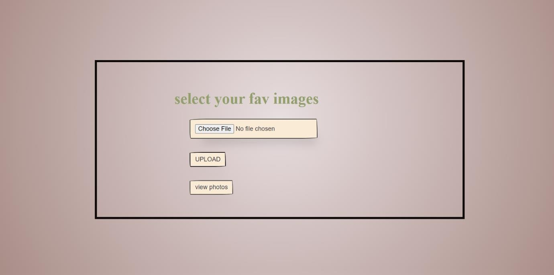

Fig 5.7: Page for image upload .

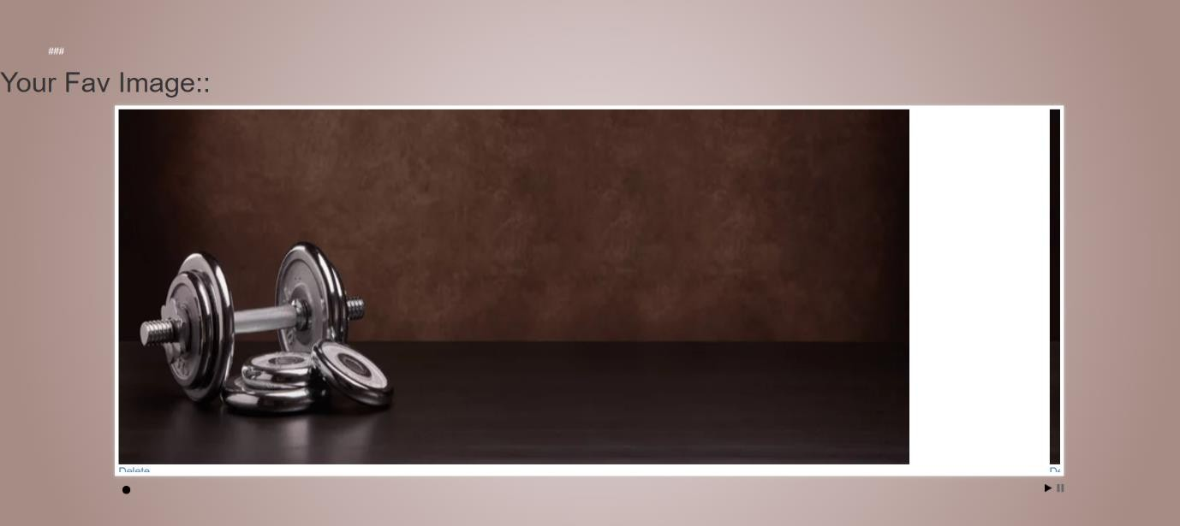

Fig 5.8 : Page for image view

The above snapshot is about images:

In the images option user can directly add the images that he wish to add from the local storage to our database.

Also user can view the photos from the data base by pressing view photos option. Here we used dynamic photo viewing style where the images view dynamic side wise.

In choose file button user can choose the image from local storage. In the upload button , the selected image will upload.

In the view button user can view the image and he can also delete the uploaded image.

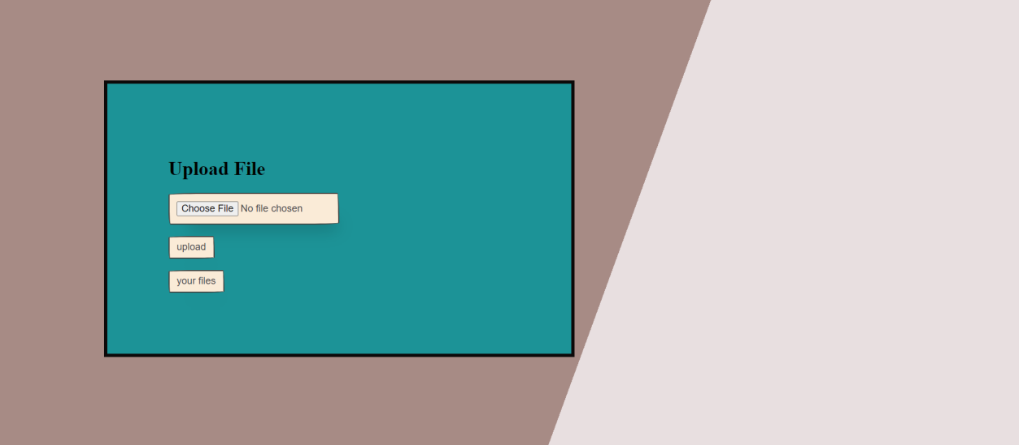

Fig 5.9 : Page for files upload.

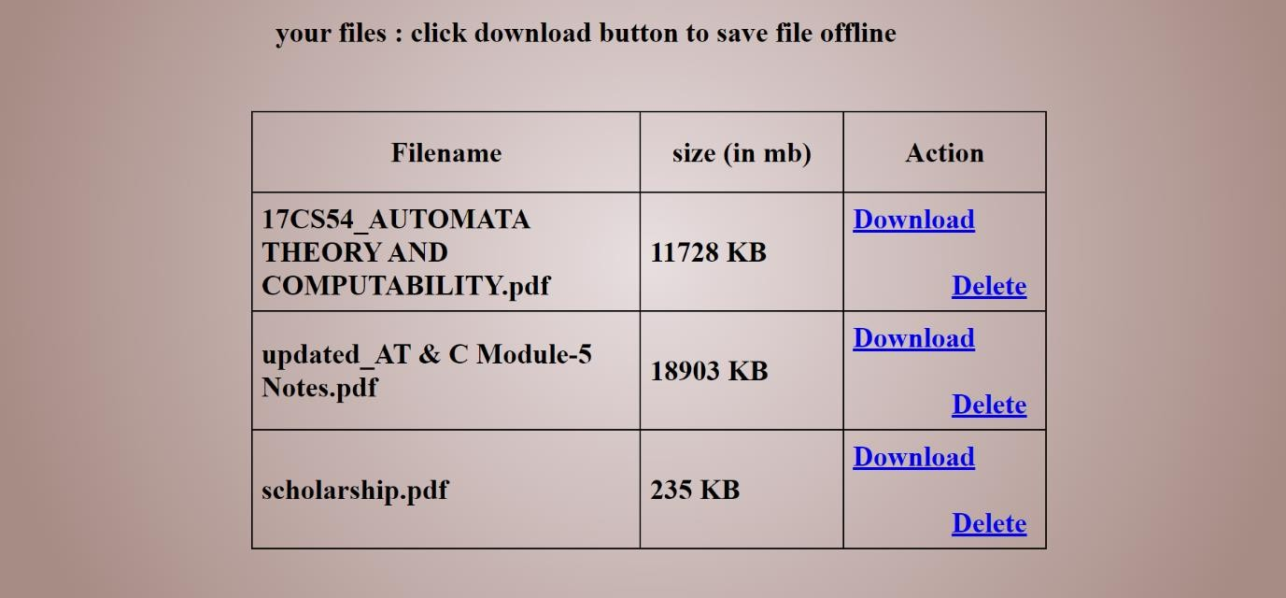

Fig 5.10: Page for files download.

The above snapshot is about files:

In the files section user can upload documents of type .docx , .pdf , .png of any size.

The uploaded files will directly store in the specified path that we have given earlier in the code section.

If we view files we can see the name and size of the files that we added.

Here user can delete or download the file. the downloaded files will save in the path specified by the user in the local storage.

In choose file button user can choose the file from local storage. In the upload button , the selected file will upload.

In the view button user can view the file and he can also delete the uploaded file.

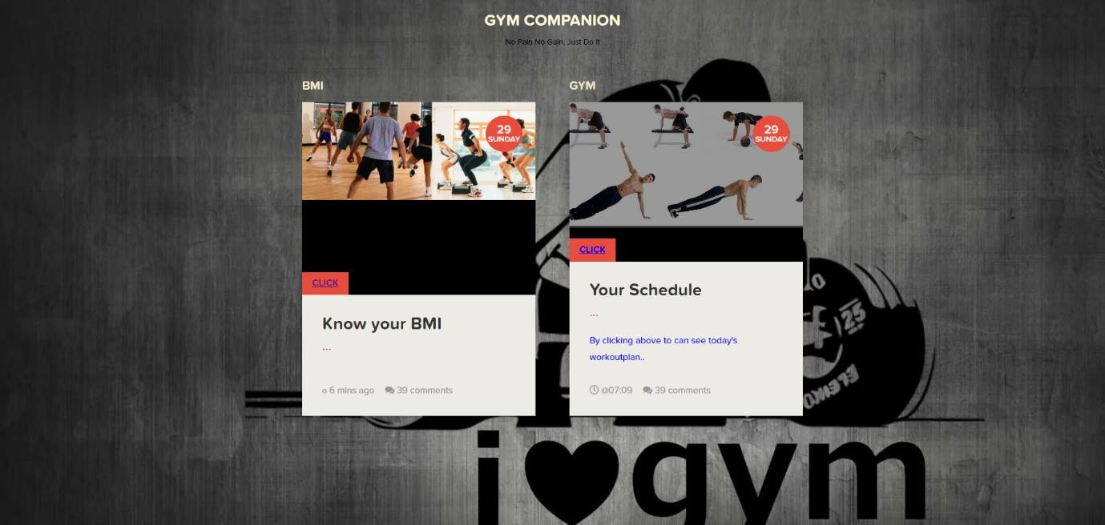

Fig 5.11: index page for gym schedule and bmi calculator.

Above snapshot shows the index page for the gym companion option. Here user will two option 1.bmi and 2.workout schedule.

User can click whichever he/she wish to.

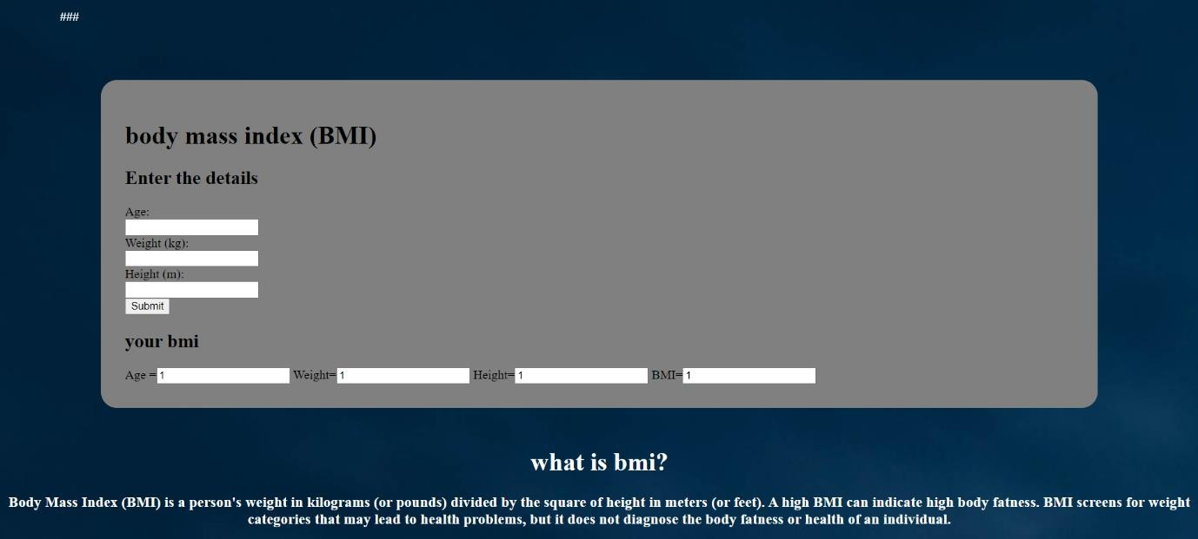

Fig 5.12: Page for bmi calculator.

Above snapshot shows about BMI:

in our project user can also check his/her BMI(body mass index) which is calculated using users entry of his/her height and weight .

this shows the body mass ratio of the person. BMI result can help the user to specify the how much calories he should burn to full fill the BMI.

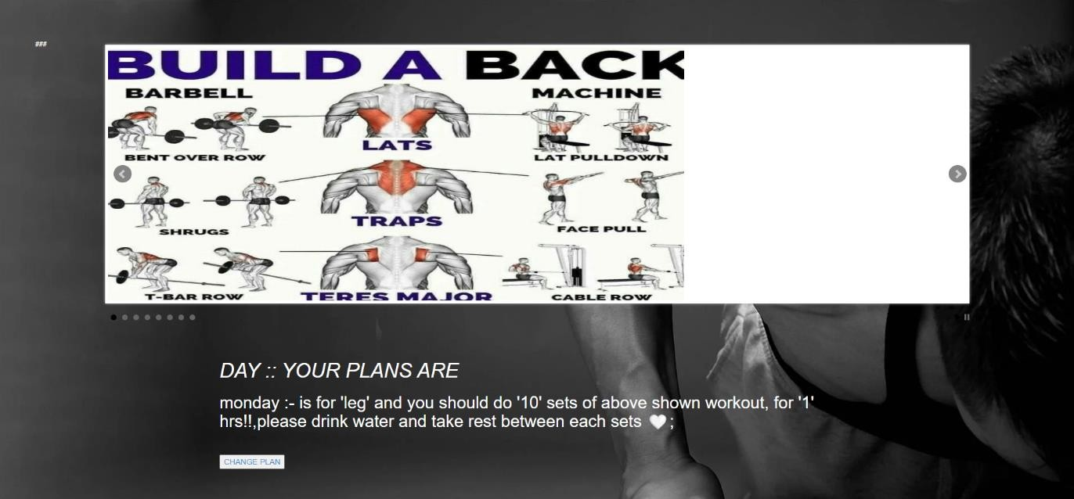

Fig 5.13: To view gym plan for day.

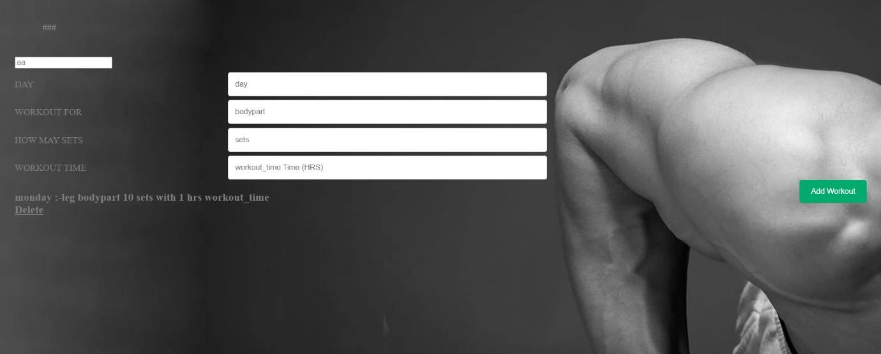

Fig 5.14: index page for gym schedule.

The above snapshot shows about gym companion :

In the gym companion section user can add his gym type and the duration of the type of the gym .

Also user can add how many sets should do on the daily basis and top of that user can add the day of the workout.

By this user can stay organized about his gym time and routines.

Also user can see the images of the workout type that he wanted to do for the day.

By this user can directly get into workout without prior preparation of what should be done today.



Fig 5.15 : Page to show about developer.

Above snapshot shows about developers of the project:

Here user can see about the developer details like photos, contact details, social platforms, skills and their work.

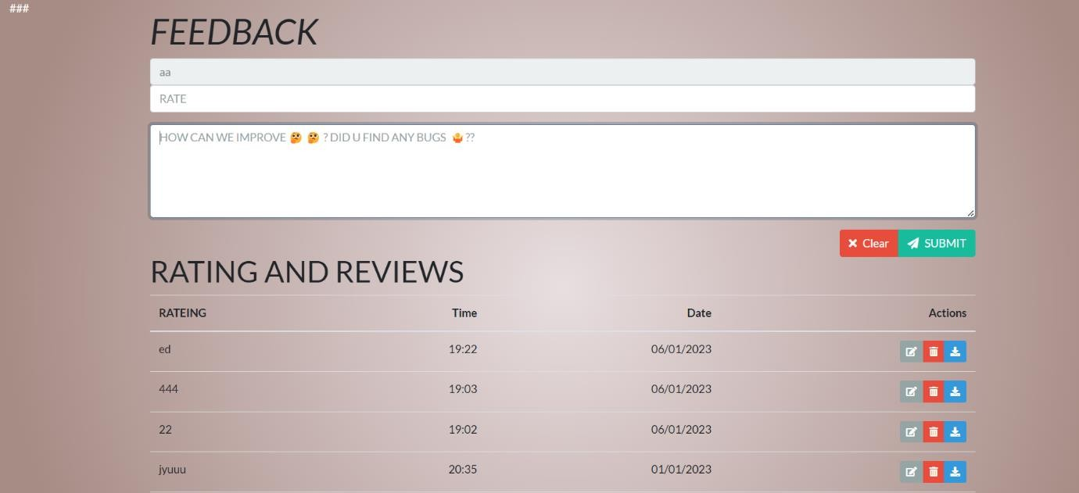

Fig 5.16: Page to give feedback.

Above snapshot shows feedback of users :

In our project we have given option that user can give open feedback where everyone can see, And also user can give ratings.

By this developer can know about bugs and he can update the system as per the user convenience.

**CONCLUSION AND FUTURE WORK**

**CONCLUSION**

Personnel management system is an important aspect of any organization. It deals with the management of his/her own performance, work schedules, and compensation. A good personnel management system helps to increase the productivity and efficiency of person, reason.

The aim of this project was to develop a personnel management system for a hypothetical organization. This system has been designed and implemented with the help of the latest software and programming languages. The system is user-friendly and provides a platform for the efficient management of personnel.

One of the key features of the personnel management system is the own management module. This module allows the user to keep track of the their performance. The module provides a platform for the management of work schedules, compensation, and benefits. This helps to ensure that the he/she are working efficiently and effectively.

The performance management module is another important feature of the personnel management system. This module provides a platform for the management of their performance and the tracking of their progress. The performance management module allows user to evaluate the performance of their and provide feedback. This helps to identify areas for improvement and to ensure that user are meeting their performance targets.

The system provides a platform for the management of user performance, workout schedules, images, files, and health. The personnel management system has been designed to be scalable and can be used in organizations of different sizes.

* 1. **FUTURE WORK**

In future days we’re planning improve this project by adding some more functionalities like

* + - near by shop,
    - todays outfit,
    - calendar and
    - event management etc….

Also we’re planning

* + - add debit and credit cards. where users can use our product as a wallet. By this user can no need carry money or dependent on bank servers.

# REFERENCES

#### For php

* <https://www.w3schools.com/php/default.asp>
* <https://www.sitepoint.com/php/>
* <https://www.php.net/>
* <https://www.javatpoint.com/php-tutorial>

#### For Mysql

* <https://www.mysql.com/>
* [https://www.mysqltutorial.org](https://www.mysqltutorial.org/)

#### For XAMPP

* <https://www.apachefriend.org/download.html>

#### For css

* <https://www.youtube.com/watch?v=u5-K_ua9sOw>
* <https://www.youtube.com/watch?v=u5-K_ua9sOw>
* <https://www.youtube.com/watch?v=u5-K_ua9sOw>
* <https://www.w3schools.com/css/>

#### For XAMPP

* <https://www.apachefriend.org/download.html>

#### For HTML

* <https://www.w3schools.com/html>