Exception Analysis Agent
Architecture & Design Document — CATS / Pay Later Domain

1. Complete Architecture Diagram
The diagram below shows the full end-to-end flow, including every exit path (completed, manual review, duplicate, not found) and how each is logged. Both internal and external exceptions now trigger an email — internal issues route to the dev team, external issues route to the owning dependency team. Detailed explanation of each stage follows in the sections after.
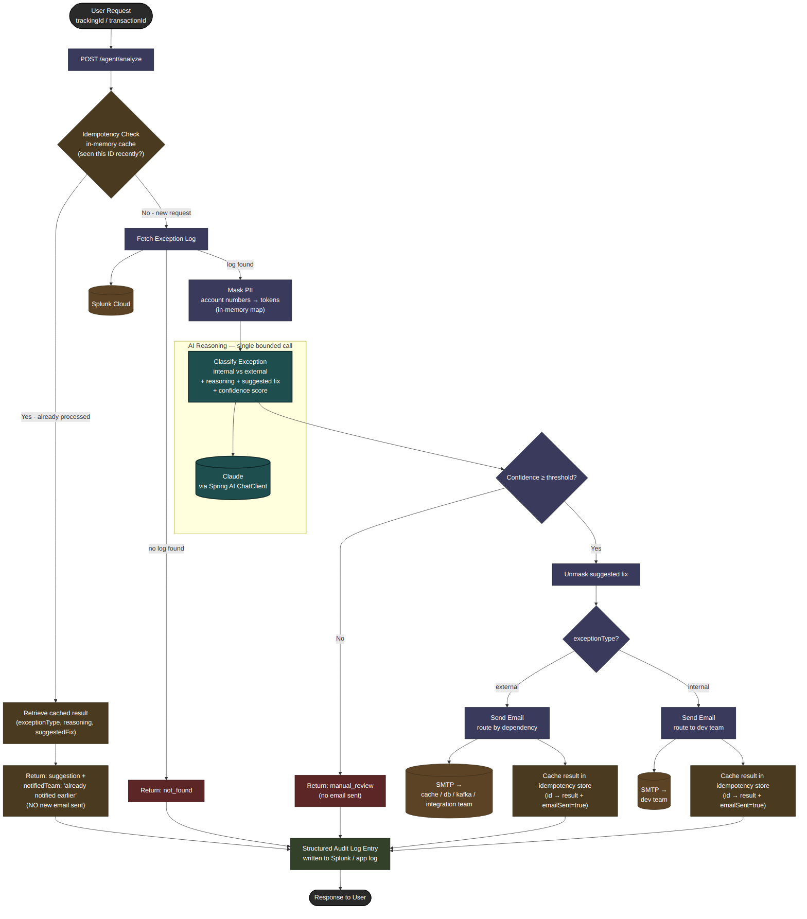

2. Overview
This agent lets a user submit a tracking ID or transaction ID, automatically retrieves the related exception from Splunk, classifies it as an internal (application bug) or external (downstream dependency) issue, and returns a suggested fix. Both internal and external issues trigger an email — internal routes to the dev team, external routes to the team owning that dependency (cache, database, kafka, etc.).
The design principle throughout: the LLM is used for a single, bounded reasoning step — classification and suggestion — while every other part of the flow (fetching, masking, notification, sequencing) is deterministic Java code. This keeps the pipeline auditable and safe for a regulated lending environment.
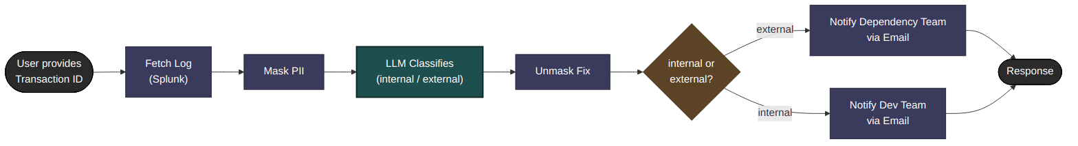

3. Why No Autonomous Tool-Calling / Agentic Loop
An autonomous agent lets the LLM decide at runtime which tools to call and in what order. This is valuable when the shape of the workflow genuinely varies per request. In this case it does not — every request follows the exact same steps in the exact same order: fetch, mask, classify, unmask, and conditionally notify.
- Masking must be guaranteed, not optional — an LLM given the choice to skip a tool call is not an acceptable risk for PII.
- Notification side effects (sending email) must not depend on model judgement about whether to trigger them.
- Deterministic code produces a simpler, more auditable trail than a transcript of model-chosen tool calls.
Tool-calling would only be justified if future requirements introduced open-ended, variable-shaped investigation (e.g., the model deciding whether to check additional systems based on what it finds). For the current requirement, fixed Java orchestration is the correct choice.

4. Component Breakdown
The system is composed of small, single-responsibility Spring services coordinated by one orchestrator. Only one component — the classifier — ever calls the LLM.
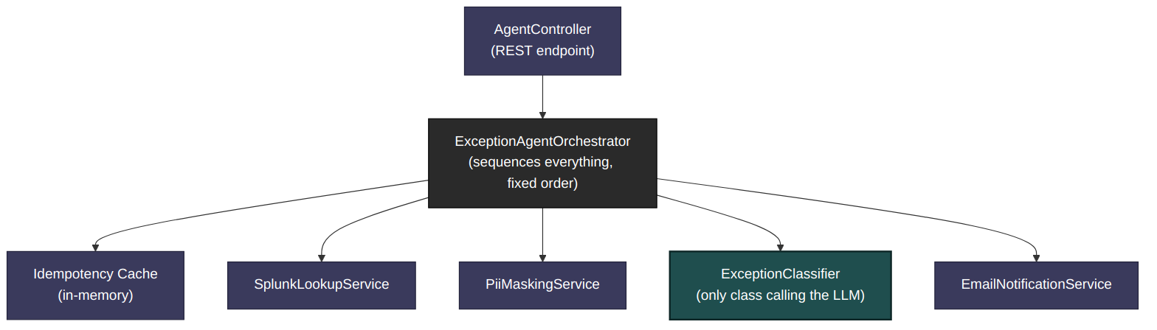
- AgentController — REST entry point, POST /agent/analyze
- ExceptionAgentOrchestrator — sequences every step in fixed order
- SplunkLookupService — fetches exception logs by transaction/tracking ID
- PiiMaskingService — masks account numbers before any data reaches the LLM, and unmasks the response afterward
- ExceptionClassifier — the only component that calls Claude via Spring AI's ChatClient, using structured output
- EmailNotificationService — routes notification to the correct team based on dependency type
- Idempotency Cache — in-memory, prevents duplicate email notifications for repeat lookups

5. Idempotency Handling
If the same transaction ID is submitted again within a configured time window, the agent does not repeat the full analysis or send another email. It returns the previously computed classification and suggestion, with the notification field marked as already notified earlier.
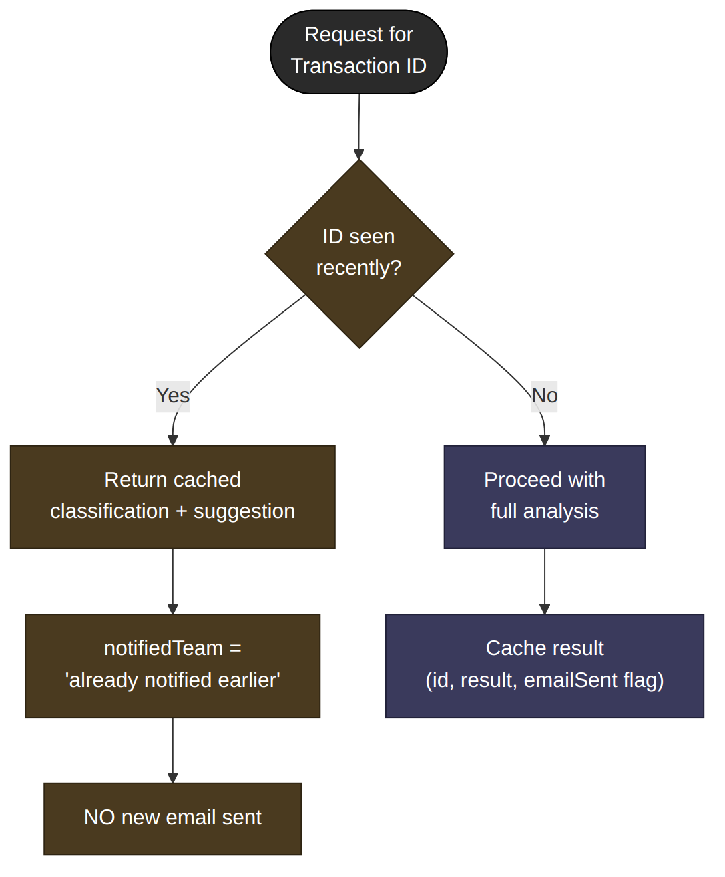
This avoids duplicate alerts to teams (e.g., from repeated dashboard refreshes or retries) while still giving the caller a useful, complete answer every time.

6. Confidence Threshold & Manual Review
The LLM returns a confidence score alongside its classification. If confidence falls below a configured threshold, the agent does not trust the classification enough to act on it automatically — it does not send an email, and instead routes the result to manual review.
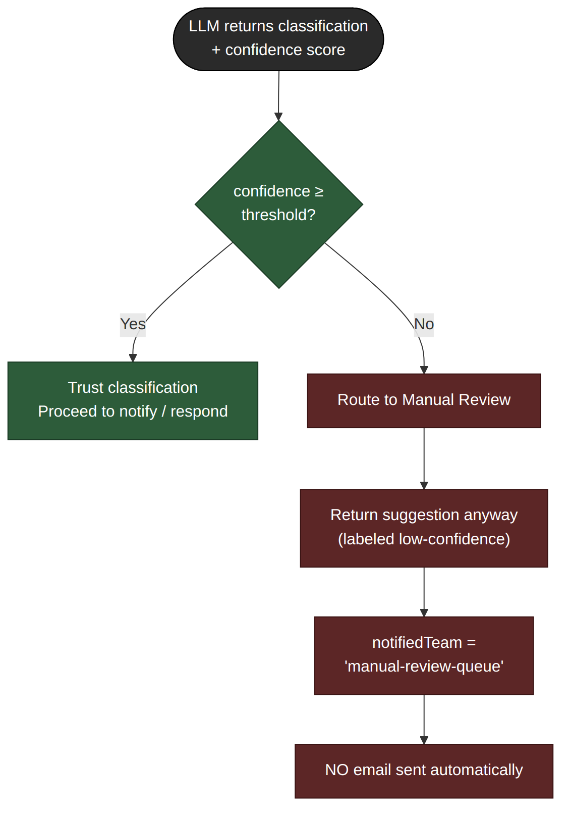
Even in manual review, the application still returns a response — including the LLM's reasoning and suggested fix — so a human has a starting point rather than nothing. The response is simply labeled as low-confidence and no automated notification is triggered.

7. End-to-End Flow Recap
Referring back to the complete diagram in Section 1: every exit path — completed, manual review, duplicate, and not found — is logged as a structured entry, written to the existing Splunk logging pipeline, without requiring a separate database.

8. Response Status Summary
Regardless of outcome, the API always returns a response. The table below summarizes what differs by status.
Status | Response Returned? | Email Sent? | Notes
completed | Yes — full suggestion | Yes — always (internal → dev team, external → dependency team) | Normal successful path
manual_review | Yes — suggestion + flag | No | Confidence below threshold
duplicate | Yes — cached suggestion | No (already sent earlier) | Same ID seen within window
not_found | Yes — explains nothing found | No | No Splunk log matched the ID

9. Guardrails Summary
- PII masking happens in code before any data reaches the LLM — never exposed as an optional tool call.
- Confidence threshold prevents low-certainty classifications from triggering automated actions.
- Idempotency check prevents duplicate email notifications on repeated requests.
- Every outcome (including failures and duplicates) is logged as a structured entry for audit purposes.
- The LLM never sees real account numbers and never controls sequencing — email routing (internal → dev team, external → dependency team) is decided by deterministic code based on the LLM's classification, not triggered by the LLM itself.

