

American International University-Bangladesh

Department of Computer Science

Computer Graphics

Project Title: A Model Town

Group no: 6

Submitted By

|  |  |  |
| --- | --- | --- |
| ID | Name | Section |
| 15-29499-2 | Sayem Mohammad Zishan | A |
| 15-29796-2 | Karim,Md reza ul | A |
| 15-29774-2 | Saha,Rajesh | A |

**Introduction**

A Model Town or a development plan or a town plan may be defined as a general plan for the future layout of a city showing either the existing and proposed streets or roads, open spaces, public buildings etc. A Model Town plan is prepared either for improvement of an old city or for a new town to be developed on a virgin soil. A Model town plan is a blueprint for the future.

**Motivation**

**The art and science of ordering the use of land and siting of buildings and communication routes so as to secure the maximum practicable degree of economy, convenience, and beauty.**

**An attempt to formulate the principles that should guide us in creating a civilized physical background for human life whose main impetus is thus … foreseeing and guiding change.**

**A city should be built to give its inhabitants security and happiness- Aristotle**

**Problems Identification**

There were so many problems in old town like health issue, poor house infrastructure, traffic problems, environment problems that’s why we introduced a new model of town so that we can solve this issue.

**Objective Of the project**

It aims at intelligent and economic spending of the public funds for achieving welfare of the inhabitants in respect of amenity, convenience and health. It arranges the pattern of a town in such a way so as to satisfy the present requirements without introduction of future improvements by the coming generations. It helps in restricting the haphazard and unplanned growth. It places various functions which a town has to perform in physical relationship of each other so as to avoid the chances of mutual conflict. It removes the defects of unco-ordinated physical growth of the various components of town due to the fact that it considers the entire city area or town as planning and development entity. It serves as a guide to the planning body for making any recommendations for public improvement.

**Methodology**

We have created a model town using Graphics Code .Learn about construction and the art of architecture through building a model town. This activity can be accomplished in the Road with Some basic materials. There are numerous feature Like-

Features:

1. Stop cars(s)
2. Run cars(s)
3. Day View(d)
4. Night View(t)
5. Auto Day-Night View(a)
6. Move Faster Day-night View(space)
7. Red Signal Activate(r)
8. Green Signal Activate(g)
9. VIP Signal Activate(v)
10. VIP Signal Deactivate(v)
11. Traffic Signal Deactivate(n)
12. Increase Car Speed(up)
13. Decrease Car Speed(down)
14. Mute Sound(m)
15. Activate Sound(m)

The Scenario is like car and bus is running on the road but when in zebra crossing traffic light will appears red signal then car will stop after appears of green light car pass the zebra crossing. The cloud move in the sky and after day when night come the star will appears in sky. When night will happen the lamp posts light will turn on. The color of Lam post light is Yellow. The color of Sun is Yellow and after day the moon will appears the color of moon is white. The flag will take down during sunset because the Flag Code states it is the universal custom to display the flag only from sunrise to sunset on buildings and on stationary flag staffs in the open.

**Significance of the Project**

Followings are the reasons which have led to the thinking of having a Model Town:

To control the development of various industries in a systematic way. To discourage the growth of town in an unplanned and unscientific way. To ensure health problems, Traffic Issue and poor house infrastructure and environments etc.

**Conclusion and Future Work**

Here we proposed a model town if we use in our lives we will get rids of so many problems .Basically there are so many problems in our live because of poor system if we develop this system we will be secure and happy.

**Screenshot of System**

A Model Town

**-------------------Day View--------------------**

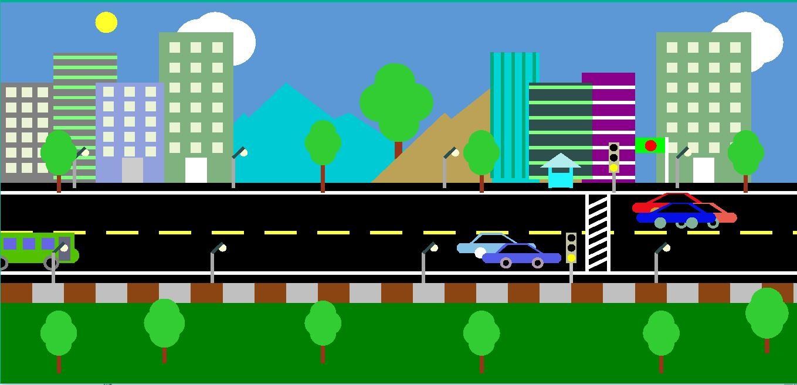

**-------------------Night View--------------------**

