Assignment 2 – Part 2: Situated Learning
Topic 7 – Machine Translation in the Automotive Industry
AIML ZG519 – Natural Language Processing Applications · Group 81

Student details
Team member names | RAJESH R. SHENOI (2025AE05200) · PARUL MITTAL (2025AE05198) · SIDDHARTH KUCHIMANCHI (2025AE05199) · CHAUHAN AYUSH UPENDRA (2025AE05684)
BITS Email id | 2025ae05200@wilp.bits-pilani.ac.in · 2025ae05198@wilp.bits-pilani.ac.in · 2025ae05199@wilp.bits-pilani.ac.in · 2025ae05684@wilp.bits-pilani.ac.in
Industry / Domain | Automotive
Organisation type | Automotive organisation that receives technical documents from German and Japanese automotive customers (workplace of group member Rajesh R. Shenoi; anonymised)
How to read this report. [Observed] marks how machine translation is used in the organisation today, as reported by the group member who works there. [Proposed] marks the group’s own suggestion and demonstration. No confidential, customer or personal information is included; all example sentences are synthetic.

5.1 Industry context – Anchor
Industry / Organisation | Automotive; an organisation whose customers send technical documents in German and Japanese.
Selected NLP concept | Machine Translation (MT) – neural, Transformer‑based MT and LLM‑based translation.
Application / use case | [Observed] Translating German and Japanese customer documents – e.g. customer‑specific requirements (CSRs) and vehicle specifications – into English so that engineering, quality and project teams can understand and implement them.
Problem addressed | Customers write requirements in their own language while engineering works in English. A misunderstood requirement can cause a design error, a failed validation or a contractual non‑conformity. Full human translation of long specifications is slow and costly; MT gives engineers fast access to the content.
Users / stakeholders | Engineers and project managers (readers); the language‑competent department (reviewers); quality / requirements managers; the customer (owner of the document and its confidentiality); IT security and legal (approve tools, enforce confidentiality agreements).
Status | Deployed – MT is used today for this purpose.

5.2 Concept in practice – Apply
Data / input. [Observed] German and Japanese customer documents: customer‑specific requirements and vehicle specifications. Their language is special: obligations (muss, しなければならない → shall), prohibitions (darf nicht → must not), numeric limits with units and signs (−40 °C, 320 Nm, 10 ms), references to standards (ISO 26262) and dense terminology (Steuergerät – control unit, Lastenheft – requirements specification, 耐久試験 – durability test).
NLP approach / concept (course link). Today’s MT systems are neural encoder–decoder Transformers: the encoder builds contextual representations of the source sentence with self‑attention; the decoder generates the English sentence token by token, attending to the source through cross‑attention, and beam search keeps the best partial translations. Text is split into sub‑word units (SentencePiece), so long German compounds such as Dauerlaufprüfung can still be translated. Multilingual models (NLLB‑200) share one network across ~200 languages; LLMs translate by prompting. Quality is measured automatically with BLEU (word n‑gram overlap) and chrF (character n‑gram F‑score) against reference translations, and in practice by human post‑editing (MTPE).
Tool / model / framework. [Observed] Google Translate and other translation tools approved by the enterprise. [Proposed – demo] Open‑source models run locally with HuggingFace transformers: Helsinki‑NLP OPUS‑MT (Marian Transformer, ~75 M parameters, one model per language pair) and Meta NLLB‑200 distilled (615 M parameters, multilingual).
Workflow / architecture.
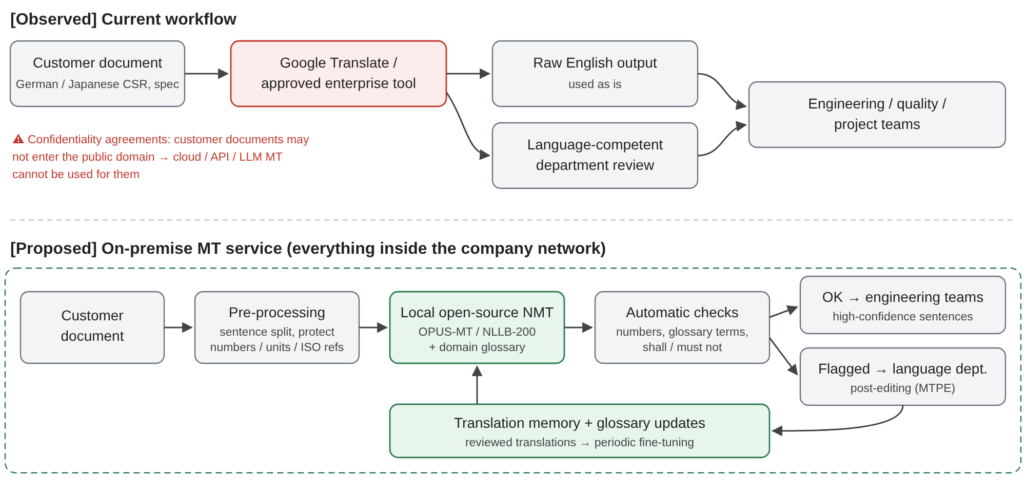
Current (observed) and proposed on‑premise MT workflow
- [Observed] current workflow: document received → translated with Google Translate or an approved tool → output used as is for understanding, or reviewed by the language‑competent department where accuracy matters. Customer confidentiality agreements forbid putting these documents into the public domain, so public web translators and API‑ or LLM‑based translation services cannot be used for them.
- [Proposed] on‑premise workflow: the document never leaves the company network → pre‑processing (sentence split, protect numbers, signs, units and standard names) → locally hosted open‑source NMT with a domain glossary → automatic checks (numbers, glossary terms, shall / must not) → flagged sentences go to the language department for post‑editing → reviewed translations feed a translation memory used for later fine‑tuning.
Output / result. [Observed] English versions of customer documents used by engineering, raw or after review. [Proposed – demo] Translations, quality scores and checks below, produced offline on a single CPU thread – the models were copied once to a local folder and loaded with local_files_only=True, so no text left the machine.
Evidence.
E1 – On‑premise MT demo (mt_demo.ipynb, Google Colab CPU, 1 thread, beam size 4; 8 German and 6 Japanese synthetic requirement sentences; references prepared by the group). Small test set – results are indicative only.
Model (local, offline) | Pair | BLEU | chrF | Glossary terms correct | Numbers kept (auto‑check) | CPU s / sentence | Size on disk
OPUS‑MT de‑en | de→en | 75.8 | 82.6 | 9/10 | 8/8 | 0.86 | 299 MB
NLLB‑200 distilled 600M | de→en | 63.1 | 74.2 | 7/10 | 8/8 | 6.25 | 2.49 GB
OPUS‑MT ja‑en | ja→en | 28.7 | 55.6 | 7/10 | 6/6 | 0.89 | 304 MB
NLLB‑200 distilled 600M | ja→en | 49.0 | 72.3 | 9/10 | 6/6 | 6.90 | (same model)
E2 – Example outputs (synthetic sentences).
Source (synthetic) | MT output | Problem
Das Steuergerät muss bei einer Umgebungstemperatur von -40 °C bis +85 °C fehlerfrei funktionieren. | OPUS‑MT: The control unit shall function correctly at an ambient temperature of -40 °C to +85 °C. | none – correct term, modal and numbers
Das Lastenheft gilt in Verbindung mit den kundenspezifischen Anforderungen … | NLLB: The package leaflet shall be valid in conjunction with the customer‑specific requirements … | wrong domain term (pharmaceutical sense)
制御ユニットは、-40℃から+85℃の周囲温度で正常に動作しなければならない。 | NLLB: … at ambient temperatures between 40°C and +85°C. | minus sign lost – not caught by the automatic number check
サプライヤーは、量産開始の6週間前までに…通知すること。 | NLLB: … notify the customer … within six weeks of the start of mass production. | deadline meaning changed (“at least six weeks before”)
本仕様書に記載のない事項については、顧客と協議の上決定する。 | OPUS‑MT: I’ll decide on matters that don’t appear in my specs in a discussion with my customers. | omitted Japanese subject filled with an invented “I”
耐久試験は、1,000時間以上実施すること。 | OPUS‑MT: The endurance exam should take more than 1,000 hours. | obligation weakened to “should” (a recommendation in standards language)
E3 – Workflow diagram (above). Screenshots of the internal tools are omitted because of confidentiality.

5.3 Industry analysis – Analyse
Key benefits / value.
- Speed and access: engineers can read a German or Japanese specification immediately instead of waiting for a full human translation – valuable during quotations and change requests.
- Cost: expert review is focused on documents and passages that need it, instead of translating every page by hand.
- Coverage: one workflow serves German and Japanese customers; multilingual models can add further languages.
Limitations / problems.
- Confidentiality (major): [Observed] customer agreements forbid uploading documents to public domains, which rules out public web translators, cloud MT APIs and LLM services for exactly the documents that most need translating.
- Domain terminology: general models do not know automotive terminology – Lastenheft became “package leaflet”, OPUS‑MT rendered Bordnetz (vehicle electrical system) as “on‑board system” (glossary 7–9 of 10 terms per model, E1).
- Requirement semantics: a fluent translation can still change a requirement: a lost minus sign, a changed deadline, shall weakened to should, an invented subject (E2). These errors look correct, so raw output is risky.
- Japanese is harder than German: the best Japanese result (chrF 72.3) is clearly below the best German one (82.6) – long sentences and omitted subjects.
- Simple checks are not enough: the automatic number check passed all sentences, yet missed the lost minus sign.
- Raw output risk: [Observed] output is sometimes used as is, without review.
Evidence of effectiveness or impact. [Observed] MT is part of the daily workflow for German and Japanese documents, with the language department as the quality gate – it is useful enough to have been adopted. [Proposed – demo] Local open‑source models reach usable quality without any data leaving the machine: OPUS‑MT de→en scores chrF 82.6 with 9/10 glossary terms correct at 0.86 s per sentence on one CPU thread (about 1.5 minutes for a 100‑sentence document), and NLLB‑200 is the better choice for Japanese (chrF 72.3 vs 55.6, 9/10 terms). No single model is best for both pairs, and every model made at least one terminology or meaning error, so on‑premise MT must be combined with a glossary, better checks and human review.

5.4 Reflection and future scope – Reflect
Major challenge / gap. Confidentiality. The best‑known MT and LLM services are cloud‑based, but customer confidentiality agreements do not allow these documents to leave the organisation. The documents that matter most therefore cannot use those tools, and translation falls back to slower manual work or carries a compliance risk.
Recommended improvement. [Proposed] An on‑premise MT service inside the company network:
- Per‑language model selection based on a small internal test set – e.g. OPUS‑MT for German and NLLB‑200 for Japanese in our demo.
- A domain glossary / terminology database enforced during or after translation (Lastenheft → requirements specification).
- Stronger automatic checks for signs, numbers, units, deadlines and shall / must not / should, and routing of flagged sentences to the language department for post‑editing.
- Fine‑tuning on the organisation’s reviewed translations (translation memory) to adapt the model to its customers’ style.
Requirements: approval from IT security and legal; an internal server (the demo shows that small models run on a CPU; a GPU or more CPU threads would speed up the larger model); an owner for the glossary; and a test set with reference translations to measure quality before and after roll‑out.
Potential future use. Comparing new versions of customer documents in English to highlight changed requirements; multilingual search / RAG over past specifications; automatic extraction of requirements into the requirements‑management tool after translation (link to Information Extraction, Part 1); and an on‑premise open LLM for translation and summarisation once suitable hardware is available.

References and acknowledgements
- Vaswani, A. et al. (2017). Attention Is All You Need. NeurIPS.
- Tiedemann, J. & Thottingal, S. (2020). OPUS‑MT – Building open translation services for the World. EAMT.
- NLLB Team (2022). No Language Left Behind: Scaling Human‑Centered Machine Translation. arXiv:2207.04672.
- Post, M. (2018). A Call for Clarity in Reporting BLEU Scores. WMT (sacreBLEU).
- Popović, M. (2015). chrF: character n‑gram F‑score for automatic MT evaluation. WMT.
- Tools: HuggingFace transformers, sacrebleu, Google Colab. Models: Helsinki-NLP/opus-mt-de-en, Helsinki-NLP/opus-mt-ja-en, facebook/nllb-200-distilled-600M.
- Organisational practice described by group member Rajesh R. Shenoi (anonymised).
- AI tools: Claude Code (Anthropic) helped structure the report, write the demo notebook and prepare the synthetic sentences and reference translations; all content was reviewed by the group.

