AIML ZG546 - Software Engineering for Machine Learning
Assignment II
BrakeGuard AI - Implementation, Code Quality and Testing of an ML-enabled Predictive-Maintenance System
Group No: <Fill Group No>
Sl. No | BITS ID | Name | Contribution of team member (Qualitative) | Percentage Contribution (out of 100)
1 | <BITS ID> | <Name> | Refactoring into the brakeguard package (data, features, models, pipeline); research-vs-production comparison (Tasks 1, 2) | <%>
2 | <BITS ID> | <Name> | FastAPI REST API: schemas, status codes, error envelope, API-key security, dashboard (Task 5) | <%>
3 | <BITS ID> | <Name> | Test strategy and pytest suites: unit, data-quality, ML training/inference, integration; coverage (Tasks 6, 7) | <%>
4 | <BITS ID> | <Name> | Logging and error handling, black/isort/flake8/pylint, quality metrics and drift, production testing and security, report (Tasks 3, 4, 8, 9) | <%>

Code: BrakeGuard_AI_Assignment_Application/brakeguard_ai-3 (builds on the Assignment I prototype in brakeguard_ai-2). Implementation notebook: notebooks/Group_XX.ipynb (rename to <Group no>.ipynb).

Contents
0. System overview
Objective 1 - Implementation and code sharing [5 marks]
Task 1 - OOP / functional design of the ML application
Task 2 - Research code vs production code
Task 3 - Error handling and logging
Task 4 - Code formatting and linting (before / after)
Task 5 - REST API (FastAPI)
Objective 2 - Quality assurance [5 marks]
Task 6 - Types of tests (pytest)
Task 7 - Tests specific to ML components (training, inference)
Task 8 - Model-quality and data-quality metrics
Task 9 - Testing in production and security
Appendix A - How to run; Appendix B - Deliverables

0. System overview
BrakeGuard AI predicts the probability that a vehicle's brake system will develop a fault within the next 30 days / 1,000 km, using six telemetry signals: rotor temperature, line pressure, pad wear, caliper vibration, brake-fluid age and odometer. A Random-Forest classifier produces a probability, which is mapped to a LOW / MEDIUM / HIGH risk band (thresholds 0.40 / 0.70) with an explanation of the main drivers. The ML component sits inside non-ML components: a REST API, a feature store, an event bus for telemetry, an audit log and drift monitoring.
Assignment I delivered a working prototype (brakeguard_ai-2) with module-level globals, no data validation, one happy-path test file, no logging, and a dashboard bug (the audit table read fault_probability while the log stored probability). Assignment II rebuilds it as the production-style package below. The model family and hyper-parameters are kept, so the comparison isolates software-engineering changes.
Package / module | Responsibility | Key classes / functions
brakeguard/config.py | Immutable, environment-overridable settings | Settings, RiskThresholds, ModelHyperParams
brakeguard/schemas.py | Single source of truth for the telemetry contract | TELEMETRY_SCHEMA, FeatureSpec
brakeguard/data/ | Data ingestion; data-quality validation | TelemetryDataSource (ABC), SyntheticTelemetrySource, CSVTelemetrySource, DataValidator, DataQualityReport
brakeguard/features/ | Feature engineering; online feature store | FeatureEngineer (sklearn transformer), FeatureStore
brakeguard/models/ | Training; versioned persistence; inference | ModelTrainer, ModelRegistry, ModelBundle, BrakeFaultPredictor, Prediction
brakeguard/evaluation/ | Model-quality metrics | evaluate_classifier, expected_calibration_error
brakeguard/monitoring/ | Audit log, pub/sub, drift | AuditLog, EventBus, DriftDetector, population_stability_index
brakeguard/pipeline.py | Orchestration with quality gates | TrainingPipeline, load_or_train
brakeguard/api/ | REST layer | create_app, routes, schemas, error handlers, API-key security, ServiceContainer
scripts/ | CLIs | train.py, quality_report.py, build_notebooks.py

Objective 1 - Implementation and code sharing

Task 1 - OOP / functional design of the ML application
The code is organised around the ML lifecycle, with one class per responsibility. The design follows these principles:
- Single responsibility: ingestion, validation, feature engineering, training, persistence and inference are separate classes. Each can be tested on its own (Section 6) and replaced independently.
- Dependency inversion: TrainingPipeline depends on the abstract TelemetryDataSource, so synthetic data, a CSV export or a database are interchangeable. The integration test trains from a CSV without code changes.
- Composition over globals: the API builds a ServiceContainer (predictor, feature store, event bus, audit log, drift detector) per application instance through the create_app factory. Tests create isolated apps with no model or with an API key, without shared mutable state.
- Functional core: metrics (evaluate_classifier, expected_calibration_error, population_stability_index) are pure functions of their inputs, and settings and value objects are frozen dataclasses.
- Training/serving consistency: FeatureEngineer is an sklearn transformer placed inside the model Pipeline. The same fitted transformation, including imputation medians and the derived features pressure_deviation, thermal_wear_index and fluid_age_years, is serialised with the model and replayed at inference time.
The training workflow with its two quality gates (data quality before training, model quality before registration):
brakeguard/pipeline.py - TrainingPipeline.run
def run(self, register: bool = True) -> ModelBundle:
"""Execute the pipeline and (optionally) register the model."""
logger.info("Training pipeline started (model version %s)", self.settings.model_version)
frame = self.source.load()
quality = self.validator.validate_or_raise(frame, require_target=True)
result = self.trainer.train(frame)
self._check_quality_gates(result.test_metrics.to_dict())
bundle = ModelBundle(
pipeline=result.pipeline,
version=self.settings.model_version,
metrics=result.test_metrics.to_dict(),
feature_names=list(ENGINEERED_FEATURES),
reference_frame=result.reference_frame.sample(
n=min(1000, len(result.reference_frame)), random_state=self.settings.random_seed
).reset_index(drop=True),
data_quality=quality.to_dict(),
)
if register:
self.registry.save(bundle)
logger.info("Training pipeline finished")
return bundle

brakeguard/features/engineering.py - FeatureEngineer.transform
def transform(self, X: pd.DataFrame) -> pd.DataFrame: # noqa: N803
"""Return a frame with raw + derived features, imputed."""
if not hasattr(self, "medians_"):
raise FeatureEngineeringError("FeatureEngineer must be fitted before transform")
frame = self._check_input(X).copy()
n_missing = int(frame.isna().sum().sum())
if n_missing:
logger.warning("Imputing %d missing value(s) with training medians", n_missing)
frame = frame.fillna(value=self.medians_)
frame["pressure_deviation"] = (frame["brake_pressure"] - self.nominal_pressure).abs()
frame["thermal_wear_index"] = frame["brake_temperature"] * frame["pad_wear_pct"] / 100.0
frame["fluid_age_years"] = frame["fluid_age_days"] / 365.0
return frame[list(ENGINEERED_FEATURES)]

Task 2 - Research code vs production code
Component compared: model training and inference. The research version is notebooks/01_research_prototype.ipynb, written as typical exploratory cells with the same logic as Assignment I's model_service.py. The production version is the brakeguard package plus the scripts/train.py CLI. The notebook is kept on purpose, and its outputs show two defects the production code removes:
- Its explanation heuristic (importance x raw value) always ranks odometer_km first (score 7,681 vs 39 for the next feature) because odometer values are in tens of thousands of km. Production uses importance x |z-score|, and the top drivers for BG-10245 become thermal_wear_index, pad_wear_pct and vibration_rms.
- It scores physically impossible input (pad_wear_pct = 450 gives p = 0.94). Production rejects this with HTTP 422.
Research (notebook cell)
# research notebook - globals, magic numbers, implicit feature order, prints
model = RandomForestClassifier(n_estimators=160, max_depth=8, min_samples_leaf=4, random_state=42, class_weight="balanced")
model.fit(X_train, y_train)
print("recall", recall_score(y_test, pred))
joblib.dump(model, "model_research.joblib") # relative path, no metadata
vehicle = [186.4, 72.1, 78.0, 3.2, 410, 84250] # which number is which?
prob = model.predict_proba([vehicle])[0, 1]
risk = "HIGH" if prob >= 0.70 else "MEDIUM" if prob >= 0.40 else "LOW"

Production (package API)
# production - typed, validated, logged, versioned, tested
settings = get_settings() # env-overridable, frozen
bundle = TrainingPipeline(settings=settings).run() # validate -> train -> gate -> register
predictor = BrakeFaultPredictor(bundle, settings.thresholds)
prediction = predictor.predict(feature_store.get("BG-10245")) # dict keyed by schema names
prediction.risk, prediction.fault_probability, prediction.top_factors

Concern | Research notebook | Production package
Structure | Linear cells and global variables; results depend on execution order | Classes with single responsibilities, wired by TrainingPipeline
Configuration | Magic numbers and hard-coded paths | Settings dataclass + BRAKEGUARD_* environment variables
Data contract | Implicit NumPy column order | TELEMETRY_SCHEMA shared by validator, model and API
Data quality | None | DataValidator gate (schema, missing, range, labels, duplicates)
Model acceptance | Human reads printed metrics | Automatic gate: recall >= 0.75, PR-AUC >= 0.70
Persistence | Bare model, relative path | ModelBundle: version, metrics, timestamp, sklearn version, drift reference
Errors / logs | Tracebacks / print | Typed exceptions -> HTTP codes; logging with levels
Tests / style | None | 96 pytest tests (97 % coverage); pylint 10.00/10, flake8 0

Task 3 - Error handling and logging
All modules log through the brakeguard.* logger hierarchy configured in logging_config.py (format time | level | module | message). Levels have a fixed meaning: INFO for normal lifecycle events, WARNING for degraded but recoverable situations, and ERROR for failed operations where the caller receives an error. Failures raise typed exceptions from exceptions.py, which api/errors.py maps to HTTP status codes, so the API never returns a raw stack trace.
Critical function | INFO | WARNING | ERROR / exception
CSVTelemetrySource.load | rows loaded | file has no rows | file missing / unparsable -> DataIngestionError
DataValidator.validate_or_raise | validation passed | duplicates; missing values below gate; issues found | data set rejected -> DataValidationError
FeatureEngineer.transform | - | missing values imputed with training medians | missing / non-numeric columns -> FeatureEngineeringError (422)
ModelTrainer.train | rows, positive rate, hold-out metrics | - | single-class target / fit failure -> ModelTrainingError
TrainingPipeline quality gate | model passed gates | - | model rejected -> ModelTrainingError, nothing registered
ModelRegistry.load / load_or_train | model loaded / registered | sklearn version mismatch; artefact missing -> retrain fallback | corrupt artefact -> ModelRegistryError
BrakeFaultPredictor.predict* | records scored | - | no model -> ModelNotReadyError (503)
FeatureStore.get | vehicle inserted / updated | unknown vehicle | VehicleNotFoundError (404)
EventBus.publish | subscriber registered | event with no successful subscriber | failing subscriber logged with traceback; others still run
AuditLog.record / DriftDetector | drift summary | HIGH-risk prediction; PSI >= 0.10 / 0.25 | -
HTTP middleware / handlers | method, path, status, latency per request | 422 / 404 responses | unexpected exception -> generic 500 with request id

brakeguard/models/registry.py - error handling with meaningful levels
def load(self) -> ModelBundle:
"""Load a bundle; raises :class:`ModelRegistryError` on any problem."""
if not self.exists():
raise ModelRegistryError(f"No model artefact at {self.path}")
try:
bundle = joblib.load(self.path)
except Exception as exc: # joblib can raise many unpickling errors
logger.error("Model artefact %s is corrupt: %s", self.path, exc)
raise ModelRegistryError(f"Corrupt model artefact: {exc}") from exc
if not isinstance(bundle, ModelBundle):
logger.error("Artefact %s has unexpected type %s", self.path, type(bundle).__name__)
raise ModelRegistryError("Artefact is not a ModelBundle")
if bundle.sklearn_version != sklearn.__version__:
logger.warning(
"Model trained with scikit-learn %s, running %s - consider retraining",
bundle.sklearn_version,
sklearn.__version__,
)
logger.info("Loaded model %s (trained %s)", bundle.version, bundle.trained_at)
return bundle

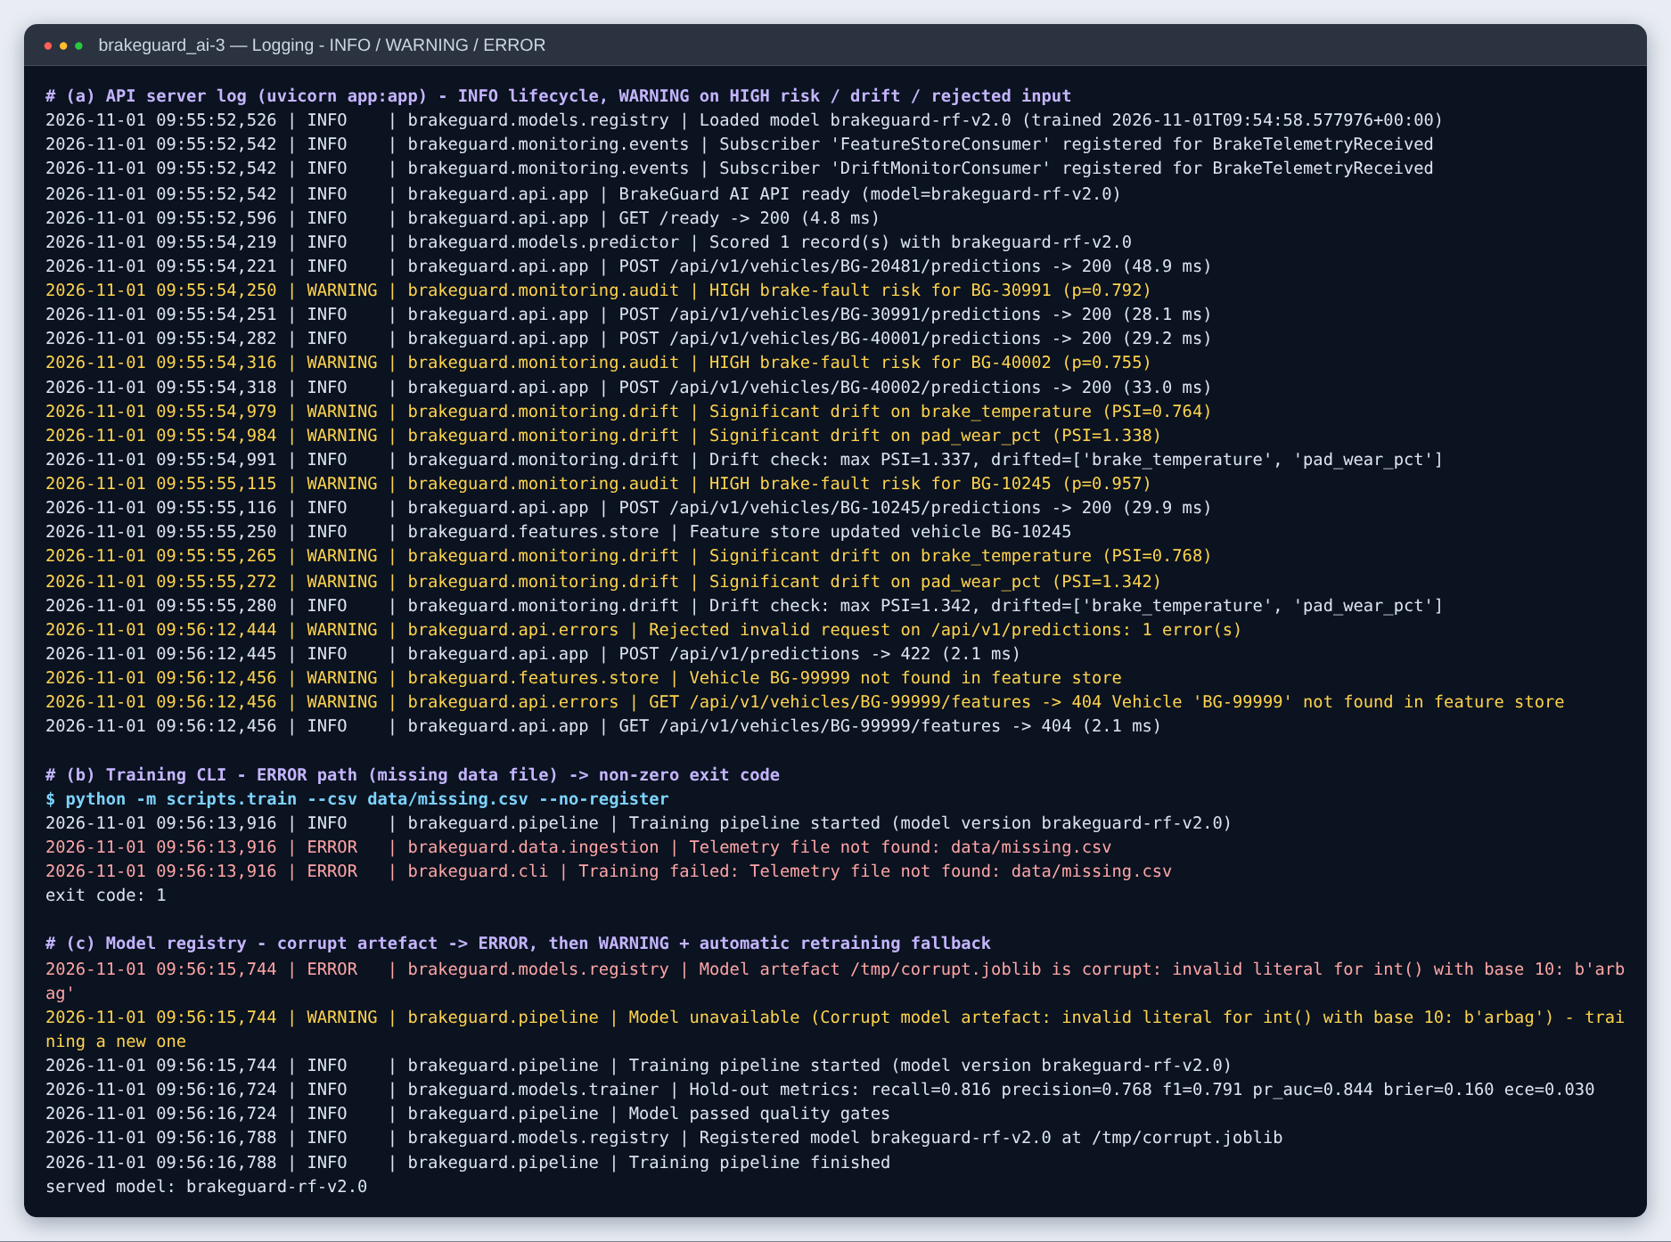
Figure 1 - Real log output: INFO lifecycle, WARNING for HIGH risk / drift / rejected input, ERROR for a missing data file (CLI exits with code 1) and a corrupt model artefact (automatic retraining fallback).

Task 4 - Code formatting and linting
Tools: black (formatting, line length 110), isort (import order, black profile), flake8 (PEP 8 / pyflakes) and pylint (static analysis). Configuration is in pyproject.toml and .flake8. The same commands run as a build gate in the Dockerfile. Two "before" baselines were captured: the Assignment I code base, and the new package before black and isort were run and findings fixed.
Check | Assignment I code (before) | New package before fixes | Final package (after)
black | 6 of 8 files would be reformatted | 7 of 44 files would be reformatted | all 46 files unchanged
isort | 3 files incorrectly sorted | clean | clean
flake8 | 37 issues (E231 x15, E302 x13, E501 x7, E305 x2) | 12 issues (E501) | 0 issues
pylint | 7.25 / 10 (missing docstrings, long lines, too many args, ...) | 9.83 / 10 | 10.00 / 10

Fixes applied to the package after the baseline: automatic reformatting (black) and import sorting (isort); renaming VehicleId to VEHICLE_ID_PATH (constant naming); removing variable shadowing (audit -> entry); marking intentionally unused arguments; and documenting why sklearn's fit()-time attributes and the dataclass field counts are acceptable. Suppressions are local and commented, never global. Raw reports are in reports/lint/.
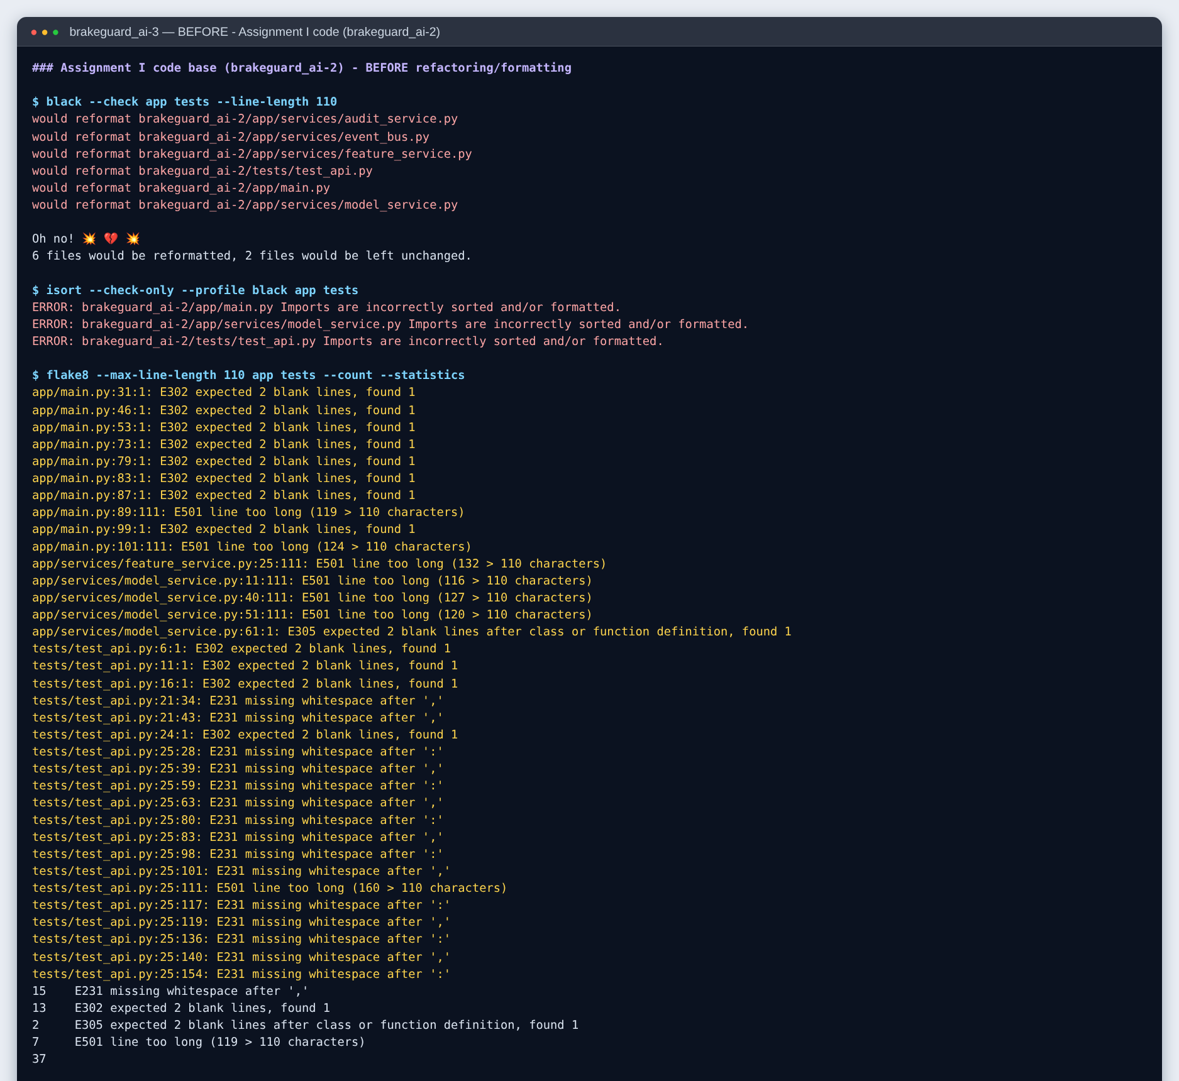
Figure 2a - BEFORE: black, isort and flake8 on the Assignment I code base.
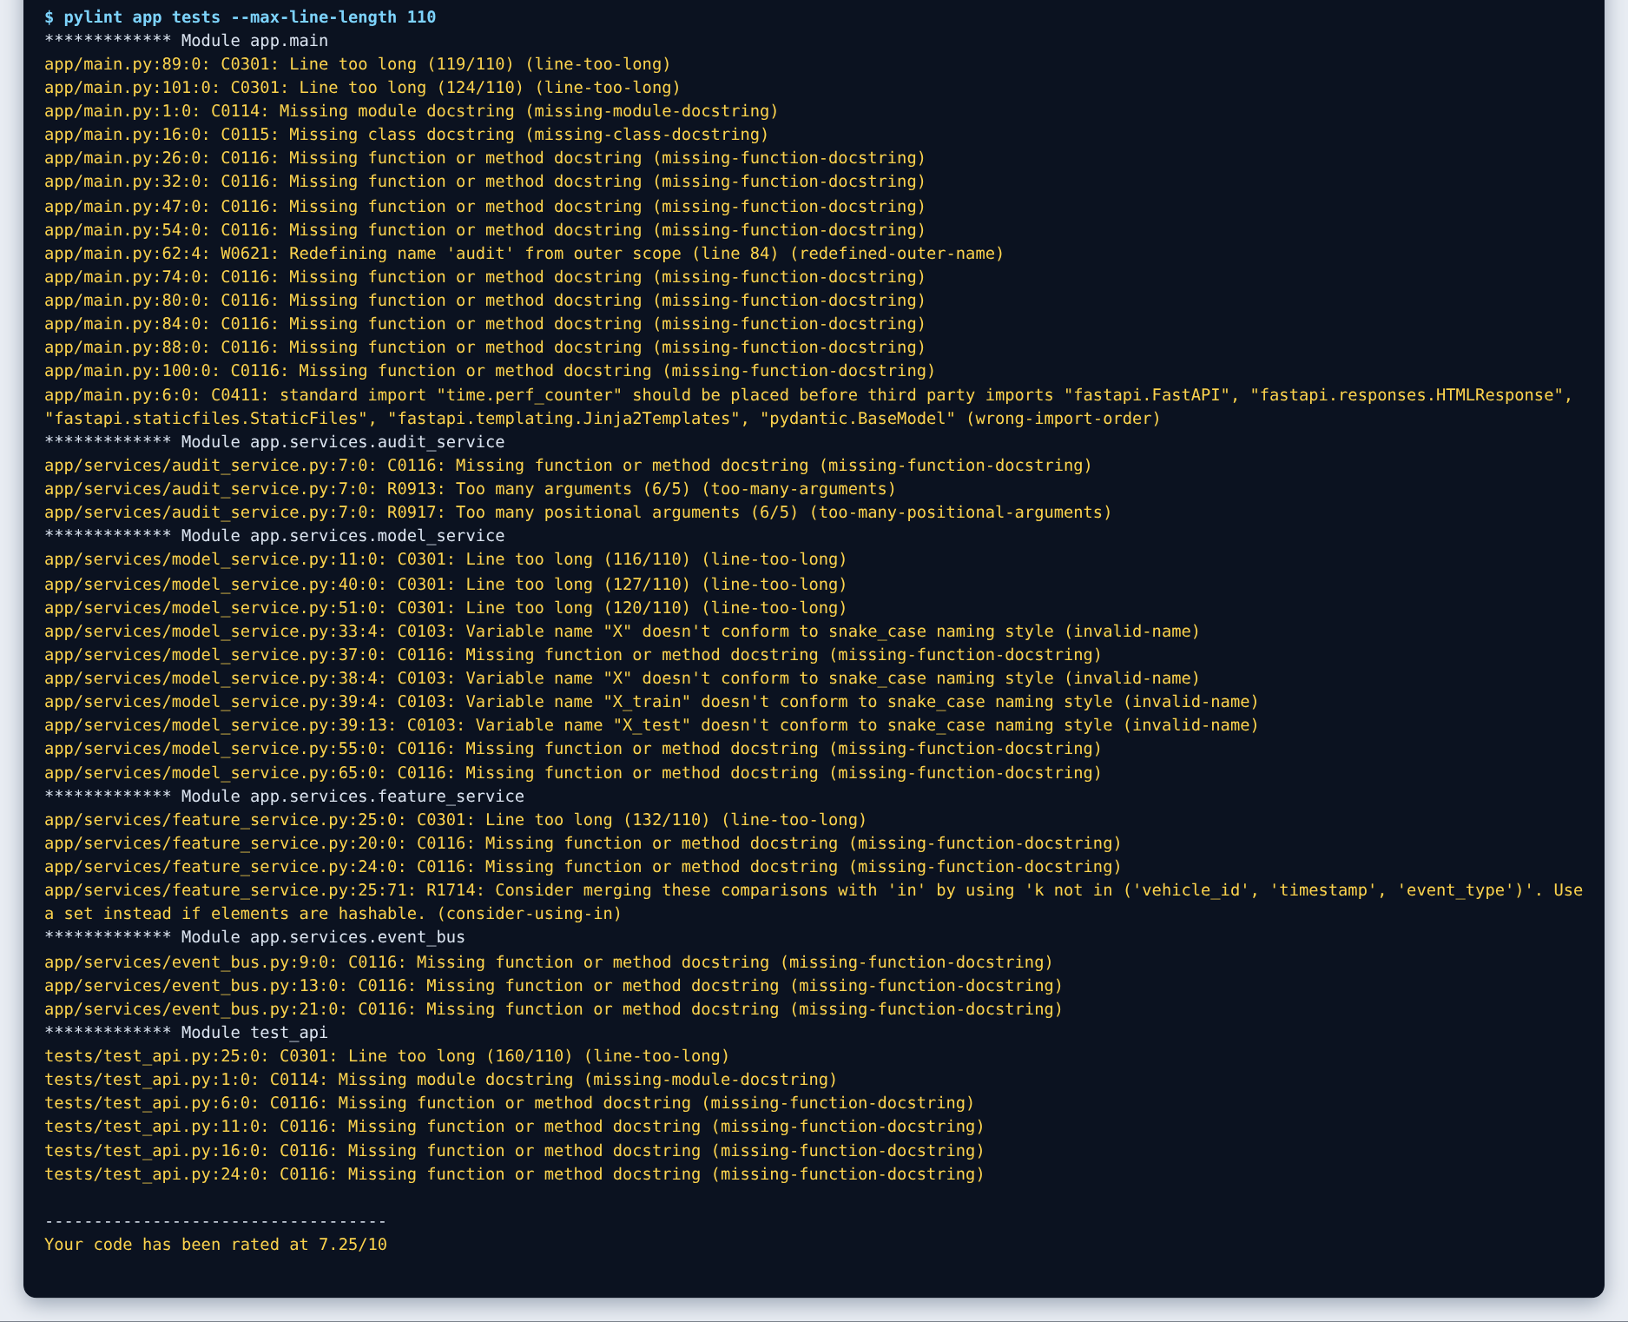
Figure 2b - BEFORE: pylint on the Assignment I code base (7.25/10).
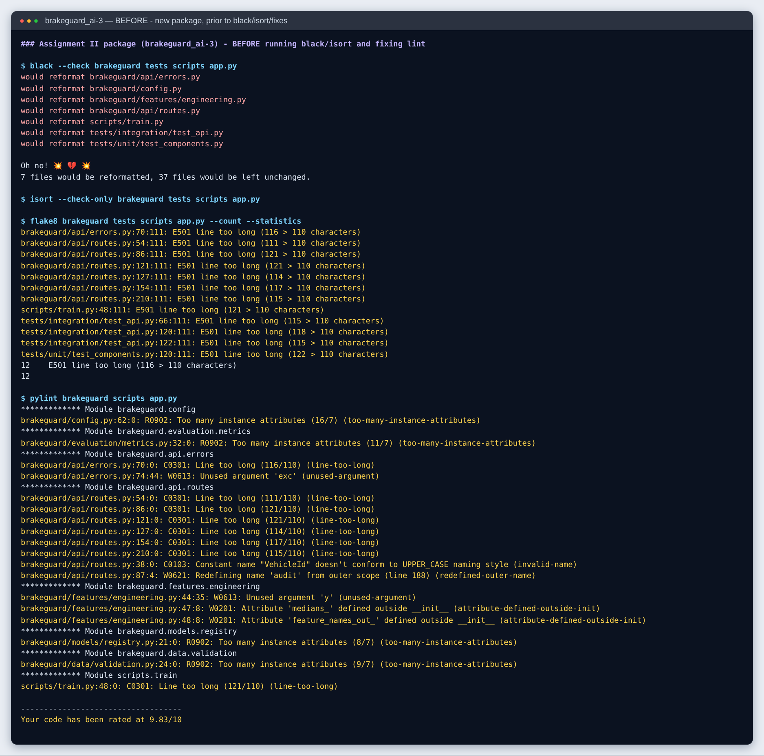
Figure 3 - BEFORE: the new package prior to black/isort and lint fixes (9.83/10, 12 flake8 issues).
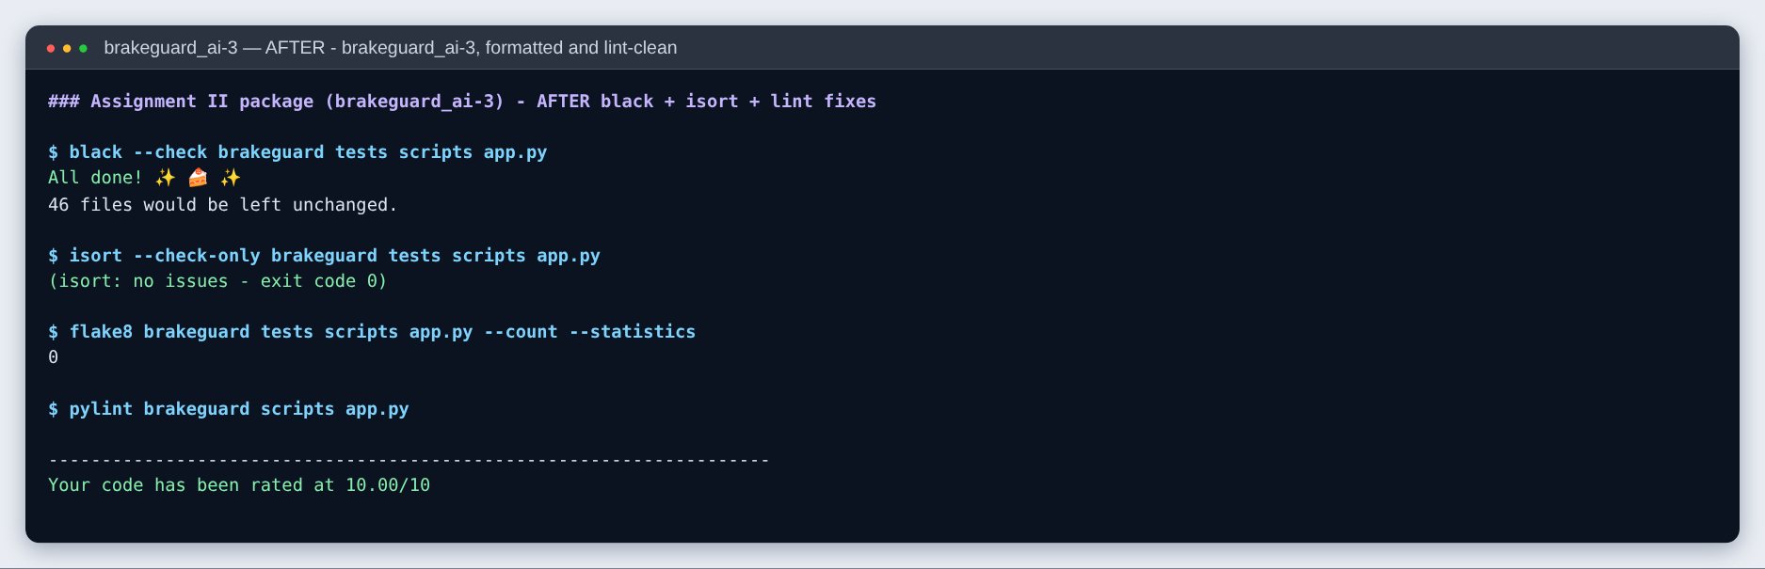
Figure 4 - AFTER: black and isort clean, flake8 0 issues, pylint 10.00/10.

Task 5 - REST API (FastAPI)
The API is created by brakeguard.api.create_app() and served by uvicorn app:app. It follows these design practices:
- Resource-oriented, versioned URLs under /api/v1, with nouns and HTTP verbs (POST /predictions, GET /vehicles/{id}/features). Operational probes (/health liveness, /ready readiness) are kept outside the versioned prefix.
- Explicit request/response schemas (Pydantic) published in OpenAPI/Swagger. Field ranges are derived from TELEMETRY_SCHEMA, unknown fields are forbidden, and batch size is limited to 1-500.
- Meaningful status codes: 200 OK, 202 Accepted (telemetry is processed asynchronously in production), 401 Unauthorized, 404 Not Found, 422 Unprocessable Content, 503 Service Unavailable (no model). All are documented per endpoint.
- Uniform error envelope {"error": {"code", "message", "request_id", "details"}} for every non-2xx response.
- Traceability: every response carries X-Request-ID and X-Process-Time-ms, and every prediction gets a prediction_id stored in the audit log with the model version.
- Security: optional X-API-Key authentication on /api/v1/* (Section 9).
Method | Endpoint | Purpose | Codes
GET | /health, /ready | Liveness / readiness probes | 200 / 200, 503
GET | /api/v1/model | Model version, training time, metrics, thresholds | 200, 401, 503
POST | /api/v1/predictions | Score telemetry in the request body | 200, 401, 422, 503
POST | /api/v1/predictions/batch | Score up to 500 records (vectorised) | 200, 401, 422, 503
GET | /api/v1/vehicles | List vehicles in the feature store | 200, 401
GET | /api/v1/vehicles/{id}/features | Latest features of a vehicle | 200, 401, 404, 422
POST | /api/v1/vehicles/{id}/predictions | Score a vehicle from the feature store | 200, 401, 404, 503
POST | /api/v1/telemetry | Publish a BrakeTelemetryReceived event | 202, 401, 422
GET | /api/v1/events, /api/v1/audit | Recent events / audited predictions | 200, 401
GET | /api/v1/monitoring | Latency p50/p95, model quality, data drift | 200, 401

brakeguard/api/routes.py - prediction endpoint
@api_router.post("/predictions", response_model=PredictionResponse, responses=ERRORS, tags=["predictions"])
def predict(body: PredictionRequest, c: ServiceContainer = Depends(get_container)) -> PredictionResponse:
"""Score telemetry supplied in the request body."""
start = perf_counter()
pred = c.predictor.predict(body.telemetry.model_dump())
return _to_response(c, body.vehicle_id, pred, (perf_counter() - start) * 1000)

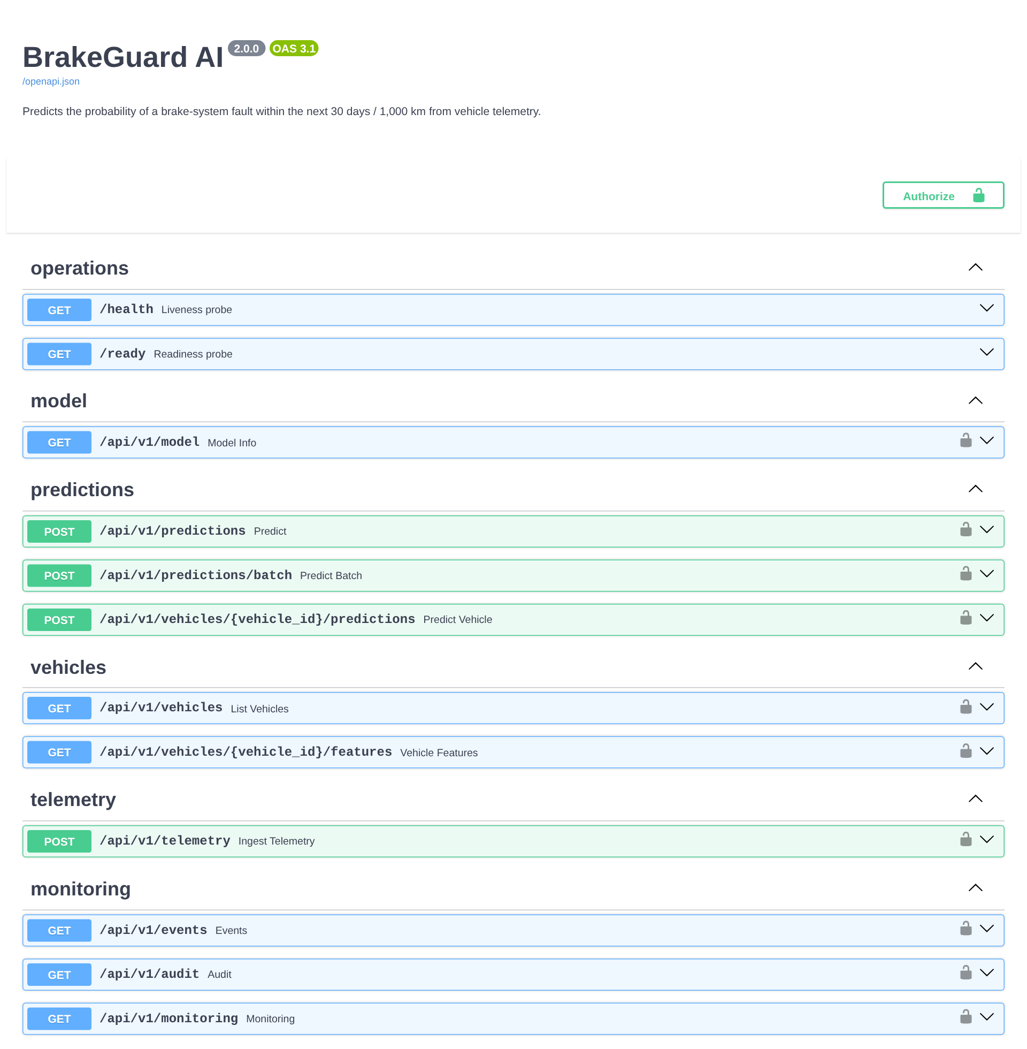
Figure 5 - Swagger UI (/docs): endpoints grouped by tag; lock icons mark API-key-protected routes.
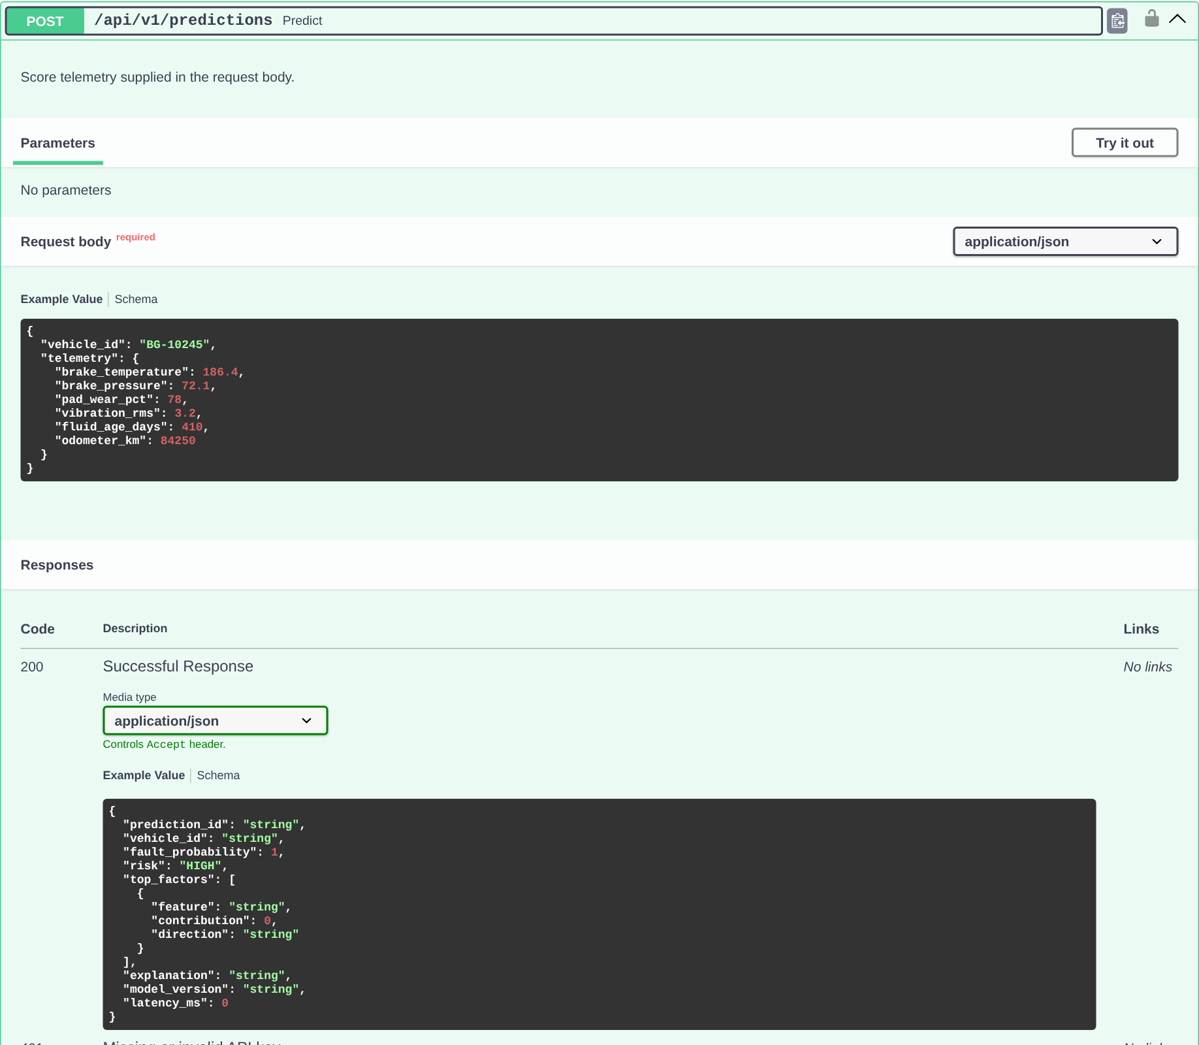
Figure 6 - Request schema with example, and documented 200/401/422/503 responses for POST /api/v1/predictions.
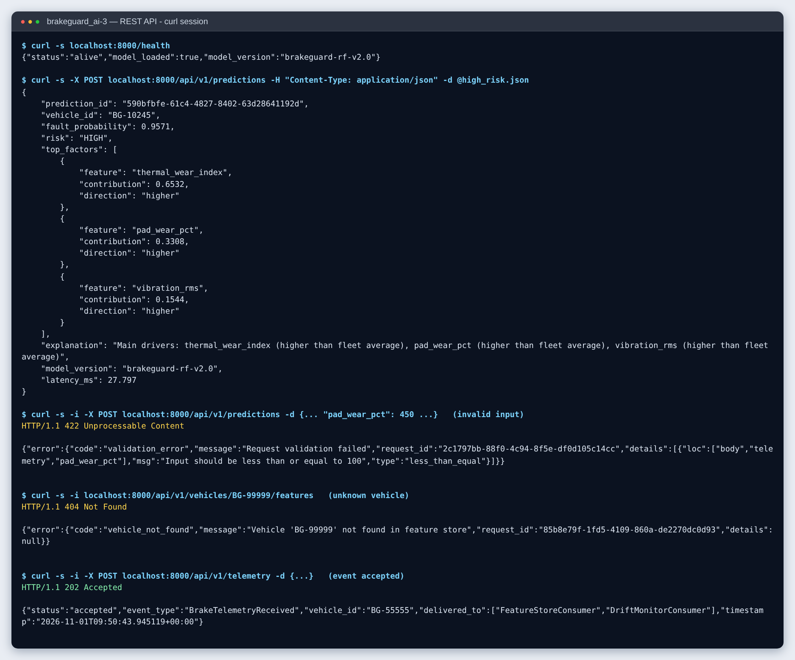
Figure 7 - curl session: 200 prediction with explanation, 422 for pad wear of 450 %, 404 for an unknown vehicle, 202 for a telemetry event.
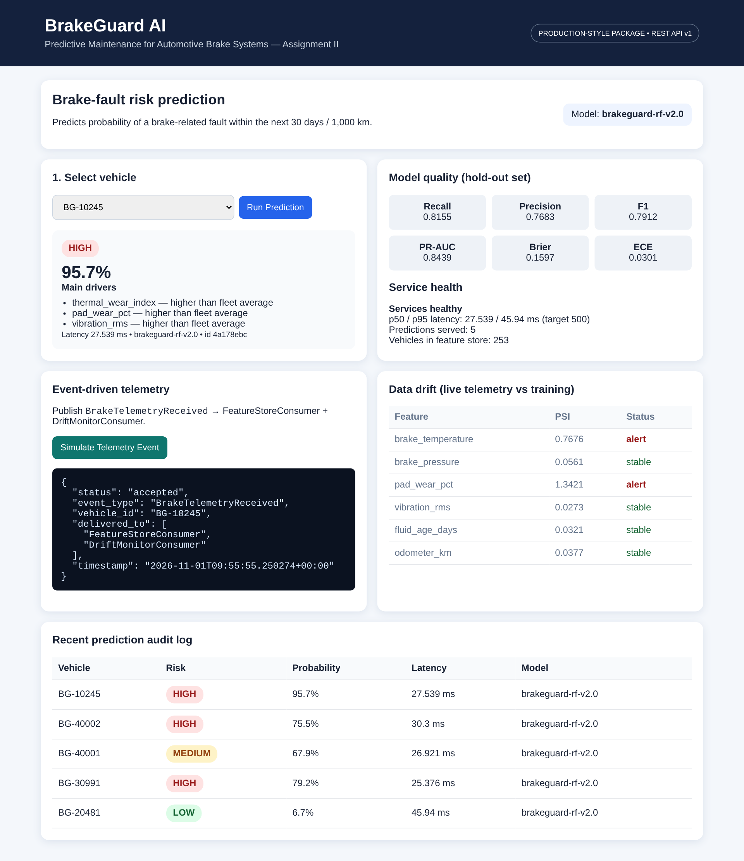
Figure 8 - Dashboard served by the API: prediction with drivers, hold-out model-quality metrics, latency, event-driven telemetry, live drift (a simulated heat-wave fleet drifts on brake temperature and pad wear only) and the audit log.

Objective 2 - Quality assurance

Task 6 - Types of tests (pytest)
The suite has 96 tests in four categories. All pass in about 12 s, with 97 % line coverage of the brakeguard package. Session-scoped fixtures in tests/conftest.py train the production model once. Each API test gets a fresh app instance, so tests never share state.
Type | Location | # | What is verified
Unit tests | tests/unit/ | 26 | Risk-threshold boundaries; FeatureEngineer (derived values, median imputation + WARNING log, missing/non-numeric columns); FeatureStore copies / unknown ids; EventBus isolation of failing subscribers; bounded AuditLog; ECE / metric correctness on hand-computed cases; registry round-trip, missing and corrupt artefacts
Data-validation tests | tests/data_quality/ | 19 | Schema (missing columns, target), completeness gate, physical-range violations, non-numeric types, invalid labels, duplicates, empty data, CSV ingestion errors, PSI behaviour, DriftDetector on stable vs shifted fleets
ML tests | tests/ml/ | 24 | Training behaviour (8) and inference behaviour (16); see Task 7
Integration tests | tests/integration/ | 27 | HTTP -> services -> model end to end: every endpoint and status code, input-validation and auth rules, event-driven feature-store update, drift monitoring, CSV -> train -> register -> load, bad data blocks registration, retrain fallback, CLI exit codes

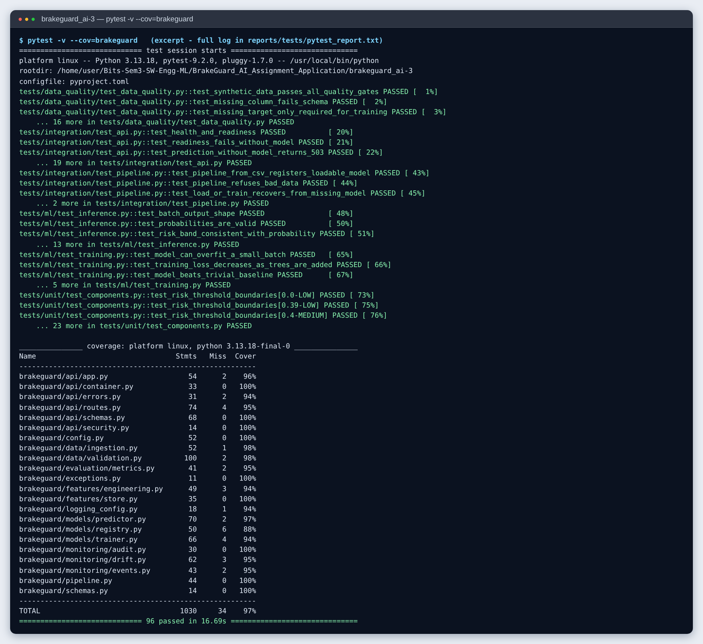
Figure 9 - pytest run (excerpt; full verbose log in reports/tests/pytest_report.txt) with the coverage table.

Task 7 - Tests specific to ML components

7a. Testing model training (tests/ml/test_training.py)
Test | Rationale
test_model_can_overfit_a_small_batch | A high-capacity forest must memorise 32 samples (100 % training accuracy). Failure means misaligned labels or dropped features.
test_training_loss_decreases_as_trees_are_added | Random forests have no epochs, so the analogue is training log-loss as trees are added (warm_start). It falls from 0.6842 (1 tree) to 0.344 (160 trees) and must never rise by more than 0.01 (Figure 10).
test_model_beats_trivial_baseline | PR-AUC must exceed the positive rate (a random classifier's PR-AUC) by 0.2; ROC-AUC > 0.75.
test_model_meets_quality_targets | Recall >= 0.75, ECE <= 0.10, Brier <= 0.20.
test_training_is_reproducible | Same data and seed give identical metrics.
test_no_severe_overfitting | Train-test ROC-AUC gap < 0.15.
test_single_class_target_is_rejected | Degenerate data raises ModelTrainingError.
test_quality_gate_rejects_model_trained_on_noise | With shuffled labels the pipeline refuses to register the model and logs an ERROR.

tests/ml/test_training.py
def test_model_can_overfit_a_small_batch():
"""A model with enough capacity must memorise 32 samples.

If it cannot, the pipeline is broken (e.g. labels misaligned with
features or features silently dropped) - the classic "overfit one
batch" sanity check.
"""
batch = SyntheticTelemetrySource(n_samples=32, seed=3).load()
trainer = ModelTrainer()
X, y = trainer.split_xy(batch)
pipeline = trainer.build_pipeline(n_estimators=50, max_depth=None, min_samples_leaf=1, class_weight=None)
pipeline.fit(X, y)
assert (pipeline.predict(X) == y).mean() == 1.0

def test_training_loss_decreases_as_trees_are_added():
frame = SyntheticTelemetrySource(n_samples=600, seed=5).load()
trainer = ModelTrainer()
X, y = trainer.split_xy(frame)
losses = trainer.loss_curve(X, y, steps=(1, 5, 10, 25, 50, 100))
assert losses[-1] < losses[0] * 0.5 # big drop from a single tree to the ensemble
# once converged the curve may plateau, but it must never climb noticeably
assert all(later <= earlier + 0.01 for earlier, later in zip(losses, losses[1:]))

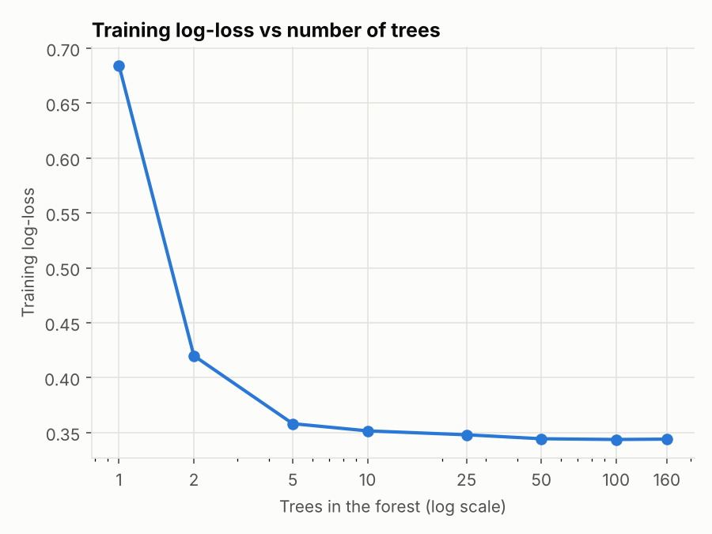
Figure 10 - Training log-loss as trees are added (basis of the 'loss decreases' test).

7b. Testing model inference (tests/ml/test_inference.py)
These tests follow the CheckList approach: shape and range checks, minimum-functionality cases, invariance tests (changes that must not affect the output) and directional-expectation tests (changes that must move the output in a known direction).
Category | Tests
Output shape / range | Batch output shape = (n,); all probabilities in [0, 1] and not NaN; risk band consistent with thresholds; explanation has top-k known features; deterministic; batch == single predictions
Minimum functionality | Obviously failing brakes (230 degC, 92 % wear, 5.5 g vibration) -> HIGH; new brakes -> LOW
Invariance | Key order of the input; extra metadata (vehicle_id, driver name); 0.1 % sensor noise changes probabilities by < 0.01 on average
Directional | Higher pad wear, vibration, temperature or fluid age raises mean fleet probability (> +0.02); line pressure 25 bar or 105 bar both score above nominal 65 bar

tests/ml/test_inference.py - directional expectation tests
# -- directional expectations ------------------------------------------------------------------
@pytest.mark.parametrize(
("feature", "low", "high"),
[
("pad_wear_pct", 15.0, 90.0),
("vibration_rms", 0.5, 5.0),
("brake_temperature", 100.0, 240.0),
("fluid_age_days", 30.0, 800.0),
],
)
def test_worse_condition_increases_risk(predictor, fleet, feature, low, high):
"""Averaged over the fleet, a worse value must not lower the fault probability."""
better = predictor.predict_proba([{**r, feature: low} for r in fleet])
worse = predictor.predict_proba([{**r, feature: high} for r in fleet])
assert worse.mean() > better.mean() + 0.02

def test_pressure_deviation_in_either_direction_increases_risk(predictor, fleet):
nominal = predictor.predict_proba([{**r, "brake_pressure": 65.0} for r in fleet]).mean()
too_low = predictor.predict_proba([{**r, "brake_pressure": 25.0} for r in fleet]).mean()
too_high = predictor.predict_proba([{**r, "brake_pressure": 105.0} for r in fleet]).mean()
assert too_low > nominal and too_high > nominal

Task 8 - Model-quality and data-quality metrics
All values below were measured by python -m scripts.quality_report (output in reports/metrics/quality_report.json) on a 600-row stratified hold-out set of the 3,000-row synthetic fleet data. The same model metrics are stored in the model bundle and served at /api/v1/model and on the dashboard.

8a. Model quality
Metric | Why it matters for BrakeGuard | Hold-out | Train | Target / gate
Recall | Share of real brake faults caught; a missed fault is the costly error | 0.816 | 0.861 | >= 0.75 (registration gate)
Precision | Share of alerts that are real; controls workshop false alarms | 0.768 | 0.885 | monitored
F1 | Balance of recall and precision | 0.791 | 0.873 | monitored
PR-AUC | Threshold-free ranking quality on the positive class | 0.844 | 0.957 | >= 0.70 (registration gate)
ROC-AUC | Threshold-free discrimination | 0.847 | 0.950 | > 0.75 (test)
Brier score | Calibration + sharpness of probabilities (lower is better) | 0.160 | 0.101 | <= 0.20 (test)
ECE (10 bins) | Does a 70 % shown to a fleet manager mean 70 %? | 0.030 | 0.095 | <= 0.10 (test)

Recall is 0.816 at threshold 0.5. Across other synthetic seeds hold-out recall varied between about 0.70 and 0.82, which is why recall is a gate rather than a single trusted number, and why it is re-checked online (Section 9). Calibration is good (ECE 0.030), so the probability shown on the dashboard can be read at face value.
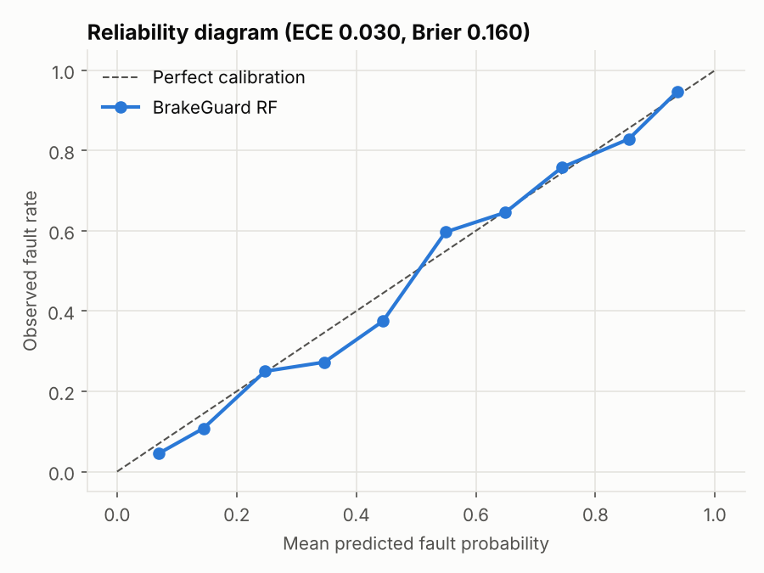
Figure 11 - Reliability diagram: predicted probabilities track observed fault rates.
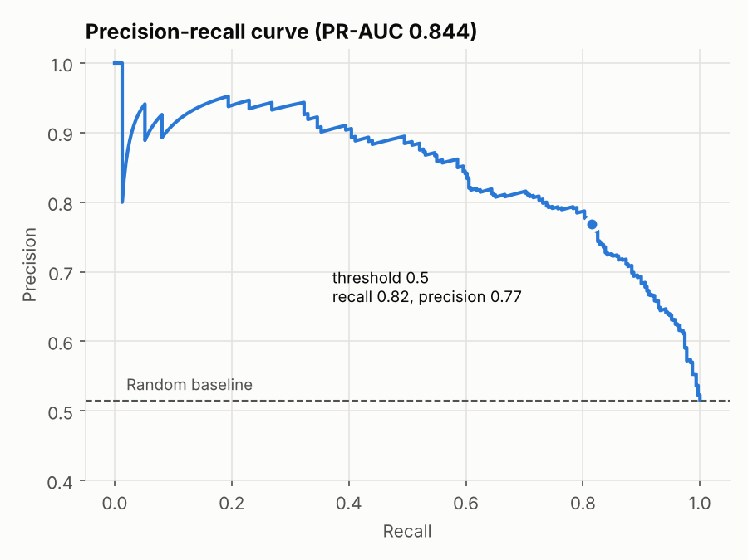
Figure 12 - Precision-recall curve with the operating point at threshold 0.5.

8b. Data quality
DataValidator measures data-quality metrics for every batch, and DriftDetector compares live telemetry with the training reference. They were run on a clean batch, a deliberately corrupted batch (sensor dropouts, a fraction-vs-percent unit bug and duplicated rows), and a stable and a shifted fleet:
Metric | Definition | Clean batch | Corrupted batch | Gate
Schema validity | All required columns present and numeric | true | true | must be true
Missing-value ratio | Share of null cells per column | 0.00 % | 7.77 % (brake_temperature) | <= 5 % per column
Out-of-range ratio | Values outside the physical range in TELEMETRY_SCHEMA | 0.00 % | 5.05 % (pad_wear_pct) | <= 1 % per column
Duplicate-row ratio | Exact duplicate records | 0.00 % | 2.91 % | warning
Gate result |  | PASSED | REJECTED

Drift metric | Stable fleet (max over features) | Shifted fleet | Thresholds
PSI (10 reference-quantile bins) | 0.021 | brake_temperature 1.29, pad_wear_pct 1.45; others <= 0.018 | warning 0.10, alert 0.25
Kolmogorov-Smirnov p-value | min 0.139 | brake_temperature < 1e-6 | < 0.01 confirms shift
Drifted features | none | brake_temperature, pad_wear_pct

While building the live drift monitor, PSI over 10 bins on a 30-40-sample window flagged every feature as drifting, because the estimate is dominated by noise. The minimum window was therefore made a setting (BRAKEGUARD_DRIFT_MIN_SAMPLES, default 200), and an integration test checks that an in-distribution fleet of 250 vehicles raises no drift alert.
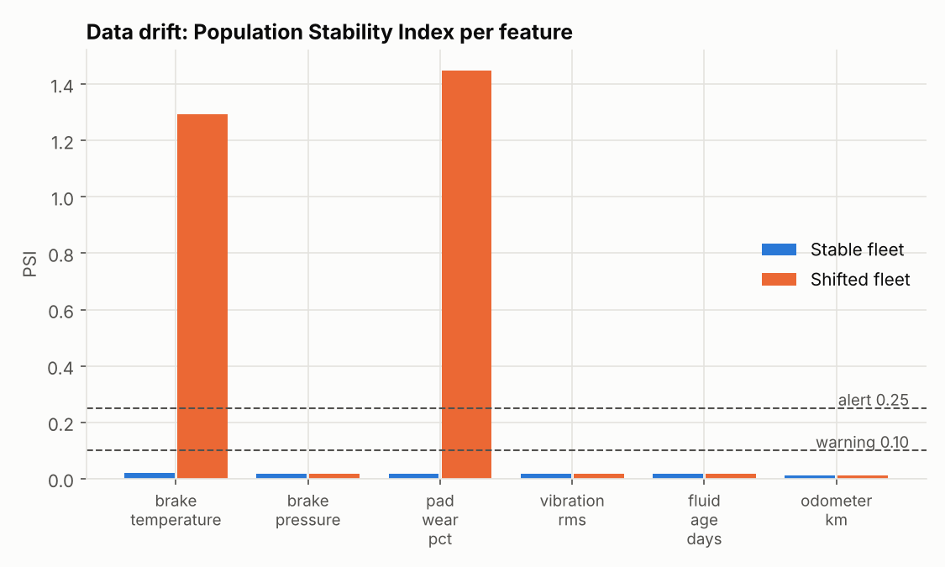
Figure 13 - PSI per feature: the shifted (heat-wave) fleet drifts on temperature and pad wear only.

Task 9 - Testing in production and security

Testing / experimentation in production: shadow -> canary -> A/B
Offline metrics come from synthetic data, and brake faults are only confirmed at the workshop weeks later. A new model version (the challenger) is therefore rolled out against the current champion in three stages:
Stage | Traffic | Exit criteria
1. Shadow (2-4 weeks) | 100 % of requests mirrored to the challenger; only the champion's answer is returned and the challenger's is logged | No errors; p95 latency < 500 ms; >= 90 % agreement on HIGH/LOW; challenger recall >= champion on vehicles whose outcome is already known
2. Canary (1-2 weeks) | 5 % -> 25 % -> 50 % of vehicles, sticky by vehicle_id hash | Error rate and latency not worse; HIGH-alert rate within +/-20 % of champion; automatic rollback on breach
3. A/B, then full rollout | 50/50, then 100 % | After the 30-day label horizon: recall not significantly lower (one-sided test, alpha 0.05), false-alarm rate lower or equal; old version kept in the registry for one-click rollback

Shadow mode comes first because a missed brake fault is a safety incident, so a challenger must not influence a real maintenance decision before its live behaviour is known. The code base already has the needed pieces: ModelRegistry versions artefacts, AuditLog records prediction_id and model_version for joining with workshop outcomes, and /api/v1/monitoring reports the latency and drift guard-rail metrics that pause or roll back a rollout.

Security consideration: input validation and model access control
Threat. Crafted or faulty telemetry could suppress a real HIGH alert (an evasion attack), poison the feature store and drift statistics, or be used to query the model at high volume to reverse-engineer it. The Assignment I API and the research notebook accept any value; the notebook scores 450 % pad wear as a valid reading.
- Schema-driven input validation: physical ranges per field, extra="forbid", a vehicle_id pattern and a batch cap of 500. Violations return 422 and are logged as WARNING. Covered by 6 integration tests.
- Model access control: when BRAKEGUARD_API_KEY is set, /api/v1/* requires an X-API-Key header, compared in constant time with hmac.compare_digest. The key comes only from the environment. Probes stay public for orchestration.
- Safe failure: generic 500 responses without stack traces; details are logged under the request_id.
- Bounded state (audit, event and drift windows) against memory exhaustion, and drift alerts as a detection control for coordinated data injection.
- Hardened deployment: multi-stage Docker build with lint and tests as a gate, non-root user, read-only filesystem.
Next steps for production: mTLS from vehicle gateways, per-client rate limiting at the gateway, and signed model artefacts. Unpickling an untrusted joblib file executes code, so only a file whose hash matches the registry entry should be loaded. Full write-up: docs/production_testing_and_security.md.

Appendix A - How to run
cd BrakeGuard_AI_Assignment_Application/brakeguard_ai-3
python -m venv .venv && source .venv/bin/activate # Windows: .venv\Scripts\activate
pip install -r requirements-dev.txt
python -m scripts.train --metrics-out reports/metrics/training_metrics.json
uvicorn app:app --reload # dashboard http://127.0.0.1:8000, Swagger /docs
pytest -v --cov=brakeguard # 96 tests
black --check brakeguard tests scripts app.py && isort --check-only brakeguard tests scripts app.py
flake8 brakeguard tests scripts app.py && pylint brakeguard scripts app.py
python -m scripts.quality_report # metrics + figures
docker compose up --build # lint + tests run inside the image build

Appendix B - Deliverables in the repository
Path | Content
brakeguard/ | Production package (about 2,000 lines across 29 modules)
tests/ | 96 pytest tests in unit / data_quality / ml / integration
notebooks/Group_XX.ipynb | Executed implementation notebook with group details (rename to <Group no>.ipynb)
notebooks/01_research_prototype.ipynb | Research-code version used for the Task 2 comparison
docs/ | research_vs_production.md, production_testing_and_security.md
reports/lint/ | Lint reports: before (Assignment I), before (new package), after
reports/tests/ | pytest verbose log + coverage, summary
reports/metrics/ | quality_report.json, training_metrics.json, figures
reports/api/ | curl transcript, logging evidence
reports/screenshots/ | Dashboard, Swagger, lint, tests, API, logging screenshots

