Git and Github— DevOps Assignment
Git and GitHub Assignment Documentation
Project Name: Git and GitHub
Student Name: Rajesh Singh

Assignment setup: I’m doing the assignment in window machine though using below tools and setup
- Git - for Git commands and version control and using Git Bash for git command etc.
- Visual Studio Code - for editing your Flask project.
- GitHub - for hosting your repository.
- Source Code – HTML, text file, Readme.md, Python etc.

Installed and setup the above requirements on local machine below is the screenshot

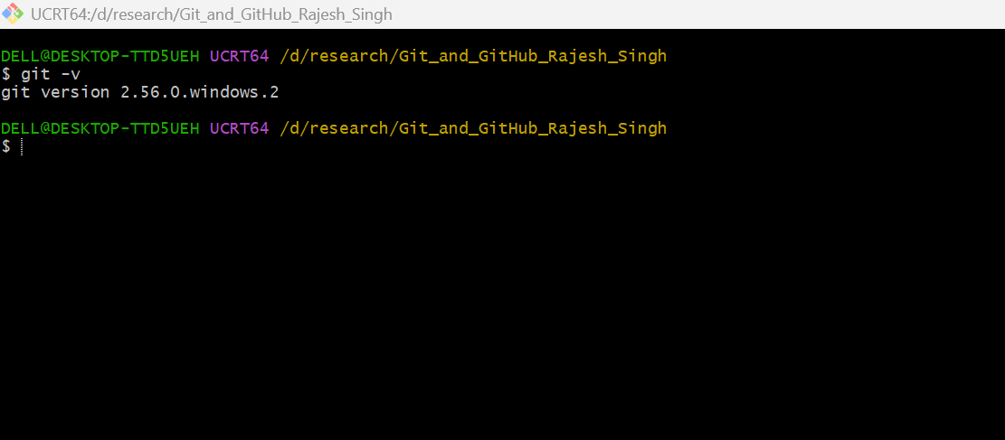
Git Bash and Version check
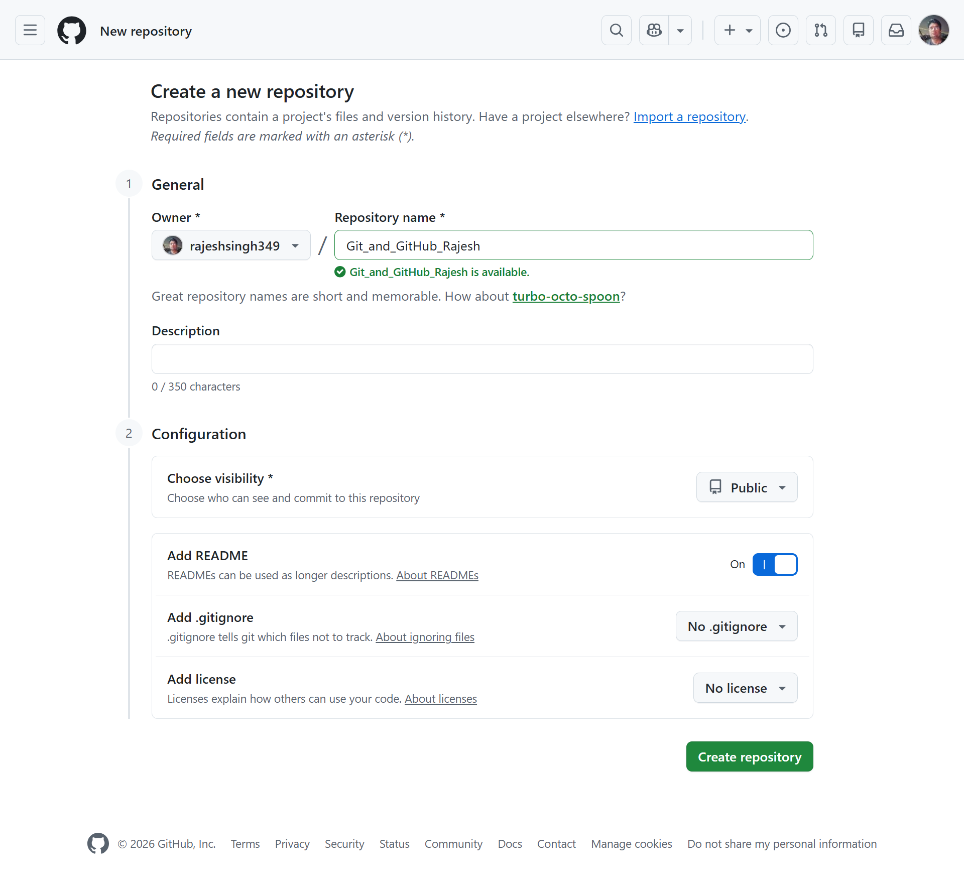
Task 1: Repository Setup & First Branch Creating a new repository name as “Git_and_GitHub_Rajesh
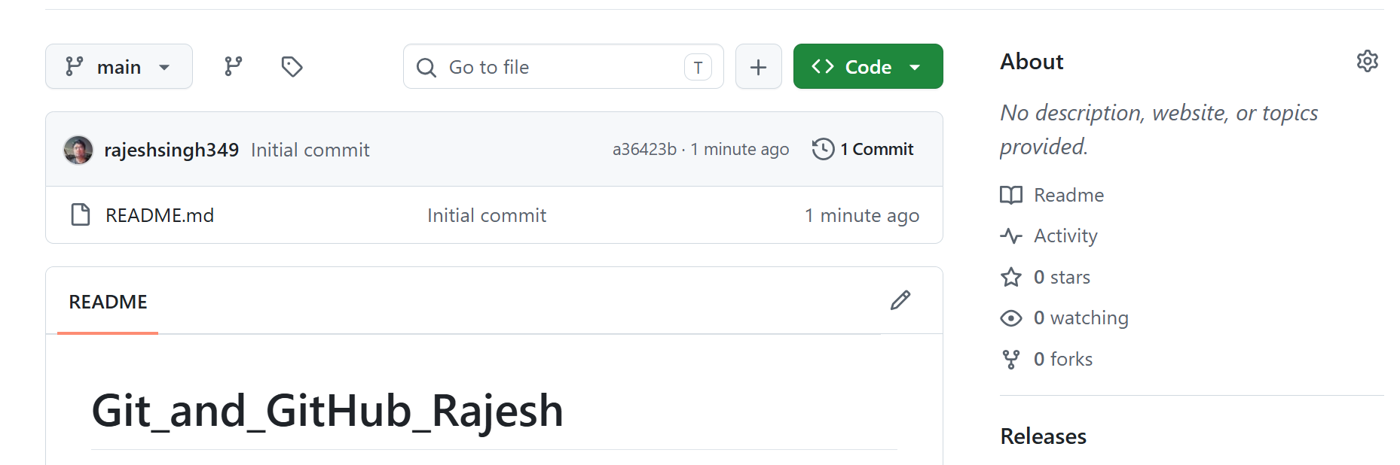
After creating initial Git repository screen as below

Clone the repository to your local machine using SSH (generate an SSH key if needed, and add the public key to your GitHub account).

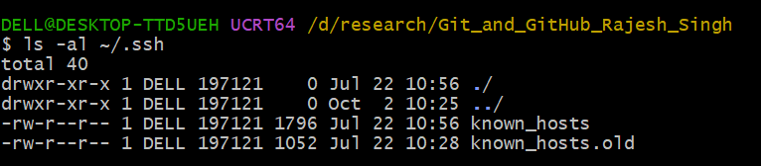
- Add a Git SSH Key to GitHub: Open the Git Bash then check whether an SSH key already exists using below command
ls -al ~/.ssh

- Generate a new SSH key:
- Run below with my git resisted email
$ ssh-keygen -t ed25519 -C rajeshsingh349@gmail.com
- Verify the generated files
ls -al ~/.ssh
I have seen the below generated key files (id_ed25519
id_ed25519.pub)
- Add the key to the SSH agent as below command
ssh-add ~/.ssh/id_ed25519
- Display your public key
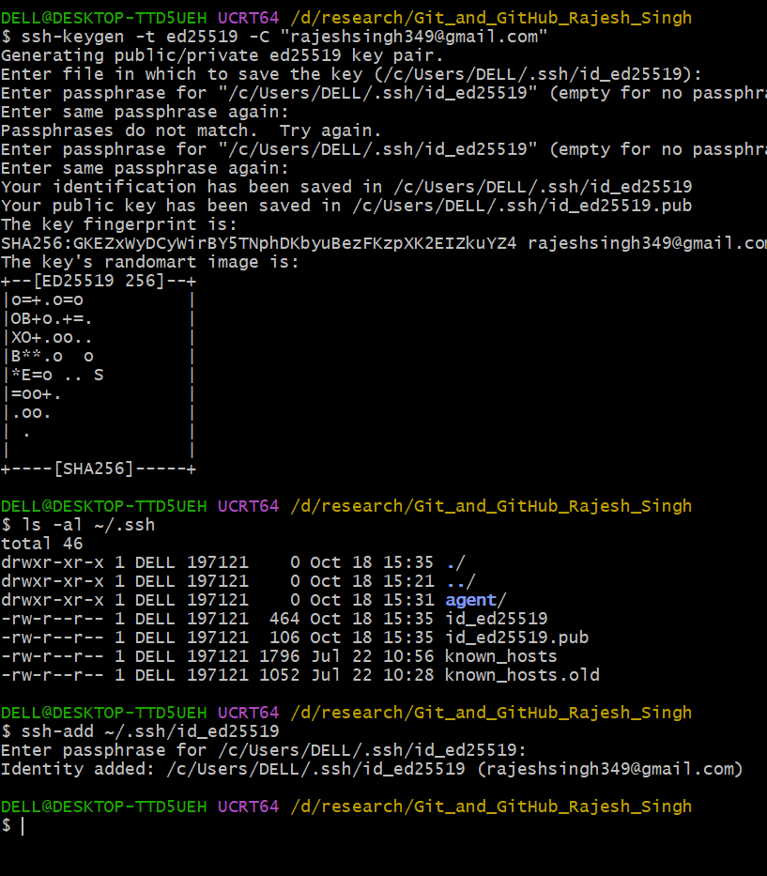
cat ~/.ssh/id_ed25519.pub
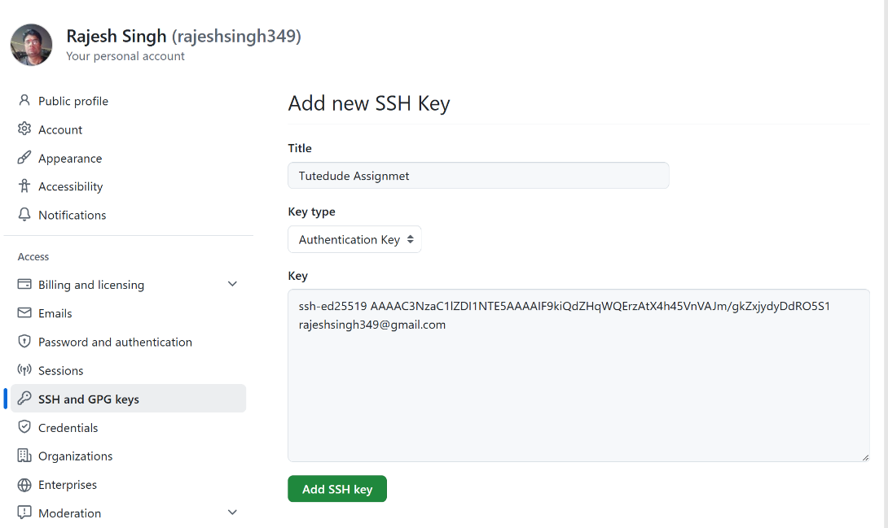
- Added the key to GitHub

After Added SSH key in git look like see below Screenshot
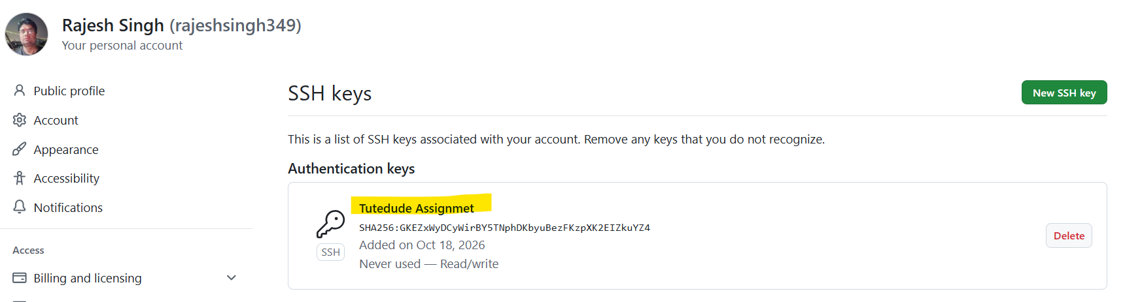

- Clone Git Repository
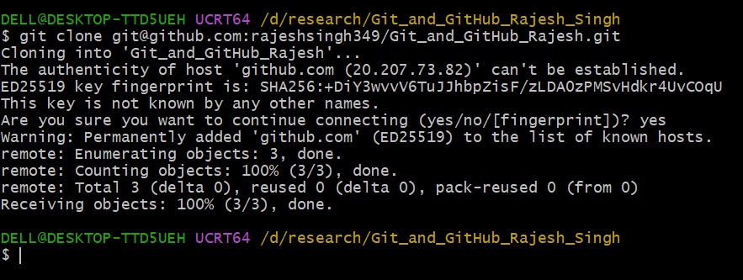
git clone git@github.com:rajeshsingh349/Git_and_GitHub_Rajesh.git

- Check the repository status and verify the remote connection as below command
git status
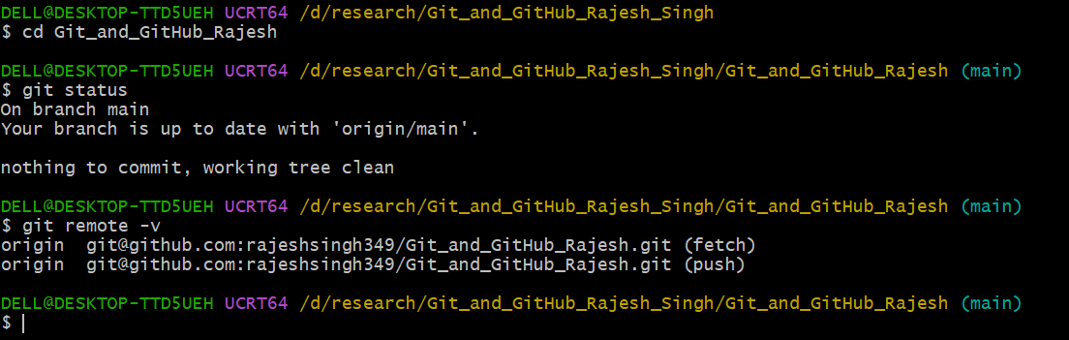
git remote -v

- Create a Branch Named After Your Username
  - First verify the current branch using below command
git branch
  - Create your username branch as below command my username is rajeshsingh349
git switch -c rajeshsingh349
check the branch
git branch
  - Push the branch to GitHub
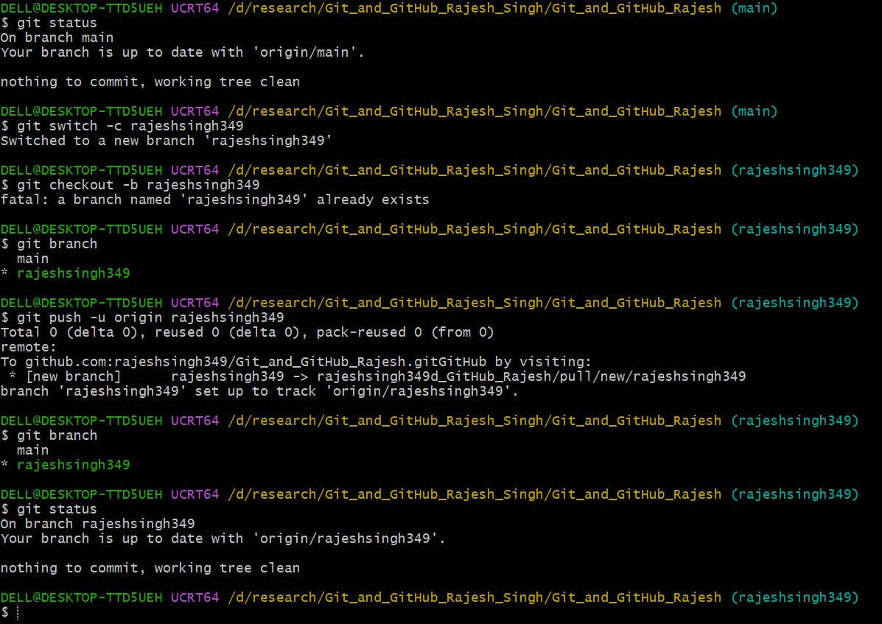
git push -u origin rajeshsingh349
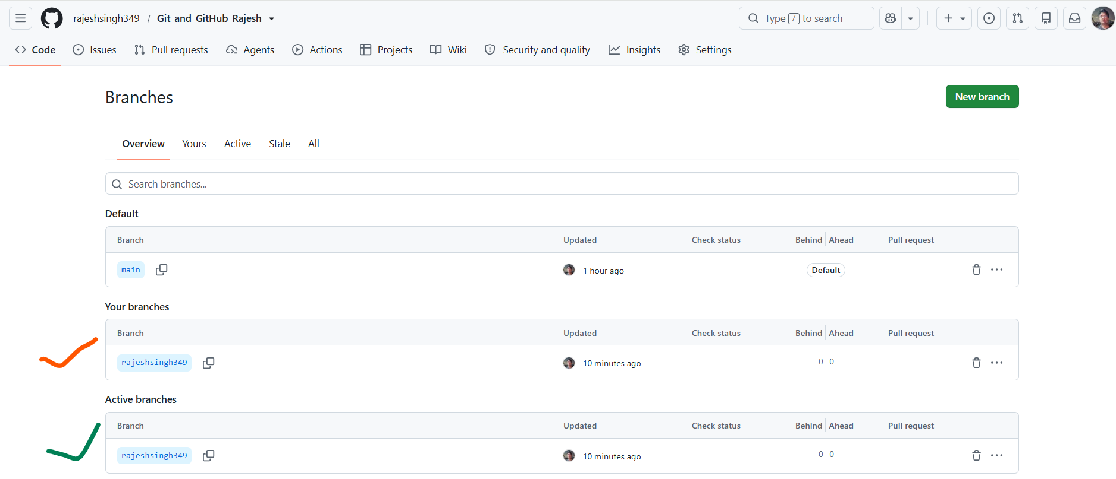

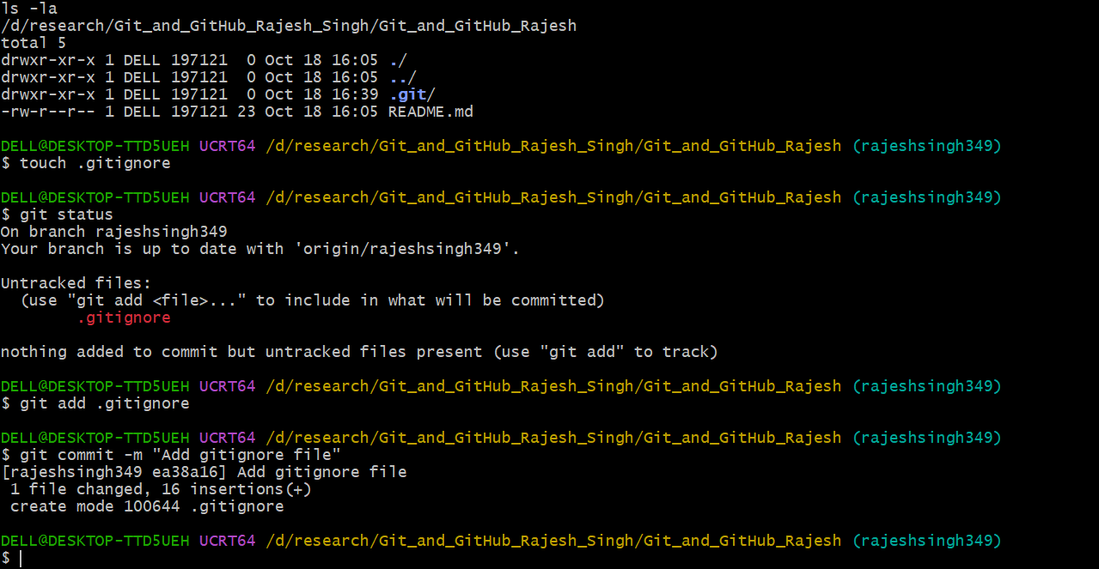
Added .gitignore file

- Added earlier Flask project files to this branch (branch rajeshsingh349)
- Copy and paste both tasks in /Git_and_GitHub_Rajesh
- Added some unnecessary and secure to .gitignore like .env, __pycache__ etc
- Adding and commit file and folder in git branch rajeshsingh349 using below command
git add ./
after that checking git status as below screenshot
git status
then git commit the added files and folder
git commit -m "Add initial Flask project"
- Push in branch (rajeshsingh349) to GitHub
git push -u origin rajeshsingh349

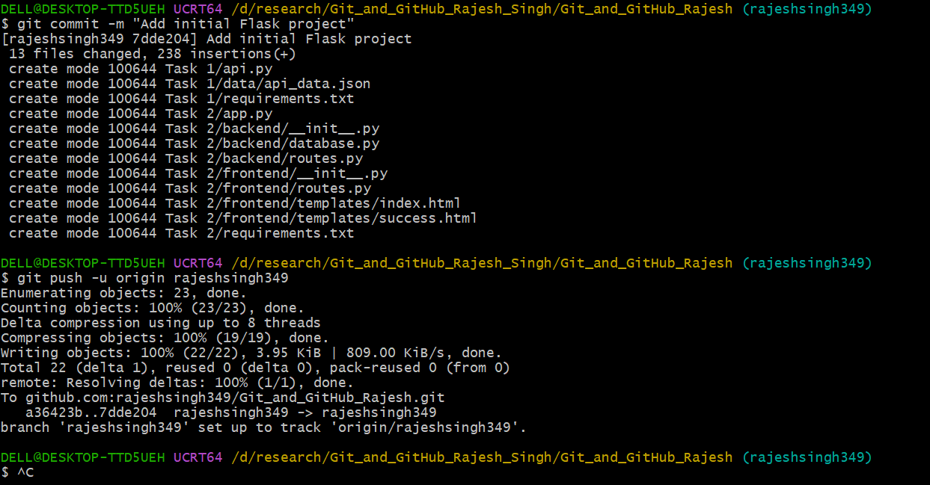
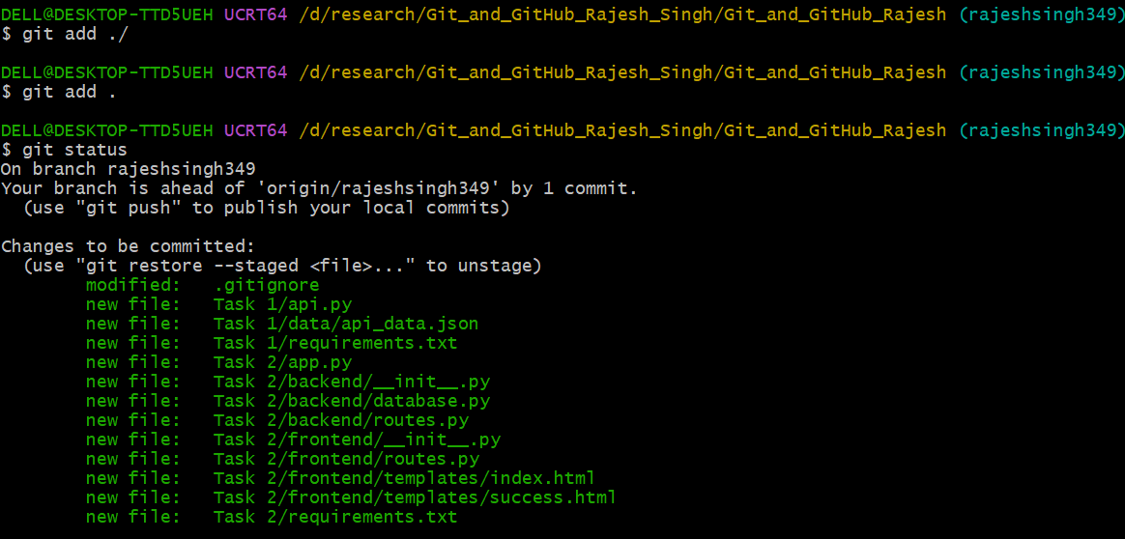

- Commit the changes and merge the branch into the main branch
  - First, check the available branches
git branch -a
  - Switch the main branch
git switch main
  - Pull main branch
git pull origin main
  - Merge into main branch
git merge rajeshsingh349
  - Push to main branch
git push -u origin main
  - Check git status to verify result
git status
git log --oneline --graph --all
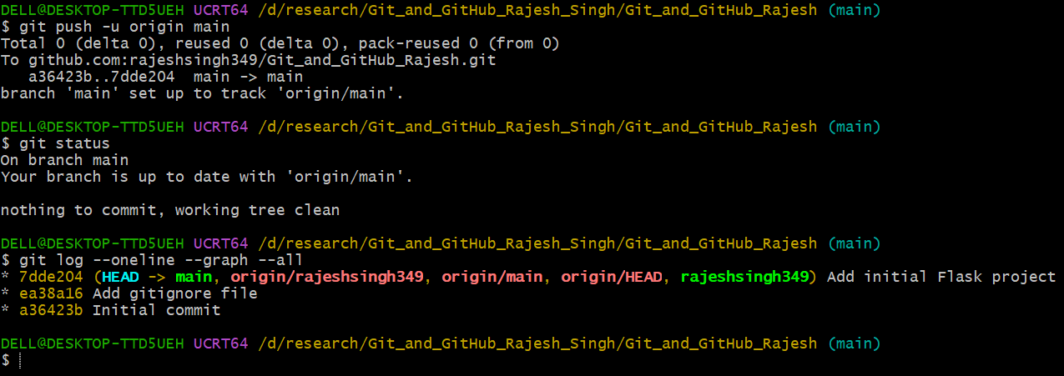
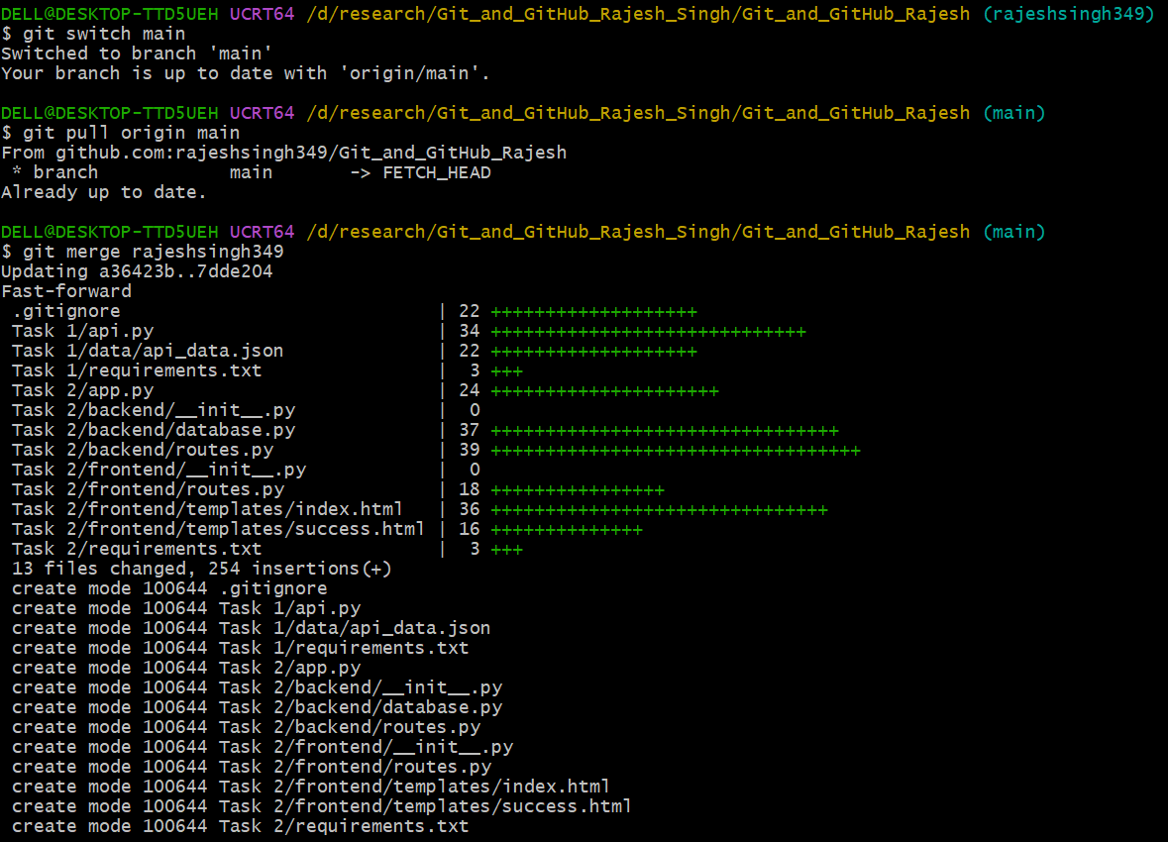

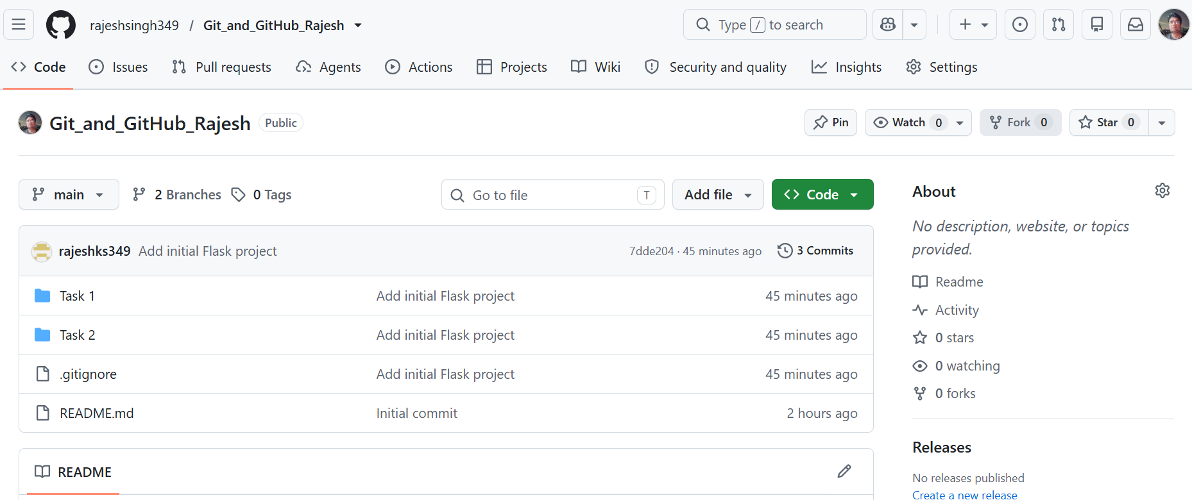

Task 2: Update JSON & Resolve Conflicts

- Switch to main and update it
  - Switch the main branch if other and pull it
git switch main
git pull origin main
  - Check git status
git status
- Create a new branch named _new (for e.g. rajeshsingh349_new)
  - Creating a new branch using the command below
git switch -c rajeshsingh349_new
  - Verify the branch
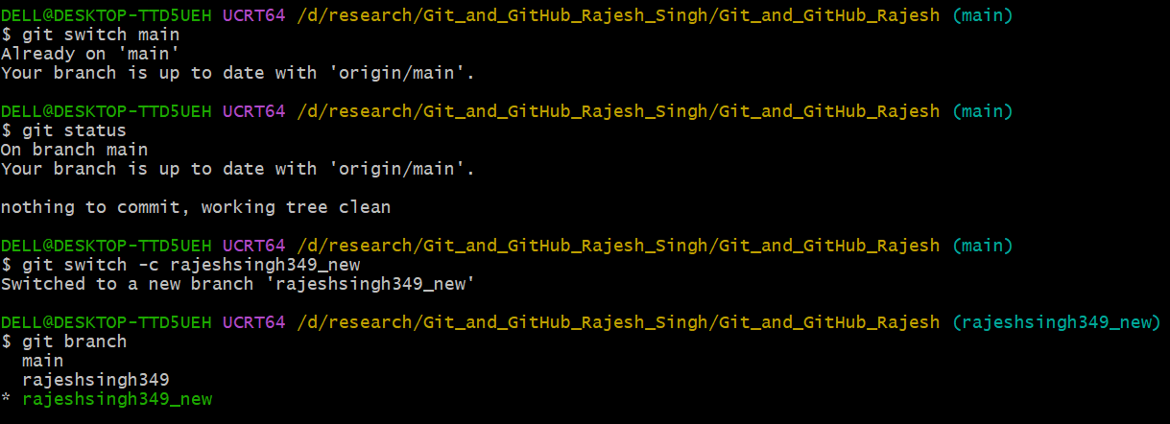
git branch

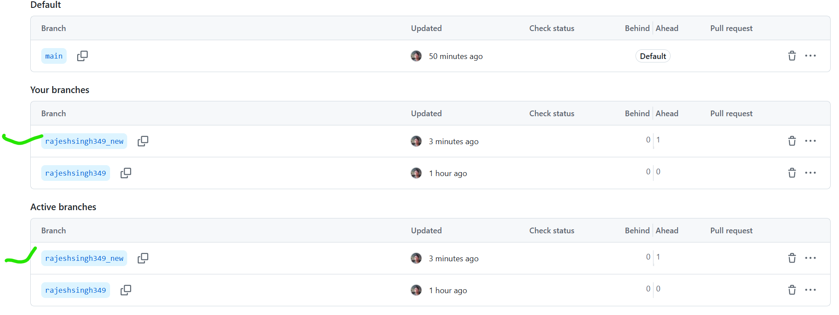
- Updated earlier created json file api_data.json
  - Commit and push the _new branch (rajeshsingh349_new) using below commands
git add api_data.json
git status
git commit -m "Update JSON data for Flask API"
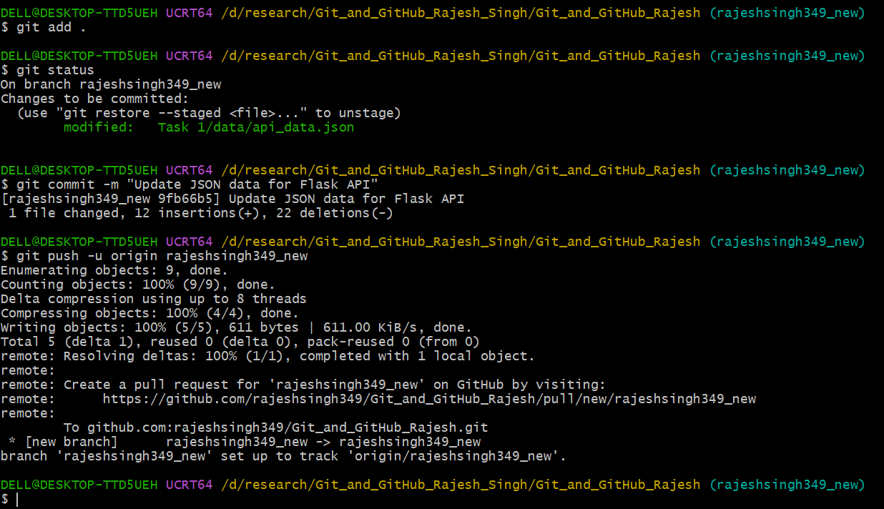
git push -u origin rajeshsingh349_new

- Create a merge conflict intentionally – creating a genuine conflict, we need to edit the same JSON file differently on both branches (edit it in main branch).
  - Switch the main branch
git switch main
  - Update the json file (api_data.json) through the main branch
  - Save the file, then commit the change
git add api_data.json
git commit -m "Update JSON on main for conflict practice"

  - Now merge the _new branch (rajeshsingh349_new)
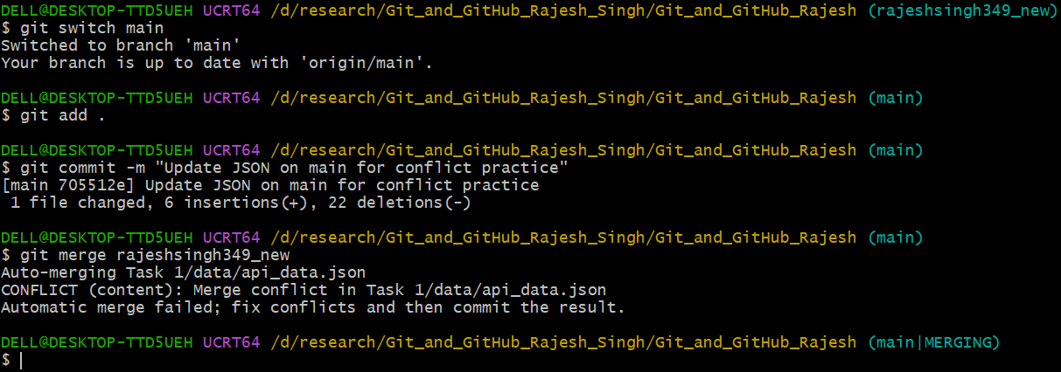
git merge rajeshsingh349_new

- Resolving the conflict by accepting _new branch changes
In VS Code, now choosing Accept Incoming Change for the conflicted section.
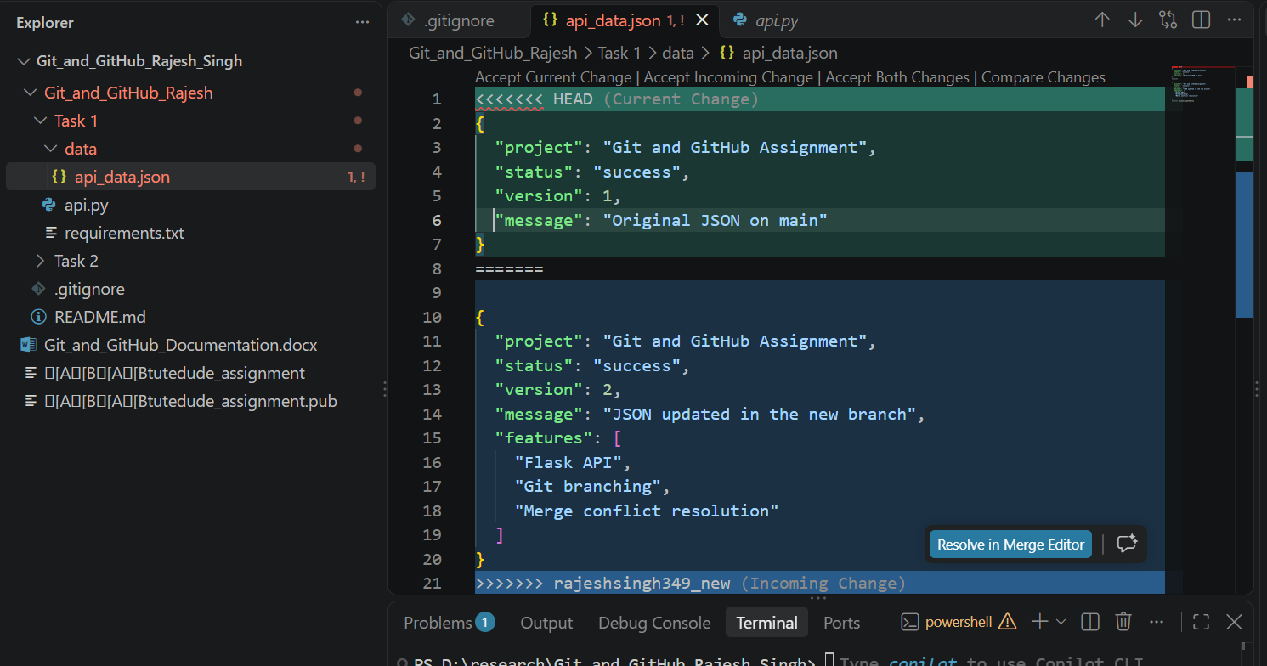

Then stage and complete the merge - below command while the merge is in progress
git checkout --theirs – Task\ 1/data/api_data.json
git add Task\ 1/data/api_data.json
git status
git commit -m "Resolve JSON merge conflict using new branch"

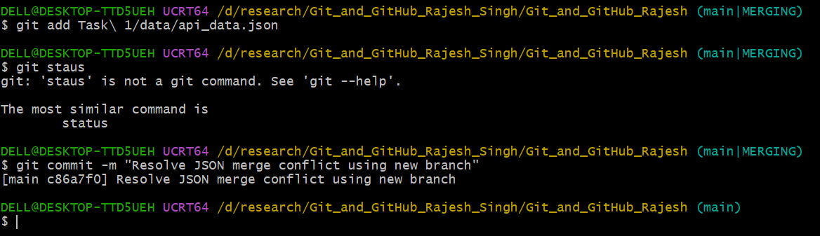

- Push the merged main branch
git push origin main
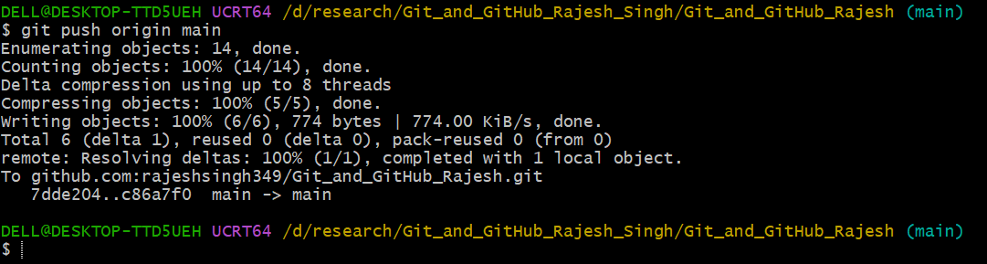

- Verify repo status
git status
git log --oneline --graph --all

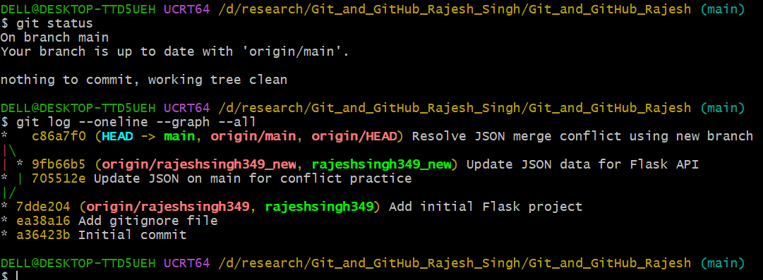

Task 3 — Parallel Feature Development

- Developing the To-Do frontend and backend on two separate Git branches, then merge both features into main.
- You will use your existing Flask project and MongoDB for storing To-Do items.
- This activity performs under the Source code Task 2 MongoDB.

- Check your working tree
  - Check the git status
git status
  - Switch and pull the main branch
git switch main
git pull origin main
  - Verify the branch
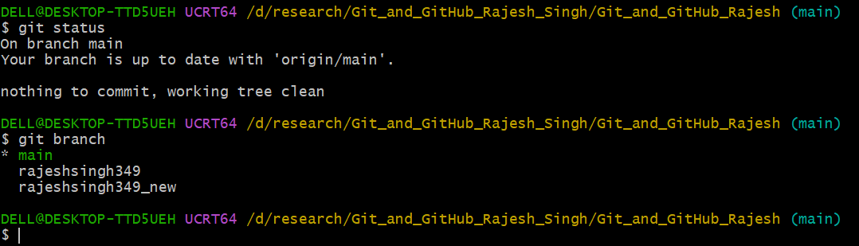
git branch

- Create the master_1 branch
  - Creating a branch master_1 using below command
git branch master_1
  - switch then branch master_1
git switch master_1
  - Verify the branch
Git branch
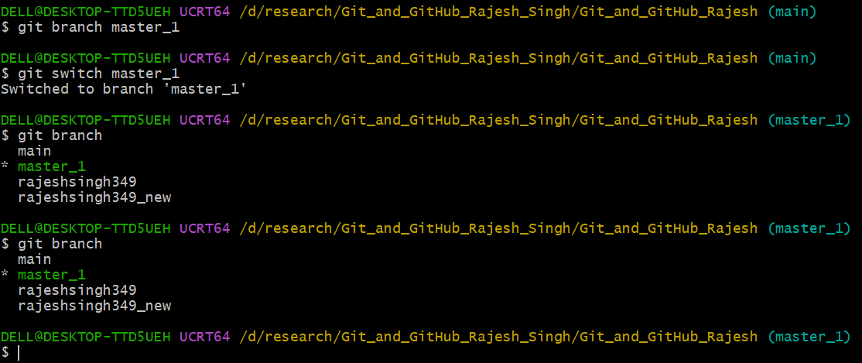
- Create the To-Do frontend
  - Inside it, create todo.html and added few html lines and changed the app.py for template rending and routing
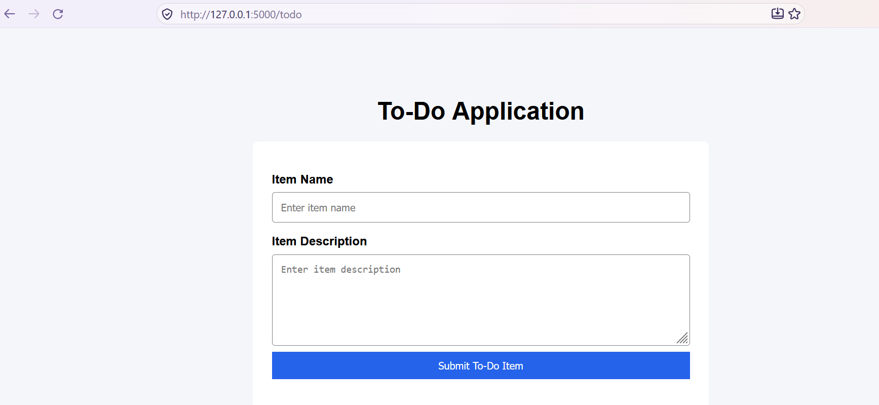

- Commit the frontend changes
  - Commit changes in master 1 for fronted below is commands
git status
git add ./
git commit -m "Add To-Do frontend form"
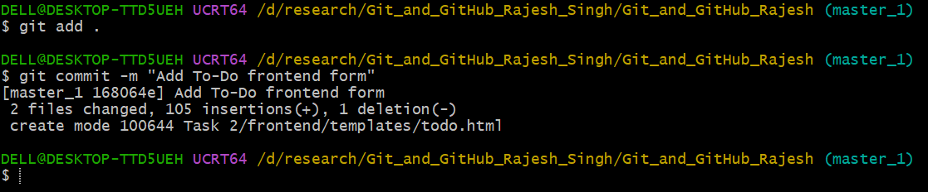
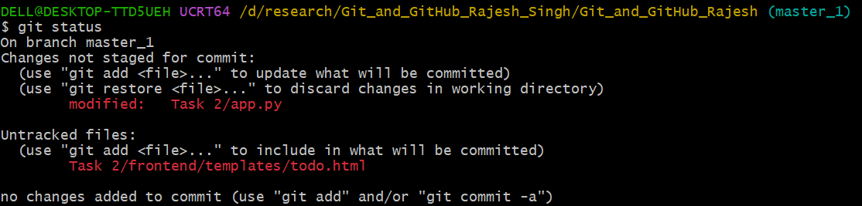

- Push in origin master_1 branch

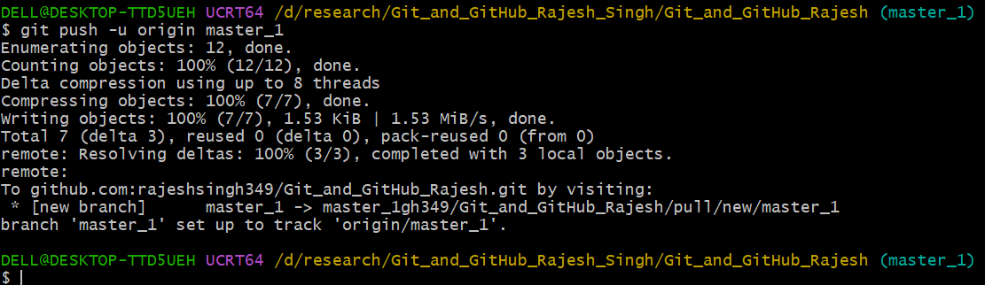
- Verify the the repo state
git status
git log --oneline --graph --all

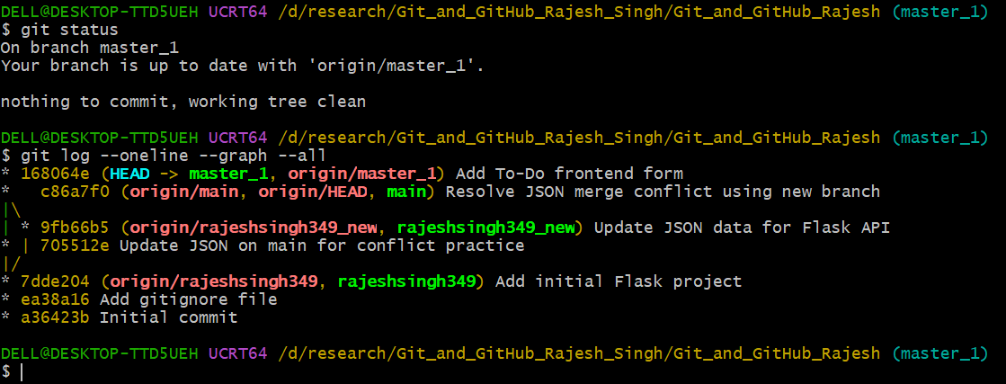

- Creating master_2 for the Backend API
- Switch to main branch and check status as below command
git switch main
git status
- Update your local main branch as below command
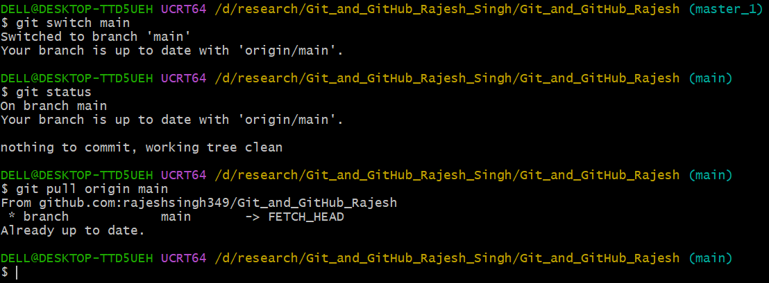
git pull origin main
- Creating a branch master_2 for Backend
  - Created master_2 branch using below command and branch status
git switch -c master_2
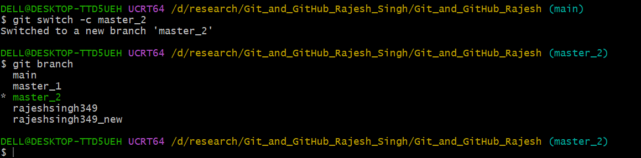
git branch

- Updated the exiting code submittodoitem routes in app.py

