**WAREHOUSE OPTIMIZATION: IMPROVING OPERATIONAL EFFICIENCY AND SPACE UTILIZATION**

**By**

**S. RAJESH**

**Roll No. 950021631022**

**A PROJECT REPORT**

**Submitted to**

**THE FACULTY OF MANAGEMENT STUDIES**

**In partial fulfilment for the award of the degree**

**Of**

**MASTER OF BUSINESS ADMINISTRATION**



**ANNA UNIVERSITY**

**CHENNAI 600 025**

**August, 2022**

|  |  |
| --- | --- |
| **C:\Users\User\Desktop\anna-university-logo.gif** | **ANNA UNIVERSITY REGIONAL CAMPUS,**  **TIRUNELVELI–627007.**  **DEPARTMENT OF MANAGEMENT STUDIES** |

**BONAFIDE CERTIFICATE**

Certified that the summer training report titled, “**AN ORGANISATIONAL STUDY ON CANNAN GLOBAL INTERNATIONAL”** is the bonafide work of **Mr. S RAJESH** who carried out the work under my supervision. Certified further that to be the best of my knowledge the work reported herein does not form part of any report or dissertation on the basis of which a degree or award was conferred on an earlier occasion on this or any other candidate.

|  |  |
| --- | --- |
| Signature of Student  **S. RAJESH** | Signature of Guide  **Dr. R. Banumathi**  **Assistant Professor** |

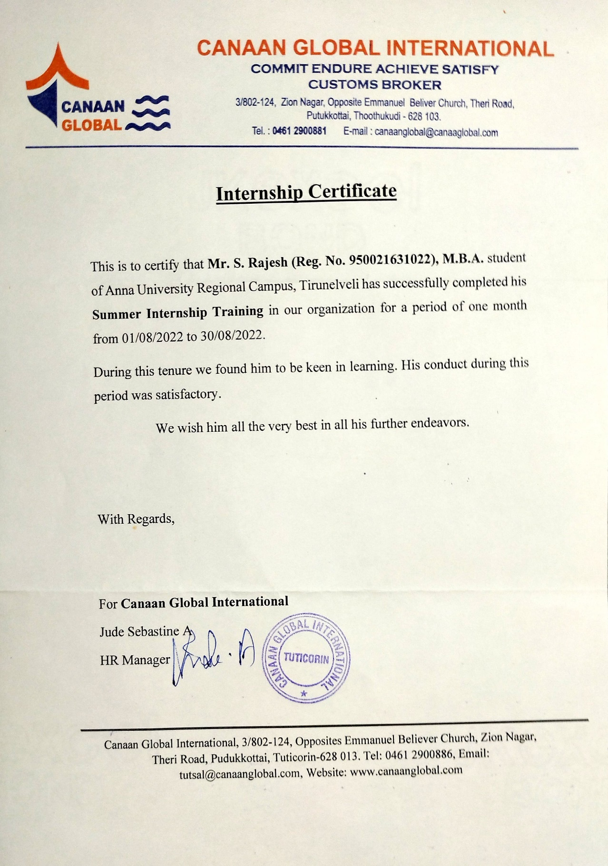

|  |
| --- |
| **S. RAJESH**  **Reg. No. :950021631022**  **Department of Management Studies**  **Anna University Regional Campus,**  **Tirunelveli–627007.** |

**DECLARATION**

I hereby declare that the Summer Training Report titled, **“AN ORGANIZATIONAL STUDY ON CANNAN GLOBAL INTERNATIONAL”** submitted by me in partial fulfillment for the award of the degree **MASTER OF BUSINESS ADMINISTRATION** of Anna University is my own work. The report has not been submitted for the award of any degree of the University or any other university before.

Place: Tirunelveli **S. RAJESH**

Date:  **(950021631022)**

**ABSTRACT**

The logistics sector represents five percent of India’s Gross Domestic Product (GDP) and employs 2.2 crore people. India handles 4.6billion tonnes of goods each year, amounting total annual cost of INR 9.5 lakh crore. This report presents a global perspective on the internship carried out in one of the leading logistics service-related company “Canaan Global International, Thoothokudi”. This study helped me to gain knowledge about the logistics industry. The general objective of this program was to gain practical knowledge on the overall functioning of the various departments involved in logistics services, responsibilities of employees and work flow of the company. Also, this report continues to assess the organization through a SWOT analysis.

|  |  |
| --- | --- |
| **C:\Users\User\Desktop\anna-university-logo.gif** | **ANNA UNIVERSITY REGIONAL CAMPUS,**  **TIRUNELVELI–627007.**  **DEPARTMENT OF MANAGEMENT STUDIES** |

**Certificate of Summer Training Presentation-Examination**

This is to certify that **Mr. S. RAESH** (Register No. 950021631022) has been subjected to summer training presentation on ……………. at Department of Management Studies, Anna University Regional Campus, Tirunelveli–627007.

|  |  |
| --- | --- |
| **GUIDE,**  Dr. R. Banumathi  Assistant Professor | **HEAD,**  Dr. S.Silas Sargunam  Assistant Professor |
|  |  |

**ACKNOWLEDGEMENT**

I express my gratitude to our **DEAN, Dr. N. Shenbaga Vinaya Moorthi, M.E, Ph.D.,** Anna University Tirunelveli, who provided all facilities for carrying out this project.

I immensely thank to our Head of the Department of Management Studies **Dr.S.Silas Sargunam, M.E.,MBA.,PhD.,** Anna University Tirunelveli, for his valuable suggestions and guidance for the completion of project work and for guiding me throughout the work.

I am greatly indebted to **Dr. R. Banumathi, B.E., MBA., Ph.D.,**  Assistant Professor, Department of Management Studies, Regional Campus, Anna University, Tirunelveli Region, who have given a valuable suggestions for completing the Summer Training and preparing this report.

I express my sincere gratitude to all other faculty members of the Department of Management Studies for their expertise and help in my project.

I am thankful to all staff members and respondents of **CANNAN GLOBAL INTERNATIONAL, THOOTHUKUDI** for their friendly co-operation to complete the summer training.

I acknowledge with sincere gratitude to my family members, friends for their inspiration and encouragement throughout this training.

**S. RAJESH**

(950021631022)