CHAPTER 1 1

INTRODUCTION AND RESEARCH PLAN 1

1.1 INTRODUCTION OF THE STUDY 1

1.2 OVERVIEW OF INDUSTRY AND COMPANY 2

1.3 NEED FOR THE STUDY 14

1.4 STATEMENT OF THE PROBLEM 14

1.5 RESEARCH QUESTIONS 15

1.6 OBJECTIVES OF THE STUDY 15

1.7 SCOPE OF THE STUDY 15

1.8 LIMITATIONS OF THE STUDY 16

CHAPTER 2 17

LITERATURE SURVEY 17

2.1 INTRODUCTION 17

2.2 REVIEW OF LITERATURE 18

2.3 RESEARCH GAP 20

CHAPTER 3 22

RESEARCH METHODOLOGY 22

3.1 INTRODUCTION 22

3.2 RESEARCH DESIGN 22

3.3 JUSTIFICATION OF SELECTING THE STUDY AREA 22

3.4 DATA COLLECTION 23

3.5 RESEARCH TOOLS AND TECHNIQUES USED 24

CHAPTER 4 25

DATA ANALYSIS AND INTERPRETATION 25

4.1 INTRODUCTION 25

4.2 DESCRIPTIVE ANALYSIS 25

4.3 INFERENTIAL ANALYSIS 30

CHAPTER 5 33

FINDINGS, SUGGESTIONS AND CONCLUSIONS 33

5.1 INTRODUCTION 33

5.2 FINDINGS 33

5.3 SUGGESTIONS 34

5.4 SCOPE FOR FUTURE RESEARCH 36

5.5 CONCLUSIONS 37

BIBLIOGRAPHY 39

# CHAPTER 1

INTRODUCTION AND RESEARCH PLAN

## INTRODUCTION OF THE STUDY

In today's competitive business environment, logistics performance plays a critical role in the success of a company. A well-designed logistics system can help a company to achieve its strategic goals, enhance customer satisfaction, and gain a competitive advantage. The effective management of logistics operations is becoming increasingly important for firms to meet customer demands and maintain their market share. Therefore, companies are investing significant resources in their logistics operations to ensure efficiency and effectiveness.

The purpose of this study is to analyse the logistics performance of Bosch Company, a leading manufacturer of consumer goods in India. The study will focus on various aspects of logistics operations, including order fulfilment rate, delivery time, transportation, order complexity, and inventory accuracy. The research will employ a quantitative approach and utilize secondary data to identify the factors that affect logistics performance.

The analysis will focus on identifying the key performance indicators (KPIs) of logistics operations and measuring the performance of Bosch Company against these KPIs. The section will also identify the factors that have a significant impact on inventory accuracy.

Overall, this study aims to provide a comprehensive analysis of the logistics performance of Bosch Company. The research will identify the key performance indicators of logistics operations and examine the factors that affect them. The findings of this study can provide valuable insights to other companies in the consumer goods industry that aim to improve their logistics performance.

## 1.2 OVERVIEW OF INDUSTRY AND COMPANY

### 1.2.1 Industry Profile

The automotive industry is one of the most significant industries in the world, both in terms of its economic impact and the number of people it employs. The automotive industry comprises companies and organizations involved in the design, development, production, marketing, and sale of motor vehicles, such as cars, trucks, buses, and motorcycles. Historically, the automotive industry has been a vital contributor to economic growth and development in many countries. The industry has evolved rapidly over the years, with advancements in technology, changes in consumer preferences, and new environmental and safety regulations influencing its direction and focus.

#### 1.2.1.1 Market Overview

The global automotive industry is worth over $3 trillion and is expected to grow in the coming years due to the increasing demand for vehicles in emerging economies and the shift towards electric and autonomous vehicles. Asia-Pacific is currently the largest automotive market in the world, with China, Japan, and India being the top three countries in terms of production and sales. The United States and Europe are also major markets, with the U.S. being the second-largest market for new vehicle sales after China.

#### 1.2.1.2 Segmentation of the Industry

The automotive industry can be broadly segmented into two categories: Original Equipment Manufacturers (OEMs) and automotive suppliers. OEMs are companies that design, manufacture, and sell vehicles under their brand names, while automotive suppliers are companies that provide components, systems, and services to the OEMs.

The automotive industry is further segmented into several sub-segments, including passenger cars, commercial vehicles, two-wheelers, and three-wheelers. Passenger cars make up the largest segment, accounting for over 60% of the total market share. Commercial vehicles include light-duty vehicles, medium-duty vehicles, and heavy-duty vehicles.

#### 1.2.1.3 Trends in the Automotive Industry

The automotive industry is undergoing significant changes due to several trends, including:

1. Electric Vehicles: The shift towards electric vehicles is one of the most significant trends in the automotive industry. With the growing concern over climate change and air pollution, many countries are encouraging the use of electric vehicles by offering subsidies and incentives to buyers.

2. Autonomous Vehicles: Another major trend in the automotive industry is the development of autonomous vehicles. Self-driving cars have the potential to improve road safety and reduce traffic congestion, among other benefits.

3. Shared Mobility: Shared mobility services such as ride-hailing and car-sharing are also gaining popularity, especially among millennials who prefer access to mobility rather than ownership.

4. Digitalization: Digitalization is transforming the automotive industry, with technologies such as connected cars, telematics, and big data analytics being increasingly used to enhance the driving experience and improve vehicle safety.

The automotive industry is a critical sector that drives economic growth and provides employment opportunities globally. The industry is undergoing significant changes due to various trends, including electric and autonomous vehicles, shared mobility, and digitalization. To stay competitive, manufacturers must adapt to these changes and address the challenges facing the industry, including environmental and safety regulations, supply chain disruptions, and shifts in consumer preferences.

### 1.2.1.4 Logistics and Supply Chain

The logistics and supply chain industry are a critical component of global trade and commerce. It encompasses a wide range of activities, including transportation, warehousing, inventory management, and order fulfilment. The industry's primary goal is to ensure that goods are delivered to the right place, at the right time, and in the right condition. These are essential for businesses of all sizes, from small local operations to multinational corporations. These businesses rely on efficient and effective logistics and supply chain management to keep their operations running smoothly and ensure customer satisfaction.

In recent years, the logistics and supply chain industry has undergone significant changes and transformations. Advances in technology have led to the development of new tools and techniques for managing logistics and supply chains, including automated warehouses, predictive analytics, and real-time tracking. The rise of e-commerce has also had a profound impact on the industry. Online shopping has increased the demand for faster and more reliable delivery, as well as greater visibility and transparency in the supply chain. The logistics and supply chain industry are highly competitive, with many players vying for market share. Some of the biggest players in the industry include logistics and transportation companies such as FedEx, UPS, and DHL, as well as e-commerce giants like Amazon and Alibaba.

Despite the challenges and complexities of the industry, logistics and supply chain management remains a critical factor in the success of businesses across the globe. The ability to manage inventory, optimize transportation, and fulfil orders efficiently and accurately can make all the difference in a company's bottom line.

### 1.2.2 About the Project

Inventories are stock of the product a company is manufacturing for sale and components that make up the product. The various forms in which inventories exits in a manufacturing company raw material, work in process and finished goods.

### 1.2.2.1 Definition of Inventory Management

Inventory is a very expensive asset that can be replaced with a less expensive asset called “Information”. In order to do this the information must be timely, accurate, reliable and consistent. When this happened you can less inventory, reduce cost and get products to customer faster. – J. David Viale.

### 1.2.2.2 Need for the Holding Inventories

The managing inventories arise only when the company holds inventories. Maintaining the inventories involves tying up the company funds and incurrence of storage and handling costs if it is expensive to maintain inventories. There are three general motives for holding inventories.

1. Transactions Motive: This emphasizes the need to maintain inventories to facilitate smooth production and sales Operations.

2. Precautionary motive: This necessitates of holding inventories to guard against the risk of unpredictable changes in demand and supply forces and other factors.

3. Speculative Motive: These influences the decisions to increase of reduce of inventory levels to take advantage of price fluctuations.

A Company should maintain the adequate stock of materials for a continuous supply to the factory for an uninterrupted production. In is not possible for a company to procure raw materials whenever it is needed. A time leg exists between demand for the materials and its supply. Also there exists uncertainty on procuring raw materials in time many occasions. The procurement of materials may be delayed because of factors such as strike, transport disruption or short supply. The firm purchase the large quantities of raw materials than needed for the desired production and sales levels to obtain quantity discounts of bulk purchasing. Work in process inventory builds up because of the production cycle. Production cycle is the time span between introduction of raw material into production and emergence into production at the completion of production cycle. Stock of finished goods has to be held because production and sales are not instantaneous. A firm cannot produce immediately when customers demand goods. Therefore, to supply finished goods on a regular basis, their stock has to be maintained. Stock of finished goods has also to be maintained for sudden demands from customers. In case of firm's sales are seasonal in nature substantial finished goods inventories to peak the demand. Failure to supply the products to customers, when demanded, would mean loss of the firm's sales to competitors. The level of finished goods inventories would upon the coordination between sales and production as well as on production time.

Warehouse management selected as the topic of the project for BOSCH Ltd., Gangaikondan Plant (India) to provide valuable information regarding the project findings and suggestions that will be of utility to the company in the context of the inventory system.

### 1.2.3 Company Profile

Bosch Group is a leading global supplier of technology and services. Its operations are divided into four business sectors: Mobility Solutions, Industrial Technology, Consumer Goods, and Energy and Building Technology.

In India, Bosch is a leading supplier of technology and services in Mobility Solutions, Industrial Technology, Consumer Goods, Energy and Building Technology. Additionally, Bosch’s largest development centre, outside Germany, is located in India, and provides for end-to-end engineering and technology solutions. The Bosch Group operates in India through fifteen companies, viz, Bosch Limited, Bosch Chassis Systems India Private Limited, Bosch Rexroth (India) Private Limited, Robert Bosch Engineering and Business Solutions Private Limited, Bosch Automotive Electronics India Private Limited, Bosch Electrical Drives India Private Limited, BSH Home Appliances Private Limited, ETAS Automotive India Private Limited, Robert Bosch Automotive Steering Private Limited, Automobility Services and Solutions Private Limited, Newtech Filter India Private Limited, Mivin Engg. Technologies Private Limited, Robert Bosch India Manufacturing and Technology Private Limited, PreBo Automotive Private Limited and Precision Seals.

Gangaikondan Plant in Tamil Nadu is a proven strategic low-cost location in Asia and has made its presence felt with the competitive labour cost and quality levels, that meet IPN standards. The Plant continues to have product portfolio which comprises mainly of Gasoline power train sensors, Fuel Supply modules, Air management products & Fuel Charge assemblies. Business Units like Sensor Division (SD), Components & Connectors (CC) and Gasoline Injection (GI) are further trying to enhance in-house manufacturing by way of relocation of lines from other overseas locations to support the “Local for Local” strategy. In 2020, plant has kick started the Digitalization and i4.0 Connectivity projects like MES and MAS based Manufacturing lines, Data analytics, etc. The Plant has been recognized for its Manufacturing Excellence, by Frost & Sullivan India Manufacturing Excellence Award (IMEA) under “Gold Category” during 2018. The Plant has won the “Best Newcomer” award in 2019 for its Lean Manufacturing Practices among Bosch India Locations. Also, in Customer forefront the plant has won the “Best 4M Change Management” award given by precious Customer Ashok Leyland in 2020 for its best 4M Change Management practices.

Bosch Ltd is a diversified company that manufactures a range of products in India across various industries. Some of the products that Bosch Ltd manufactures in India include:

1. Automotive components: Bosch Ltd is a leading supplier of automotive components such as fuel injection systems, alternators, starters, and batteries. These components are used by many Indian automobile manufacturers, including Tata Motors, Mahindra & Mahindra, and Maruti Suzuki.

2. Industrial technology: Bosch Ltd manufactures a range of products for the industrial technology sector, including packaging machines, solar inverters, and security systems. These products are used in industries such as food and beverage, pharmaceuticals, and renewable energy.

3. Consumer goods: Bosch Ltd manufactures a range of consumer goods, including home appliances such as washing machines, refrigerators, and dishwashers. These products are sold under the brand name Bosch and are popular among Indian consumers.

4. Power tools: Bosch Ltd manufactures a range of power tools, including drills, saws, and grinders, which are used by professionals and DIY enthusiasts in India.

Overall, Bosch Ltd has a diversified product portfolio in India and is known for its high-quality products and innovative technology. Bosch Limited is a subsidiary of the German company Robert Bosch GmbH, which was founded in 1886 by Robert Bosch in Stuttgart, Germany.

Listed below are the 14Q principles that have been developed and implemented in Bosch Limited. These principles serve as guiding values and standards for the company's operations, ensuring high-quality products and services, customer satisfaction, and continuous improvement.

1. Stop sign
2. Add on court
3. Instructions
4. Process parameters
5. Measures and tests.
6. check the Checker
7. Total productive maintenance
8. Tools
9. Restart
10. Labeling
11. Rework and scrap
12. Dropped parts
13. Correct pots.
14. remaining items.

This section provides a brief overview of the history of Bosch Ltd. India. It highlights important milestones, achievements, and significant events that have contributed to the company's growth and success over the years.

* 1922 - Bosch Ltd is established in India as a private limited company.
* 1951 - Bosch Ltd sets up its first manufacturing plant in India in Bangalore.
* 1953 - The company expands its operations by setting up a new manufacturing plant in Mumbai.
* 1961 - Bosch Ltd establishes a new manufacturing plant in Pune, which becomes the company's largest manufacturing facility in India.
* 1972 - The company establishes a joint venture with Motor Industries Company Ltd (MICO), which later becomes a subsidiary of Bosch Ltd.
* 1991 - Bosch Ltd sets up a new manufacturing facility in Jaipur, which manufactures automotive components and industrial products.
* 2003 - Bosch Ltd acquires the Indian company MICO, making it a fully-owned subsidiary of Bosch Ltd.
* 2010 - Bosch Ltd sets up a new manufacturing plant in Bidadi, Karnataka, which becomes the company's largest manufacturing facility in Asia-Pacific.
* 2011 - Bosch Limited opens a new research and development center in Bangalore, which focuses on developing new technologies for the automotive industry.
* 2012 - The company sets up a new manufacturing facility in Nashik, Maharashtra, which produces common rail injectors for diesel engines.
* 2013 - Bosch Limited establishes a new software development center in Coimbatore, Tamil Nadu, which focuses on developing software for automotive and industrial applications.
* 2015 - The company opens a new manufacturing plant in Gangaikondan, Tamil Nadu, which produces automotive components such as fuel injectors and spark plugs.
* 2016 - Bosch Limited sets up a new research and development center in Adugodi, Bangalore, which focuses on developing internet of things (IoT) technologies for various industries.
* 2018 - The company invests in a new smart manufacturing facility in Bidadi, which uses Industry 4.0 technologies such as robotics and artificial intelligence to improve efficiency and productivity.
* 2020 - Bosch Limited partners with the Indian government to set up a new manufacturing facility in Bidadi, which produces critical medical equipment such as ventilators to help combat the COVID-19 pandemic.

Bosch Limited is a leading technology and engineering company in India, with a strong focus on innovation and sustainability and strong presence in the automotive, industrial, and consumer goods sectors. The company employs over 31,000 people in India and has manufacturing facilities in multiple locations across the country. The company continues to invest in new technologies and manufacturing capabilities to stay ahead of the curve and provide cutting-edge solutions to its customers.

The following given the key information and details regarding the Bosch Gangaikondan plant. It includes an overview of the plant's location, facilities, capacity, and other relevant factors.

1. Company registrar: The company registrar for Bosch Limited is the Registrar of Companies, Chennai, which is responsible for maintaining records related to the company's registration and compliance with various statutory regulations.

2. Established date: The Gangaikondan plant was inaugurated in September 2015 and has been in operation since then. Bosch Limited has invested over Rs. 3,000 crores in setting up the facility, which is one of the largest single-location investments by the company in India.

3. Financials: As a subsidiary of the Bosch Group, Bosch Limited does not publish separate financial statements for its individual manufacturing facilities. However, the company's overall financial performance is publicly available through its annual reports and other financial disclosures. According to the company's latest annual report for the fiscal year 2020-21, Bosch Limited reported consolidated revenue of Rs. 7,946 crores and a net profit of Rs. 1,119 crores.

4. Production capacity: The Gangaikondan plant has a production capacity of around 50 million units per year and produces a range of automotive components such as fuel injectors, spark plugs, and lambda sensors.

5. Employment: The Gangaikondan facility employs over 3,500 people, including engineers, technicians, and skilled workers. The plant has a strong focus on employee training and development and offers various programs to enhance the skills and knowledge of its workforce.

6. Awards and recognition: The Gangaikondan plant has received several awards and recognitions for its manufacturing excellence and sustainability practices. In 2019, the plant was awarded the "National Energy Conservation Award" by the Bureau of Energy Efficiency, Government of India, for its efforts to reduce energy consumption and promote energy efficiency. Additionally, the Gangaikondan plant has been certified as a "GreenCo Platinum" facility by the Confederation of Indian Industry for its sustainable manufacturing practices.

7. Location: The Gangaikondan plant is located in the Gangaikondan Special Economic Zone (SEZ) in the Tirunelveli district of Tamil Nadu. The SEZ is spread over an area of around 1,000 acres and is a hub for manufacturing and industrial activities.

8. Products: The Gangaikondan plant produces a range of automotive components for various applications, including gasoline and diesel engines. Some of the key products manufactured at the facility include fuel injectors, spark plugs, and lambda sensors. The plant also produces components for electric vehicles, such as charging connectors and power electronics.

1. FSM Fuel Supply Module.

2. DG6 Crank Shaft sensor.

3. DSS Inlet Manifold air pressure sensor and temperature sensor.

4. APM Accelerator paddle model.

5. FRL Fuel return line.

6. LCK Lid construction kit.

7. ZSK Ignition coil.

8. RKLE Engine Throttle Body.

9. Manufacturing processes: The Gangaikondan plant uses advanced manufacturing processes and technologies to ensure high quality and efficiency in production. The facility has a fully automated assembly line for fuel injectors, which uses robotics and artificial intelligence to improve accuracy and consistency. The plant also has an advanced testing and validation center, which is equipped with state-of-the-art equipment for quality control and product testing.

10. Research and development: The Gangaikondan plant has a dedicated research and development center, which focuses on developing new products and technologies for the automotive industry. The R&D center works closely with Bosch's global R&D network and collaborates with leading academic institutions to drive innovation and technology development.

11. Sustainability: The Gangaikondan plant has implemented several measures to reduce its environmental impact and promote sustainability. The facility has installed a 2 MW wind turbine and a 2 MW solar power plant to generate renewable energy, which accounts for around 30% of the plant's energy consumption. The facility also has a zero-liquid discharge system, which recycles and reuses all the water used in the manufacturing process. In addition, the plant has implemented various waste reduction and recycling initiatives, such as composting, recycling of paper and plastic, and hazardous waste management.

12. Partnerships: The Gangaikondan plant has collaborated with several leading companies and organizations in the automotive industry to drive innovation and promote sustainable manufacturing practices. Some of the key partnerships include collaborations with Ford, Mahindra & Mahindra, and the Indian Institute of Technology, Madras.

### 1.2.3.1 Mission:

The mission statement of Bosch Ltd reflects the core purpose and aspirations of the company. It outlines the company's commitment to its stakeholders, customers, employees, and society as a whole. The mission statement is as follows,

“Inclusive growth through transformation and performance.”

### 1.2.3.2 Vision:

The vision statement of Bosch Ltd encapsulates the company's long-term aspirations and strategic direction. It outlines the desired future state that Bosch Ltd aims to achieve. The vision statement is as follows,

“Secure new Business be green, be competitive, grow together.”

### 1.2.3.3 Values:

The values statement of Bosch Ltd reflects the core principles and beliefs that guide the company's behaviour, decision-making, and relationships with stakeholders. These values serve as a moral compass for employees and set the foundation for a strong corporate culture. The values statement is as follows,

1. Responsibility and sustainability: We act prudently and responsibly for the benefit of society and the environment.

2. Fairness: We deal fairly with our colleagues and business partners and view this fairness as a cornerstone of our corporate success.

3. Initiative and determination: We act on our initiative, take entrepreneurial responsibility, and pursue our goals with determination.

4. Reliability, credibility, legality: We promise only what we can deliver, accept agreements as binding, and respect and observe the law in all our business transactions.

5. Openness and trust: We communicate important company matters in a timely and open fashion. This is the best foundation for a relationship built on trust.

6. Diversity: We appreciate and encourage diversity for the enrichment it brings and see it as essential for our success.

7. Future and result focus: Our actions are result-focused. This allows us to secure our future. It also creates a sound basis for the social initiatives of the company and the foundation.

### 1.2.3.4 SWOT analysis for Bosch Ltd in India:

A comprehensive SWOT analysis of Bosch Ltd. India is provided. The analysis examines the strengths, weaknesses, opportunities, and threats associated with the company's operations,

**Strengths**:

1. Strong brand reputation and recognition globally, as well as in India
2. Diversified product portfolio, including automotive components, industrial technology, and consumer goods
3. Extensive research and development capabilities, allowing for innovation and new product development
4. Established manufacturing facilities and supply chain network in India, allowing for efficient production and distribution

**Weaknesses**:

1. Reliance on the automotive industry for a significant portion of revenue, making the company vulnerable to fluctuations in the market
2. High initial investment costs required for research and development, which can be a barrier to entry for smaller companies
3. Limited brand awareness and market share for consumer goods in India, compared to competitors such as LG and Samsung

**Opportunities**:

1. Growing demand for electric and hybrid vehicles in India, providing an opportunity for Bosch to expand its product portfolio and market share in this segment
2. Expansion into emerging markets such as Africa and Southeast Asia, where there is potential for growth in the automotive and industrial technology sectors
3. Potential for strategic partnerships and collaborations with other companies in the industry to share expertise and resources.

**Threats**:

1. Increasing competition in the automotive and industrial technology sectors from both domestic and international companies
2. Fluctuations in the global economy, affecting demand for products and revenue growth
3. Changes in government regulations and policies, impacting the industry's ability to operate and innovate.

## 1.3 NEED FOR THE STUDY

The challenges faced by warehouse managers in optimizing the operational efficiency and space utilization of their facilities. Effective warehouse management is crucial for businesses to achieve their operational goals, such as meeting customer demands, reducing costs, and improving overall efficiency. By improving the operational efficiency and space utilization of warehouses, businesses can minimize waste, increase productivity, and improve their bottom line. Thus, there is a need to identify the best practices for warehouse optimization and determine how they can be applied to specific warehouse settings to improve operational efficiency and space utilization. This study aims to fill this gap in the existing literature and provide practical recommendations for warehouse managers to improve their warehouse operations.

## 1.4 STATEMENT OF THE PROBLEM

This study is to identify the current operational inefficiencies and space utilization issues in a warehouse and develop strategies to optimize operations and space utilization. The goal is to improve efficiency and reduce costs while maintaining or improving service levels to customers. This requires a comprehensive analysis of the current system, identification of potential bottlenecks, and implementation of new processes and technologies to improve warehouse operations.

## 1.5 RESEARCH QUESTIONS

The main research question of this study is to explore the methods and techniques for optimizing warehouse space utilization and improving operational efficiency.

## 1.6 OBJECTIVES OF THE STUDY

The research objectives of this study outline the specific goals and aims that the study aims to achieve. These objectives provide a clear direction for the research and help guide the data collection, analysis, and overall investigation. The research objectives of this study are as follow,

a. To identify the current challenges and issues related to warehouse space utilization and operational efficiency.

b. To review and analyse existing literature and research studies related to warehouse optimization.

c. To identify the best practices and techniques for optimizing warehouse space utilization and improving operational efficiency.

d. To provide recommendations for warehouse managers to improve their warehouse space utilization and operational efficiency.

## 1.7 SCOPE OF THE STUDY

The scope of this study delineates the boundaries and extent of the research investigation. It defines the specific aspects and areas that will be covered within the study, as well as those that will be excluded. The scope of this study is as follows,

1. To know about proper utilization of space without loss.

2. To analyse the existing warehouse management practices, identifying areas of improvement, and recommending strategies to optimize space utilization and increase efficiency.

3. To improve their warehouse management practices.

## 1.8 LIMITATIONS OF THE STUDY

While this study strives to provide valuable insights into warehouse management at Bosch Ltd Gangaikondan plant, it is important to acknowledge and address certain limitations. These limitations include:

1. As this study relies solely on secondary data, there may be limitations in terms of the quantity and quality of data available.

2. The findings of this study may only be applicable to the specific company and warehouse being studied, and may not be generalizable to other settings.

3. The study may be limited by time constraints in terms of the amount of data that can be collected and analysed.

4. To do this study the time is limited to 2 months only.

5. Availability of Confidential data is limited.

# CHAPTER 2

LITERATURE SURVEY

## 2.1 INTRODUCTION

Inventory accuracy is a critical component of supply chain management, and it has been an area of interest for researchers and practitioners for many years. In today's competitive business environment, companies face increasing pressure to improve their inventory accuracy to reduce costs, improve customer service, and increase operational efficiency. Several studies have investigated the factors that affect inventory accuracy, and different methods have been proposed to measure and improve it.

One of the most commonly used methods to measure inventory accuracy is cycle counting. This method involves counting a small subset of inventory items on a regular basis, and the results are used to estimate the accuracy of the entire inventory. Several studies have shown that cycle counting can significantly improve inventory accuracy, and it is an effective way to identify and correct errors in the inventory system. Another method that has been proposed to improve inventory accuracy is the use of RFID (radio frequency identification) technology. RFID tags can be attached to each inventory item, and the tags can be read automatically using RFID readers. This technology can provide real-time visibility into inventory levels, and it can significantly improve the accuracy of inventory records.

Several studies have also investigated the relationship between inventory accuracy and other factors such as order volume, delivery time, transportation, and technology. For example, one study found that order volume is positively correlated with inventory accuracy, while delivery time and transportation are negatively correlated. Another study found that the use of advanced technology such as barcode scanning and RFID can significantly improve inventory accuracy. In addition to these factors, the complexity of the order is another factor that can affect inventory accuracy. Complex orders with multiple items and specifications are more difficult to process accurately, and they are more likely to result in inventory errors. Several studies have proposed methods to reduce the complexity of orders, such as simplifying product design and reducing the number of product variants.

Despite the significant progress made in the area of inventory accuracy, there are still several challenges that need to be addressed. For example, the cost of implementing advanced technologies such as RFID can be prohibitive for some companies, and there is a need for more cost-effective solutions. In addition, the effectiveness of different methods for improving inventory accuracy may vary depending on the specific industry and context. In conclusion, inventory accuracy is a critical component of supply chain management, and it is an area of ongoing research and development. The factors that affect inventory accuracy are numerous and complex, and different methods have been proposed to measure and improve it. As companies continue to face increasing pressure to improve their inventory accuracy, there is a need for further research to develop cost-effective and context-specific solutions.

## 2.2 REVIEW OF LITERATURE

### 2.2.1 Ozols & Edgars (2015)

In the article the author analyses the nature of the warehouse in the company’s logistics system, identifies main basic problems with what businesses face, while grappling with warehouse system tasks, as well as gives improvement and optimization recommendations of warehouse operation. The basic problems with what faces warehouse logistics, is closely related to the business management and its leadership?! In appropriate levels, where the most significant aspect of the problem is related to the warehouse network foundation, what is followed by warehouse ménage elaboration and finally at the operational level the management of logistics processes in the warehouse. In order to successfully grapple with warehouse ménage challenges, there must be given answers to a whale of questions such as: option of warehouse ownership form, determination of amount of warehouses, placement of warehouse network in definite geographic location, option of warehouse supply forms etc.

### 2.2.2 Gu Jinxiang (2010)

The research on warehouse design, performance evaluation, practical case studies, and computational support tools. This and an earlier survey on warehouse operation provide a comprehensive review of existing academic research results in the framework of a systematic classification. Each research area within this framework is discussed; including the identified warehouse management systems (WMS) is likely to result in desirable outcomes for the warehouse firm or distribution center. This study sought to examine potential outcomes of firms’ resource commitment to WMS. Research suggests that the warehousing and distribution community is beginning to embrace technological advancements that promise to make basic functions more effective and efficient. One of the most interesting findings of the research was that the human resource elements—WMS dedicated employees who assist with the installation; implementation and/or management of the systems—seem to have little influence when firms seek to develop internal logistics and customer capabilities.

### 2.2.3 Lam & Cathy H.Y (2009)

To provide a decision support system (DSS) to enhance the performance of cross border supply chain, the goal of which is to improve order planning and fulfill customer orders within the warehouse. Design/methodology/approach an intelligent DSS, namely order picking planning system (OPPS) with the adoption of case-based reasoning, is proposed to support managers in making appropriate order fulfilling decisions when an order involves cross-border activities. Similar cases in the past are retrieved and adapted in reference to the new order. A case study is then conducted to illustrate the feasibility and effectiveness of the system. Findings Recommendations are given to replace the objective decision-making process in cross-border supply chain with the help of the DSS. The warehouse order planning time has been reduced and useful information from past order records can be applied to solve new problems. Rental costs. The focus on warehouse operations can increase efficiency in order delivery by considering cross-border requirements.

### 2.2.4 Napolitano & Maida (2009)

Napolitano Maida states that in this current economic decline, many warehouse and DC managers are struggling with higher inventories as they lag behind in adjusting supply chain operations to lower-than-expected demand trends. Suggestions geared to help warehouse/DC managers increase storage capacity in existing space are presented. Many of the suggestions require no capital costs, while a few call for minor layout reconfiguration and the purchase of low cost storage and handling equipment.

### 2.2.5 Harry K.H. Chow, King Lun Choy & W.B. Lee (2006)

The selection of resources to execute various warehouse operation services was done solely by experts. In this paper, a RFID-based Resource Management System (RFID-RMS) is designed to help users to select the most suitable resource usage packages for handling warehouse operation orders by retrieving and analyzing useful knowledge from a case-based data warehouse for solutions in both time saving and cost-effective manner. In addition, a pure integral-linear programming model using a branch and bound algorithm to define the optimum travel distance of forklifts is also developed and embedded in the proposed system. The proposed system, which is suitable for usage in a warehouse operation environment, enhances the effectiveness in formulating resource usage packages and managing resource operation by integrating the Radio Frequency Identification (RFID), case-based reasoning (CBR) technologies and the programming model for forklift route optimization. Through applying RFID-RMS in the GENCO Distribution System, a multinational logistics company, the utilization of warehouse resources is expected to be maximized while work efficiency will be greatly enhanced.

### 2.2.6 Witt & Clyde E (2002)

States that maximizing space utilization in a new manufacturing facility has allowed the company to store more raw materials for production lines and reach new production and efficiency goals. The key element is the “production warehouse”, a very narrow aisle narrow racking system that maximizes use of storage cubes, and challenges Watkins to create an efficient storage and retrieval system. The company opted for a unique man-up order picking/stacking lift truck that allows operators to ride along with the forks to accurately store pallet loads and fill production orders.

## 2.3 RESEARCH GAP

In this study, there is a notable research gap that exists in the current literature on warehouse management practices at Bosch Ltd Gangaikondan plant. The research gap lies in the absence of comprehensive investigations into the specific warehouse management practices, processes, and systems implemented at the Gangaikondan plant. There is a need to explore and analyze the plant's warehouse management performance, identify areas for improvement, and propose tailored solutions that address the plant's specific requirements.

There is a dearth of studies examining the impact of technological advancements, such as the utilization of Power BI for data visualization and analysis, on warehouse management at the Gangaikondan plant. Investigating the effectiveness and benefits of these technological tools can fill the research gap and provide valuable insights into their practical application and implications for inventory optimization. By addressing this research gap, the study aims to contribute to the existing knowledge by providing a detailed examination of warehouse management practices at the Gangaikondan plant and offering recommendations for enhancing efficiency, accuracy, and productivity in inventory operations.

# 

# CHAPTER 3

RESEARCH METHODOLOGY

## 3.1 INTRODUCTION

The research methodology for this study will involve a combination of quantitative and qualitative research methods to gather and analyse data. The primary aim of this research is to investigate and improve the operational efficiency and space utilization in warehouse management. The study will be conducted using a descriptive research design that will enable the collection and analysis of data to describe and explain the current situation in the warehouse.

The research methodology would also involve analysing the data and information gathered from secondary sources to identify key patterns and trends, as well as potential opportunities for improving operational efficiency. This could involve using statistical analysis tools and software to identify relationships between different variables, as well as visualizing data using charts, graphs, and other visual aids to help identify trends and patterns.

## 3.2 RESEARCH DESIGN

This study will follow a descriptive research design that aims to describe and analyse the current state of warehouse space utilization and operational efficiency, as well as the techniques and practices used to optimize them. Secondary data sources, such as academic journals, industry reports, and online resources, will be used for data collection.

## 3.3 JUSTIFICATION OF SELECTING THE STUDY AREA

The study area is a warehouse that experiences warehouse management problems, including unorganized inventory arrangement, a large number of inventory days, and inaccurate records due to a lack of a systematic approach. Therefore, selecting this warehouse as the study area is justified because it provides an opportunity to investigate the effectiveness of warehouse management practices in addressing these problems.

Furthermore, the selected warehouse is representative of many other warehouses that experience similar warehouse management challenges. Therefore, the findings of this study can contribute to the development of effective warehouse management practices that can be applied in other warehouses to improve inventory efficiency and operational efficiency.

## 3.4 DATA COLLECTION

The data collection for this study will be based on secondary sources. Therefore, the data collection process will involve the collection of information from various sources such as reports, articles, journals, and other relevant literature related to the topic of warehouse optimization and operational efficiency.

Also gather data from the company's records and databases related to their warehouse management practices, warehouse management systems, and space utilization. Additionally, though interviews with key personnel involved in warehouse management and inventory control to gather more specific and detailed information.

### 3.4.1 Secondary Data

The Secondary data sources that could be used for this study on warehouse optimization:

1. Company records: The records and reports kept by the company itself. This could include information on inventory levels, order fulfilment rates, space utilization, and other metrics that are relevant to study. Basically, inside company data collected from SAP database.

2. Industry reports: There are likely to be a number of reports and studies available from industry associations, balance sheet, trade publications, and research firms that provide data on warehouse management and optimization. These could include information on best practices, benchmarks, and trends in the industry.

### 3.4.2 Period of Study

Warehouse Optimization: Improving Operational Efficiency at Bosch ltd, is conducted from February 2023 to May 2023.

## 3.5 RESEARCH TOOLS AND TECHNIQUES USED

### 3.5.1 Descriptive statistics

This technique involves the use of measures such as sum, frequency, percentile to summarize and describe the main features of the data.

### 3.5.2 Data visualization:

This technique involves the use of graphs, charts, and other visual aids to help understand the data. Power BI is utilized to visualize data for this project.

### 3.5.3 Regression analysis:

Regression analysis to examine the relationship between the dependent variable and one or more independent variables. The general form of a linear regression model can be represented by the equation:

Y = b0 + b1X1 + b2X2 + ... + bnXn

Where,

Y is the dependent variable

X1 , X2….., Xn are the independent variables

B0,b1,b2…..,bn are the regression coefficients (also known as slope coefficients)

# CHAPTER 4

DATA ANALYSIS AND INTERPRETATION

## 4.1 INTRODUCTION

Data analysis and interpretation are critical components of any research project, including the present study. The data analysis process involves the transformation of raw data into meaningful information that can be used to draw conclusions and make decisions. Interpretation, on the other hand, refers to the process of making sense of the results obtained from the data analysis.

In this study, the data analysis process was conducted using both descriptive and inferential statistics. The data collected from secondary sources were analysed using POWER BI and Statistical software such as SPSS (Statistical Package for the Social Sciences). The analysis was conducted with the objective of answering the research questions and testing the hypotheses formulated earlier.

Data collected from SAP database to Power BI using SQL(Structured Query Language). Data Validated manually by using SAP t-codes LX02 and LT22. The transaction code LX02 in SAP is used to display a Warehouse Activity Monitor. It provides real-time visibility into the current warehouse activities and allows users to monitor the movements of materials within the warehouse. The transaction code LT22 in SAP is used to confirm transfer orders. LT22 allows users to confirm the movement of materials between storage locations or within a warehouse.

## 4.2 DESCRIPTIVE ANALYSIS

The descriptive statistics used in this study include mean, sum and frequency. The inferential statistics used in this study include regression analysis, correlation analysis. These statistical techniques were used to determine the relationships between the variables under investigation and to identify any significant differences between the variables.

### 4.2.1 WAREHOUSE SPACE UTILIZATION

Warehouse utilization analysis involves assessing the efficiency and effectiveness of warehouse space and resources. It helps identify opportunities to optimize storage capacity, improve operational efficiency, and maximize the use of available warehouse resources.

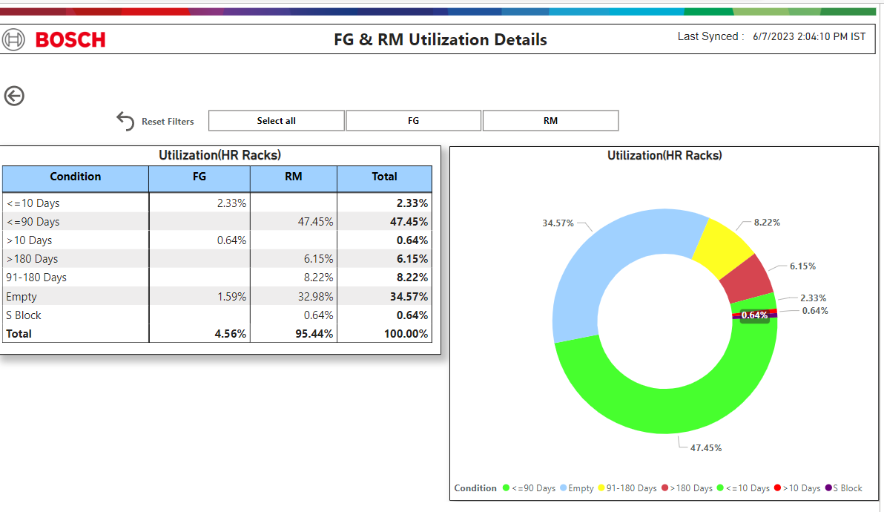

Figure 4.1 Warehouse Utilization Power BI Dashboard

#### INFERENCE

In Figure 4.1, it is depicted that 34.57% of locations are empty, almost 50% of locations have materials stored for less than 90 days, 8.22% of locations contain materials aged between 91-180 days, and approximately 7% of locations are occupied by other materials.

### 4.2.2 WAREHOUSE FG/RM STORAGE DETAILS VISUALIZATION

The warehouse is utilized for storing materials in a well-organized manner. To facilitate understanding of warehouse operations, stakeholders in logistics can leverage Power BI visualizations, which provide quick access to specific information and significantly reduce the

time required for manual and SAP checks.

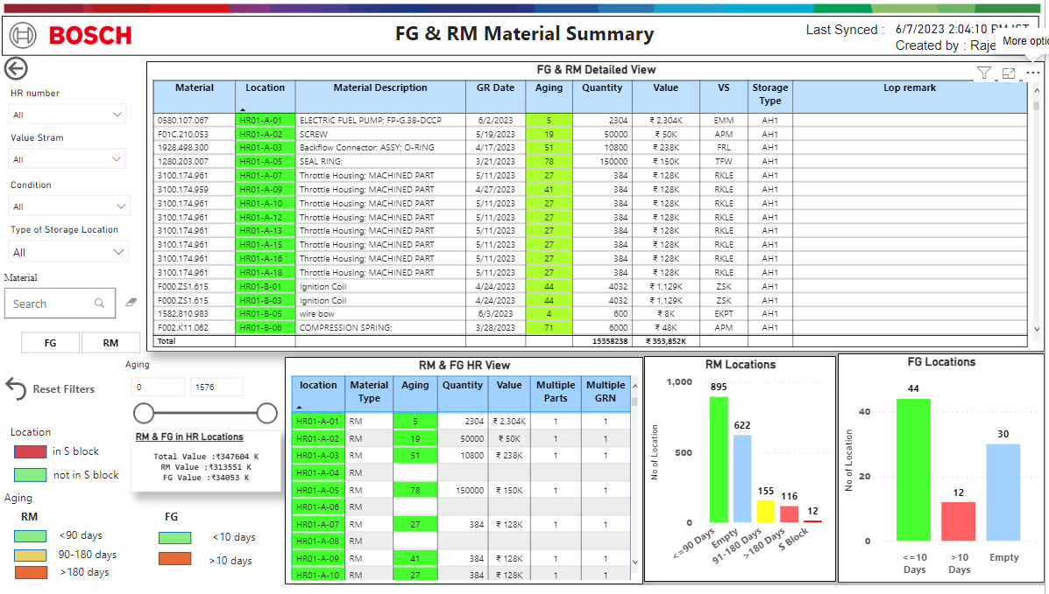

Figure 4.2 FG/RM Depth View-Power BI Dashboard

#### INFERENCE

Within this Power BI visual, the Aging column utilizes Green, Yellow & Red colours to represent materials aged below 90 days, between 90-180 days, and over 180 days in HR01 to HR10 for Raw Materials (RM). Additionally, Green and Red colours indicate materials aged below and above 10 days in HR11, HR12 & HR14 for Finished Goods. The Location column is color-coded to indicate materials in the S block. Separate column charts are provided for RM and Finished Goods (FG), enabling easy identification of the number of locations occupied by each category.

### 4.2.3 WAREHOUSE HIGH RACK VISUALIZATION

Warehouse High Rack Visualization refers to the graphical representation or visualization of the high rack storage system within a warehouse. In Power BI **SYNOPTIC VISUAL** tools used to creating dashboard. In Bosch Warehouse, out of the total 14 high racks available, HR01 to HR10 are designated for storing Raw Materials, while HR11, HR12, and HR14 are allocated for Finished Goods.

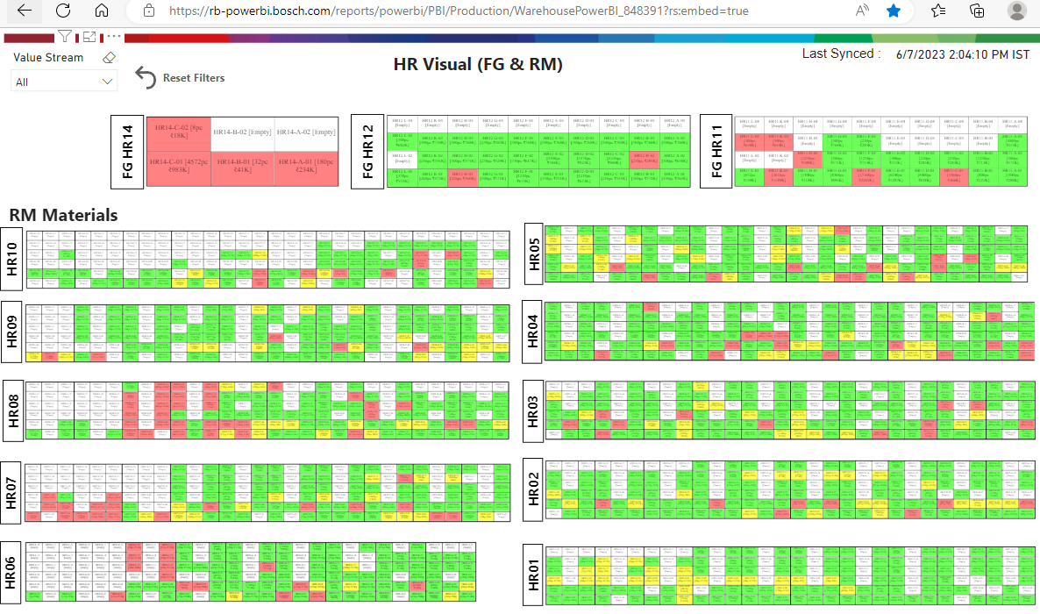

Figure 4.3 Warehouse High Rack Power BI Dashboard

#### INFERENCE

The Power BI visual in this report provides stakeholders with valuable insights into warehouse rack occupancy and identifies areas that require attention to improve material flow. By leveraging the colour coding, stakeholders can quickly understand the number of occupied and empty racks, enabling them to prioritize resources effectively. This information empowers stakeholders to optimize material placement by easily identifying available racks without the need for manual checks.

### 4.2.4 WAREHOUSE PUTAWAY VISUALIZATION

Putaway in a warehouse refers to the process of receiving, inspecting, and storing incoming goods or materials in their designated locations within the warehouse. Putaway transfer order refers to a system or process used in warehouse management to allocate and track the movement of items from the receiving area to their designated storage locations. It involves the generation of a transfer order specifically for the purpose of organizing and managing the putaway process. When goods are received in the warehouse, a putaway transfer order is created to assign each item to a specific storage location.

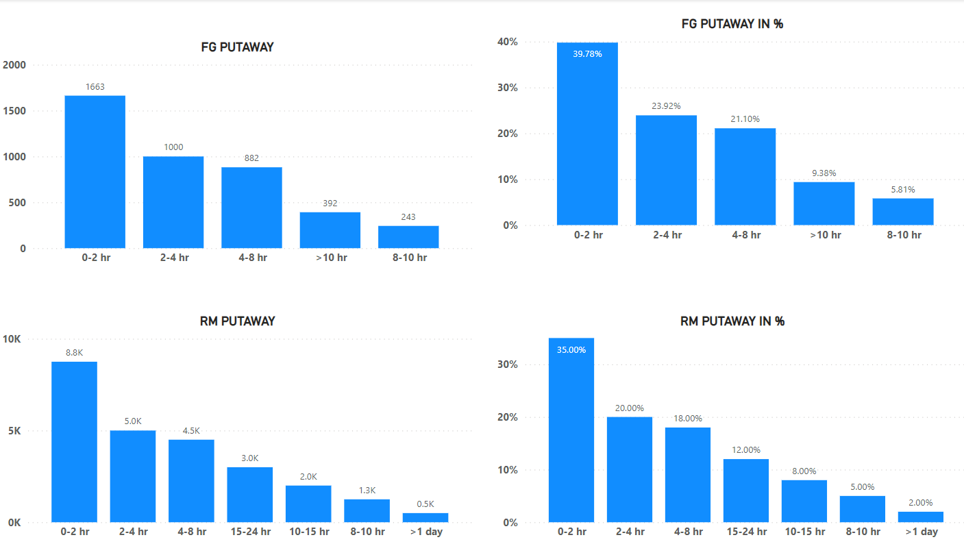

Figure 4.4 Warehouse High Rack Power BI Dashboard

#### INFERENCE

In Figure 4.4, the putaway process for Finished Goods (FG) indicates that over 50% of Transfer Orders (TO) are completed within 4 hours. Approximately 21.10% of TOs take between 4 to 8 hours for completion, while 9.38% of TOs require more than 10 hours. Regarding Raw Materials (RM), 35% of TOs are completed within 2 hours, around 38% are processed within 2 to 8 hours, and approximately 2% of TOs take more than one day for completion.

## 4.3 INFERENTIAL ANALYSIS

Inferential analysis is a statistical approach used to make inferences or draw conclusions about a population based on data collected from a sample. It involves analysing sample data to make predictions, test hypotheses, or estimate parameters of the population. Regression analysis was used to determine the relationship between the dependent variable (order fulfillment rate) and the independent variables (delivery time, order volume, transportation, technology, and order complexity).

### 4.3.1 **REGRESSION ANALYSIS**

Regression analysis was used to determine the relationship between the dependent variable (order fulfillment rate) and the independent variables (order volume, transportation, and order complexity).

##### Table 4.1 Variables with Values used in Regression Analysis

|  |  |  |  |  |
| --- | --- | --- | --- | --- |
| Month | Order Fulfilment Rate (out of 100) | Order Volume (in Thousands) | Transportation Cost (mINR) | No of Complexity Orders |
| Feb-22 | 91 | 707 | 13 | 3 |
| Mar-22 | 90 | 921 | 16 | 5 |
| Apr-22 | 95 | 950 | 17 | 4 |
| May-22 | 96 | 970 | 18 | 3 |
| Jun-22 | 95 | 1063 | 19 | 4 |
| Jul-22 | 96 | 1080 | 20 | 3 |
| Aug-22 | 96 | 763 | 14 | 3 |
| Sep-22 | 96 | 954 | 18 | 3 |
| Oct-22 | 94 | 1186 | 22 | 4 |
| Nov-22 | 80 | 1170 | 18 | 10 |
| Dec-22 | 99 | 1187 | 23 | 3 |
| Jan-23 | 78 | 881 | 13 | 8 |
| Feb-23 | 96 | 910 | 17 | 3 |
| Mar-23 | 92 | 903 | 16 | 4 |
| Apr-23 | 92 | 1044 | 19 | 5 |

##### Table 4.2 Regression Analysis for Order Fulfilment rate

|  |  |  |  |  |  |
| --- | --- | --- | --- | --- | --- |
| Model | Unstandardized Coefficients | | Standardized Coefficients | t-test | Sig. |
| B | Std. Error | Beta |
| (Constant) | 57.886 | 9.617 |  | 6.019 | 0.000 |
| Order Volume (in Thousands) | 0.007 | 0.002 | 0.124 | 3.848 | 0.003 |
| Transportation Cost (mINR) | 1.886 | 0.549 | 0.362 | 3.435 | 0.006 |
| No of Complexity Orders | -1.803 | 0.289 | -0.683 | -6.231 | 0.000 |
| a. Dependent Variable: Order Fulfilment Rate (out of 100) | | | | | |

#### INFERENCE

The regression equation is Y = b0 + b1X1 + b2X2 + b3X3

Where,

Y is the dependent variable Order Fulfilment Rate

X1 is independent variable Order Volume

X2 is independent variable Transportation Cost

X3 is independent variable No of Complexity Orders

b0 is regression constant 92.159

b1 is regression coefficient of Order Volume 0.009

b2 is regression coefficient of Transportation Cost 1.072

b3 is regression coefficient of No of Complexity Orders -2.209

Substituting the values,

Y= 92.16+0.009*X1+1.072*X2-2.209*X3

The regression equation indicates the following,

1. The base value (intercept) of Order Fulfilment Rate is 92.16.

2. For every unit increase in Order Volume, Order Fulfilment Rate is predicted to increase by 0.009.

3. For every unit increase in Transportation Cost, Order Fulfilment Rate is predicted to increase by 1.072.

4. For every unit increase in No of Complexity Orders, Order Fulfilment Rate is predicted to decrease by 2.209.

The equation infers that the values of Order Volume, Transportation Cost, and No of Complexity Orders have a relationship with the predicted value of Order Fulfilment Rate. When Order Volume increases, Order Fulfilment Rate tends to increase slightly. When Transportation Cost increases, Order Fulfilment Rate tends to increase more significantly. However, when No of Complexity Orders increases, Order Fulfilment Rate tends to decrease.

# CHAPTER 5

FINDINGS, SUGGESTIONS AND CONCLUSIONS

## 5.1 INTRODUCTION

The chapter presents the key outcomes and recommendations derived from the research conducted. It provides a comprehensive overview of the significant findings related to warehouse management, including inventory storage, warehouse performance, and order processing.

Based on these findings, practical suggestions are proposed to address the identified challenges and enhance overall warehouse operations. The chapter concludes by emphasizing the importance of implementing the suggested improvements to optimize warehouse performance, streamline order fulfillment, and achieve operational excellence. These findings and recommendations offer valuable insights to Bosch Ltd Gangaikondan plant, enabling them to enhance their warehouse management practices and effectively meet customer requirements.

## 5.2 FINDINGS

The findings of this study shed light on various important aspects of warehouse management at Bosch Ltd Gangaikondan plant. The analysis and interpretation of the data revealed several key findings, which are summarized below,

1. Warehouse stores a large volume of inventory, including both old and new stock. Currently, the process of identifying old stock versus new stock requires significant manual effort and is prone to errors.

2. Warehouse is responsible for managing a large volume of inventory and fulfilling customer orders. Currently, analysing warehouse performance is challenging without effective visualization tools, making it difficult to identify areas for improvement and implement changes.

3. The process of identifying materials stored in a location is time-consuming and inefficient, leading to decreased productivity.

4. High Inventory Days and Lack of Cycle Counting: Figure 4.2 and figure 4.3 shows that warehouse has a large number of inventory days, indicating excessive inventory holding and potential cash flow constraints. Additionally, the absence of regular cycle counting practices may contribute to inaccuracies in inventory records. This finding emphasizes the importance of implementing cycle counting procedures and optimizing inventory levels to reduce carrying costs.

5. Figure 4.4 reveals significant insights regarding the efficiency of transfer orders. It highlights that 7% of transfer orders in RM putaway and over 30% in FG putaway exceed the designated time limit of 8 hours. These findings strongly indicate a communication gap between the planning department and the warehouse operations, which needs to be addressed for smoother coordination and improved efficiency.

6. Figure 4.1 illustrates the warehouse utilization, indicating that approximately 34% of the locations are currently unoccupied. Additionally, the analysis reveals that 6.15% of aged materials are stored in the high rack area. These findings highlight opportunities for optimizing space utilization and addressing the issue of aging inventory within the warehouse.

7. The regression analysis in Table 4.2 revealed that three variables significantly influence the order fulfillment rate. Firstly, order volume showed a positive relationship, indicating that as the order volume increases, there is a slight improvement in the order fulfillment rate. Secondly, transportation cost exhibited a stronger positive relationship, indicating that higher transportation costs lead to a more significant increase in the order fulfillment rate. Lastly, the number of complexity orders demonstrated a negative relationship, suggesting that an increase in complexity orders is associated with a decrease in the order fulfillment rate.

## 5.3 SUGGESTIONS

Based on the findings of this study, the following suggestions are proposed to address the identified challenges and improve warehouse management at Bosch Ltd Gangaikondan plant:

1. Power BI visuals are instrumental in identifying aged stocks and improving decision-making processes within a warehouse. The utilization of Power BI visuals, particularly in the context of High Rack storage, plays a significant role in efficiently presenting data related to stock movement. Figure 4.3 exemplifies the Power BI visual designed specifically for High Rack storage, offering a comprehensive overview of the materials occupying this space on a single page. By leveraging Power BI visuals, stakeholders are empowered to quickly and effortlessly identify materials that have remained stagnant without any movement.

2. The Power BI visualization showcased in Figure 4.2 optimizes warehouse performance analysis, yielding increased accuracy in pinpointing areas for improvement and driving overall productivity gains. Furthermore, it provides a comprehensive overview of material availability within the warehouse, enabling efficient searches across multiple locations.

3. Focus on space optimization by developing a comprehensive plan to maximize occupancy through reorganization and efficient shelving systems.

4. Implement effective warehouse management practices such as regular audits, FIFO system, and automated alerts for aging inventory.

5. Streamline the material handling process by optimizing picking routes, adopting technology for tracking, and providing staff training. Fourth, enhance demand forecasting to align inventory levels with customer demand.

6. Foster better communication and collaboration between planning and warehouse operations to ensure alignment of inventory plans and resource allocation.

7. Establish a culture of continuous improvement through regular evaluations and data-driven decision-making. Implementing these suggestions will lead to improved space utilization, reduced aged inventory, and enhanced operational efficiency in the warehouse.

8. Based on the regression analysis, following recommendations can be made to enhance the order fulfillment rate. Firstly, it is crucial to effectively manage and optimize order volume by implementing streamlined processes, improving inventory management, and ensuring timely order processing. Secondly, efforts should be directed towards optimizing transportation operations to minimize costs and improve delivery efficiency. Lastly, reducing the number of complexity orders or simplifying their processing can contribute to a higher order fulfillment rate. By implementing these suggestions, businesses can improve their order fulfillment process, enhance customer satisfaction, and achieve more efficient and timely order deliveries.

## 5.4 SCOPE FOR FUTURE RESEARCH

While this study has provided valuable insights into warehouse management and order fulfillment at Bosch Ltd Gangaikondan plant, there are several areas that offer scope for future research. These areas include:

1. Advanced Analytics and Predictive Models: Future research can focus on developing advanced analytics models and predictive algorithms to optimize warehouse management and order fulfillment processes. This can involve the integration of machine learning, artificial intelligence, and data mining techniques to forecast demand, optimize inventory levels, and improve order fulfillment accuracy.

2. Integration of Internet of Things (IoT): The application of IoT in warehouse management can offer significant benefits in terms of real-time tracking, inventory monitoring, and process automation. Future research can explore the integration of IoT devices and sensors to enhance visibility, improve efficiency, and minimize errors in the warehouse operations.

Sustainable Warehouse Practices: With increasing emphasis on sustainability and environmental responsibility, future research can delve into the development and implementation of sustainable warehouse practices. This can include studying the impact of green technologies, energy-efficient processes, and waste reduction strategies on warehouse performance and order fulfillment.

3. Supply Chain Integration and Collaboration: Future research can focus on investigating the impact of supply chain integration and collaboration on warehouse performance and order fulfillment. This can involve exploring strategies for improving communication and coordination among suppliers, manufacturers, distributors, and customers to enhance overall supply chain efficiency.

4. E-commerce and Omni-channel Fulfillment: As e-commerce continues to grow, future research can examine the unique challenges and opportunities of order fulfillment in the context of online retail and omni-channel distribution. This can include studying the impact of e-commerce on warehouse operations, inventory management, and customer satisfaction.

5. Automation and Robotics: The use of automation and robotics in warehouse operations is rapidly evolving. Future research can explore the implementation and effectiveness of autonomous systems, robotics, and robotic process automation in optimizing warehouse processes and improving order fulfillment speed and accuracy.

6. Customer Experience and Satisfaction: Future research can investigate the impact of order fulfillment performance on customer experience and satisfaction. This can include studying customer expectations, preferences, and feedback to develop strategies for enhancing the overall order fulfillment experience and improving customer loyalty.

By focusing on these areas of future research, scholars and practitioners can contribute to the ongoing development and optimization of warehouse management and order fulfillment processes. The findings from such research can provide valuable insights for organizations to improve their warehouse operations, enhance order fulfillment efficiency, and ultimately deliver superior customer experiences.

## 5.5 CONCLUSIONS

This study focused on warehouse management and improving operational efficiency. Through an analysis of the warehouse's inventory problems, such as unorganized inventory arrangement and inaccurate records, the study identified the need for effective utilization and automation in warehouse processes.

By utilizing tools like Power BI for data visualization, the study demonstrated the significant role of visual analytics in identifying aged stocks, analysing warehouse performance, and facilitating decision-making. The visualizations support data-driven decision-making and enhance operational efficiency within the warehouse.

The findings highlighted the importance of addressing communication gaps between planning and warehouse operations, optimizing space utilization, improving inventory accuracy, and streamlining material handling processes. The study recommended strategies such as space optimization plans, warehouse management practices, efficient material handling, enhanced demand forecasting, and improved communication and collaboration.

By implementing these recommendations, the warehouse can enhance operational efficiency, improve inventory accuracy, and optimize resource allocation. Overall, this study contributes to the understanding of warehouse management practices and provides valuable insights for organizations aiming to improve their warehouse operations and achieve better operational efficiency.

BIBLIOGRAPHY

1. Amato F, Basile F, Carbone C, Chiacchio P (2005). An approach to control automated warehouse systems. Control Engineering Practice.
2. Ang M, Lim Y F (2019). How to optimize storage classes in a unit-load warehouse. European Journal of Operational Research.
3. Aviral (2022) A Report on Indian Express Logistics Industry 2022, https://www.indianchamber.org/wp-content/uploads/2022/02/Express-Logistics-Industry-Report-2022_compressed.pdf (accessed on 28 may 2023).
4. Azadeh K, de Koster R B M, Roy D (2019a). Robotized and automated warehouse systems: Review and recent developments. Transportation Science.
5. Azadeh K, Roy D, de Koster R B M (2019b). Design, modeling, and analysis of vertical robotic storage and retrieval systems. Transportation Science.
6. Bartolini M, Bottani E, Grosse E H (2019). Green warehousing: Systematic literature review and bibliometric analysis. Journal of Cleaner Production.
7. Basso F, Epstein L D, Pezoa R, Varas M (2019). An optimization approach and a heuristic procedure to schedule battery charging processes for stackers of palletized cargo. Computers & Industrial Engineering.
8. Ben-Daya M, Hassini E, Bahroun Z (2017). Internet of Things and supply chain management: A literature review. International Journal of Production Research.
9. Bosch Ltd Balance sheet from NSE website, https://www.bseindia.com/bseplus/AnnualReport /500530/73625500530. pdf (accessed on 28 may 2023).
10. Bosch Limited 2023, https://www.bosch.in/ (accessed on 28 may 2023).
11. Bottani E, Vignali G (2019). Augmented reality technology in the manufacturing industry: A review of the last decade. IISE Transactions.
12. Boysen N, Briskorn D, Emde S (2017). Parts-to-picker based order processing in a rack- moving mobile robots environment. European Journal of Operational Research.
13. Boysen N, de Koster R B M, Weidinger F (2019). Warehousing in the e-commerce era: A survey. European Journal of Operational Research.
14. Boywitz D, Boysen N (2018). Robust storage assignment in stack- and queue-based storage systems. Computers & Operations Research.
15. C.R. Kothari (2009) Research Methodology - methods and techniques Edition, new Age international publishers.
16. Edv.rard J. Bardi, C.John Langley, and John Joseph Coyle (2003) Introduction of logistics - The Management of Business Logistics 7th Edition.
17. J. Viale (1996). Inventory Management: From Warehouse to Distribution Center.