Cybersecurity Firewall Access Classification
Kris Ghimire, Rajesh Satluri, Suchismita Moharana
July 4, 2021
Abstract
Maintaining digital privacy is one of the major challenges of any organization in this time of information age. Both our home and business organization are continuously inundated by malicious internet threat trying to infiltrate our computer through the internet. We continuously hear news about cyberattack and the damage it has caused. With the lack of skilled professional, there is a tremendous need of Machine learning model to automate the process of filtering the incoming requests. In this case study we have build Support Vector Machine (SVM) and Stochastic Gradient Descent (SGD) model that classify the incoming request with high accuracy of <place holder for accuracy > and precision of <precision place holder>

1. Introduction:

Cybersecurity in general is defined as the measure taken to protect the data and information that can be stolen via computer and internet. It is an idea of creating a barrier called firewall to prevent unauthorized bodies from getting access to sensitive information. Firewall, similar to wall in our house is a computer system software designed to restricts and filter the internet traffic based on the organization established protocols. As firewall is the first line of defense, relying only on human judgment can sometime lead to misclassification of which information to passed through the defense wall and which to restrict. Hence, there is a need for machine learning automation process to classify whether or not to accept or deny access to all inundated requests that are coming into the system. Building model that can accurately predict the incoming traffic of information can not only protect the organization valuable information, it can also save company cost and lot of other resources. Figure below shows the simple approach of how we are going to leverage Data Science and Machine Learning approach to solve the cybersecurity problem presented to us in this case study. The model will examine each incoming information and classify those into one that is allow and the one that need to be blocked.

Historical Data
Prediction
ML SVM/SGD classifier




Allow


Deny

Figure 1: Basic ML schema

2. Methods
Dataset:
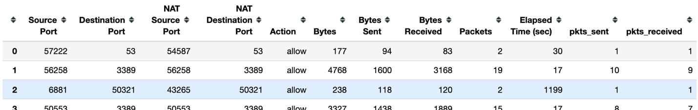
Table 1
The dataset as depicted in table 1 consists of 65532 samples, 12 features. It is a good size data to build SVM classification model as SVM slows down significantly with larger volume of data. At the first glance, the features seems little confusion as all of them are numerical features except the target feature ‘Action’ and are in different scale. Hence, we cannot feed these numeric features into model as it is. After some investigation we decided to treat features: 'Source Port', 'Destination Port', 'NAT Source Port', 'NAT Destination Port' as categorical features and dummy coded them. While the features, 'Bytes', 'Bytes Sent', 'Bytes Received', 'Packets', 'Elapsed Time (sec)', 'pkts_sent', 'pkts_received' are treated as numeric features and we scaled them before feeding into algorithms.
We did not find any missing data upon initial check. Target features had four levels: allow, drop, deny and reset-both. Even though, these seems like a multiclass problem, we will be preforming binary classification as per the business requirement by converging four levels to just two. Allow is treated as class 1 (allow) and rest three levels: drop, deny and reset-both as class 0 (deny).
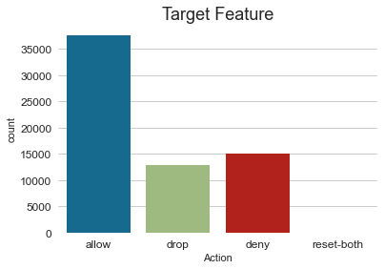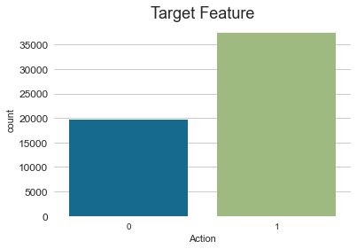

Before After

Allow
Deny

Figure 2: Target features before and after
Data Exploration:
As we were exploring some categorical features: 'Source Port', 'Destination Port', 'NAT Source Port', 'NAT Destination Port' to how they are related to target features, we can see from figure 7, 8 below that an action is allowed majority of times when the source port is 27005 and destination port is 53. And the figure 9,10 shows that actions is denied when NAT source port is 0 and NAT destination port is 0.
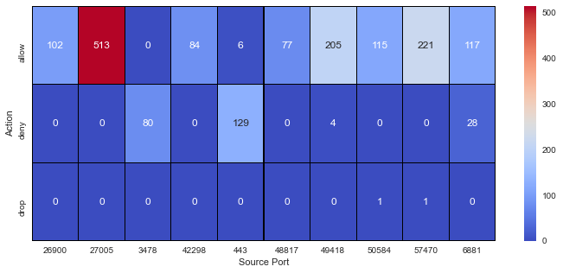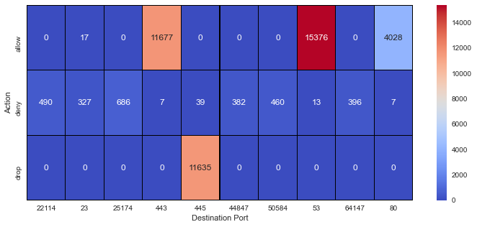
Figure 2
Figure 3

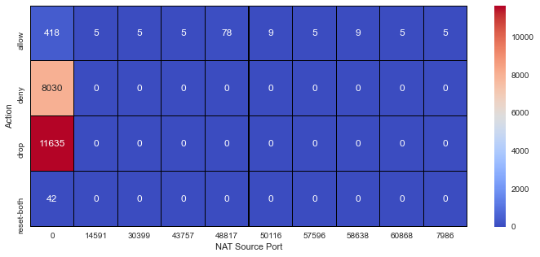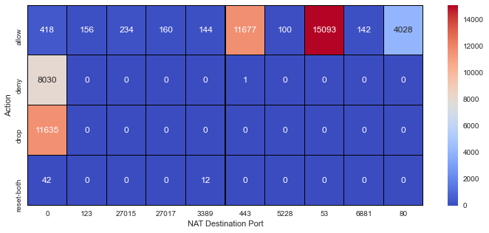
Figure 5
Figure 4
Train Test Split: Dataset was split into training and test set (80/20 split) to keep test data separate and to perform modeling and tuning only on training set.
Support Vector Machine Model: SVM is a powerful algorithm when it comes to small to medium dataset that has the capabilities to perform both linear and nonlinear classification. SVM tries to separate points into two classes by maximizing the margin. The margin here is defined as the distance between the separating line or decision boundary (also called hyperplane when we have larger dimension data) and the training data that are close to this hyperplane which are called as support vectors. Figure 2.

Figure 6: Support Vector Machines

The point to note here in this case of maximum separation is that, it’s not the distance between the points but the distance between the point and the plane (green decision boundary) that separates them. Another thing to note is that the margin is inversely proportional to the vector $β$, hence smallest $β$ gives the maximum margin. In summary what we can say from the above figure is that, the planes that intersect and are parallel to both the points (blue and red) on either side come out be a slope of equation y = mx+b but in this case, we are saying y = +1 and -1 which is analogous to other classifier when we say 1 if part of the class else 0.
It seems simple if we have linear dataset that is easily separable. However, many datasets that we work on are not even close to being linearly separable. The points are on the wrong side of the line, and we can’t find a straight line that splits the classes perfectly. To overcome this challenge, what we can do is induce a penalty for points that are on the wrong side of the line. The penalty measures the points i.e., if the points are on the wrong side of dividing line, then that points will contribute to the loss but if the points are on the right side of the dividing line than they don’t contribute to the loss.

Hard margin

Soft margin

Figure 7: Margin

In figure 4 we can see that there are blue points that are on the right side of the line are assigned class +1, there are also some blue point that is in the margin area which are also assigned +1, but the difference is, the point on the margin contribute to lose even though they have the correct prediction. Unlike logistic regression, it doesn’t matter how far the points are they still gave the same prediction. So, for the point on the margin, further they are from the margin line, the more they contribute to the loss. In the figure above, the two red points that are in the margin but within the right side contributes much less to the loss compared to one red point that is way out in the wrong side of the plain that contributes lot to the loss. So, the idea is now, we will have to find new plain that best separates the points which leads to shrinkage and expansion of the margin and the decision boundary line will move further or closer to the split line, because only the points in the margin contribute to the loss. And that when we decide soft or hard margin. If we allow points to be in the margin, then it’s called a soft margin but if don’t allow anything on the margin then it’s called the hard margin. The objective is to find a good balanced and keep the margin as large as possible and limit margin violations. In sklearn we will use parameter C to keep the margin as wide as possible.

One of the main reasons behind SVM popularity among Data Scientist is that SVM can be easily kernelized to solve any non-linear classification problem. The key idea behind kernel trick is to project original features into higher dimensional space via two important concepts. The first is called transformation using mapping function phi $∅$(x) and the second is the dot product in the higher dimension. Nice thing about kernel trick is we don’t really have to know about the map function $∅$(x). What’s important is the dot product. We can calculate the loss without doing the projection. And this shortcut is known as the trick of the kernel trick. i.e., know the dot product without knowing the projection. One the most popular kernels is the Radial Bias Function (RBF kernel) or Gaussian kernels. Hence, the key to finding a nonlinear solution is to project training data into a higher dimension such that the hyperplane can easily separate the classes into two groups. Figure 5.

Kernel

Figure 8: Kernel Trick
Imbalance target features: Dataset had imbalanced target features. However, it is not significantly imbalance to make difference in our prediction of classes. For simplicity, we have used sklearn class_weight argument and specified the class_weight as “balanced.” which invert the ratio of the class distribution in the training dataset and gives equal importance to both classes.
Scaling: Just like for all linear model one key assumption of SVM is that all independent features should be normalized or scaled. As algorithm makes decision based on distance metrics, feature scaling or standardization is very important. We used StandardScaler to scale all the independent features. Mathematically scaling is done using formula below:
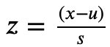
Subtract the mean (called centering) and divide by the standard deviation to shift the distribution to have a mean of zero and a standard deviation of one.
Parameter selection: Two most importance parameters that we need to focus on in case of SVM first is C or also known as regularizations parameters which takes case of margin maximization. Mathematically it is represented as , which mean we have inverse relations, high C means low margin and low C means the high margin. And the second parameter of interst is kernel. There are four types of kernels: linear, polynomial, RBF(Radial Bias Function), and sigmoid. The most common kernel that is often used is RFB which changes linear SVM to non-linear. We have performed grideSerach to get best parameters.
$$\frac{1}{||β||}$$
Cross-Validation (CV): The StratifiedKFold cross-validation with k=5 was not performed in this case study due to data being sparse and scaling issue with SVM classifier.
3. Result:
Using sklearn library we have built two models. First, we built model linear SVM model with parameters: penalty='l2', class_weight='balanced',C=1, loss='hinge' gave us an accuracy of 100% and f1 score of 99%. Figure Next, we build second model, SGD classifier. SGD classifier performed about the same as linear SVM with accuracy of 100% and f1 score of 100 at time period little more than linear SVM. Figure 11, 12. Hence, we decided linear SVM classifier is more useful than SVM for this given problem.
Model 1
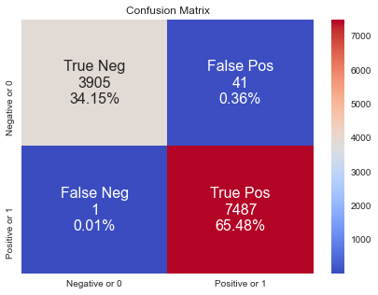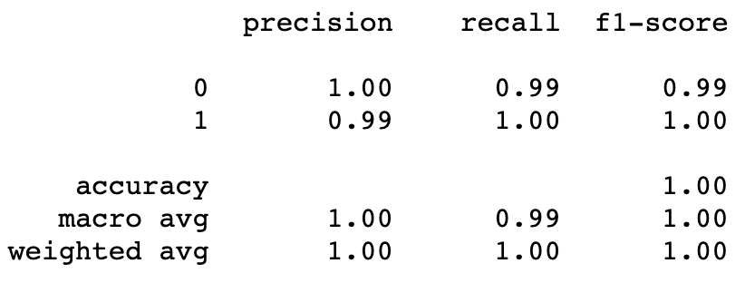

Figure 9: Confusion metric Figure 10: Classification Report
Model 2

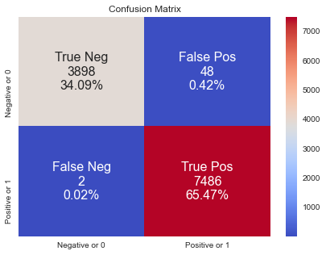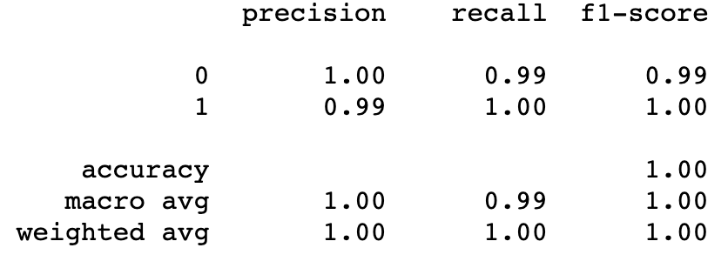
Figure 11: Confusion metric Figure 12: Classification Reprot

4. Conclusion:
In this case study, we have successfully leveraged the data science and machine learning approach to build the classification model that can automate the process of predicting which incoming internet traffic to allow access and which to deny with very high accuracy. We have built two different SVM classifiers, linear SVM and SDG to meet the business requirement.
Out of two models, model 1 would be a better model even though both the models have similar accuracy, as model 1 is more time efficient than model 2.

Although the linear SVM has been quite effective in filtering incoming internet traffic, our results and conclusion are without cross validation and parameter tunning. We were unsuccessful in performing CV and parameter tunning due to data being huge after one-hot-encoding. Models in this case study could be further refine by performing cross-validation and hyperparameter tunning.

