DBMS – Database Management System
Where data is stored in the form of tables (rows and columns). The issue is whole data was saved in one or two tables.
Softwares of DBMS – Dbase, Foxpro, MS Access etc…
RDBMS – Relational Database Management System
Where the data is stored in multiple tables by establishing relationship between them, so that data retrieval and operations can be performed faster
Softwares of RDBMS – Oracle (Purchasing DB), MS-SQL Server (Purchasing DB), MySQL (Open Source from Oracle), DB2 (Purchasing from IBM), MS-Access (Purchasing from MS) etc..

Database – Data Storage Area
Three layers of application – GUI (Front end)– Application layer (Business Logic) – Database Layer (Backend)
Front end layer i.e. GUI is developed by scripting languages such as – HTML, XML, ASP.Net, JSP
WebLogic is developed by using Programming Languages such as – C, C++, Java, .Net, C#
Database can be such as – Oracle, MS SQL Server, MySQL
Once the database is defined, it will occupy some space in the hard drive for the data to be stored in the DB.

SQL – Structure Query Language (For communicating with DB on performing different kind of operations like – Insert, Update, Delete, Retrieve, Add etc…)

Database Components – Client and Server
Every or Any DB has 2 components – Client and Server. Client is used to request the data to Server using SQL commands using Client Software and Server stores the information. Note: Connection need to be established between Client and Server for communication.
Client and Server can be installed in one machine or different machines (Server can be installed in remote machine). DB servers will be installed on LINUX or UNIX Operating Systems. Very rarely installed on windows OS due to less security purpose.
Any DB has 2 types of Clients –
GUI (Graphical User Interface)
CLI Command Line Interface)
Examples –
Oracle Database has 2 clients –
SQL Developer (GUI)
SQLPLUS (CLI)
Toad (3rd party clients)
Squirell (3rd party clients)

MySQL – MYSQL WorkBench (GUI)
MYSQL Command Line Client (Command Line Interface)
Toad (3rd party clients)
Squirell (3rd party clients)
Aquadata Studio (3rd party clients)

Command Line Client Commands –
Show databases; (It will list out databases available)
mysql> show databases;
+--------------------+
| Database |
+--------------------+
| employeeportal |
| information_schema |
| mysql |
| performance_schema |
| sakila |
| sys |
| world |
+--------------------+
use world; i.e. use database name
mysql> use world;
Database changed
mysql> show tables;
+-----------------+
| Tables_in_world |
+-----------------+
| city |
| country |
| countrylanguage |
+-----------------+
3 rows in set (0.00 sec)

SQL Language –

DDL (Data Definition Language)
DML (Data Manipulation Language)
DRL/DQL (Data Retrieval Language/Data Query Language)
TCL (Transaction Control Language)
DCL (Data Control Language)
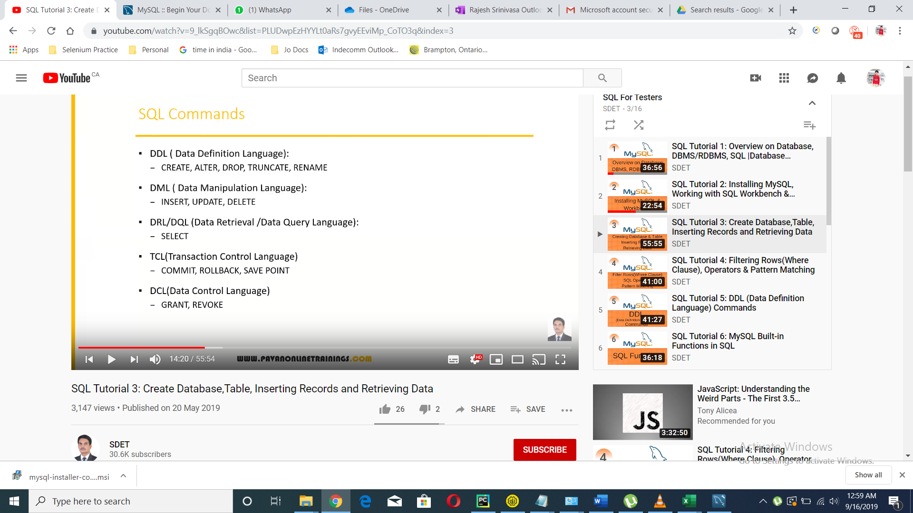

Database Creation –
CREATE DATABASE mydb;
DROP DATABASE mydb;

CREATE SCHEMA mydb;
DROP SCHEMA mydb;

CREATE DATABASE IF NOT EXISTS mydb;

Table Creation in DB –
USE mydb;
CREATE TABLE STUDENT (SNO INT(5),SNAME VARCHAR(15),MARKS INT(3));
DESCRIBE STUDENT;

Insert Data into Table –
INSERT INTO STUDENT VALUES(101,'KIRAN',80);
INSERT INTO STUDENT(SNAME,MARKS,SNO) VALUES('RAM',90,102);
INSERT INTO STUDENT VALUES(103,'RAHUL',NULL);

Selecting the data from table –
USE HR;
SELECT * FROM EMPLOYEES;
SELECT EMPLOYEE_ID EMPID, FIRST_NAME FNAME FROM EMPLOYEES;

Filtering Rows, Operators and Pattern Matching –
SELECT * FROM EMPLOYEES;
SELECT EMPLOYEE_ID EMPID, FIRST_NAME FNAME FROM EMPLOYEES;

SELECT * FROM EMPLOYEES WHERE MANAGER_ID IS NULL;
SELECT * FROM EMPLOYEES WHERE MANAGER_ID IS NOT NULL;

SELECT DISTINCT SALARY FROM EMPLOYEES;
SELECT DISTINCT * FROM EMPLOYEES;

SELECT * FROM EMPLOYEES WHERE SALARY>=10000 AND JOB_ID= 'AD_PRES';
SELECT * FROM EMPLOYEES WHERE SALARY>=10000 OR JOB_ID= 'AD_PRESS';
SELECT * FROM EMPLOYEES WHERE NOT FIRST_NAME='STEVEN';

SELECT * FROM EMPLOYEES WHERE SALARY BETWEEN 10000 AND 20000;
SELECT * FROM EMPLOYEES WHERE SALARY NOT BETWEEN 10000 AND 20000;

SELECT * FROM EMPLOYEES WHERE SALARY IN (24000,9000,6000);
SELECT * FROM EMPLOYEES WHERE SALARY NOT IN (24000,9000,6000);
SELECT * FROM EMPLOYEES WHERE FIRST_NAME LIKE '%a';
SELECT * FROM EMPLOYEES WHERE FIRST_NAME LIKE 'A%';
SELECT * FROM EMPLOYEES WHERE FIRST_NAME NOT LIKE 'A%';
SELECT * FROM EMPLOYEES WHERE FIRST_NAME LIKE 'A%m';
SELECT * FROM EMPLOYEES WHERE FIRST_NAME LIKE '%e_';
SELECT * FROM EMPLOYEES WHERE FIRST_NAME LIKE '___';

DDL Commands – (CREATE, ALTER, DROP, TRUNCATE, RENAME )
CREATE
- CREATE TABLE STUDENT (SID INT(3),SNAME VARCHAR(15));
ALTER, RENAME and DROP
- ALTER TABLE STUDENT ADD COLUMN GRADE VARCHAR(40);
- ALTER TABLE STUDENT DROP COLUMN GRADE;
- ALTER TABLE STUDENT MODIFY COLUMN SNAME VARCHAR(30);
- ALTER TABLE STUDENT RENAME COLUMN SNAME TO STUDENT_NAME;
DELETE
- DELETE FROM TABLE_NAME;
TRUNCATE
- TRUNCATE TABLE TABLE_NAME;
DROP
- DROP TABLE TABLE_NAME;
RENAME
- RENAME TABLE OLD_TABLENAME TO NEW_TABLENAME;
DROP – Drop will remove database and database objects completely including table, data and structure.
TRUNCATE – Truncate will remove the data in the table but table structure is present. The data will be permanently removed. You CANNOT revoke the operation once performed.
DELETE – Delete also will remove the data in the table but table structure is present. The data is temporarily removed. You CAN revoke the operation once performed.

SQL Built-In Functions – Strings, Numeric, Date and Aggregate
String Functions –
- SELECT UPPER(FIRST_NAME) FROM EMPLOYEES;
- SELECT LOWER(FIRST_NAME) FROM EMPLOYEES;
- SELECT LENGTH(FIRST_NAME) FROM EMPLOYEES;
- SELECT TRIM( 'WELCOME' );
- SELECT TRIM('Z' FROM 'ZZZORACLEZZZ');
- SELECT INSTR('ORACLE','E');
- SELECT SUBSTR(FIRST_NAME,1,3) FROM EMPLOYEES;
- SELECT CONCAT(FIRST_NAME,LAST_NAME) FROM EMPLOYEES;
Numeric Functions –
- SELECT ABS(-40); -- 40
- SELECT TRUNCATE(40.12232,3); -- 40.122
- SELECT TRUNCATE(4012345,-3); -- 4012000

Date Functions –
- SELECT * FROM EMPLOYEES WHERE YEAR(HIRE_DATE)='1991';
- SELECT * FROM EMPLOYEES WHERE MONTH(HIRE_DATE)='5';
- SELECT * FROM EMPLOYEES WHERE MONTHNAME(HIRE_DATE)='JUNE';
- SELECT * FROM EMPLOYEES WHERE DAY(HIRE_DATE)='10';
Aggregate Functions
- SELECT SUM(SALARY) FROM EMPLOYEES;
- SELECT AVG(SALARY) FROM EMPLOYEES;
- SELECT MIN(SALARY) FROM EMPLOYEES;
- SELECT MAX(SALARY) FROM EMPLOYEES;
- SELECT COUNT(SALARY) FROM EMPLOYEES;

GROUPBY, HAVING AND ORDER BY –
Group results by some column-
- SELECT DEPARTMENT_ID, SUM(SALARY) FROM EMPLOYEES GROUP BY DEPARTMENT_ID;
- SELECT DEPARTMENT_ID, MANAGER_ID, COUNT(*) FROM EMPLOYEES GROUP BY DEPARTMENT_ID, MANAGER_ID;
Note: If GROUP BY is applying then that class should be present in SELECT class.
Having class is followed by Group BY – (It will filter on top of the results of Group By)
- SELECT DEPARTMENT_ID, MANAGER_ID, COUNT(*) FROM EMPLOYEES GROUP BY DEPARTMENT_ID, MANAGER_ID HAVING COUNT(*)>5;
Note: WHERE ------ GROUP BY ----- HAVING
- SELECT DEPARTMENT_ID, MANAGER_ID, COUNT(*) FROM EMPLOYEES WHERE DEPARTMENT_ID<>50 GROUP BY DEPARTMENT_ID, MANAGER_ID HAVING COUNT(*)>1;
If Where condition is applying it should be applied before GROUP BY and followed by HAVING
Order By –
- SELECT * FROM EMPLOYEES ORDER BY DEPARTMENT_ID DESC;
- SELECT * FROM EMPLOYEES ORDER BY DEPARTMENT_ID ASC; -- By default Order By is sorted by Ascending Order if ASC or DESC is not specified.
- SELECT DEPARTMENT_ID,SUM(SALARY) FROM EMPLOYEES WHERE DEPARTMENT_ID<>50 GROUP BY DEPARTMENT_ID HAVING SUM(SALARY)>10000 ORDER BY SUM(SALARY) DESC;
  - Sequence of conditions –
    - WHERE --- GROUP BY --- HAVING --- ORDER BY
Union and Union All –
If we need to retrieve the data from more than 1 table, we can use 3 concepts –
- Union
- Joins
- Sub-queries
Union – Extract data from two tables by eliminating the duplicate values of particular columns
Table1 – 1, 3, 5,
Table2 – 3, 5, 6
Table1 Union Table2 – 1,3,5,6
- SELECT NUM FROM A UNION SELECT NUM FROM B;
Union All – Extract data from tables by including the duplicate values of particular columns
- SELECT NUM FROM A UNION ALL SELECT NUM FROM B;
Other databases has INTERSECT and MINUS these are not present in MySQL
INTERSECT – Which gives common data in both the tables
MINUS – It gives the data which is present in one table and not present in another table.
T1-T2 = 1
T2-T1 = 6

SQL Joins and Sub-Queries –
Joins helps to retrieve the data from two or more tables.
- Equi Join/Inner Join/Simple Join
- Right Join
- Left Join
- Full Join
- Self Join

