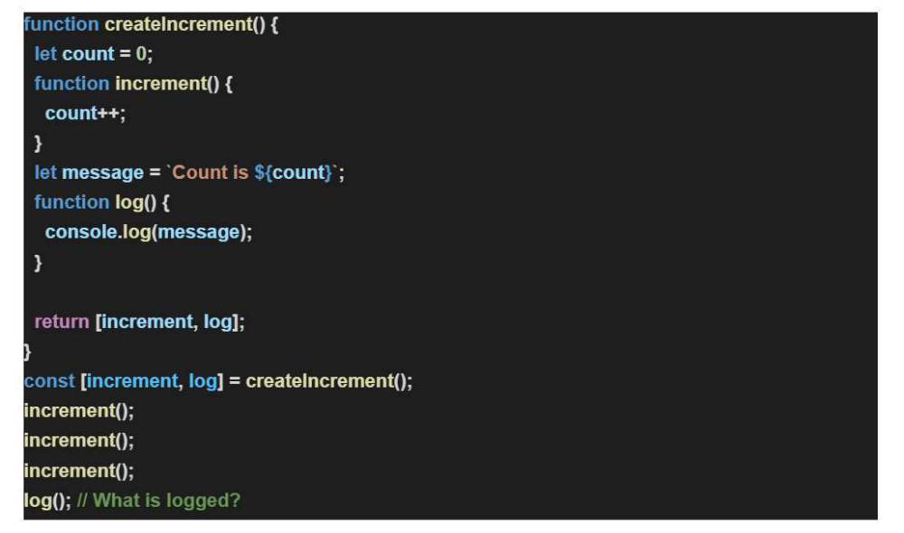
The output of the above is
ANS -> ‘Count is 0’.
This is because the template literals is derived in the message at once. At this point of time we have count as 0. There will be no impact of impact of the increment function whatsoever.

