# Linking-react-native-and-firebase-
this repository helps us to understand creating a react-native app and using firebase authentication,cloud firestore i n the created react-native app
GETTING ERRORS WHILE LINKING REACT WITH FIREBASE NO PROBLEM I WILL GIVE U CLEAR EXPLANATION AND EXECUTABLE CODE FOR YOUR PROJECT.

GETTING STARTED:
1.CREATE A REACT-NATIVE PROJECT USING EPXO(BEACUASE MANY DESKTOPS ARE NOT MAC HERE NOT GOOD ENOUGH FOR TESTING AND FOR GOOD NATIVE ELEMENTS USE EXPO)
->You can check the environment setup for expo project at https://reactnative.dev/docs/environment-setup

expo init projectname

result:
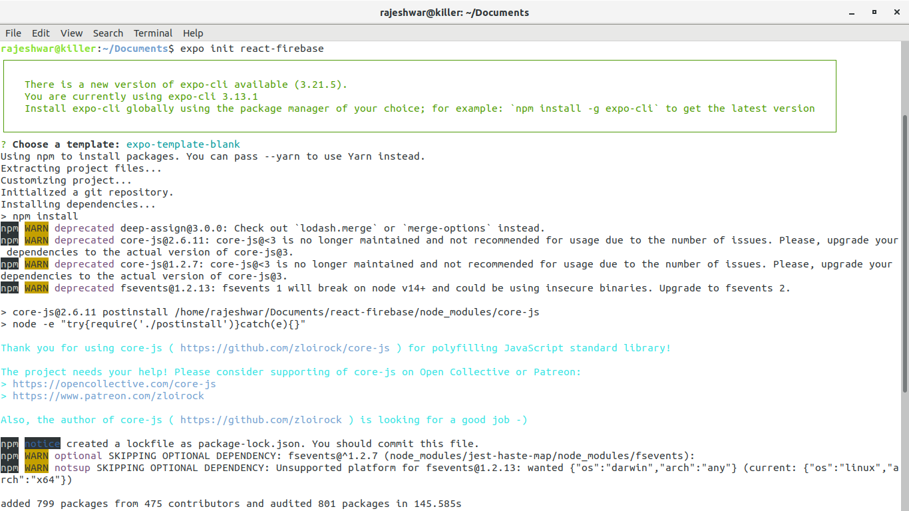
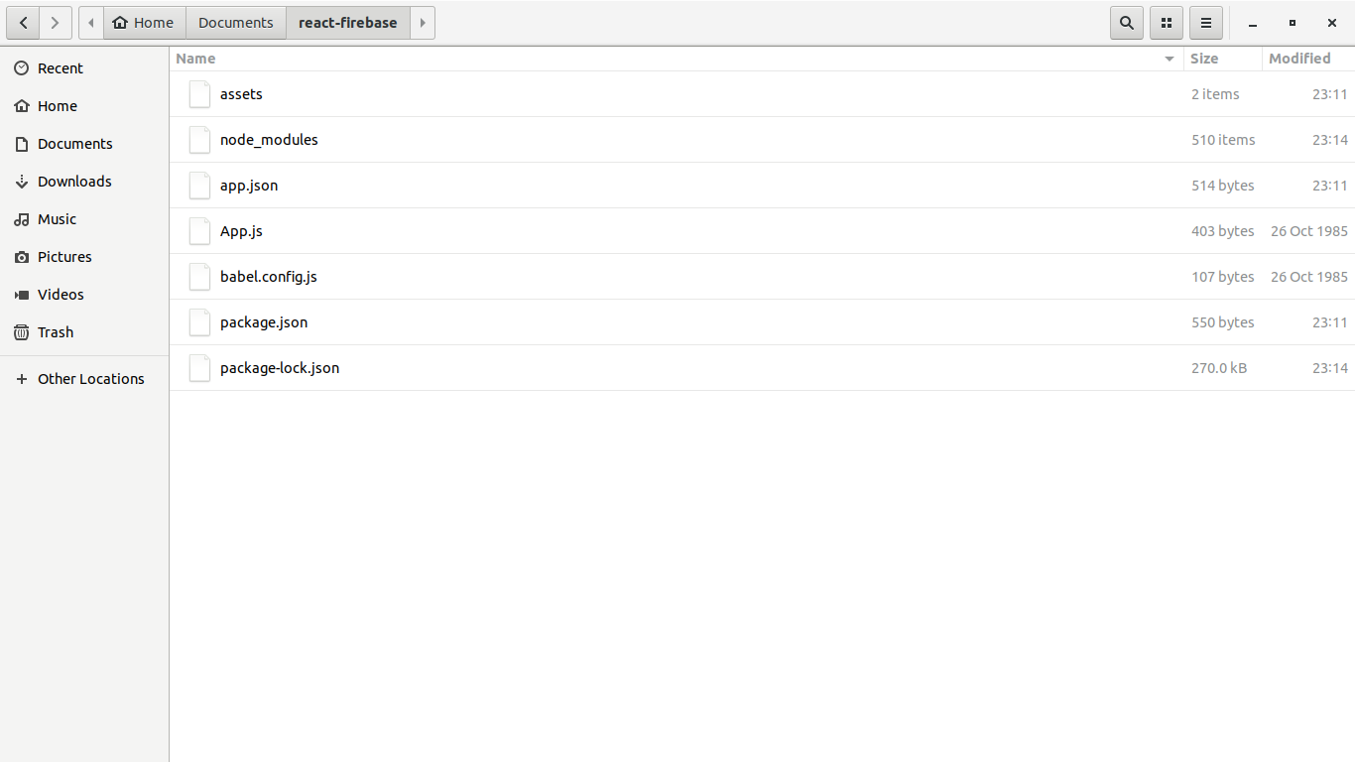
->You can see diiferent folders and files in the created folder,they are

2.RUNNING OUR PROJECT:

->Enter the created app directory and try npm start
cd projectname
npm start
->Download expo app in your mobile from app store and scan the QR CODE appeared in cmd.
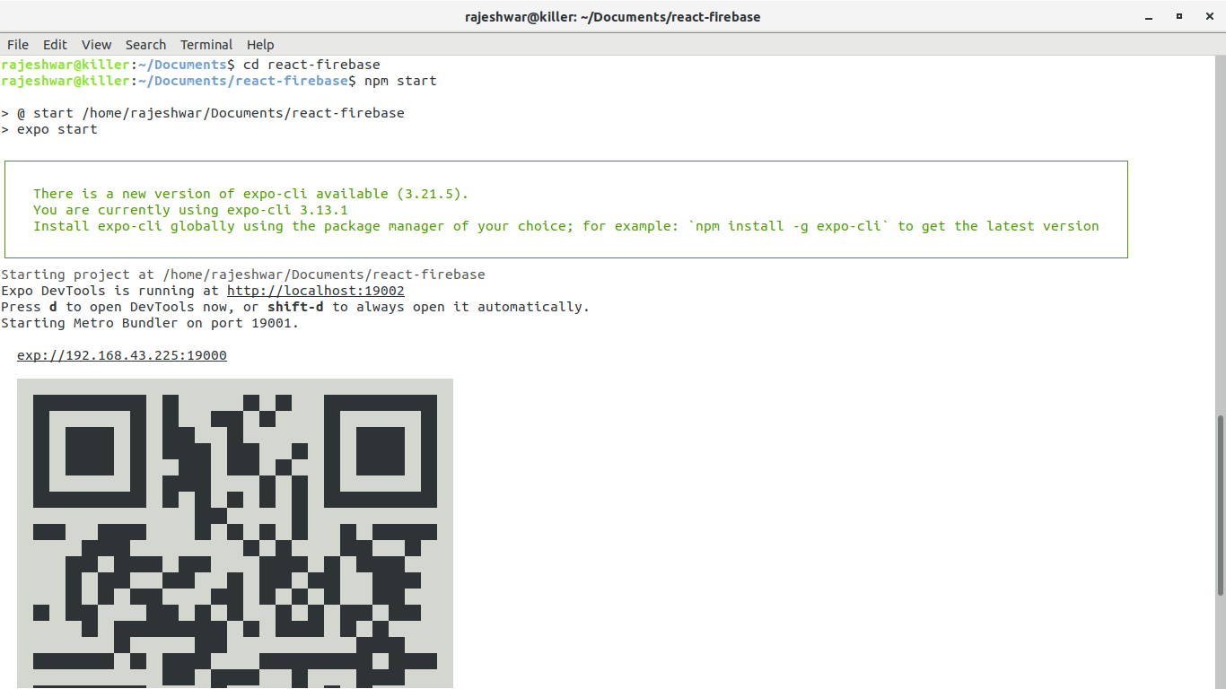

3.ADDING FIREBASE TO OUR PROJECT

react-native add firebase
or
expo install firebase
or
npm install –save firebase

->create a firebase project and add a web app in that project , copy the configuration file from the
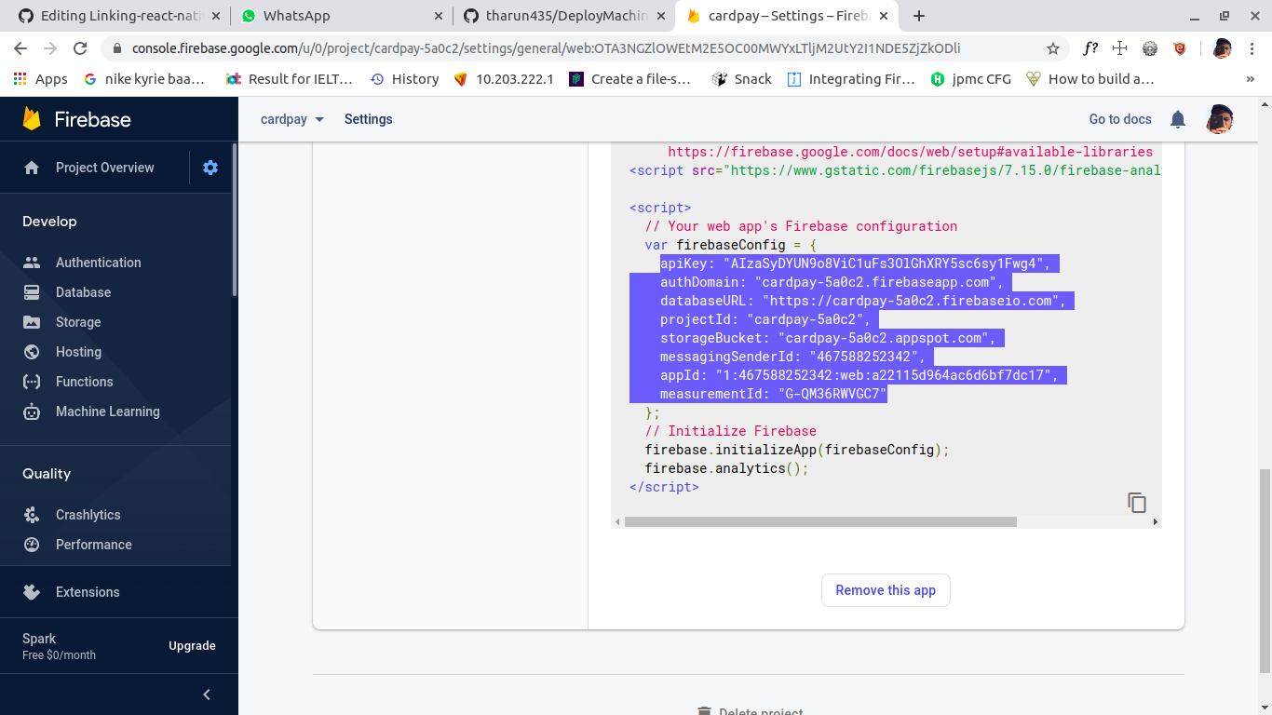
console.
->Add config folder in root directory of the project and create a file name called Firebase.js

config/Firebase.js

4.LETS START EDITING OUR APP FOR EMAIL AUTHENTICATION

->In the firebase console in authentication section ,in sign-in methods add email .
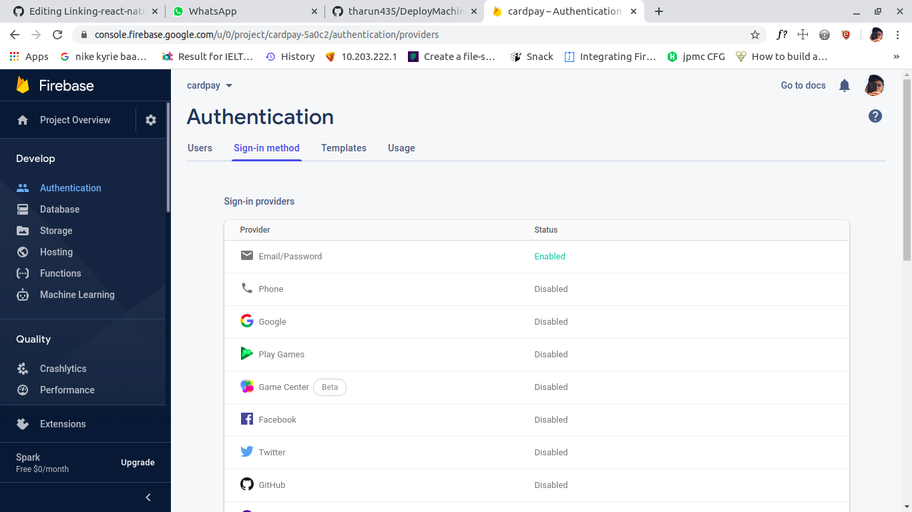

->Adding react-naviagtion for our project (it helps us to navigate between screens in our app)

npm install –save react-navigation
or
expo install react-navigation
....Create a folder in root directory named navigation and add create file SwitchNavigator.js

navigation/Switchnavigation.js

->Adding the screens folder in root directory and create 4 files as shown below

screens/Signup.js
screens/Login.js
screens/Profile.js
screens/Details.js

5.RUNNING OUR EMAIL-AUTHENTICATION PROJECT IN OUR MOBILE.

save the files -> npm start -> open expo client ->scan QR code ->try our

amazing email-authentication app

lets see the app and details that entered by our user are updated in firebase or not
