Project Documentation
Implement Client Script & UI Policy (Incident)
ServiceNow | Incident Management
Team Group Project
Platform | ServiceNow Personal Developer Instance (PDI)
Table | Incident [incident]
Team members | Pavithra P,  Pooja sri P,  Prasanna S,  Ramya B
Date | 28/09/2026

1. Introduction
ServiceNow is a cloud platform for IT Service Management (ITSM). Incident Management records, tracks and resolves issues reported by users. The quality of incident data decides how quickly an issue is triaged, routed and fixed. This project shows how UI Policies and Client Scripts control the Incident form and improve data quality.

2. Problem Statement
Incident records need consistent and accurate data entry to support effective triage, routing and resolution. Relying only on users' awareness and manual checks leads to incomplete, inconsistent or incorrect entries. For example, a High impact incident can be saved without an assignment group and may never reach the right team.

3. Objectives
- Understand UI Policies and Client Scripts and where each one fits.
- Create a UI Policy that changes the Incident form when Impact is High.
- Create a Client Script that adds client-side logic on the Incident form.
- Test both and document the results with screenshots.

4. Scope and Environment
Item | Details
Platform | ServiceNow Personal Developer Instance (PDI)
Table | Incident [incident]
Application | Global
Features used | UI Policy, UI Policy Actions, Client Script
User | Admin (development and testing)

5. Concepts
UI Policy: changes form behaviour (mandatory, read-only, visible) when its conditions are true. It is mostly no-code and runs on the client side.
Client Script: JavaScript that runs in the browser on form events. The types are onLoad, onChange, onSubmit and onCellEdit.
 | UI Policy | Client Script
Coding | Little or none | JavaScript needed
Best for | Mandatory, read-only, visible | Custom validation, messages, complex logic
Trigger | Conditions on the form | Form events

6. Implementation

6.1 Incident form before changes
Open Incident > Create New. The default form shows Impact = 3 - Low, Urgency = 3 - Low and Priority = 4 - Low. Caller and Short description are mandatory (red asterisk).
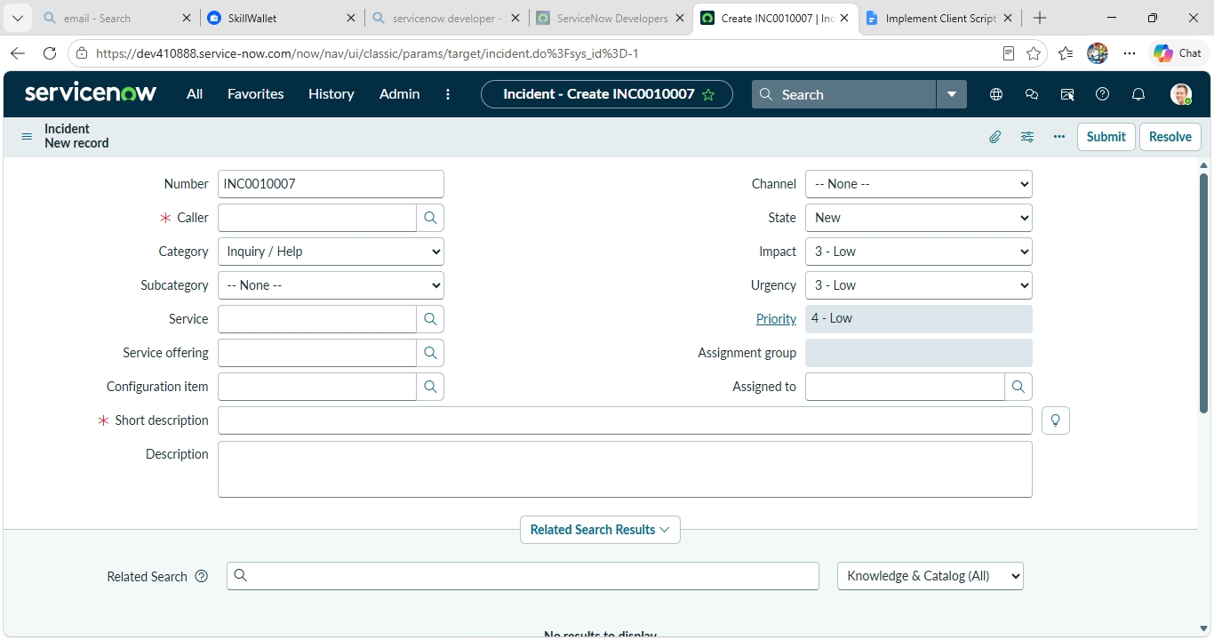
Figure 1: New Incident form (INC0010007) with default values

6.2 Create the UI Policy
- Go to All > System UI > UI Policies and click New.
- Set Table = Incident [incident], Application = Global and Active = checked.
- Set Short description = High Impact Control.
- Under When to Apply, add the condition Impact is 1 - High.
- Click Submit / Save.
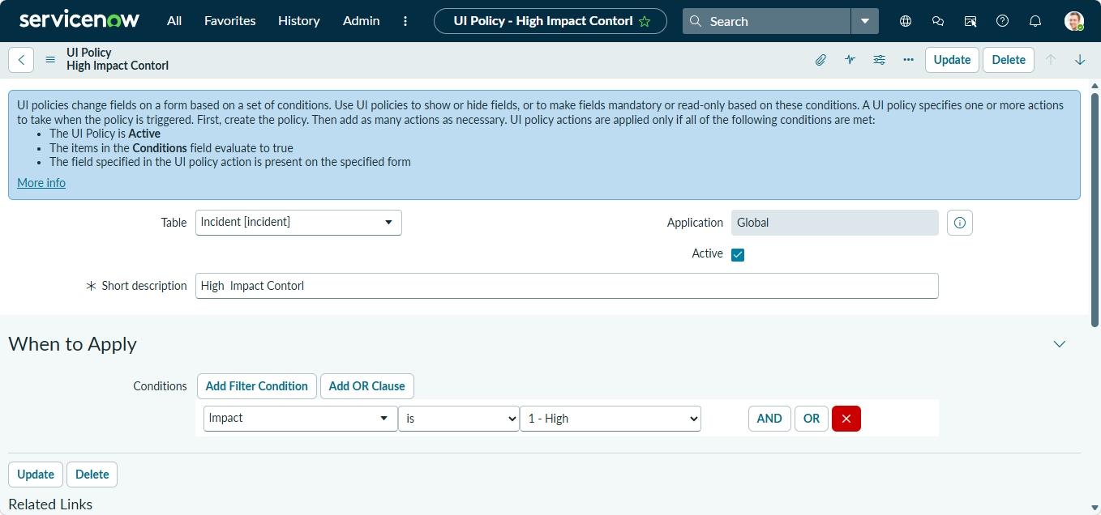
Figure 2: UI Policy configuration and condition (Impact is 1 - High)

6.3 Add UI Policy Actions
In the UI Policy Actions related list, click New and create two actions:
Field name | Mandatory | Visible | Read only
urgency | Leave alone | Leave alone | True
assignment_group | True | Leave alone | False
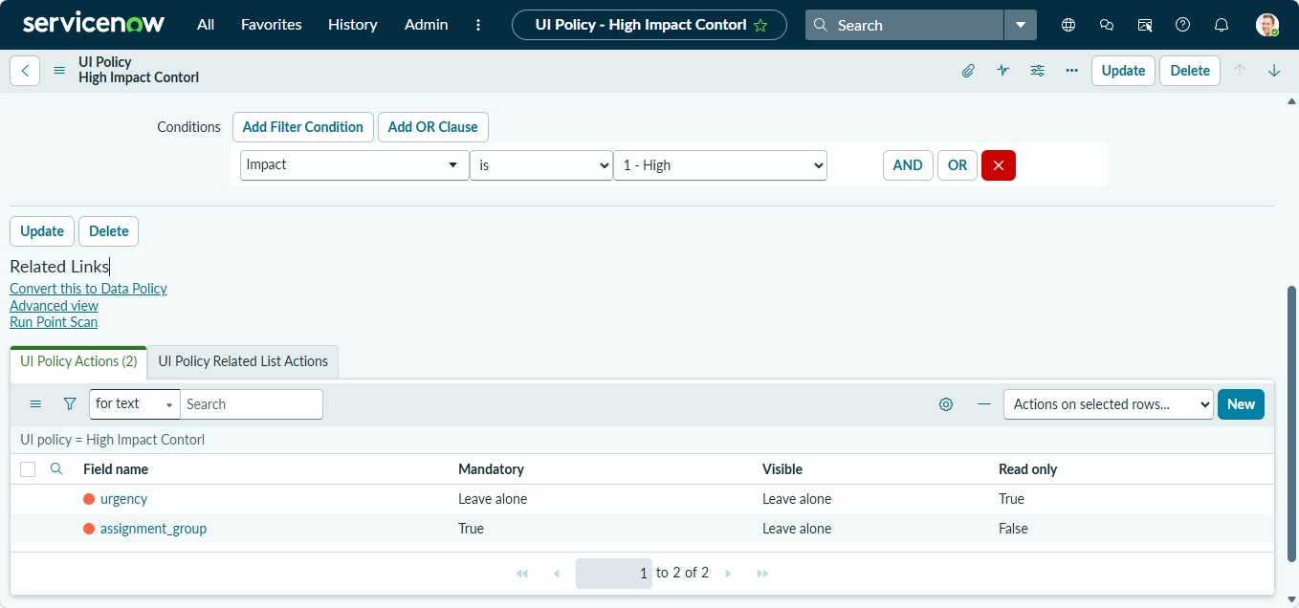
Figure 3: UI Policy Actions (2 of 2)

6.4 Create the Client Script
- Go to All > System Definition > Client Scripts and review the existing scripts.
- Click New and fill in the fields shown in the table below.
- Add the script and click Submit.
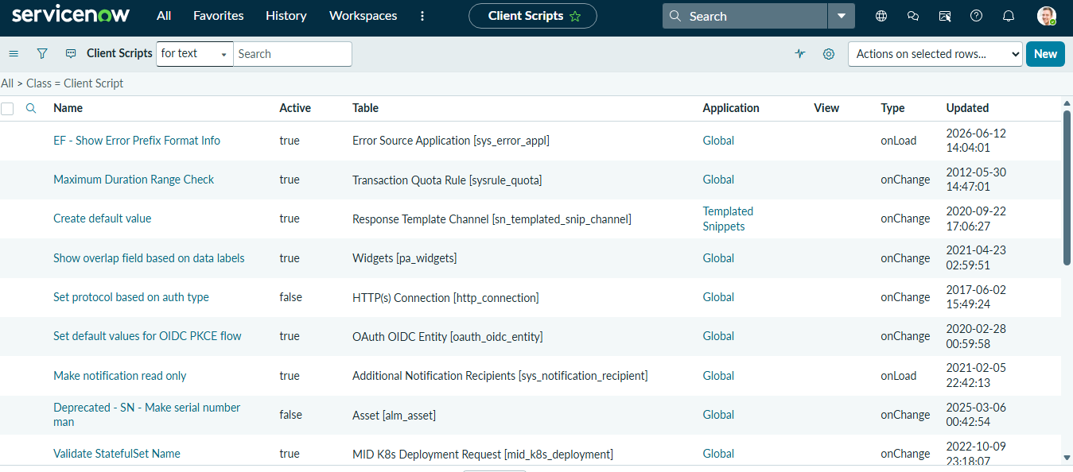
Figure 4: Client Scripts list
Field | Value
Name | [EDIT: e.g. Incident - High Impact Alert]
Table | Incident [incident]
UI Type | Desktop
Type | onChange
Field name | Impact
Active | Checked
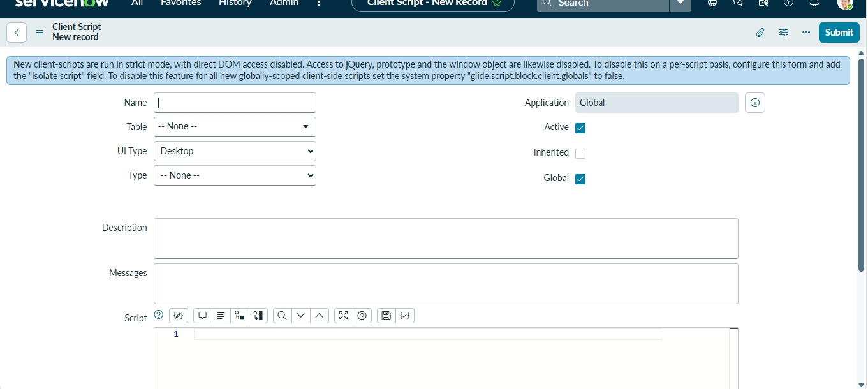
Figure 5: New Client Script form
Example script (replace with your team's actual code):
function onChange(control, oldValue, newValue, isLoading, isTemplate) {
if (isLoading || newValue === '') {
return;
}
// Impact value 1 = High
if (newValue == '1') {
g_form.addInfoMessage('High impact incident: please select an Assignment group.');
} else {
g_form.clearMessages();
}
}
Note: new client scripts run in strict mode, so use the g_form API and avoid direct DOM access, jQuery and the window object.

7. Testing and Results
# | Test case | Expected result
1 | New incident with Impact = 3 - Low | Urgency editable, Assignment group optional
2 | Change Impact to 1 - High | Urgency read-only, Assignment group mandatory
3 | Save with High impact and empty Assignment group | Save blocked with mandatory field message
4 | Change Impact back to Low | Fields return to normal
5 | Client Script on Impact change | [EDIT: message displayed]
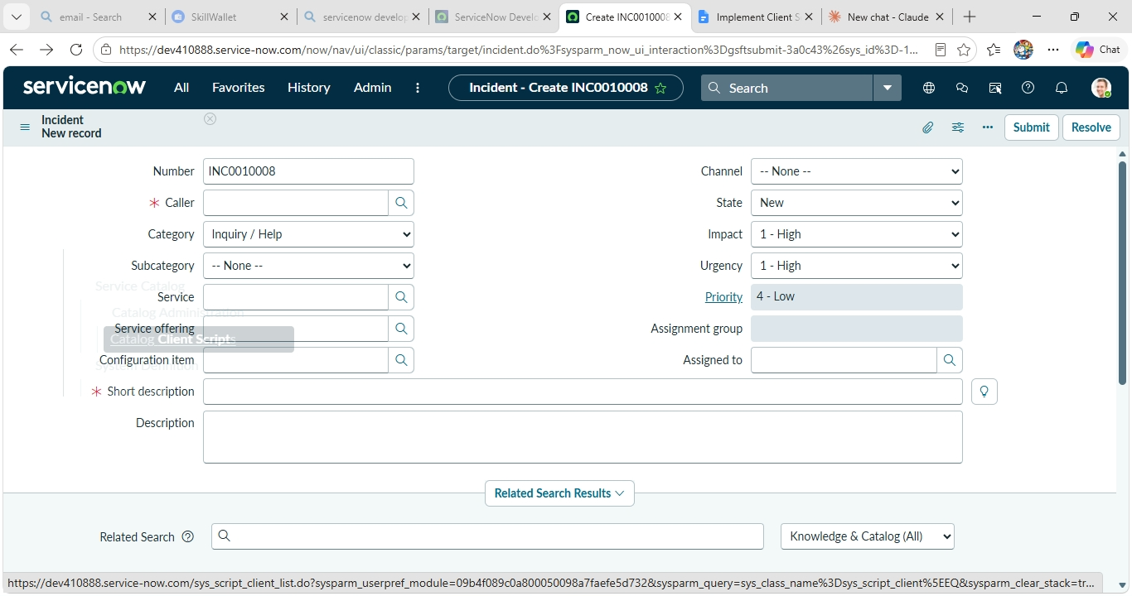
Figure 6: New Incident (INC0010008) with Impact set to 1 - High

8. Observations
- UI Policies handle standard field behaviour with no code.
- Client Scripts cover custom logic that UI Policies cannot.
- Together they prevent incomplete high-impact incidents and improve routing.

9. Conclusion
The UI Policy and Client Script enforce data quality at the point of entry on the Incident form. This reduces incomplete records, speeds up triage and gives a consistent process for high-impact incidents.

10. Future Enhancements
- Auto-set Urgency and Priority from Impact.
- Add validation with onSubmit client scripts.
- Use Data Policies to enforce rules on imports and integrations.

