How to Attach and Mount an EBS volumeto EC2 Linux Instance



AWS allows you to create new EBS volumes, and you can attach them to instances for extra storage. However, to make EBS volume usable as storage inside the instance, you need to mount it to a specific folder.

## Mount an EBS Volume to EC2 Linux

This tutorial will teach you how to attach and mount an EBS volume to ec2 Linux instances.

Follow the steps given below carefully for the setup.

**Step 1:** Head over to EC2 –> Volumes and create a new volume of your preferred size and type.

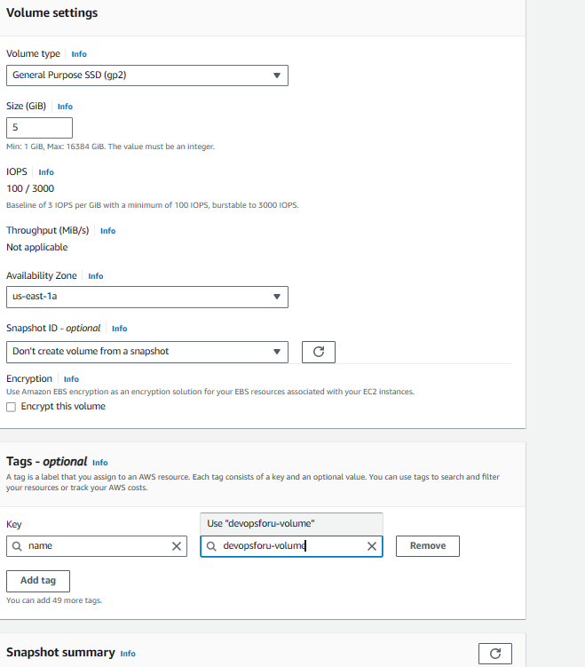

**Note**: Make sure the EBS volume and the instance are in the same zone

**Step 2:** Select the created volume, right-click and select the “attach volume” option.

**Step 3:**Select the ec2 instance from the instance

**Step 4:** Now, login to your ec2 instance and list the available disks using the following command

lsblk

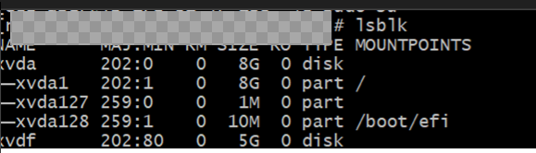

**Step 6:** Format the volume to the xfs/ext4  filesystem using the following command.

mkfs -t xfs /dev/xvdf

or

mkfs -t ext4 /dev/xvdf

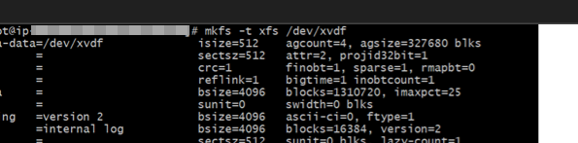

**Step 7:** Create a directory of your choice to mount our new ext4 volume. I am using the name “devopsforu. You can name it something meaningful to you



**Step 8:** Mount the volume to “**devopsforu**” directory using the following command.

mount /dev/xvdf /devopsforu



**Step 9:** cd into devopsforu directory and check the disk space to validate the volume mount.

cd /devopsforu



df -h

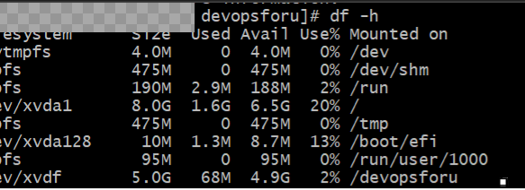

10.umount the volume, use the unmount command as shown below

Umount /xvdf/devopsforu

11. Automount EBS Volume on Reboot

**Step 1:** Back up the **/etc/fstab** file.

sudo cp /etc/fstab /etc/fstab.bak

**Step 2:** Open**/etc/fstab** file and make an entry in the following format.

device_name mount_point file_system_type fs_mntops fs_freq fs_passno

ex:

/dev/xvdf /devopsforu xfs defaults,nofail 0 0



**Step 3:** Execute the following command to check if the **fstab** file has any errors.

Sudo mount -a

Conclusion

You’ve successfully attached and mounted an extra EBS volume to your Linux EC2 instance. This additional storage can now be used for your applications, databases, or any other use case. Always remember to backup critical data and monitor your storage usage to ensure it meets your application’s needs. With this newfound flexibility, you’re better equipped to manage your EC2 instances in AWS.