AI API Cost Analysis for the CSR Dashboard
Question analysis and natural language search agent
Prepared for management review | 26 October 2026
This report estimates the cost of adding a cloud language model API to the AI Analysis section of the CSR dashboard. The current dashboard already answers supported data questions locally and without an API. A paid model is needed only for broader questions that the built-in parser cannot interpret. This hybrid design should be retained because it gives grounded answers and keeps recurring API spend very low.
Recommendation: use OpenAI GPT 5.6 Luna as the first production model, keep the deterministic query engine as the first route, and apply a monthly API budget cap. At the expected usage level in this report, model charges are approximately INR 68 per month before tax. If the current Render service has enough capacity, no additional hosting service is required.

Executive Decision
Decision item | Recommended choice | Reason
Architecture | Local query engine first, cloud model only as fallback | Preserves accuracy and avoids paying for routine questions
Initial provider | OpenAI API with GPT 5.6 Luna | Already supported in the code and lowest listed cost among directly compatible choices
Expected model budget | INR 100 to INR 500 per month | Includes headroom above the expected INR 68 usage estimate
External web search | Do not enable in phase one | The agent answers from the dashboard dataset; live web results add cost and evidence risk
Vector database | Not required | The dashboard sends a structured fact pack, not a document library

Current Dashboard Architecture
The existing implementation is already designed as a grounded analytics assistant rather than a general chatbot. The request first goes to the built-in natural-language query engine. If that engine understands the question, it calculates the answer directly from the CSR fact table. Only an unsupported question is passed to the configured cloud model.
Stage | What happens | API cost
1 User question | The user asks about companies, years, states, sectors, domains, trends, compliance or CSR amounts. | None
2 Deterministic analysis | The local parser identifies known entities and metrics, then computes the answer from dashboard data. | None
3 Cloud fallback | If the parser cannot understand the question, a compact pre-calculated fact pack is sent to the model. | Token based
4 Grounded response | The system prompt requires the model to use only supplied figures and state when information is unavailable. | Included in model call

No customer report PDF, workbook or full raw database needs to be uploaded to the model in the present design. The model receives a compact JSON summary containing KPIs, trends, forecasts, leading companies, states, sectors, thematic areas, implementation modes, anomalies and data caveats.

What the API Is Needed For
- Interpret questions that fall outside the built-in parser's supported patterns.
- Turn the supplied fact pack into a concise management explanation.
- Explain changes, risks and gaps in natural language without recalculating dashboard figures.
- Optionally generate a short executive briefing when a user explicitly requests narration.
The API is not required for filtering, dashboard calculations, charts, forecasting, report generation or the supported question patterns. Those functions remain available when the API key is absent.

Cost Formula and Assumptions
Monthly model cost equals input tokens divided by one million multiplied by the input rate, plus output tokens divided by one million multiplied by the output rate, multiplied by the number of cloud-model calls.
Assumption | Planning value | Basis
Input per cloud call | 3,000 tokens | System instructions, question and compact fact pack
Output per cloud call | 300 tokens | A concise dashboard answer
Questions answered locally | 75 percent | Planning assumption; measure after launch
Questions sent to the model | 25 percent | Fallback-only architecture
Currency conversion | USD 1 = INR 95 | Rounded planning rate near 26 October 2026; invoices vary

Cloud Model Price Comparison
Model | Input per 1M | Output per 1M | Per 1,000 calls | Approx INR | Assessment
OpenAI GPT 5.6 Luna | USD 0.20 | USD 1.20 | USD 0.96 | INR 91 | Recommended for production cost control
Google Gemini 3.1 Flash Lite | USD 0.25 | USD 1.50 | USD 1.20 | INR 114 | Low cost but requires a new provider adapter
Anthropic Claude Sonnet 5.5 | USD 2.00 | USD 10.00 | USD 9.00 | INR 855 | Strong quality and already supported
OpenAI GPT 5.6 Terra | USD 2.00 | USD 12.00 | USD 9.60 | INR 912 | Higher reasoning quality than needed for routine Q and A

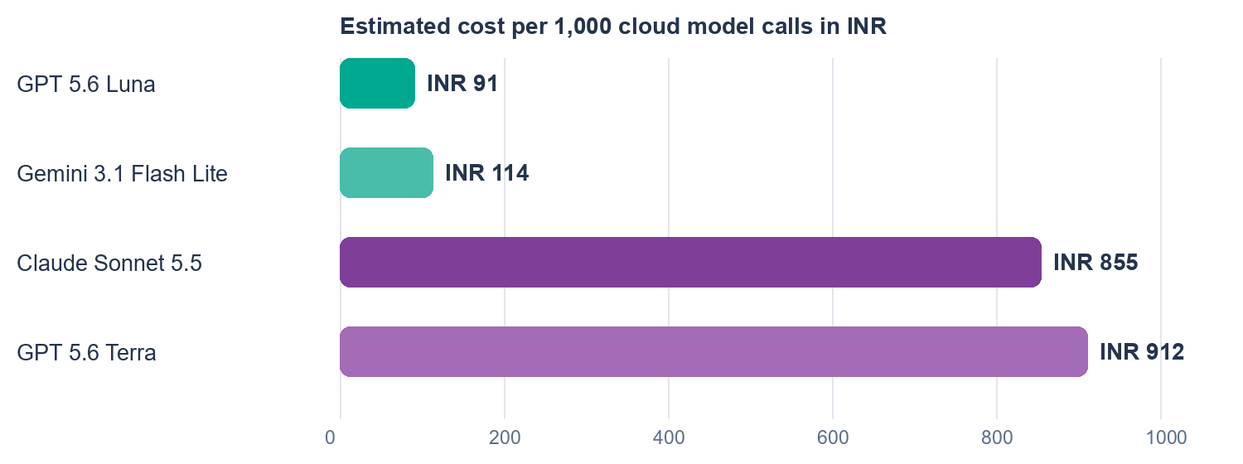
Figure 1 Estimated provider cost for 1,000 cloud model calls
Price is not the only criterion. The selected model must follow the supplied facts, return concise answers, work reliably at the required latency, and support the organization's data-governance requirements. A short benchmark using 30 to 50 real dashboard questions should precede production approval.

Monthly Usage Scenarios
Scenario | Users | Questions per user | Cloud fallback | Model calls | Model cost | Approx INR
Pilot | 100 | 5 | 20% | 100 | USD 0.10 | INR 9
Expected internal use | 300 | 10 | 25% | 750 | USD 0.72 | INR 68
High adoption | 1,000 | 20 | 30% | 6,000 | USD 5.76 | INR 547

Even if every question in the expected scenario went to GPT 5.6 Luna, 3,000 calls would cost about USD 2.88 or INR 274 under these assumptions. The hybrid route is still recommended because it improves auditability and protects the system from unnecessary model dependence.

Additional and Indirect Costs
Cost item | When it applies | Indicative impact
Render hosting | Only if the current service needs a paid compute plan | Free plan may be usable for testing; entry paid compute is approximately USD 6 per month
Taxes and payment charges | Foreign SaaS billing to an Indian entity | Allow for applicable GST, bank or card foreign exchange markup and invoice conversion differences
Web search | Only if the agent must retrieve external internet evidence | OpenAI lists USD 10 per 1,000 web search calls plus model tokens
File search or vector storage | Only if the agent must search a growing report library | Not needed for the present structured dashboard fact pack
Monitoring | Recommended in production | Usage logging can begin in the existing application; a paid monitoring service is optional
Engineering | One-time implementation and testing | Provider configuration is small; benchmarking, guardrails, usage limits and QA require the main effort
Support and maintenance | Ongoing | Review model deprecations, prices, failed requests and answer quality quarterly

Hosting Cost View
If the CSR dashboard is already running on Render and has available memory and request capacity, adding outbound API calls does not require another server. The incremental hosting cost can therefore be zero. If a paid entry compute plan is required, budget approximately USD 6 or INR 570 per month before taxes, using the same planning exchange rate.
Expected monthly component | Estimated amount
GPT 5.6 Luna model usage | INR 68
Render paid entry compute if required | INR 570
Subtotal before tax and payment charges | INR 638
If existing hosting has capacity | Incremental subtotal approximately INR 68

Provider Recommendation
Preferred production option: OpenAI GPT 5.6 Luna. It fits the dashboard's bounded question-answering task, has the lowest listed token cost in this comparison, and the application already contains an OpenAI provider route. The integration should be updated to the current OpenAI Responses API and the model should be pinned in configuration rather than hard-coded.
Alternative: Anthropic Claude Sonnet 5.5. The current code already supports Anthropic and the quality is suitable, but the estimated recurring model cost is about nine to ten times the Luna estimate for this workload. The absolute cost is still modest at expected usage.
Budget alternative requiring development: Gemini 3.1 Flash Lite. Its list price is close to Luna, but the present application has no Gemini provider adapter. Use the paid service for business data; Google's unpaid service terms permit submitted content to be used for product improvement.

Security and Governance Requirements
- Store the provider key only as a Render environment secret. Never expose it in browser code, GitHub, logs or exported reports.
- Keep all provider calls on the server-side API route and require an authenticated dashboard session.
- Apply per-user and per-IP rate limits, a maximum question length, request timeouts and a monthly spending cap.
- Send only the minimum fact pack needed to answer the question; do not send email addresses, passwords or personal user data.
- Record usage metadata such as timestamp, user ID, selected filters, provider, model, input tokens, output tokens, latency and result status. Avoid retaining full prompts unless approved.
- Show the answer source in the interface: built-in calculation or cloud model. Keep evidence figures visible for review.
- Do not allow the model to execute database queries or arbitrary code. Calculations should remain in the deterministic dashboard layer.
- Review provider data retention and data residency requirements with the organization's legal and information-security teams before launch.
OpenAI states that API data is not used for model training by default. Standard abuse-monitoring logs may be retained for up to 30 days, with additional controls available to qualifying organizations. Paid Gemini services state that prompts and responses are not used to improve Google products, while unpaid services have different data-use terms.

Implementation Plan
Phase | Work | Acceptance criterion
1 Configure | Create a provider project, restricted API key, spending limit and Render environment variables. | No secret appears in the repository or browser network payload
2 Modernize | Use the current provider endpoint, pin the model and capture token usage returned by the API. | A test question returns a grounded response and usage record
3 Protect | Add authentication enforcement, rate limits, timeout handling and friendly failure messages. | Abuse and provider outages do not affect dashboard calculations
4 Benchmark | Run 30 to 50 representative CSR questions against deterministic answers and expert review. | Accuracy and refusal behavior meet the agreed threshold
5 Pilot | Release to a small user group and measure fallback rate, cost, latency and unanswered questions. | Actual monthly cost is within the approved cap
6 Review | Review provider pricing, model lifecycle and answer quality every quarter. | No deprecated model or uncontrolled spend remains

Recommended Approval
Approve a four-week pilot with a monthly model budget cap of INR 500 and no external web search. Use the current local engine for supported questions and GPT 5.6 Luna only for fallback questions. Continue on the existing Render service unless monitoring shows a capacity constraint. At the end of the pilot, replace assumptions with measured token usage, fallback rate, answer quality and user volume before setting the production budget.

Sources and Pricing Date
Pricing and policy references were checked on 26 October 2026. Provider prices can change; confirm the current rate before procurement.
- OpenAI API model pricing and GPT 5.6 Luna
- OpenAI API tool pricing
- OpenAI API data controls
- Anthropic Claude pricing
- Google Gemini API pricing
- Google Gemini API terms
- Render pricing

