Team Members:

Siddhartha Roy

Rajeshwari Bhirud

Rahul Thodupunoori

Introduction to User Experience

March 18th, 2024

**Milestome#4**

1. **Primary Persona**

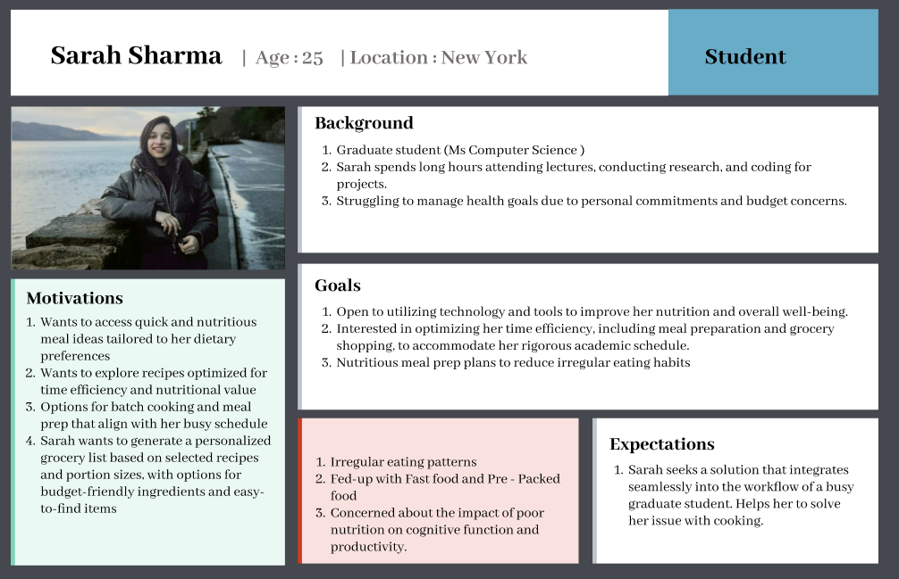

1. **Scenarios and Tasks**

* **Scenarios**

Scenario 1:

Sarah, a dedicated graduate student in Computer Science, seeks nutritious meal ideas amidst her busy schedule. She discovers a meal planning app tailored to her needs, offering quick and healthy recipes. With options for batch cooking, she effortlessly aligns her meals with her academic schedule, ensuring she stays energized throughout the day. Excited by the prospect of improved nutrition, Sarah explores the app further, generating personalized grocery lists based on her selected recipes and portion sizes. Empowered by intuitive tracking tools, she visualizes trends in her eating habits and energy levels, enhancing her overall health and academic performance.

Scenario 2:

Sarah, a graduate student with a tight budget, faces challenges in maintaining a nutritious diet. She discovers a meal planning platform designed for students like her, offering budget-friendly recipes. Delighted by the options for easy-to-find ingredients, Sarah streamlines her shopping trips, minimizing food waste and maximizing savings. As she tracks her eating habits and energy levels using intuitive graphs and charts, Sarah identifies areas for improvement in her health and productivity. With the support of the platform, she embraces healthier food choices, fuelling her brain for success in her academic pursuits.

* **Tasks / User Stories**

1. As a user, Sarah wants to access quick and nutritious meal ideas tailored to her dietary preferences and academic schedule, so she can fuel her brain with healthy food choices while juggling coursework and research projects.
2. As a user, Sarah wants to explore recipes optimized for time efficiency and nutritional value, with options for batch cooking and meal prep that align with her busy schedule as a graduate student in Computer Science.
3. As a user, Sarah wants to generate a personalized grocery list based on selected recipes and portion sizes, with options for budget-friendly ingredients and easy-to-find items, so she can streamline her shopping trips and minimize food waste as a graduate student on a tight budget.
4. As a user, Sarah wants to track her eating habits and energy levels throughout the week, along with study hours and project deadlines, using intuitive graphs and charts to visualize trends and identify areas for improvement in her overall health and academic performance.

* **Features:**

1. From above user stories the app will have following features:
2. User can login and register in the application.
3. User gets to set its preferences in profile for diet, goal, and restrictions.
4. User can navigate through home, saved recipes, collection and shopping list.
5. User can click on a recipe and get overview, ingredients, direction and nutrition chart for the same.
6. User can add ingredients to the shopping list from the recipes ingredient list.
7. **Prototype Sketches**

Some of the protoype Sketches/features:

To Login or Register into the App:

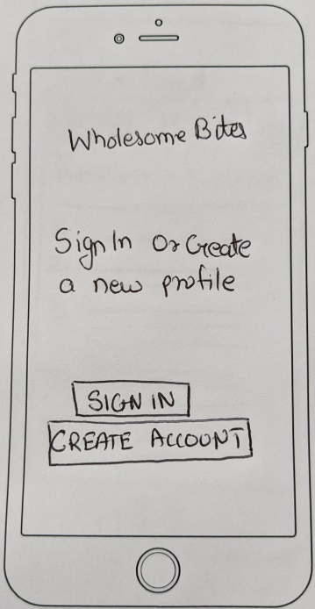 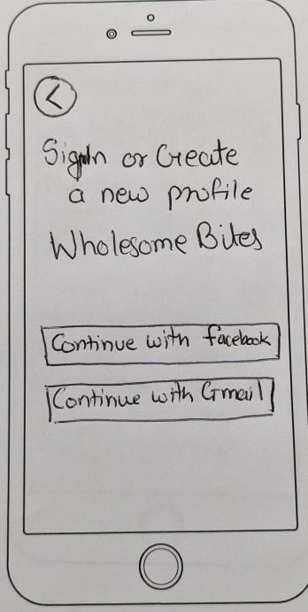 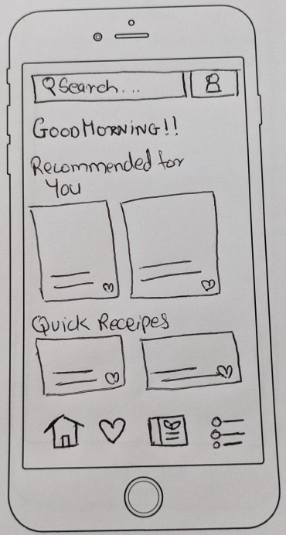

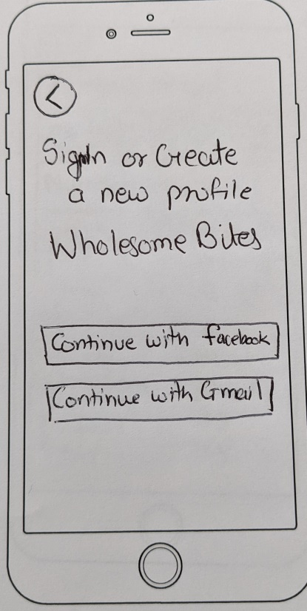 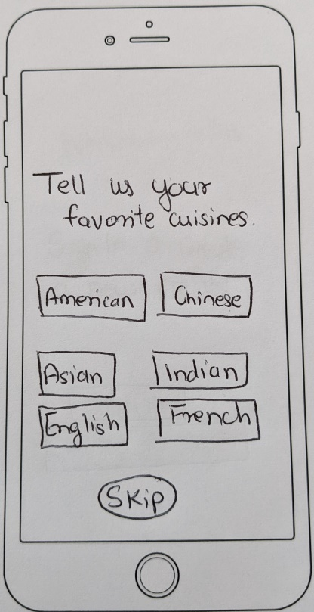 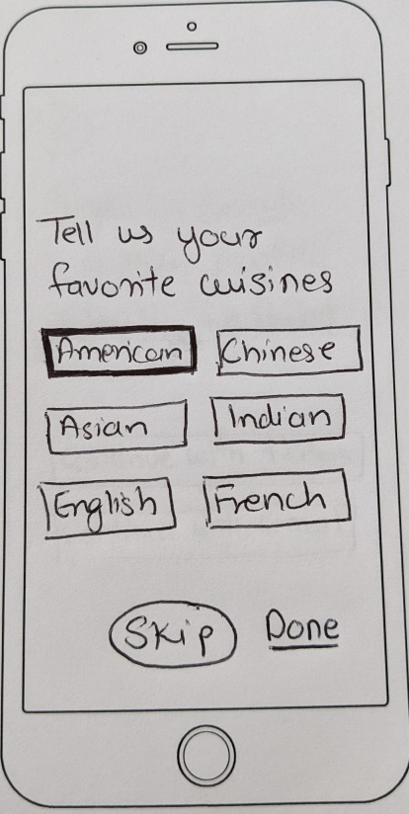

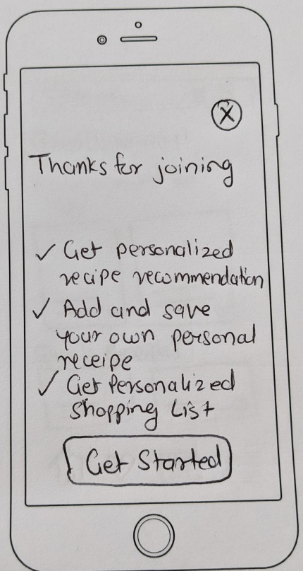

Saved Recipes and shopping list:

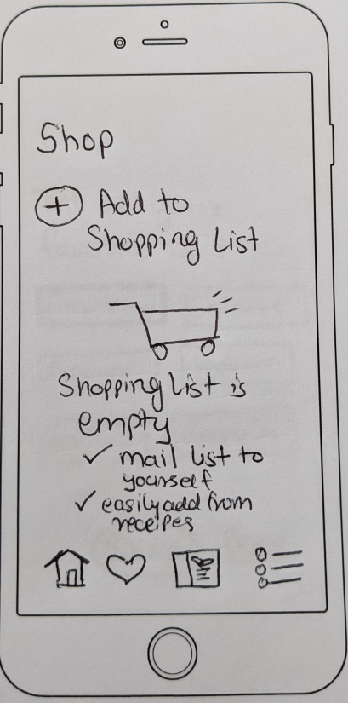 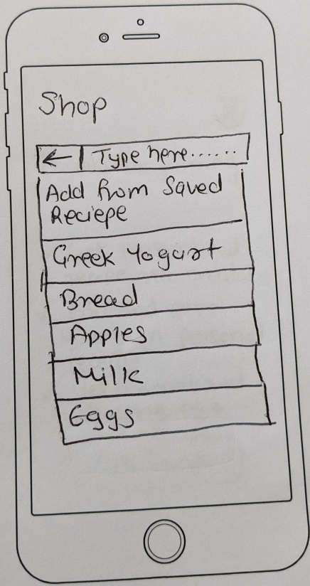 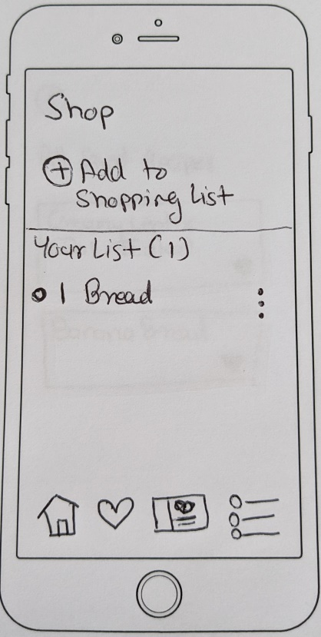

Recipe :

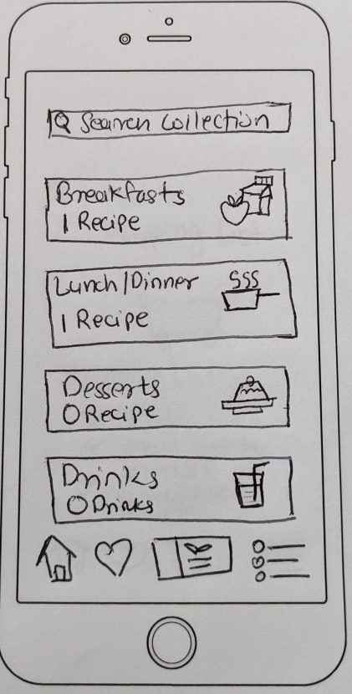 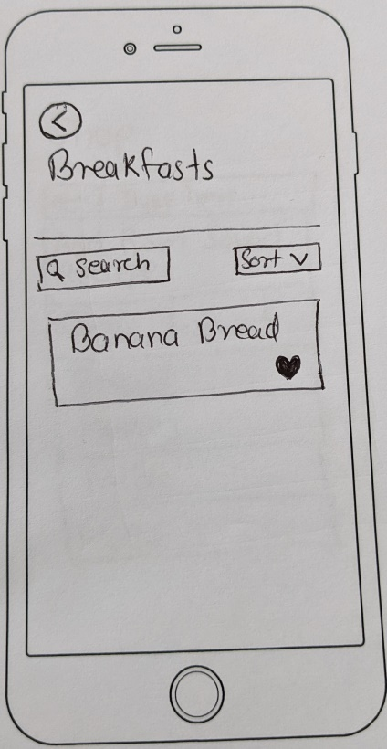

Recipe Overview, ingredients, charts and direction:

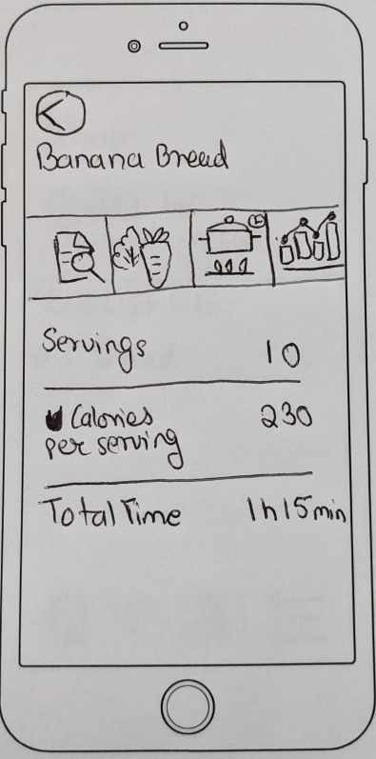 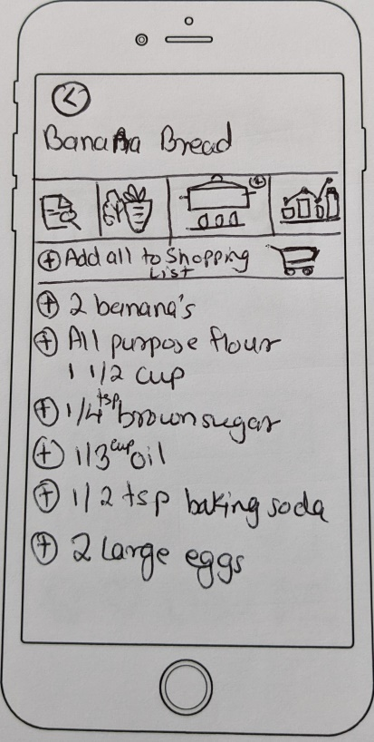 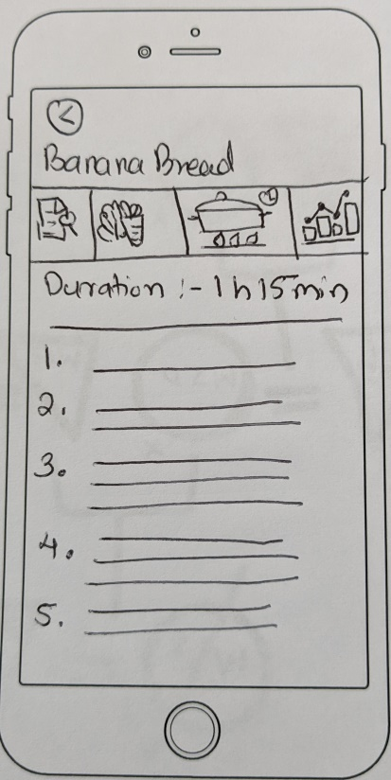

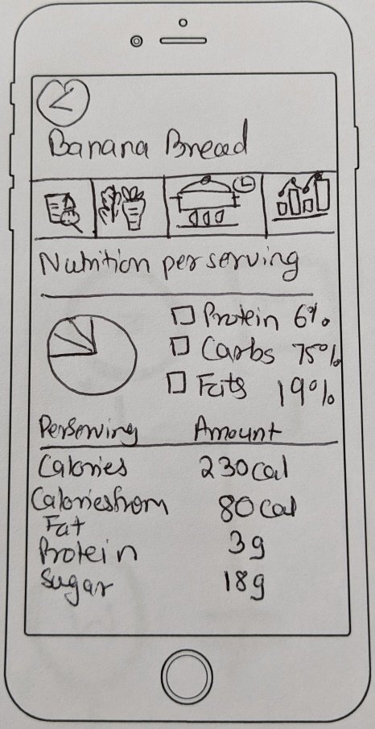

User Profile:

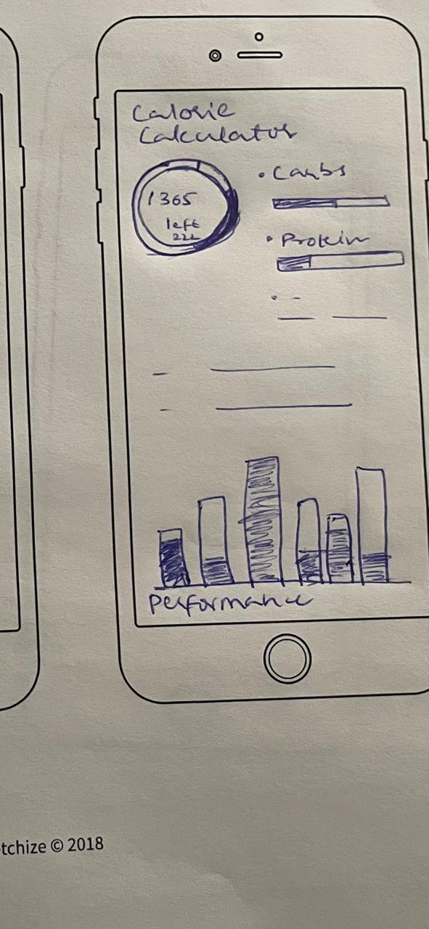 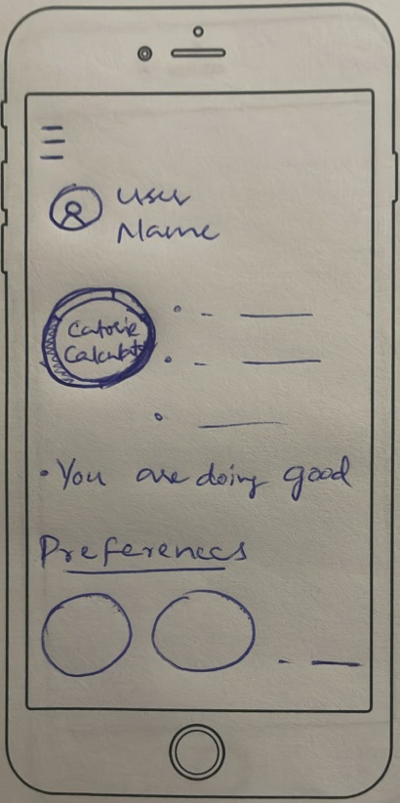

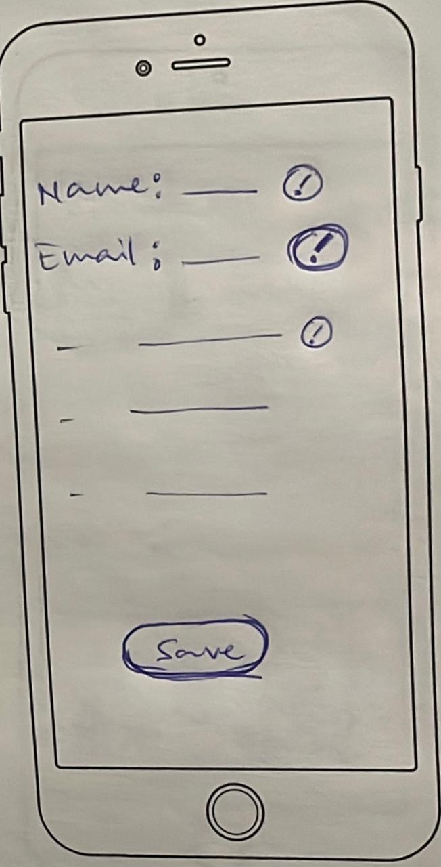 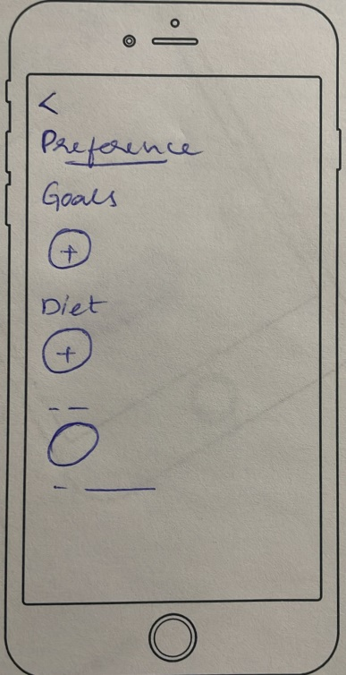 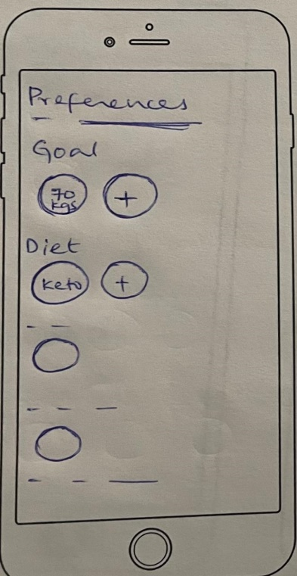

1. **Interactive Prototype**

Link to interactive prototype done on Marvel App:

<https://marvelapp.com/prototype/6gg01ca>

**References:**

* <https://www.figma.com/file/8UMqTDVqwUuxpPylZ9PONY/User-Personas?type=design&node-id=0-1&mode=design&t=7QsNUxGG4Kbivupt-0>