Issues Faced:

- Requirement.txt was not getting generated hence docker did not build
- Once of docker was appended with ```dockerfile
- The file was not opening with UTF-8 encoding docker build failed
- After fixing the error the docker was successfully build and the services were up and running

Code

1. create_folder — Creates directories
2. create_file — Writes files to disk
3. _run_cmd — Runs shell commands
4. generate_services — Node 1: Generates Flask microservices
5. generate_requirements — Node 2: Generates requirements.txt
6. generate_dockerfiles — Node 3: Generates Dockerfiles
7. generate_k8s — Node 4: Generates K8s manifests
8. validate_k8s — Node 5: Validates K8s YAML
9. scaffold_files — Node 6: Writes all files to disk
10. generate_docker_compose — Node 7: Generates docker-compose.yml
11. run_docker_containers — Node 8: Builds and starts containers

Generated folder structure

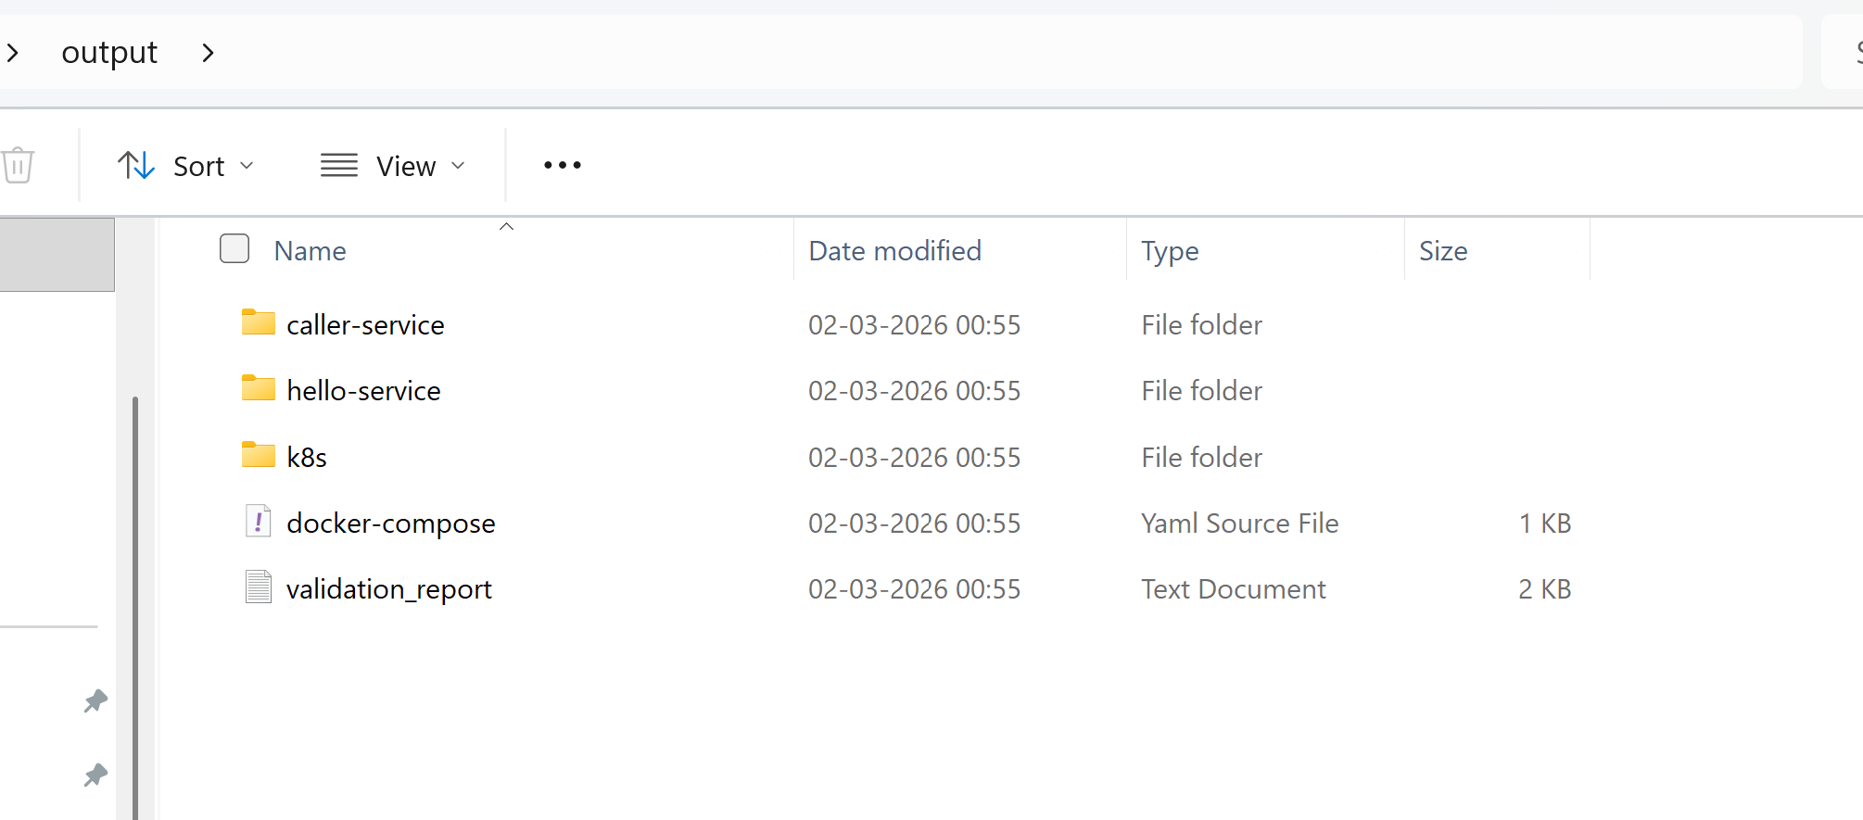

Code execution:
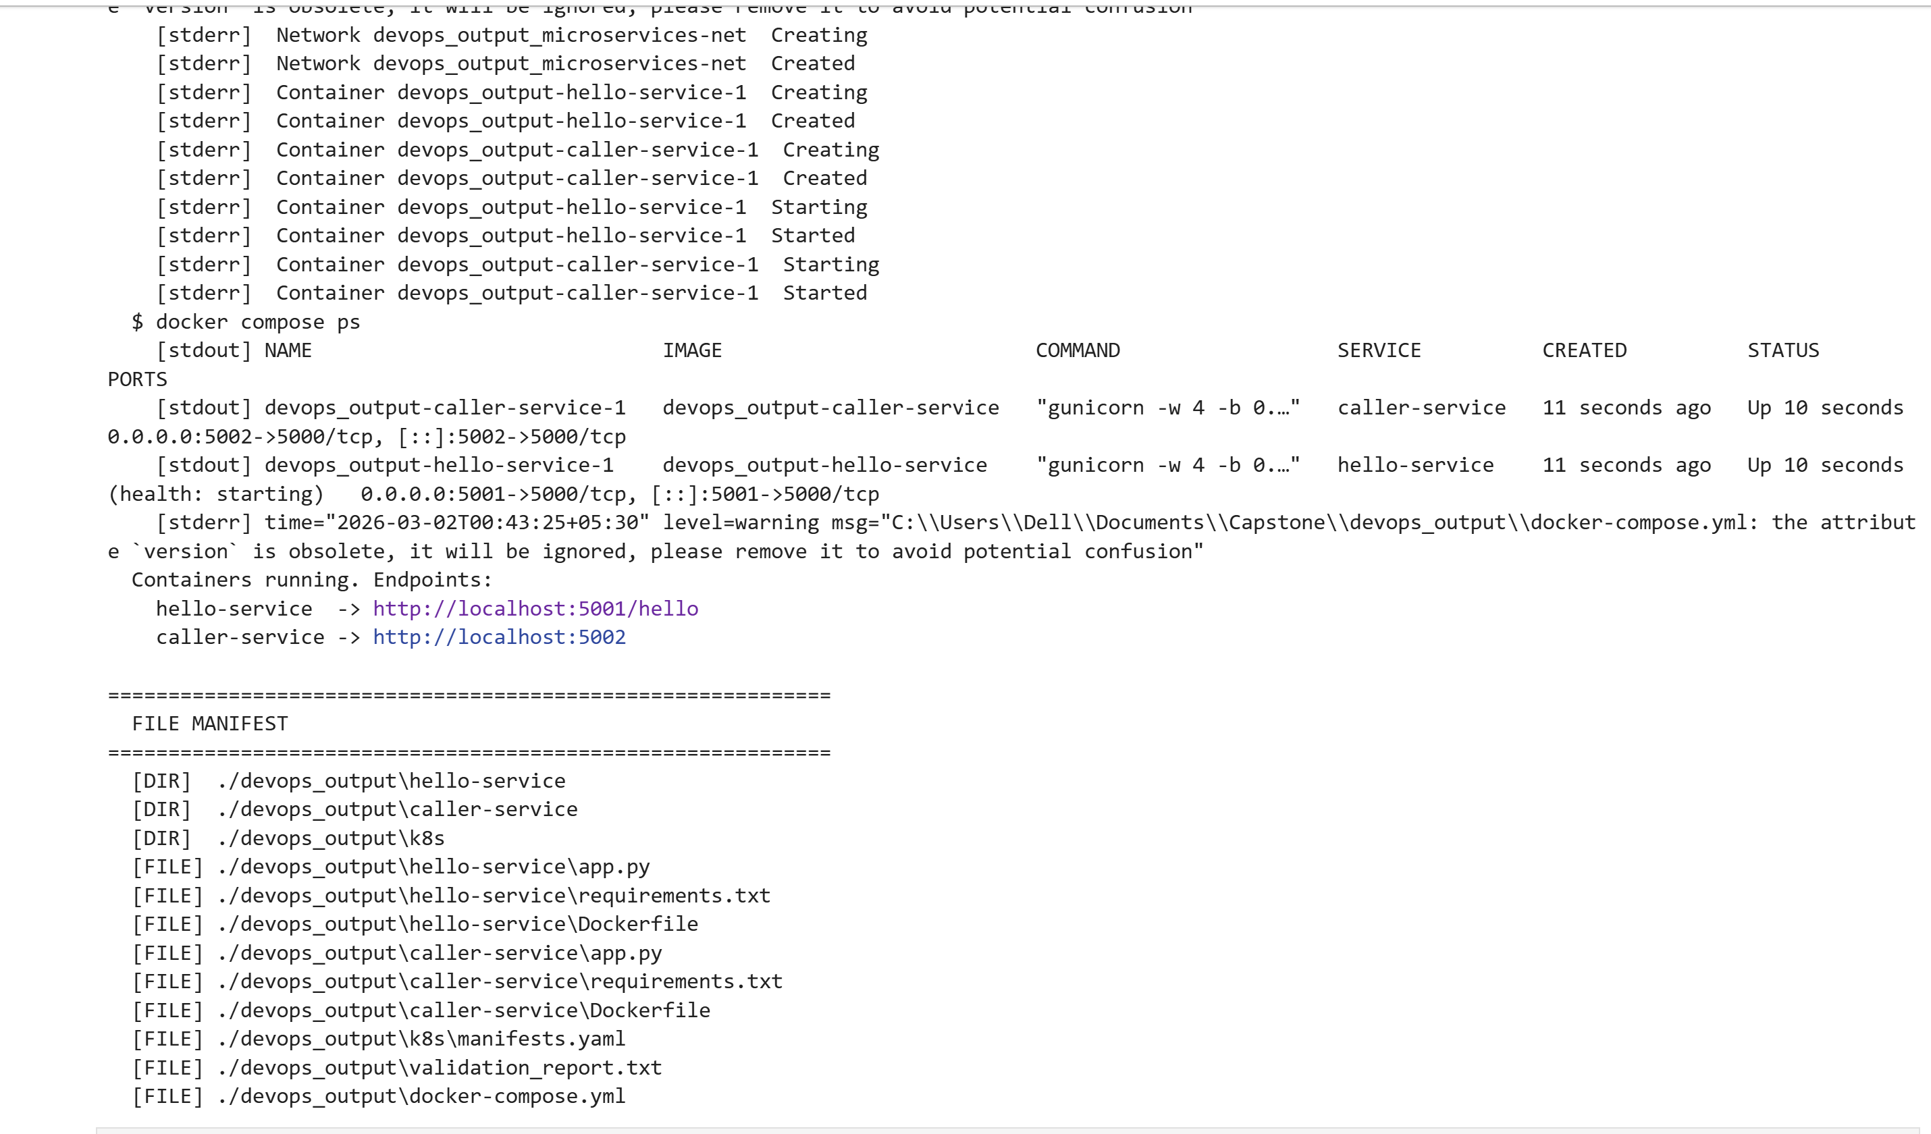
Docker screenshot
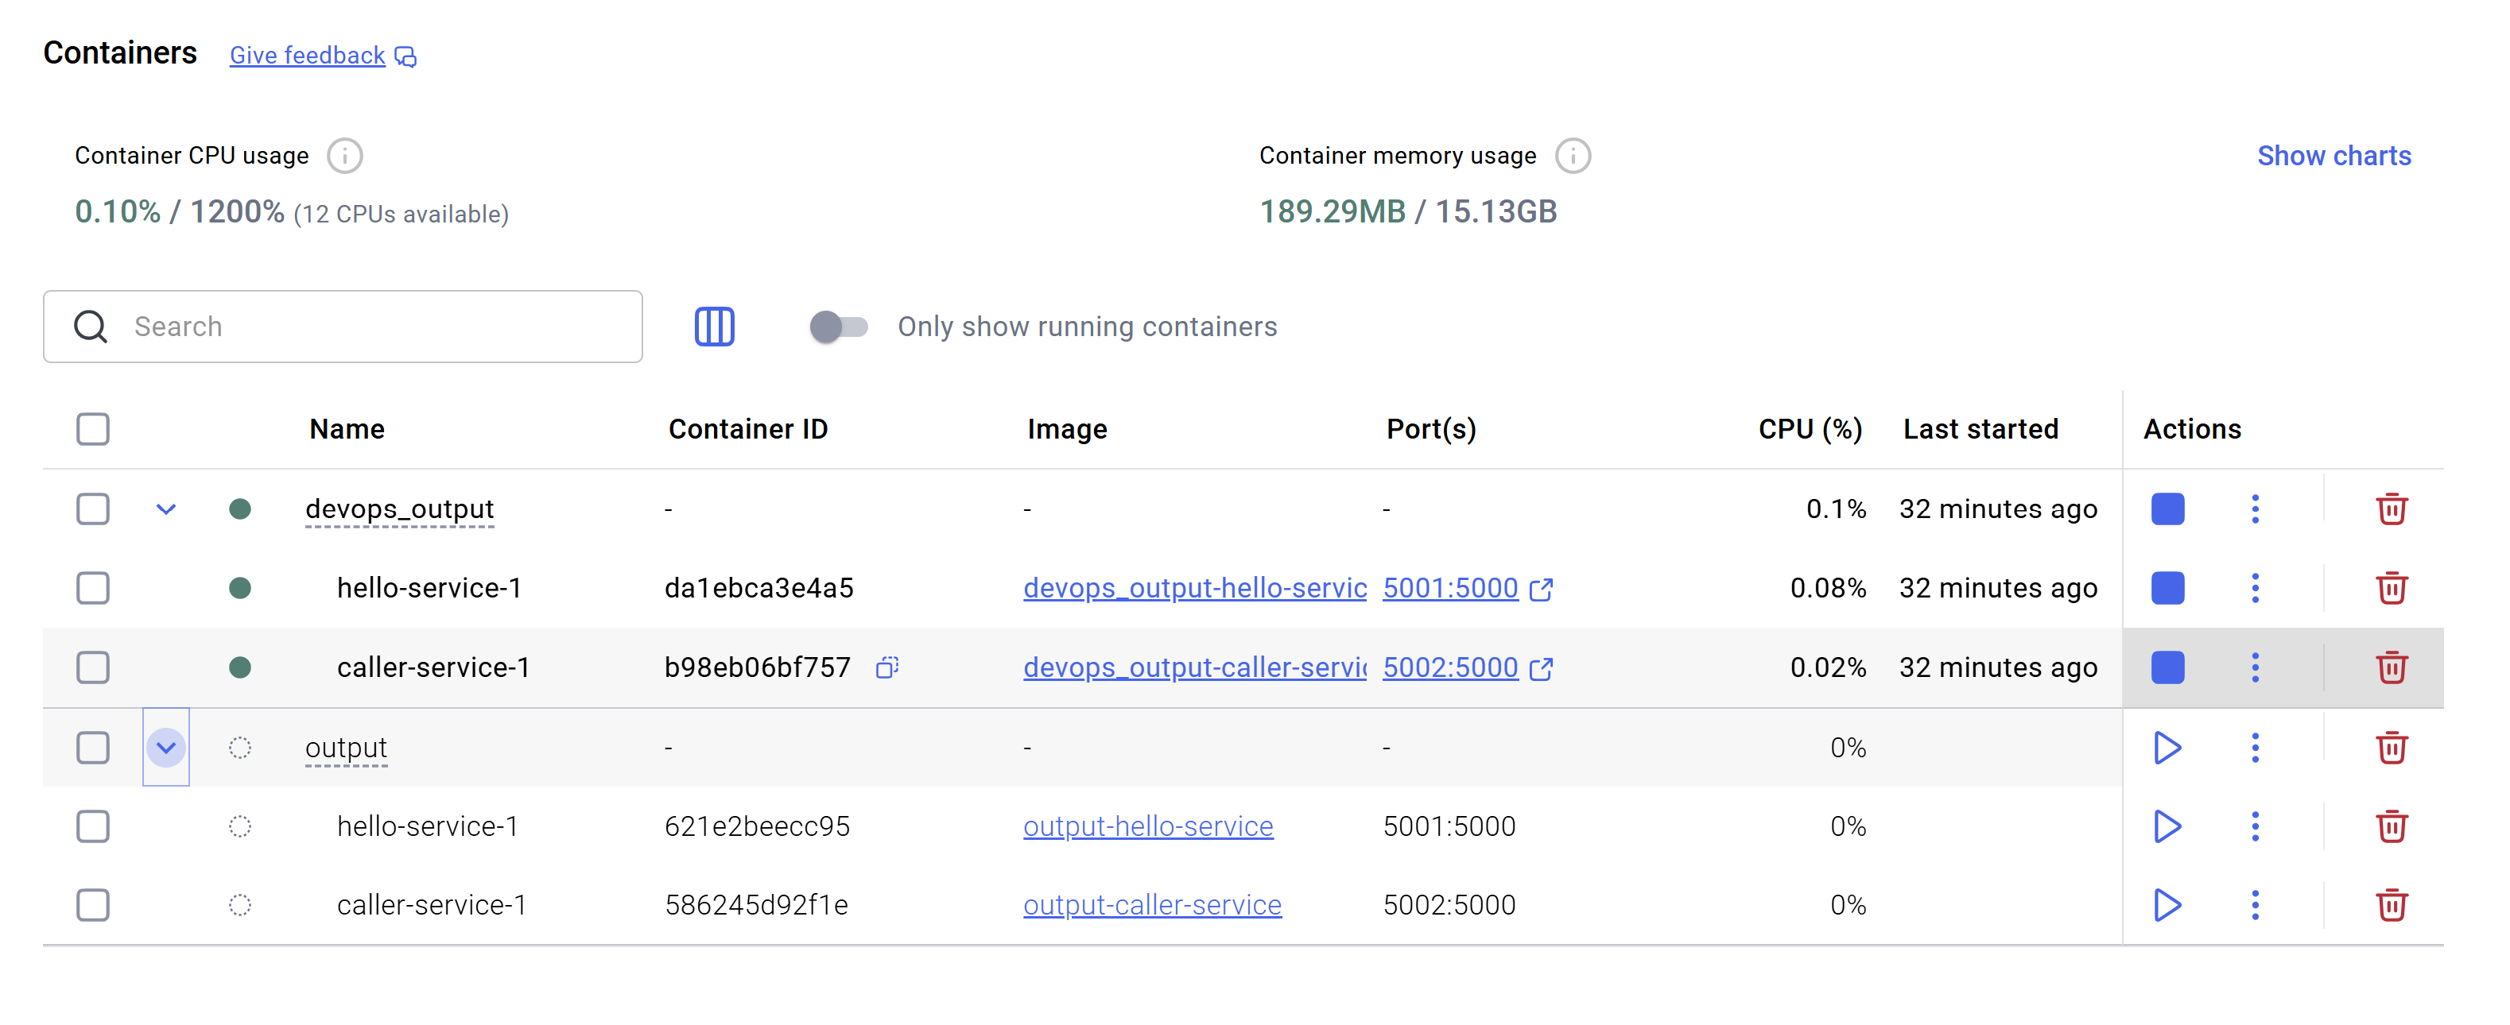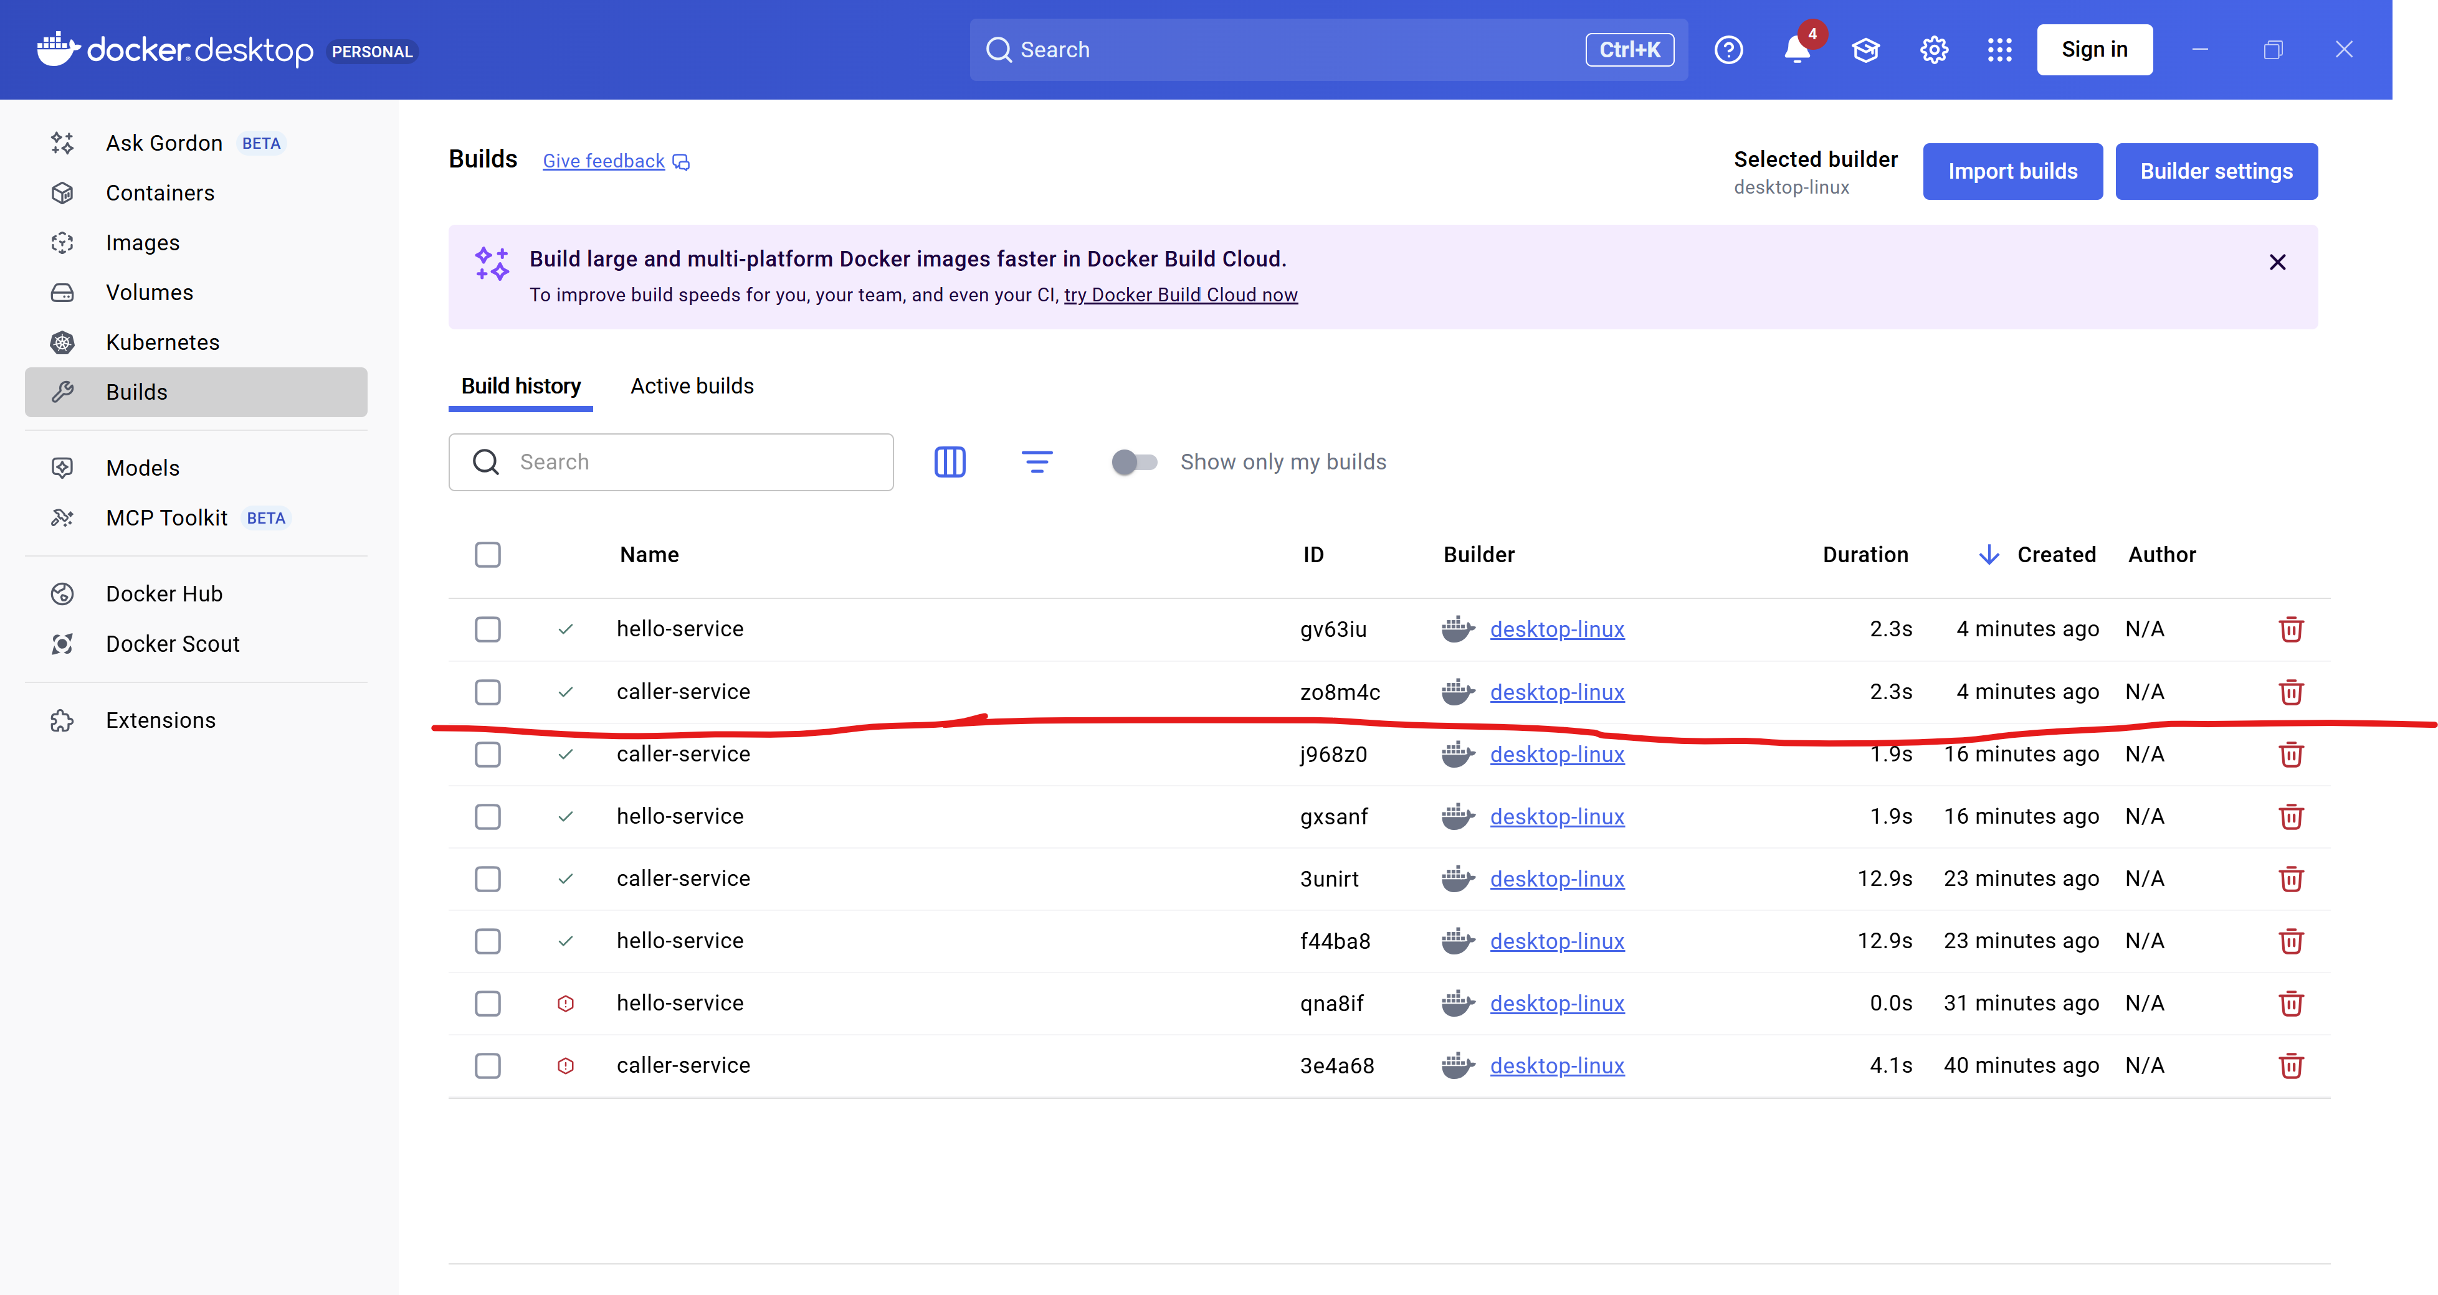
Client screenshot