

MapWindow
Internationalization Manual
（プロジェクト内部用）（Draft 1.1）

MapWindow Open Source Team

Revision History
Version | Date | Notes | Author
Draft 1.0 | 2005/9/30 | The initial draft | Chen
1.1 | 2005/10/03 | Minor edits | Ames
1.2 | 2005/10/12 | Added manuals for dealing with none-form classes | Chen
1.3 | 2008/1/28 | Added instructions for translating dialog messages | Jiří Kadlec

INDEX
1. Preface 1-1
1.1. About MapWindow Internationalization 1-1
1.2. Target Audiences 1-1
2. Work to do 2-2
2.1. Extract strings into the default resource file. 2-2
2.1.1. Extract strings from forms 2-2
2.1.2. Extract strings from other classes without a form 2-4
2.2. Port to a first local language 2-6
2.3. Port to more local languages 2-9
2.4. Satellite assemblies explained 2-10
2.5. Team Members working on specific languages 2-10
3. References 3-11

Preface

About MapWindow Internationalization
The MapWindow Open Source Team has adopted an approach to internationalizing MapWindow, or creating support for multiple languages, using the Microsoft built-in internationalization tools. This approach involves the use of both an embedded resource file in with all labels and text provided in the English language as well as “satellite assemblies” which provide the same set of resources in other languages. These satellite assemblies are based on XML resource files which are constructed dynamically by the .NET IDE, and can also be edited manually. The compiled assemblies take the name, “MapWindow.resources.dll” and are placed in folders identified by the international shorthand name for each language (e.g. Simplified Chinese is represented by the folder name, “zh-CHS”).

We are in need of individuals to help with the internationalization effort. If you would like to participate, please contact Dan Ames (amesdani@isu.edu) and indicate the language for which you are comfortable providing the needed text and labels. The remainder of this document provides a set of instructions and guidelines for doing the internationalization of static controls, and also internationalization of dynamic controls and messages.

Target Audiences

MapWindow Develop Team
The MapWindow Develop Team is responsible for the initial internationalization work, which is described in detail in Chapter 2.1. After this first step of work, all the embedded strings for the captions of controls, messages, and etc will be extracted from the source code and put into the default resource file.

MapWindow Active Contributor
After the initial work, All the MapWindow Contributors should bare in mind that we are creating an international application. Always remember to use strings from a resource file.

MapWindow Plug-in Developer
This manual will also help MapWindow plug-in developers to develop internationalized plug-ins. Although it is not mandatory, we strongly recommend developers to use strings from resources file. Someday when you decide to internationalize your product, you will find your work now will help greatly then.

Other MapWindow Users
Anyone who knows how to use a text editor (e.g. Notepad) will be able to localize MapWindow to their own language by working on the resource file generated by the previous work by the first internationalization. This work is very simple: generate a new resource file for the new language, overwrite it with the resource file for the first language, and then translate it and compile the solution.

Work to do

Extract strings into the default resource file.

Extract strings from forms
Open the Form you want to internationalize in design mode, then open the property dialog of the form, change the [Localizable] property to true:
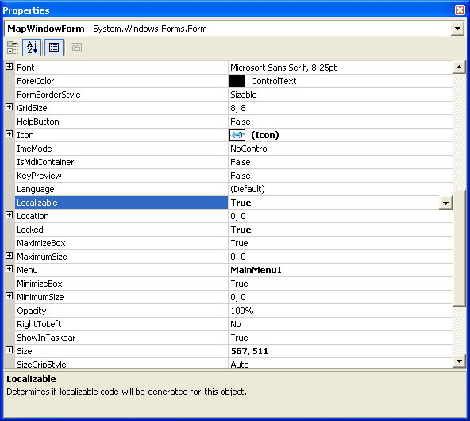

Save the project, and open the resource file in the project you will see the following:

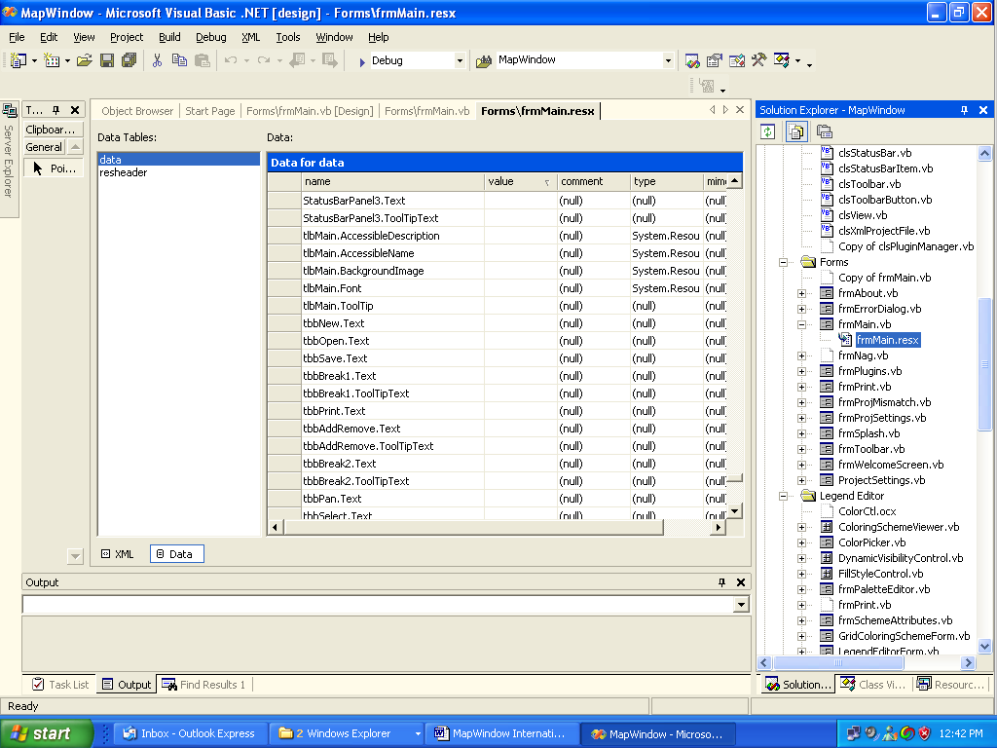
Resource file
Click this button to show resource in the tree file

All the strings of the static controls (menus, buttons, etc) are extracted into the resource file automatically by the form designer.
To extract strings from the dynamically created controls or messages, we need to do some more work manually, first, we need to find all the dynamically controls and messages, and then we should add an entry in the resource file manually. For MapWindow, texts of the dynamically created controls or messages are placed in a separate resource file (GlobalResource.resx) For example, there is a dynamic control created by the following statement:

m_Menu.AddMenu("mnuWelcomeScreen", "mnuHelp", Nil, "&Welcome Screen");

We just change the code into the following:

m_Menu.AddMenu("mnuWelcomeScreen", "mnuHelp", Nil, resources.GetString("mnuWelcomeScreen.Text"))

And then add an entry into the resource file GlobalResource.resx called mnuWelcomeScreen.Text:
(Attention: You may need to use the xml mode of the resource file to do this)
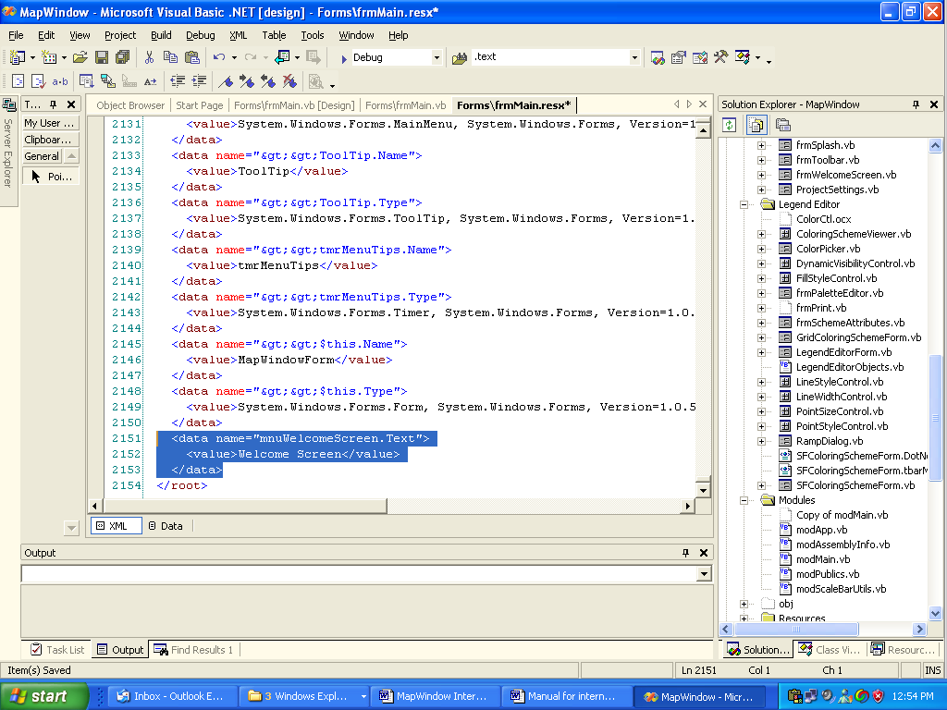

Do the same thing to all the dynamically created controls (menus, buttons, etc) as well as all the messages.
Repeat this work on all the other forms.

Extract strings from other classes without a form
First you need to add a resource file to your project:
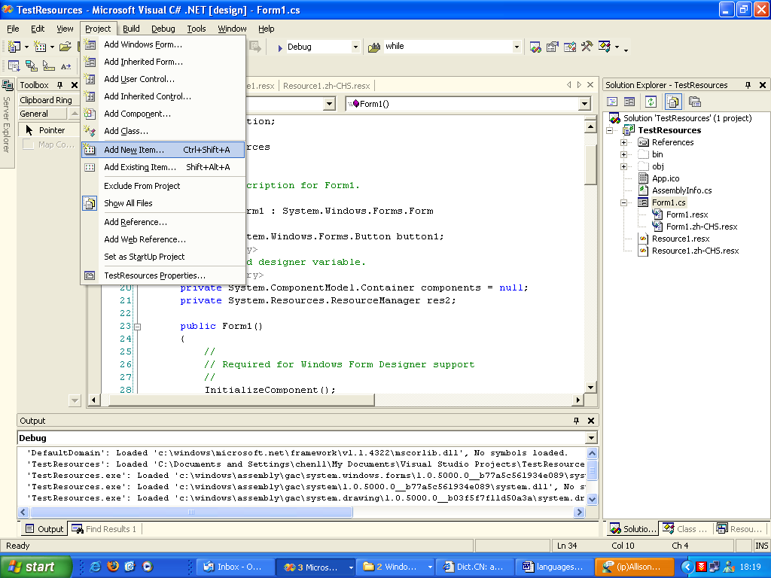
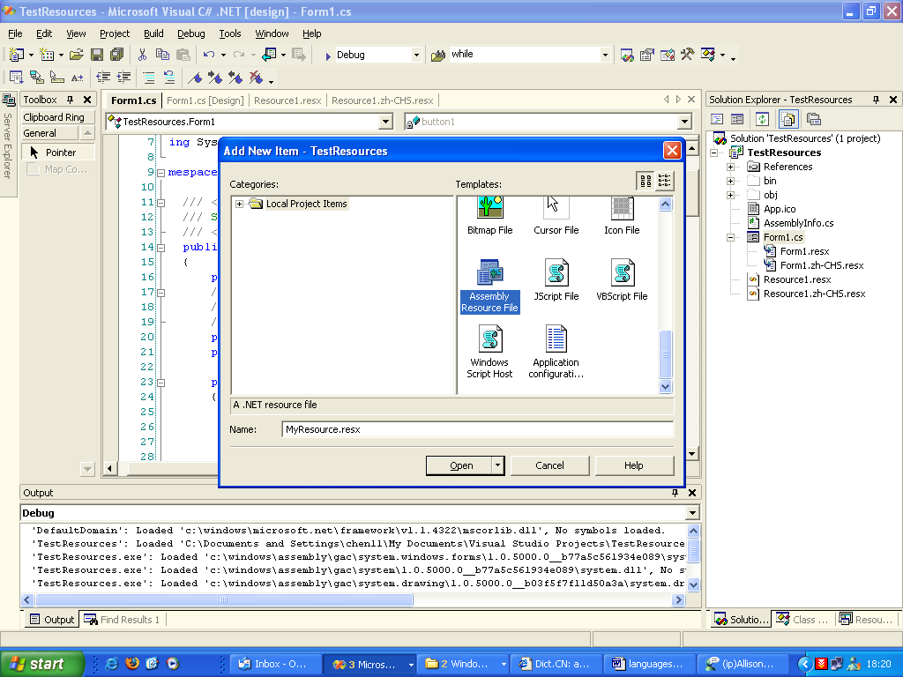

Added the entries of the strings you want into the resource file.
To initial a resource manager, you should declare a member of your class as ResourceManager:
private System.Resources.ResourceManager resMan;

And then initialize it in the constructor of you class:
resMan = new System.Resources.ResourceManager("TestResources.Resource1",Assembly.GetExecutingAssembly());
You can create resource file for other languages by following the following convention: [name].[culture code].resx, for example the Chinese version of “MyResource.resx” is MyResource.zh-CHS.resx, The Japanese verion for “MyResource.resx” is MyResource.jp.resx.

Port to a first local language
Do the following steps for each of the MapWindow forms.
Open the form that hosts the controls which you want to internationalize in design mode:
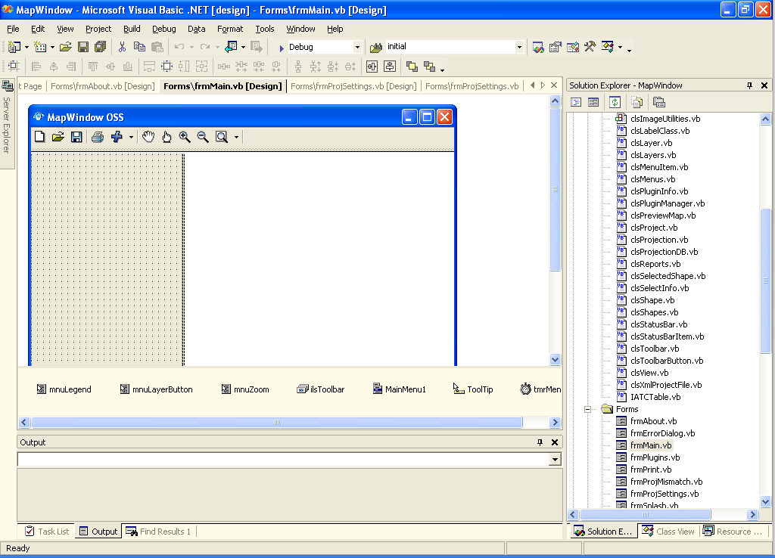
Make sure this is the property dialog for the FORM
Open the property dialog of the form:
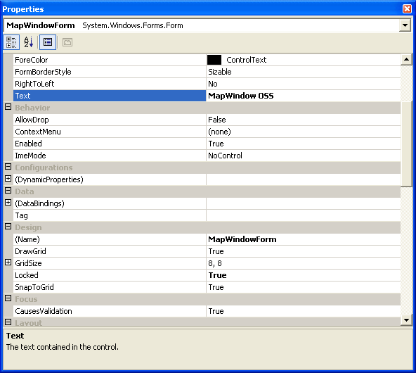

Then change the [Language] property to the language you need.

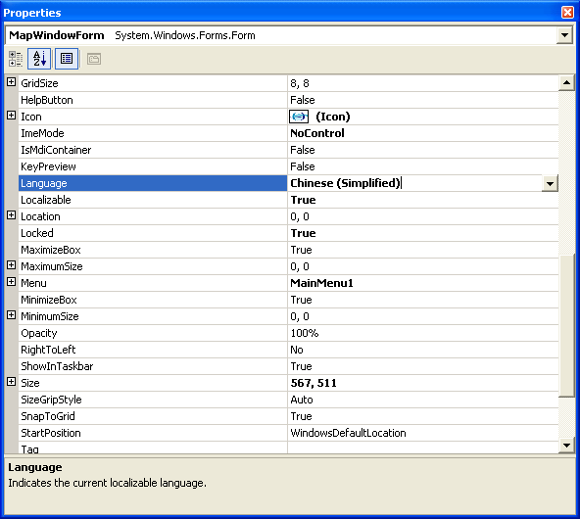

Now save the project. This will create a new resource file for the target language.
Ok, let’s do some editing work; change all the captions of the menus, buttons, toolbars, tool tips, and etc into the target language:
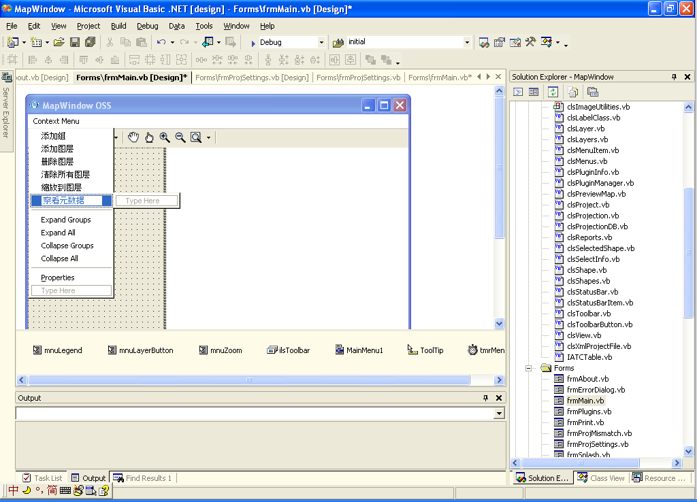
Till now all the static controls have been internationalized. As to the dynamic controls and messages, we simply copy them from the default resource file (GlobalResouce.resx) we have generated in 2.1 and paste into the new resource file (for example, GlobalResource.zh-CHS.resx) and then translate it into the target language (In this example, Simplified Chinese).

NOTES: The reason why we do not simply copy all the entries of the default resource file into the target resource file and translate them is that there are many entries in the default resource file are not what we want ( like the *.name entries, and etc), But if you want to display your language in a certain font, you may also need to copy the *.font entries from the default resource files into your target resource files.

Port to more local languages
Based on the previous work, this step is relatively very simple, you just create a new resource file by copying the existing resource file generated for the first language in 2.2, and rename its middle part to the language code of your target language. For example, suppose the ones you created in 2.2 are *.zh-CHS.resx. You just need to make another copy of them and rename the copies into *.[your language code].resx. Then translate all of the entries of the copies into your lauguage. Recompile the solution and your work is done.

Satellite assemblies explained
The compiler will generate a separate assembly for each of the localized language. This assembly is called a satellite assembly. The following is example for Simplified Chinese:
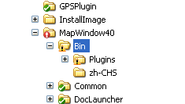
This new dir for the resource assembly (zh-CHS means simplified Chinese)

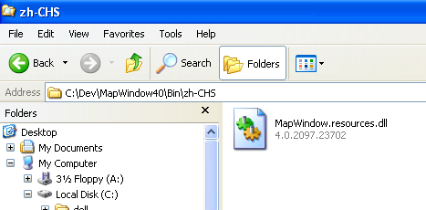
The assembly for the new resource file

Now if you run MapWindow on a computer running a Simplified Chinese version of the Windows operating system, the CLR (common language runtime) will automatically load this assembly and show the captions of the menus in Chinese using the work you have done before.

Team Members working on specific languages
* Forest (Lailin) Chen – Simplified Chinese
* Paul Meems – Dutch, German, French.
* Jiri Kadlec -- Czech
* Other?

References

http://msdn.microsoft.com/msdnmag/issues/04/03/Bugslayer/default.aspx
http://msdn.microsoft.com/msdnmag/issues/04/04/Bugslayer/default.aspx
http://msdn.microsoft.com/msdnmag/issues/02/06/Internat/

