MapWinGeoProc.SpatialOperations.ClipShapesWithPolygon( )

This function returns all shapes in a shapefile that fall within the given polygon’s border.

ClipShapesWithPolygon: Save-to-Disk Variations

With these overloaded versions, all shapes found within the polygon will be saved to disk at the location: resultSFPath.

1) bool ClipShapesWithPolygon(ref string inputSFPath, ref MapWinGIS.Shape polygon, ref string resultSFPath)

The accurate method for clipping lines will always be called with this version.

2) bool ClipShapesWithPolygon(ref string inputSFPath, ref MapWinGIS.Shape polygon, ref string resultSFPath, bool speedOptimized)

If speedOptimized is true, the fast method for clipping lines will be called.
If speedOptimized is false, the accurate method for clipping lines will be called.

ClipShapesWithPolygon: In-Memory Variations

With these overloaded versions, all shapes found within the polygon will be saved in memory to: resultSF. It is left to the user to decide to save the file to disk or not.

1) bool ClipShapesWithPolygon(ref MapWinGIS.Shapefile inputSF, ref MapWinGIS.Shape polygon, out MapWinGIS.Shapefile resultSF)

The accurate method for clipping lines will always be called with this version.

2) bool ClipShapesWithPolygon(ref MapWinGIS.Shapefile inputSF, ref MapWinGIS.Shape polygon, out MapWinGIS.Shapefile resultSF, bool speedOptimized)

If speedOptimized is true, the fast method for clipping lines will be called.
If speedOptimized is false, the accurate method for clipping lines will be called.

ClipShapesWithPolygon: Fast Variation

This variation applies only when using line shapefiles. When speedOptimized is set to true, the fast version for calculating the internal sections of a line clipped by a polygon will be called. In order for these calculations to be quick, there are several important assumptions that must be made about the lines:

- At most, one intersection point will exist between any two consecutive points in a line.
X
- For an intersection to occur, one point must lie outside of the polygon, while the other must be inside the polygon.
- If two points lie outside of the polygon, no intersection point will exist. Therefore, the line segment connected by these two points can be ignored.
- If two points are inside the polygon, no intersection point will exist. Therefore, the line segment connected by these two points can be added directly to the result shapefile.

If any line in the shapefile violates one of the above conditions, the user should rely on the accurate (but perhaps slower) version for clipping the lines with the polygon.

ClipShapesWithPolygon: Accurate Variation

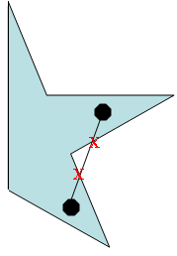
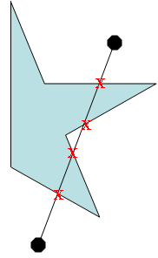
This variation applies only when using line shapefiles. When SpeedOptimized is set to false, or when one of the overloaded versions that do not require the Boolean variable is used, the accurate method for calculating internal sections of a line clipped by a polygon will be called. Unlike the fast version, the accurate form makes no assumptions about the lines it will evaluate. Therefore, the following conditions are acceptable:

- Multiple intersections may exist between two consecutive points.
- Intersection points may exist between two consecutive outside points.
- Intersection points may exist between two consecutive inside points.
- More than one intersection point may exist between two consecutive points, where one point is inside the polygon and one point is outside the polygon.

In order for this function to handle all line types, it must divide each line and the polygon into two-point segments. To find all possible intersection points, each two-point segment of a line must be compared with each two-point segment in the polygon. Due to this requirement, the speed of the “accurate” function is directly related to the number of points that define the polygon and lines.

ClipShapesWithPolygon: Sample Output

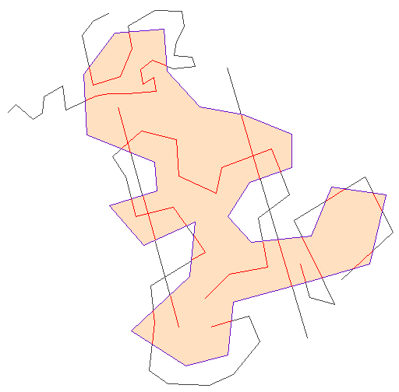
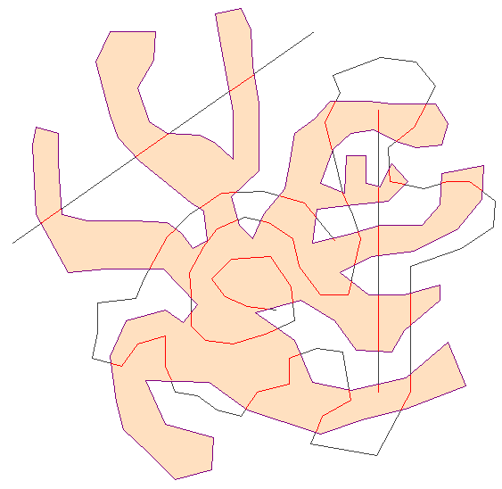
Here are some examples of line shapefiles and polygons that work with the “accurate” version but would have failed with the “fast” version:

While some line/polygon combinations require that the “accurate” version be used, significant time can be saved when calling the “fast” version whenever possible:

Results for "Fast" and "Accurate" versions of ClipShapesWithPolygon()

 | Num points in | Num points in | "Fast" Time | "Accurate" Time
Polygon | polygon | result line shapefile | (min:sec) | (min:sec)
3 | 901 | 987 | 0:02 | 2:04
6 | 836 | 1059 | 0:02 | 2:23
9 | 547 | 153 | 0:00 | 0:29
12 | 311 | 265 | 0:00 | 0:26
15 | 1001 | 1292 | 0:04 | 4:05
18 | 1146 | 204 | 0:03 | 3:16
21 | 1000 | 526 | 0:03 | 2:12
24 | 1022 | 626 | 0:04 | 4:29
27 | 795 | 1339 | 0:02 | 1:46
30 | 813 | 53 | 0:02 | 1:35
33 | 1029 | 47 | 0:00 | 0:08
CPU: Pentium4 3.00GHz
Line shapefile: "loriv2.shp", contains 250 streams.
Polygon shapefile: "lo.shp", contains 35 watersheds.

The following image shows the original line shapefile (blue streams), the original polygon shapefile (tan watersheds) and the resulting line shapefile (red streams) generated from clipping the shapefile with all polygons listed in the table above:
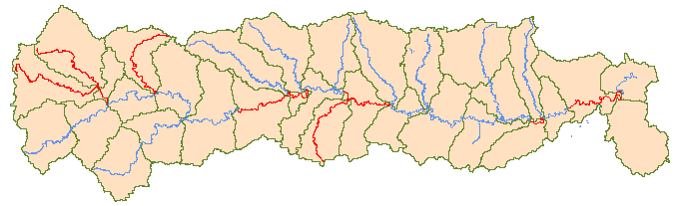
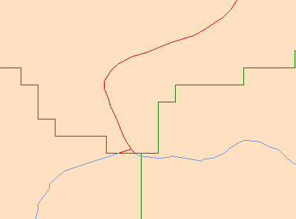

Whether the stream shapefile is clipped using the accurate or the fast method, the results are identical. So, while several assumptions must be satisfied, the fast method can also be accurate for real-world applications.
ClipShapesWithPolygon: Sample Code

Here is an example in C# showing how to call each version of ClipShapesWithPolygon():

private bool ClipLinesWithPolygon(bool saveToDisk, bool speedOptimized)
{
string lineSFPath = @"C:\PathToFolder\lineSF.shp";
string polySFPath =@"C:\PathToFolder\polygonSF.shp";
string resultSFPath = @"C:\PathToFolder\resultSF.shp";
bool status = false;

//Get a single polygon for clipping lines with:
Shapefile polySF = new ShapefileClass();
polySF.Open(polySFPath, null);
Shape polygon = new ShapeClass();
polygon = polySF.get_Shape(0);

if(saveToDisk && speedOptimized)
{
status = SpatialOperations.ClipShapesWithPolygon(ref
lineSFPath, ref polygon, ref resultSFPath, true);
}
else if(saveToDisk && !speedOptimized)
{
status = SpatialOperations.ClipShapesWithPolygon(ref
lineSFPath, ref polygon, ref resultSFPath, false);
//or use the equivalent form:
//status = SpatialOperations.ClipShapesWithPolygon(ref
lineSFPath, ref polygon, ref resultSFPath);
}
else if(!saveToDisk)
{
//Open input file and create a result file
Shapefile lineSF = new ShapefileClass();
lineSF.Open(lineSFPath, null);
Shapefile resultSF= new ShapefileClass();
resultSF.CreateNew(resultSFPath, ShpfileType.SHP_POLYLINE);

if(speedOptimized)
{
status = SpatialOperations.ClipShapesWithPolygon(ref
lineSF, ref polygon, out resultSF, true);
}
else
{
status = SpatialOperations.ClipShapesWithPolygon(ref
lineSF, ref polygon, out resultSF);
}

//do more processing....or save result file to disk
resultSF.StopEditingShapes(true, true, null);
resultSF.Close();
lineSF.Close();
}
return status;
}
ClipShapesWithPolygon: Final Note

Remember: in addition to clipping line shapefiles, ClipShapesWithPolygon( ) will also handle polygon and point shapefiles.

-polygon sample
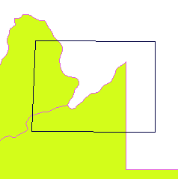
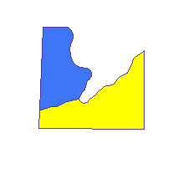

Output: polyon shapefile containing the two portions of the original shapefile that fell within the clipper polygon

Input: polygon shapefile (green counties), clipper polygon shape (black box)

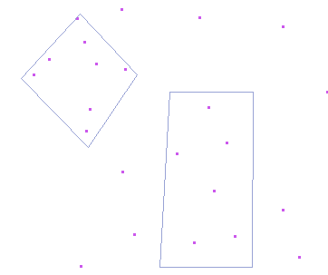
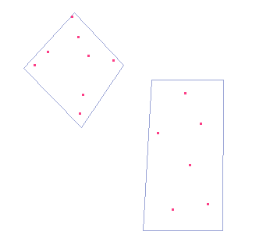
-point sample
Input: point shapefile (purple points), clipper polygons (diamond and rectangle)

Output: point shapefile (red) includes only points found within each polygon.

MapWinGeoProc.SpatialOperations.ClipPolygonWithLine( )

Divides a polygon into multiple sections depending on where the line crosses it. All new polygons are saved to the result shapefile located at: resultSFPath.
Any portion of the line that falls within the polygon, but does not divide the polygon, will be ignored.

ClipPolygonWithLine: Fast Variation

bool ClipPolygonWithLine(ref MapWinGIS.Shape polygon, ref MapWinGIS.Shape line, ref string resultSFPath, bool speedOptimized)

By setting speedOptimized to true, the fast version will be called.

In order for fast processing to be accurate, the line/polygon combination must satisfy the following conditions:
- At most, one intersection point will exist between any two consecutive points in a line.
X
- For an intersection to occur, one point must lie outside of the polygon, while the other must be inside the polygon.
- No intersections occur between two consecutive inside line points.
- No intersections occur between two consecutive outside line points.

If any line/polygon combination fails to satisfy any of the above assumptions, the function will return false (in the case of multiple intersection points existing between a valid two point segment), or it will return inaccurate results (in the case of intersection points existing between two outside points or between two inside points). In such a case, the user should rely on the accurate form of the function instead.

ClipPolygonWithLine: Accurate Variations

Any example that can be processed by the fast variation will be successfully processed by the accurate form. However, the reverse case is not true. This is why the accurate version for clipping a polygon is called by default (when a Boolean value is not present).

1) bool ClipPolygonWithLine(ref MapWinGIS.Shape polygon, ref MapWinGIS.Shape line, ref string resultSFPath)

2) bool ClipPolygonWithLine(ref MapWinGIS.Shape polygon, ref MapWinGIS.Shape line, ref string resultSFPath, bool speedOptimized)

By setting speedOptimized to false, the accurate version will be called.

The accurate version will make no assumptions about the shapes passed to it. Therefore, the following conditions are allowed:
1- Multiple intersections may exist between two consecutive points.
- Intersection points may exist between two consecutive outside points.
- Intersection points may exist between two consecutive inside points.
- More than one intersection point may exist between two consecutive points, where one point is inside the polygon and one point is outside the polygon.

The speed of the accurate version may suffer with polygon/line combinations that have a large number of points, or when a large number of intersections occur.

ClipPolygonWithLine: Sample Output

If an inside line section fails to completely divide the polygon, it will be ignored by both the accurate and fast versions:
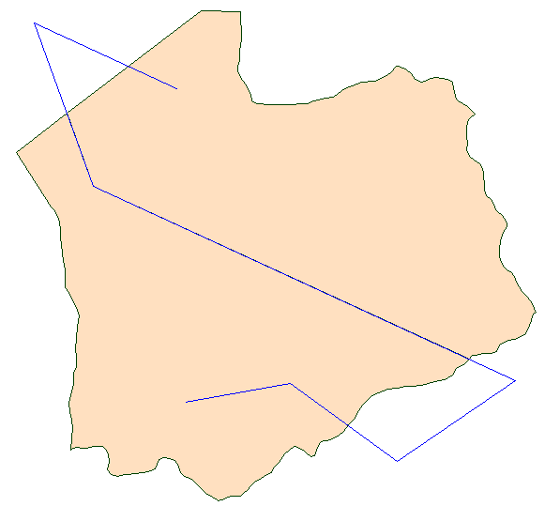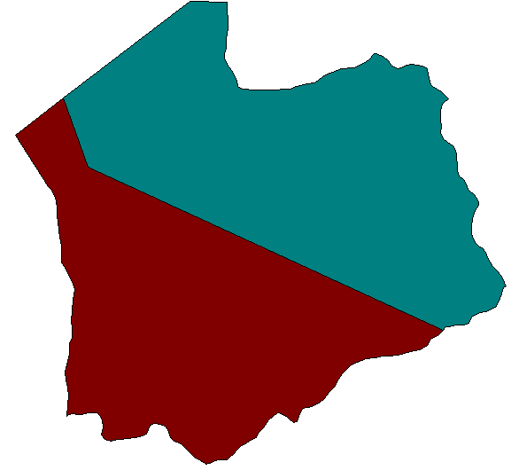
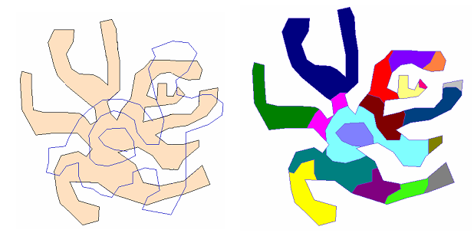
The following polygon/line combination will only work with the accurate version because multiple intersection points exist between all types of two-point segments:
Original polygon (tan) and clipper curve (blue).
Result polygons (each color represents a different polygon).
ClipPolygonWithLine: Sample Code

The following C# code shows how to call the two ClipPolygonWithLine() versions:

bool ClipPolyWithLine(bool speedOptimized)
{
bool status;
string resultSFPath = @"C:\PathToFolder\resultSF.shp";
Shapefile lineSF = new ShapefileClass();
Shapefile polygonSF = new ShapefileClass();

if(speedOptimized)
{
//provide a polygon/line combo that satisfies the fast
//algorithm conditions
polygonSF.Open(@"C:\PathToPolygonSF\polygonSF.shp", null);
Shape polygon = polygonSF.get_Shape(0); //diamond
lineSF.Open(@"C:\PathToLineSF\lineSF.shp", null);
Shape line = lineSF.get_Shape(2);
//line w/ 2 intersects, 2 polygons will result
status = SpatialOperations.ClipPolygonWithLine(ref
polygon, ref line, ref resultSFPath, true);
}
else
{
//The result of this call is shown in the previous section polygonSF.Open(@"C:\PathToPolygonSF\polygonSF.shp", null);
Shape polygon = polygonSF.get_Shape(5); //strange flower
lineSF.Open(@"C:\PathToLineSF\lineSF.shp", null);
Shape line = lineSF.get_Shape(15);
//squiggle w/ multiple intersects, 19 polygons will result
status = SpatialOperations.ClipPolygonWithLine(ref
polygon, ref line, ref resultSFPath, false);
}
return status;
}

MapWinGeoProc.SpatialOperations.ClipGridWithPolygon( )

This function creates a new grid containing only data from the input grid that falls within the polygon boundary. The new grid is saved to the location: resultSFPath.

1) bool ClipGridWithPolygon(ref string inputGFPath, ref MapWinGIS.Shape polygon, ref string resultGFPath)

2) bool ClipGridWithPolygon(ref string inputGFPath, ref MapWinGIS.Shape polygon, ref string resultGFPath, bool trimResult)

If trimResult is set to true, or the Boolean value is not provided, all peripheral rows and columns that contain only values of “NoData” will be removed from the result. This is the default behavior for ClipGridWithPolygon. However, if the user does not want trimming to occur (perhaps to save some time) then set trimResult to false.

ClipGridWithPolygon: Sample Code

The following C# example shows how to call the ClipGridWithPolygon( ) method:

bool ClipGridWithPoly(bool trimResult)
{
bool success;
string gridFile = @"C:\PathToInputGrid\clippeddem.bgd";
string polyFile = @"C:\PathToPolygonFile\gridClipper.shp";
string resultFile = @"C:\PathToResultFile\resultGrid.shp";

Shapefile polygons = new ShapefileClass();
Shape polygon = new ShapeClass();
polygons.Open(polyFile, null);

if(trimResult)
{
success = SpatialOperations.ClipGridWithPolygon(ref
gridFile, ref polygon, ref resultFile, true);
//or use alternate form:
// success = SpatialOperations.ClipGridWithPolygon(ref
// gridFile, ref polygon, ref resultFile);
}
else
{
success = SpatialOperations.ClipGridWithPolygon(ref
gridFile, ref polygon, ref resultFile, false);
}
if(success == false)
{
string errorMsg = MapWinX.Error.GetLastErrorMsg();
Debug.WriteLine("ErrorMsg: " + errorMsg);
}
return success;
}

ClipGridWithPolygon: Sample Output

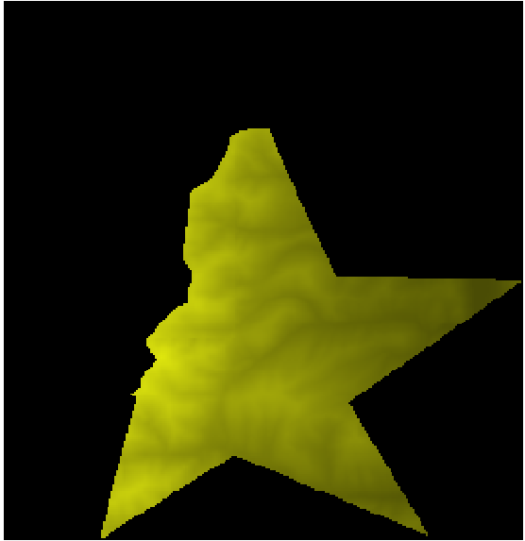
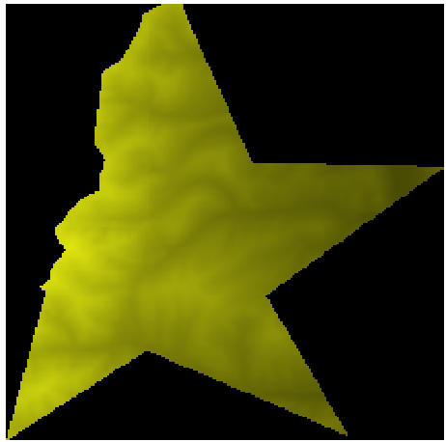
To achieve the smallest possible result
TrimResult = true TrimResult = false
grid, set trimResult equal to true:

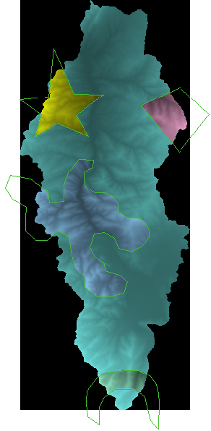
ClipGridsWithPolygon( ) is very useful for cutting large grids down to manageable (and perhaps more meaningful) pieces, thus allowing for faster processing in other applications.

The image to the right shows a large grid (light teal and black) overlaid with four smaller grids (yellow, pink, blue, green – “NoData” areas are transparent). These four smaller grids have been clipped from the larger one by using the bright green polygons which surround them in the image.

