MapWinGeoProc.SpatialReference
The class SpatialReference of the MapWinGeoProc library provides methods for altering the coordinate reference system of a grid or shapefile from one projection to another. There are two public methods: ProjectShapefile() and ProjectGrid(), along with overloaded versions of each.

Proj.4 – external library
SpatialReference relies on the external Proj.4 library for projecting points (www.remotesensing.org/proj). The proj.dll file should be included in the same folder as MapWinGeoProc.dll for any project where SpatialReference methods will be used. For certain transformations, it may be necessary to have the nad folder available on the user’s system. The PROJ_LIB environment variable will need to be set to enable use of initialization and datum grid shift files (in command line type: C:\> set PROJ_LIB=C:\directory\NAD, where directory is the path to where the file resides on your computer) if it has not previously been set.

Using the Nad/esri file:
The SpatialReference methods require that the parameters: source projection and destination projection, be passed in as Proj.4 command initialization strings. To find the initialization string, open up the nad\esri file in notepad, go to edit > find, then type in the name of the projection that you want to find the initialization string for.
For example, if you type in “albers”, then hit next, you should see the following lines:

# USA_Contiguous_Albers_Equal_Area_Conic
<102003> +proj=aea +lat_1=29.500000000 +lat_2=45.500000000 +lat_0=37.500000000 +lon_0=-96.000000000 +x_0=0.000 +y_0=0.000 +ellps=GRS80 +datum=NAD83 +units=m

The initialization string is everything after the identification number, that is, the string beginning with +proj=aea and ending with +units=m. If your source projection was USA Contiguous Albers, then you would set the parameter sourceProj = “+proj=aea +lat_1=29.500000000 +lat_2=45.500000000 +lat_0=37.500000000 +lon_0=-96.000000000 +x_0=0.000 +y_0=0.000 +ellps=GRS80 +datum=NAD83 +units=m” when using a SpatialReference method.

ProjectShapefile( )
public static bool ProjectShapefile(ref string sourceProj, ref string destProj, ref string inputSF, ref string resultSF)

Sample C# Code:
------------------
bool status;
string inputSF = @"C:\Temp\counties.shp";
string resultSF = @"C:\Temp\projCounties.shp";

//# NAD_1983_UTM_Zone_12N <26912>
string sourceProj = "+proj=utm +zone=12 +ellps=GRS80 +datum=NAD83 +units=m";
//# World_Robinson <54030>
string destProj = "+proj=robin +lon_0=0.000000000 +x_0=0.000 +y_0=0.000 +ellps=WGS84 +datum=WGS84 +units=m";
//Transform a UTM Zone 12N shapefile into World Robinson coordinates:
status = MapWinGeoProc.SpatialReference.ProjectShapefile(ref sourceProj, ref destProj, ref inputSF, ref resultSF);

Debug.WriteLine("Done. Status = " + status);
------------------
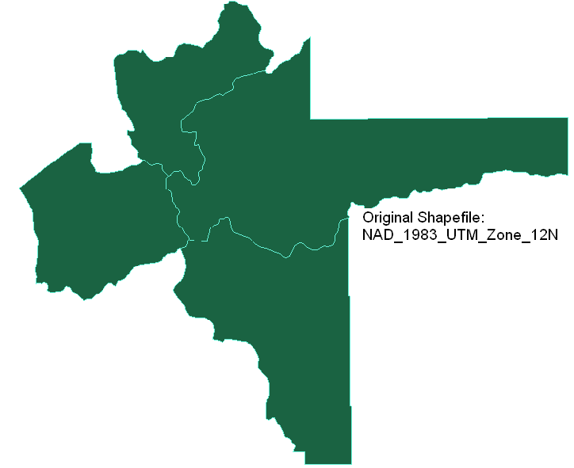
Sample Output:

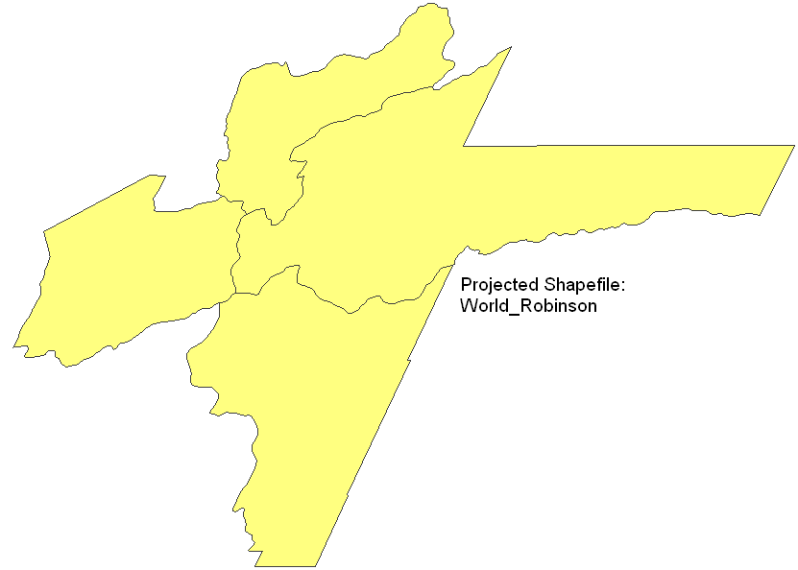
Projecting a shapefile from UTM Zone 12N to World Robinson:

If we project the World Robinson shapefile back to UTM coordinates, we get exactly the same shapefile as our original one.

ProjectGrid( )
public static bool ProjectGrid(ref string sourceProj, ref string destProj, ref string inputGrid, ref string resultGrid, bool trimResult)

Sample C# Code:
--------------------
bool status;
string inputGrid = @"C:\Temp\testGrids\clipped.bgd";
string resultGrid = @"C:\Temp\testGrids\projectedClipped.bgd";

//# NAD_1983_UTM_Zone_12N <26912>
string sourceProj = "+proj=utm +zone=12 +ellps=GRS80 +datum=NAD83 +units=m";
//# USA_Contiguous_Albers_Equal_Area_Conic <102003>
string destProj = "+proj=aea +lat_1=29.500000000 +lat_2=45.500000000 +lat_0=37.500000000 +lon_0=-96.000000000 +x_0=0.000 +y_0=0.000 +ellps=GRS80 +datum=NAD83 +units=m";

//Transform inputGrid from UTM Zone 12N to USA Contiguous Albers:
status = MapWinGeoProc.SpatialReference.ProjectGrid(ref sourceProj, ref destProj, ref inputGrid, ref resultGrid, true);
Debug.WriteLine("Done. Status = " + status);
--------------------

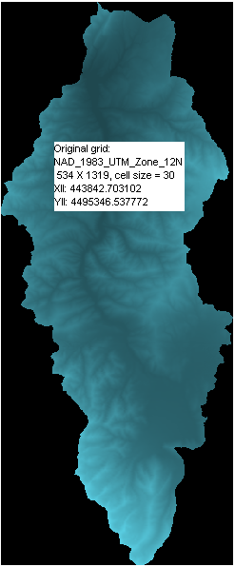
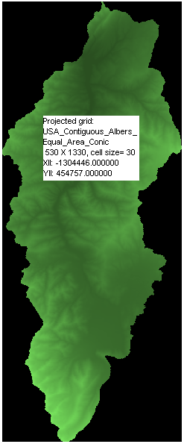
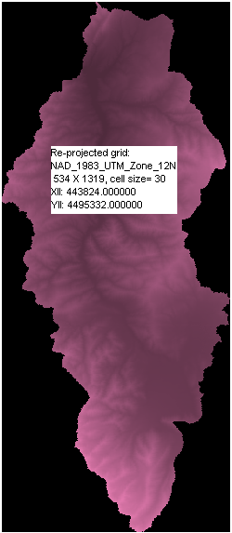
Sample Output: (with trimResult == true)
File size: 3734 KB 3618 KB 3706 KB
(If trimResult == false: >5000KB >7000 KB)

By zooming into the top point and overlaying the original and re-projected grids, we can see that there are some slight differences between them:



Converting from NAD_83 to WGS_84 and then back again:
(NAD83 string: +proj=utm +zone=12 +ellps=GRS80 +datum=NAD83 +units=m)
(WGS84 string: +proj=longlat +ellps=WGS84 +datum=WGS84)

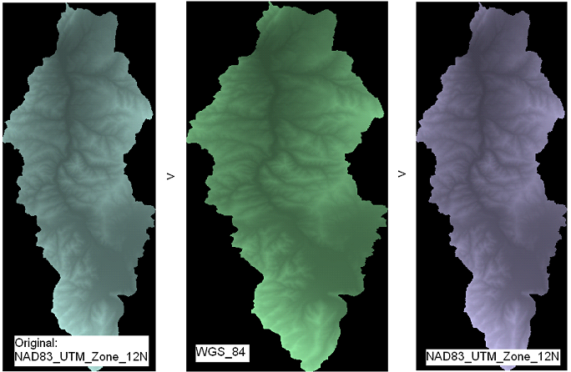
NCOLS 534 NROWS 1319 NCOLS 703 NROWS 1319 NCOLS 591 NROWS 1465
XLL center 443842.703102 XLL center -111.666052 XLL center 443844.025442
YLL center 4495346.537772 YLL center 40.607566 YLL center 4495329.159383
CELLSIZE 30 CELLSIZE 0.000270239 CELLSIZE 27.0239

If we overlay the original and re-projected grids, we can see that there is a slight variation in the results:


Therefore, if multiple projections are required, it is always best to transform from the original grid to the new coordinate system to minimize data corruption.

