**ART GALLERYMANAGEMENT**

**SYSTEM**

1)Artist Table

Create table Artist (

Artist_No varchar(5) Primary key Not Null,

Artist_Name Varchar (30) Not Null,

Artist_DOB Date Not Null,

Art_type Varchar (30) Not Null

);

2)Artwork

CREATE TABLE ARTWORK (

Artwork_No varchar(5) PRIMARY KEY Not Null,

Artwork_Year int Not null,

Artwork_Price int Not Null,

Artist_Id varchar(5) Not Null,

FOREIGN KEY(Artist_id) REFERENCES Artist(Artist_No) ON DELETE CASCADE

);

3)Customer

create table customer

(customer_no varchar(5) primary key not null,

customer_name varchar(30),

customer_DOB date not null,

Artwork_no varchar(5) not null,foreign key(artwork_no) references artwork(artwork_no)ON DELETE CASCADE);

4)Gallery

create table gallery(Gallery_No Varchar(5) primary key not null,gallery_location varchar(30),

Artwork_No varchar(5) not null,Foreign Key(Artwork_No)

references artist(artist_no)ON DELETE CASCADE);

5)Manager

create table manager(manager_no int primary key not null,

manager_name varchar(30) not null,manager_dob date not null,

gallery_code varchar(5) not null,foreign key(gallery_code) references gallery(gallery_no)ON DELETE CASCADE);

INSERTION VALUES

1)artist

insert into artist values

('A101','Leonardo Da Vinci','1974/05/08','LITERARY');

('A102','Vincent Van Gogh ','1984/04/09','PAINTING'),

('A103','Rembrandt ','1989/07/11','CULINARY'),

('A104','Michelangelo ','1949/04/11','SCULPTURE'),

('A105','Claude Monet ','1840/04/17','PAINTING'),

('A106','Pablo Picasso ','1870/02/21','DRAWNINGS'),

('A107','Raphael ','1740/02/21','LITERARY'),

('A108','Auguste Renoir ','1841/07/12','CULINARY'),

('A109','Jan Vermeer ','1901/07/12','PAINTING'),

('A110','Paul Cezanne ','1632/07/12','SCULPTURE'),

('A111','Caravaggio','1635/07/20','CULINARY'),

('A112','Van Gogh','1780/07/22','LITERARY');

2)ARTWORK

insert into artwork values

('P101','LITERARY',1800,25000,'A112'),

insert into artwork values

('P102','LITERARY',1940,25700,'A101'),

('P103','CULINARY',1850,45700,'A111'),

('P104','PAINTING',1470,74000,'A102'),

('P105','SCULPTURE',1890,42100,'A110'),

('P106','CULINARY',1980,24270,'A103'),

('P107','PAINTING',1994,45780,'A109'),

('P108','SCULPTURE',1847,25894,'A104'),

('P109','CULINARY',1947,24754,'A108'),

('P110','PAINTING',1897,25844,'A105'),

('P111','LITERARY',1459,47800,'A107'),

('P112','DRAWNINGS',1490,42800,'A106'),

('P113','LITERARY',1850,25008,'A112'),

('P114','LITERARY',1950,25707,'A101'),

('P115','CULINARY',1890,45705,'A111'),

('P116','PAINTING',1570,74500,'A102'),

('P117','SCULPTURE',1990,42500,'A110'),

('P118','CULINARY',1910,24370,'A103'),

('P119','PAINTING',1995,45280,'A109'),

('P120','SCULPTURE',1857,25794,'A104'),

('P121','CULINARY',1917,24754,'A108'),

('P122','PAINTING',1797,25744,'A105'),

('P123','LITERARY',1419,47700,'A107'),

('P124','DRAWNINGS',1495,43800,'A106');

('P125','CULINARY',1917,24774,'A108'),

('P126','PAINTING',1890,25874,'A105'),

('P127','LITERARY',1454,47870,'A107'),

('P128','DRAWNINGS',1497,42400,'A106'),

('P129','LITERARY',1147,25018,'A112'),

('P130','LITERARY',1478,25777,'A101');

3)customer

INSERT INTO CUSTOMER VALUES

('C151','RAJESH YADAV','1995/05/02','P130'),

('C152','RAHUL YADAV','1995/02/13','P110'),

('C153','AMIT SHUKLA','1996/06/12','P122'),

('C154','ANKIT MISHRA','1998/07/15','P110'),

('C155','UDEET CHAUHAN','199/08/22','P111'),

('C156','VISHAL SATPUTE','1991/01/21','P115'),

('C157','ADITYA CHOPRA','1992/09/14','P114'),

('C158','ARTI YADAV','1996/06/06','P101'),

('C159','JYOTI SINGH','1993/05/22','P105'),

('C160','KANAK SHARMA','1994/05/17','P103'),

('C161','ARVIND YADAV','1995/05/15','P120'),

('C162','PRIYA PAWAR','1995/11/02','P129'),

('C163','SWEETY GURJAR','1991/08/22','P125'),

('C164','VIRAT KOHLI','1983/11/05','P109'),

('C165','ROHIT SHARMA','1984/07/14','P121'),

('C166','ASHOK YADAV','1994/07/24','P117'),

('C167','REKHA VISHWAKARMA','1970/01/01','P130'),

('C168','KUNAL MUKADAM','1994/06/02','P116'),

('C169','VILESH SALUNKE','1945/01/22','P105'),

('C170','RAHUL DRAVID','1975/05/02','P109'),

('C171','LAXMAN RAGHUVANSHI','1915/03/25','P106'),

('C172','LIO MESSI','1985/02/22','P103'),

('C173','RONALDO R','1971/04/22','P120'),

('C174','RAHUL KORI','1945/05/22','P114'),

('C175','KARTHIK THEVAR','1990/05/20','P130'),

('C176','ARYAN NISHAD','1991/03/29','P102'),

('C177','ANTHONY PALLIPAT','1971/09/19','P104'),

('C178','VINOD PATIL','1986/03/29','P119'),

('C179','MAMTA CHAUHAN','1990/03/19','P107'),

('C180','KUMAR KOTEHKAR','1991/03/29','P112');

4)gALLERY

INSERT INTO GALLERY VALUES

('G101','VASHI','A112'),

('G102','TURBHE','A105'),

('G103','NERUL','A106'),

('G104','BELAPUR','A111'),

('G105','GHANSOLI','A110'),

('G106','AIROLI','A109'),

('G107','KHANDESHWAR','A104'),

('G108','PANVEL','A107'),

('G109','KHARGHAR','A101'),

('G110','THANE','A103'),

('G111','CHEMBUR','A102'),

('G112','DEONAR','A104'),

('G113','ANDHERI','A108'),

('G114','JOGESHWARI','A112'),

('G115','VIRAR','A105');

5)insert into manager values

(101,'ARVIND','1995/05/14','G114'),

(102,'ASHOK','1993/04/17','G109'),

(103,'RAMESH','1990/07/19','G108'),

(104,'TARUN','1990/07/15','G110'),

(105,'VIRAT','1987/03/05','G107'),

(106,'HARISH','1997/05/05','G106'),

(107,'WARNER','1787/03/05','G101'),

(108,'SMITH','1974/08/15','G102'),

(109,'MAXWELL','1947/04/17','G103'),

(110,'MARCUS','1947/03/15','G111'),

(111,'ZAMPA','1977/03/21','G105'),

(112,'SHAMI','1987/03/17','G113'),

(113,'VIRAT','1987/03/05','G112'),

(114,'DAVID','1917/03/01','G104'),

(115,'ARSHDEEP','1996/02/07','G115');

**A)Select Query-**

**1)Display All Information of All Artist Who Make Art 'Sculpture'**

Select * from artist where art_type='sculpture'

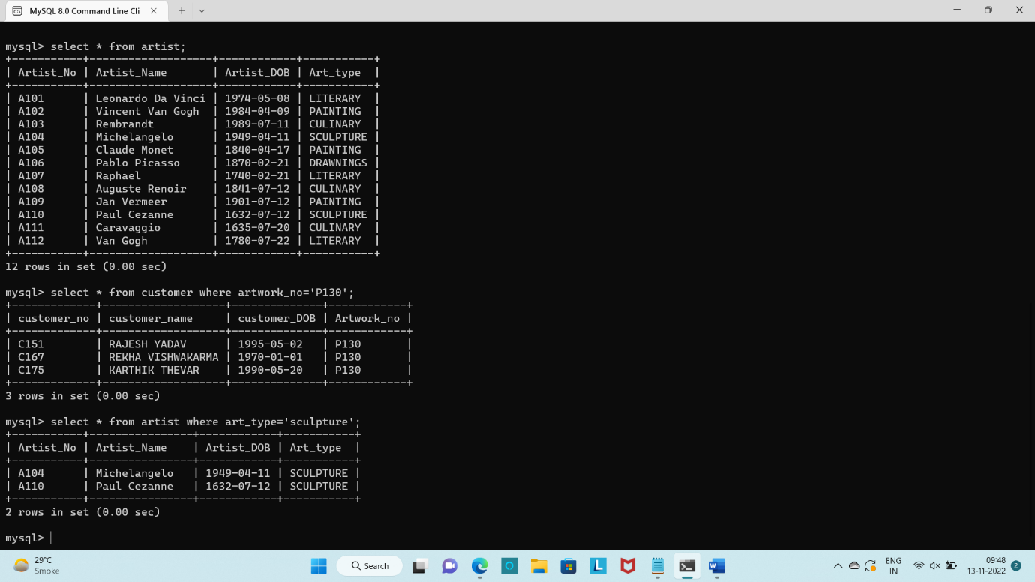

**2)Display All Data From A Customer Who Buy Artwork No P130**

select * from customer where artwork_no='P130';

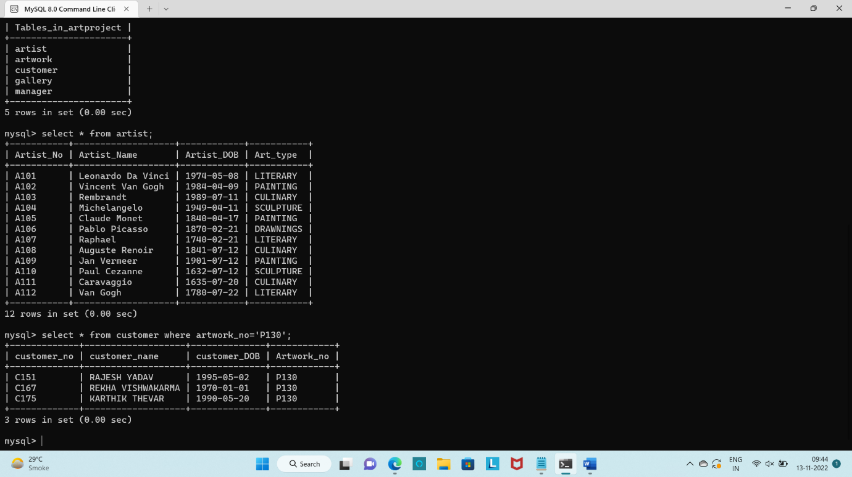

**3)Display All Data From Gallery Which Is In Vashi.**

select * from gallery where gallery_location='vashi';

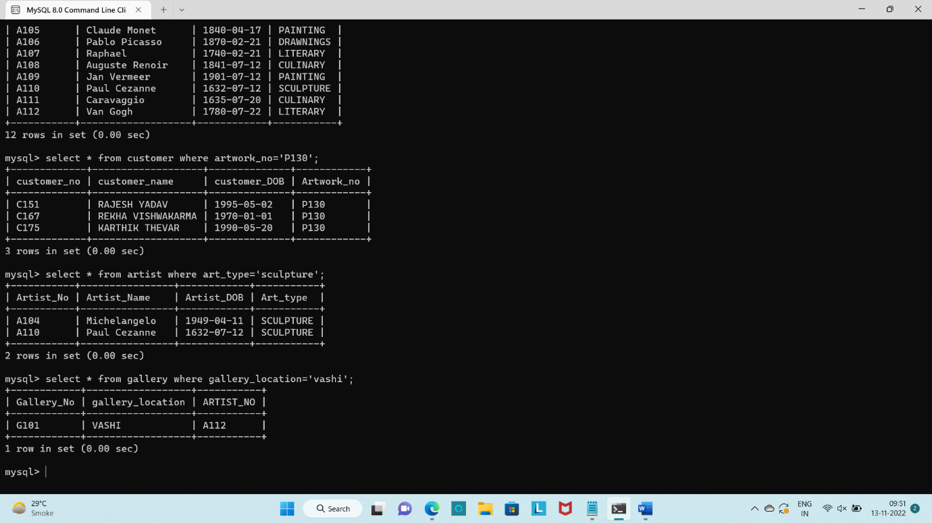

**4)Display All Information Of Customer Who Were Born In 1991 or before 1991**

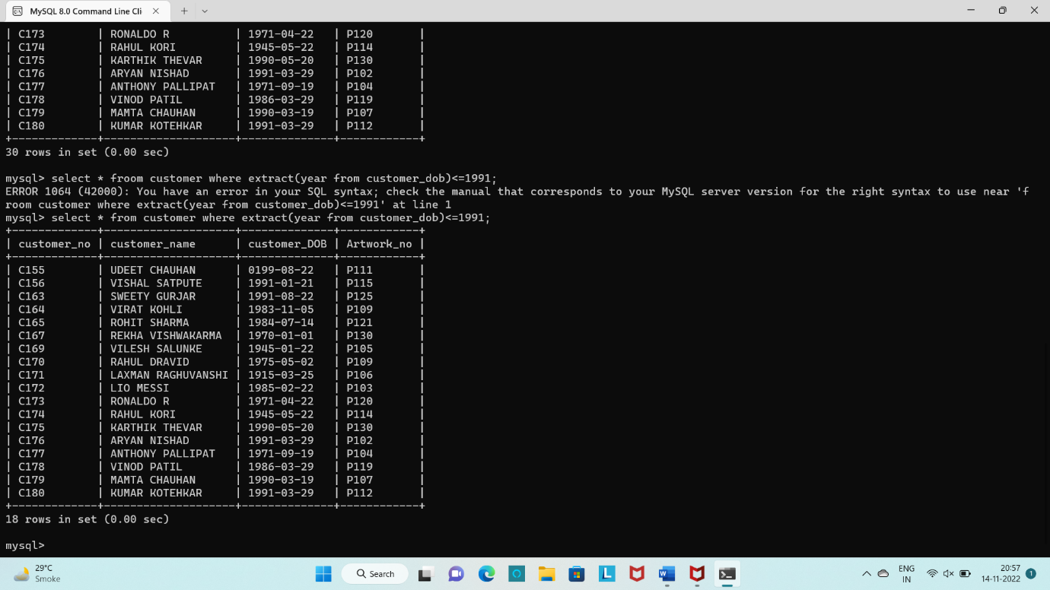

**B)Aggregration**

**1)Dislpay Total Artwork Made By Artist**

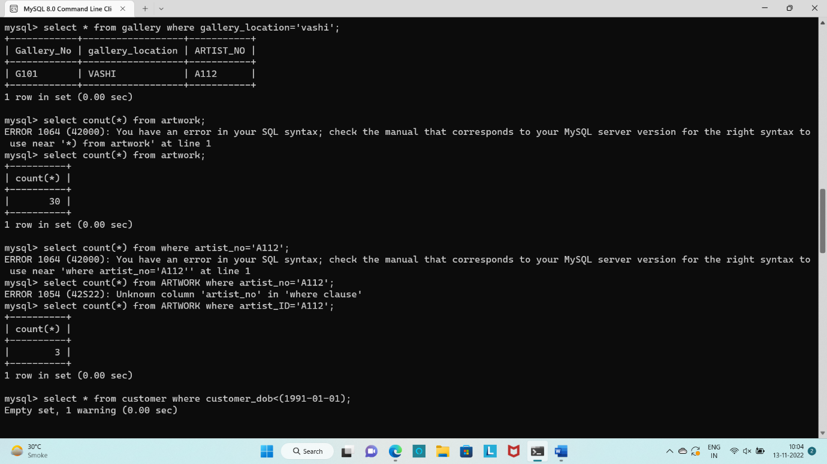

**2)Display Total Artwork Made By Artist No -A112**

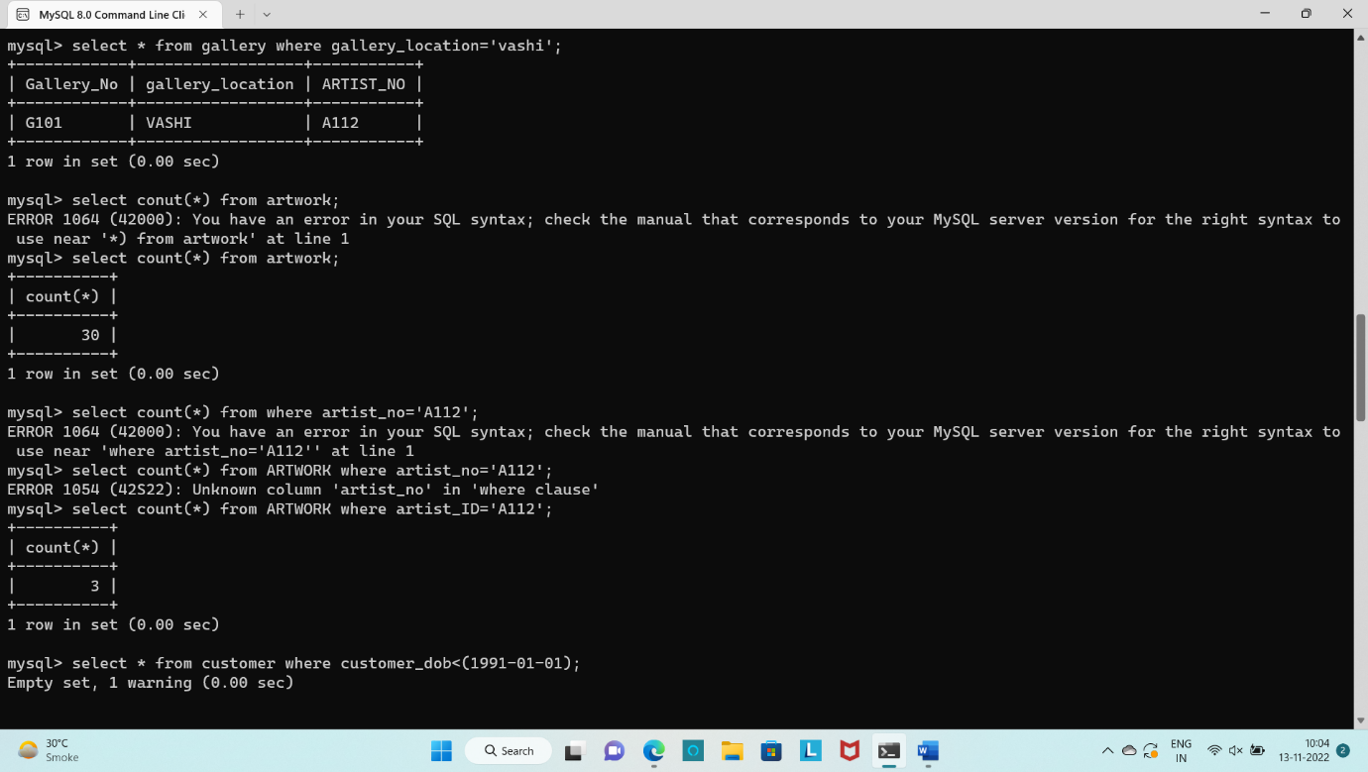

**3)Display Total Number Of Managers**

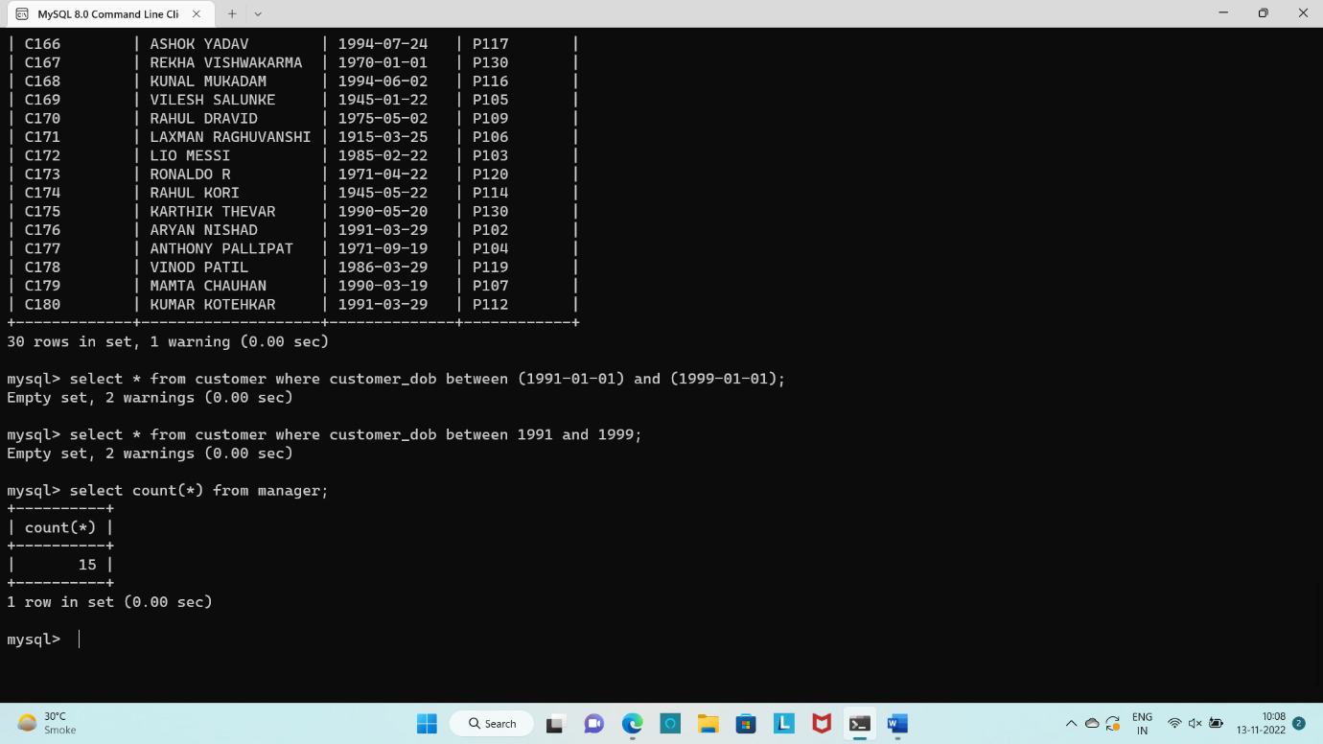

**C)Joins**

**1)Display All Artwork Create By Artist(Left Join)**

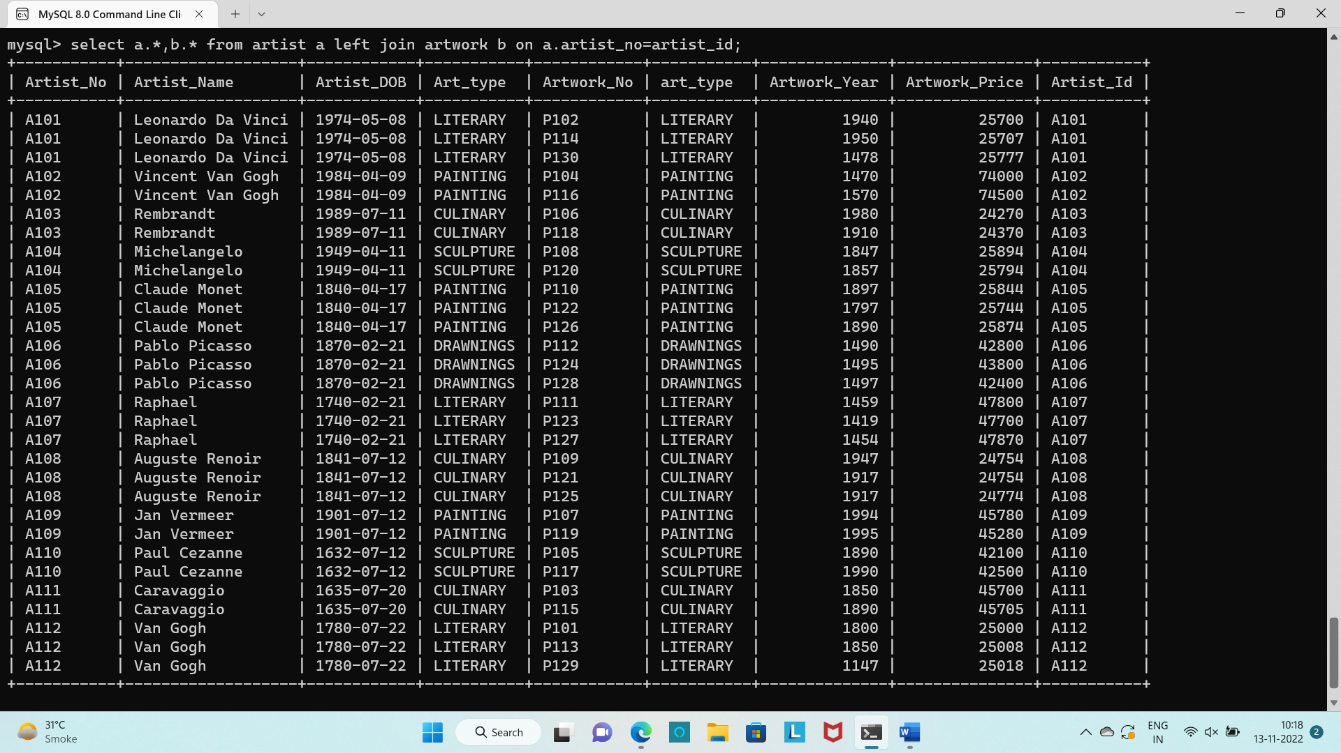

2) **Display All Artwork Create By Artist(Right Join)**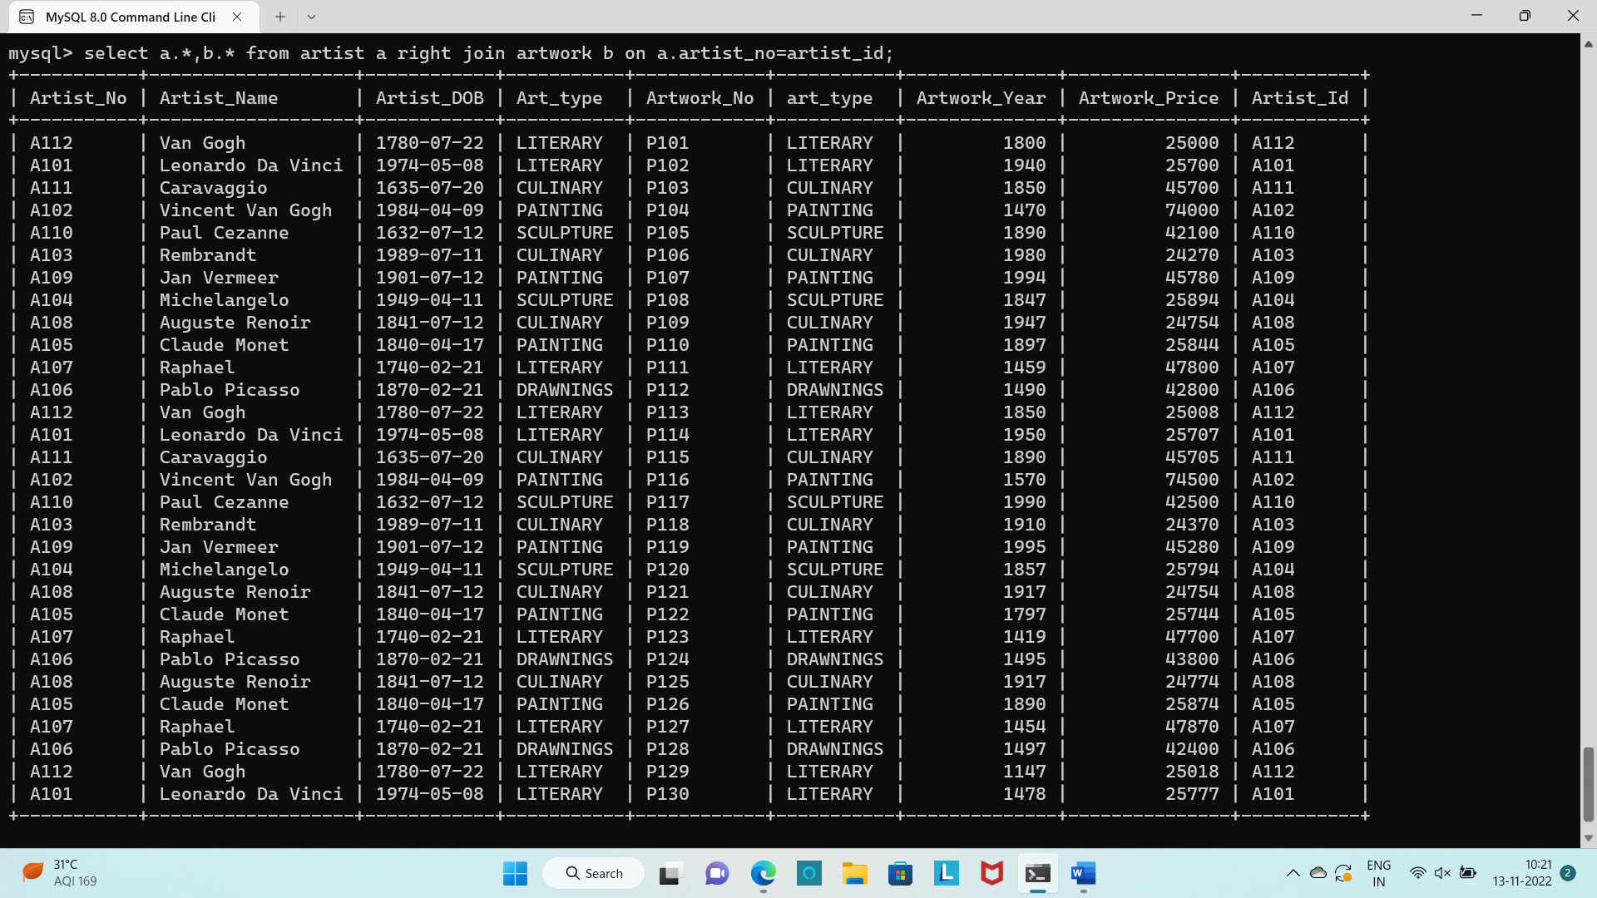

**D)Nested/Subqueries**

**1)Dislpay All Data From Artwork Where Artist Name Is Leonardo Da Vinci**

Select * from artwork where artist_id in(select artist_no from artist where artist_name='Leonardo Da Vinci');

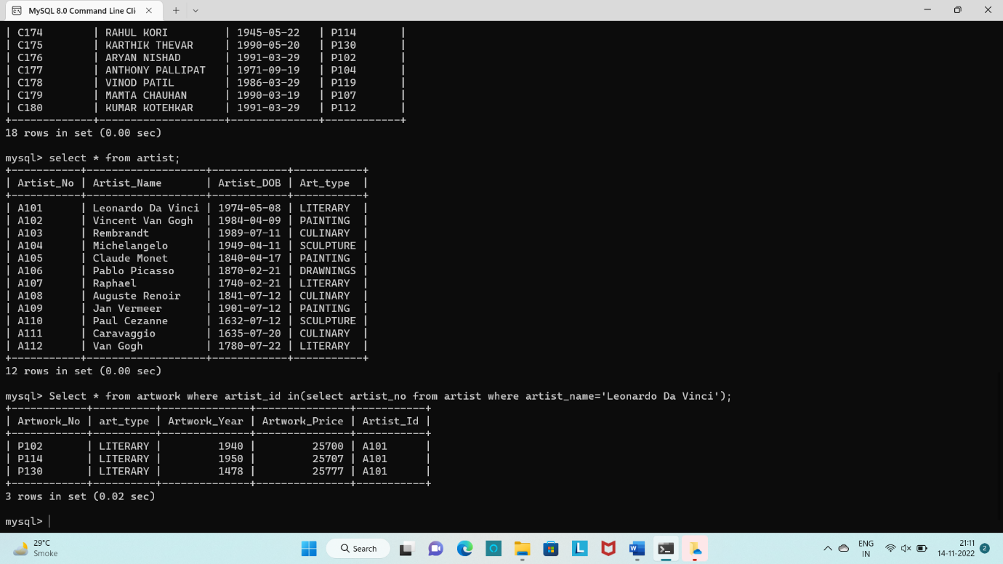

**2)Display Gallery Code ,Gallery Location For Manager Number ‘108’**

select gallery_no,gallery_location from gallery where gallery_no in(select gallery_code from manager where manager_no=108);

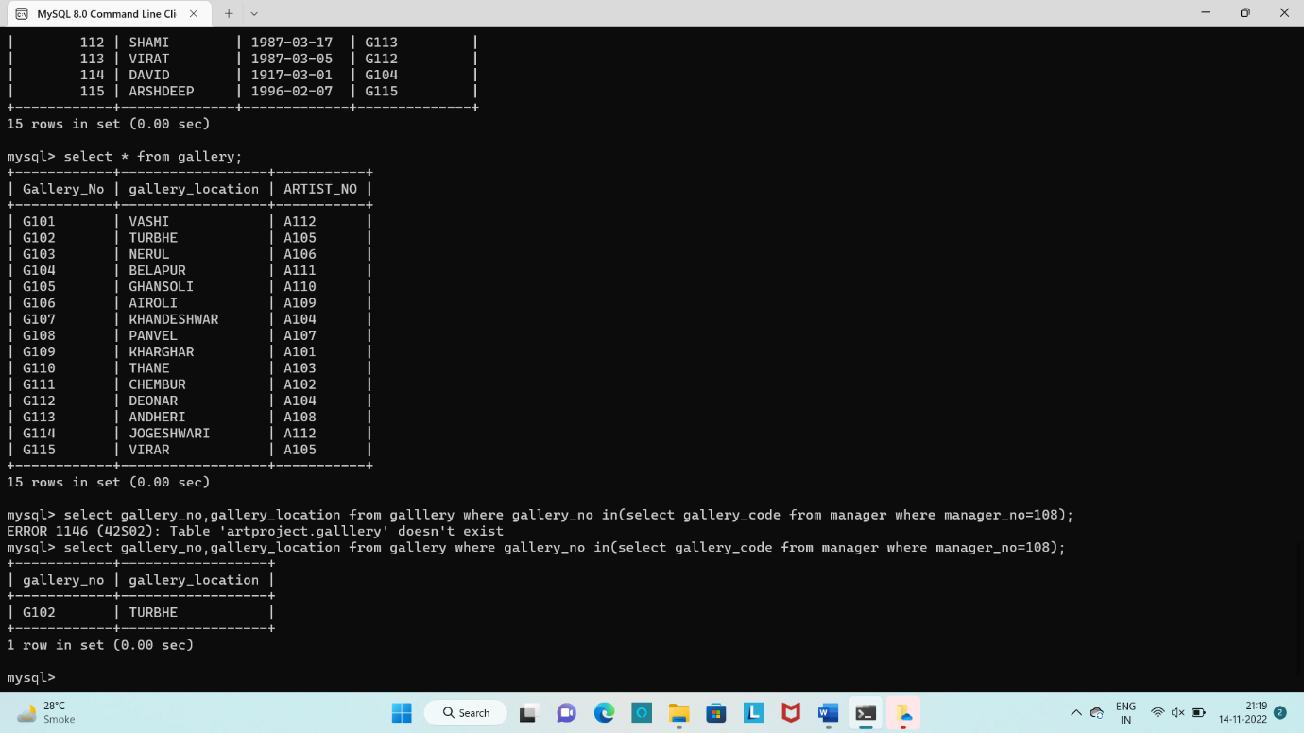

**3)Display All Data From Manager Who Manage Gallery In Belapur**

select * from manager where gallery_code in(select gallery_no from gallery where gallery_location='belapur');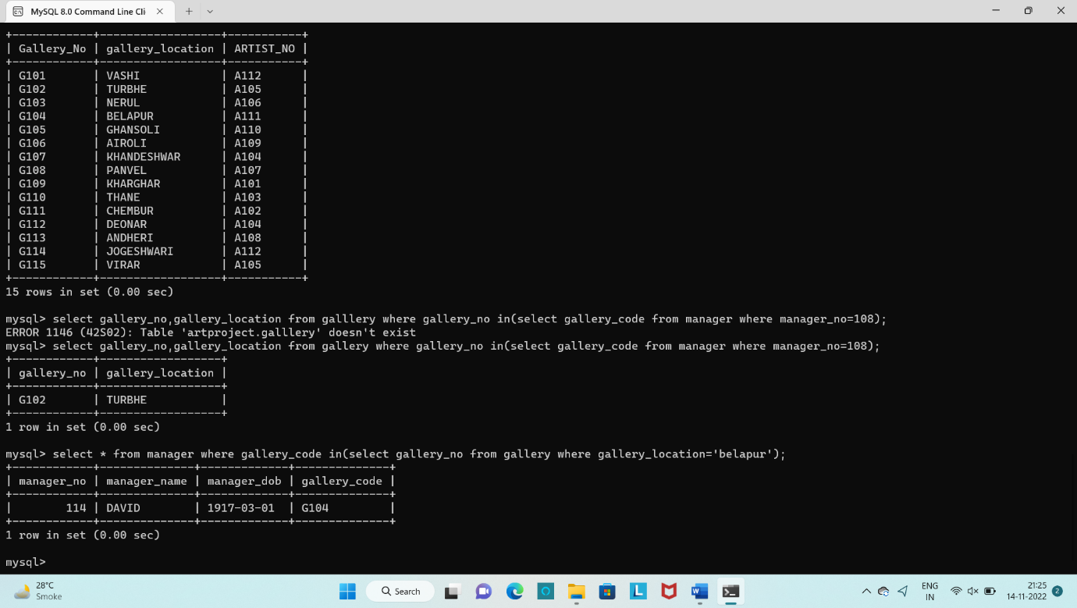

**4)Display Artist Information Who Create More Than One Artwork.**

select * from artist where artist_no in(select artist_id from artwork having count(artist_id)>1);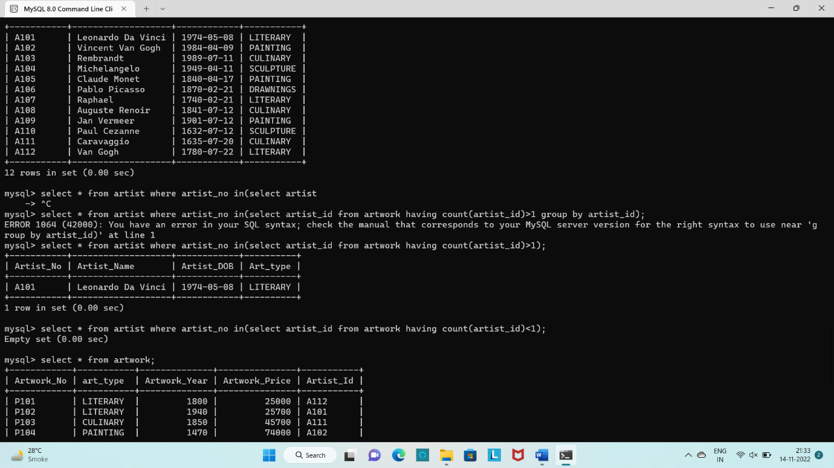

**5)Display Artwork Information From Artist Who Create ‘Culinary’ Art Type**

select * from artwork where artist_id in(select artist_no from artist where art_type='culinary'); 