PhishDriftBench + DASH
The Reported–Deployed Gap in Phishing URL Detection:
A Time-, Source-, Provenance- and Evasion-Aware Benchmark
with Drift-Aware Selective Hardening
Final Year Project — Project Definition, Literature Review and Architecture
1. Abstract
Published phishing URL detectors routinely report 97–99.5% accuracy, yet these figures are almost always produced under one evaluation protocol: a random or k-fold split of a single dataset, balanced at roughly 50% phishing prevalence, with no adversary in the loop. Each of those choices is individually defensible and collectively misleading. Random splits leak time, because phishing URLs arrive in campaigns whose near-identical members land in both train and test partitions. Single-source evaluation hides source-specific artifacts — a feature can carry opposite meaning in different corpora. Balanced test sets conceal the base-rate problem: a detector with 99% accuracy and a 1% false-positive rate, deployed at a real prevalence of 1:10⁴, yields precision near 1%.
This project builds PhishDriftBench, a four-axis evaluation protocol that measures detectors across time, across data sources, against rule-based and generative evasion, and at deployment-realistic class priors. Under this protocol we re-evaluate five representative architectures drawn from the base papers. We add a feature-provenance audit that separates statically computable lexical features from those requiring a live network lookup, and quantifies how much reported accuracy is attributable to lookup artifacts rather than phishing semantics. Finally we propose DASH (Drift-Aware Selective Hardening), a lightweight mitigation combining drift-stability feature weighting, unsupervised drift detection, a bounded active-labelling budget, and a calibrated abstention band. The project is URL-only: no page is fetched, rendered, hosted or transmitted at any point.
Status: design and protocol complete; experiments not yet run. Every quantitative claim in the accompanying paper draft is an explicit unfilled placeholder. No results are reported until they are measured.

2. Improvements over the base papers
Each improvement names a specific, verified gap in the ten base papers.
1. Temporal evaluation instead of random splits
Gap: 0 of 10 base papers uses a chronological split. All use random or k-fold partitioning. Improvement: train on URLs first observed ≤ T, test on disjoint windows at +1, +3, +6 and +12 months; report a decay curve, not a single accuracy. Paper 5 accidentally demonstrates why — 99.35% on its 2025 data but 89.17% on an older corpus.
2. True cross-source transfer
Gap: only 1 of 10 (X-PHIDE) performs genuine transfer; Paper 5 evaluates on multiple datasets but retrains per dataset, which measures dataset difficulty, not transfer. Improvement: train once, evaluate on all source pairs plus leave-one-source-out.
3. Prevalence-corrected reporting
Gap: 0 of 10 reports precision at a realistic deployment base rate; all train and test near 50/50. Improvement: report precision, FPR and alerts per 10⁶ URLs at prevalences of 1:10², 1:10³ and 1:10⁴, alongside balanced figures for comparability.
4. Evasion testing against our own detector
Gap: Paper 10 catalogues cloaking and evasion thoroughly; no method paper evaluates its own detector against that catalogue. Paper 4 states outright that homograph attacks were never systematically evaluated. Improvement: E1 label-preserving transformations from the cloaking taxonomy (homoglyph/IDN substitution, subdomain and path padding, percent-encoding, shortener wrapping, TLD swap, hyphenated brand insertion) and E2 URLs from a contemporary generative model.
5. Feature-provenance and lookup-dependency audit (most novel)
Gap: no base paper — and no adjacent work we could find — asks where a feature's value comes from or when it was resolved. Improvement: classify every feature as P1 static-lexical, P2 lookup-at-inference (WHOIS, DNS, SSL, domain age, shortener expansion) or P3 third-party reputation; then measure accuracy with P2/P3 ablated, accuracy when P2 features are resolved today versus at collection time, and recall when the lookup channel is unavailable or attacker-controlled. The hazard is concrete: Paper 6 reports WHOIS, DNS and domain-age features over a 549,346-URL corpus containing only URL strings. If those lookups were performed retrospectively they encode domain mortality — phishing domains die within days, legitimate ones persist for years — which any classifier can exploit without learning anything about phishing. Paper 4, which deliberately avoids third-party features, is the control.
6. Drift-stability feature scoring
Gap: drift is mentioned by 4 of 10 papers and implemented by none. Improvement: score each feature by Population Stability Index across time windows and sources plus the variance of its permutation importance; partition into drift-stable and drift-brittle before deployment. Validation target: the HTTPS inversion X-PHIDE found (100% of legitimate URLs in PhiUSIIL, 59.2% in their own corpus) should be flagged without access to the second corpus's labels.
7. DASH — a mitigation, not just a diagnosis
Gap: 0 of 10 proposes any drift mitigation. Improvement: (i) stability-weighted training; (ii) unsupervised drift detection over the prediction-confidence stream, requiring no labels — the binding constraint in deployment; (iii) a bounded active-labelling budget (≈2% of the window by uncertainty sampling) on drift alarm; (iv) a calibrated abstention band that escalates instead of guessing, reported as a coverage–risk curve.
8. Duplicate-leakage probe (supporting)
Report exact and near-duplicate rates across the train/test boundary for every corpus, and accuracy before and after deduplication. With k-fold CV over scraped corpora, campaign duplicates are near-certain.

3. System architecture
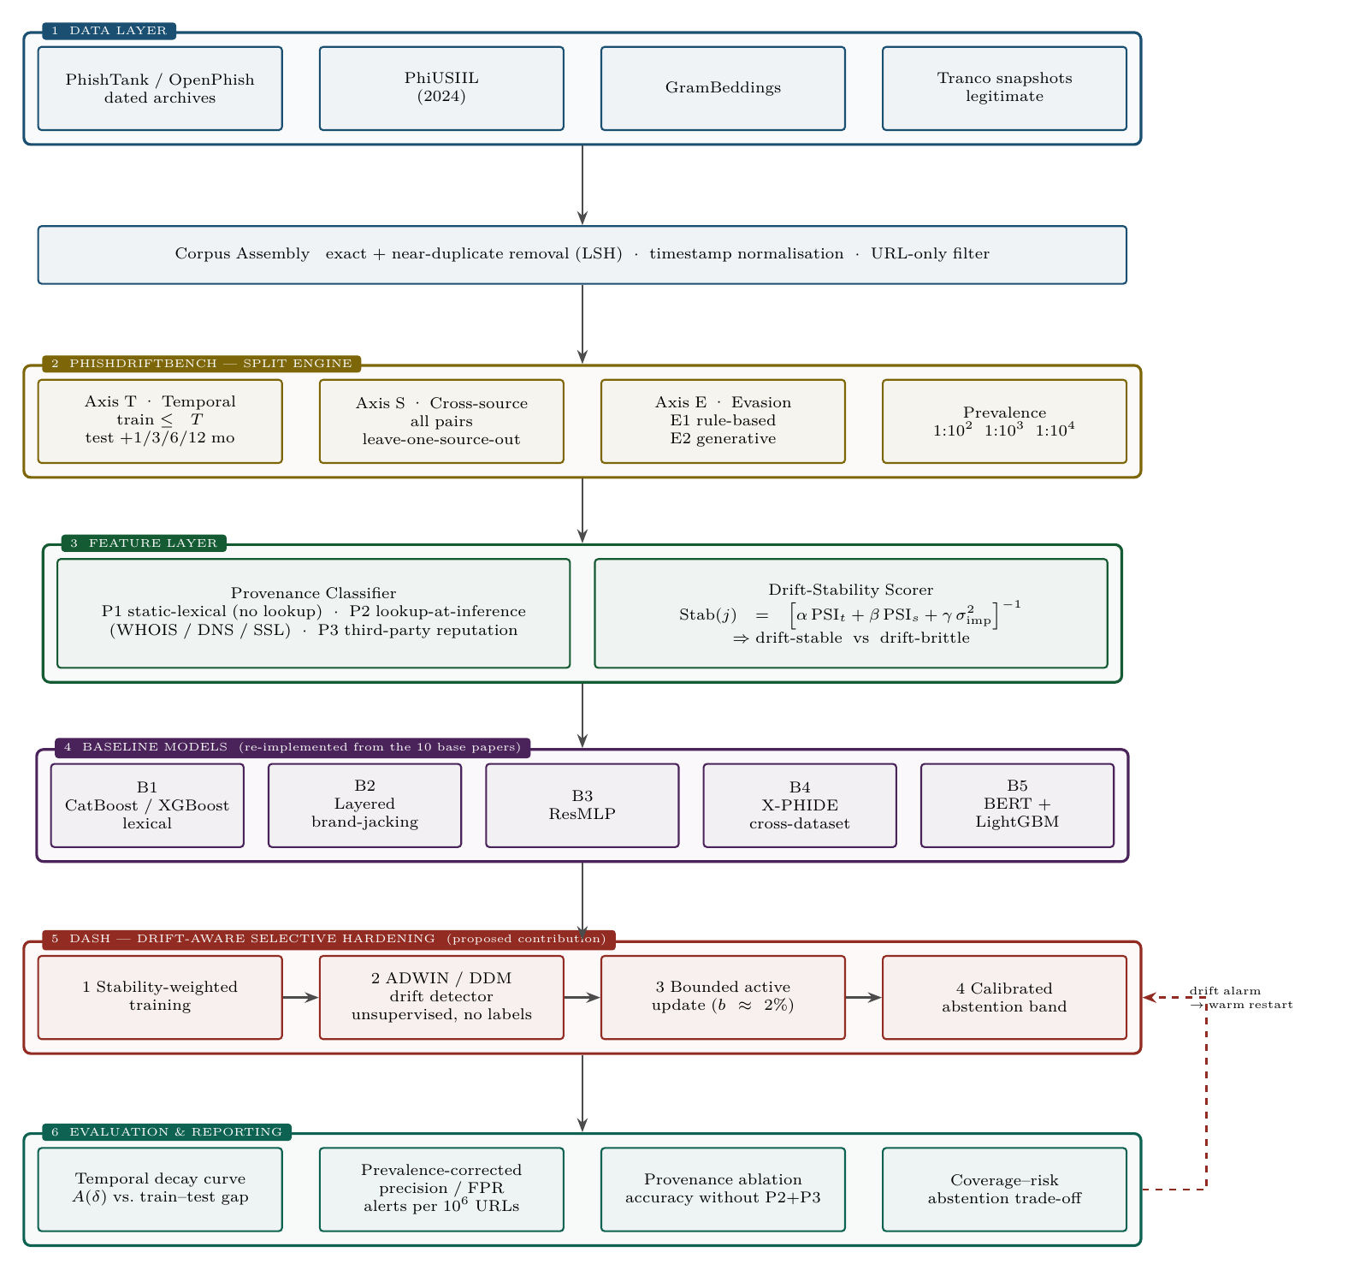
The pipeline is strictly URL-only. Layer 1 assembles dated corpora; Layer 2 generates the four evaluation axes; Layer 3 classifies features by provenance and scores their drift stability; Layer 4 hosts five baselines re-implemented from the base papers; Layer 5 is the proposed DASH mitigation; Layer 6 produces deployment-honest reporting. The dashed return path carries a drift alarm back into DASH for a warm restart.

4. Literature review
Ten base papers, all published 2023 or later: eight method or empirical studies plus two reviews.
# | Title | Authors | Publication & Year | Key Findings | Research Gap | Methodology | Future Work
1 | An Effective Detection Approach for Phishing URL Using ResMLP | S. Remya; M. J. Pillai; K. K. Nair; S. R. Subbareddy; Y. Y. Cho | IEEE Access, vol. 12, 2024 | 98.29% accuracy; residual pipelining outperforms traditional ML baselines on the same features | Blacklists cannot identify dynamic and newly registered URLs; optimal detection accuracy remains an open pursuit | Lexical + sentiment + domain-age features → convolutional and inverted-residual blocks → MLP; Kaggle dataset, 80:20 random split | Address limitations affecting practical viability; explore self-organising networks and online-learning representations
2 | On Phishing URL Detection Using Feature Extension | D. He; Z. Liu; X. Lv; S. Chan; M. Guizani | IEEE Internet of Things Journal, vol. 11, no. 24, 2024 | Feature extension enriches information-poor URLs; two-layer BERT→CNN improves detection, including on cryptocurrency phishing | URLs are short and carry little signal; blacklist/whitelist methods have inherent limitations | TextRank keyword extraction builds a feature-extension library; BERT embeddings feed a CNN classifier; single real-phishing dataset | Extend to broader transaction-security threats in the blockchain and cryptocurrency ecosystem
3 | Evaluating the Impact of Feature Engineering in Phishing URL Detection: A Comparative Study of URL, HTML, and Derived Features | Y. A. Kustiawan; K. I. Ghauth | IEEE Access, vol. 13, 2025 | 99.45% (CatBoost); derived features contribute most; systematic comparison across three feature families and ten models | Prior work studies URL or HTML features in isolation; no comparative study of engineered feature sets across models | 101,063-URL corpus; URL / HTML / derived feature groups × 10 ML models; single dataset, random split | Cascading architecture — cheap URL analysis first, heavier content and relationship analysis only for borderline cases; craft further derived features
4 | PhishOFE: A Novel Machine Learning Framework for Real-Time Phishing URL Detection With Optimized Feature Engineering | Y. A. Kustiawan; K. I. Ghauth | IEEE Access, vol. 13, 2025 | 99.48% (CatBoost) with no third-party features, enabling real-time deployment | Prior studies depend on outdated datasets and on third-party services that break in deployment | Optimised feature-engineering pipeline avoiding third-party lookups; CatBoost plus comparison models; single dataset, random split | Homograph-attack detection via character normalisation, visual-similarity metrics and Unicode-aware features — explicitly not evaluated in the paper
5 | Enhanced Phishing Detection Approach Using a Layered Model: Domain Squatting and URL Obfuscation Identification and Lexical Feature-Based Classification | R. Goenka; M. Chawla; N. Tiwari | IEEE Access, vol. 13, 2025 | 99.35% (XGBoost) at 12.49 ms; but only 89.17% on an older dataset, which the authors attribute to 2025 target brands differing from 2018 | Prevailing approaches overlook domain-squatting and URL obfuscation (brand-jacking), which cause most successful phishing | Layer 1: bad-domain features detect brand names in unwanted positions or misspelled forms; Layer 2: lexical-feature ML classifier; own corpus + 6 datasets, retrained per dataset | Extend the brand-jacking feature set beyond conventional lexical features
6 | BGL-PhishNet: Phishing Website Detection Using Hybrid Model — BERT, GNN, and LightGBM | S. Remya; M. J. Pillai; B. S. Aparna; S. R. Subbareddy; Y. Y. Cho | IEEE Access, vol. 13, 2025 | Hybrid 97.3% accuracy / 97.8% precision / F1 97.3 / ROC-AUC 0.97; individually BERT 90.4%, GNN 88.3%, LightGBM 85.8% | Single models lack flexibility, turnaround time and scalability on large, evolving datasets | BERT (semantic) + GNN (structural) + LightGBM (metadata) with ensemble late fusion; Kaggle corpus of 549,346 URLs; 10-fold cross-validation | Improve GNN memory efficiency; adapt the model to the evolving phishing landscape
7 | Staying Ahead of Phishers: A Review of Recent Advances and Emerging Methodologies in Phishing Detection | S. Kavya; D. Sumathi | Artificial Intelligence Review, vol. 58, no. 50, 2025 | Consolidated taxonomy spanning list-based, ML, DL, graph-based and GAN-based detection | No consolidated view of recent deep-learning, graph and generative approaches | Systematic literature review | Dataset diversity, adversarial robustness, interpretability and real-time deployability named as unfilled gaps
8 | A Multimodal Phishing Website Detection System Using Explainable Artificial Intelligence Technologies | A. Vulfin; A. Sulavko; V. Vasiliev; A. Minko; A. Kirillova; A. Samotuga | Machine Learning and Knowledge Extraction (MAKE), 2026 | F1 0.989 on own data, 0.953 on MTLP; quantifies an 8–15% temporal decay and a 3–9% adversarial drop; SOC deployment scenario on zero-day URLs | Single-modality detectors are brittle and offer no explanation to a human analyst | Late fusion of CatBoost (URL), 1D-CNN (characters), CodeBERT (HTML) and EfficientNet-B7 (screenshot); SHAP and Grad-CAM plus local LLM explanation | Improve explanation quality; broaden zero-day evaluation
9 | XGBoost-Based URL Phishing Detection Method With Cross-Dataset Validation (X-PHIDE) | M. Misiek; T. Hyla | IEEE Access, vol. 14, 2026 | 97.80% single-dataset → 77.84% cross-dataset average (Custom 90.72, GramBeddings 70.65, PhiUSIIL 72.16); HTTPS inverts meaning across corpora | Dataset shift is “a factor often overlooked in existing literature”; single-dataset results do not transfer | XGBoost over a cross-dataset feature intersection; three distinct datasets; Chrome plug-in for real-time use | Operational challenges of distribution shift; model compression and lightweight deployment
10 | Uncovering the Cloak: A Systematic Review of Techniques Used to Conceal Phishing Websites | W. Li; S. Manickam; S. U. A. Laghari; Y.-W. Chong | IEEE Access, vol. 11, 2023 | Taxonomy of server-side and client-side cloaking, 2012–2022; a small number of sophisticated campaigns account for over 89% of attacks | Cloaking and evasion techniques are scattered across the literature with no unified taxonomy | Systematic literature review (SLR) | Strategies targeting sophisticated campaigns; the role of certificate authorities; collaborative data sharing and faster takedown response

What the table shows at a glance
Evaluation property | Base papers satisfying it
Temporal / chronological split | 0 / 10
Prevalence-corrected metrics | 0 / 10
Genuine cross-source transfer | 1 / 10 (X-PHIDE)
Evasion tested against own detector | 0 / 10
Drift detection or mitigation implemented | 0 / 10
Feature-provenance audit | 0 / 10
Drift is mentioned by four papers and implemented by none.

5. Scope, feasibility and honesty constraints
URL-only. No crawling, rendering, hosting or third-party API calls. This sidesteps the dependency Papers 4 and 9 complain about, and makes the evasion axis safe: strings are perturbed or generated inside an offline dataset, never deployed.
Compute. Gradient boosting, a small char-CNN and one BERT fine-tune. A laptop suffices for most of it; requiring no GPU is itself a selling point for a real-time detector.
Riskiest ingredient: timestamps. Axis T needs first-observation dates. Where a source lacks them, dated dataset releases serve as a coarse time axis (2023 → 2024 → 2025 → 2026).
Non-negotiable. Every number in every results table must come from an experiment actually run. The paper draft carries explicit red resultTODO{} placeholders wherever a measured value belongs. Fabricating results in work submitted for publication is research misconduct.

Novelty must be scoped honestly. Two concurrent works overlap parts of this proposal and must be cited: PhreshPhish (arXiv 2507.10854, 2025 — temporal splits, LSH leakage removal and base-rate benchmarks, but a preprint, website-based, and silent on feature provenance) and Wei et al. (IEEE Access 2025 — cross-dataset evaluation; found URL length alone yields 86.13% and 82.54% on two corpora). Claims in this project are stated as findings about this corpus of ten papers, not about the field as a whole.
Target venue: IEEE Access. Seven of the ten base papers appear there, it publishes benchmark-plus-mitigation work of exactly this shape, and it is Scopus/SCIE indexed with a 4–8 week first decision. Fallbacks: IEEE ICC / GLOBECOM / TrustCom for a shorter conference version; Computers & Security for a slower, no-APC route.

