1. CREATE A VPC AND ADD 2 SUBNETS NAMES SUBNET-A SUBNET-B
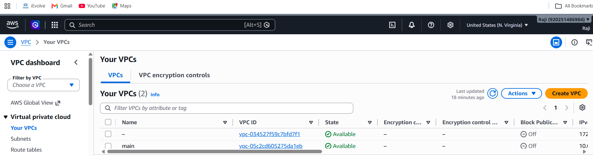
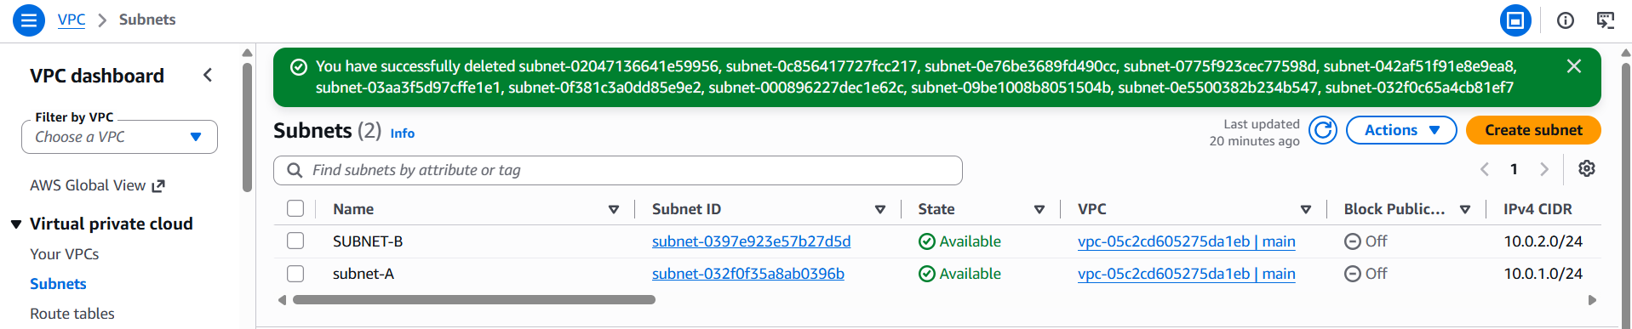
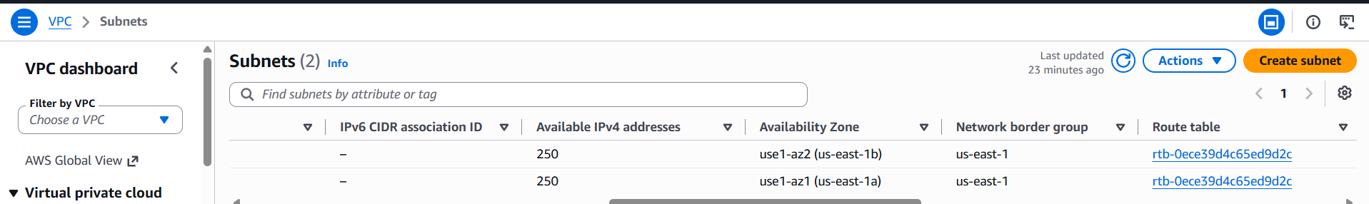

2. CREATE SERVERS ON EACH SUBNETS
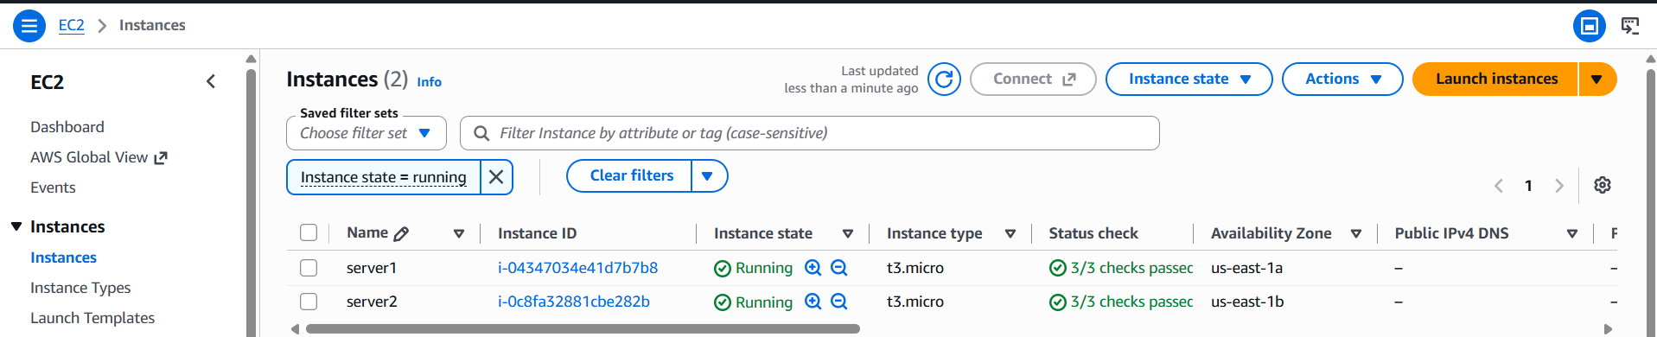

3. ADD PREVENT DESTROY AND IGNORE CHANGES BOTH
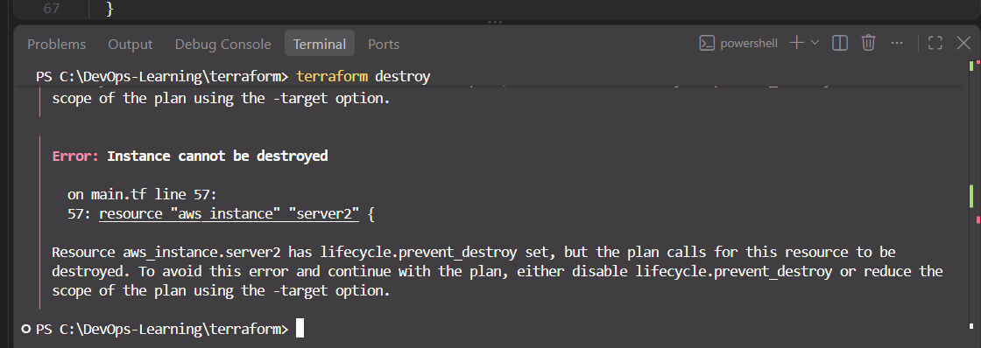

4. MODIFY THINGS IN CLOUD AND CHECK DRIFT
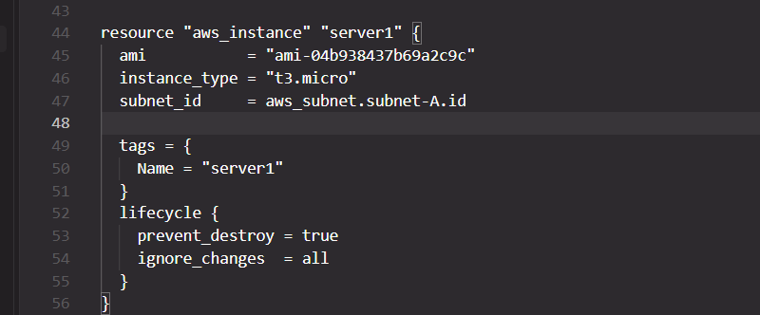
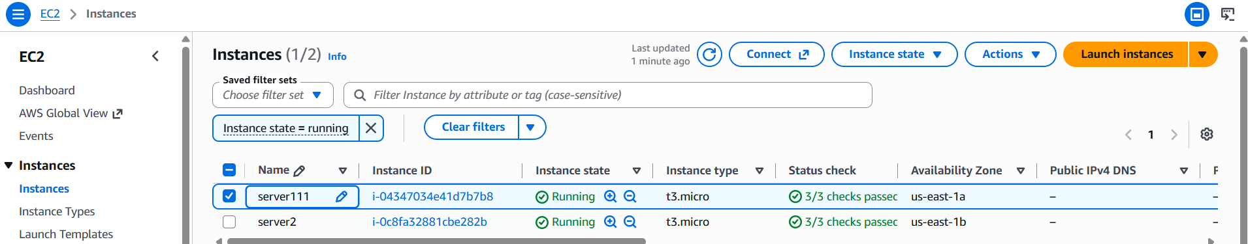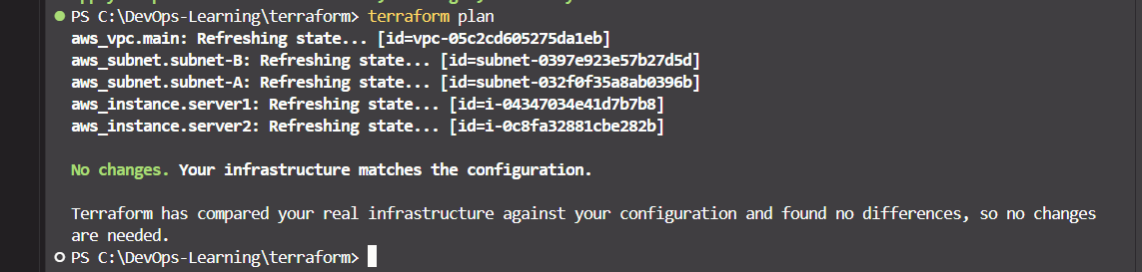
When I use ignore_changes = all, Terraform does not detect any drift, even after changing the server name manually. After removing ignore_changes = all and running terraform plan again, Terraform detects the drift and displays the error shown below.
