**Deep Learning - Lab ASSIGNMENT 1**

**Name:** Rajeswari Devi Namana

**Class ID:** 29

**Introduction:**

The task given for this lab assignment is to implement logistic regression on any data set using TensorFlow. TensorFlow is an open source software library developed by Google, which has quickly become the most popular deep learning library. Logistic Regression is used to solve classification problems. The detailed implementation of logistic regression using TensorFlow is discussed below.

**Objectives:**

The objective is to train a model to look at the data set which consists of handwritten images and predict what images they are.

**Approaches/Methods:**

The approach followed is multinomial logistic regression (that is a logistic regression with more than two classes to classify) which is also called as softmax regression.

**Datasets:**

I used MNIST data set which is a famous dataset of hand written digits and their corresponding labels. Here labels are nothing but numbers which the image represents. The digits present in these images are from 0 to 9. The image data is in the form of an array which consists of pixel values. Following image shows an example of array value.

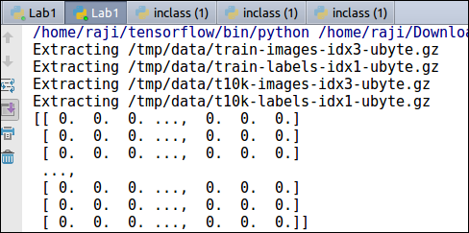

Some sample images from the data set:

The following image shows 4 different hand-written images.

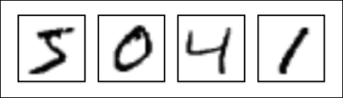

This data set is loaded into the program by using the following command and is stored in a temporary variable.

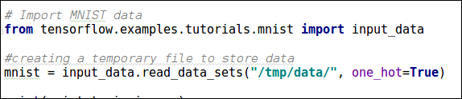

Data set consists of 55000 training data and 10,000 test data, and all are images. Each image is an array size 784.

**Workflow:**

Here effort is made to correctly predict what number is written down based solely on reading the image data i.e., by looking at the pixels present in the image. Images in the data set are considered as ‘x’ and labels as ‘y’ to perform the regression. Classes are considered as 10 since there are only 10 digits to classify into. By looking at image probability of image belonging to each class is to be given.

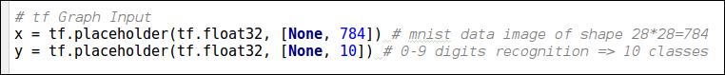

Weights and biases for the model are defined (784 indicates array size and 10 indicates no. of classes):

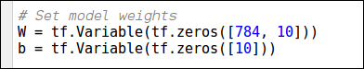

Multinomial logistic regression is implemented by the following formula:



Cost or loss represents how far is our model from the desired output. This is determined by cross entropy function. We will try to minimize this cross entropy for better results using gradient descent optimizer. By going through 25 training epochs the data has been trained. And model will be tested, and accuracy is predicted.

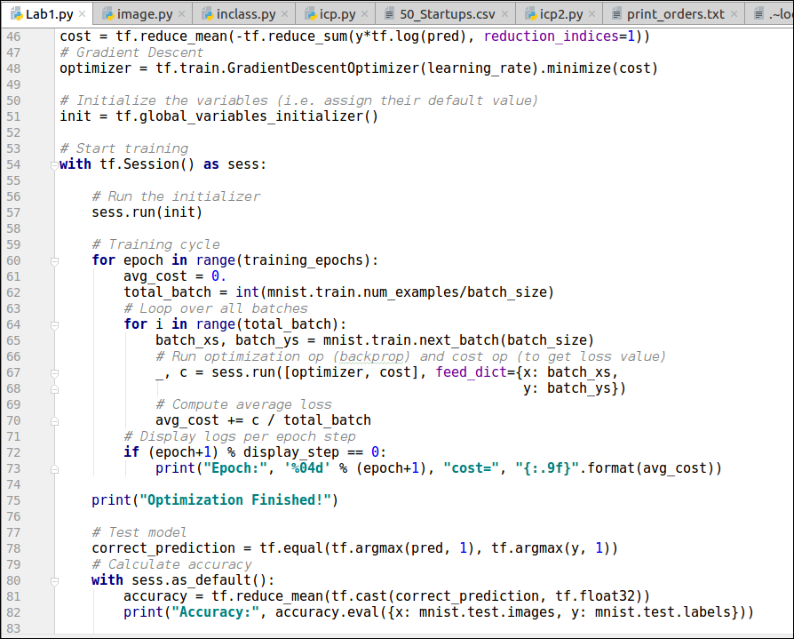

The 25 epoch and accuracy outputs have been shown in the below figure.

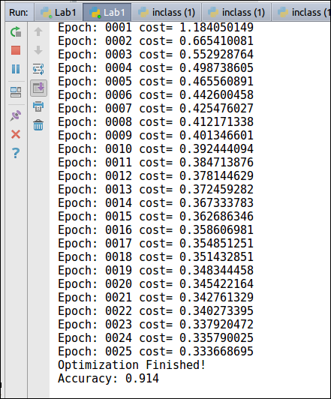

**Parameters:** The different parameters used are as follows:

1. learning_rate: How quickly the cost function is adjusted.
2. Training_epochs: How many training cycles we go through
3. Batch_size: Sizes of training data

**Evaluation & Discussion:** This method had produced good results since it produced an accuracy value of 91.4% which implies the probability of predicting the digit correctly. So, this model can be considered as a good model.Below image shows the accuracy value produced.

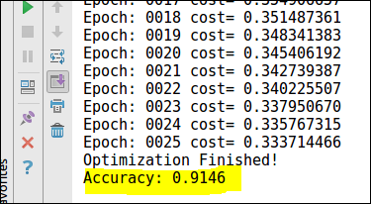

**Conclusion:**

Multinomial logistic regression has been successfully implemented to train a model to look at the data set which consists of handwritten images and predict what image they are, producing accuracy of 91.4%.