**Deep Learning Lab Assignment – 3**

**Name: Rajeswari Devi Namana**

**Class Id: 29**

**I. Introduction:**

For this lab assignment three tasks have been given:

* Text classification using RNN
* Text classification using LSTM and
* Comparing results of CNN, RNN, LSTM.

RNN stands for Recurrent Neural Networks which uses the previous outputs as inputs to predict the present output. LSTM stands for Long Short-Term memory, is a form of RNN, which are capable of learning long term dependencies and CNN stands for Convolutional Neural Networks which is a feed forward neural network, and which applies different concepts like convolution, non-linearity, pooling and fully connected layers.

**II. Objective:**

To classify text and predicting words using RNN and LSTM. Also comparing with CNN model. The data set used is story of little red riding hood.

**III. Approaches/ Methods:**

Two different approaches are followed here:

* Feed forward type of neural network: CNN
* Back propagation neural networks: RNN, LSTM (LSTM is a special case of RNN)

**IV. Datasets:**

I have used a story as a dataset so that it would be useful to predict the next words based on the context of the previous words especially in case of RNN and LSTM models.

**V. Workflow:**

* For all the three models, dataset is imported.
* Data sets are labelled in case of CNN – I Split the positive part of the story into one dataset and the negative part of the story into another dataset for CNN.
* All the required training parameters are loaded into the program.
* To pad the sentences, embedding layers are used.
* For CNN- convolution, non-linearity, pooling, and fully connected layers are applied.
* For RNN and LSTM- the weights and biases and corresponding filters are used.
* Models are trained.
* Losses are calculated.
* Graphs are visualized.
* Models are evaluated.

**VI. Parameters:**

Different training parameters have been used, some of them are as follows:

* Batch size
* Embedding dimensions
* Learning rate
* Filter size
* Number of classes
* Number of filters
* Training epochs
* Checkpoints
* Training iterations

**VII. Evaluation & Discussion:**

Using RNN MODEL, since data is limited accuracy is very small.

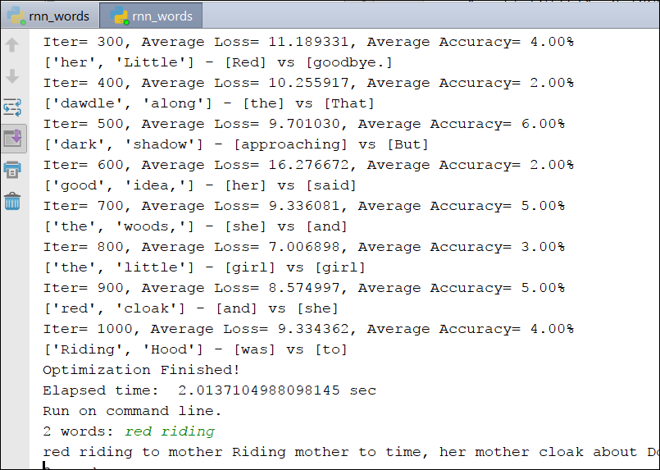

Using LSTM MODEL, here also since data is limited accuracy is very small.

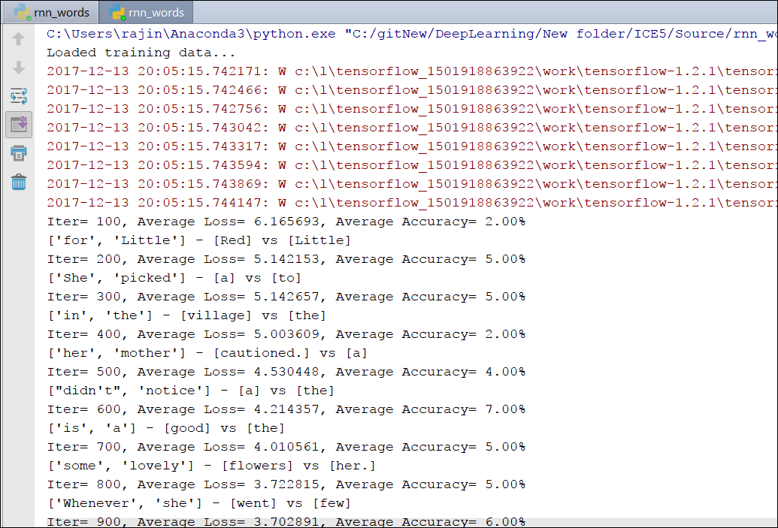

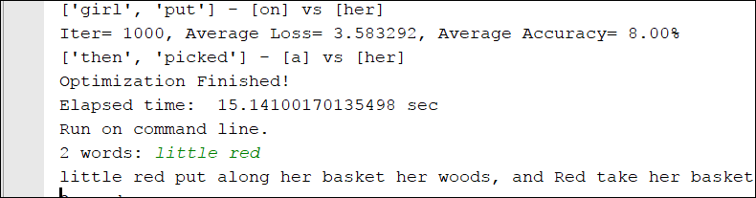

The graph generated for both RNN and LSTM is similar which is shown below:

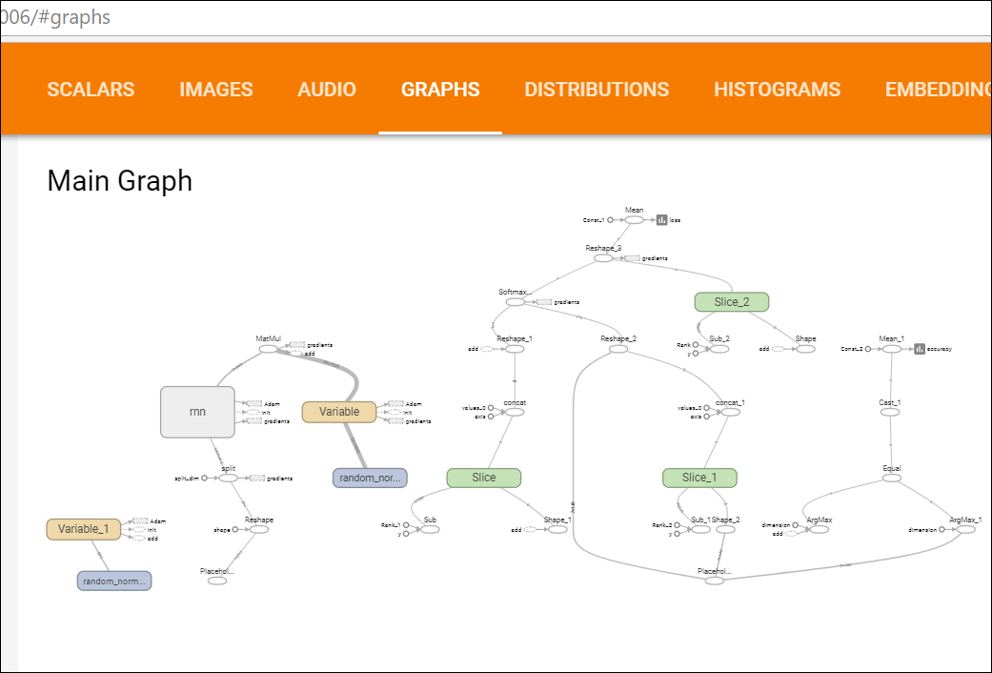

CNN model result:

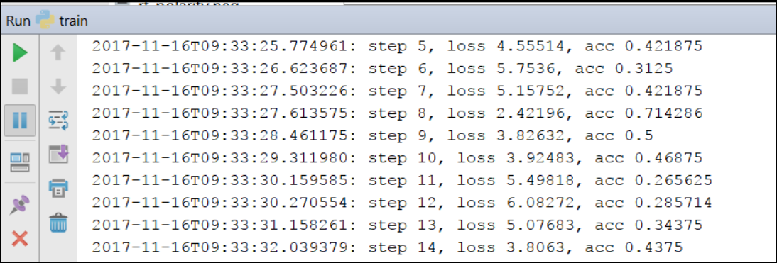

The graph generated for CNN is as follows:

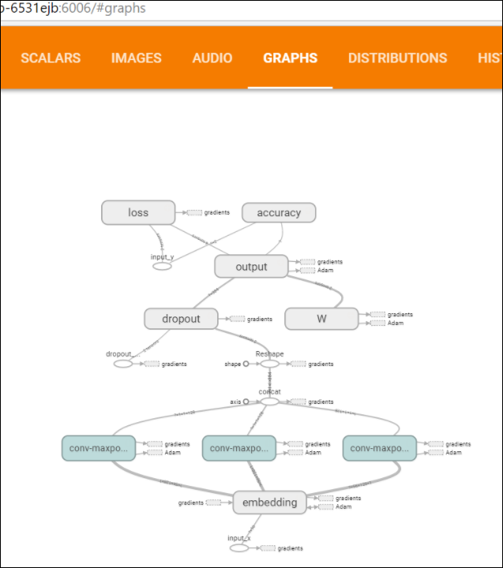

**VIII. Conclusion:**

As per my output results I found out that CNN is a better model for text classification, but I feel that my results are biased based on my dataset since I have used limited amount of text.