Vehicle management system using salesforce

1.INTRODUCTION:

* 1. OVERVIEW:

Vehicle Management System is a windows application written for 32-bit Windows operating systems which focused in the area of adding, editing and deleting the passengers, staff and the bus routes. In this software a person can be register as a user and he can manage the bus routes and the staff, passengers' details.

* 1. Purpose:

I. OBJECTIVE:

a. To assist in the tracking of vehicles operation and the planning of maintenance (i.e.: replacement of spare parts, etc.) that is important to avoid any damage/unexpected problem that might occur in the future that may cause hindrance to the operation and/or risking the safety of the drivers and passengers.

b. To assist in the tracking of fuel use and other running costs per vehicle and per program more effectively.

c. To give effective assistance in the estimation of actual cost for vehicles maintenance.

d. To preserve good vehicles performance for better organizational mobility.

e. To assist programs department in terms of having a more effective and efficient budget allocation to avoid over/under spending of budget for costs associated with the use of the vehicles.

II OUTCOME :

a. Provided more accurate and timely reports on recorded relevant data of vehicles.

b. Provided quality analysis on the physical condition, as well as functional and economical values of the vehicles to determine plan for assets (i.e.: whether the vehicles will be of any economical value to be kept and repaired or need to be auctioned for the purpose of buying a new one).

c. Good vehicles performance and better organizational mobility.

d. More effective and efficient vehicles related budget allocation in programs department.

2.PROPBLEM DEFINITION AND DESIGN THINKING:

2.1 EMPATHY MAP:

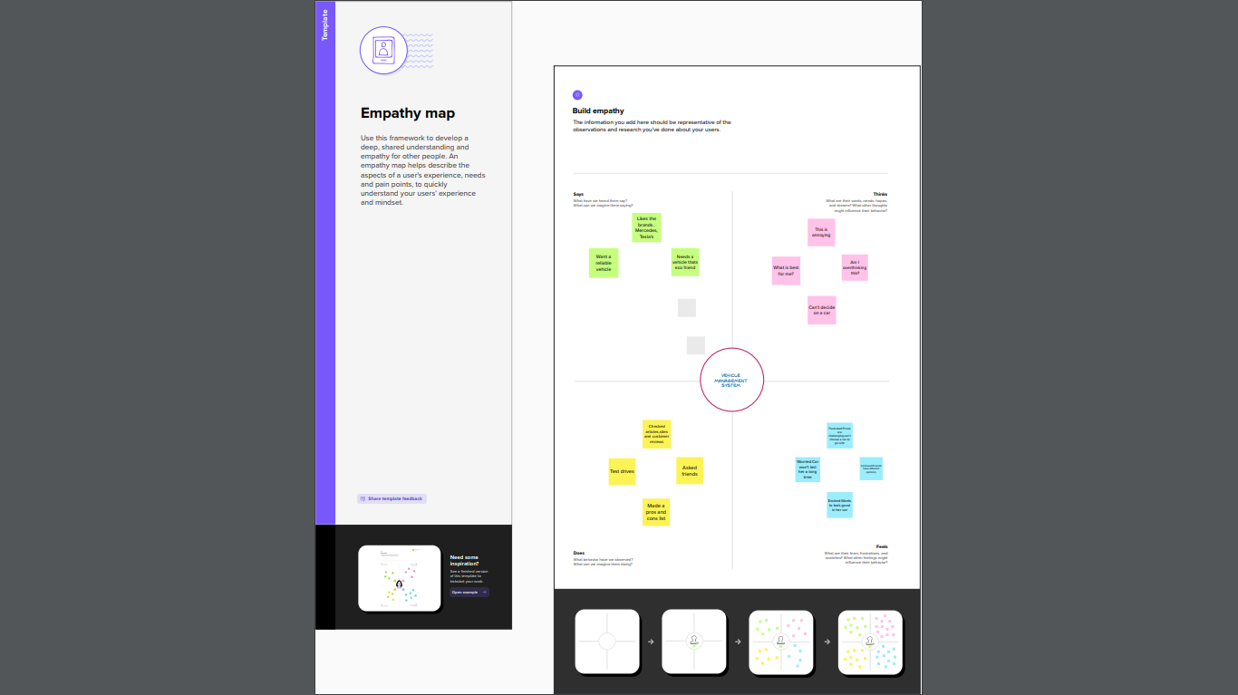

2.2 IDEATION AND BRAINSTORMING MAP:

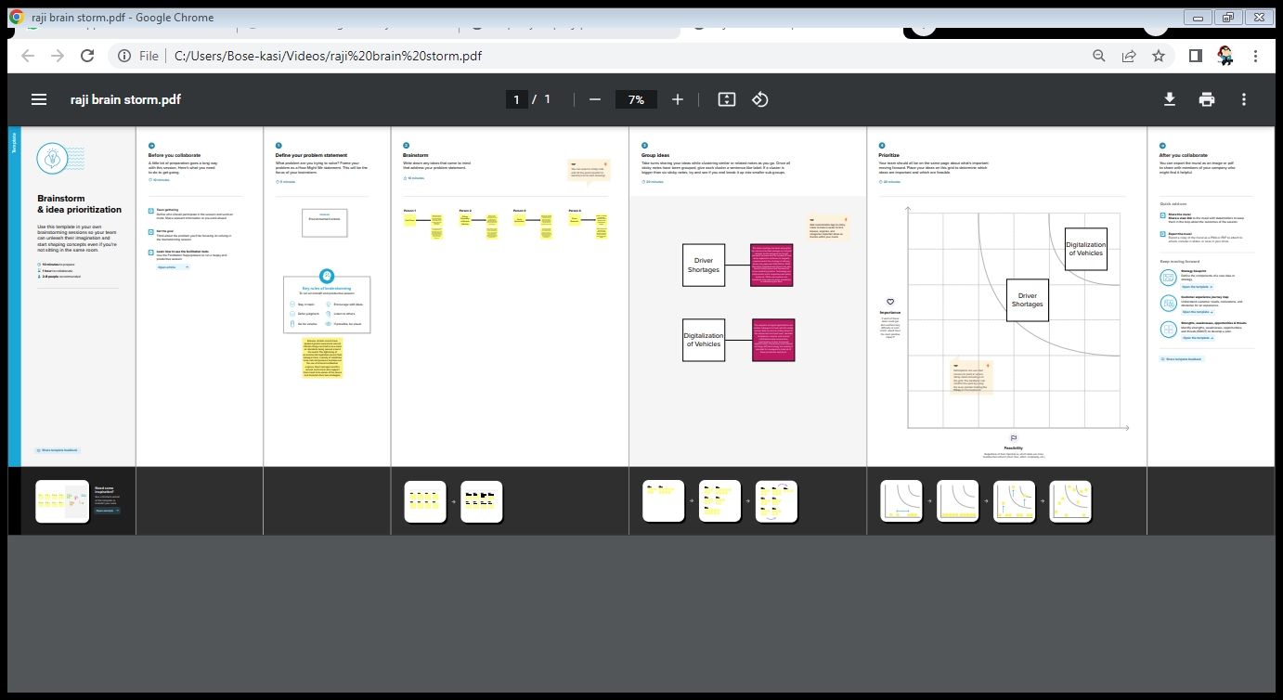

3.RESULT:

3.1 Data Model:

|  |  |
| --- | --- |
| Objective name | Fields in the object |
| VEHICLE | |  |  | | --- | --- | | Field Label | Data type | | Customer Name | Text | | Customer Mobile  Number | Number | | Vehicle Type | Picklist | | 2 Wheelers | Picklist | | 4 Wheelers | Picklist | | Vehicle Name | Text | | Vehicle Number | Text | | Chassic number | Text | | Colour | Text | | Body Type | Text | | Vehicle | Multi Picklist | | Condition | Picklist | | Mileage | Text | | Seats | Number | | Start date | Date/time | | End date | Date/time | | Opportunity | Lookup  (opportunities) | |
| DRIVER | |  |  | | --- | --- | | Field Label | Data type | | Driver name | Text | | Licence Number | Text | | Mobile Number | Number | | Fair per hour | Text | | Vehicle | Lookup(Vehicle) | |

3.2 ACTIVITY AND SCREENSHOT:

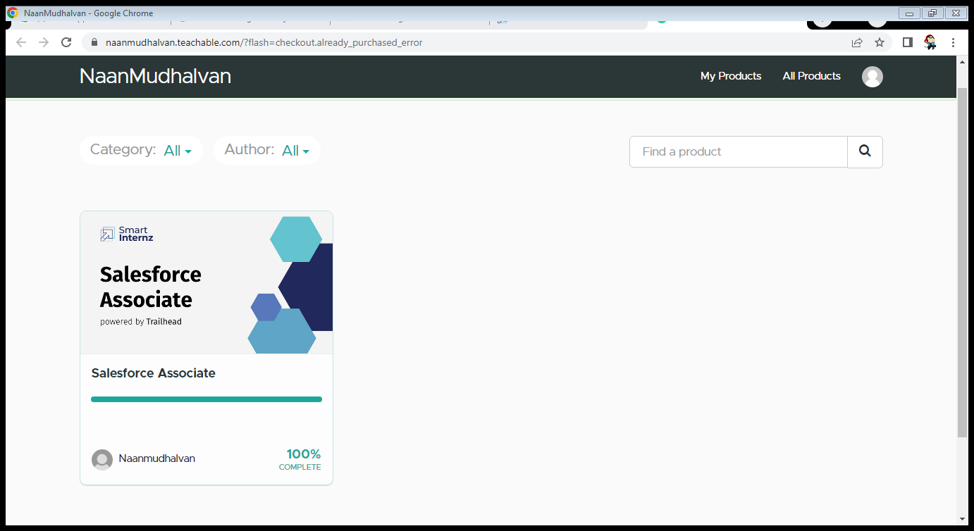

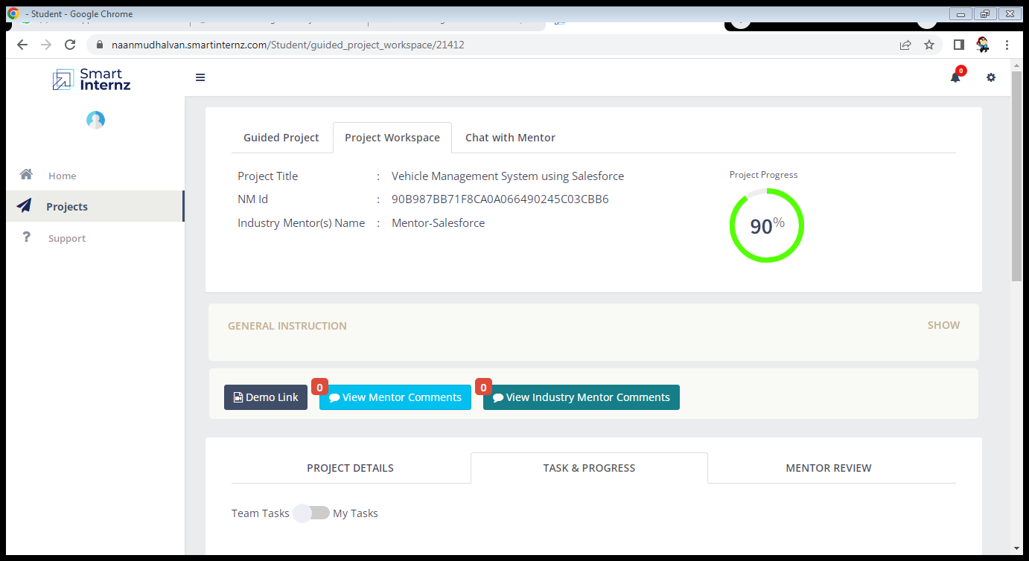

4. TRAILHEAD PROFILE PUBLIC URL:

Team Lead -https://trailblazer.me/id/rajeswarip

Team Member 1 -https://trailblazer.me/id/arafathm2

Team Member 2 -https://trailblazer.me/id/ameena02

Team Member 3 -https://trailblazer.me/id/abinaya334

5.

(i)ADVANTAGE:

➨It improves productivity by saving delivery time due to use of advance route information, traffic alerts etc.

➨It helps to reduce cost of fuel.

➨It ensures safety of vehicles, drivers and goods

.  
➨It provides real time location of fleets and serves the customers in better way.

➨It helps in saving of maintenance costs by maintaining fleet effectively.

➨It reduces risk of theft and road accident chances. Hence it decreases insurance cost.

(ii) DISADVANTAGE:

➨Active tracking based fleet management requires monthly subscription charges and data usage charges.

➨It is difficult to manage and maintain fleet management system due to use of multiple technologies such as cloud servers, cellular wireless systems, fleet management software etc.

➨It requires skilled resources to maintain such system. This increases maintenance costs.

➨GPS device used in fleet management is power hungry which drains battery faster.

➨GPS signal does not pierce through the walls, solid structures, under water or dense trees. Hence it is difficult to track the fleet when they are in such regions or behind such locations.

6. APPLICATIONS:

There are mainly 5 modules in this software

* Bus Management
* Route Management
* Employee Management
* Passenger Management

7. CONCLUSION:

A vehicle management system is a software system or platform that serves to manage commercial fleets of vehicles, such as cars, vans or trucks or even heavy equipment to ensure they're utilized safely, efficiently and professionally, while making sure they're well maintained and high-performing.

8. FUTURE SCOPE:

**To assist in the tracking of vehicles operation and the planning of maintenance** (i.e.: replacement of spare parts, etc.) that is important to avoid any damage/unexpected problem that might occur in the future that may cause hindrance to the operation and/or risking the safety of the drivers and passengers.