Watch

Nothing but monitoring. Keeping track of (or watching) scope variables and the changes of their values.

- Keep track of variable and its values.

- Watched by angular framework.

- Some variables may not be watched.

- If the value changes, angular performs necessary updates ( propagation to DOM, UI updates etc)

- Angular can execute custom functions ( watch listerens ) on value change.

- Can add our own $watch using $watch function available through $scope object.

Available at $rootscope as well.

* $watch is used when AngularJs does not consider scope variable for watching.   
  Eg. Scope variable not being used in data-binding.
* Watch Listener: a function which gets executed when a “watch” detects a value change.
* Reference watch: When watching a primitive variables.
* Equality watch: When watching objects.. $watch with true. Check every property of an object to see if it has been chaged… $scope.$watch(‘o’, function() { .. }, true);
* $watchGroup: When referencing multiple variables $scope.watch( [‘a’, ‘b’)
* $watchCollection: When watching arrays. Only detect changes in array (add/remove). Change in the item of an array is not detected, by default. Use ‘equality watch’ to detect item changes in the array.
* Recommended to keep the watchers as low as possible.
* Can use Chrome Extn ( Angular watches or Batarang) to count watchers.

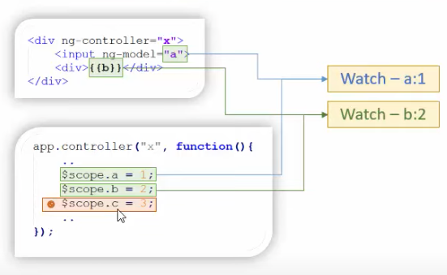

Digest Cycle

|  |  |
| --- | --- |
|  |  |
|  | |