EduGenie
Google Gemini–Powered Learning Assistant

Project Description
EduGenie is a lightweight AI-powered educational assistant that simplifies learning through generative AI. Designed for students of all academic levels, EduGenie enables users to:
- Ask questions and receive smart, concise answers
- Understand complex concepts through simplified explanations
- Generate quizzes from topics or text
- Receive personalized learning recommendations
- Summarize large educational passages
Built with FastAPI for the backend and a simple HTML+CSS frontend, EduGenie leverages both lightweight local models and cloud-based AI for efficiency and power. It runs well on devices like the Mac M1, making it accessible to a broad range of learners and developers.

Scenarios
- Scenario 1: A student curious about oceans and rivers uses EduGenie to ask, “Which is the largest ocean?”
- Scenario 2: A student wants to check her understanding of the Pythagoras Theorem and clicks “Generate Quiz.”
- Scenario 3: A learner exploring SQL requests a personalized learning path to guide their study.

Prerequisites & Tech Stack

Python 3.10+
- Popular tutorial:
- Python Programming Tutorial — Full Course for Beginners
Installation steps:
- Download the latest Python 3.10+ installer for your operating system from the official website.
- Run the installer and check the box “Add Python to PATH.”
- Follow the installation prompts to complete setup.
- Verify the installation by running: python --version

FastAPI Framework
- Official documentation: FastAPI
- Tutorial: FastAPI Crash Course

HTML & CSS
Basic templating used in /templates and /static.

Google Gemini API Key
- Official documentation: Google AI for Developers
Setup steps:
- Visit Google AI Studio and sign in with your Google account.
- Create a new project and enable the Gemini API.
- Generate an API key and store it securely (use environment variables, not hard-coded strings).

Uvicorn (ASGI Server)
Install with: pip install uvicorn

Jinja2 (HTML Templating Engine)
Install with: pip install jinja2

Project Workflow

Milestone 1: Model Selection and Architecture

Activity 1.1 — Select AI Models
- Gemini 1.5 Pro (via API) — used for Q&A, summarization, quiz generation, and learning paths. Chosen for its advanced reasoning, structured outputs, and cloud inference.
- LaMini-Flan-T5-783M (local) — used for concept explanation. Chosen for being instruction-tuned, lightweight, and CPU-compatible.

Folder Architecture
EduGenie/
1. main.py — FastAPI app
2. explanation_module.py — Concept explanation logic
3. qna.py — Question answering
4. quiz_module.py — Quiz generation
5. summary_module.py — Summarization
6. learning_path.py — Learning recommendations
7. templates/index.html — HTML frontend
8. static/style.css — Styling
9. requirements.txt — Python dependencies

Fig. Folder architecture

Milestone 2: Core Functionalities Development

Activity 2.1 — Module Implementation
1. Explanation Module
EduGenie utilizes the LaMini-Flan-T5 model, a lightweight yet powerful generative AI, to deliver educational content in a simplified and highly readable manner. This model is fine-tuned to provide concise, context-aware responses that break down complex topics into easily understandable language. By focusing on clarity and brevity, EduGenie ensures learners with minimal background knowledge can grasp essential concepts without feeling overwhelmed — making it especially valuable for beginners, school students, and self-learners.

Fig. Explanation module logic
2. QnA Module
EduGenie is powered by Gemini 1.5 Pro, enabling it to handle a wide range of general knowledge and academic question-answering tasks with precision. Its advanced understanding and contextual capabilities make it an effective tool for learners seeking accurate, AI-driven assistance across diverse subjects.

Fig. Q&A module
3. Quiz Module
EduGenie generates three multiple-choice questions (MCQs) from a given passage, each with four carefully crafted options. It uses the Gemini model to comprehend the context and meaning of the passage, ensuring questions are relevant and distractors are plausible. The output is structured as JSON for easy integration.

Fig. Quiz module logic
It sends a structured prompt to the model, expecting a valid JSON response where each question includes four options and a correct answer. To ensure proper parsing, it strips any Markdown code fences using a clean_json_block function, then parses the cleaned response into a Python list. If an error occurs during generation or parsing, it returns a detailed error message for debugging.
4. Summary Module
This feature leverages Gemini's generative capabilities to condense long paragraphs into concise, easy-to-understand summaries — ideal for quick revision. It retains core information while eliminating redundancy, helping learners absorb key points efficiently without losing clarity or context.
5. Learning Path Module
The get_learning_recommendations function uses Google Gemini to generate a personalized, structured learning path for any given topic. By crafting a detailed prompt, it instructs the AI to suggest beginner-to-advanced concepts, organized by difficulty and supported with useful resources such as videos, articles, or books — adapting to the learner's level. The function safely handles API responses and errors, returning either the generated text or a helpful error message.

Fig. Learning path module

Activity 2.2 — Backend API with FastAPI
Defined RESTful endpoints for each module:
- /qa
- /explain
- /quiz
- /summarize
- /learn/recommendations
Each endpoint is connected to its respective module logic.

Fig. Endpoints of the API

Fig. Endpoints of the API (continued)

Milestone 3: Frontend Development

Activity 3.1 — Build Web Interface
HTML Form (index.html):
- Task dropdown (Explain, QnA, Quiz, Summary, Recommend Path)
- Text area for user input
- Submit button
CSS Styling (style.css):
- Responsive design
- Styled buttons, input areas, and result container

Fig. Frontend integration

Activity 3.2 — Live Integration
- Form submission sends a POST request to the FastAPI backend
- Results appear below the input box in real time

Milestone 4: Deployment

Activity 4.1 — Run Locally
Run locally with:
uvicorn main:app --reload
Then navigate to: http://127.0.0.1:8000

Fig. Application running locally

Activity 4.2 — Functional Testing
- Ask a question
- Get an explanation
- Generate a quiz
- Summarize content
- Get a personalized learning plan
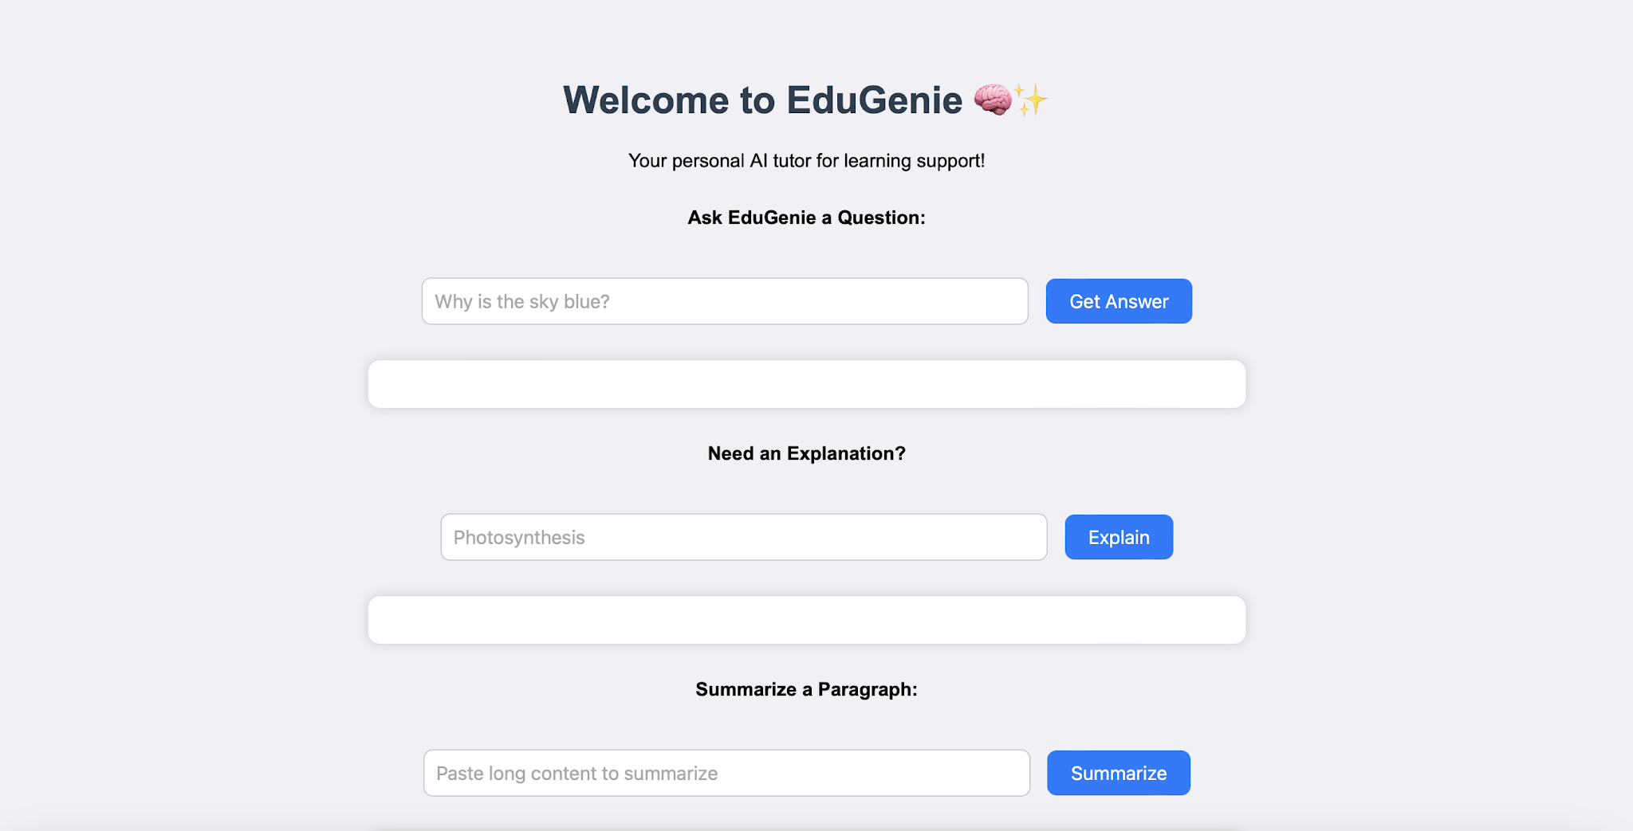
Fig. EduGenie interface
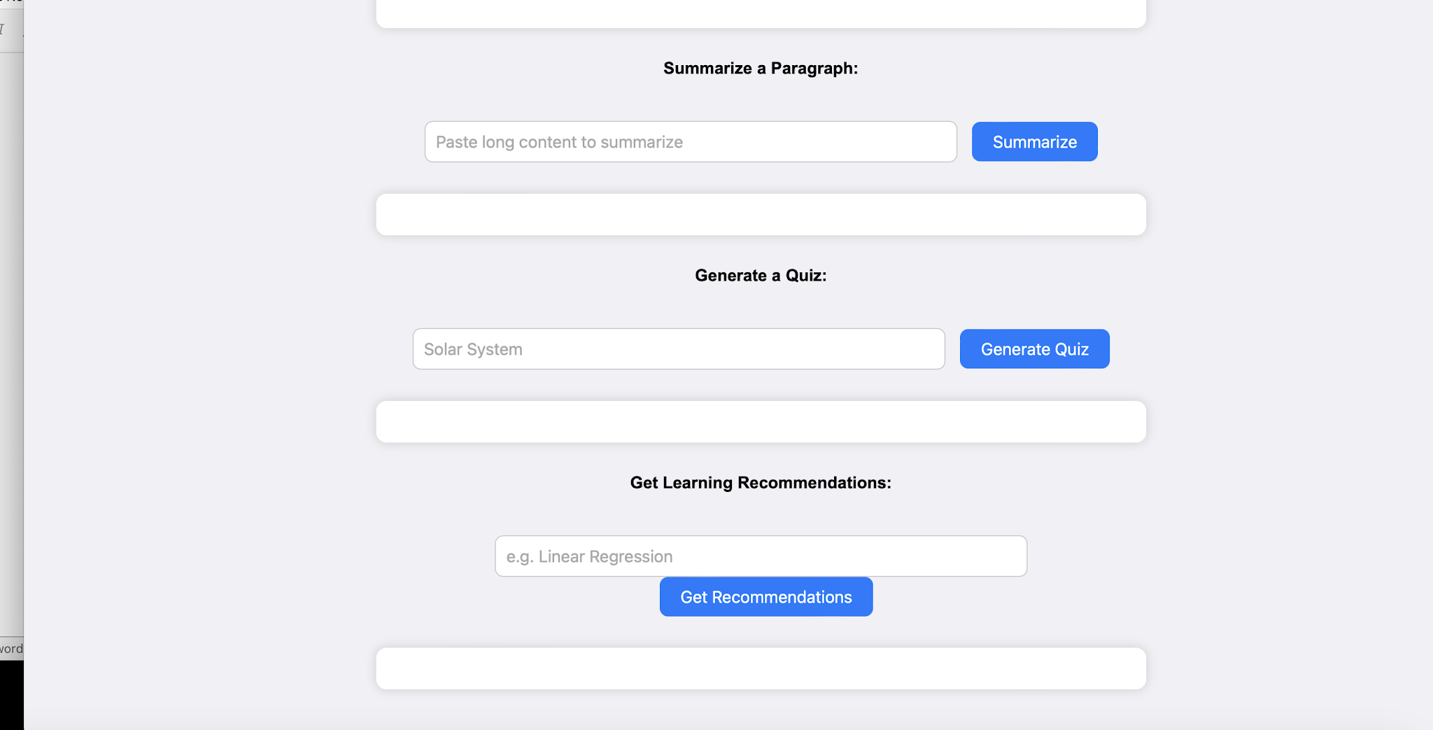
Fig. EduGenie interface

Exploring EduGenie

a. Asking questions
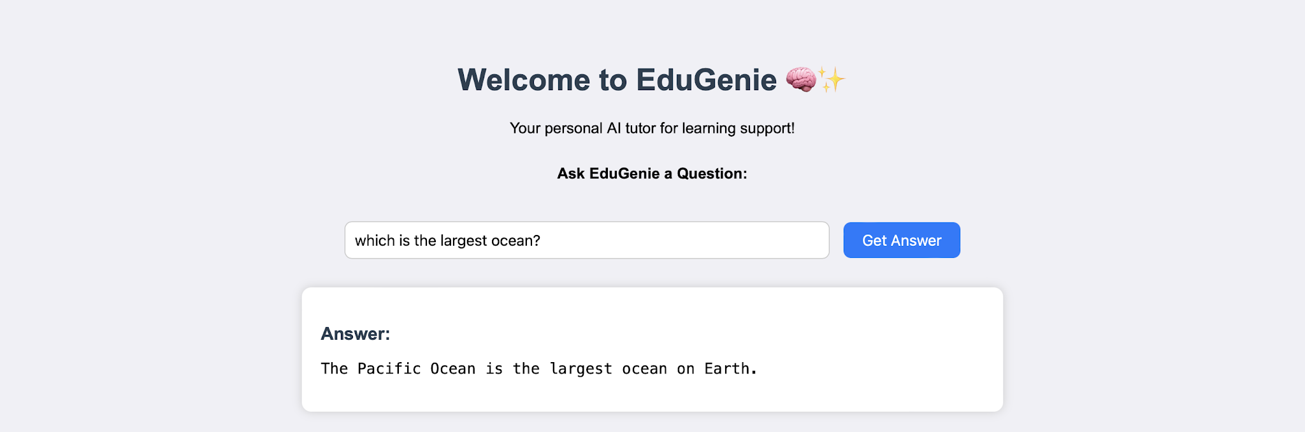
Fig. Q&A in action

b. Explanation of any topic
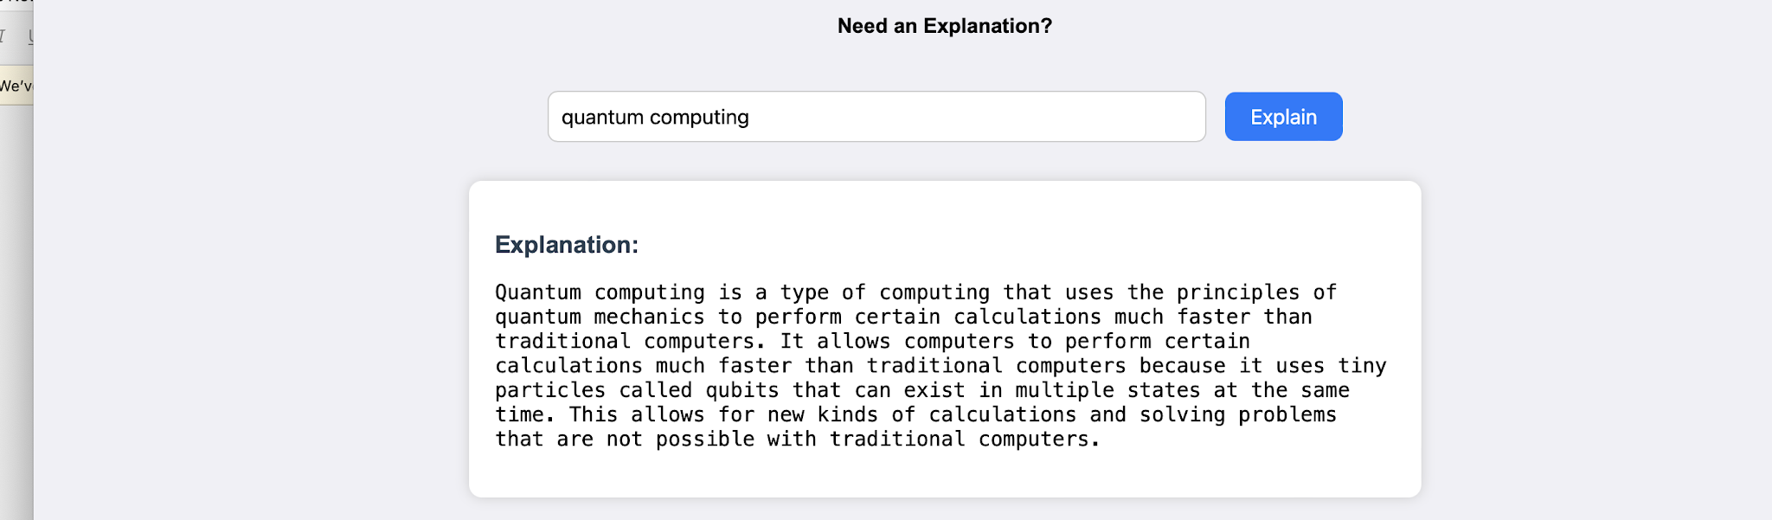
Fig. Concept explanation
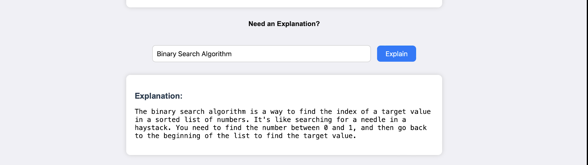
Fig. Concept explanation (continued)

c. Summarizing long paragraphs
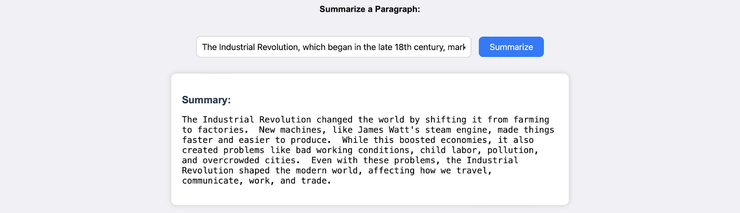
Fig. Summarization in action

d. Generating quizzes
It generates three questions with four options each, and corrects the answer if the user chooses wrong.
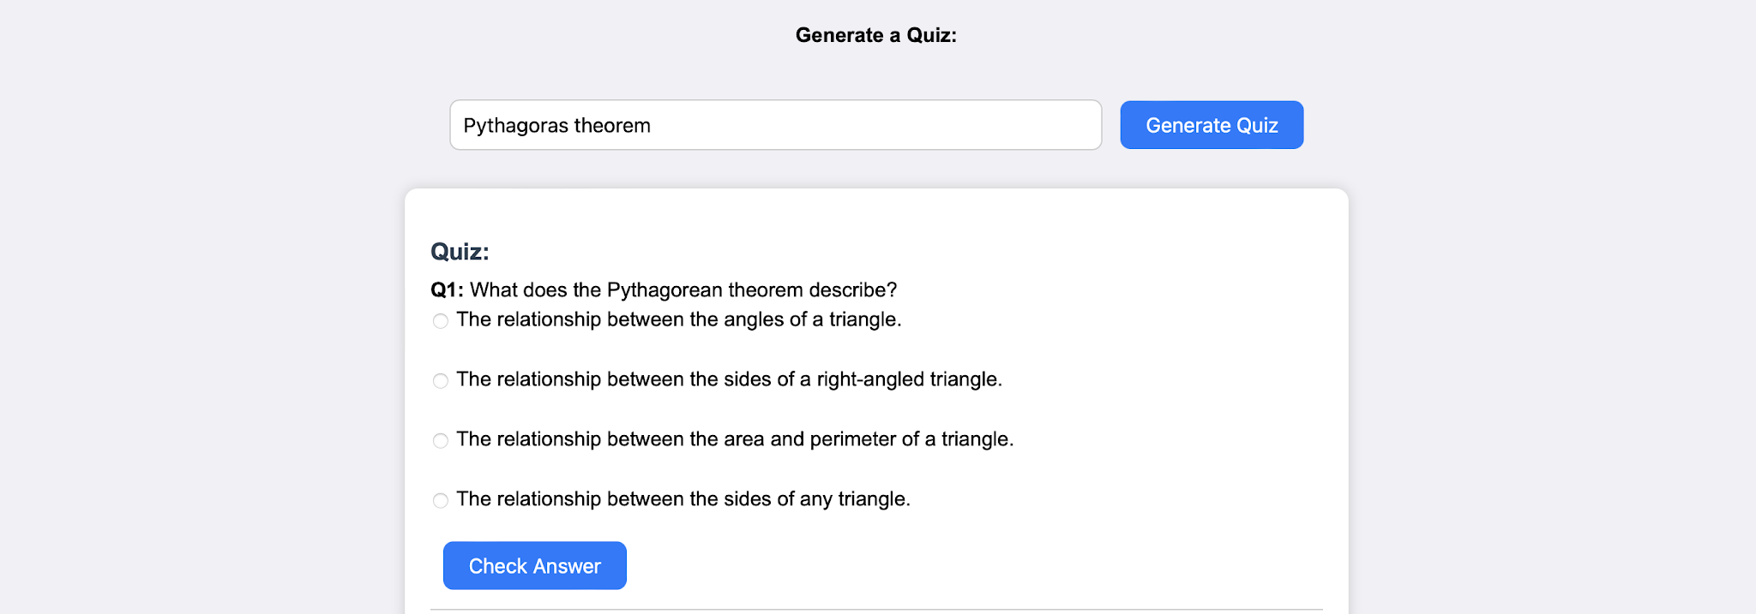
Fig. Quiz generation
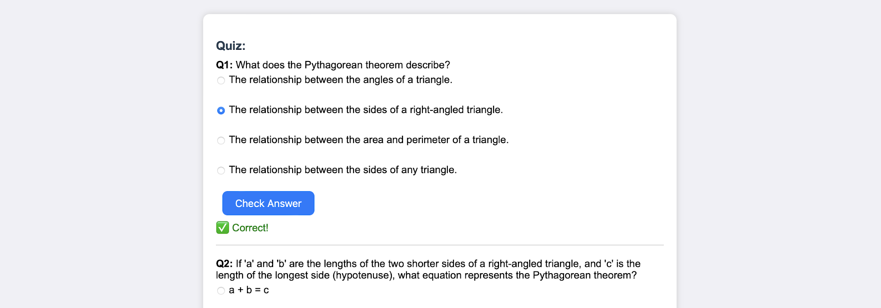
Fig. Quiz generation (continued)
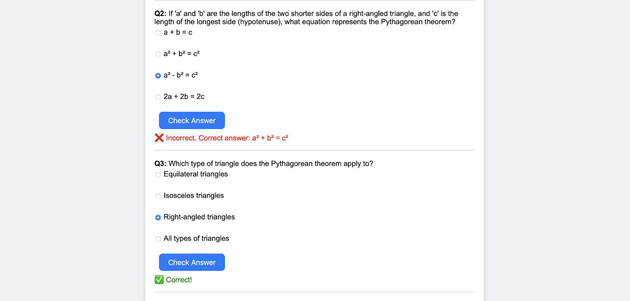
Fig. Quiz results

e. Guiding with learning recommendations, beginner to advanced
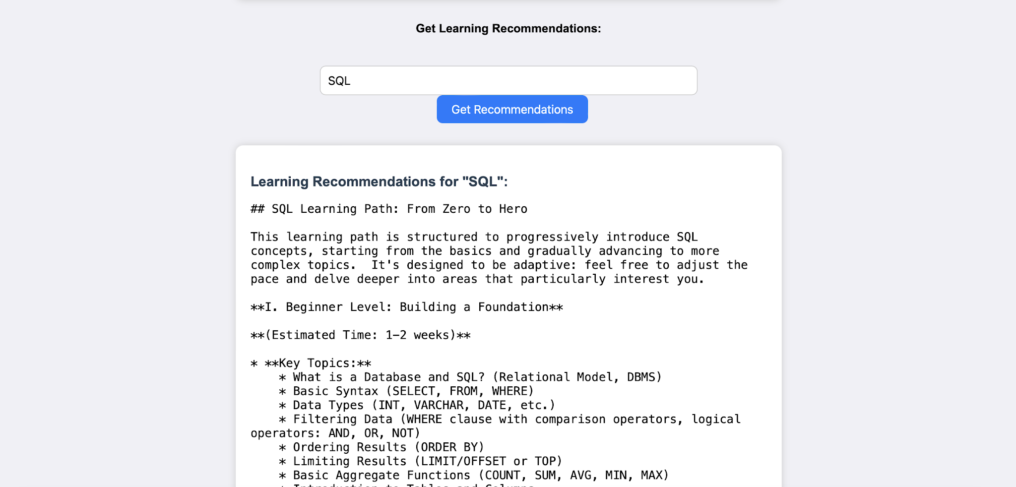
Fig. Learning recommendations
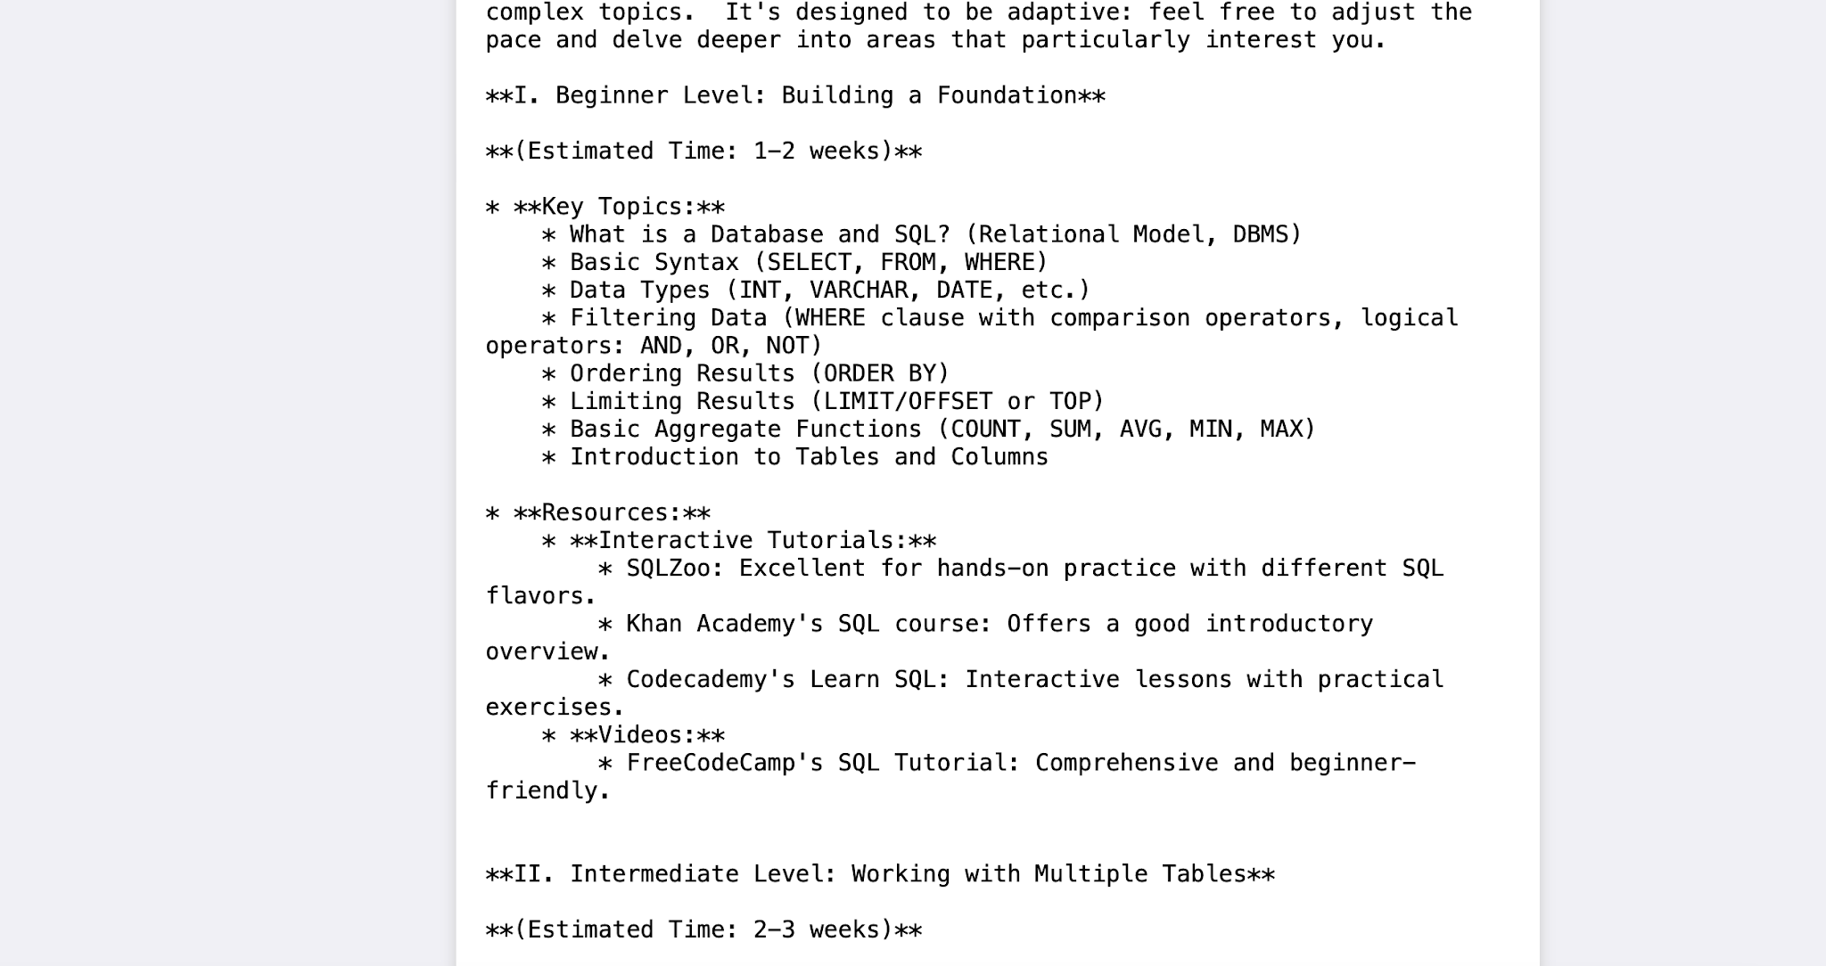
Fig. Learning recommendations (continued)
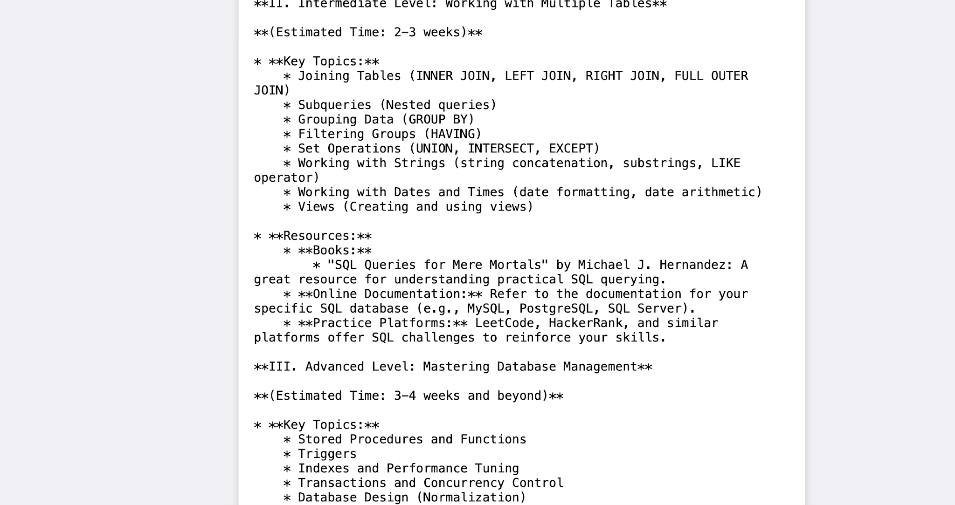
Fig. Learning recommendations (continued)
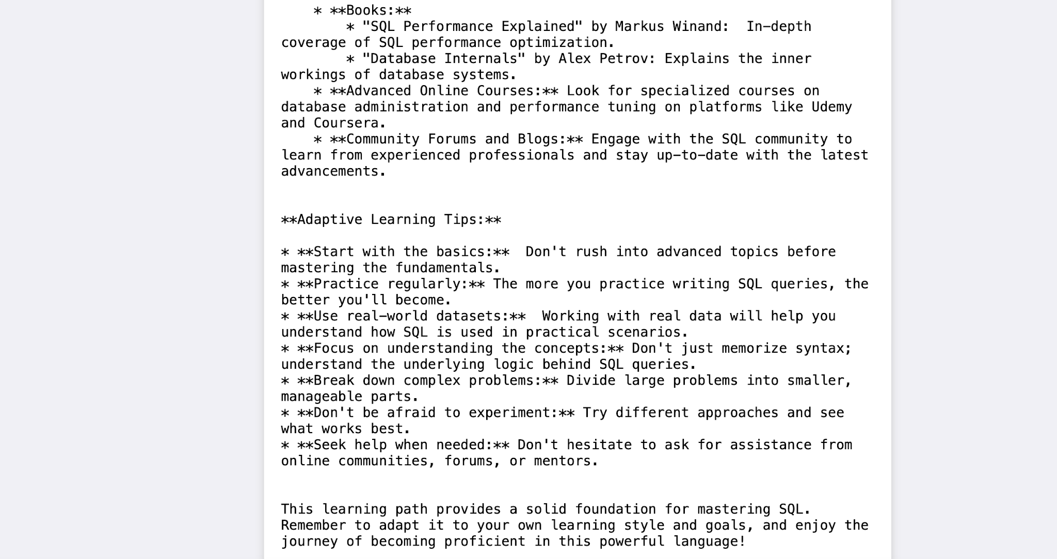
Fig. Learning recommendations (continued)
EduGenie also provides details of resources for further learning, with stepwise guidance throughout.

Conclusion
EduGenie has been developed as a robust and accessible AI-powered educational assistant that seamlessly integrates cloud-based intelligence with an intuitive, low-footprint web interface. Designed to support self-learners, educational institutions, and content platforms, EduGenie democratizes learning by simplifying complex concepts, providing instant question-and-answer interactions, generating personalized quizzes, offering detailed summaries, and tailoring smart learning paths based on individual needs. Its lightweight infrastructure ensures that even users with minimal hardware resources can access high-quality, personalized education without barriers.
Throughout development, the project achieved key milestones in AI integration, user experience design, and content adaptability. Leveraging advanced generative AI, it transforms static learning into a dynamic and interactive process. The platform's simplicity and clarity cater to learners of all levels — especially those who may find traditional educational content overwhelming or inaccessible. Its modularity allows for easy future upgrades, while the cloud-based backend ensures scalability and data-driven intelligence.
The development journey also came with challenges: ensuring accuracy in AI-generated responses, maintaining performance across devices, and balancing personalization with general usability. Overcoming these required continuous testing, fine-tuning AI prompt structures, optimizing the UI for clarity, and addressing data privacy concerns — yielding valuable learning outcomes in prompt engineering, cloud integration, user-centric design, and scalable architecture.
Looking ahead, EduGenie holds strong potential for expansion. Voice-based interaction would let users learn hands-free — useful for accessibility and multitasking. Multilingual support would help bridge language barriers and reach a broader global audience. A mobile application is also envisioned, with offline features for uninterrupted access.
Future iterations could incorporate progress-tracking dashboards, letting users visualize their learning journey through metrics and insights. Gamified elements such as badges, learning streaks, and challenge-based assessments could boost engagement and motivation, while adaptive learning paths powered by data analytics could guide users more intelligently based on their strengths and weaknesses.
From a collaboration perspective, EduGenie can evolve to support group study sessions, teacher or parent dashboards, and integration with Learning Management Systems such as Moodle or Google Classroom. Input recognition for images and PDF files could expand how students interact with content, enabling snapshot-based doubt solving and resource summarization, with real-time sync and smart notifications improving continuity and interactivity.
In conclusion, EduGenie is not just an AI tool — it's a foundation for the future of personalized, inclusive, and intelligent education. By bridging gaps in access, comprehension, and adaptability, it redefines the learning experience for digital natives and underserved communities alike. As it continues to evolve, EduGenie is poised to become a comprehensive learning companion for the modern era — smart, scalable, and learner-first.

Submitted by: Tella Divya Sree
Mentor: Siri
Date: 11/04/2025

