# Marine Healthcare Platform Demo

Date: 9th June 2015

Platforms: Merge, Clip

From The Start:

Assumptions:

1. List of candidates pre-filled into the system
2. List of Medical profiles pre-filled into the system
3. List of Vessels pre-filled into the system (Linked with their P&I association)
4. List of Medical Doctors pre-filled into the system
5. User List defined.
   1. User A – Full access
   2. User B – Only PEME Appointments
   3. User C – Only Treatment
   4. User D – Only Vessel Calls & Sickbay Management.

[](http://www.google.com.sg/url?sa=i&rct=j&q=&esrc=s&source=images&cd=&cad=rja&uact=8&ved=0CAcQjRw&url=http://www.jsmartintranscription.com/our-blog/&ei=A1F1VcuBKcO3mwW8uYOACA&bvm=bv.95039771,d.dGc&psig=AFQjCNEhlj6vFv1mdkSsafKcp2q23PZ4dg&ust=1433838183908762)

Ship management company administrator can set up user accounts with various access levels. This allows for feature based access brining greater security.

Task (I): Booking Medical Appointment with “synchronizing, standardized, compliant” reports.

Step A: Goto [www.3cubehealth.com](http://www.3cubehealth.com)

Step B: Click on Merge

Step C: Login User A (full access)

Step D: Dashboard

Step D.1: Global Map (Explanation)

|  |  |
| --- | --- |
|  | Graph displays the coordinates of all the vessel at the time of “Call”  Colours represent the “category” of the medical issue.  *ON-CLICK feature.* |

Step D.2: View of Counts by cateogry below.

Step D.3: Explanation on Counts

|  |  |  |
| --- | --- | --- |
|  |  |  |
| Calls are categorized at the “Control Room” by authorization of the “Doctor” | If candidate in hospital, counted as Hospitalized. For all other treatments in process = “~~Open~~ Others” | Medical Status is updated on the result “recorded by the examining doctor”. |
| Can we link with specific vessels? | Can we keep limited to region? | This displays for all Geographic regions. Can we keep limited to some doctors or Region Only? |

Step D.4: Click on PEME

*(cont next page)*

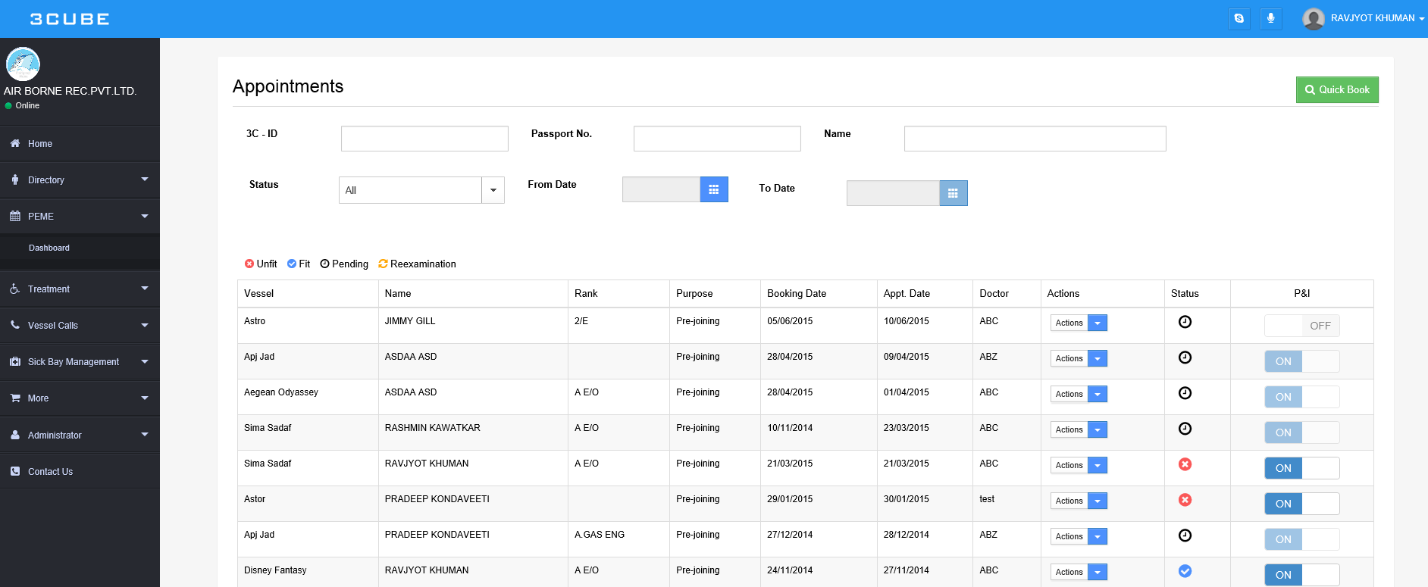Step D.4: Click on PEME

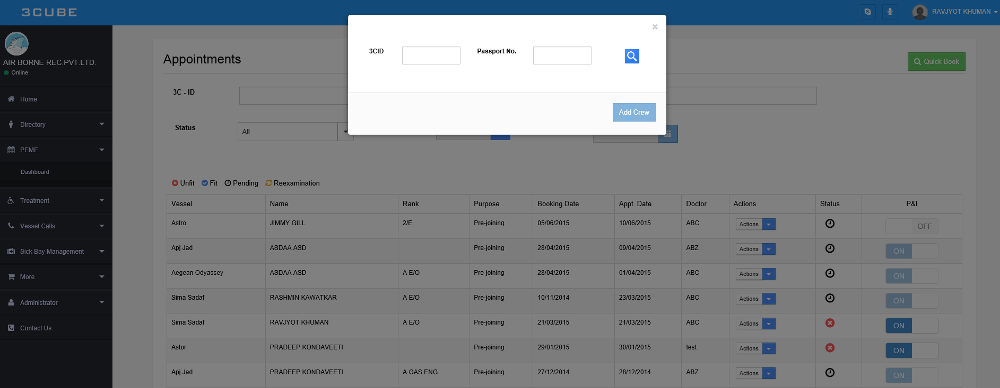Step D.5: Click on “Quick Book”

D.6 (i) ---- > Assumption: [Candidate’s passport number / 3C-ID is known and fed into the system]

Step D.6(i): Enter Passport No - “**M4012F6**”

Explain how search works with and without “space”

For same candidate also show search by 3C-ID – “**3C102438674120**”

Then put back search by Passport No.

Step D.7: Book Appointment

*(cont next page)*

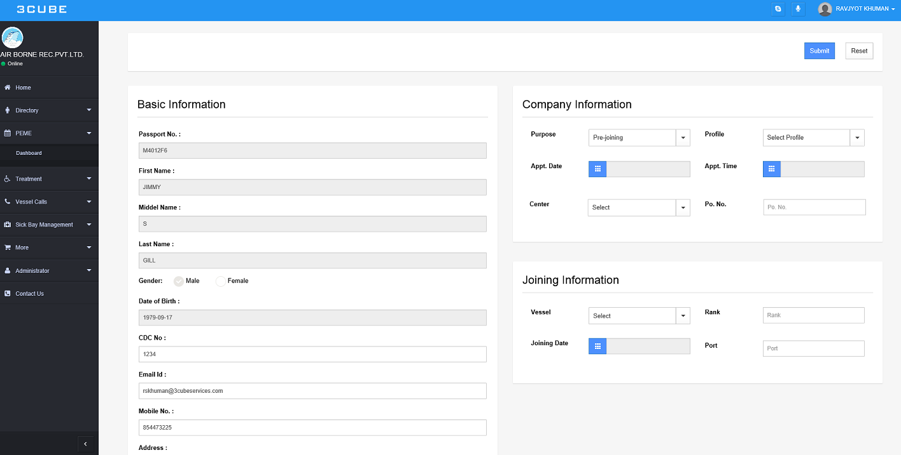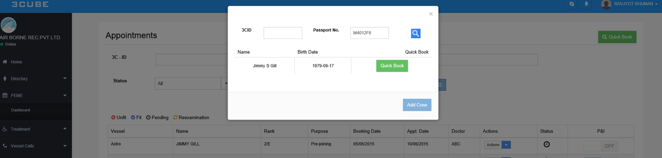Step D.7: Book Appointment

|  |  |  |
| --- | --- | --- |
| Basic Information | Company Information | Joining Information |
| Data is input from the master DB (candidate details given by company). | Purpose: Defines “what the medical is for” | Vessel list drop-down to select which vessel medical is being conducted for. |
| CDC No, Email ID, Mobile No. and Address fields are editable | Profile: Gives list of all Medical profiles. | Rank – “option as you enter” feature. |
|  | Appt Date and time can be selected by the company. | Joining Date and Port can be mentioned. |
|  | ~~“Center”~~ Doctor: will display option of doctors. |  |
|  | P.O number can be entered for invoicing convenience and tracking. |  |

**CLICK ON SUBMIT**

Step D.8: View the appointment on the PEME dashboard.



Step D.9: Show the Action Items Dropdown

|  |  |  |
| --- | --- | --- |
| Edit / Reschedule | Report | Delete Appointment |
| Allows user to Edit / Reschedule appointment **BEFORE DOCTOR CHANGES STATUS** | D.9(i): Click on Report:  Will take you to Gallery page where all uploads of the medicals will be visible.  Show Pending  Show Unfit  Show Fit | Allows user to Delete (Void) appointment **BEFORE DOCTOR CHANGES STATUS. That is before candidate reports for medicals.** |

Step D.10: Explain P&I Share

P&I Share is an option where by the details / reports etc. of that appointment can directly be shared with the P&I Club.

This feature can also later be a “GLOBAL SHARE” feature whereby would allow the user to email the contents to “authorized” parties or individuals using our *“Connector”*

Summary:

Once the appointment is booked, an email is sent out to the company and the candidate to confirm and inform them of the same.

***To the Doctor there are 2 Options***

*(cont next page)*

[](http://www.google.com.sg/url?sa=i&rct=j&q=&esrc=s&source=images&cd=&cad=rja&uact=8&ved=0CAcQjRw&url=http://web.mdoctorbd.com/&ei=uEl1VY2TOMTAmwWk2oDoCg&bvm=bv.95039771,d.dGc&psig=AFQjCNHGRYRYs_E8tWiaecvfPObP-TIUGg&ust=1433836316991582) Doctors who are authorized by the company are already in the directory. Their main contact email and other information is taken at the time of registration. Our team will correspond with the doctor and get them to sign up for “CLIP” which a platform made for Medical practitioners automating and standardize reports along with giving real-time updates. **This is Option A**

However in the event that the doctor is not setup with all that is required, the *“Connector”* will be used to achieve the same results. **Option B**

Option A: Using CLIP

Task (II): “synchronizing, standardized, compliant” reports when Doctors use clip.

Step A: Goto [www.3cubehealth.com](http://www.3cubehealth.com)

Step B: Click on CLIP

Step C: Doctor Login

Step D: Select Center

Step E: List of Appointments

Step F: Search Candidate appointment [Jimmy S Gill, PPNo. - **M4012F6**]

Step G: Select Action Items

Step H: Go to respective Tab.

Go through each and every Tab on each and every page.

Option B: Using “Connector”

Task (III): “synchronizing, standardized, compliant” reports when Doctors use connector.

Step A: Show Email

Step B: Show Link

Step C: Show how features on that page work

Step D: Show “one-time access” security measure.

Step F: Show how to contact us for request to “Re-Activate Link”

Comparison of the CLIP v/s Connector

|  |  |
| --- | --- |
| CLIP | Connector |
| Dedicated portal for doctor, irrespective of company | Link based on appointment received. |
| Anytime, always access with secure login | One-time access Link. Request for Re-Activation req. |
| Auto reporting compliance checks, saving and direct linking with company | Reports need to be scanned and uploaded. |
| Requires Doctor registration and confirmation along with basic e-training | No training, registration required. Company will instruct email address to send emails to. |
| Friendly, comprehensive system for doctors with long term vision and affiliation. | Easy to use platform, best of 1-time usess |
| Get detailed business and health trend reports. Part of 3Cube value add service. | Not applicable, due to operational model of the system. |

Survey

|  |  |  |  |
| --- | --- | --- | --- |
| Sr. No | Question | Score (1 – Poor , 10 – Good) | Notes |
| 1 | Ease of booking appointment |  |  |
| 2 | Ease of viewing and sharing reports of Medicals |  |  |
| 3 | Flow and Page transition for task. |  |  |
| 4 | Relevance of Data displayed. |  |  |
| 5 | Ease of understanding process |  |  |
| 6 | Look and feel of the platform |  |  |
| 7 | Features Provided |  |  |
| 8 | Icons and Terminology used |  |  |