**Review of User Portal**

|  |  |  |  |
| --- | --- | --- | --- |
| Page / header | Issue / Comment | Notes | Status: |
| Login Page: | Remove / Fix login with Facebook. | It does not adjust with screen size. Nor does it display correctly. |  |
| Dashboard | Remove tabs from top and put in sidebar as on other platforms. |  |  |
| Tile: Uploaded Reports | Put as Tab – on sidebar and create page for same. Can link with Upload files page. | In place of this we will have a basic Input Box as : BHI (basic health indicators)  Date: Auto  Weight: (Input) Height: (Editable)  BMI: Auto  ##Others to follow## |  |
| Medical History | Replicate Questionnaire as on CLIP3.3 | Save data as independent for internal purposes do not link with what doctor end inputs come. Also ensure that the 2 can be crosschecked at a later stage. Or viewed by 3Cube simultaneously. |  |
| Newsletter | Redirect to desired “page”. This page needs to be prepared. |  |  |
| Home Icon on sidebar | Not Functioning |  |  |
| Upload & Contact Us Pages | Not Functioning (see screenshots below) |  |  |
| User account settings | Create a user account settings where by the following basic functionalities:   * Change password * Enter Phone no. * Enter email add. * Date of Birth * Upload Image * Address * Emergency Contact form. * Consent to 3Cube (mandatory) | Consent form will be provided by 06/05/2015 |  |

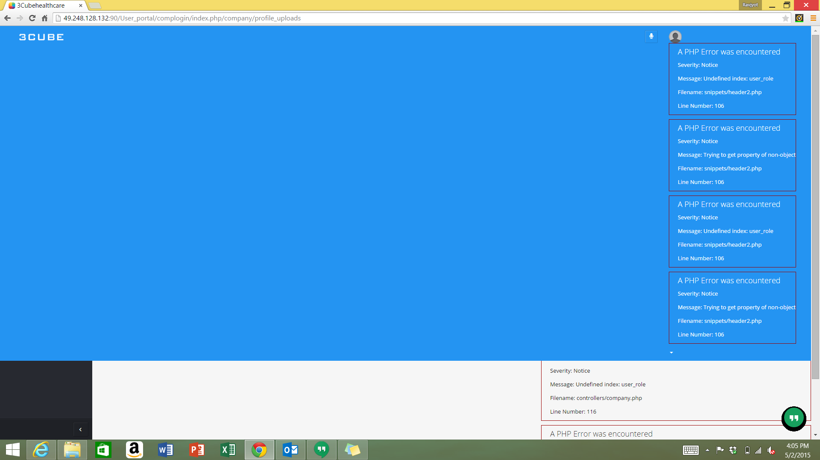

Screenshot 1 - Onclick of Uplaod Files

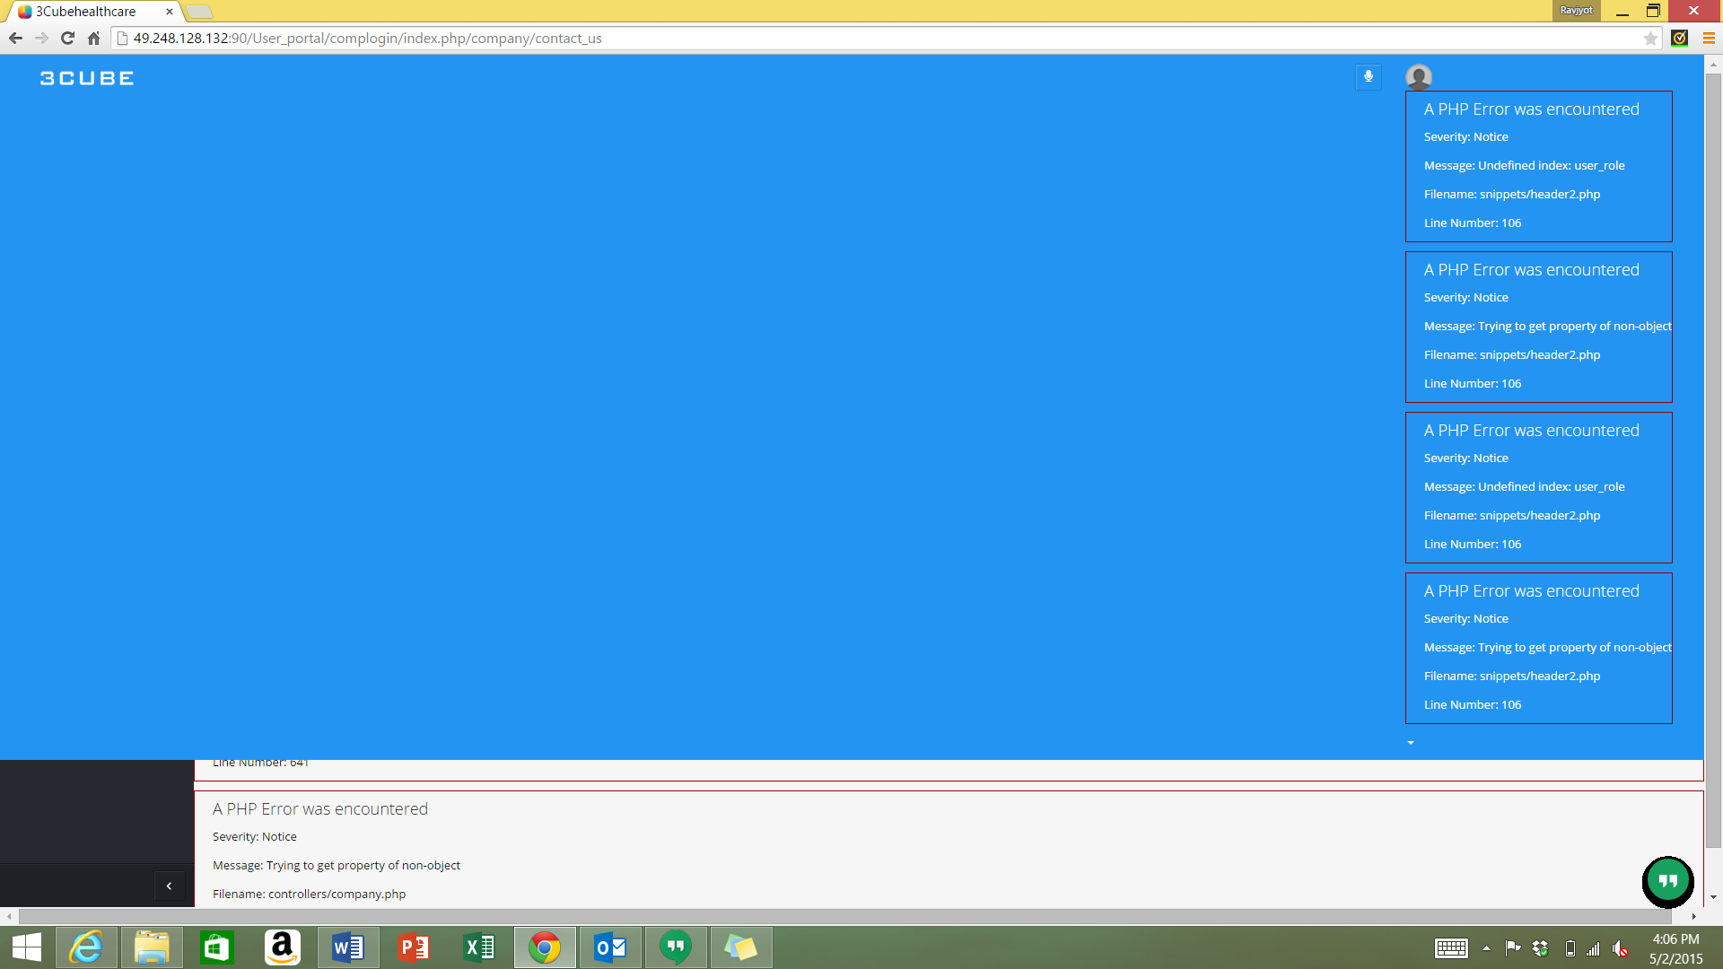

*Screenshot 2 - On Click of Contact Us*

Review the above and fix. The best would be that once you have fixed this to upload the preliminary version online.