Selective Unit Testing
Writing “Unit Tests” is a good thing. Writing bad Unit Tests and/or unnecessary Unit Tests can lead to considerably high maintenance cost to your overall project. Do you believe on statements such as
“We should aim for 100% code coverage”, “Any Unit Test is better than none”, or “Our main priority is the Unit Testing”?. All these statements do not add much value at all. These are some examples of expressing the way of the excitement, which causes by the Unit Testing.

Few years ago we hired a developer to one of our projects. He is very keen on Unit Testing and he spent lot of time writing and managing Unit Tests. At the end our project was over the budget, and not what we really expected. If he decided what is really important, and write only the necessary Unit Tests, it would have reduced our cost.

This is where it is really important that we need to ensure we write the absolutely necessary Unit Tests. This is also applicable if you practice TDD. You just don’t need to write Unit Tests for every method you write with in your application. Lets see some of these characteristics, and then how you decide what Unit Tests to write.

If you are aiming to write Unit Tests for every method to make your manager happy with higher code coverage, then it is fantastic to write these types of tests. But did you know that most of your tests did not add much value to the quality of your system at all. You see your entire tests pass with green ticks. There are so many green ticks make you feel good. Someone could argue that “All the tests are there to ensure that every method behave as expected when it runs”. Well not necessarily correct. Did you consider if you have to make a change to a component how much re-factoring need to be carried out?

Let’s explain this with an example. When you have an obvious method, which takes a String parameter and returns a Boolean, and there are 100 methods calling this simple method, change to this method to return a String would require changing all those 100 methods. How about the repetition? Your Unit Test probably written to ensure that calling method takes a String value and returns a Boolean. Isn’t this repeating the same thing? How about the DRY? The time you have spent to write this Unit Test, you should have spent for some important task such as analysing some business requirements.

Consider the future maintenance cost for both production code and all these Unit Tests? The amount of time you need to write Unit Tests for every single method, the amount of time you have to spend to write tests for complicated methods, which add no obvious benefits to the design of the system. They do not add any value at all.

You may also reluctant to make changes to your code because of the amount to Unit Tests and the fear of breaking them.

Decisions
So how you decide what Unit Tests to write. In order to decide this, you need to understand the types of methods you would normally write within your application.

- Simple methods – These methods are very obvious and simple. Just by having a look at code you can clearly see what it does. The code it self explains the design of it.

/// <summary>
/// Gets the first name from fulllname.
/// </summary>
/// <param name="fullName">The full name.</param>
/// <returns>First Name</returns>
public string GetFirstNameFromFulllname(string fullName)
{
if (string.IsNullOrEmpty(fullName))
{
return string.Empty;
}

return fullName.Substring(0, fullName.IndexOf(" "));
}

If you perform additional design and verification through Unit Testing, this method will give you a minimal benefit.
So if the method is simple and the design is obvious, you don’t need a Unit Test. If you are a TDD partitioner, the concept is the same. You do not need to write tests for every method you write within your application.

- Components that are already tested – I see some developers trying test components that have already been tested by the framework.

/// <summary>
/// Adds the companies to cache.
/// </summary>
/// <param name="companyList">The company list.</param>
public void AddCompaniesToCache(IList<Company> companyList)
{
if (companyList != null && companyList.Count() > 0)
{
HttpContext.Cache.Add("companyCahchkey", companyList, null, Cache.NoAbsoluteExpiration, new TimeSpan(0, 15, 0), CacheItemPriority.Normal, null);
}
}

The real purpose of this method is to add a list of companies to cache. A test would be to ensure the list is added to the cache. Why would do you need to write Unit Tests against this method when the ASP.NET caching – Cache is already tested for its capabilities. You can also see this method is very simple and hence Unit Tests are not required.

- Complex methods and have no value to the design at all –
For example you may have a method that writes to a registry using a complex pattern, and then using a complex algorithm to generate some custom strings, then serializes the data before calling a web service.

It will be very exhaustive exercise to write dependencies for some of these complex methods. There are so many things and variations to consider. These methods are not related to your main design or requirements but to assist or help other methods to get the job done. Most of these methods are self-contained algorithms.

- High Level methods – There are methods within your application that integrated or calls other Units of methods.

public void ManageResourceData(string resources)
{
if (string.IsNullOrEmpty(resources))
throw new ArgumentNullException("resources");

string retResourceValues = MergeResources(resources);
SaveResourcesToAFile(resources);
EmailReaources(resources);
AddResourcesToDatabase(resources);
SetUserPermission();
}

As you see here there are few units of methods being called. Writing Unit Tests for these types of methods, often waist of time.

- Complex methods with so many dependencies.
Some refer to this as GOD methods. Most TDD practitioners not experience these type of methods as they would to like to perform one assert per single method. Also methods are smaller and always written for a single responsibility. You might come across with a situation where complex method with so many dependencies. The method itself performs so many other things and need to be re-factored in order to make it more testable. You can see these methods really hard to Unit Tests. You have two options

  - Re-factor your method and consider using interfaces, so you can mock all your dependencies during Unit Test.
  - Simply do not waist your time to write the Unit Test. You may not have enough time to re-factor, and you can spend this time for something more useful.

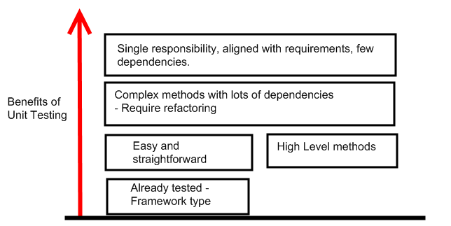

So the next important question is “What types of methods that you write Unit Tests against?”. The answer is not simple, which why you need to think carefully, before you write Unit Tests.

If you an application author, you would consider writing Unit Tests against the method that actually define your requirements. The focus should be to write methods with less number of dependencies by providing a single responsibility, while focusing on a specific requirement. Your dependencies should be easily mockable. The same consideration is applied if you are practicing TDD. When you implement your method with, then to pass your Unit Test, you should consider it as defining a specific requirement. If not, the test it self does not add value to your app.

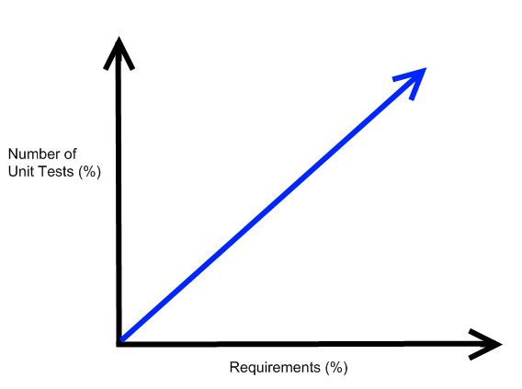

The above graph displays the number of Unit Tests increases with the requirements. The more requirements you have the more Unit Tests you should have.

For example you may have a high level requirement to write a Banking application where customer performs banking operations. When you design your application, you will consider more detail requirements, such as customers should be able to withdraw, deposit, transfer, print statements within your application. Regardless of wether you are TDD practitioner or not, you should consider writing Unit Tests for withdraw, deposit, transfer and print statements. By doing this you add the real quality to your application. You will have the confidence that your application performs as expected from the Unit Level.

You should not consider writing Unit Tests for any algorithms that may have to calculate your balances, encryptions, serializations, locked/isolated, or wether the database get initialised. These are some of the examples that you should avoid as they do not add much values your Unit Tests.

If you framework author you would consider writing Unit Tests ensure that the methods you have written confirms to the key design principles of your framework. Framework author should target the requirements, which provided by the design of the framework. For example, you are developing a resource management framework, and you need to ensure the developer who uses the framework could successfully retrieve images from your resource management system. So you would write a Unit Test to ensure that developers can retrieve images as expected.

I do not say that we should avoid Unit Tests and should not practice TDD. They both provide some real benefits to the application. However having unnecessary code / Uni Tests leads to more maintenance, and extra cost to projects.

Research Tools

Microsoft Pex
A tool developed by Microsoft Research. It is an automated tool, which allows you to perform white-box type testing. Using Pex you can achieve higher code coverage. It also assists you with regression testing.

You can download Pex from Microsoft Research. Pex is also included part of VS2010 Power Tools.

Pex will generate all the necessary inputs and outputs by looking at your method. Then you can generate Unit Tests and run them as required. I highly recommend for methods with complex algorithms. You can also use Pex with other Unit Test frameworks such as nUnit, xUnit.

Pex allows you to create Parameterized Unit Tests. When you download Pex, it comes with another tool called Moles, which allows you to replace any method with a delegate at test time.

You can download Pex from here.

CHESS
Another useful tool developed by Microsoft Research, which allows you to find and reproduce bugs (Heisenbugs)
in concurrent and multithreaded programs. CHESS supports testing both managed and unmanaged code.

How CHESS track bugs?
In a nutshell, CHESS repeatedly exercise/run each threads multiple times with different interleaving. If the interleaving result an error CHESS will allow you to debug the error.

You can make aware of your Unit Test that CHESS is integrated by just specifying the attribute, for example

[TestMethod]
[HostType(“Chess”)]
public void MyConcurrentThreadTestMethod()
{
……
}

CHESS allows you to locate the bug, reproduce it consistently, and then allow you to debug the issue.

