

A Research Project Report On
KrushiMitra: AI-Powered Farming Assistant

Research Project Report submitted to

Masters of Computer Application (SEM-III)

Of

University of Mumbai

Submitted by
Rajvardhan Ganpatrao Patil
Under the guidance of

Ms. Nidhi Poonia



Bharati Vidyapeeth’s
Institute of Management and Information Technology
Navi Mumbai.
BATCH: 2024- 2026

KrushiMitra: AI-Powered Farming Assistant

Chapter 1 – Introduction

1.1 Background of the Study
Agriculture is the backbone of the Indian economy, with a large portion of the population depending on farming for livelihood. Farmers often face challenges such as pest control, irrigation management, crop selection, and market price fluctuations. Access to agricultural officers or experts is limited, especially in rural areas. With advancements in Artificial Intelligence (AI) and Natural Language Processing (NLP), it is now possible to provide farmers with instant, localized, and language-specific support.
The KrushiMitra project aims to build a farmer-friendly platform where users can ask questions in Marathi (or other languages) and receive accurate, safe, and practical agricultural advice through a chatbot. Additionally, a Knowledge Base managed by admins ensures that trusted farming articles are always available.

1.2 Problem Statement
Farmers often lack immediate access to agricultural experts. Traditional methods of seeking advice involve visiting agricultural offices, which can be time-consuming and impractical. Online resources are either not available in regional languages or contain unverified information. This leads to wrong practices, crop loss, and financial setbacks.
Therefore, there is a need for a digital assistant that provides:
- Instant agricultural advice in local language (Marathi).
- A trusted knowledge base of farming articles.
- Voice input and output support for less tech-savvy farmers.

1.3 Objectives of the Study
- To design and develop a chat-based assistant for farmers using the MERN stack.
- To integrate Gemini AI for providing natural language answers.
- To implement Marathi voice input and output, making the system farmer-friendly.
- To create a Knowledge tab where admin-controlled farming articles are stored.
- To enable admins to manage articles and monitor system performance.
- To improve accuracy by combining AI with a structured knowledge base (future RAG).

1.4 Scope of the Study
- The platform is built using MERN stack with AI features powered by Gemini API.
- Supports Marathi (regional language) input and answers.
- Farmers can ask questions, read articles, and listen to answers.
- Admins manage knowledge articles and control content quality.
- The project is designed for smallholder farmers, focusing on crop management, pest control, and farming techniques.
- Future scope includes integrating market price data, weather forecasts, and IoT-based crop monitoring.

1.5 Significance of the Study
- For Farmers: Provides instant, reliable advice in a language they understand.
- For Researchers: Demonstrates how AI and RAG (Retrieval-Augmented Generation) can solve real-world agricultural problems.
- For Government/NGOs: Can be used as a scalable tool to reach rural farmers digitally.
- For Developers: A practical implementation of AI integration in the MERN stack.

1.6 Research Questions
- How can AI be leveraged to provide safe, reliable farming advice to smallholder farmers?
- What role does regional language support play in improving adoption among farmers?
- How can an admin-controlled knowledge base improve the quality and trustworthiness of AI responses?
- Which AI model (Gemini or custom fine-tuned model) is most effective for agricultural advisory?

Chapter 2 – Literature Review

2.1 Overview of the Domain
Agriculture remains the backbone of India’s economy, with more than half of the population dependent on farming for livelihood. However, farmers face multiple challenges such as crop diseases, pest infestations, unpredictable weather, and lack of immediate access to expert guidance. Traditional agricultural advisory systems, such as in-person visits to government agricultural offices, are often limited by time and distance. With the rise of Artificial Intelligence (AI), Machine Learning (ML), and Natural Language Processing (NLP), digital tools can now provide instant, accessible, and localized advisory services. AI-driven chatbots, plant disease detection systems, and precision farming solutions are emerging as promising tools to enhance productivity and decision-making for smallholder farmers. The inclusion of regional languages and voice-based interaction is critical to ensure adoption among rural populations, who may not be comfortable with English or text-only interfaces.
2.2 Review of Related Work
[1] Artificial Intelligence in Agriculture: Applications, Challenges, and Opportunities (2023) highlights the use of AI in crop monitoring, disease detection, and advisory systems. The paper stresses the importance of integrating knowledge bases and conversational AI to support farmers. It also identifies key challenges such as lack of regional language datasets, speech recognition limitations, and the need for reliable evaluation methods. This study provides the foundation for developing farmer-friendly AI solutions like KrushiMitra.
Similarly, Tripathi and Jain [2] highlight that natural language processing (NLP) systems provide farmers with localized answers but require careful prompt engineering to avoid unsafe pesticide recommendations.
The integration of voice technologies in agriculture advisory systems has also been studied. A paper by Suryawanshi et al. [3] explains that voice-enabled systems in Marathi and Hindi allow illiterate farmers to benefit from digital platforms, making the advisory process more inclusive. Meanwhile, Kaur, et al. [4] demonstrate that the use of speech-to-text combined with AI improves accessibility, but accuracy of recognition remains a challenge in rural dialects.
RAG (Retrieval-Augmented Generation) approaches have gained attention in agricultural applications. In the work of Bansal et al. [5], a vector database of farming best practices was integrated with a transformer-based model to ensure accurate and trusted outputs. This is in contrast to direct large language model (LLM) usage, which often produces generic answers.
Machine learning techniques have also been applied for specific agricultural problems such as pest detection and yield prediction. For instance, Chouhan et al. [6] developed a deep learning model for plant disease classification that achieved over 90% accuracy on image datasets. While this improves disease identification, it lacks the interactive conversational layer that farmers prefer.
The importance of multilingual support in agricultural advisory is highlighted by Sharma et al. [7], who show that regional language interfaces increase trust among farmers. Without language support, farmers often ignore mobile apps, despite their availability.

2.3 Existing Methodologies and Tools
Several methodologies and tools have been applied in agricultural AI systems:
- Machine Learning Models: Techniques like Random Forest, Decision Trees, and CNNs are commonly used for disease detection and yield prediction.
- Natural Language Processing (NLP): Used for chatbots and advisory systems, enabling farmers to ask questions in natural language.
- Voice Technologies (STT & TTS): Speech-to-Text (STT) and Text-to-Speech (TTS) systems improve accessibility, especially for non-literate farmers.
- Knowledge Bases: Structured repositories of agricultural practices help ensure accuracy and reliability of information.
- RAG Systems: Retrieval-Augmented Generation combines AI with vector databases to provide domain-specific, context-aware answers.
- MERN Stack: Popular for building scalable full-stack applications with MongoDB, Express.js, React.js, and Node.js.

2.4 Gap Analysis
Based on the reviewed literature and existing systems, the following gaps have been identified:
- Lack of Multilingual Support – Many agricultural advisory systems are built in English, limiting usability among farmers who primarily speak regional languages such as Marathi, Hindi, or Tamil.
- Limited Conversational AI Integration – Most AI applications focus on disease classification or static advisory rather than interactive Q&A.
- Absence of Voice Accessibility – Few platforms provide voice input/output, which is essential for rural farmers with low literacy levels.
- Weak Knowledge Management – Existing systems do not provide an admin-controlled knowledge base to store trusted agricultural articles for cross-verification.
- Safety Concerns in AI Advice – Without expert-curated data or constraints, AI systems risk providing unsafe pesticide or farming recommendations.
- Fragmented Solutions – Tools exist for disease detection, chatbots, or knowledge management individually, but integrated systems combining all three are rare.

Chapter 3 – Methodology

3.1 Research Design (UML Diagrams)

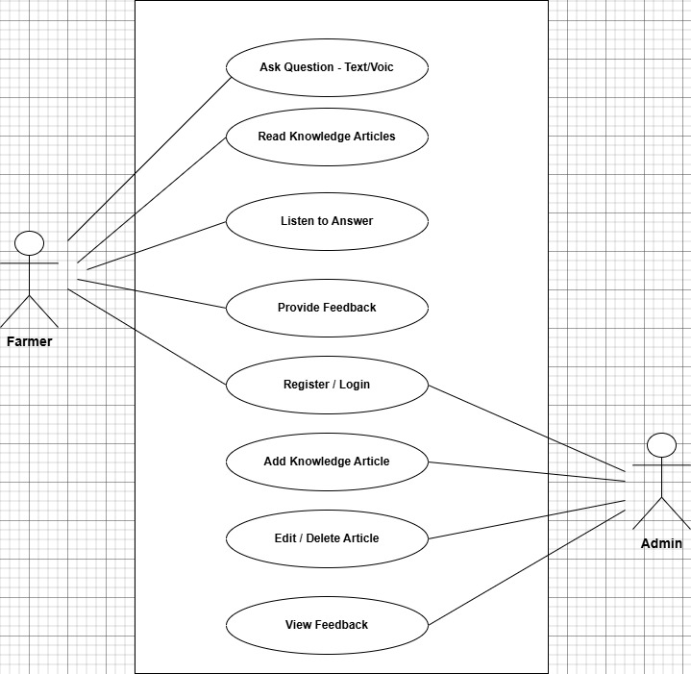

3.2 Framework/ Workflow Diagram / Architecture

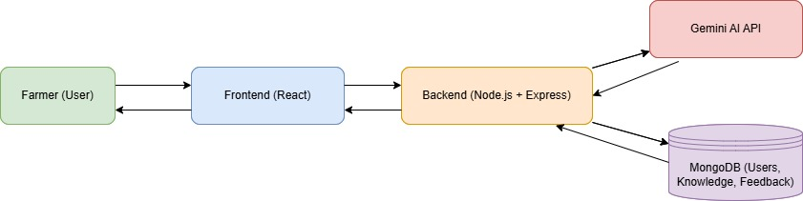

REFERENCES
[1] Singh, N., Wang’ombe, J., Okanga, N., Zelenska, T., Repishti, J., Jayasankar, G. K., Mishra, S., Manokaran, R., Singh, V., Rafiq, M. I., Gandhi, R., Nambi, A., “Artificial Intelligence in Agriculture: Applications, Challenges, and Opportunities,” Digital Green & Microsoft Research, India, 2023.
[2] Tripathi, R., & Jain, P. “Natural Language Processing in Agricultural Chatbots.” Journal of AI Research and Development, 2021.
[3] Suryawanshi, S., & More, P. “Voice-Enabled Agricultural Advisory System for Rural Farmers.” International Conference on Smart Agriculture, 2020.
[4] Kaur, G., Singh, H., & Verma, A. “Speech-to-Text Approaches for Agricultural Advisory Systems.” IEEE Access, 2021.
[5] Bansal, M., & Yadav, S. “Retrieval-Augmented Generation for Domain-Specific Question Answering in Agriculture.” AI for Social Good Conference, 2023.
[6] Chouhan, S. S., Singh, U. P., & Jain, S. “Plant Disease Detection Using Deep Learning.” Neural Computing and Applications, 2020.
[7] Sharma, N., Gupta, P., & Rawat, R. “The Impact of Multilingual Digital Platforms on Farmer Adoption.” ICT in Agriculture Journal, 2019.

