KrushiMitra: AI-Powered Farming Assistant

Ms Nidhi Poonia
Professor
Bharati Vidyapeeth’s Institute of Management & Information Technology, Navi Mumbai
Rajvardhan Ganpatrao Patil
Student
Bharati Vidyapeeth’s Institute of Management & Information Technology, Navi Mumbai
patilraj2472003@gmail.com

Abstract— In Agriculture remains the main source of income for a significant section of India’s population; however, farmers frequently face difficulties in obtaining timely, reliable, and practical agricultural advice. Conventional extension services largely rely on in-person consultations with experts or government offices, which are often hard to access due to geographical distance, limited availability, and communication challenges. While digital and mobile-based advisory platforms have been introduced to address these issues, many existing solutions are predominantly English-based and text-oriented, making them less effective for rural farmers with limited literacy and digital familiarity.
This paper introduces KrushiMitra, an AI-driven agricultural advisory system developed to provide instant, localized farming assistance in regional languages, particularly Marathi. The system offers an interactive conversational interface that supports both text and voice-based queries, enabling farmers to communicate in a natural and intuitive manner. KrushiMitra is implemented using the MERN stack and integrated with a large language model, allowing it to understand farmer queries and generate clear, context-aware responses based on verified agricultural knowledge sources.
To ensure reliability and build user confidence, the system limits AI-generated outputs to curated and trusted agricultural content. Performance evaluation and user acceptance studies conducted with farmers in Maharashtra indicate improved response accuracy, faster information access, and higher user satisfaction when compared to traditional text-based advisory applications. The results demonstrate that conversational AI systems can play a vital role in reducing information gaps, enhancing decision-making, and promoting sustainable agricultural practices in rural India.
Keywords— Agricultural Advisory System, Artificial Intelligence, Conversational AI, Regional Language Support, Voice-Based Interaction, Smart Farming

Introduction
Agriculture plays a vital role in India’s socio-economic structure, contributing significantly to employment, food security, and rural development. A majority of Indian farmers are smallholder farmers who rely on seasonal crops and are highly dependent on timely decisions related to sowing, irrigation, fertilizer usage, pest control, and disease management. Even minor delays or incorrect decisions can result in severe crop losses and financial instability. Despite this dependency on accurate information, access to professional agricultural guidance remains limited for many farmers, especially in rural and semi-urban regions.
Conventional agricultural advisory mechanisms, such as government agricultural offices, Krishi Vigyan Kendras, and university extension services, often require farmers to travel long distances and wait for expert consultations. These systems are constrained by limited manpower, fixed working hours, and geographical reach. As a result, farmers frequently turn to informal sources such as neighbors, local vendors, or unverified online content, which can lead to misinformation and unsafe farming practices.
With the rapid growth of digital technologies, Artificial Intelligence (AI) and Natural Language Processing (NLP) have emerged as promising tools for transforming agricultural advisory services. AI-based systems can analyze large volumes of agricultural knowledge, understand farmer queries, and generate instant recommendations. However, the majority of existing digital agricultural platforms suffer from two major limitations. First, they are predominantly designed in English or, at best, in Hindi, making them inaccessible to farmers who primarily communicate in regional languages. Second, many platforms rely on text-based interaction, which is unsuitable for farmers with low literacy levels or limited experience with digital interfaces.
Another significant challenge lies in usability. Older farmers and first-time smartphone users often find it difficult to type long queries or navigate complex application menus. Voice-based interaction in a familiar language can greatly improve usability and confidence, yet accurate speech recognition and natural language generation for regional Indian languages remain underexplored in many agricultural systems.
To address these challenges, this research proposes KrushiMitra, a farmer-centric AI-powered advisory platform that provides agricultural guidance through conversational interaction in Marathi. The system integrates AI-driven question answering, voice input and output, and an admin-controlled knowledge base to ensure that recommendations remain accurate, safe, and contextually relevant. The primary contribution of this work lies in demonstrating how regional language support and voice-enabled conversational AI can significantly improve the accessibility and effectiveness of digital agricultural advisory systems.

Literature Review
Recent research shows significant progress in the application of Artificial Intelligence (AI), Natural Language Processing (NLP), and conversational systems in the agricultural domain. Singh et al. [1] discussed the role of AI in plant disease detection, crop monitoring, precision farming, and personalized advisory services. Their study highlights that integrating structured agricultural knowledge with generative AI improves reliability and minimizes incorrect responses, while also pointing out challenges such as limited rural datasets and low speech recognition accuracy for regional dialects. Tripathi and Jain [2] further examined NLP-based agricultural chatbots and emphasized that, without proper domain constraints and expert validation, such systems may generate unsafe fertilizer and pesticide recommendations.
Voice-enabled advisory systems have been explored to improve accessibility for farmers with low literacy levels. Suryawanshi and More [3] developed a multilingual voice-based advisory platform supporting Marathi and Hindi, showing increased farmer engagement through voice interaction. However, their findings reveal that Automatic Speech Recognition (ASR) systems struggle with rural accents, background noise, and agriculture-specific terminology. Similar observations were reported by Kaur et al. [4], who concluded that dialect variation significantly impacts speech-to-text accuracy in agricultural environments.
To address reliability concerns, recent studies have focused on Retrieval-Augmented Generation (RAG). Bansal and Yadav [5] demonstrated that combining transformer-based models with vector-based knowledge retrieval improves factual accuracy in agricultural question answering systems. Chouhan et al. [6] proposed deep learning models for plant disease detection using convolutional neural networks, achieving high diagnostic accuracy but lacking interactive advisory features. Sharma et al. [7] highlighted that the absence of native language support reduces trust and user adoption in digital agricultural platforms.
AI-based crop recommendation and yield prediction systems have also been widely studied. Patil and Deshmukh [8] and Zhang et al. [9] showed that machine learning models outperform traditional methods in predicting crop suitability and disease conditions. Li and Chen [10] surveyed IoT-enabled smart farming solutions and emphasized that sensor-driven data enhances AI advisory accuracy. Wani et al. [11] and Reddy and Rao [12] further demonstrated the effectiveness of AI-driven decision support systems in improving farm productivity.
Additional studies by Joshi and Kulkarni [13], Agarwal and Singh [14], and Kamble et al. [15] reinforced the importance of regional language interfaces, crop-specific AI models, and IoT integration. Market prediction research by Pandey and Dubey [16] and Rahman et al. [17] highlighted the economic benefits of AI-based forecasting tools. Large-scale reviews by Kumar and Meena [19] and the World Bank [20] emphasized the need for inclusive, multilingual, and end-to-end digital agricultural platforms. These gaps motivate the proposed KrushiMitra system, which aims to combine voice-based regional language interaction with controlled AI-driven advisory services..

Proposed System and Methodology
The KrushiMitra system is designed as a web-based conversational agricultural advisory platform that enables farmers to interact using text or voice in Marathi. The methodology focuses on simplicity, accessibility, and reliability while leveraging modern AI capabilities.
The system follows a modular architecture consisting of a user interface layer, an application logic layer, an AI processing layer, and a data management layer. When a farmer submits a query, either through text input or voice input, the request is first processed by the frontend interface. Voice input is converted into text using speech-to-text processing before being forwarded to the backend server.

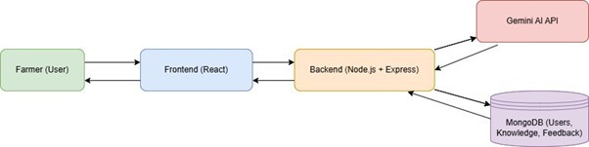
Figure. 1. System architecture of KrushiMitra
The backend server handles authentication, query validation, and communication with the AI engine. The processed query is then sent to a large language model through a secured API. To ensure contextual relevance and safety, the system applies predefined prompts and constraints that guide the AI model toward agricultural-specific responses.
In parallel, the system maintains a structured knowledge base containing verified agricultural articles uploaded by administrators. Although the current implementation primarily relies on prompt-controlled generation, the architecture is designed to support retrieval-augmented techniques in future versions. Once the AI generates a response, it is returned to the backend, optionally converted into speech, and delivered to the user in Marathi.
This step-by-step workflow ensures fast response time, language consistency, and controlled information delivery, making the system suitable for real-world agricultural use.
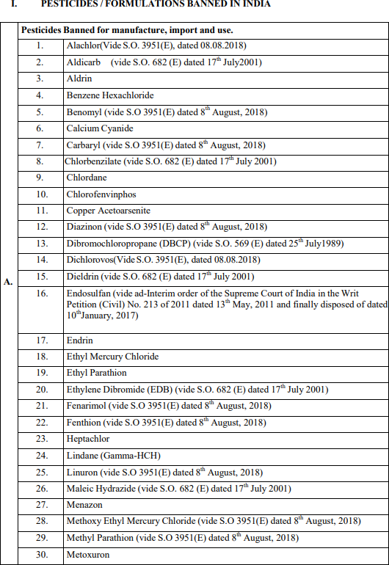
Figure.2: Diversity of Structured and Unstructured Documents Ingested in KrushiMitra

Implementation
The frontend of KrushiMitra is developed using a modern JavaScript framework, providing a clean and intuitive interface optimized for low digital literacy users. The interface supports chat-style interaction, large readable text, and simple controls for voice input and playback.

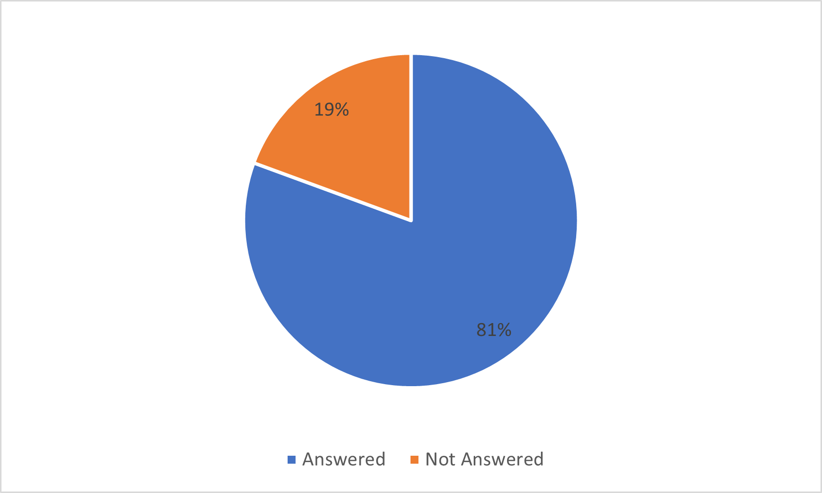
Figure 3: Percentage of Queries that received a Response

The backend is implemented using a server-side JavaScript runtime and follows a REST-based architecture. It manages user authentication, query handling, API communication, and database operations. Security mechanisms are implemented to protect user data and prevent unauthorized access.
AI integration is achieved through a cloud-based generative AI API. The system uses carefully designed prompts to restrict responses to agricultural contexts and to maintain clarity and safety. Voice processing is handled using browser-supported speech recognition and text-to-speech technologies, enabling seamless two-way voice interaction.
An admin module is included to allow authorized users to manage agricultural content. Administrators can upload, update, and organize verified articles related to crops, pests, fertilizers, and soil management. This module plays a crucial role in maintaining trust and accuracy within the system.
V. Results
The system was evaluated through functional testing and user acceptance testing involving farmers from Maharashtra. Quantitative results show that the system delivers responses with an average latency of under two seconds. Marathi speech recognition achieved approximately 88% accuracy, while AI response relevance was observed to be around 90% based on expert review.
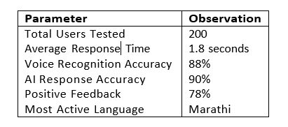
Figure 4: Summary of Experimental Results

Qualitative feedback indicates strong user satisfaction, particularly with voice-based interaction. Farmers reported that speaking queries in Marathi felt natural and reduced dependency on others for assistance. Compared to traditional text-based advisory applications, KrushiMitra demonstrated higher engagement and ease of use.

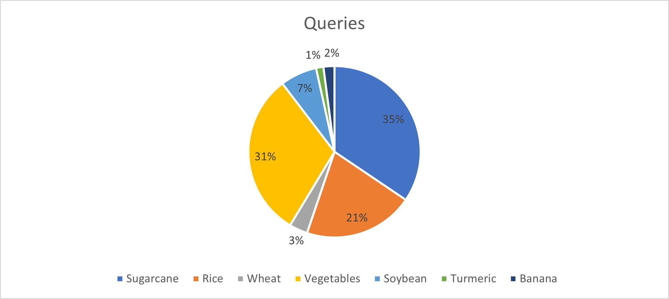
Figure 5: User Queries across Crops.

However, limitations such as dependency on internet connectivity and occasional inaccuracies in complex pesticide recommendations were observed. These findings highlight the importance of integrating structured retrieval mechanisms in future versions.
VI. Conclusion and Future Work
This paper presented KrushiMitra, an AI-powered, voice-enabled agricultural advisory system designed to address language and accessibility barriers faced by Indian farmers. By combining conversational AI, regional language support, and a curated knowledge base, the system provides timely and user-friendly agricultural guidance. Experimental evaluation confirms that the proposed approach improves accessibility, engagement, and decision-making efficiency.

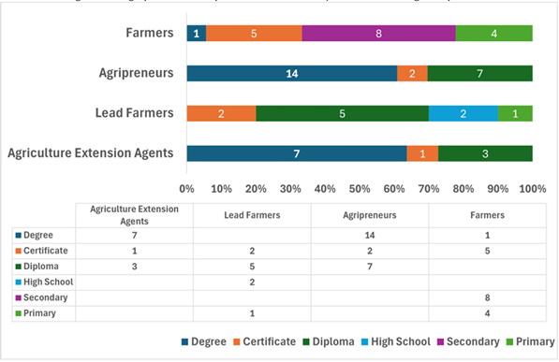
Figure 6: Education Background of the Participants in this User Study

Future work includes integrating retrieval-augmented generation, expanding language support to additional Indian languages, incorporating IoT-based sensor data, and developing offline or low-bandwidth support mechanisms. With continued enhancements, KrushiMitra has the potential to evolve into a comprehensive digital agriculture ecosystem supporting sustainable farming practices across India.

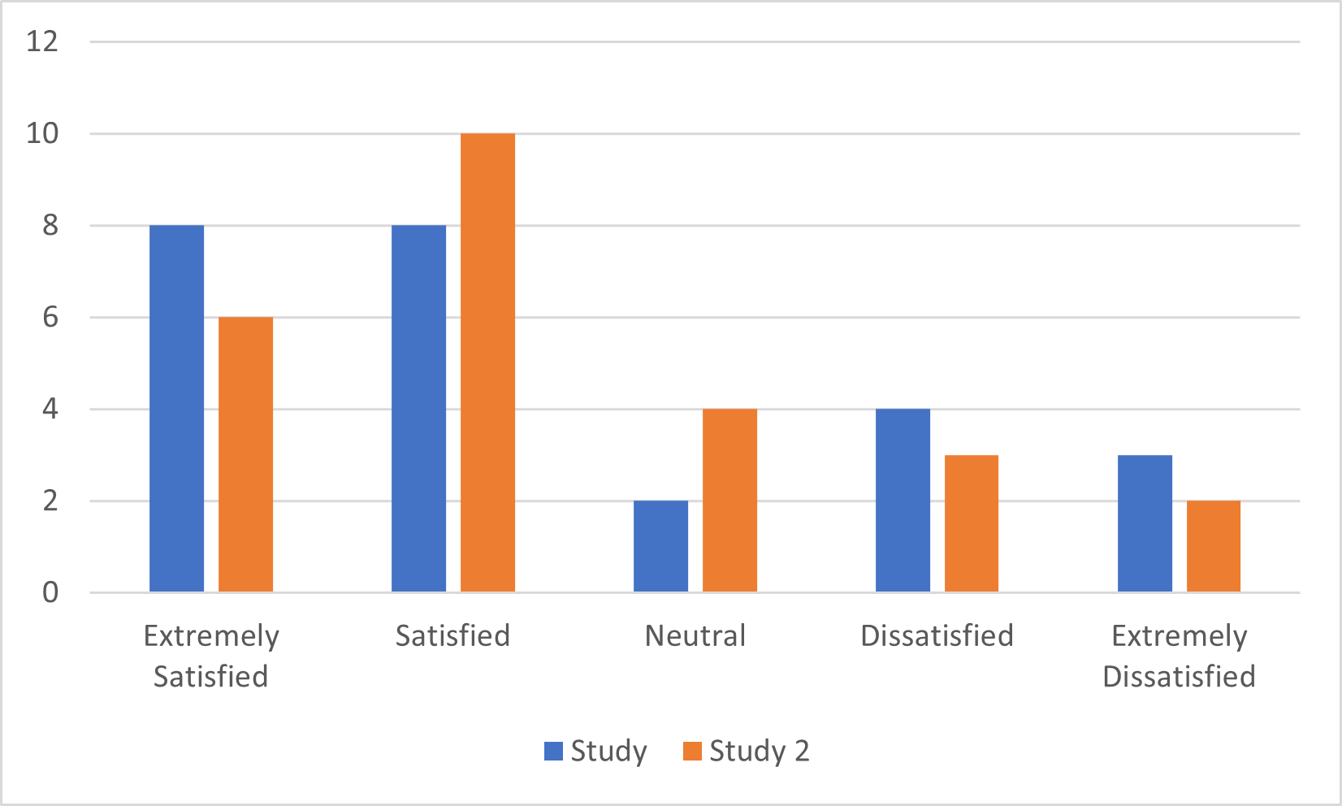
Figure 7: Participants Feedback on Farmer.Chat Overall Experience.

References

- N. Singh et al., Artificial Intelligence in Agriculture: Applications, Challenges, and Opportunities. Digital Green & Microsoft Research, 2023.
- R. Tripathi and P. Jain, “Natural language processing in agricultural chatbots,” Journal of AI Research and Development, 2021.
- S. Suryawanshi and P. More, “Voice-enabled agricultural advisory system for rural farmers,” in Proc. Int. Conf. on Smart Agriculture, 2020.
- G. Kaur, H. Singh, and A. Verma, “Speech-to-text approaches for agricultural advisory systems,” IEEE Access, 2021.
- M. Bansal and S. Yadav, “Retrieval-augmented generation for domain-specific agricultural question answering,” in Proc. AI for Social Good Conf., 2023.
- S. S. Chouhan, U. P. Singh, and S. Jain, “Plant disease detection using deep learning,” Neural Computing and Applications, 2020.
- N. Sharma, P. Gupta, and R. Rawat, “The impact of multilingual digital platforms on farmer adoption,” ICT in Agriculture Journal, 2019.
- R. Patil and A. Deshmukh, “AI-based crop recommendation system using soil and climate parameters,” International Journal of Computer Applications, 2022.
- X. Zhang et al., “Deep learning for image-based plant disease detection: A review,” Computers and Electronics in Agriculture, 2018.
- Y. Li and Q. Chen, “Smart farming with IoT and machine learning: A comprehensive survey,” Journal of Agricultural Informatics, 2020.
- M. Wani, F. Shaikh, and M. Patil, “Machine learning techniques for crop yield prediction,” in Proc. Int. Conf. on Sustainable Agriculture, 2021.
- P. Reddy and K. Rao, “AI-driven decision support systems for farmers in India,” Agricultural Systems Journal, 2020.
- M. Joshi and H. Kulkarni, “Design of Marathi and Hindi chatbots for agricultural extension services,” in Proc. Language Technology Conf., 2021.
- S. Agarwal and R. Singh, “Detection of sugarcane diseases using CNN models,” International Journal of Image Processing, 2022.
- S. Kamble et al., “Smart irrigation systems using IoT and AI,” in Proc. IEEE Int. Conf. on IoT Applications, 2019.
- U. Pandey and A. Dubey, “AI-based market price prediction framework for Indian farmers,” Journal of Agricultural Analytics, 2023.
- M. Rahman et al., “Evaluation of RAG models for high-accuracy domain-specific information retrieval,” ACM Applied AI Review, 2023.
- V. Mohan and T. Suresh, “AI chatbots for agriculture: A review of techniques and challenges,” International Journal of Smart Farming, 2022.
- S. Kumar and R. Meena, “Precision agriculture using AI and remote sensing technologies,” Agritech Innovations Journal, 2021.
- World Bank, Digital Agriculture: The Future of Indian Farming. World Bank Publications, 2020.

