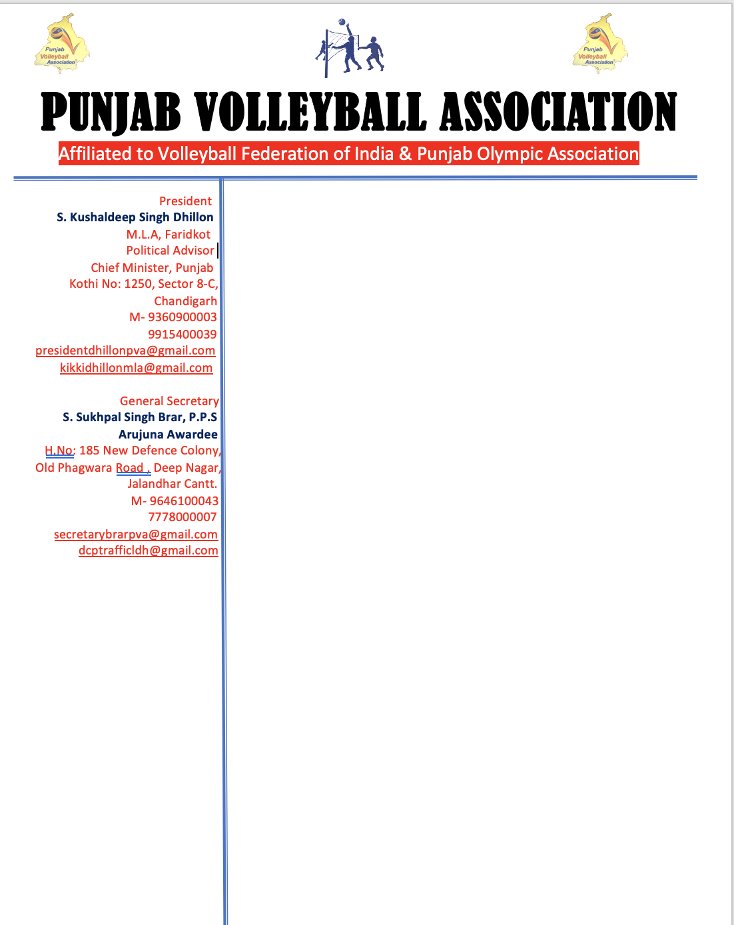

**Ref. No: PVA/BRAR//Spl-2/301219 Dated :30-12-2019**

To,

Prof. Gurbeer Singh

President

District Volleyball Association

Mansa

Sub: Congratulatory letter

Dear Prof. Gurbeer Singh ,

It gives me immense pleasure to inform you that your unanimous elections of the District Volleyball Association, Mansa which was held on 25st December 2019 at Gandhi Senior Secondary School and the D.V.A, Mansa was held unanimously.

The following are the ofiice bearer’s :

**President Prof. Gurbeer Singh**

**General Secretary Mr. Gurdarshan Singh**

**Treasurer Mr. Happy Jindal**

Punjab Volleyball Association is please to recognize your team of District Volleyball Association, Mansa .

My heartiest congratulations and wish you successful tenure.

I look forward to your cooperation in the promotion and development of volleyball. I extend my best wishes for your good health, happiness and great success.

With warm regards

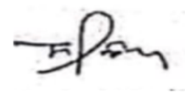

Sukhpal Singh Brar, P.P.S

Arjun Awardee

Copy to President, P.V.A