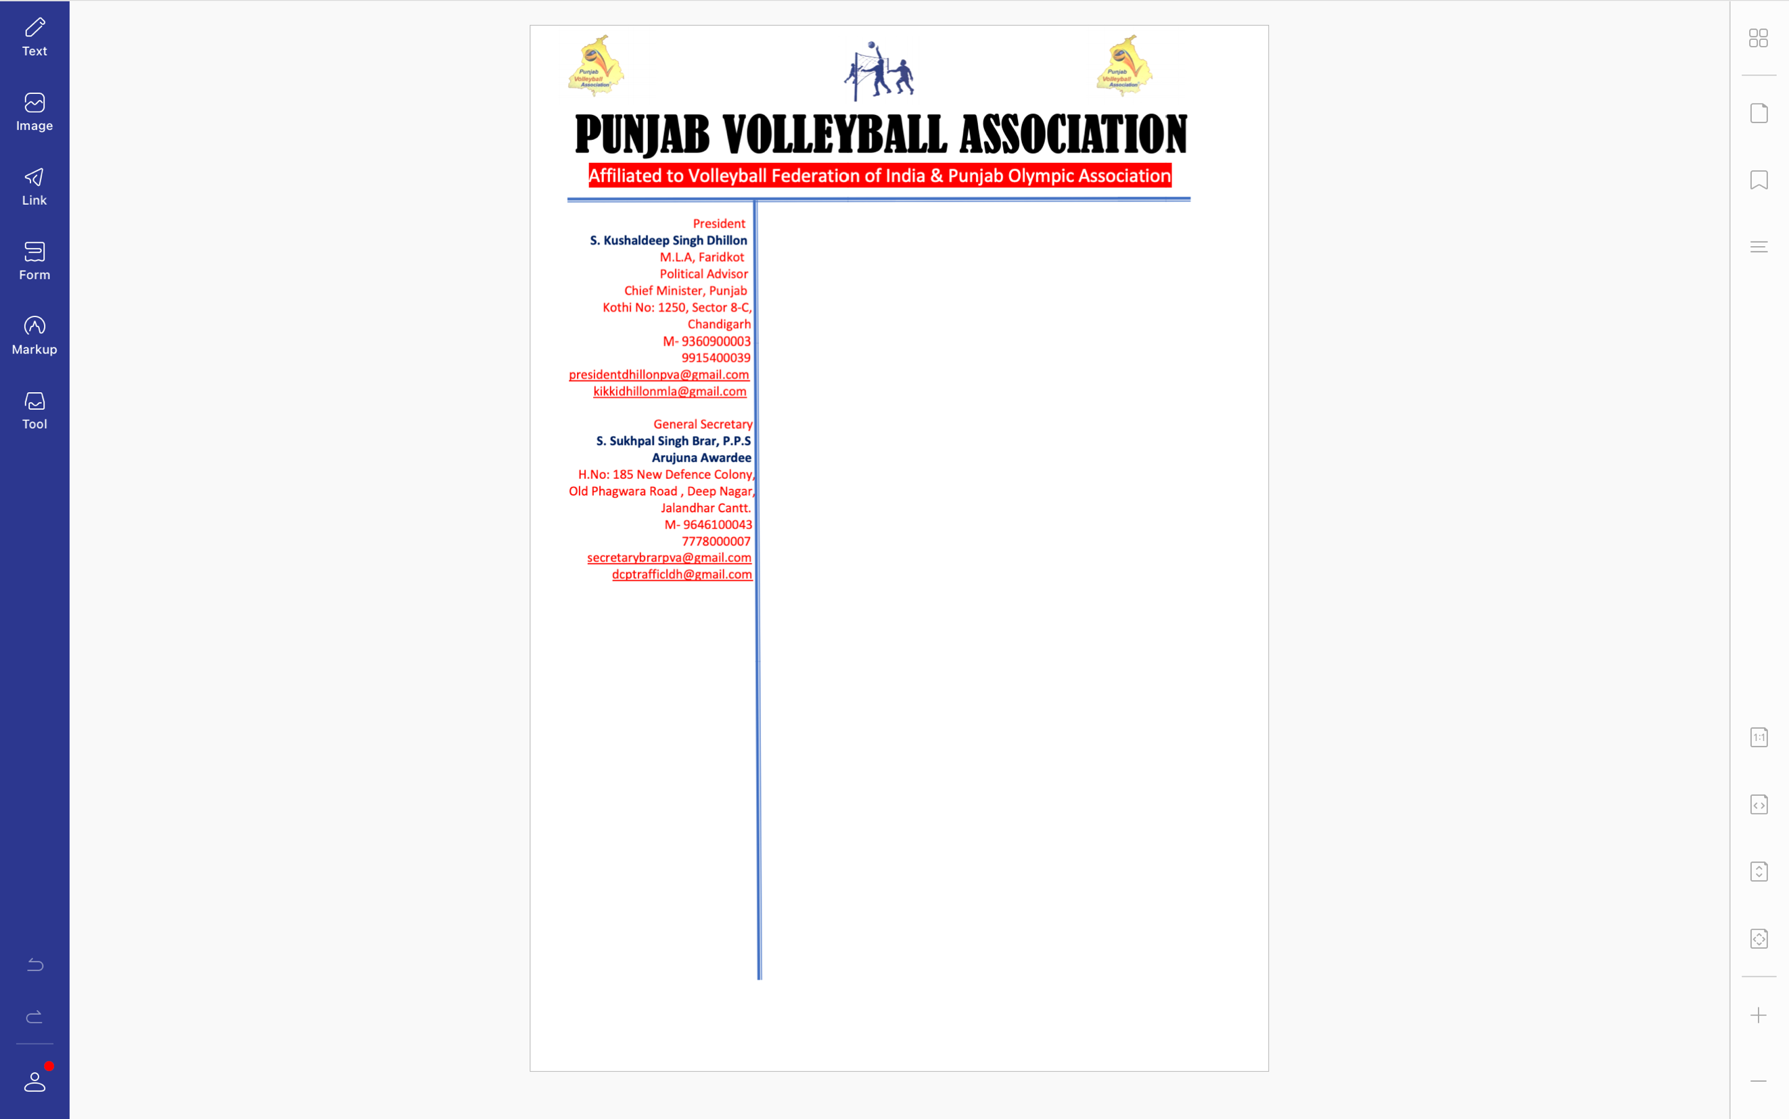



**Ref. PVA/BRAR/2021/Spl.-(2)/2721** Dated: 27-12-2021

v`l:

smUh izlwH pRDwn/jnrl sk`qr

pMjwb vwlIbwl AYsosIeySn

ivSw: pMjwb vwlIbwl AYsosIeySn dI ie`k mIitMg sbMDI

auprokq ivSy dy sbMD iv`c Awp jI dI jwxkwrI leI d`isAw jWdw hY ik AYsosIeySn dI jnrl bwfI mIitMg imqI 29-12-2021 idn buDvwr nUM mwrkPYf dPqr sYktr-35 cMfIgVH ivKy dupihr 12 vjy vwlIbwl Kyf nUM hor pRPuilq krn sbMDI r`KI geI hY[ies mIitMg iv`c hr mYNbr dw Bwg lYxw lwzmI hovygw[

DMnvwd sihq

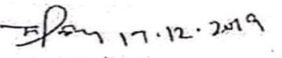

suKpwl isMG brwV, Arujnw AvwrfI

jnrl sk`qr

pMjwb vwlIbwl AYsoSIeySn