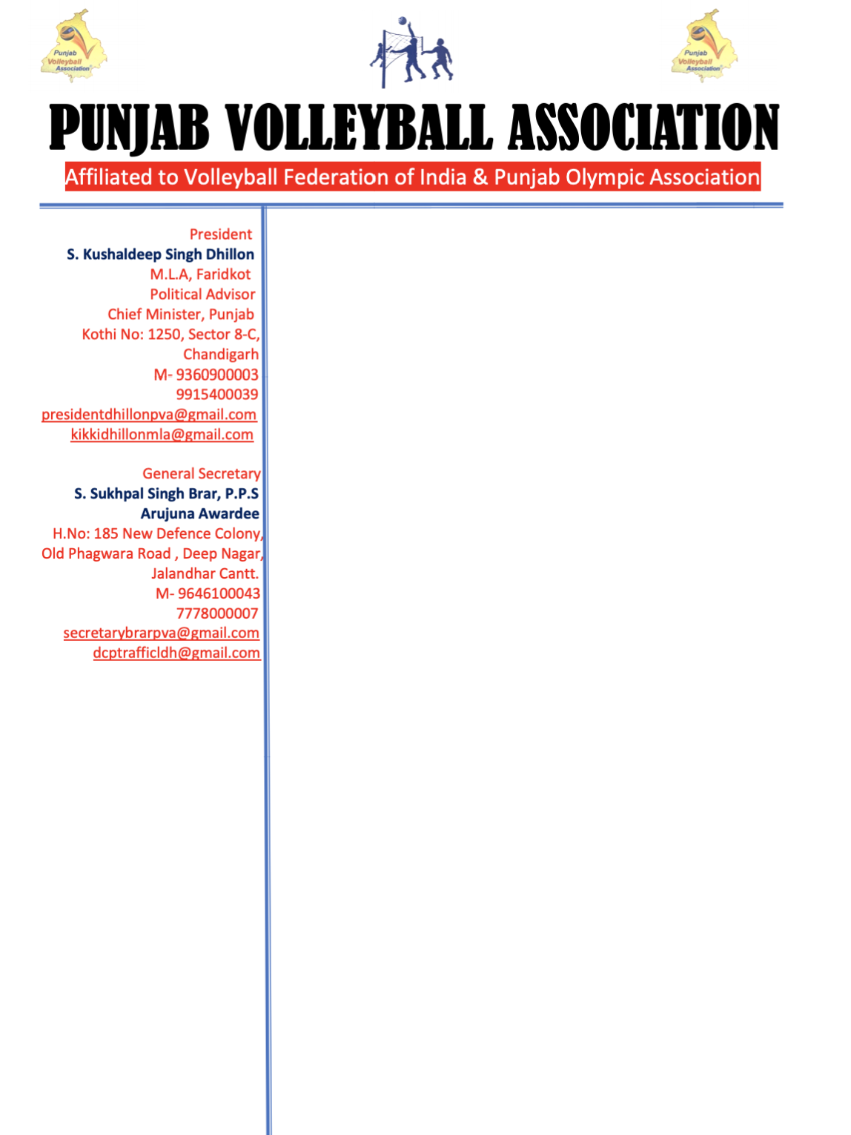

Ref No P.V.A/BRAR/2021/0504 Dated:05-04-2021

To,

Sports Officer

Northern Railway

New Delhi

Sub: Regarding permission to participate in championship

Respected Mam/Sir,

With reference to the above mentioned subject, I humbly request you to grant permission to the following employees working under your division to participate in the Senior State Volleyball championship to be held at Fardikot, Punjab on 10th and 11th April, 2021 representing the team of Ludhiana in the above said championship.

1. Rajinder Kumar. T.E
2. Dilraj Singh. T.E
3. Ranvir Singh, T.E
4. Lakhvir Singh, T.E

Kindly do the needful and oblige

Regards

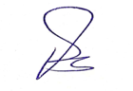

Sukhpal Singh Brar, Arjuna Awardee

General Secretary

Punjab Volleyball Association